Data set for the treemap chart: food_sales.xlsx (GitHub)

Data set for the area chart: printer_sales.xlsx (GitHub)

Data set for the area chart:us-population-by-age.xls (GitHub)

**Python. Plotly. Treemap**

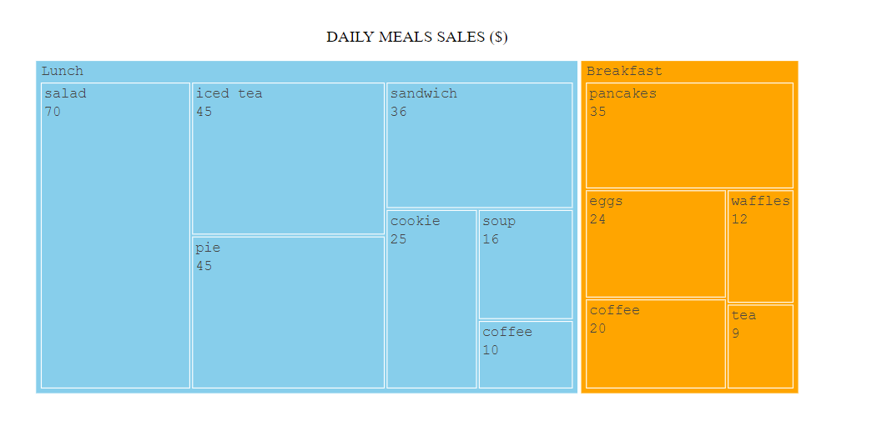

**Python. Matplotlib. Area Chart.**

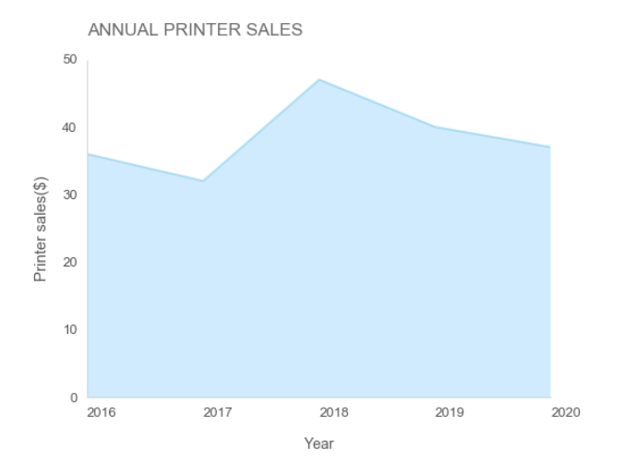

**Python. Matplotlib. Stacked Area Chart.**

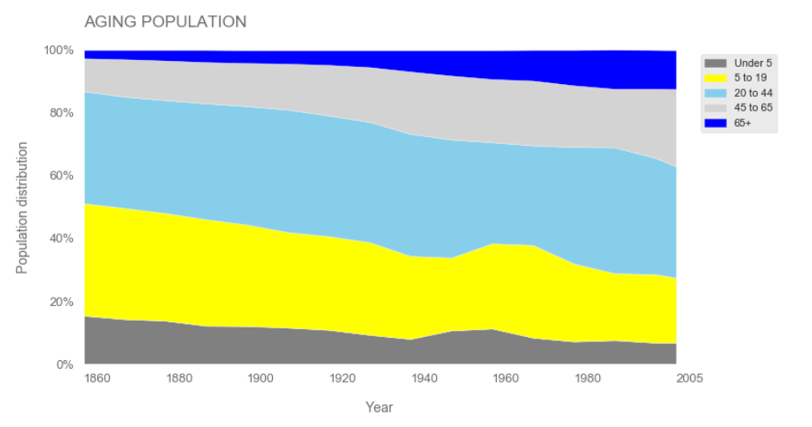

**R. GGplot2. Treemap.**

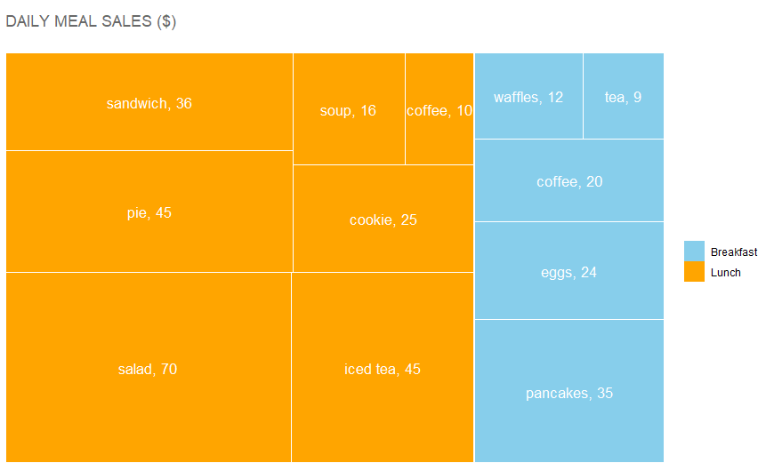

**R. GGplot2. Area Chart.**

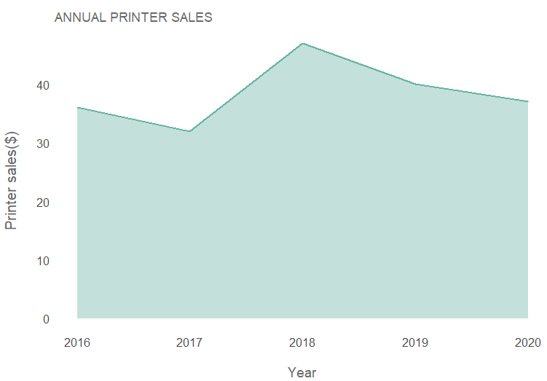

**R. GGplot2. Stacked Area Chart.**

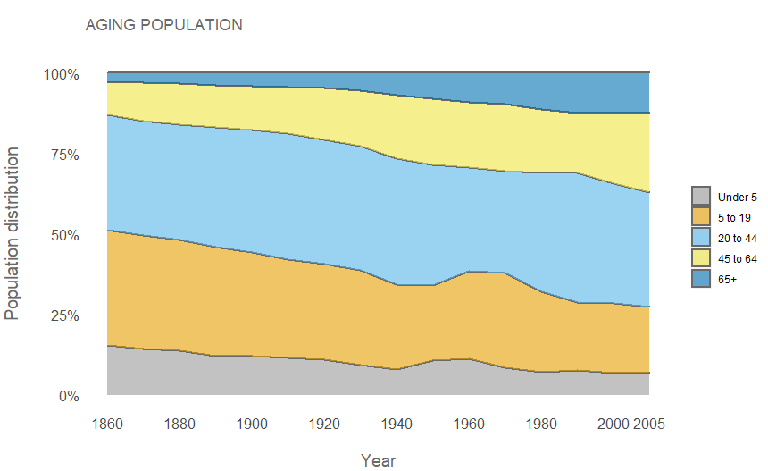

**Tableau. Treemap.**

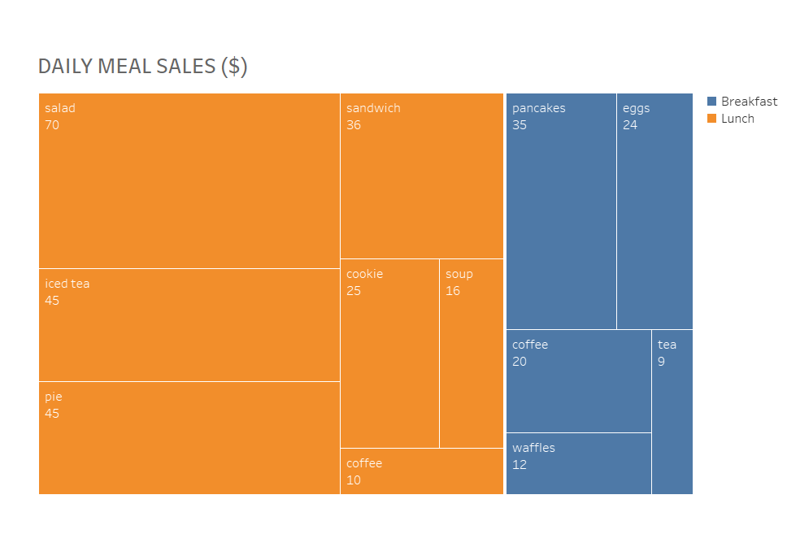

**Tableau. Area Chart.**

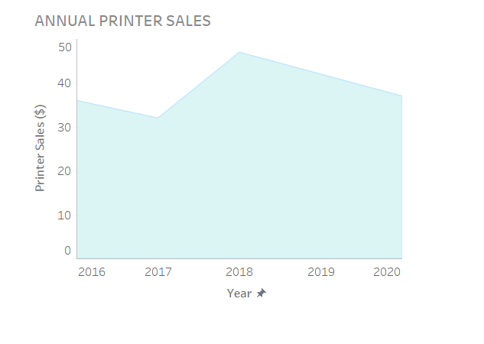

**Tableau. Stacked Area Chart.**

