Data sets used: ppg2008.csv, costcos-geocoded.csv, Data 4_Migrated Data.csv

**Python. Heatmap**

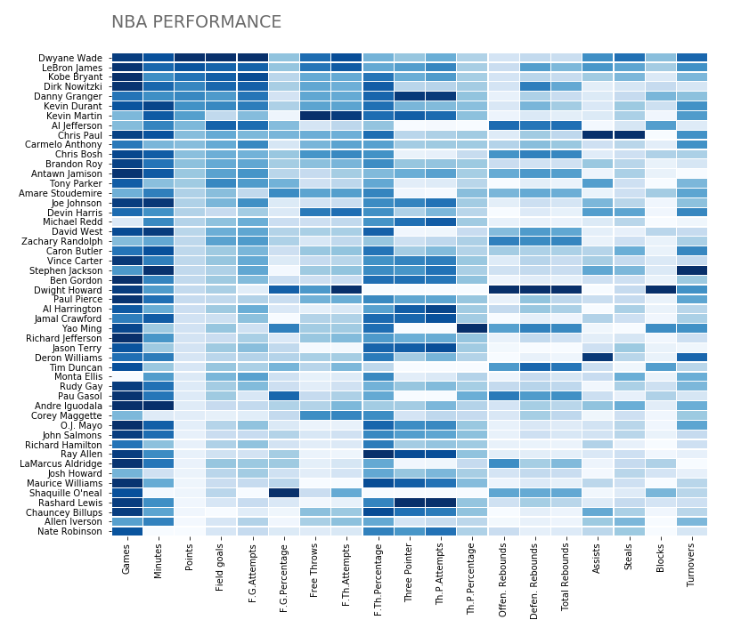

**Python. Contour plot highlighting games that were lost**

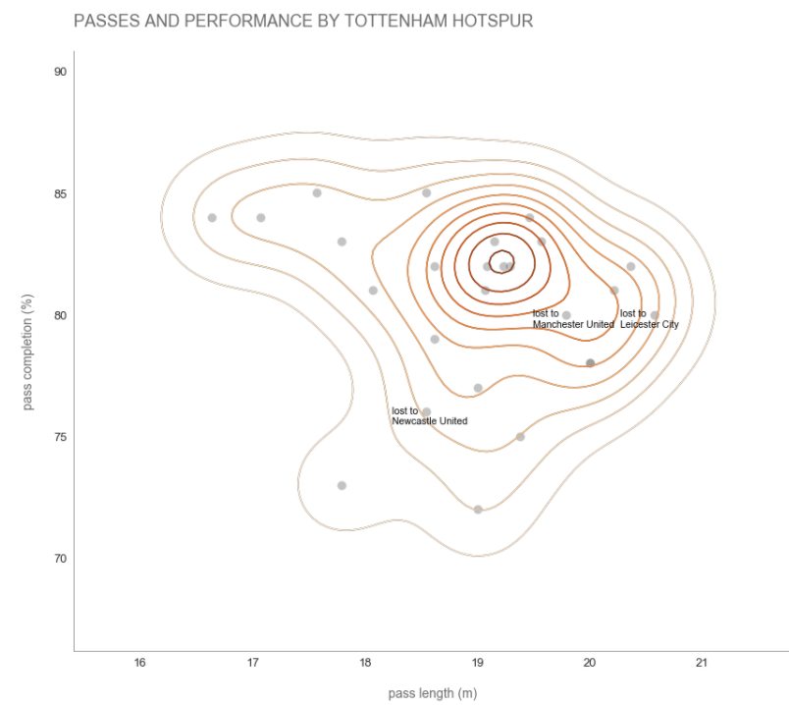

**Python. Map**

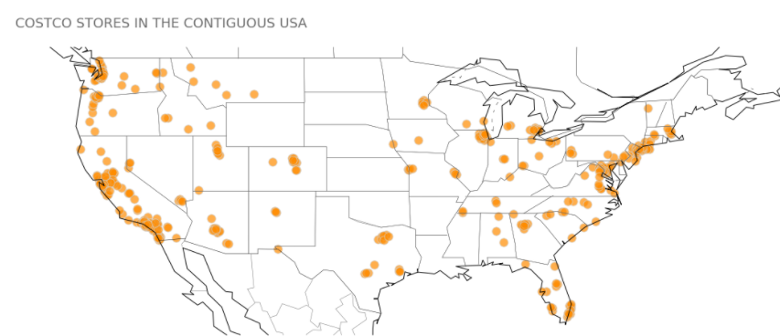

**R. Heatmap**

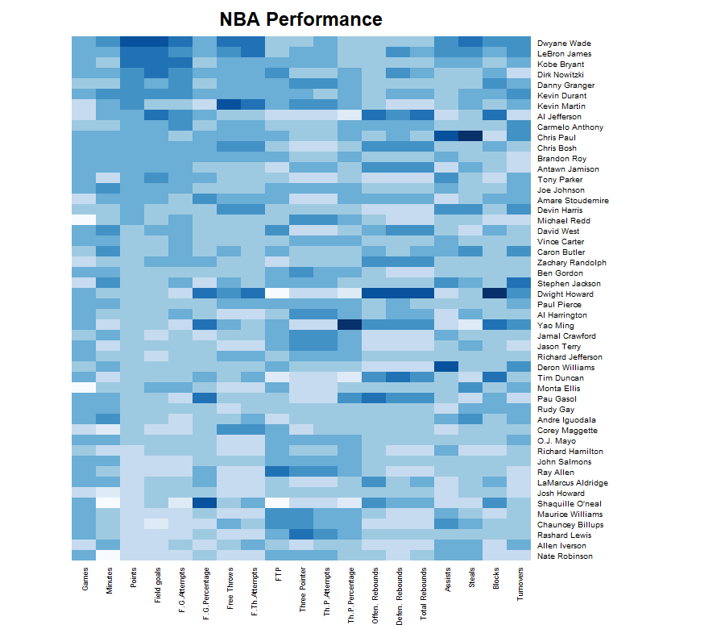

**R. Contour plot highlighting games that were lost**

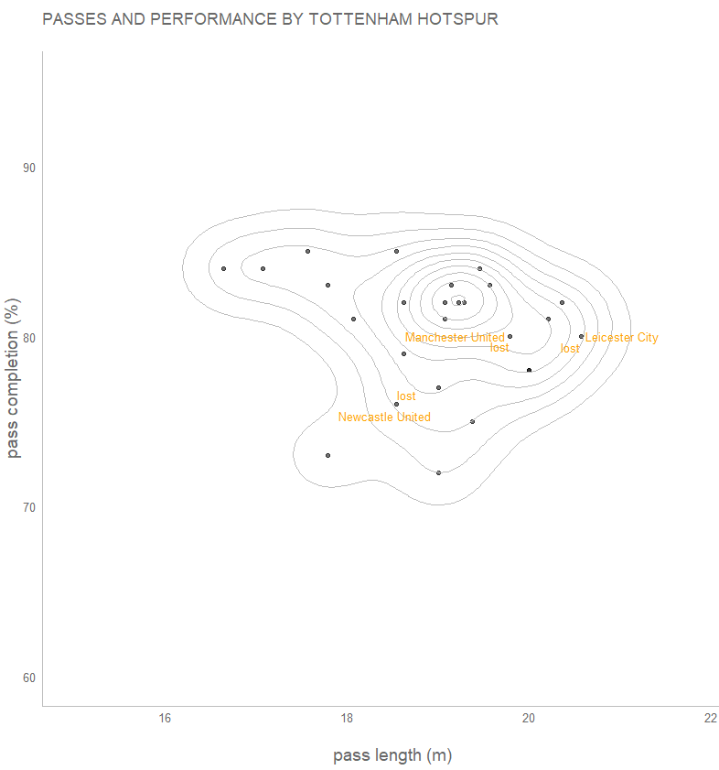

**R. Map**

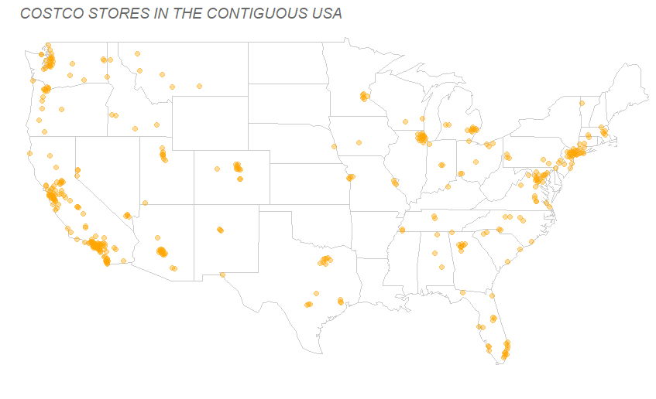

**Tableau. Heatmap**

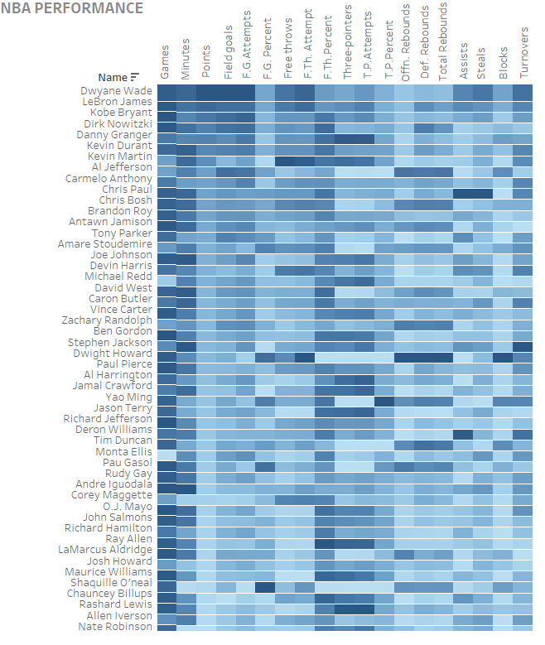

**Tableau. Contour plot highlighting games that were lost**

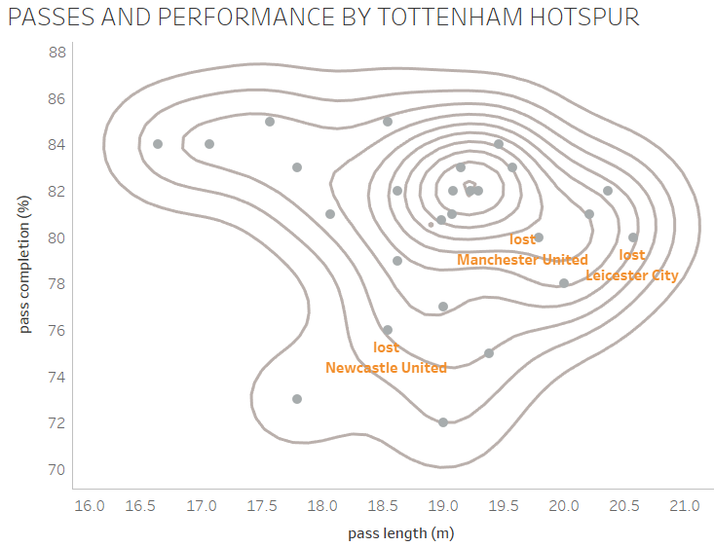

**Tableau. Map**

