Datasets: birth-rate.csv, crimeratesbystate.csv, sales-devices.xlsx

**Python. Histogram**

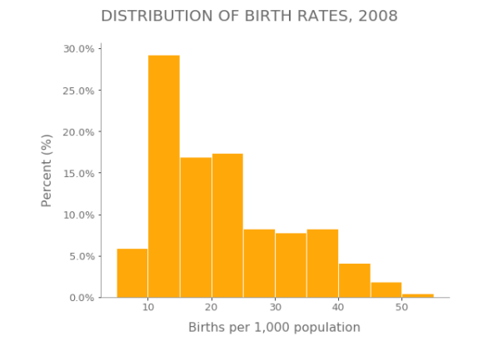

**Python. Boxplot**

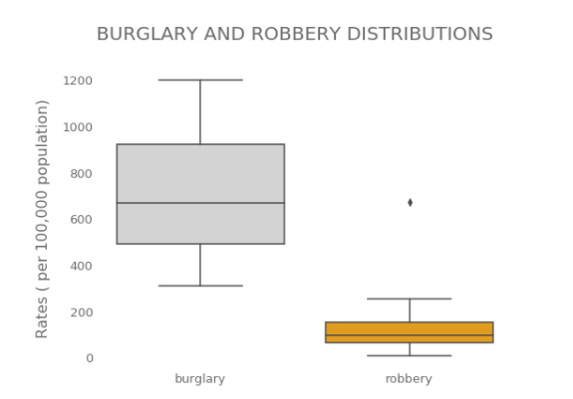

**Python. Bullet chart**

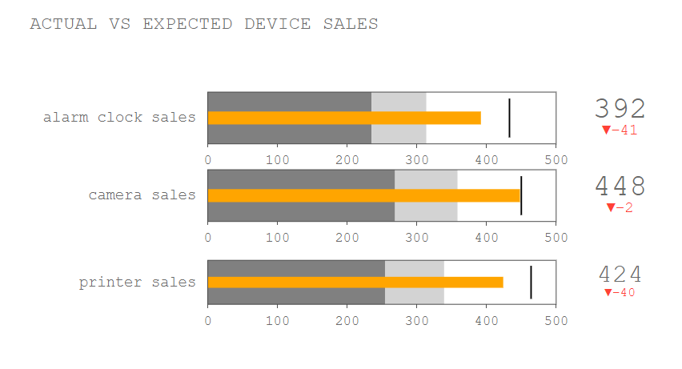

**Python. Radar chart**

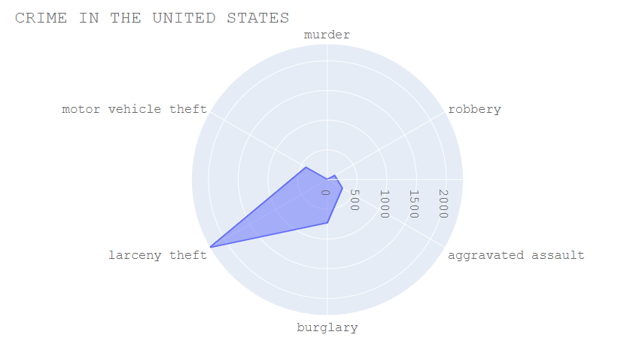

**R. Histogram**

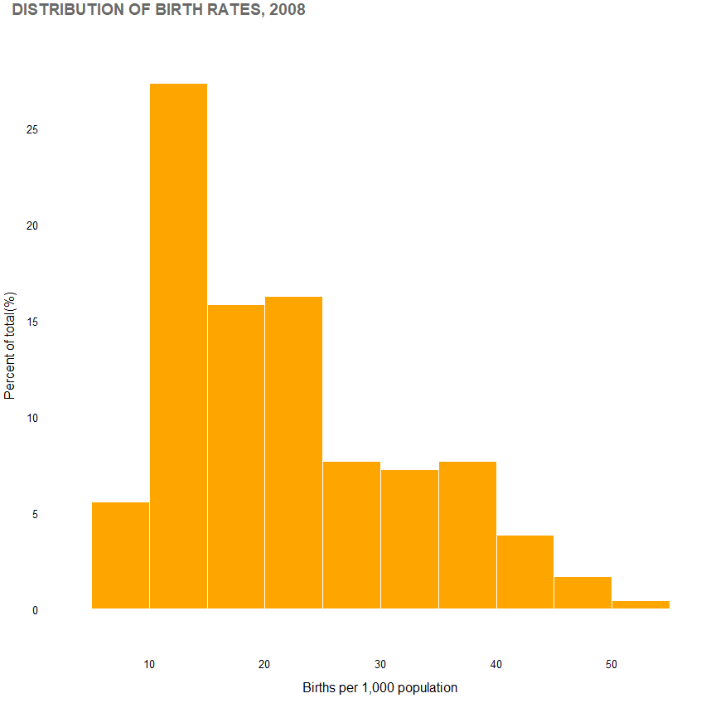

**R. Boxplot**

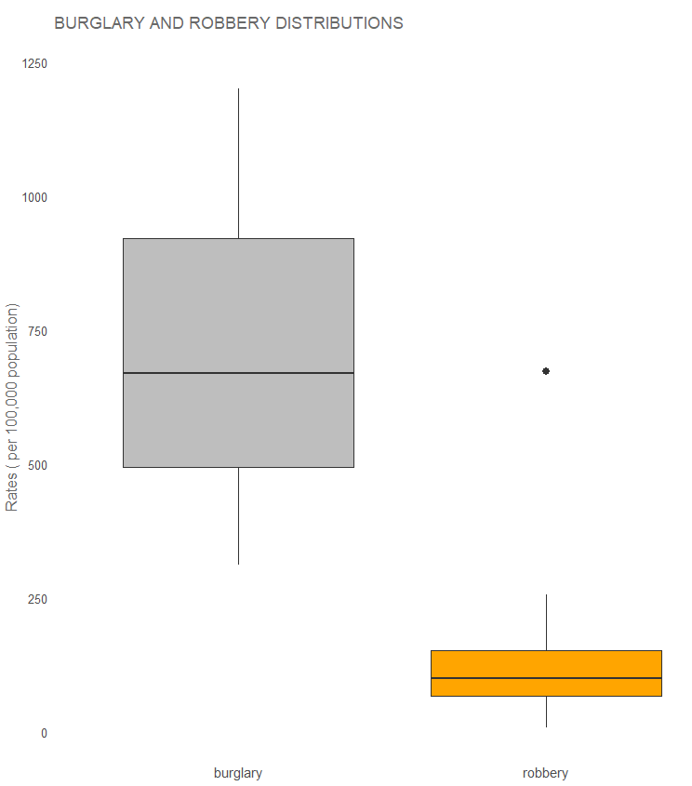

**R. Bullet chart**

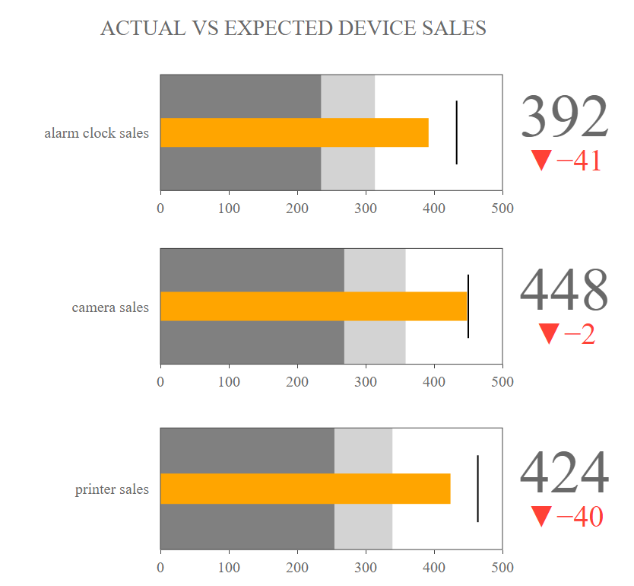

**R. Radar chart**

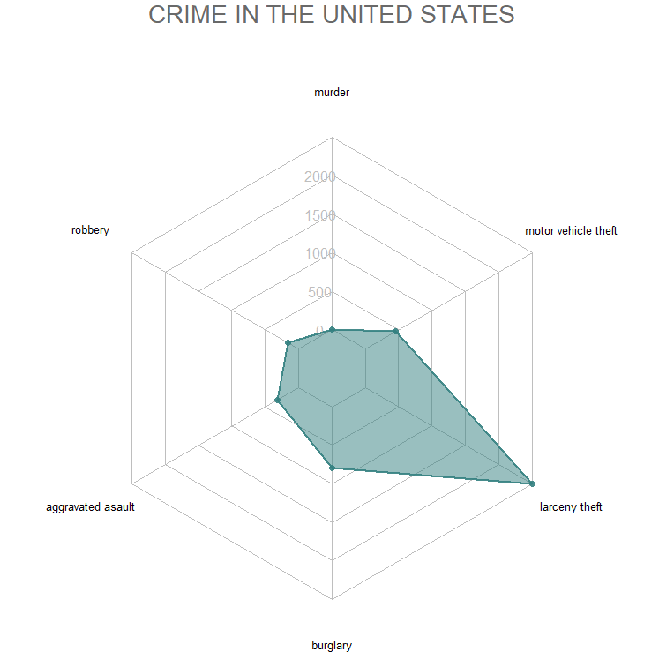

**Tableau. Histogram**

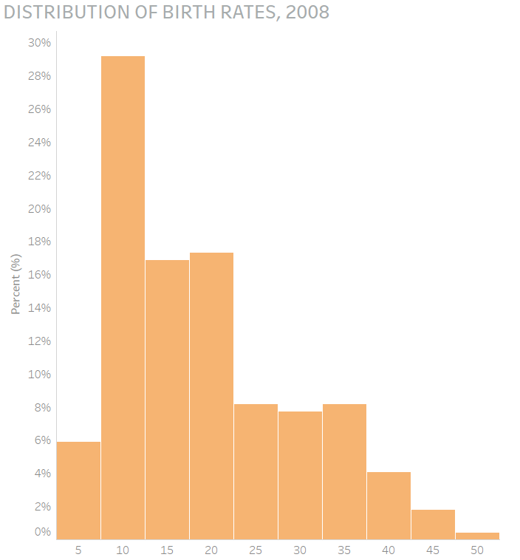

**Tableau. Boxplot**

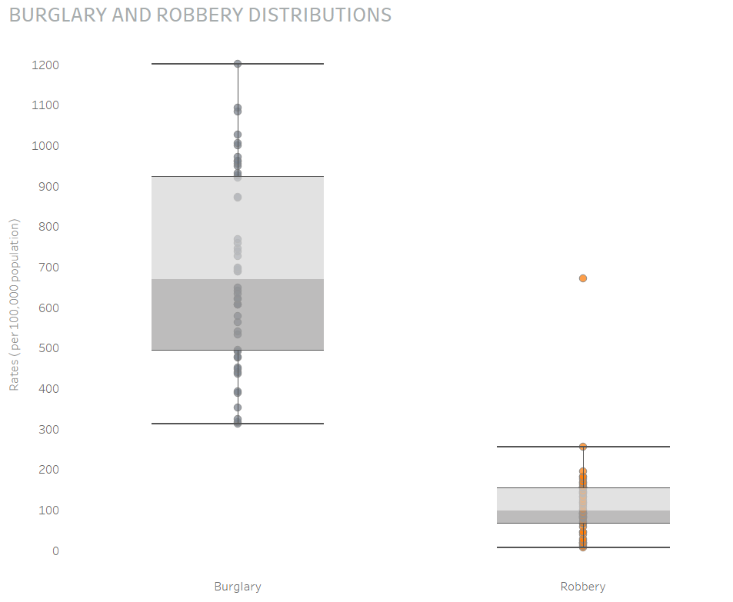

**Tableau. Bullet chart**

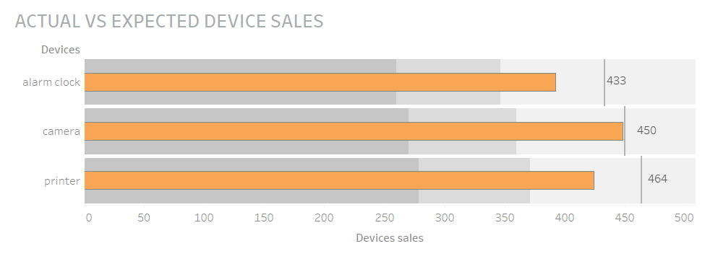

**Tableau. Radar**

