HW2: Write a Java program that reads a number from the user and prints
Default for all:

import java.util.Scanner;
public class HW2 {
public static void main(String[] args) {
Scanner input = new Scanner(System.in);
System.out.print("Enter a number: ");
int n = input.nextInt();

1)a row of stars:
System.out.println("Row of Stars:");
for (int i = 0; i < n; i++) {
System.out.print("* "); }

2) Print a column of stars:
System.out.println("Column of Stars:");
for (int i = 0; i < n; i++) {
System.out.println("*"); }

3) Print a square of stars:
System.out.println("Square of Stars:");
for (int i = 0; i < n; i++) {
for (int j = 0; j < n; j++) {
System.out.print("* "); }
System.out.println(); }

4) Print a right triangle of stars:
System.out.println("Right Triangle:");
for (int i = 1; i <= n; i++) {
for (int j = 1; j <= i; j++) {
System.out.print("* ");}
System.out.println();}

5) Print an mirrored right triangle:
System.out.println("Mirrored Right Triangle:");
for (int i = 1; i <= n; i++) {
for (int j = 1; j <= n - i; j++) {
System.out.print(" ");
for (int j = 1; j <= i; j++) {
System.out.println();}

6) Diamond shape:
System.out.println("Diamond Shape:");
for (int i = 1; i <= n; i++) {
for (int j = i; j < n; j++) {
System.out.print(" ");}
for (int j = 1; j <= 2 * i - 1; j++) {
System.out.print("*");}
System.out.println();}
for (int i = n - 1; i >= 1; i--) {
for (int j = n; j > i; j--) {
System.out.print(" "):}
for (int j = 1; j <= 2 * i - 1; j++) {
System.out.print("*");}
System.out.println();}

7): Right diagonal (وتر لليمين)
System.out.println("Right diagoual:");
for (int i = 0; i < n; i++) {
for (int j = 0; j < i; j++) {
System.out.print(" ");}
System.out.println("*");}
8)and left diagonal (وتر لليسار).
System.out.println("Left diagoual:");
for (int i = 0; i < n; i++) {
for (int j = 0; j < n - i - 1; j++) {
System.out.print(" ");}
System.out.println("*");}

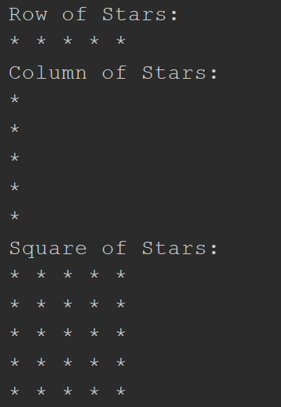
- Output if the user entered number 5:

