1. Clone GIT project from https://github.com/natalelea/DQE_SQL_NM/tree/main/HW_6/GE_task

2. Run in cmd: pip install great_expectations

3. To run test run the following command:   
great_expectations checkpoint run test_db_check

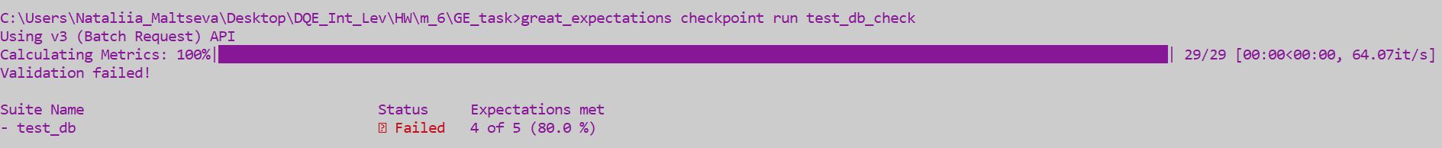

4. To open Data Docs run the following command:  
great_expectations docs build

5. Screenshots are attached in the file GE_task/GE_task.docx