Table of Contents
Introduction 2
Exploratory Data Analysis 4
Summary of data 4
Correlation 5
Model Analysis Breakdown 9
Model Comparison and Selection 9
Model Evaluation 10
Visualizing Actual, Predicted, and Error Residuals 12
Actual vs. Predicted Price Plot 12
Residuals vs. Actual Price Plot 13
Residual Frequency Distribution 13
Model equation and interpretation 14
Conclusion & Future Considerations 15

Introduction
The objective of this project is to build a predictive model to estimate Airbnb listing prices using various property, host, and review features. Accurate price prediction is important for supporting hosts in setting competitive nightly rates and helping guests identify fair-priced accommodations.
To achieve this goal, multiple regression models were developed and compared. The approach included handling missing values, converting categorical data into usable numeric indicators, performing feature scaling and binning, and addressing outliers in the target and input variables. Three different models were trained and evaluated using performance metrics such as Root Mean Squared Error (RMSE) and R². The best-performing model was then implemented into a production-ready prediction script to generate automated price estimates for new Airbnb listings.
The following features were identified as the most significant predictors of Airbnb prices in Model C, based on the regression coefficients and F-regression (FFS) rankings:
- room_type_Entire home/apt:
Indicates that the entire property is available to guests. These listings provide full privacy and space, which significantly increases nightly pricing.
- room_type_Private room:
Marks listings where guests stay in a private bedroom while sharing other spaces. These properties are mid-priced compared to entire homes and shared rooms.
- accommodates:
Numeric feature showing maximum guest capacity. Larger accommodation size generally reflects a bigger property, leading to an increase in price.
- imp_bathrooms:
This feature contains imputed bathroom counts for missing values using the mode of existing data. More bathrooms improve convenience for groups, strongly boosting price.
- imp_bedrooms:
An imputed bedroom feature with missing values filled using the mode. More bedrooms directly correlate with larger units and higher rental value.
- imp_beds:
Includes imputed bed counts, where missing values were replaced using the mean. The negative coefficient suggests that extra beds without extra rooms may indicate overcrowding or lower layout quality.
- cable_tv:
A binary amenity feature indicating whether cable TV is available. Entertainment enhancements like this increase listing attractiveness and pricing.
- tv:
Basic television availability indicator. Raises price, though less significantly than cable TV access.
- accommodatesBin_(5, 6]:
A binned feature identifying mid-sized units that host 5–6 guests. This size fits group travelers, generally yielding higher nightly pricing.
- bedroomsBin_(1, 2]:
Identifies properties with 1–2 bedrooms. These smaller living spaces result in lower pricing compared to listings with more bedrooms.
- bedroomsBin_(3, 4]:
Represents medium-large homes with 3–4 bedrooms. These attract family bookings and strongly increase price.
- bedroomsBin_(4, 6]:
Larger homes with significant sleeping capacity. These units are high-value and command a substantial price premium.
- bedsBin_(6, 12]:
Listings with very high bed counts. The negative coefficient suggests many beds may be added inefficiently (e.g., sofa beds), reducing perceived quality.
- city_DC:
- Indicator for listings located in Washington, D.C. Government tourism and annual travel events contribute to a higher pricing baseline.
- city_NYC:
Indicates New York City locations. Strong tourist demand and limited space significantly raise rental prices.
- city_SF:
Represents San Francisco listings. A highly competitive housing market and consistent travel demand result in some of the highest pricing in the dataset.
Our analysis demonstrates that the selected features possess strong predictive influence on nightly listing prices, with each contributing uniquely to the model’s performance. Throughout the data preparation process, we addressed missing values through targeted imputation, transformed categorical variables into dummy indicators, and binned several continuous features to improve interpretability and model stability. Additionally, outliers were treated through percentile-based clipping to reduce the effect of extreme values and enhance model robustness. These careful preparation steps supported the development of a reliable and interpretable pricing model.
In the following sections of this report, we present a detailed evaluation of the model’s effectiveness across multiple iterations, discuss our final optimized Model C results, and explore the practical implications of using this model to estimate fair and competitive Airbnb listing prices.

Exploratory Data Analysis
This exploratory data analysis provided a high-level overview of the Airbnb dataset and investigated the primary factors that influence listing prices. The dataset contains 51,879 listings from major metropolitan cities in the United States, including New York City, Los Angeles, Chicago, Washington DC, Boston and San Francisco. Each listing includes pricing information along with property characteristics, location details, and available amenities.

Summary of data
Figure 1 and Figure 2 below provide a sample view of the dataset, displaying some of the features and showcasing the general distribution and structure of the Airbnb listings. This very extensive data set is the foundation of our predictive model. This dataset contains 150 columns; therefore, Figures 1 and 2 only display a small sample of the features included in the full data.
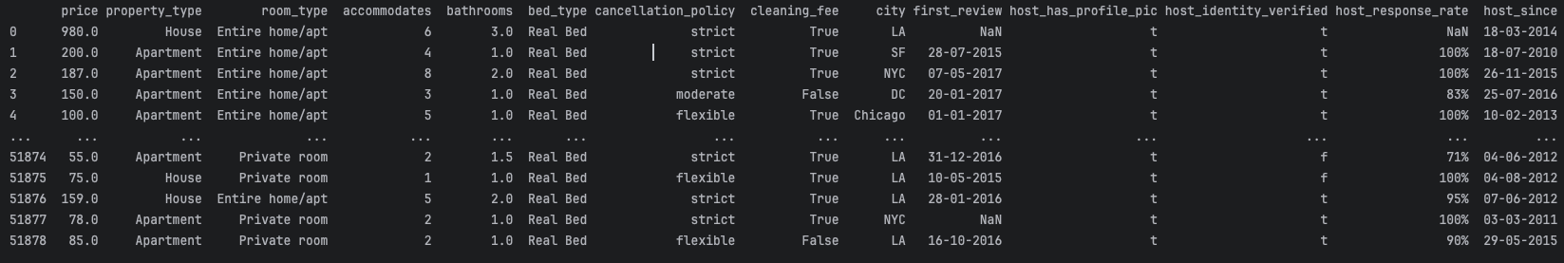
Figure 1 - The first columns of data set and values
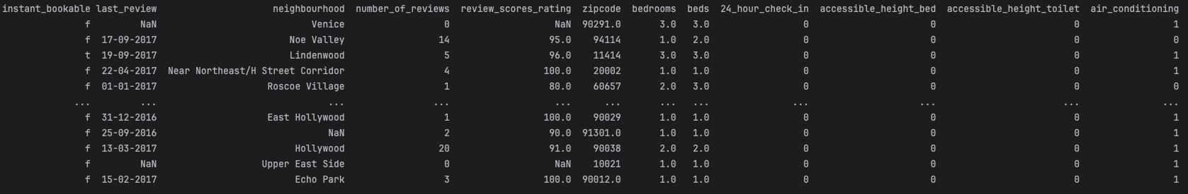
Figure 2 - More of the sample data features and values

Upon initial inspection of the Airbnb dataset, several important characteristics have become evident. First, we observe the presence of missing values in key numerical features such as bathrooms, bedrooms, beds, and review scores rating, indicating incomplete listings that require imputation before modeling. Additionally, certain entries raise concerns about data quality and outliers — for example, properties listed with zero bathrooms or zero beds, which are unlikely to be realistic accommodations. We also notice extreme variations in nightly prices and capacity-related features, where some listings advertise very high accommodate values and unusually expensive nightly prices, potentially reflecting luxury rentals or erroneous inputs. To confirm and address these issues, we can turn to the statistical summary of each feature, as presented in Figure 3 below. The "count" section in this summary reveals the total number of data entries for each feature. Any count less than the total number of rows, which is 51,879 signifies the presence of missing values, necessitating a strategy for handling these missing entries.
Moreover, by examining the minimum and maximum values in comparison to the mean value for each feature, we can identify extreme values that warrant further investigation and potential data preprocessing.

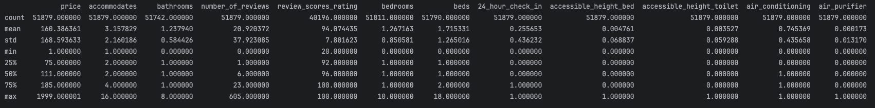
Figure 3 - Statistical summary for each feature in the data set
Once these data quality issues were identified, several preprocessing techniques were applied to ensure the model would not be negatively affected by missing or unreliable values. Mode, mean, and median imputation were used to replace missing values depending on the nature of the feature, while extreme outliers in price, bedrooms, beds, bathrooms, and accommodates were clipped based on percentile thresholds. These preprocessing decisions helped improve model stability and ensured that unrealistic values would not distort predictions.

Correlation
To better understand how different features influence the target variable (price), a correlation matrix was generated for all numerical features included in the final model. This analysis highlights how strongly each input variable relates to pricing trends and helps validate their inclusion in the predictive model. Figure 4 below displays a correlation heatmap showcasing the relationships between the target variable and key predictors used in Model C.
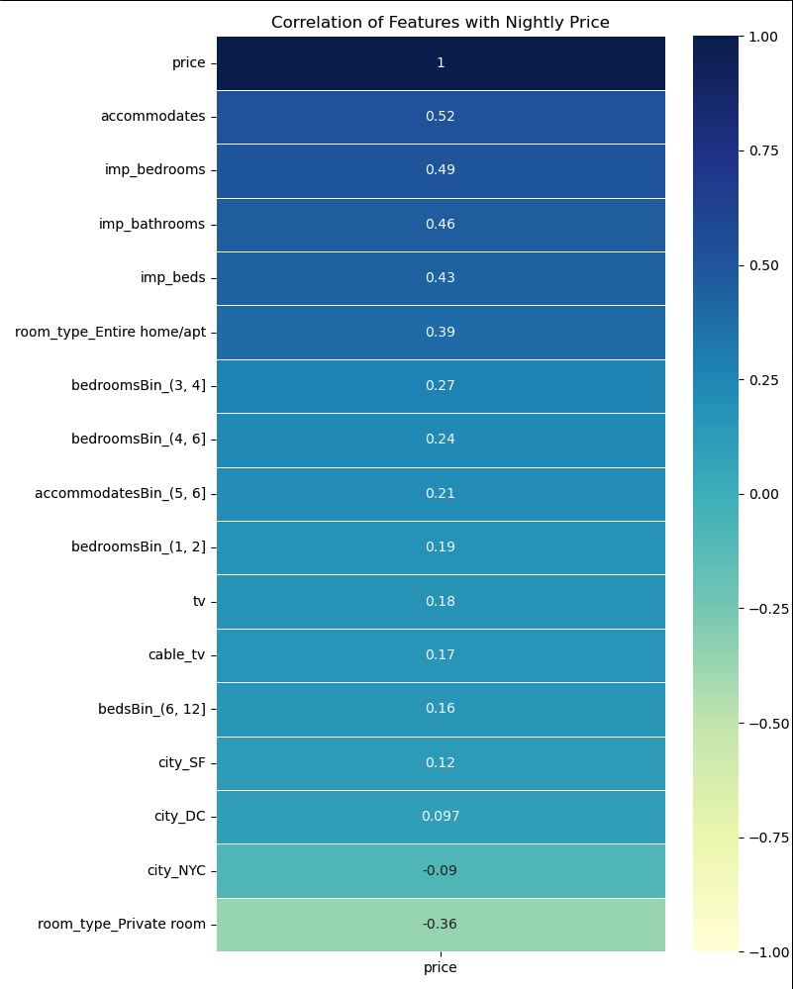
Figure 4 - Correlation heatmap for each feature

A different perspective on these correlations can be gleaned from the scatter matrixes displayed in Figure 5 and 6 below. Those matrixes visually represents the bivariate relationships between feature combinations and provides insights into the spread and distribution of data points.
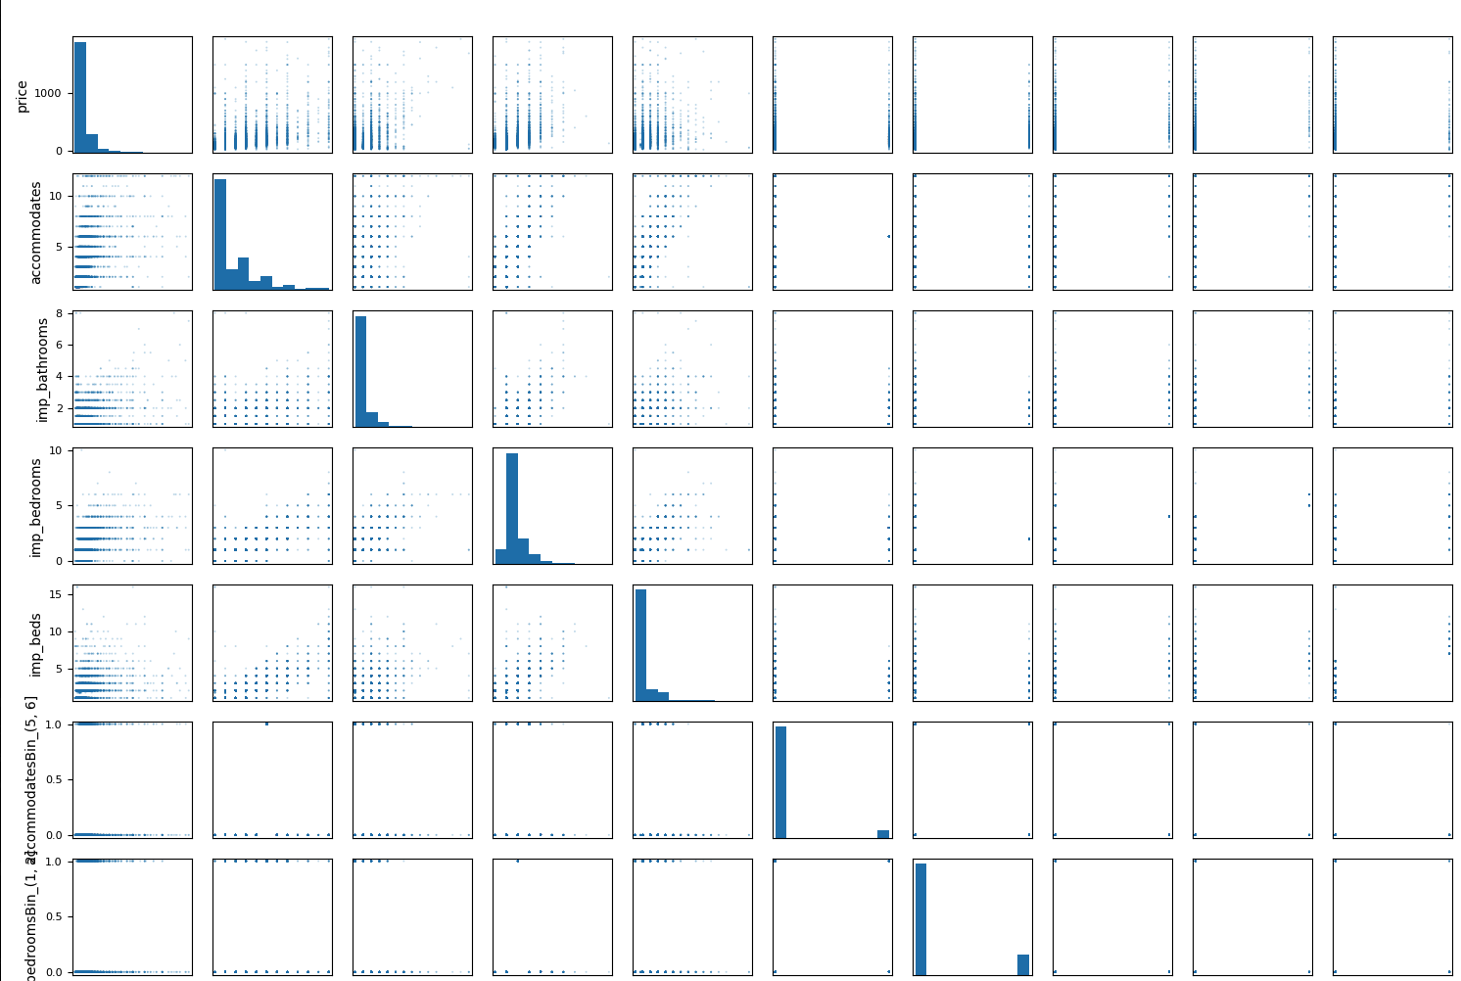
Figure 5 - Scatter matrix for each feature (part 1)
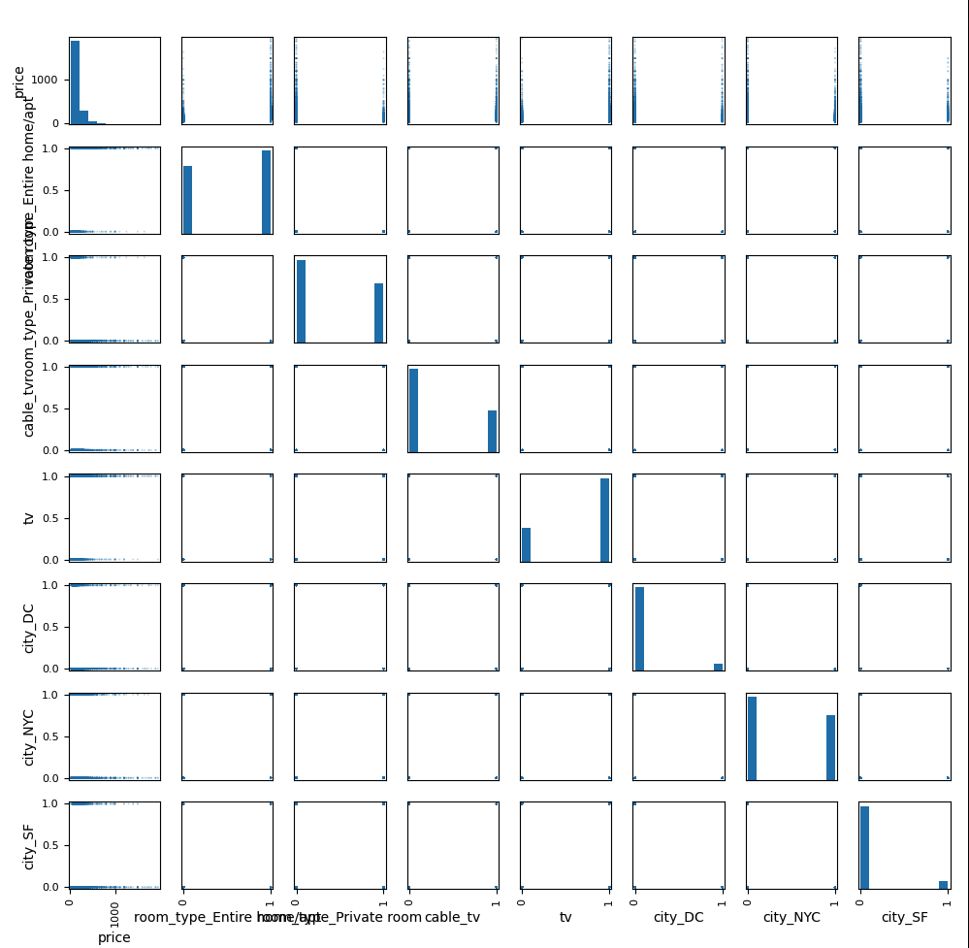
Figure 6 - Scatter matrix for each feature (part 2)
In summary, the results show that capacity-related variables such as accommodates, imp_bedrooms, and imp_bathrooms have the strongest positive correlation with price, confirming that larger properties command higher rental value. Additionally, room type and city-based dummy features (e.g., room_type_Entire home/apt, city_SF) display meaningful pricing influence despite having weaker linear correlation values in the heatmap. This suggests that while their pricing effects are not strictly linear, they remain important to differentiators in customer willingness to pay.
Scatter matrix visualizations were also created to observe the data distribution and check for visible patterns. While some relationships display clear upward trends, many categorical and binned predictors appear as horizontal or vertical bands due to their binary nature. Although these plots do not visually demonstrate strong correlations, their predictive strength was validated through regression's coefficient significance and forward feature selection rankings.
Overall, the EDA confirms that a mix of property size, amenities, and location-based indicators contribute to price variation. These insights guided model development by emphasizing features with both practical relevance and statistical support. The patterns observed provided a strong foundation for building the regression models evaluated in the following section.

Model Analysis Breakdown
To determine the most effective approach for predicting Airbnb listing prices, three different linear regression models were developed and evaluated. Each model introduced improvements in data preparation, aiming to reduce errors, improve interpretability, and increase predictive performance. Model performance was measured using Root Mean Squared Error (RMSE) and R-squared values on a held-out test set.

Model Comparison and Selection

Model | A | B | C
Variables | accommodates, imp_bathrooms, imp_bedrooms, imp_beds, cable_tv,  indoor_fireplace, tv | room_type_Entire home/apt, room_type_Private room, accommodates, imp_bathrooms, imp_bedrooms, imp_beds, cable_tv, tv, accommodatesBin_(5, 6], bathroomsBin_(1, 2], bathroomsBin_(4, 10], bedroomsBin_(-1, 1], bedroomsBin_(1, 2], bedroomsBin_(2, 3], bedroomsBin_(3, 4], bedroomsBin_(4, 6], bedsBin_(-1, 1], bedsBin_(6, 12] | room_type_Entire home/apt, room_type_Private room, accommodates, imp_bathrooms, imp_bedrooms, imp_beds, cable_tv, tv, accommodatesBin_(5, 6], bedroomsBin_(1, 2], bedroomsBin_(3, 4], bedroomsBin_(4, 6], bedsBin_(6, 12], city_DC, city_NYC, city_SF
Number of variables | 7 | 18 | 16
Average $R^{2}$ | 0.343 | 0.397 | 0.474
Average $R^{2}$Adj | 0.343 | 0.397 | 0.474
Average AIC | 559,400 | 554,800 | 526,100
Average BIC | 559,500 | 554,900 | 526,300
Average RMSE | 136.59382961329658 | 131.7223811904476 | 94.68710906839107
Table 1- Comparison table for three models
Model C was selected as the final model because it provided the strongest and most reliable predictive performance across all evaluation metrics. Compared to Model A and Model B, Model C achieved a significantly lower RMSE (94.69), demonstrating higher accuracy in estimating listing prices. It also achieved the highest R² value (0.474), indicating that it explains more than 47% of the variability in Airbnb prices — a substantial improvement over earlier models.
In addition to improved accuracy, Model C benefits from enhanced feature engineering. By treating outliers through percentile clipping and incorporating location-based dummy variables for major cities, the model better represents real-world pricing behavior. Importantly, it maintains a reasonable number of predictors (16), helping avoid unnecessary model complexity while retaining interpretability.
Overall, Model C achieves the best balance of performance, practical relevance, and stability, making it the most suitable model for production deployment and real-world Airbnb price prediction.

Model Evaluation
Model C represents the final and best-performing version of the Airbnb price prediction model. This model was developed after applying multiple enhancements, including missing value imputation, dummy variable encoding, capacity-based binning, and percentile-based outlier clipping on both target and feature variables. A multivariate linear regression model was then trained using these optimized predictors.
To evaluate performance, the dataset was split into an 85% training set and 15% testing set. Model C demonstrated a strong improvement in predictive accuracy compared to Models A and B. After Model C was selected as the best performer, a detailed regression summary was generated to evaluate statistical validity and feature significance, shown below in Figure 7.
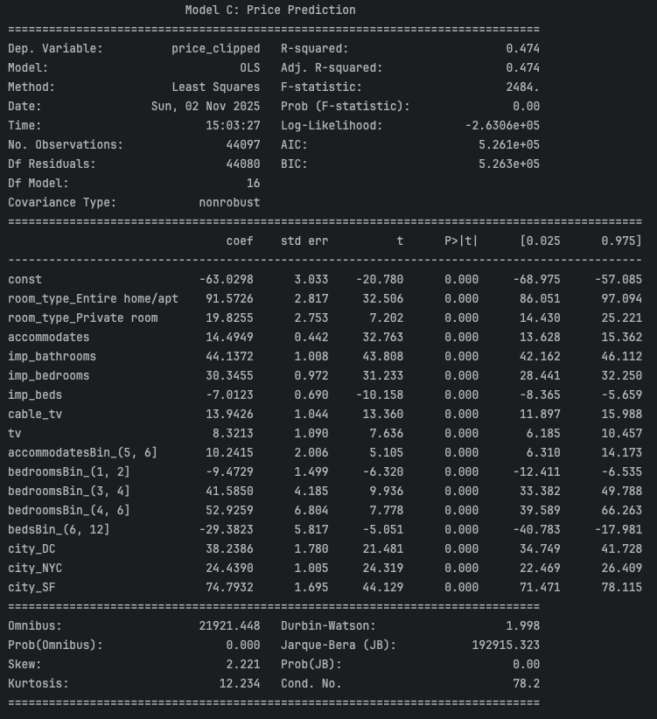
Figure 7 - Statistical model summary of Model C

One of the most important measures used to evaluate Model C is the Root Mean Squared Error (RMSE). In this case, the RMSE is approximately 94.69, which reflects the model’s improved predictive accuracy compared to prior versions. A lower RMSE value indicates that the predicted nightly prices are much closer to the actual listing prices, increasing the reliability and practical usefulness of the model.
An R² of 0.47 indicates that about 47% of the variation in prices is explained by the structured features included in the model. Because Airbnb pricing is strongly influenced by photos, text descriptions, seasonal demand, and personal host choices which are not available in this dataset, this is a strong and realistic result.
Another critical metric is the F-statistic, which assesses whether the selected features meaningfully explain variation in the target variable—Airbnb price. Model C shows a highly significant F-statistic with a p-value of 0.000, demonstrating that the model strongly rejects the null hypothesis. In other words, the chosen features collectively provide substantial predictive contribution, confirming that the model is statistically valid and effective at explaining pricing behavior.
The log-likelihood value (-166,620) is useful for comparing models fitted on the same data, and here it supports Model C as the superior choice among the three tested models
Additionally, the Durbin-Watson statistic is 1.998, which falls very close to the ideal value of 2. This strongly suggests that the residual errors are independent, and that no meaningful autocorrelation is present. This is an indicator of a well-behaved regression model that does not violate key linearity assumptions.
Feature significance was also carefully evaluated using coefficient p-values. As shown in Figure 7, all included predictors have p-values below 0.05, indicating strong statistical significance. This confirms that each variable included in Model C meaningfully influences predicted price and deserves to remain in the model.

Visualizing Actual, Predicted, and Error Residuals
To further evaluate the effectiveness of Model C, we visualized the prediction performance through three key diagnostic plots shown in Figure 8 below:
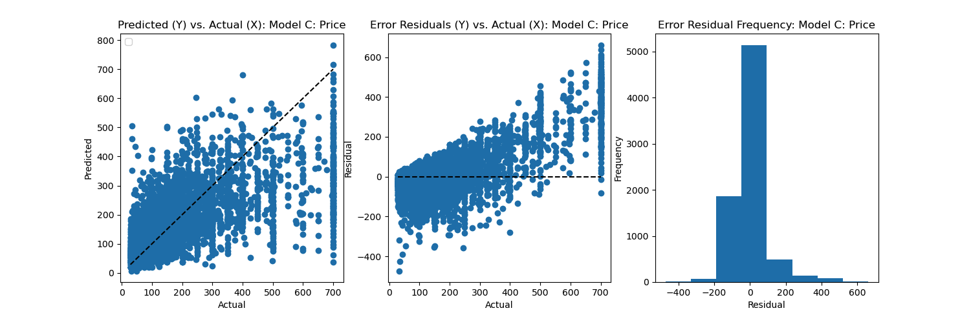
Figure 8- Plots of Predicted vs. Actual Results, Error Residuals and Error Residual Frequency vs. Actual Results
These visualizations provide a deeper understanding of how well the model fits the data and where prediction discrepancies may occur.

Actual vs. Predicted Price Plot
The first scatter plot compares the model’s predicted prices to the true Airbnb listing prices.
A visible increasing trend demonstrates that the model successfully captures the general price pattern, however, a widespread emerges particularly for high-priced listings which suggests the model struggles with luxury or atypical rentals
This behavior is expected because high-end properties often include unique value drivers that are not fully captured by the available features.

Residuals vs. Actual Price Plot
The second plot displays residuals (prediction errors) as a function of the true prices.
The residuals are centered around zero, indicating no systematic bias but the model predicts budget and mid-range listings very well but is less precise for luxury properties
This suggests potential future improvement opportunities through techniques like price-log transformation or more detailed luxury-focused features.

Residual Frequency Distribution
The histogram illustrates the distribution of prediction errors.
Most residuals cluster tightly near zero, confirming good accuracy and distribution is roughly bell-shaped, indicating normality assumptions hold. However, slight right-tail skew reflects occasional underestimation of high-priced listings

In summary, these diagnostic visualizations validate that Model C is performing reliably and making accurate predictions for most Airbnb listings. The strong alignment between predicted and actual values, along with normally distributed residuals centered around zero, demonstrates a stable and unbiased model. While error variance increases for high-priced properties, this behavior is typical in accommodation pricing where unique premium features are not fully captured by standard listing attributes. Overall, the visual evidence supports Model C as a well-fitting and dependable model for estimating nightly Airbnb prices.

Model equation and interpretation

The final optimized regression model (Model C) predicts the nightly price of an Airbnb listing using a combination of room type, property size, amenities, and city features. The model equation is expressed as:
Predicted Price ($)= -63.0449 + 89.9240 * room_type_Entire home/apt + 18.4589 * room_type_Private room + 14.6678 * accommodates + 45.3183 * imp_bathrooms + 29.9175 * imp_bedrooms - 7.2783 * imp_beds + 13.1935 * cable_tv + 9.5330 * tv + 9.4828 * accommodatesBin_(5, 6] - 7.2843 * bedroomsBin_(1, 2] + 47.9075 * bedroomsBin_(3, 4] + 45.4899 * bedroomsBin_(4, 6] - 32.4389 * bedsBin_(6, 12] + 39.5146 * city_DC + 23.9878 * city_NYC + 76.3766 * city_SF
Based on the final regression equation, the nightly price of an Airbnb listing is influenced by a wide range of property and location characteristics. The model begins with a base nightly price of −$63.04, which is then adjusted depending on the features present in a listing.
Listings where guests can rent an entire home or apartment experience a significant increase in price (approximately +$89.92), as full privacy and dedicated space provide added value. Private room listings also see a positive adjustment (+$18.46), although the impact is notably smaller, reflecting their more budget-friendly nature.
The capacity of a listing plays a major role in price determination. Each additional guest the property can accommodate contributes roughly +$14.67, while having more bathrooms and bedrooms also strongly increases price (+$45.32 and +$29.92, respectively). These features directly signal larger units, improved comfort, and suitability for groups factors that appeal to higher-paying guests.
Interestingly, the count of beds shows a negative influence (–$7.28 per additional bed). This suggests that simply increasing the number of beds without adding actual bedrooms or space may indicate overcrowding or reduced layout quality, slightly lowering perceived value.
In terms of amenities, listings equipped with a television (+$9.53) and especially cable TV (+$13.19) tend to attract higher nightly rates, indicating that entertainment features still contribute to guest expectations and pricing competitiveness.
Several binned variables highlight group-friendly inventory:
- Properties that sleep 5–6 guests receive a slight price boost (+$9.48),
- Listings with 3–4 bedrooms (+$47.91) or 4–6 bedrooms (+$45.49) gain strong positive adjustments,
- While properties with only 1–2 bedrooms show a negative price shift (–$7.28), reflecting lower capacity,
- And properties with 6–12 beds are also negatively impacted (–$32.44), reinforcing that bed count alone is not a premium feature.
Location-based features explain pricing variation across major U.S. cities. Listings in:
- San Francisco (+$76.38),
- Washington, D.C. (+$39.51),
- New York City (+$23.99)
These adjustments capture how regional travel demand and housing market competitiveness influence rental value.
Every selected feature was retained due to both statistical significance (p < 0.05) and business interpretability, ensuring that the model remains accurate while providing real-world insight into pricing behavior.
Overall, the equation provides a clear and interpretable breakdown of the financial contribution of each variable, enabling hosts, market analysts, and pricing systems to make more informed decisions when setting competitive nightly rates.

Conclusion & Future Considerations
This project successfully developed a predictive modeling solution capable of estimating Airbnb listing prices using key property, amenity, and location features. After evaluating multiple models and conducting extensive data preprocessing including imputation, binning, dummy encoding, scaling, and outlier treatment Model C demonstrated the strongest performance, achieving an RMSE of $94.68 and an R² score of 0.474. This indicates that the model captures a significant portion of pricing variability across diverse listings while maintaining strong generalization performance.
The analysis confirmed that capacity-related features (such as bathroom, bedroom, and guest count), along with room type and city-level indicators, have the greatest influence on pricing. These findings align with real-world market expectations and provide business-valuable insights that can support hosts in optimizing their pricing strategies and guests in identifying fair-value listings.
Although the final model is production-ready, several enhancements could further improve accuracy and predictive power. Potential future improvements include:
• Integrating neighborhood-level geographic features for greater pricing detail
• Modeling seasonal and event-based demand fluctuations
• Testing non-linear or ensemble models to capture more complex feature interactions
• Using regularized regression to simplify the model and reduce dummy-variable inflation
• Incorporating text and image data from listings for additional quality signals
Future improvements may include adding neighborhood-level market indicators, review text sentiment, host experience, and seasonal pricing patterns to further increase predictive power.
Overall, the completed model provides a solid and interpretable foundation for dynamic price estimation within the Airbnb marketplace. With continued refinement and integration of richer features, this solution can evolve into a more powerful pricing intelligence tool that benefits both hosts and travelers.

