**The Linux Operating System**

**Challenges**

* Display the content of the /etc/passwd, count how many lines it has and sort in a decreasing order (z-a).

1. **Display the content of the /etc/passwd**

1. **Count how many lines it has**

wc (word count); -l indicates to wc only count the number of lines in the file passed as input.

1. **Sort in a decreasing order (z-a)**

Sort with the -r option is for sort in descending order.

* Find what is your User ID and Group ID. This information is stored in the /etc/passwd file. Also, find what's the line they are. Of course, you should do this without displaying the file's content.
  1. **Find what is your User ID and Group ID**

* 1. **Find what's the line they are**

* List files and directories that are hidden on your $pwd. Also, list them by time (use the man page to see what flag you need).
  1. **List files and directories that are hidden on your $pwd**
  2. **List them by time**



* Create a file called *myfile*. Update its permissions so only your user can read, write, and execute it.

7 means that the file owner has all permissions, while 0 indicates that neither groups nor other users have any permissions.

* Create 5 files (f1,f2,...,f5) without having to type 5 times the touch command.

* Move to another location where those 5 files are not. Then do a search to find them, and execute the *ls -l* command to each of those. This should be done with just one command.

* Create the directory d1/d2/d3/foo/d4. If the previous directories don't exist, then they should also be created automatically.

* Given the following text "We have 5 days to finish 5 lines of code of the Hi5b project" Replace all "5" by "five", the number must be alone, cannot be in a word.



* List all processes running on your system and sort them by the username that's running each process.

* Run the gedit program, search for it's PID and send it a signal to stop it. After this, send another one resume its execution.
  1. **Run the gedit program, search for it’s PID and send it a signal to stop it.**

* 1. **After this, send another one resume its execution**

* Install SSH server. Start the service, and check its status. If it is not enabled, do it.
  1. **Install SSH server**

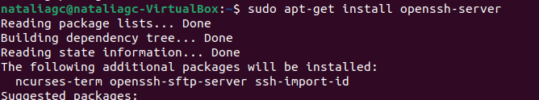

* 1. **Start the service, and check its status**

* Display the network interfaces on your system. Do you see one that isn't physical? What's that interface?



It is the "lo" interface. This interface is unique to most Unix-like operating systems, including Linux, and is designed for internal system communications.

* What's your IP and MAC address?
  1. **IP address**

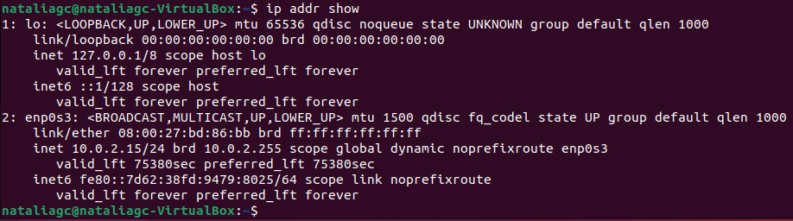

* 1. **MAC address**



* Can you communicate outside your private network? Test this with a command.

* What happens to a packet going to a host outside of the network?

When a data packet is headed to a host outside its local network, its route is determined through a series of network hops, that is, the packet is not sent directly to the final destination, but rather travels through multiple network devices, such as routers and servers, in what is known as "routing."

* What is the IP of your gateway(s)? Can you check this with two commands?
  1. **ip route**



* 1. **netstat -nr**



* Trace the route being taken to connect to cloudflare.com.

* What's the IP address of perficient.com? What's their mail server?
  1. **IP address of Perficient.com**

* 1. **Mail server**

* List all TCP and UDP connections on the system.

* A screenshot of a computer screen

  Description automatically generatedWhat ports do you have open on the system?
* List only the listening connections on the system.

