**Scripting**

**Challenges**

1. Display only the even numbers from 1 to 100

1. A screen shot of a computer

   Description automatically generatedCompare natural numbers and display "X is greater than Y", "X is equal to Y" or "X is less than Y"
2. A computer screen shot of numbers

   Description automatically generatedRead N numbers from the stdio and compute their average
3. A computer screen shot of text

   Description automatically generatedCheck if a file exists, if it doesn't exist, create it
4. Write a script that outputs the current time and date. For example: "Current time: 08:02, Current date: 2022-08-10"

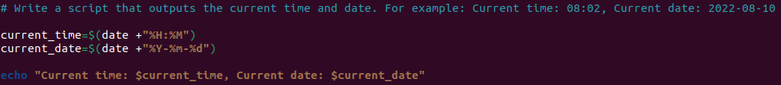

1. Write a script that prints how many parameters are passed and which ones? For example, if I run the script like this: ./script1 p1 p2 p3 p4, then it should print: 4 params were passed and they're these ones: p1, p2, p3, p4
2. A computer screen shot of text

   Description automatically generatedWrite a script that prints information about your OS and version, release number, and kernel version
3. 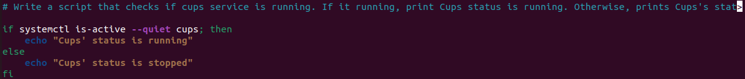Write a script that checks if cups service is running. If it running, print "Cups' status is running". Otherwise, prints "Cups's status is stopped"

**Microservice-app-example**

Building and running each of the microservices with scripts

* A computer screen shot of text

  Description automatically generatedusers-api
* auth-api

* todos-api

* redis queue

* log message processor

* frontend

