**Group 1: Executive control**

**Does adding distractions impair learning in the Weather Prediction Task?**

In the original weather prediction task, participants are instructed to focus on the card on the screen and predict the weather. This experiment is typically done in a calm environment, where there is nothing to distract the participant from the cues on the screen.

However, in the real world, distractions are everywhere. For example, you might listen to lecture material while doodling; or do homework while watching TV; or practice driving while listening to the radio. Does dividing attention impair performance on the weather prediction task? Also, are different memory systems affected differently by distrations?

**Research question:** Do people need to *attend* to the cues of the weather prediction task to perform accurately? If you add a distraction or a secondary task on top of the weather prediction task, will people not learn to associate the cues with the correct outcomes?

Hypothesis:

1. What is your hypothesis, and why?
2. Do you think different memory systems rely more on attention? For example, is encoding declarative memories (like retaining lecture material) affected by distractions? What about skill learning, like the weather prediction task?

Experiment design:

1. What changes would you make to the weather prediction task to test your hypothesis?
2. Imagine you test two groups of subjects: one group does the standard weather prediction task, and the other does the version of the task that you designed. The figure below plots participants’ performance as a function of time (# trials). Draw two lines showing your predicted results, one for each group.
3. Bonus: It’s possible that skill learning and declarative memory are affected differently by distractions. If you have time, try to think of a way you could extend your experiment to tease the effects of distraction on each of these memory systems.

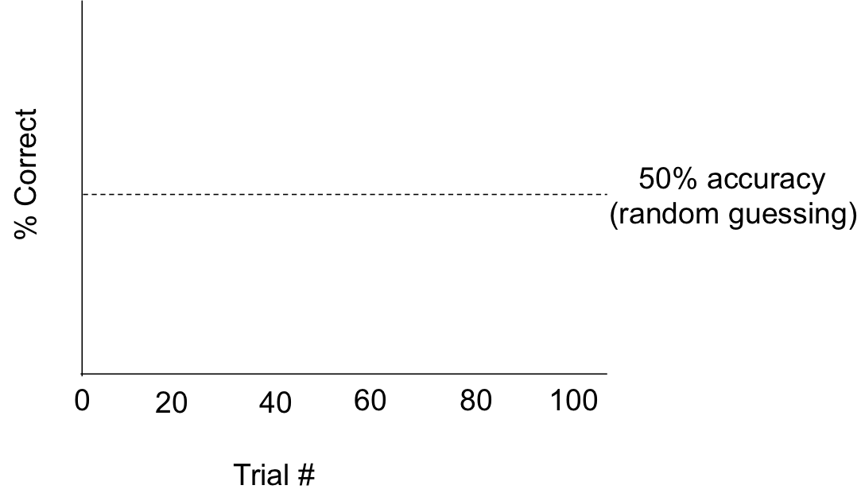

Case study:

Look up the following paper on Google Scholar or your favorite search tool:

Foerde, K., Knowlton, B. J., & Poldrack, R. A. (2006). Modulation of competing memory systems by distraction. *Proceedings of the National Academy of Sciences*, *103*(31), 11778-11783.

To get a quick sense of the results, please skim the:

1. Abstract
2. ‘Behavioral Procedure’ section of the methods (scroll to the bottom)
3. ‘Behavior’ section of the results (below the introduction)

And discuss the following questions:

1. What is the main question of this paper? What was the motivation for adding distractions to the weather prediction task?
2. How did these experimenters approach the question? What changes did they make to the basic weather prediction task? (Look at the methods and Figure 1.)
3. What is the overall pattern of the results? (Take a look at Figure 2.) Does it line up with your predictions? Why or why not?
4. The experimenters claim that declarative memory depends on working memory, while skill learning is not nearly as dependent on working memory. What is the evidence for their claim? And why do they refer to these as ‘competing’ memory systems?

(If you are done, Group 2 also spent a lot of time thinking about whether attention might affect learning performance, but in a very different way. Group 3 thought about whether adding distractions would impair amnesia patients. Group 4 thought about whether emotionally charged cues are easier to learn from; if so, it’s possible that attention is playing some role here. Go share your ideas!)

**Group 2: Attention**

**Can people learn cue-outcome associations spontaneously, without explicitly paying attention to the task?**

In the original weather prediction task, participants are instructed to focus on the card on the screen and predict the weather. That is, participants know that there is something to be learned (which cards predict rain or shine), and they are explicitly instructed to pay attention to a cue (the cards).

However, in the real world, people often learn and pick up patterns without paying attention to particular cues or, indeed, without being consciously aware that there is anything to be learned. For example, babies routinely learn language even without being explicitly taught grammar rules, and even though they are distracted by many other things—such as playing with toys, inspecting their hands, or being fed—as they’re listening to and picking up language.

**Research question:** In the weather prediction task, participants are learning associations between cues (the cards) and outcomes (the weather). Is it possible to learn these associations without being instructed to explicitly attend to them—for example, if these are presented in the background of a completely orthogonal task?

Hypothesis:

1. What is your hypothesis, and why?
2. Do you think it might be easier to do different kinds of learning incidentally? For example, is it possible to learn declarative knowledge incidentally (e.g., overhearing lecture material while playing video games)? Is it possible to do skill learning incidentally (e.g., in your task)?

Experiment design:

1. What changes would you make to the weather prediction task to test your hypothesis?
2. Imagine you test two groups of subjects: one group does the standard weather prediction task, and the other does the version of the task that you designed. The figure below plots participants’ performance as a function of time (# trials). Draw two lines showing your predicted results, one for each group.



Case study

Look up the following paper on Google Scholar or your favorite search tool:

Saffran, J. R., Newport, E. L., Aslin, R. N., Tunick, R. A., & Barrueco, S. (1997). Incidental language learning: Listening (and learning) out of the corner of your ear. *Psychological science*, *8*(2), 101-105.

The task is not a weather prediction task, but it has very similar elements. (You can look up “Statistical learning in language acquisition” on Wikipedia to get more information.) To get a quick sense of the results, please skim the:

1. Abstract
2. Experiment 1 Methods and Table 1
3. Experiment 1 Results and Figure 1

And discuss the following questions:

1. What is the main question of this paper?
2. How did these experimenters approach the question? Do you think their task might involve memory systems that are similar to your own task?
3. What is the overall pattern of the results? Does it line up with your predictions? Why or why not?

(If you are done, Group 1 also spent a lot of time thinking about whether attention might affect learning performance, but in a very different way. Group 3 thought about whether adding distractions would impair amnesia patients. Group 4 thought about whether emotionally charged cues are easier to learn from; if so, it’s possible that attention is playing some role here. Go share your ideas!)

**Group 3: Patient studies**

**Does learning in the weather prediction task require working memory?**

In class, we saw that amnesia patients do learn in the weather prediction task. This is taken as evidence that learning in this task doesn’t depend on declarative memory. But there’s one alternative explanation: it’s possible that amnesia patients are using their working memory to keep information in mind. Working memory is tremendously important for holding information “in mind”. For example, imagine you witness a hit and run, and get a glimpse of the car’s license plate. As you see the car speed away, you might repeat the license plate number over and over under your breath so that you don’t forget it before you can type it on your phone and report it to the police. However, this strategy is very fragile—if you are interrupted (by a loud car horn) or not able to use it (because you waited too long after seeing the car), you might completely forget the car’s license plate number.

**Research question:** Do amnesia patients learn in the weather prediction task because they are maintaining information in their short-term memory? If you make it difficult for amnesia patients to use their working memory, do they no longer learn?

Hypothesis:

1. What is your hypothesis, and why?
2. What are some ways that you could interrupt working memory in the lab? For example, what would be the experimental equivalent of being distracted by a loud car horn, or waiting too long to write the license plate number?

Experiment design:

1. What changes would you make to the weather prediction task to test your hypothesis?
2. Imagine you test amnesia patients and controls. Each participant does two versions of the experiment: one is the standard weather prediction task, and the other is the task you designed to interrupt working memory. The figure below plots participants’ performance in each type of task as a function of time (# trials). Draw two lines showing your predicted results, one for each group. Discuss your predictions. (Note: you may need to modify this plot or draw a new plot to explain your prediction.)

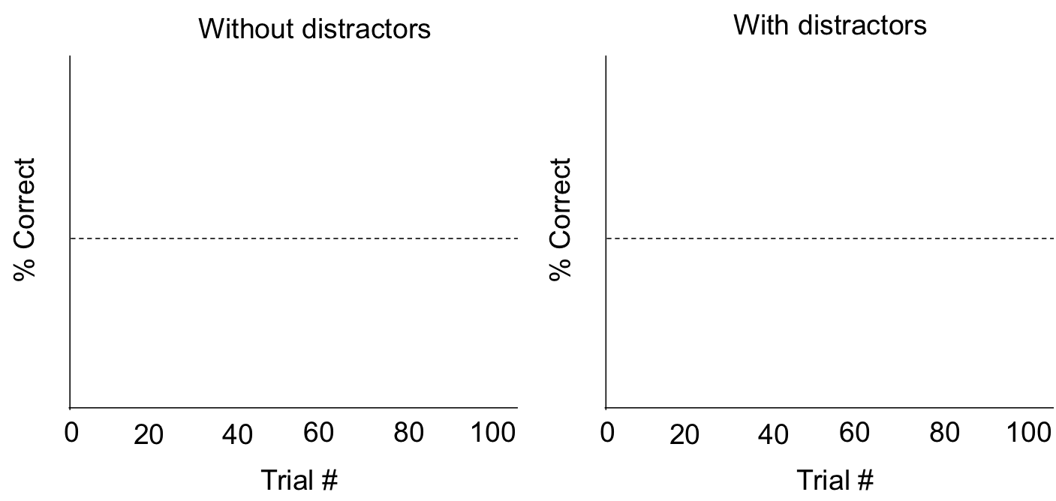

Case study:

Look up the following paper on Google Scholar or your favorite search tool:

Knowlton, B. J., Squire, L. R., & Gluck, M. A. (1994). Probabilistic classification learning in amnesia. *Learning & Memory*, *1*(2), 106-120.

To get a quick sense of the results, please skim the:

1. Abstract
2. Experiment 1 Methods, Task 3 & Figure 1
3. Experiment 2 Procedure
4. Experiment 2 Results & Figure 5

And discuss the following questions:

1. What is the main question of this paper?
2. How did these experimenters approach the question? What changes did they make to the basic weather prediction task?
3. What is the overall pattern of the results? Does it line up with your predictions? Why or why not?
4. The experimenters also find that amnesia and control patients perform about the same in the first 50 trials, but that differences between the two groups appear in later trials (Figure 2, top and middle). What do you think of these results—do they hint at some interplay between different memory systems in the weather prediction task?

(If you are done, both Groups 1 and 2 thought about the effects of attention on memory performance in healthy adults. Group 4 thought about whether emotional cues are easier to learn from in healthy adults, but you might be able to think of some patient groups that would not have any advantage in learning from emotional cues. Go share your ideas!)

**Group 4: Emotion**

**Is it easier to learn from emotional/social cues in the Weather Prediction Task?**

In class, many of the examples of learning we talk about actually involve learning outcomes that have some *emotional valence*—for example, mice show fearful reactions when they hear a tone that’s been previously paired with a shock, and macaques learn to anticipate a positive outcome (tasty juice) from certain cues.

The standard weather prediction task is neutral—both the cues (cards) and outcomes (feedback) are fairly abstract. But perhaps it would be easier to learn from *emotional* or *socially relevant* cues. If you look out the window from your warm room and see lots of unhappy people walking to class in coats, that’s a good cue that it’s cold out.

There is some research to suggest that how learning problems are frame has dramatic impacts on people’s performance.[1] For example, try this classic riddle yourself. What is the least number of cards you would have to check below to make sure that the rule is true?

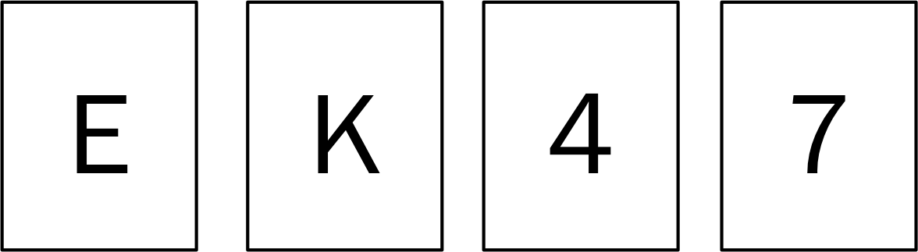“If a card has a vowel on one side, then it has an even number on the other side.”

Now try doing a slightly different version of the same riddle. Here, one side of the card indicates the age of a person at a party, and the other side indicates their drink.

“If you are drinking alcohol, then you must be over 21.”

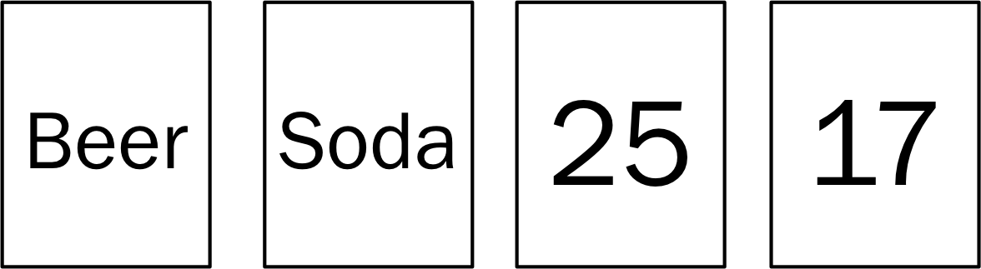

**Research question:** Do people learn more easily from emotional/social information in the weather prediction task?

Hypothesis:

1. For fun, try to work through the riddles. Is either version of the riddle easier to figure out? Why do you think that is?
2. Discuss the research question. What is your hypothesis, and why?

Experiment design:

1. What changes would you make to the weather prediction task to test your hypothesis?
2. Imagine you test two groups of subjects: one group does the standard weather prediction task, and the other does the version of the task that you designed. The figure below plots participants’ performance as a function of time (# trials). Draw two lines showing your predicted results, one for each group.



Case study:

Look up the following paper on Google Scholar or your favorite search tool:

Steidl, S., Mohi-Uddin, S., & Anderson, A. K. (2006). Effects of emotional arousal on multiple memory systems: evidence from declarative and procedural learning. *Learning & Memory*, *13*(5), 650-658.

To get a quick sense of the results, please skim the:

1. Abstract
2. ‘Behavioral Procedure’ section of the methods and Figure 1
3. ‘Behavior’ section of the results and Figure 2

And discuss the following questions:

1. What is the main question of this paper? How does it differ from your own research question?
2. How did these experimenters approach the question? What changes did they make to the basic weather prediction task? Are there any advantages to your own design?
3. What is the overall pattern of the results? Does it line up with your predictions?

If you are done, Groups 1 and 2 thought about how attention might affect performance in the weather prediction task; if you think there would be some effect of emotional cues, it’s possible that attention might have something to do with it. Group 3 spent some time designing experiments with amnesia patients; perhaps you can think of patient groups that you would like to test your task on, too. Go share your ideas!)

1. Barkow, J. H., Cosmides, L., & Tooby, J. (Eds.). (1995). *The adapted mind: Evolutionary psychology and the generation of culture*. Oxford University Press.