Grope: Devops

Student: Cutic Natali

Data: 16/06/2020

e-mail: [natalicot@gmail.com](mailto:natalicot@gmail.com)

**Cloud : Aws Final Project**

1. **Peering;**

Vpc1: Paris vpc2: N.Virginia

web1: public: 15.236.60.98 web3: public: 3.84.173.235

privet: 10.10.10.70 privet: 192.168.10.91

web2: privet: 10.10.20.164 web4: privet: 192.168.20.21

1. connecting from web1 to web3: c) Connecting from web4 to web2:

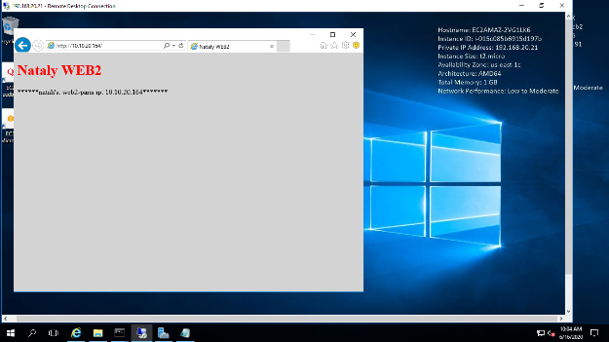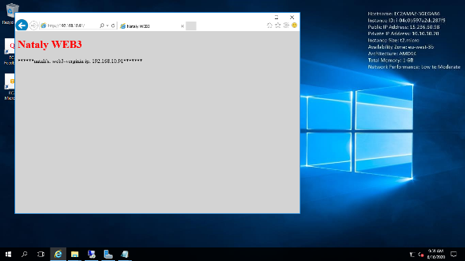

1. Connecting from web3 to web1: d) Connecting from web2 to web4:

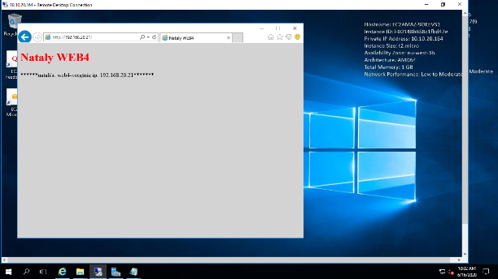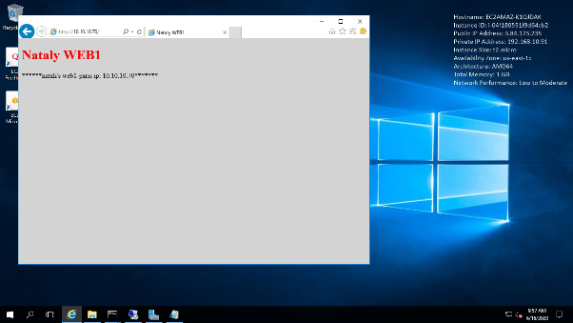

1. **NLB amazon + check from azure instance**

NLB address:  
<http://mynlb1-1192191047.us-east-1.elb.amazonaws.com/>

Instance public IP:

52.232.22.166

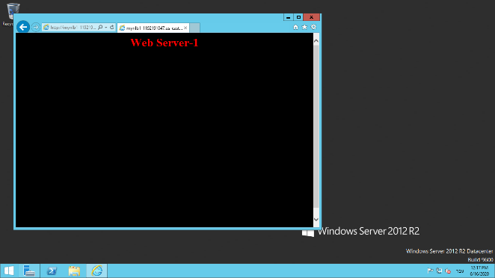web-2: web-1:

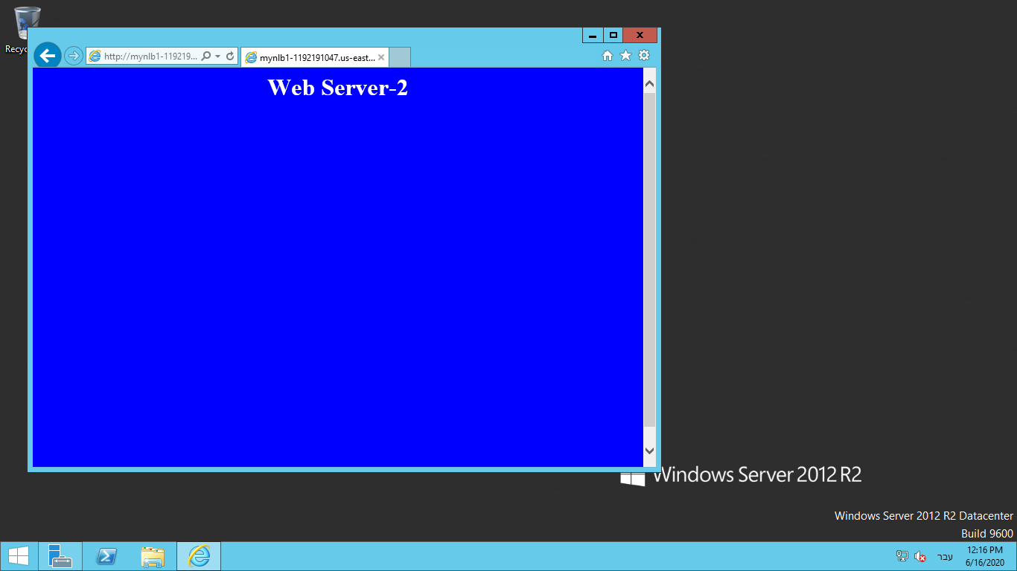

Web-3:

