Working proces:

Creating a new repository with 3 branches (staging,master,dev) and cloning echo-app into it:

*repo files are included in ‘echo-final/app’

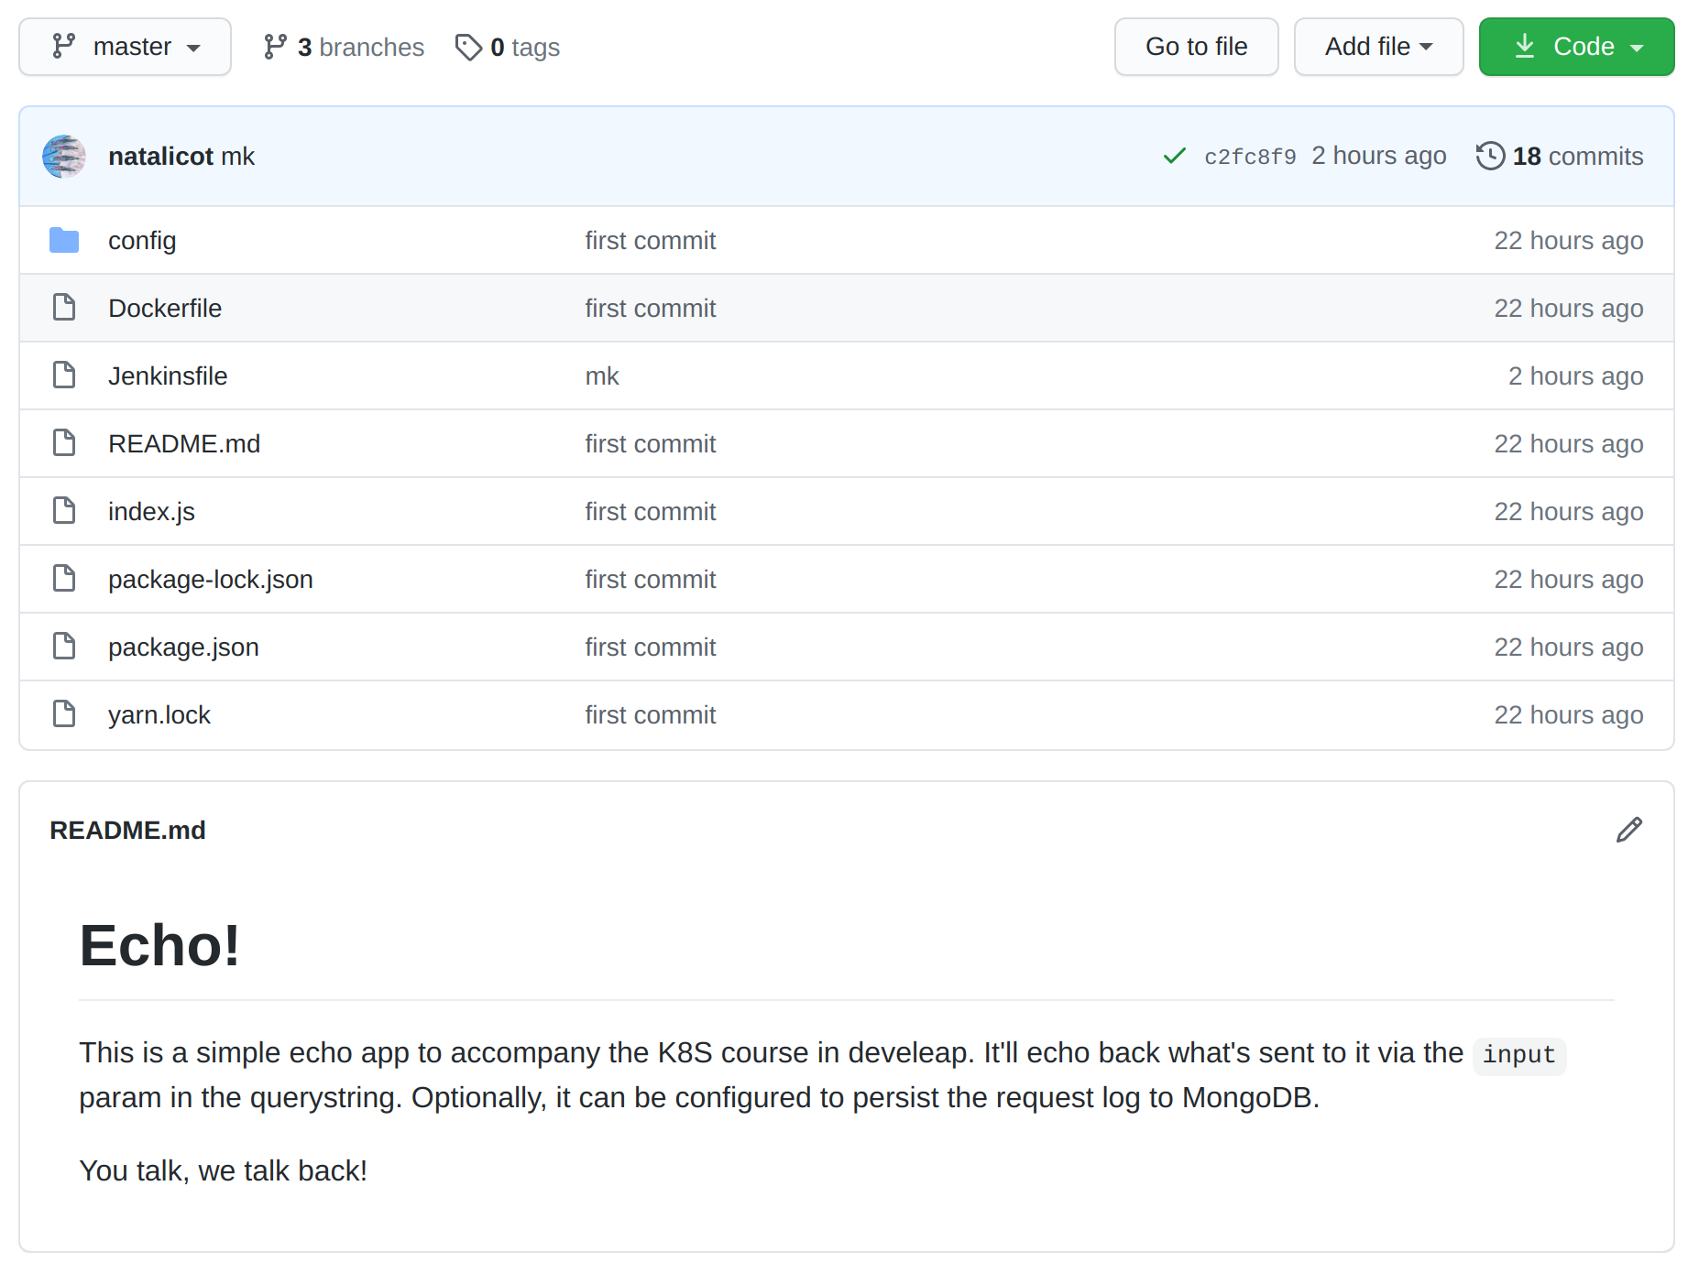
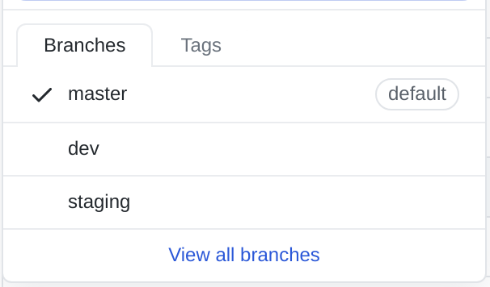

Seting up a K8S cluster on GCP:

Setin up a new standalone Jenkins VM using gcloud and terrofom

*used files are included in:
echo-final/main.tf
echo-final/entrypoint_jenkins.sh
echo-final/Dockerfile

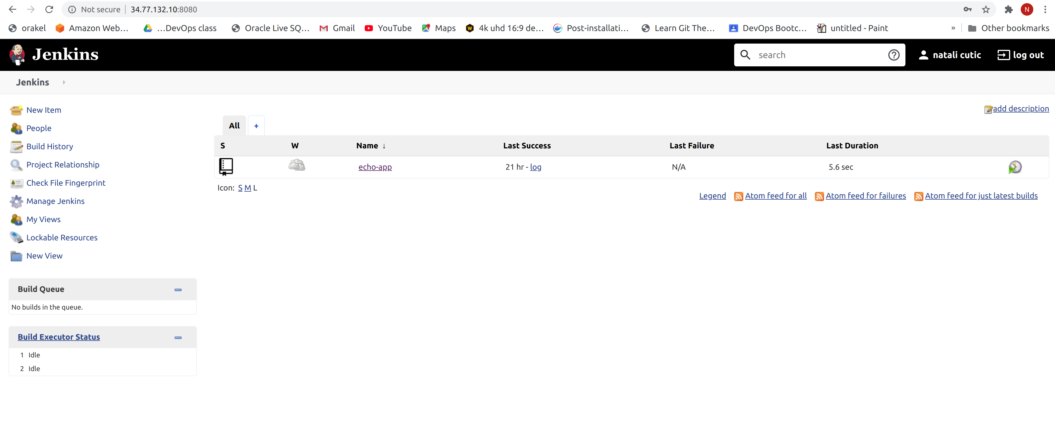

Seting up a Jenkins pipeline with 3 repos:

*used files are included in:
echo-final/app/Jenkinsfile

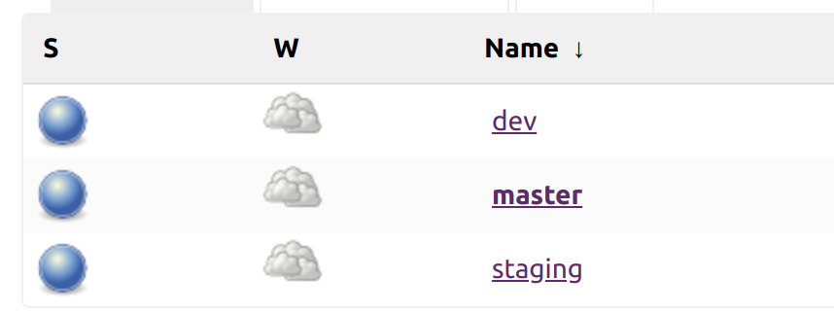

Installing Helm on cluster:
commands:

curl https://baltocdn.com/helm/signing.asc | sudo apt-key add -
sudo apt-get install apt-transport-https --yes
echo "deb https://baltocdn.com/helm/stable/debian/ all main" | sudo tee /etc/apt/sources.list.d/helm-stable-debian.list
sudo apt-get update
sudo apt-get install helm
Installing FluxCD:
commands:
helm repo add fluxcd https://charts.fluxcd.io
kubectl create ns fluxcd
helm upgrade -i flux fluxcd/flux --wait \
--namespace fluxcd \
--set git.url=git@github.com:natalicot/echo_app_helm_chart.git
kubectl apply -f https://raw.githubusercontent.com/fluxcd/helm-operator/master/deploy/crds.yaml
helm upgrade -i helm-operator fluxcd/helm-operator --wait \
--namespace fluxcd \
--set git.ssh.secretName=flux-git-deploy \
--set helm.versions=v3
fluxctl identity --k8s-fwd-ns fluxcd
entering ssh key into repo:
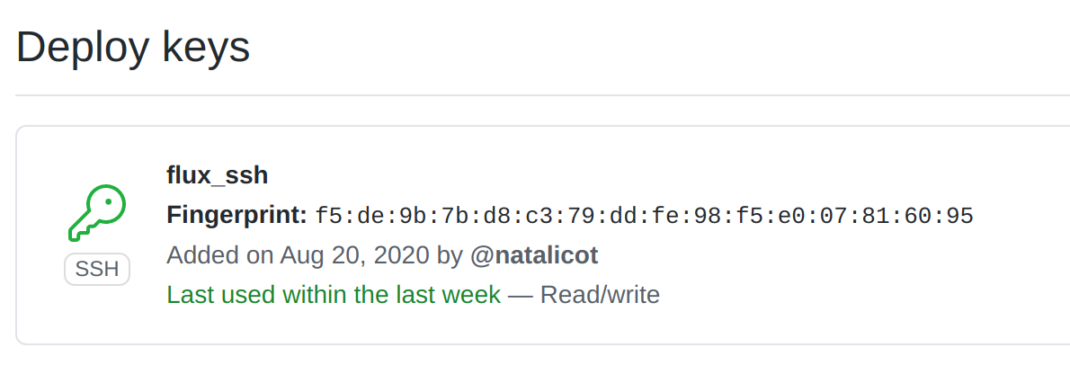

*files used in repo are included in:
echo-final/echo_chart

Seting up CD pipelines for the Echo app:

*used files are included in:
echo-final/app/jenkinsfile

uplouding images to dockerhub:



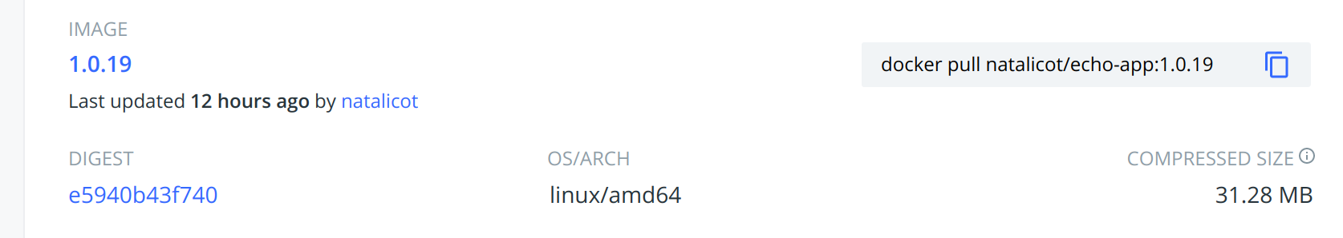
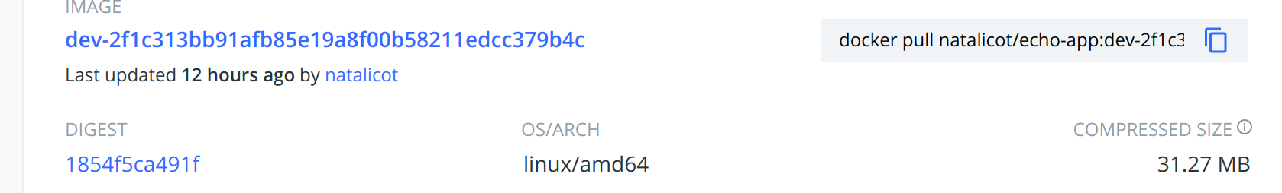

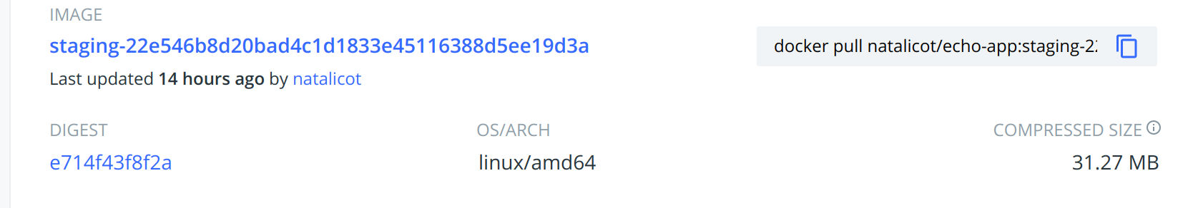

and deploying into cluster using flux:

*used files are included in:
echo-final/echo_chart/releases

Installing MongoDB to cluster:
command:

helm install mongodb -f values.yaml --namespace stg charts/mongodb-replicaset-3.17.0.tgz

Adding a dynamic configuration in each environment:

creating 2 more branches in github-flux repository:
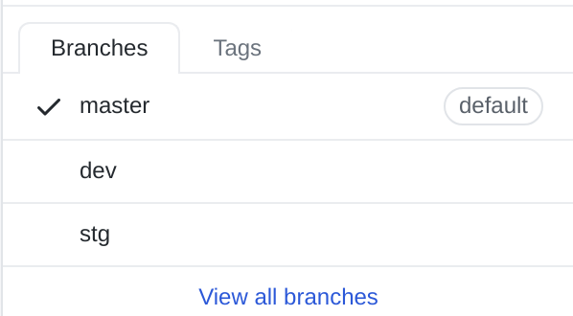

changing congig map in each branch, and specify to flux from witch branch to pull.

*All config_map are included in echo_final/configmaps

dev:
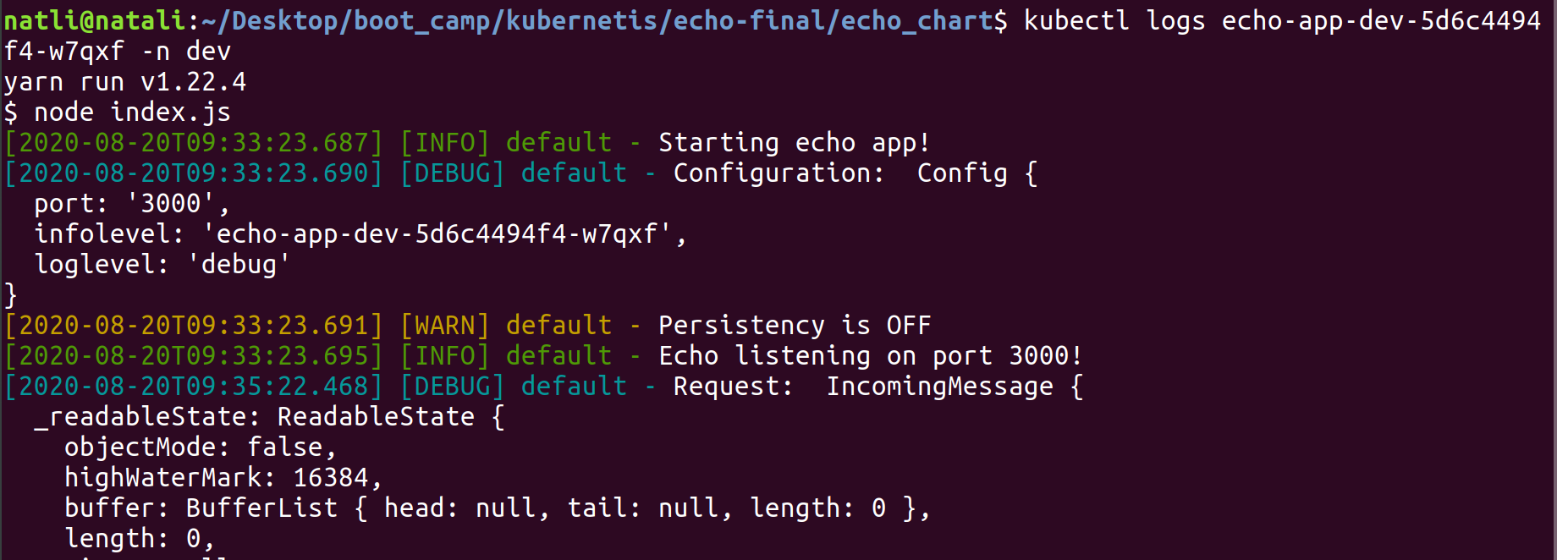

stg:

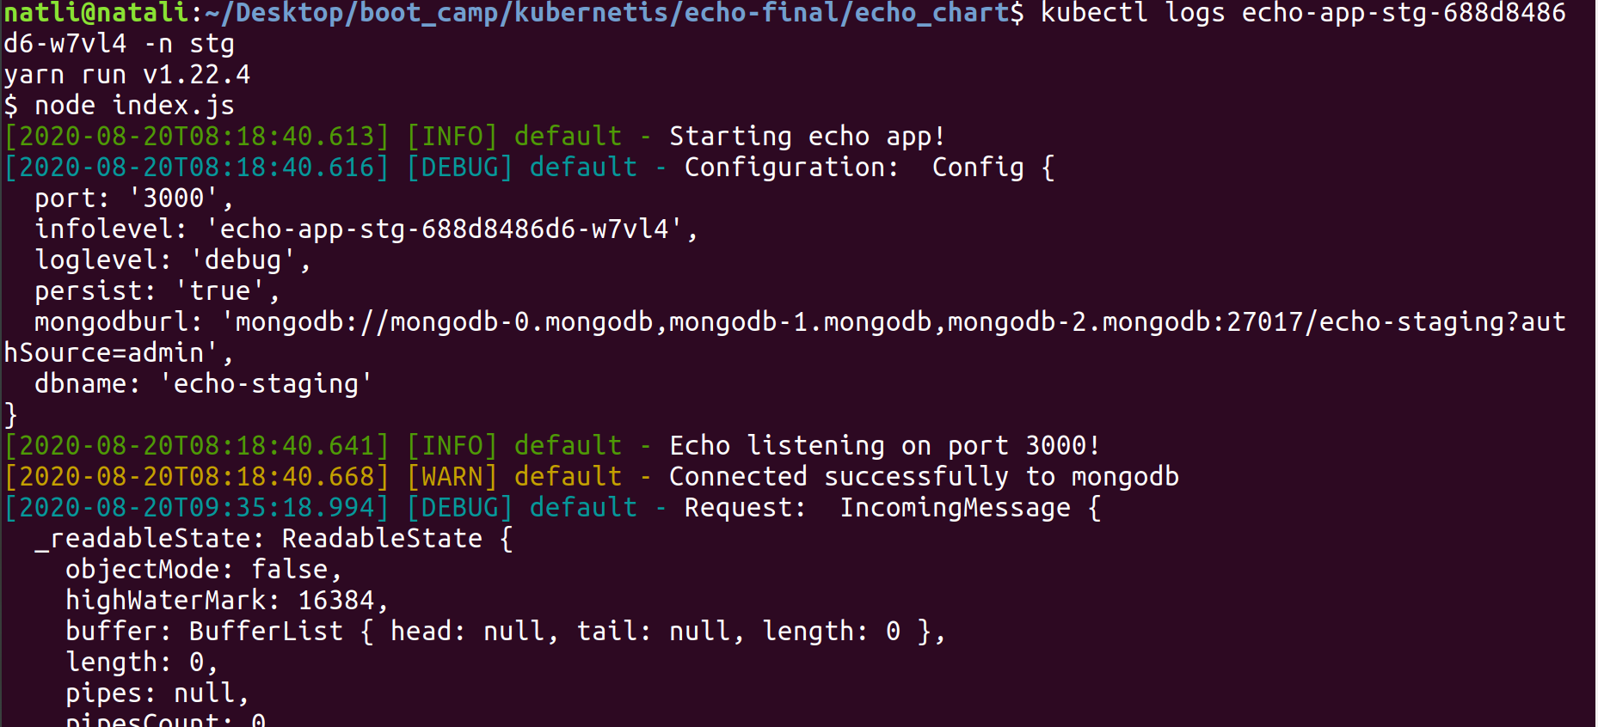

prod:

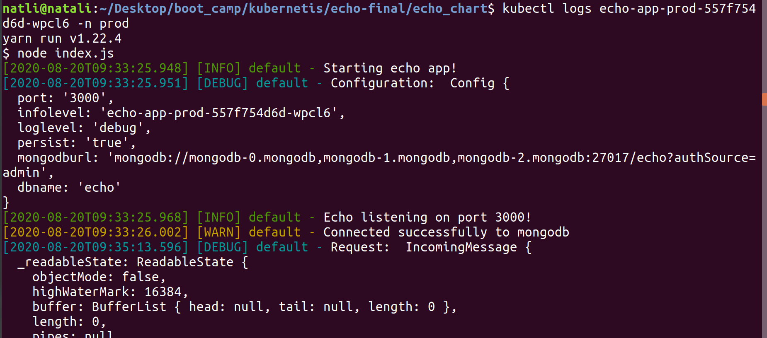

Exposing all envs to the public internet using different subdomains:

installing nginx:
commands:

helm install nginx -f values_ng.yaml nginx-ingress-1.41.2.tgz
conecting to each env using ingress:

Prod:

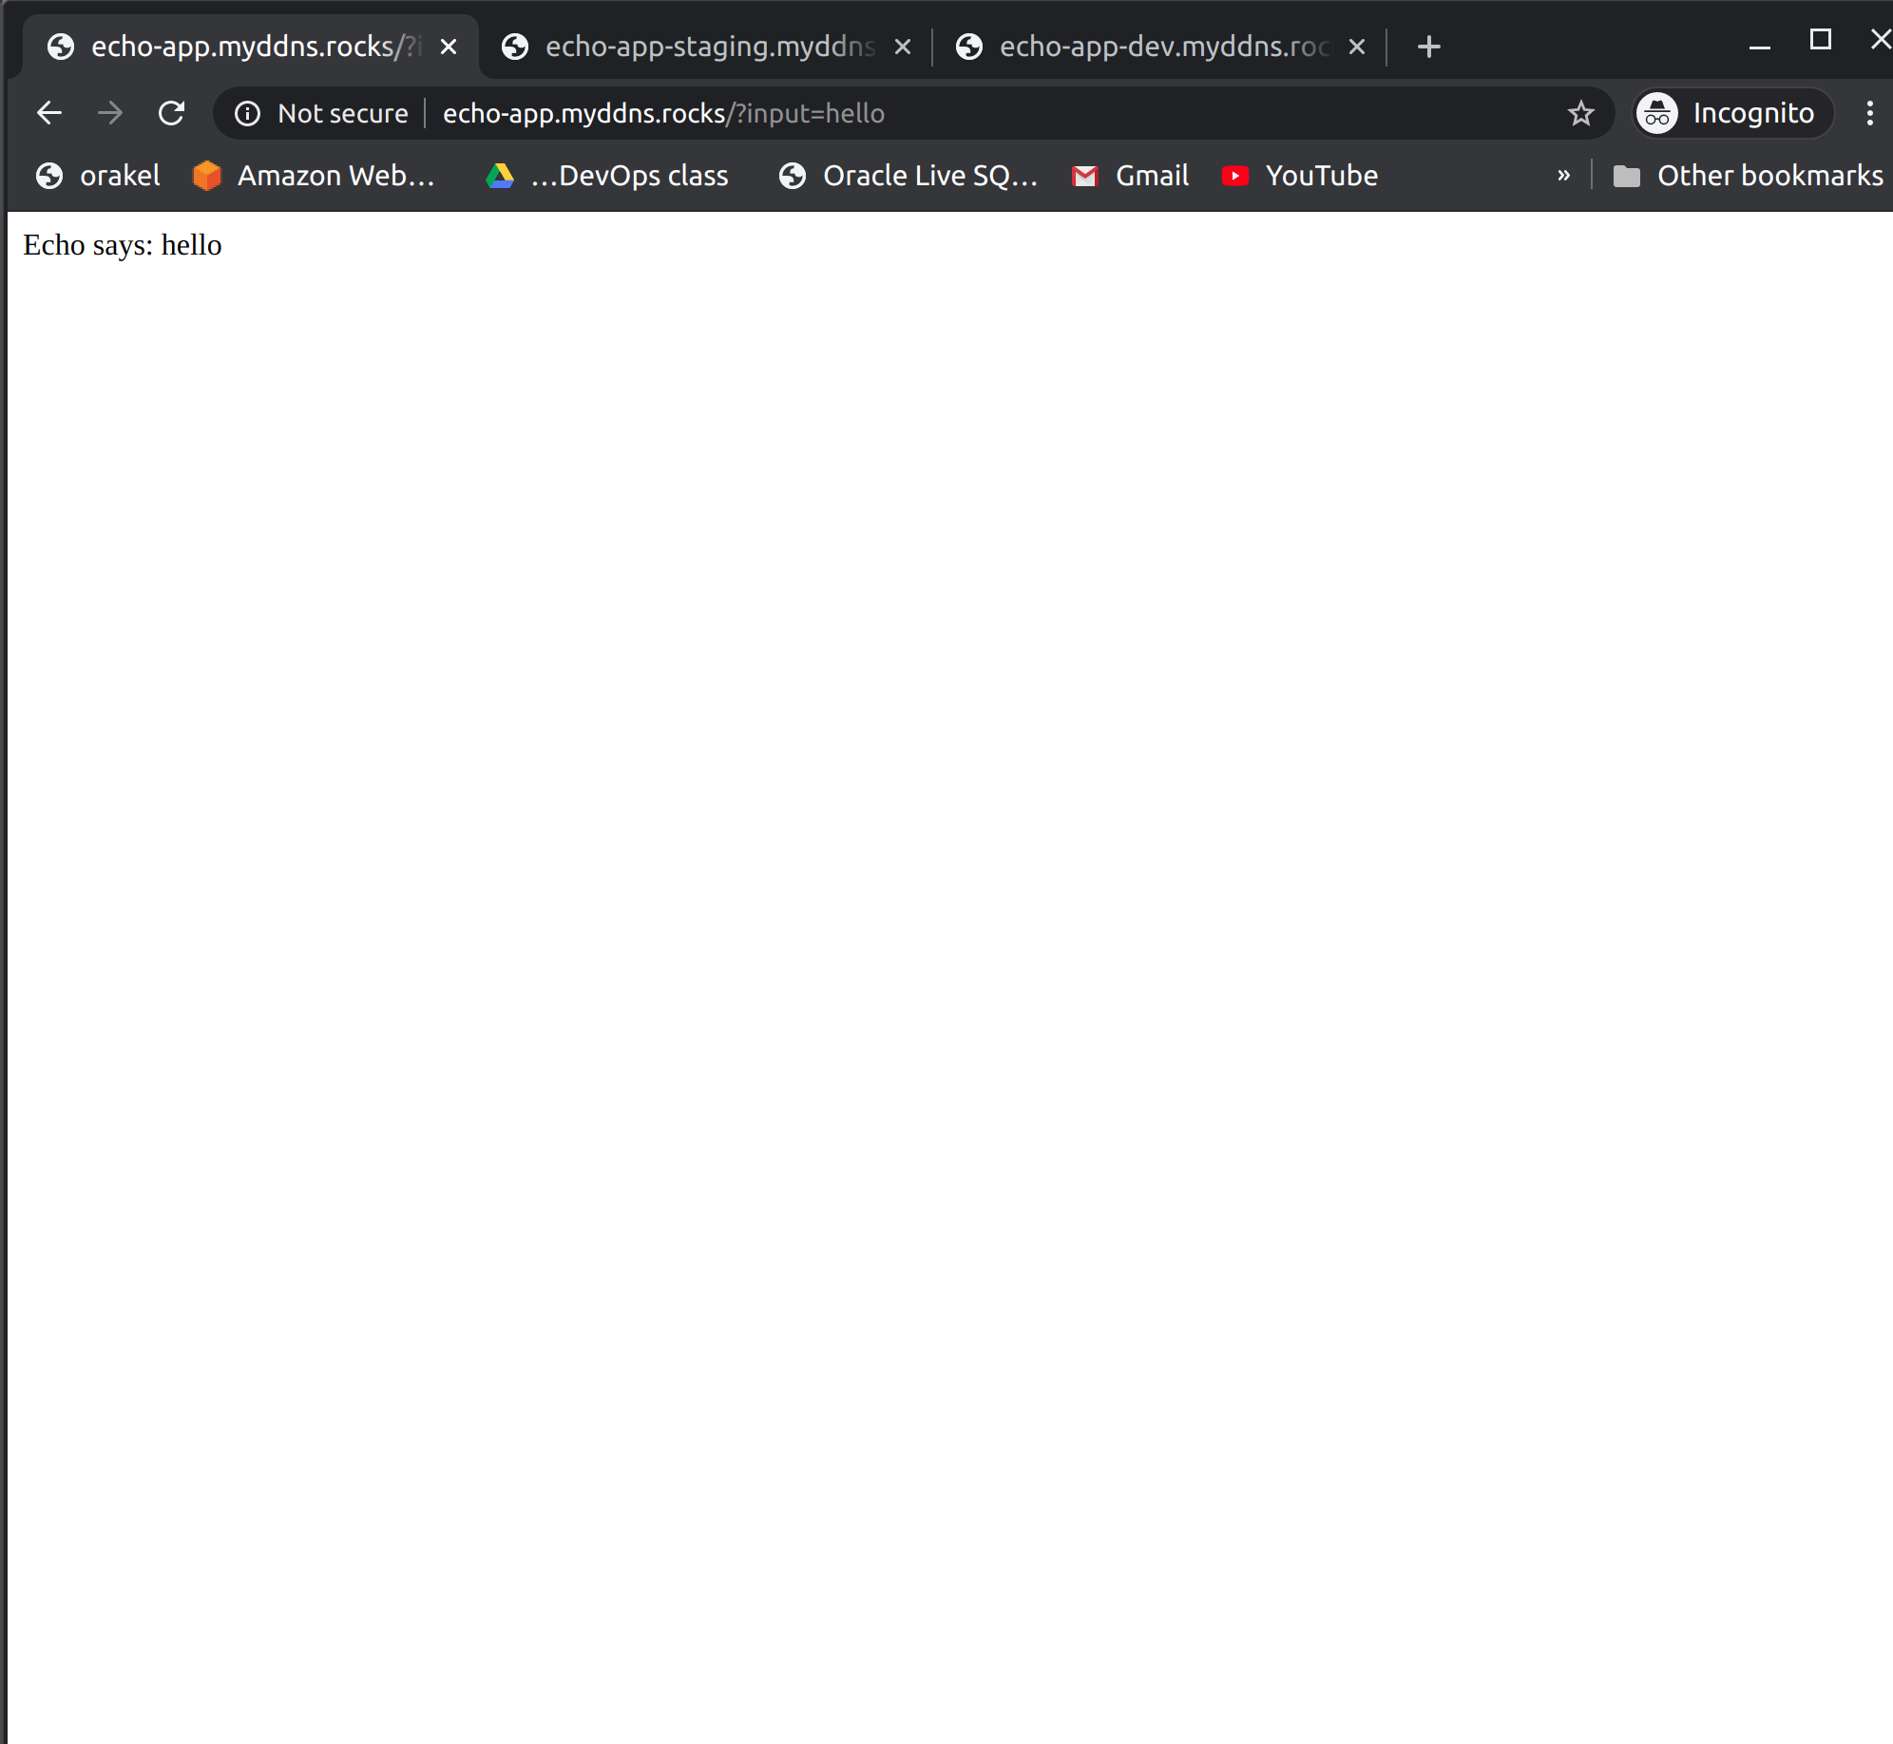

dev:

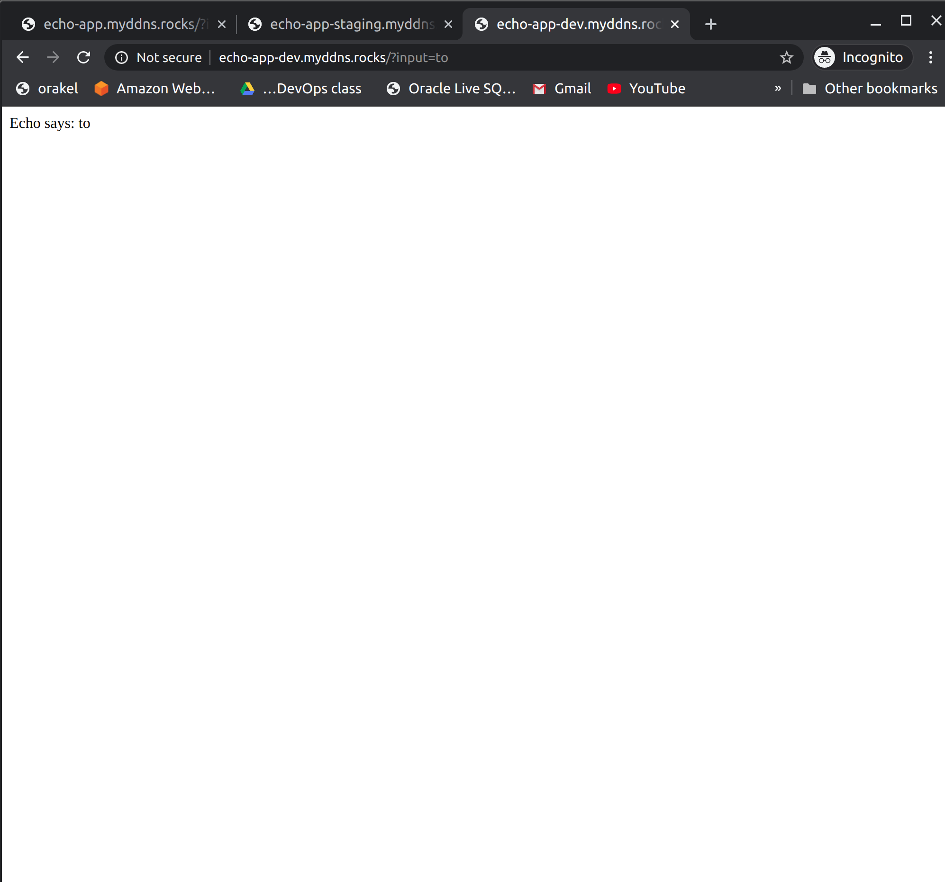

stg:

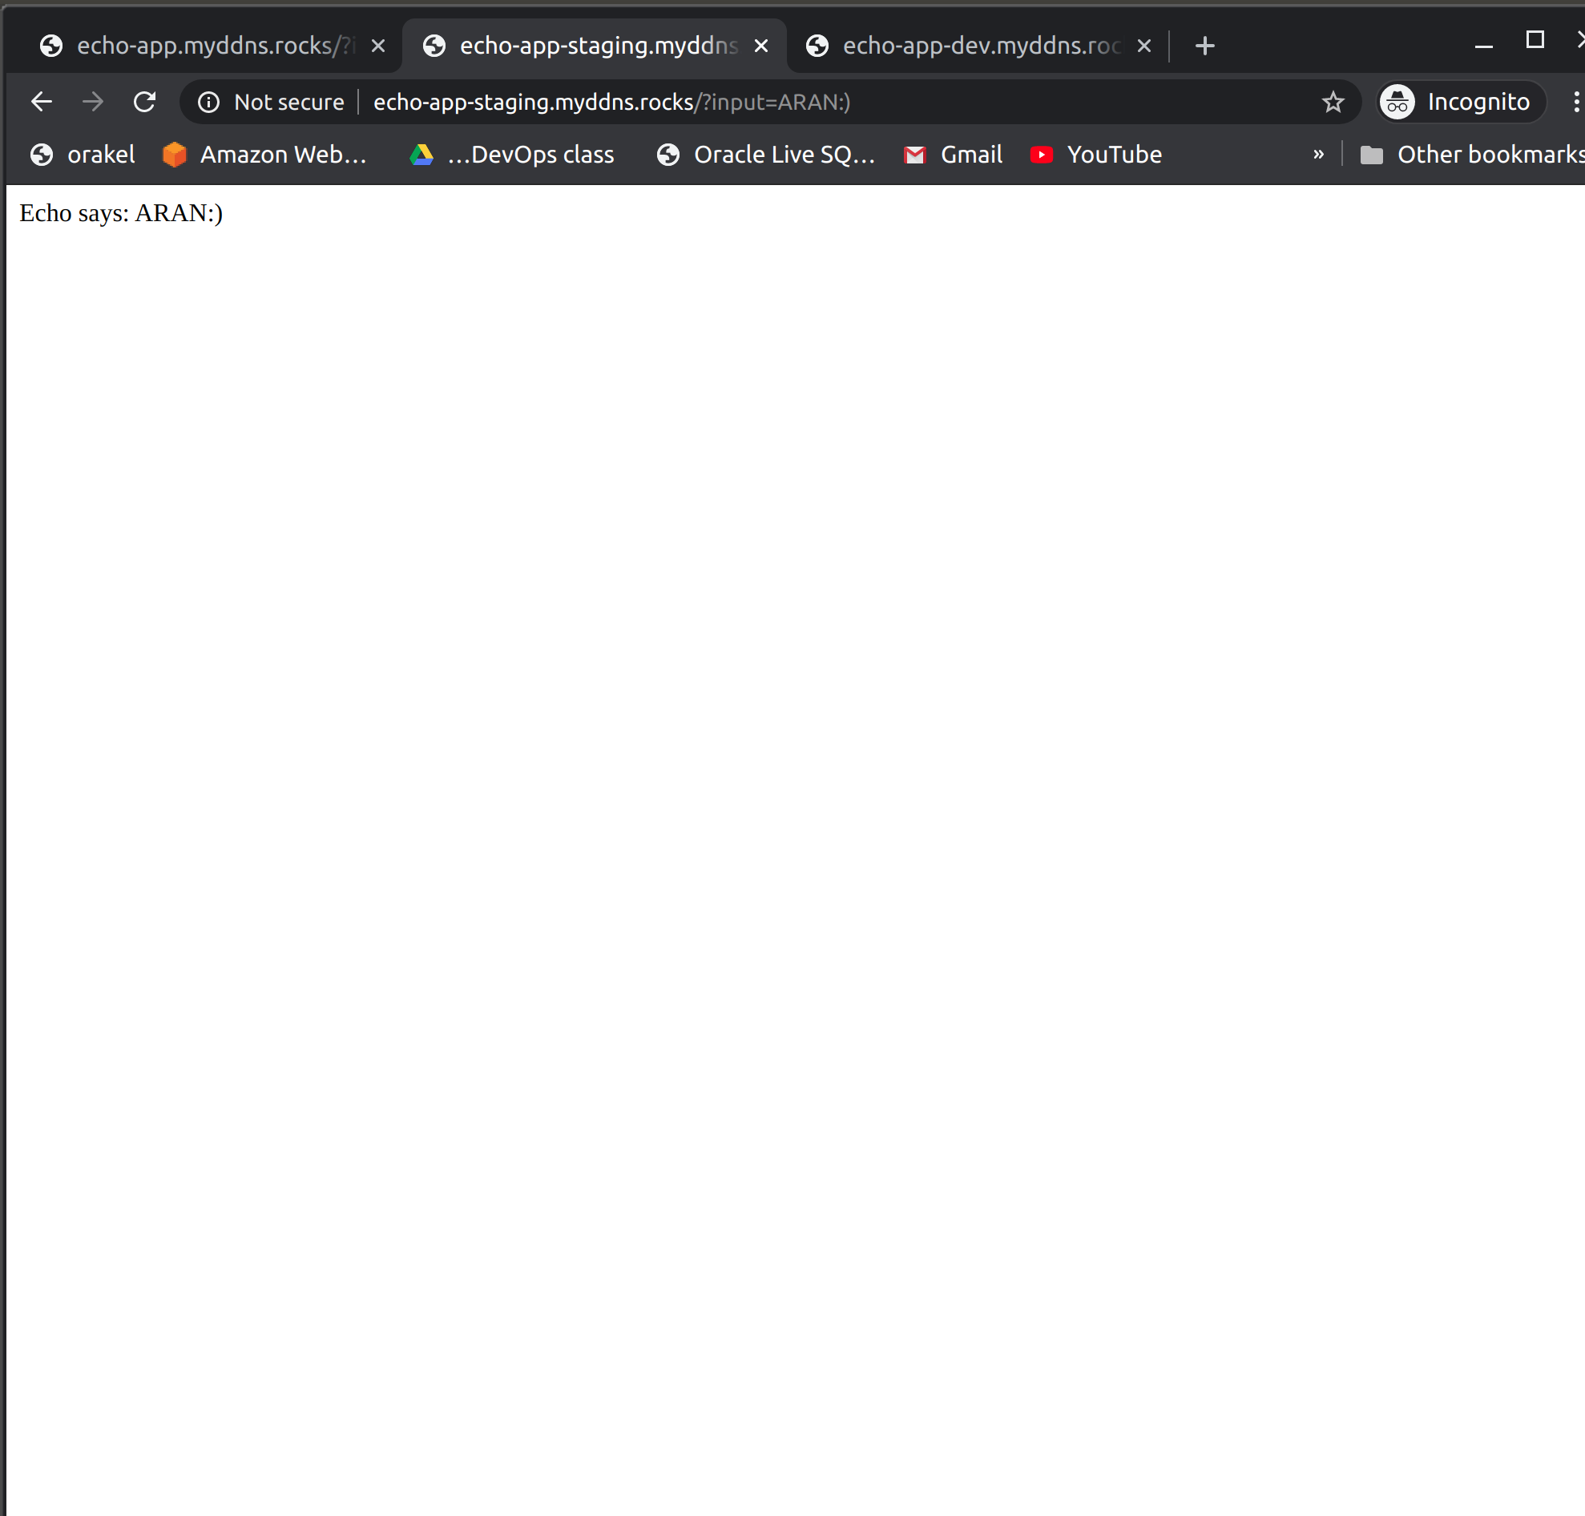

Installing the EFK:
commands:

inside echo-final/elastic-search:
kubectl create -f .
inside echo-final/kibana:
kubectl create -f .
inside echo-final/fluent:
kubectl create -f .
kubectl port-forward kibana-7449cb59d6-ddjbr 5601:5601 --namespace=kube-logging

loging:

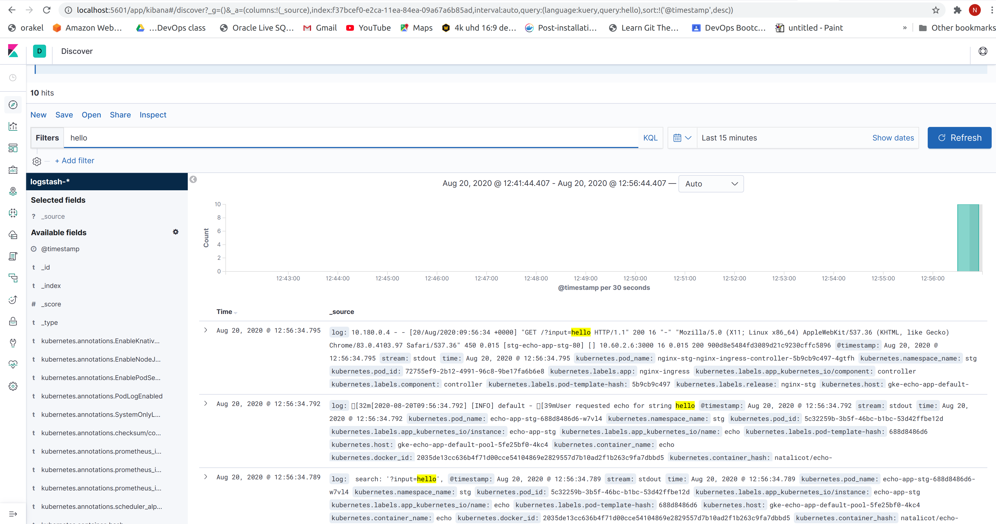

Installing the monitoring stack:
commands:

helm install pr -f values_pr.yaml --namespace kube-monitoring prometheus-11.12.0.tgz
helm install graph -f values_gr.yaml --namespace kube-monitoring grafana-5.5.5.tgz
kubectl port-forward pod/graph-grafana-6c6c85b84b-j2cws --namespace kube-monitoring 3000

nginx – monitoring:

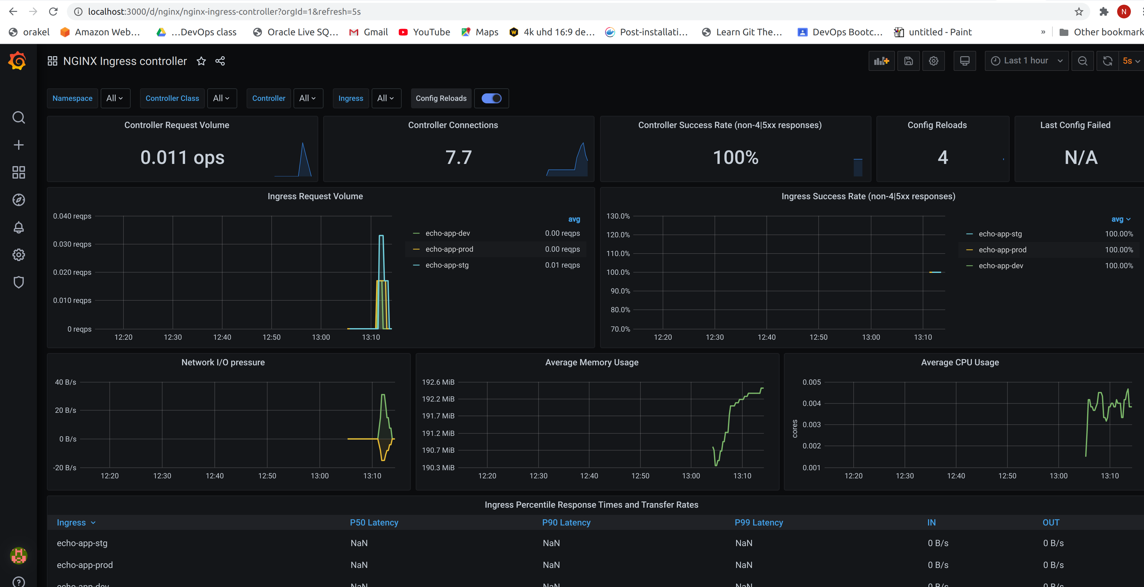
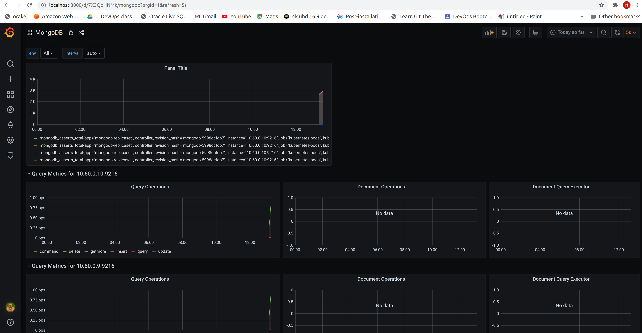
mongdb monitoring:

