Natalie Huang
ECON-3325
Dr. Collins
December 11, 2025

Maternal Labor Force Participation:
US vs. Mexico
Introduction
Understanding how family structure shapes women’s employment has been a long-standing question in labor economics. Researchers have shown again and again that fertility, children’s ages, and household arrangements matter for whether women work, though the size and direction of these effects can shift depending on the time and place (Aaronson et al., 2017). What’s less certain is how these forces behave across very different countries. Do they produce the same patterns in societies with their own norms, cultures, and labor markets?
Literature so far points in two directions. On one hand, some patterns look surprisingly similar across countries. In Mexico, for example, the change in women’s employment after a birth mirrors what researchers have found in the United States, which suggests there may be some common forces at work (Cruces & Galiani, 2007). But other factors seem more sensitive to context. Take child age. In the U.S., mothers are more likely to work as their children get older (Bureau of Labor Statistics, 2025). That makes sense, but studies suggest that this isn’t just about children, it’s about the household around them. Lundberg and Rose (2002) find that marital status and household composition shape how families divide responsibilities, which raises an important question: does having older children help mothers in the same way if they’re married or unmarried?
There is some research comparing countries which shows that education and the structure of the labor market matter a lot for whether women work. In Mexico, for instance, rising education levels and falling fertility have helped draw more women into the labor force (Bhalotra & Fernández, 2024). In other settings, women don’t leave work so much as shift into informal jobs that offer the kind of flexibility childrearing demands (Schmieder, 2021). Taken together, these studies suggest that the forces shaping women’s employment are complicated and may look quite different depending on the country in which they play out.

These ideas lead me to compare the United States and Mexico using harmonized census data. Looking at the two countries side by side helps us see whether family factors affect mothers’ work in similar ways, or whether each country shapes these relationships differently. Instead of assuming the pattern is the same everywhere, this approach lets us explore how things like number of children and family structure might work differently across places, and why those differences matter.
Objective
The purpose of this study was to examine how fertility, child age, marital status, education, and job type influence the likelihood that mothers participate in the labor force in the United States and Mexico. The analysis compared these patterns across the two countries to better understand whether demographic and socioeconomic factors operate similarly in different countries.
Hypothesis
The hypothesis is that each additional child lowers a mother’s probability of participating in the labor force and this pattern should appear in both the United States and Mexico.
Dataset
Data comes from IPUMS International (Integrated Public Use Microdata Series) 2020 census samples, which provides harmonized census microdata for cross-country research. The analysis focuses on women ages 18 to 50, capturing the prime years for both employment and child-rearing. The final dataset includes 2,499,285 women in Mexico and 1,515,840 in the United States.
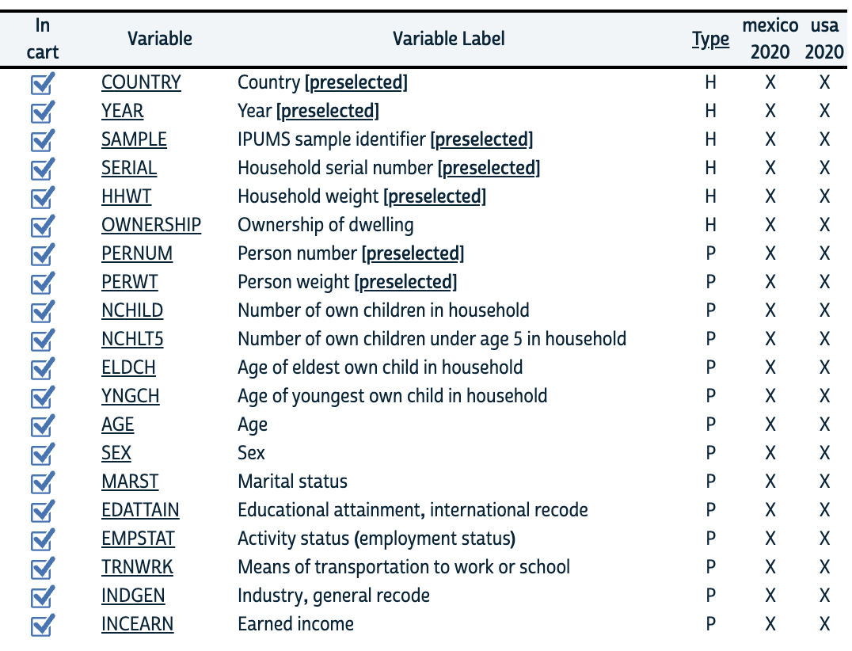
The dependent variable in this analysis is employment status (EMPSTAT), coded as a binary indicator where 1 represents being employed and 0 represents not being employed. Because the question is essentially about the probability that a mother works, the model is estimated using logistic regression. The sample is restricted to women ages 18 to 50, which captures the years when both employment decisions and child-rearing responsibilities are most active.
The independent variables reflect the different forces that might push or pull mothers into the labor market. Fertility is measured through several indicators, including the total number of children (NCHILD), the number under age five (NCHLT5), and the ages of both the youngest (YNGCH) and oldest child (ELDCH). These measures allow the analysis to distinguish not only the quantity of children but also the intensity of care they require. Age is treated in categories rather than as a single continuous value, since labor supply often changes in distinct stages rather than in a smooth line. Marital status (MARST) is included as well, along with interaction terms that capture how the effects of child age differ depending on whether a mother is married or not.
Socioeconomic characteristics such as educational attainment (EDATTAIN) and earned income (INCEARN) help account for differences in resources and opportunities across women. Additional controls capture elements of a woman’s living environment and job context, including dwelling ownership (OWNERSHIP), transportation to work (TRNWRK), and industry of employment (INDGEN). Industry categories are simplified into broad groups such as professional or office-based work versus more working-class sectors to separate jobs with different levels of stability, flexibility, and pay.
Categorical variables are converted into dummy indicators so that each characteristic can be compared cleanly in the regression analysis. This structure allows the model to isolate how each factor (children, age, marital status, education, job type) shapes the likelihood that a mother participates in the labor force.
Methods
Data Transformation and Cleaning
To make the analysis more informative, several variables were transformed to better reflect the underlying dynamics of maternal employment. The first major adjustment involved recoding the industry variable (INDGEN) into a new dummy indicator called deskjob. The goal was to distinguish between occupations that are largely desk-based and those that require more physical activity. This contrast matters because the structure of a job, its hours, its physical demands, its predictability, often shapes how compatible it is with raising children.
However, INDGEN was ultimately removed from the analysis because too many observations were coded as “not in universe,” leaving the variable with excessive missingness. This lack of complete data prevented the model from running properly and would have introduced unnecessary bias, so the final regressions exclude job-type measures.
Educational attainment (EDATTAIN) was also simplified into a binary measure. Women with less than primary or only primary schooling which in the United States we call elementary schooling were coded as having lower education (highedu = 0), while those with secondary (high school) or university education were coded as having higher education (highedu = 1). This distinction captures broad differences in access to skilled jobs and economic opportunities.
Interaction Term: Eldest 13 X Married
To explore whether having an older child helps mothers reenter or remain in the labor force, a dummy variable was created to indicate whether the eldest child in the household is 13 or older. Research suggests that around this age adolescents begin contributing to household tasks and require less hands-on supervision, easing time constraints for mothers. Accordingly, eldest13 = 1 for households where the eldest child is 13 or older and 0 otherwise. Marital status was also converted into a binary indicator, with married or in-union coded as 1 and not married coded as 0.
These two indicators were then interacted to test whether the presence of an older child has a different effect on married and unmarried mothers. Prior labor statistics consistently show that mothers work more as their children age. The interaction term allows the model to investigate whether this increase is particularly strong for unmarried mothers, who may benefit more directly from the additional help or independence that older children provide. Married mothers, by contrast, may already share childcare responsibilities with another adult, making the effect of an adolescent child smaller.
Logit Model
The final model is estimated using logistic regression, because the outcome of interest, whether a mother is employed, is a binary variable. This approach allows the analysis to estimate how each factor, from fertility to job type, shifts the probability that a mother participates in the labor force. Two models were constructed, one for each country:
logit working nchild eldest13 married eldest13_notmarried highedu age if country == 484, vce(robust)
logit working nchild eldest13 married eldest13_notmarried highedu age if country == 840, vce(robust)
The independent variables selected were chosen because prior research shows they are central predictors of maternal labor force participation. Each variable captures a different structural constraint or support that influences whether mothers are able to work, such as childcare demands, family structure, or human capital. Together, they provide a focused but comprehensive view of the demographic and socioeconomic factors most closely linked to employment outcomes.

Results
Mexico
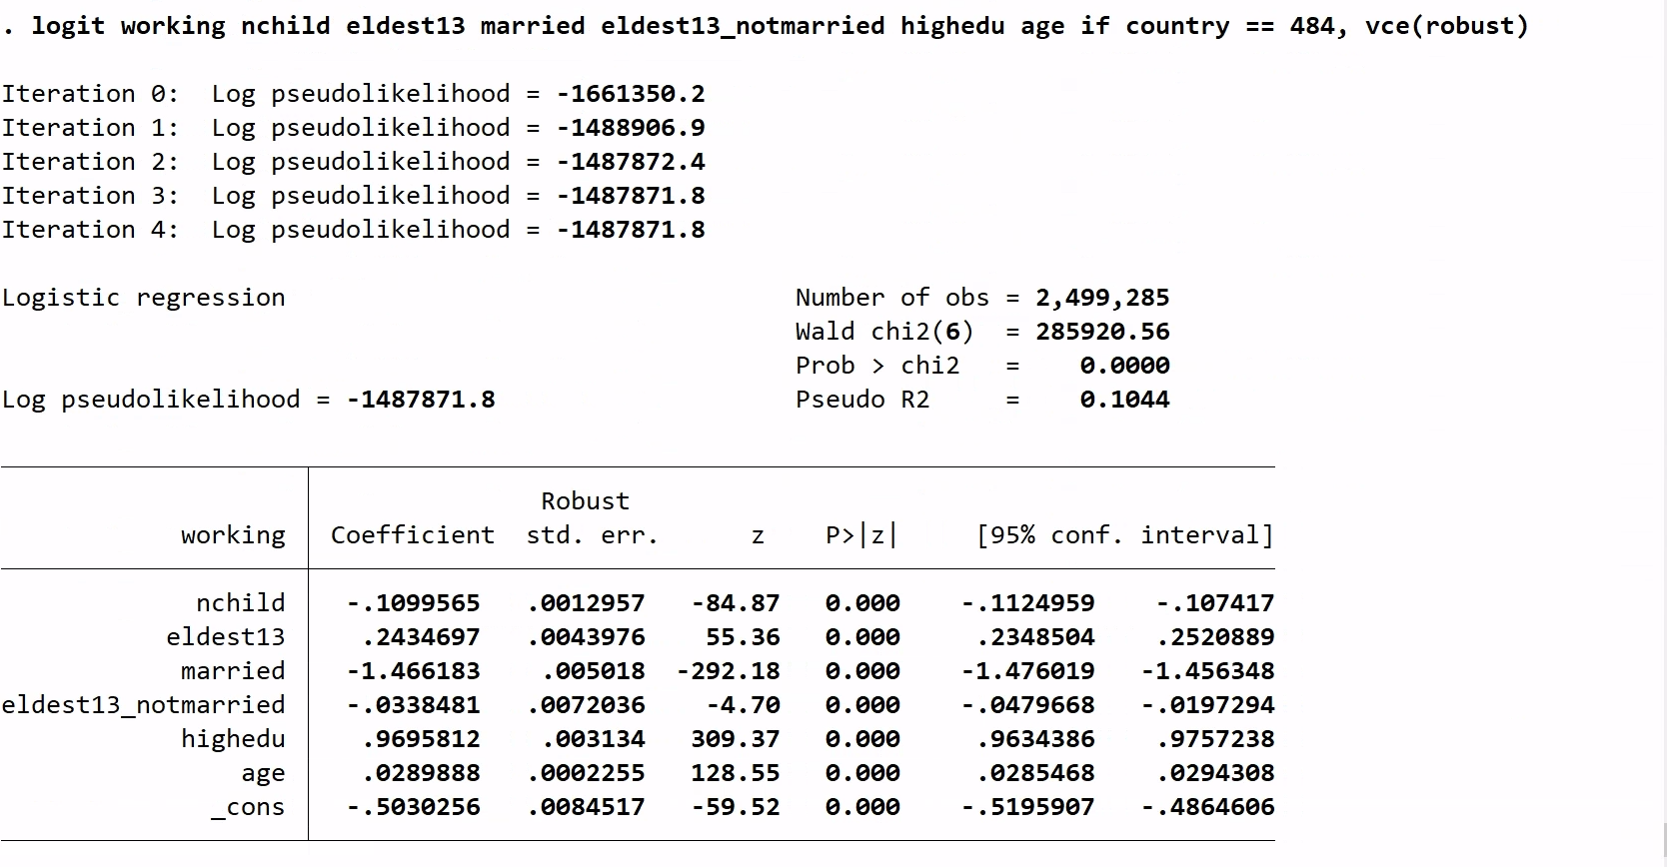
The results for Mexico show a labor market shaped heavily by family structure. The coefficient on number of children is –0.110, meaning that each additional child reduces a mother’s likelihood of employment. The effect is not subtle. Even when controlling for age, education, and marital status, adding another child consistently pushes women out of the labor force. It suggests our hypothesis is correct: more children mean more demands, and those demands narrow the space for paid work.
Older children, however, shift that equation. The coefficient for having an eldest child age 13 or older is +0.243. That is a meaningful increase in the probability of working. A teenager in the household seems to relieve enough supervision and care that employment becomes more feasible. Once maternal age is included in the model, the effect becomes slightly smaller, but the basic logic remains: older children loosen constraints.
Education plays a powerful role. The coefficient for higher education is +0.970. In practical terms, education is one of the strongest engines of labor force participation in Mexico. Women with high schoolor university education simply have more access to stable, formal jobs and the bargaining power that comes with them.
Age contributes modestly but consistently, with a coefficient of +0.029. As women grow older, they are slightly more likely to work, reflecting increased experience, more stable household routines, and fewer very young children.
The variable that stands out most statistically is marital status. The coefficient for married women is –1.466, the strongest effect in the Mexican model. This suggests that marriage significantly reduces the probability of employment, even after accounting for number of children and education. It points to deeper forces: social norms, household specialization, or structural incentives that encourage married women to stay home.
Being unmarried and having an older child tells a different story. The coefficient is –0.034, small but negative. Interestingly, for unmarried mothers, having an eldest child age 13 or older does not increase the likelihood of working. A possible explanation is that single mothers, even with older children, still bear the full weight of household responsibilities. Older children may help, but not enough to offset the absence of another adult.
Altogether, the Mexican results depict a labor environment where motherhood carries substantial employment costs, education offers a powerful counterbalance, and marriage creates one of the strongest divides in women’s work patterns.
United States
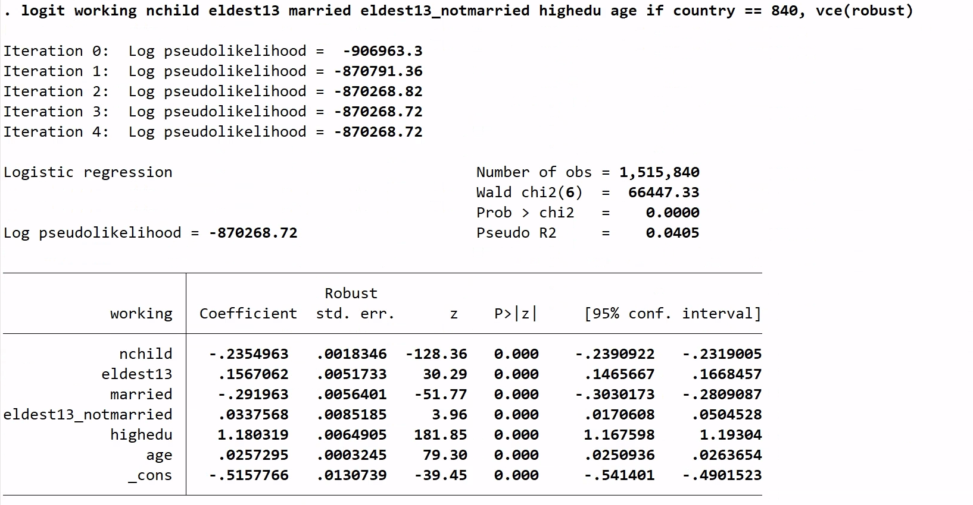
The U.S. results move in the same general direction as Mexico’s but differ markedly in scale. The coefficient for number of children is –0.235, about twice the size of the effect in Mexico. This indicates that each additional child imposes a sharper drop in employment probability for American mothers. The pattern may be similar, more children mean more demands, but the pattern seems to be amplified in the United States.
As in Mexico, having an eldest child age 13 or older increases the probability of working for American mothers. The coefficient is +0.157, smaller than Mexico’s +0.243. Older children still help, but perhaps the structure of American households or schooling limits the extent to which adolescents can meaningfully reduce care burdens.
Higher education is even more influential in the U.S. than in Mexico. The coefficient is +1.180, the single strongest predictor in the American model. Education reshapes the labor possibilities for mothers, opening doors to higher-paying, flexible, or more stable employment that is simply not as available to less-educated women.
Age shows a similar, gentle upward slope, with a coefficient of +0.026. As women age, they gain work experience and often have older children, both of which make employment easier.
Marriage, interestingly, has a weaker negative effect in the U.S. than in Mexico. The coefficient is –0.292, still negative but far smaller than the –1.466 seen in Mexico. Marriage reduces the likelihood of working in both countries, but in the United States the institutional and cultural pressures to stay home appear much less pronounced.
The interaction between being unmarried and having an older child reveals a small positive effect of +0.034. This is the opposite of the pattern in Mexico. In the U.S., unmarried mothers seem to benefit from having a teenage child, perhaps because older children can provide meaningful household help or self-manage in ways that free up the mother’s time to work.
In short, the U.S. results point to stronger penalties for additional children, stronger gains from education, and a more muted role of marriage.
Comparing the United States and Mexico:
Across both countries, the basic patterns look similar. More children reduce the likelihood of employment, older children increase it, and education strongly boosts it. These shared effects point to universal forces such as time constraints, opportunities, and child development that operate regardless of whether the mother lives in Mexico or the United States.
Where the two countries diverge is the size of these effects. The penalty for an additional child is nearly twice as large in the United States (–0.235) as in Mexico (–0.110), suggesting sharper childcare constraints or higher costs of raising children. Education has an even greater payoff in the U.S. (+1.180 vs. +0.970), suggesting a more polarized labor market where employment hinges more heavily on schooling.
Marriage shows the starkest contrast. In Mexico, being married sharply reduces employment (–1.466), while in the U.S. the effect is present but is far smaller (–0.292), reflecting different expectations around household roles.
The interaction between marital status and having an older child even flips direction: negative in Mexico (–0.034) but positive in the U.S. (+0.034). This suggests that older children contribute to household functioning in ways that support work differently across family structures.
Finally, the U.S. model explains more variation in employment (Pseudo R² ≈ 0.10) than the Mexican model (≈ 0.04), meaning the included predictors capture more of the American context.
Conclusion
Across two very different countries, the results point to something consistent: motherhood strongly shapes whether women work. In both countries, more children make employment less likely, older children make it more likely, and education acts like a slide that tilts the whole system toward employment. We see these same patterns in both the United States and Mexico, which tells us that forces like time, opportunity, and childcare affect families everywhere. These aren’t particular problems in one country or another, they seem to be basic challenges that all families must balance, no matter where they live.
Some interesting differences do exist. In the United States, every added child makes it noticeably harder for mothers to stay in the workforce, while in Mexico marriage is the factor that most strongly draws women away from paid work.
Education, though powerful everywhere, carries an especially large payoff in the U.S., where employment opportunities cluster more tightly around formal qualifications. Even the role of older children shifts across contexts. In Mexico, the results suggest having older children does little to offset the burdens of single motherhood, while in the United States they provide enough support to make work more feasible. These contrasts remind us that the same family structures can interact very differently with the surrounding economic and cultural environment.
Taken together, the findings show that maternal employment is shaped by a blend of universal constraints and country-specific conditions. The basic logic of childcare and labor supply travels across borders, but institutions, norms, and the design of work itself bend those forces in different directions. Understanding these patterns not only clarifies why mothers work, or do not, in each country, but also highlights where policy and workplace structures might relieve pressure points.

References
Aaronson, D., Dehejia, R., Jordan, A., Pop-Eleches, C., Samii, C., & Schulze, K. (2017). The effect of fertility on mothers’ labor supply over the last two centuries (IZA Discussion Paper No. 10559). Institute of Labor Economics.
Bhalotra, S., & Fernández, M. (2024). The rise in women’s labor-force participation in Mexico—Supply vs. demand factors. The World Bank Economic Review, 38(2), 319–350.
Bureau of Labor Statistics, U.S. Department of Labor. (2025, January 22). As children at home aged, labor force participation increased for mothers but decreased for fathers. The Economics Daily. https://www.bls.gov/opub/ted/2025/as-children-at-home-aged-labor-force-participation-increased-for-mothers-but-decreased-for-fathers.htm
Cruces, G., & Galiani, S. (2007). Fertility and female labor supply in Latin America: New causal evidence. Labour Economics, 14(3), 565–573. https://doi.org/10.1016/j.labeco.2005.10.006
Lundberg, S., & Rose, E. (2002). The effects of sons and daughters on men’s labor supply and wages. The Review of Economics and Statistics, 84(2), 251–268.
Schmieder, J. (2021). Fertility as a driver of maternal employment. Labour Economics, 72, 102083.
Tortarolo, D. (2014). Female labor supply and fertility: Causal evidence for Latin America and the U.S. CEDLAS Working Paper No. 166, Universidad Nacional de La Plata.

