Contents

Report 2

Design 2

Pseudocode 3

Code 5

Local Storage 26

Show/hide hireForm 28

Evaluation 30

# Report

## Design

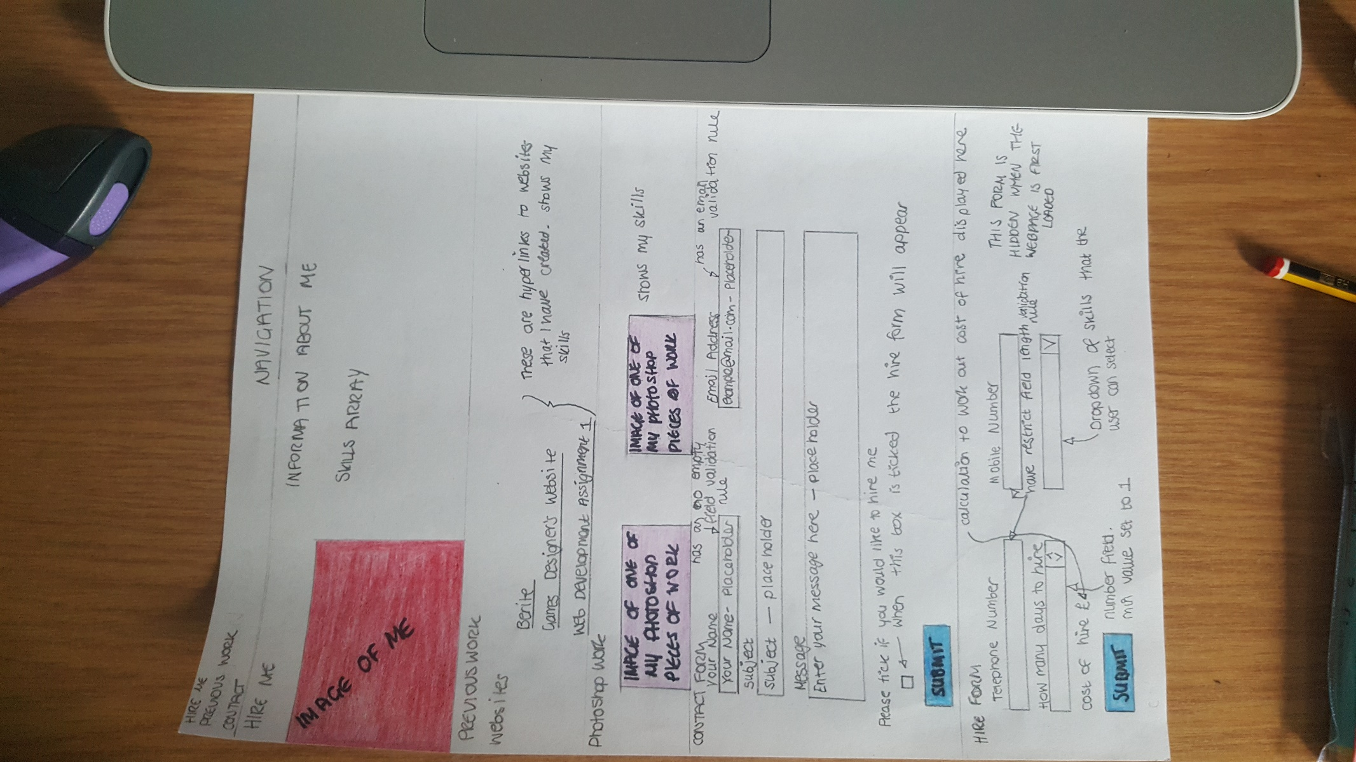

A one page website design. On the image I have explained where the JavaScript elements are going to be on the page.

## Pseudocode

**Local Storage if statement**

If (localStorage){

txtName = get Element By Id ‘name’

txtName value = local storage get item ‘name’

(display message)

txtName blur add event listener function(){

localStorage set item (‘name’ txtName value)

}) false

}

}

**noEmptyField form validation if statement**

function noEmptyField(element display message){

if (element value length is equal to 0)

display message

element focus

return false

}

return true

}

**restrictLength form validation if statement**

function restrictLength(element min max)

input = element value

if(input length is more than or equal to min value and less than or equal to max value set)

return true

}else{

display message()

element focus()

return false

}

}

**emailValidation form validation if statement**

function emailValidation (element, message){

emailCharacters = lists characters allowed to create a valid email address

if(element value matches the (emailCharacters)){

return true

}else{

Display message

Element focus()

Return false

}

}

## Code

**JavaScript**

//Skills Array

//This code is from the JavaScript and JQuery book by Jon Duckett - chapter 3 on Functions, Methods and Objects that also includes arrays. Also taken from the array that I successfully created for Assignment 1

var listSkills = ["HTML", " CSS", " JavaScript", " JQuery", " Can create and manipulate raster and vector images", " Knowledge of Adobe Suite such as Illustrator and Photoshop"]; //Lisiting my skills in an array called 'Skills'

var text = ""; //text. Is an empty string. Can be declared later

var i; //this variable called i in a loop means incrementer. This variable counts how many times the loop has been executed. This is needed because the condition of the loop would never be met, meaning an infinite loop

for (i = 0; i < listSkills.length; i++) { //loops through the items in the array. i++ means one will be added to the variable. A for loop runs through code for a specified number of times. A counter is oten used to tell the loop how many times it is to loop through the code.

text += listSkills[i] + "</br>"; // this gets the text from the listSkills array

};

document.getElementById("skills").innerHTML = text;

//Local Storage

/*This code is from the JavaScript and JQuery book by Jon Duckett - chapter 9 on APIs and Local Storage. Also elements are taken from classwork on Local Storage

http://www.w3schools.com/jsref/event_onblur.asp - About onblur events*/

if (localStorage) {

var txtName = document.getElementById('name'); // Get form elements

txtName.value = localStorage.getItem('name'); // Elements populated by the localStorage data

alert("Welcome back " + txtName.value); //Alert the stored value

txtName.addEventListener('blur', function () { // Data saved on keyup. The blur event listener means that this code is excectued one the user leaves a field

localStorage.setItem('name', txtName.value);

}, false);

};

//Calculation

//This code is from http://www.w3schools.com/jsref/tryit.asp?filename=tryjsref_number_value2

function costOfHire() {

var daysHire = parseInt(document.getElementById("days").value);//parseInt() is used to parse a string and then a integer is returned

document.getElementById("hireTotal").innerHTML = daysHire;

var rate = 100; //Setting the rate per day

var total = daysHire * rate; //Working out the total cost

document.getElementById("hireTotal").innerHTML = ("Cost of hire: " + "&pound" + total); //Displaying the cost of hire using concatenation and the var total

};

//Form Validation

//This code is from http://www.tizag.com/javascriptT/javascriptform.php a website tutorial about form validation

//Form validation - checking that there are values in the fields marked required otherwise an alert message will appear asking to enter values into these fields

function noEmptyField(elem, helperMsg){ //A function called noEmptyField is created

if(elem.value.length == 0){//If the length of the input is equal to 0 then

alert(helperMsg);//An alert will appear telling the user to enter their name

elem.focus(); //elem is a HTML text input

return false;//If no characters are entered an error message appears

};

return true;//Otherwise the form can be submitted

};

//This code is from http://www.tizag.com/javascriptT/javascriptform.php a website tutorial about form validation

//Form validation - limiting the length of characters that can be entered into a field. in this case to limit the characters for the telephone and mobile number fields as they have 11 numbers

function restrictLength(elem, min, max){//A function called restrictlength is created

var input = elem.value;

if(input.length >= min && input.length <= max){ //If the characters entered are more than 1 (declared in the index.html file) and equal to or less than 11

return true;//Then the form can be submitted

}else{//Otherwise

alert("Please enter between " +min+ " and " +max+ " characters without spaces");//An alert will appear asking for the correct amount of characters to be entered

elem.focus();//elem is a HTML text input

return false;//If the correct number of characters are not entered an error message appears

};

};

//This code is from http://www.tizag.com/javascriptT/javascriptform.php a website tutorial about form validation

//Form validation - checking to see if an email that is entered is valid

function emailValidation(elem, helperMsg){//A function called emailValidation is created

var emailCharacters = /^[\w\-\.\+]+\@[a-zA-Z0-9\.\-]+\.[a-zA-z0-9]{2,4}$/;//Listing the characters that are needed to create a valid email address. characters@characters.characters

if(elem.value.match(emailCharacters)){//If the characters inputted into the textbox match the correct fromatting of an email address then

return true;//The form can be submitted

}else{//Otherwise

alert(helperMsg);//An alert will appear telling the user to enter a valid email address

elem.focus();//elem is a HTML text input

return false;//If the correct combination of characters are not entered an error message appears

};

};

//JQuery

//This bit of code is used to show the hireForm once the tickbox has been checked. It can be toggled so if the user then unticks the hireForm it will be hidden again

//This code is from http://www.w3schools.com/jquery/eff_toggle.asp

$(document).ready(function(){ //This detects whether the document is ready (Once the DOM is ready). If the document is then the function will be ran

$("#hire").click(function(){

$(".hireForm").toggle();

});

});

**HTML**

<!DOCTYPE html>

<html lang="en">

<head>

<meta charset="UTF-8">

<title>Hire Me</title>

<link rel="stylesheet" href="css/style.css" type="text/css"/><!--Referencing external stylesheet-->

<!-- FONT - taken from google fonts - https://www.google.com/fonts

–––––––––––––––––––––––––––––––––––––––––––––––––– -->

<script src="https://ajax.googleapis.com/ajax/libs/jquery/1.12.0/jquery.min.js"></script>

<script src="https://ajax.googleapis.com/ajax/libs/jquery/2.2.0/jquery.min.js"></script>

</head>

<body>

<header>

<div class="navigation">

<nav>

<ul>

<li><a href="#hireMe">HIRE ME</a></li><!--Creating links to different sections of the page. IDhireMe section-->

<li><a href="#previousWork">PREVIOUS WORK</a></li><!--Creating links to different sections of the page. IDpreviousWork section-->

<li><a href="#contact">CONTACT</a></li><!--Creating links to different sections of the page. IDcontact section-->

</ul>

</nav>

</div>

</header>

<div class="container">

<a id="hireMe"></a><!--Creating an id for hireMe to create links to this section-->

<h1>Hire Me</h1>

<div class="row">

<div class="four columns"/>

<img src="img/me.jpg" alt="Me" class="me"/>

</div><!--End class=" five columns"-->

<div class="eight columns"/>

<p>Hello, my name is Natalie Chappelhow and I am a first year student at UCLAN where I am studying Web Design and Development.</p>

<p>These are skills that I have :</p>

<p id ="skills"></p><!--This displays the skills that are defined in the skills array-->

</div><!--End class="seven columns-->

</div><!--End class="row"-->

<div class="clear"></div>

<a id="previousWork"></a><!--Creating an id for previousWork to create links to this section-->

<h3>Previous Work</h3>

<p>Here are some examples of my previous work</p>

<h4>Websites</h4>

<p>This is a website that I made when I was working as an apprentice at A.W.Jenkinson Forest Products:</p>

<p>Please click on the image to be taken to the website.</p>

<a href="http://www.berite.co.uk/index.php" target="_blank"> <!--I looked on w3schools (http://www.w3schools.com/html/html_images.asp) on how to have an image as a link in HTML-->

<img class="examples" src="img/berite.jpg" alt="Berite Website" >

</a>

<p>This is a website that I have made for a games designer to show off their games:</p>

<p>Please click on the image to be taken to the website.</p>

<a href="http://penguin.uclan.ac.uk/~njchappelhow/monicaColeSimonetta/" target="_blank"> <!--I looked on w3schools (http://www.w3schools.com/html/html_images.asp) on how to have an image as a link in HTML-->

<img class="examples" src="img/webDesAssignment2.jpg" alt="Web Design Assignment 2" >

</a>

<p>This is a website that I created to show off my work that I did for my first Web Development assignment:</p>

<p>Please click on the image to be taken to the website.</p>

<a href="http://penguin.uclan.ac.uk/~njchappelhow/webDev1/farmyard.html" target="_blank"> <!--I looked on w3schools (http://www.w3schools.com/html/html_images.asp) on how to have an image as a link in HTML-->

<img class="examples" src="img/webDevAssignment1.jpg" alt="Web Development Assignment 1" >

</a>

<h4>Photshop Work</h4>

<img class="photoshop" src="img/graphicsAssignment2.jpg" alt="An example piece of Photoshop work">

<img class="photoshop" src="img/celebritySilhouette.jpg" alt="An example piece of Photoshop work">

<img class="photoshop" src="img/compositeImages.jpg" alt="An example piece of Photoshop work">

<a id="contact"></a><!--Creating an id for contact to create links to this section-->

<div class="contactForm"><!--Start class="contactForm"-->

<h2>Contact Form</h2>

<!--Start Form-->

<form action="#"><!--Setting an action for the contactForm. y putting a # makes the user able to sumbit the form but it does not go anywhere. Referenced from http://www.w3schools.com/tags/att_form_action.asp-->

<div class="row"><!--Start class="row"-->

<div class="six columns"><!--Start class="six columns-->

<label for="name">Your Name</label>

<input class="u-full-width" placeholder="Your Name" id="name" name="name" type="text" onblur="noEmptyField(document.getElementById('name'), 'Please Enter Your Name')" required/> <!--This is a required field so something needs to be typed into the box otherwise it will be flagged up. This code is from http://www.tizag.com/javascriptT/javascriptform.php a website tutorial about form validation-->

</div> <!--End class="six columns"-->

<div class="six columns"><!--Start class="six columns"-->

<label for="email">Email Address</label>

<input class="u-full-width" placeholder="example@mail.com" id="email" type="email" onblur="emailValidation(document.getElementById('email'), 'Please Enter A Valid Email Address')" email required /> <!--This is a required field so something needs to be typed into the box otherwise it will be flagged up. This code is from http://www.tizag.com/javascriptT/javascriptform.php a website tutorial about form validation-->

</div> <!--End class="six columns"-->

</div> <!--End class="row"-->

<label for="subject">Subject</label>

<input class="u-full-width" placeholder="Subject" id="subject" type="text"/>

<label for="message">Message</label>

<textarea class="u-full-width" placeholder="Enter your message here" id="message"></textarea>

<label for="hire">Please tick if you would like to hire me</label>

<input type="checkbox" id="hire" name="hire"/>

<div class="clear"></div>

<input class="button-primary" value="Submit" type="submit"/>

<!-- When a user tabs from one of the required field boxes but does not enter any information into those boxes an error message will appear to ask the user to enter information into these boxes. This is becuase there are validation rules on the 'name' field to see if that there have been any characters entered and th 'email' field has a validation rule to check that a correct email address has been entered when certain criteria have been met-->

</form> <!--End Form-->

</div><!--End contactForm-->

<!--Start hireFrom-->

<div class="hireForm">

<h2>Hire Form</h2>

<!--Start Form-->

<form><!--Setting an action for the contactForm. y putting a # makes the user able to sumbit the form but it does not go anywhere. Referenced from http://www.w3schools.com/tags/att_form_action.asp-->

<div class="row"><!--Start class="row"-->

<div class="six columns"><!--Start class="six columns"-->

<label for="phoneNumber">Telephone Number</label>

<input class="u-full-width" id="restrict" type="text" onblur="restrictLength(document.getElementById('restrict'), 1, 11)"/><!--This code is from http://www.tizag.com/javascriptT/javascriptform.php a website tutorial about form validation-->

</div> <!--End class="six columns"-->

<div class="six columns"><!--Start class="six columns"-->

<label for="mobileNumber">Mobile Number</label>

<input class="u-full-width" id="restrict" type="text" onblur="restrictLength(document.getElementById('restrict'), 1, 11)"/>

</div> <!--End class="six columns"-->

</div> <!--End class="row"-->

<label for="days">How many days to hire</label>

<div class="row">

<div class="six columns">

<input class="u-full-width" id="days" name="days" type="number" min="1" value="1"/>

</div><!--End class="six columns"-->

<select name="skill" id ="skill">

<option value="html">HTML</option>

<option value="css">CSS</option>

<option value="javascript">JavaScript</option>

<option value="jquery">JQuery</option>

<option value="illustratorPhotoshop">Illustrator and/or Photoshop</option>

</select>

<p id="hireTotal"></p>

<!--<input class="button-primary" value="Submit" type="submit" onclick="costOfHire()"/>-->

<button onclick="costOfHire()">Press to work out the cost of hire</button>

<!-- When a user tabs from one of the required field boxes but does not enter any numbers into those boxes an error message will appear to ask the user to enter numbers into these boxes. This is becuase there are validation rules on the 'phoneNumber' and 'mobileNumber' fields to restrict the numbers of characters that can be inputted into the box. If the amount of mubers entered matches the validation rule then the user is able to tab from box to box-->

</form>

<!--End Form-->

</div><!--End class="hireForm"-->

<script type ="text/javascript" src="javascript/javascript.js"/> </script><!--Referencing external javascript file-->

</div><!--End class="container-->

</body><!--End Body Section-->

</html><!--End HTML. End Webpage-->

**CSS**

body {

margin: 0px;

background-color:#D6D4D4;

}

header{

background-color: #5E5E5E;

height:100px;

}

/*This CSS rule of floating navigation to the right and to have the li appearing in the correct order has been taken from http://www.w3schools.com/css/css_navbar.asp*/

nav{

float:right;

}

.navigation li{

float: left;

list-style:none; /*This removes the list styling of the bullet points so that they do not appear on the page*/

margin:40px;

margin-right: 80px;

}

a {

color: #fff;

}

a:hover {

color: #000;

}

/*This bit of CSS is used to hide the hireForm when the page is loaded. jquery will be used to make this form appear once a checkbodx has been clicked on*/

.hireForm{

display:none;

}

.examples{

margin-left: 275px;

}

.photoshop{

height:270px;

width:250px;

margin-left:50px;

}

.me{

height:200px;

width:100px;

margin:50px;

margin-left:150px;

border: 4px solid black;

}

.hireForm, .contactForm{

padding:15px;

}

.clear{

clear:both;

}

/*The CSS code below is from http://getskeleton.com/ for the layout of the page, mainly the contact forms*/

/* Grid

–––––––––––––––––––––––––––––––––––––––––––––––––– */

.container {

position: relative;

width: 100%;

max-width: 960px;

margin: 0 auto;

padding: 0 20px;

box-sizing: border-box;

}

.columns {

width: 100%;

float: left;

box-sizing: border-box; }

/* For devices larger than 400px */

@media (min-width: 400px) {

.container {

width: 85%;

padding: 0; }

}

/* For devices larger than 550px */

@media (min-width: 550px) {

.container {

width: 80%; }

.column,

.columns {

margin-left: 4%; }

.column:first-child,

.columns:first-child {

margin-left: 0; }

.one.column,

.one.columns { width: 4.66666666667%; }

.two.columns { width: 13.3333333333%; }

.three.columns { width: 22%; }

.four.columns { width: 30.6666666667%; }

.five.columns { width: 39.3333333333%; }

.six.columns { width: 48%; }

.seven.columns { width: 56.6666666667%; }

.eight.columns { width: 65.3333333333%; }

.nine.columns { width: 74.0%; }

.ten.columns { width: 82.6666666667%; }

.eleven.columns { width: 91.3333333333%; }

.twelve.columns { width: 100%; margin-left: 0; }

/* Base Styles

–––––––––––––––––––––––––––––––––––––––––––––––––– */

/* NOTE

html is set to 62.5% so that all the REM measurements throughout Skeleton

are based on 10px sizing. So basically 1.5rem = 15px :) */

html {

font-size: 62.5%; }

body {

font-size: 1.5em; /* currently ems cause chrome bug misinterpreting rems on body element */

line-height: 1.6;

font-weight: 400;

font-family: "Raleway", "HelveticaNeue", "Helvetica Neue", Helvetica, Arial, sans-serif;

color: #222; }

/* Typography

–––––––––––––––––––––––––––––––––––––––––––––––––– */

h1, h2, h3, h4, h5, h6 {

margin-top: 0;

margin-bottom: 2rem;

font-weight: 300;

text-align: center;}

h1 { font-size: 4.0rem; line-height: 1.2; letter-spacing: -.1rem;}

h2 { font-size: 3.6rem; line-height: 1.25; letter-spacing: -.1rem; }

h3 { font-size: 3.0rem; line-height: 1.3; letter-spacing: -.1rem; }

h4 { font-size: 2.4rem; line-height: 1.35; letter-spacing: -.08rem; }

p {

margin-left:50px; }

/* Buttons

–––––––––––––––––––––––––––––––––––––––––––––––––– */

.button,

button,

input[type="submit"],

input[type="reset"],

input[type="button"] {

display: inline-block;

height: 38px;

padding: 0 30px;

color: #555;

text-align: center;

font-size: 11px;

font-weight: 600;

line-height: 38px;

letter-spacing: .1rem;

text-transform: uppercase;

text-decoration: none;

white-space: nowrap;

background-color: transparent;

border-radius: 4px;

border: 1px solid #bbb;

cursor: pointer;

box-sizing: border-box; }

.button:hover,

button:hover,

input[type="submit"]:hover,

input[type="reset"]:hover,

input[type="button"]:hover,

.button:focus,

button:focus,

input[type="submit"]:focus,

input[type="reset"]:focus,

input[type="button"]:focus {

color: #333;

border-color: #888;

outline: 0; }

.button.button-primary,

button.button-primary,

input[type="submit"].button-primary,

input[type="reset"].button-primary,

input[type="button"].button-primary {

color: #FFF;

background-color: #5E5E5E;

border-color: #5E5E5E; }

.button.button-primary:hover,

button.button-primary:hover,

input[type="submit"].button-primary:hover,

input[type="reset"].button-primary:hover,

input[type="button"].button-primary:hover,

.button.button-primary:focus,

button.button-primary:focus,

input[type="submit"].button-primary:focus,

input[type="reset"].button-primary:focus,

input[type="button"].button-primary:focus {

color: #FFF;

background-color: #949191;

border-color: #949191; }

/* Forms

–––––––––––––––––––––––––––––––––––––––––––––––––– */

input[type="email"],

input[type="number"],

input[type="search"],

input[type="text"],

input[type="tel"],

textarea,

select {

height: 38px;

padding: 6px 10px; /* The 6px vertically centers text on FF, ignored by Webkit */

background-color: #fff;

border: 1px solid #D1D1D1;

border-radius: 4px;

box-shadow: none;

box-sizing: border-box; }

/* Removes awkward default styles on some inputs for iOS */

input[type="email"],

input[type="number"],

input[type="search"],

input[type="text"],

input[type="tel"],

textarea {

-webkit-appearance: none;

-moz-appearance: none;

appearance: none; }

textarea {

min-height: 65px;

padding-top: 6px;

padding-bottom: 6px; }

input[type="email"]:focus,

input[type="number"]:focus,

input[type="search"]:focus,

input[type="text"]:focus,

input[type="tel"]:focus,

textarea:focus,

select:focus {

border: 1px solid #33C3F0;

outline: 0; }

label,

legend {

display: block;

margin-bottom: .5rem;

font-weight: 600; }

fieldset {

padding: 0;

border-width: 0; }

input[type="checkbox"],

input[type="radio"] {

display: inline; }

label > .label-body {

display: inline-block;

margin-left: .5rem;

font-weight: normal; }

/* Lists

–––––––––––––––––––––––––––––––––––––––––––––––––– */

ul {

list-style: circle inside;

padding-left: 0;

margin-top: 0; }

ul ul,

ul ol,

ol ol,

ol ul {

margin: 1.5rem 0 1.5rem 3rem;

font-size: 90%; }

li {

margin-bottom: 1rem; }

/* Spacing

–––––––––––––––––––––––––––––––––––––––––––––––––– */

button,

.button {

margin-bottom: 1rem; }

input,

textarea,

select,

fieldset {

margin-bottom: 1.5rem; }

p,

ul,

form {

margin-bottom: 2.5rem; }

/* Utilities

–––––––––––––––––––––––––––––––––––––––––––––––––– */

.u-full-width {

width: 100%;

box-sizing: border-box; }

## Local Storage

When a user first goes onto the website then an alert will not appear.

When a user refreshes their page but has not filled in the Your Name field in the contact form an alert will appear once the submit button has been pressed saying ‘Welcome Back.

When a user has filled in their name in the Your Name field and has clicked on the submit button them an alert will appear saying ‘Welcome Back’ plus the name that has been entered.

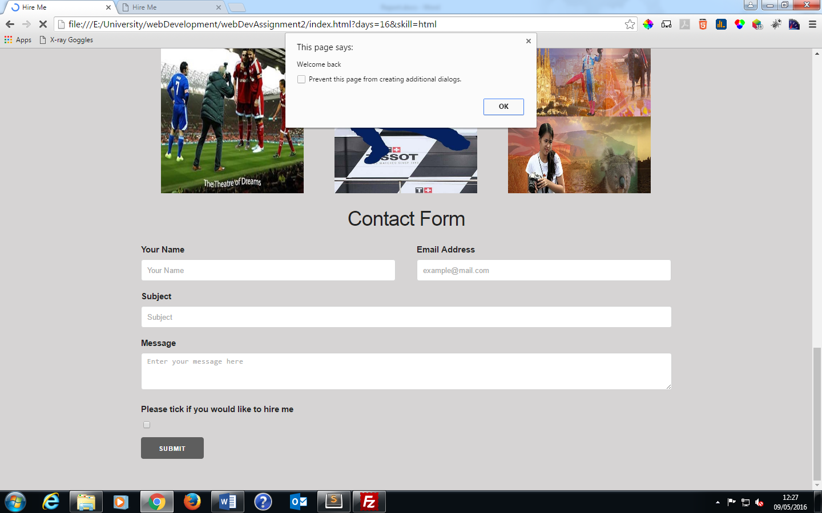

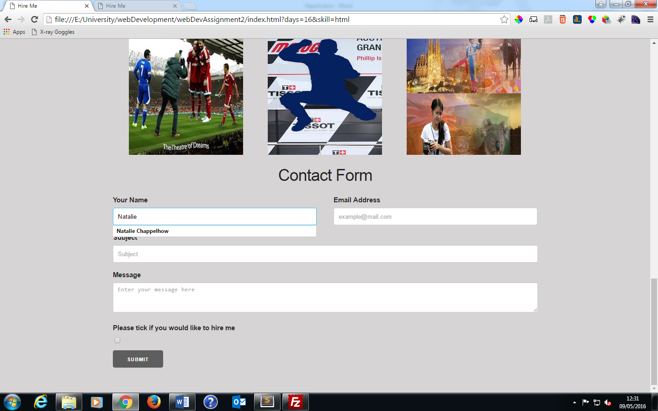

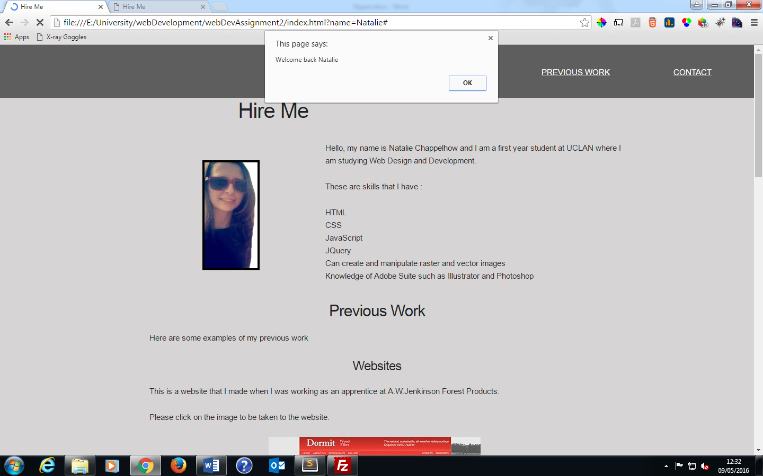

## Show/hide hireForm

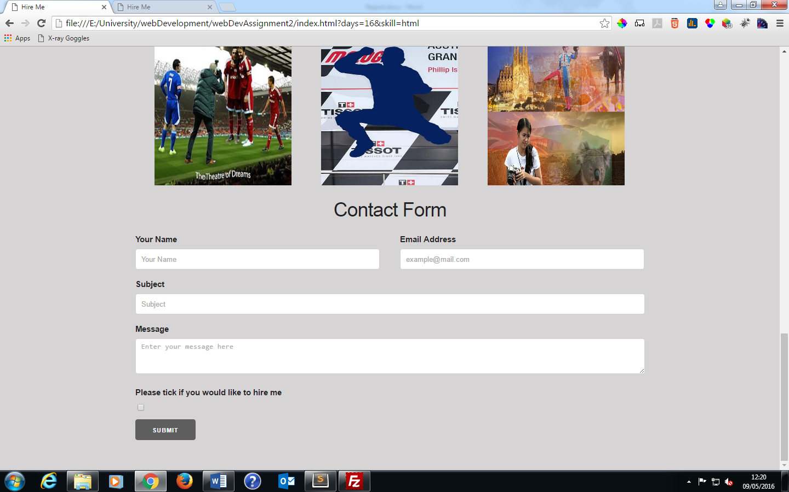

When the webpage is first loaded only the contact form is visible. At the bottom of the contact form there is a tickbox. When the tickbox is ticked, the hire form appears on the screen. The tickbox can also be unticked and the hire form will be hidden again.

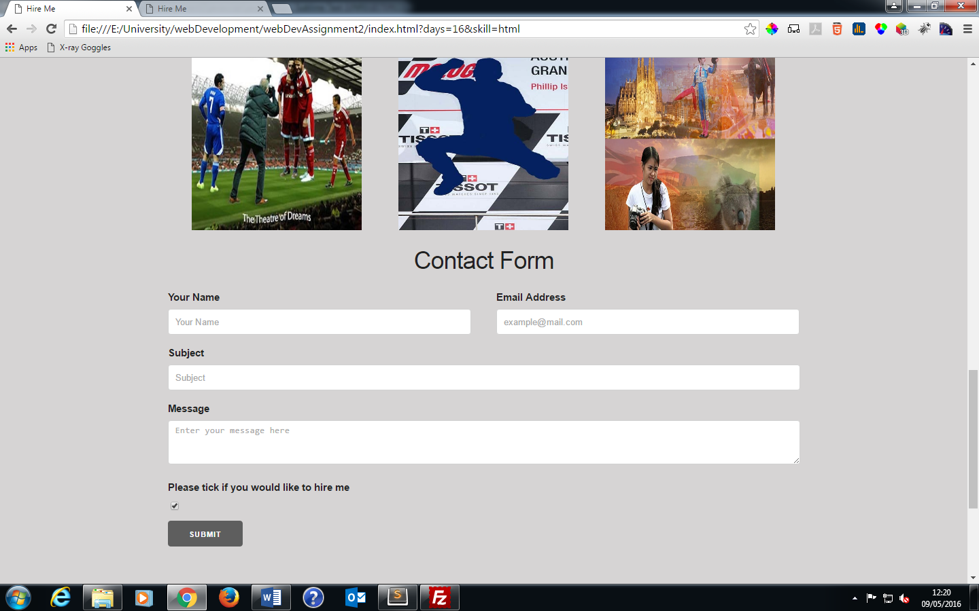

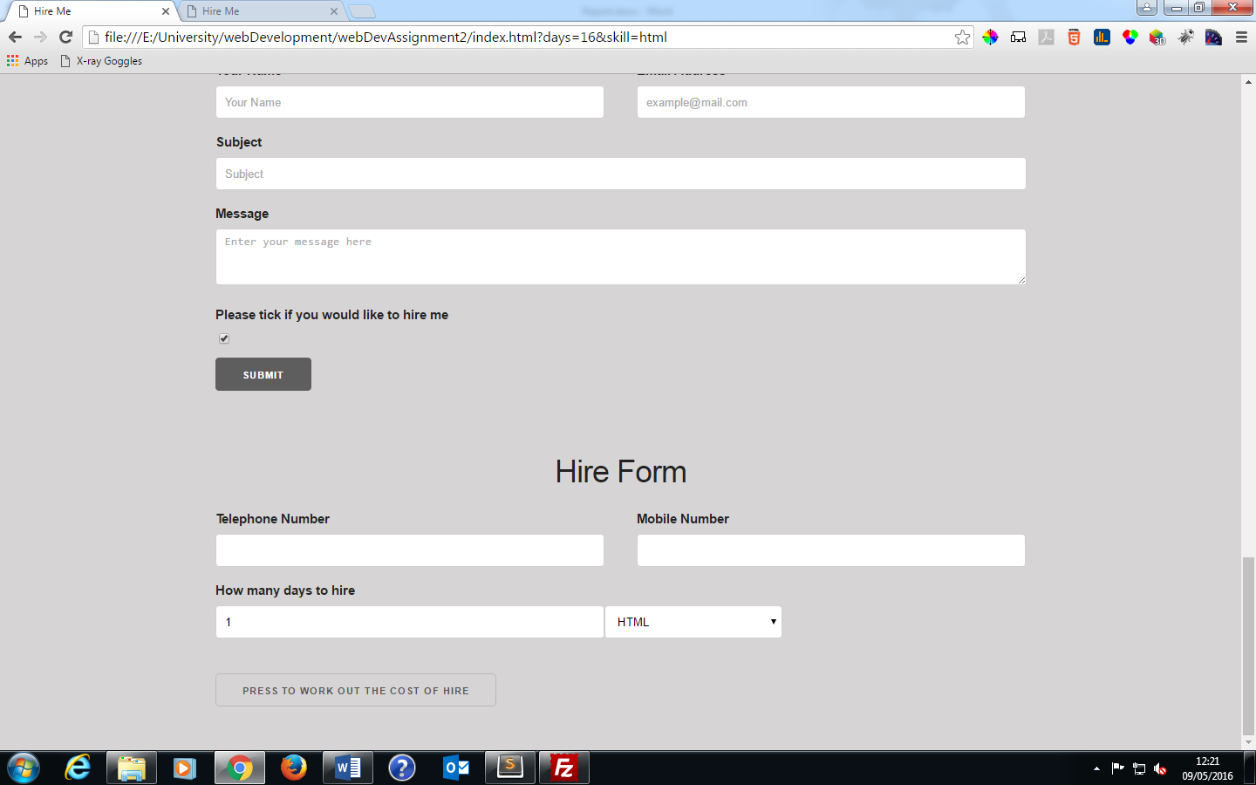

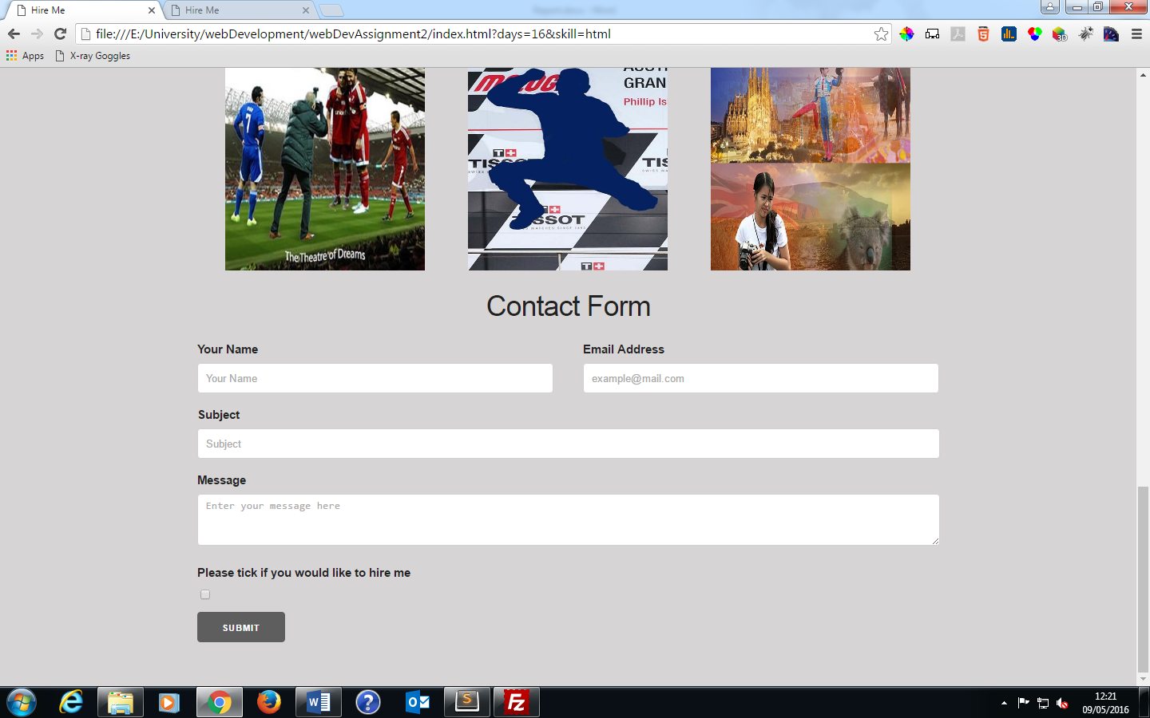

## Flowchart

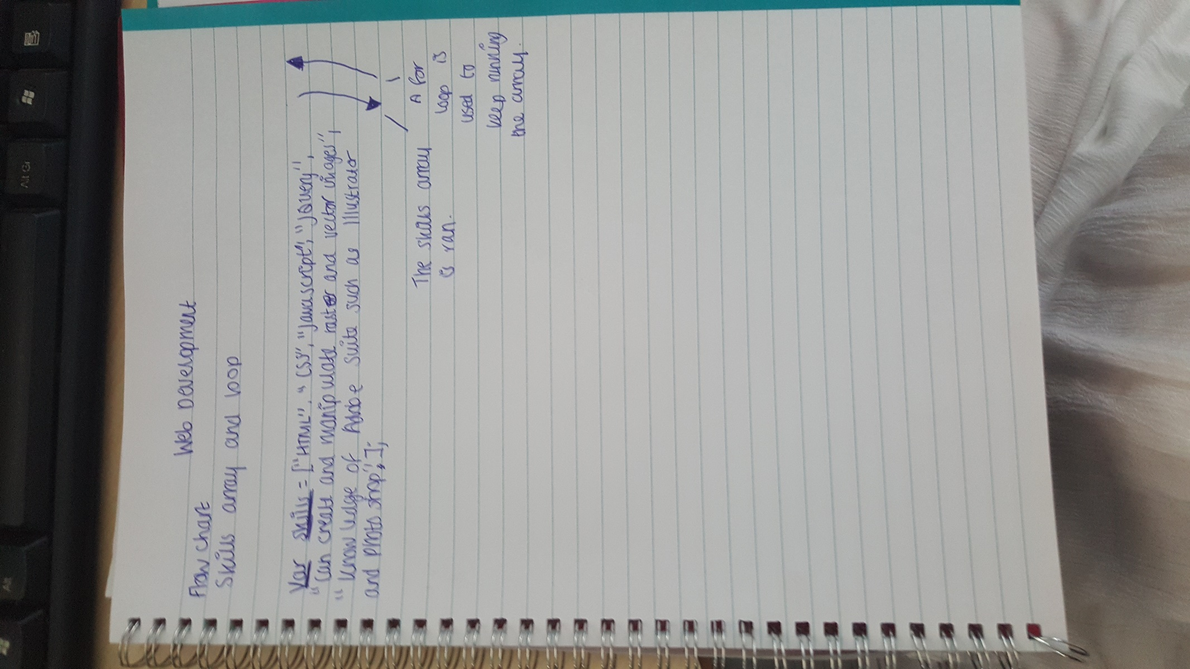

## Evaluation

My website that I made included everything from the assignment brief. I have created a skills array to list my skills so the user knows what skills I have and then can hire me for the appropriate job. I have included some examples of previous work. As my skills that I listed also included manipulation of vector and raster images I included some of my graphics work alongside a link to my first web development work and a link to a website that I had made for a previous employer. I have created a contact form and a hire form. The contact form appears on the screen when the page is loaded but the hire form is hidden. The hire form appears once a tickbox has been checked. I tried using a variety of methods to get the tickbox when ticked to get the hire form to appear. One of these methods I used was adding an onchange event listener which did not work. I tried to combine this with using the CSS rule of making the hire form hidden (.hireForm {visability:hidden}) but this also did not work. I then decided to use toggle so the tickbox can hide and show the form interchangeably when ticked or unticked. At first this did not work as I wanted it to because the form would disappear when the tickbox was unticked. I then decided to try a different CSS rule on the hire form (.hireForm{display:none}). This then worked correctly. In the hire form, the cost of hire per day is calculated and then displayed. With the calculation there is a small problem in that when you click on the button to do the calculation it displays the cost for a couple of seconds then it takes you back to the top of the webpage.

In the end I managed to get all of the elements working. Some of the JavaScript code would start working and then it wouldn’t. For example, I used local storage for the browser to capture the name of the user who enters it into the contactForm. If they refreshed the page then a pop up appears saying welcome back plus their name that was entered. I resolved this issue of the local storage not working by changing the event listener on the form validation I had on the field. On the name field was where the local storage and a validation rule was. At first I used an onclick on the submit button so when the form would submit then the validation rule would check the input field. I then changed this so that the validation rule was applied to the field rather than the submit button and the onclick was changed to onblur so that the validation rule is executed when the user moves from that field. This solved the issue and the local storage now works.

I used jquery to create a document.ready function so that all of the JavaScript code would run the code after the HTML code/ elements. I then used best practice by putting the reference for the external JavaScript file in the head section. However, this would not work and only worked if I moved the reference to the end of my HTML code in the body section and removed the document.ready function.

When doing my array I wanted the items of the array to be displayed in a list. However when I put the array output into a list item it did not work because the first item in the array was not displaying how I wanted it to. Due to this, I used a break tag.

Overall, I think the JavaScript that I used and the website that I created to show the JavaScript was successful because it worked how I wanted it to and it fulfils all of the criteria of the assignment brief.