Natalie’s Work For The Week: **Project Idea:** We will be creating multiple data visualizations overlaid on a map of the United States depicting the impact of climate change over certain regions (wild fires, temperature change, flooding, etc.) Possible datasets:https://data.world/data-society/global-climate-change-data

https://www.climate.gov/maps-data/dataset/global-temperature-anomalies-graphing-tool https://www.kaggle.com/morgans/climate-change-data

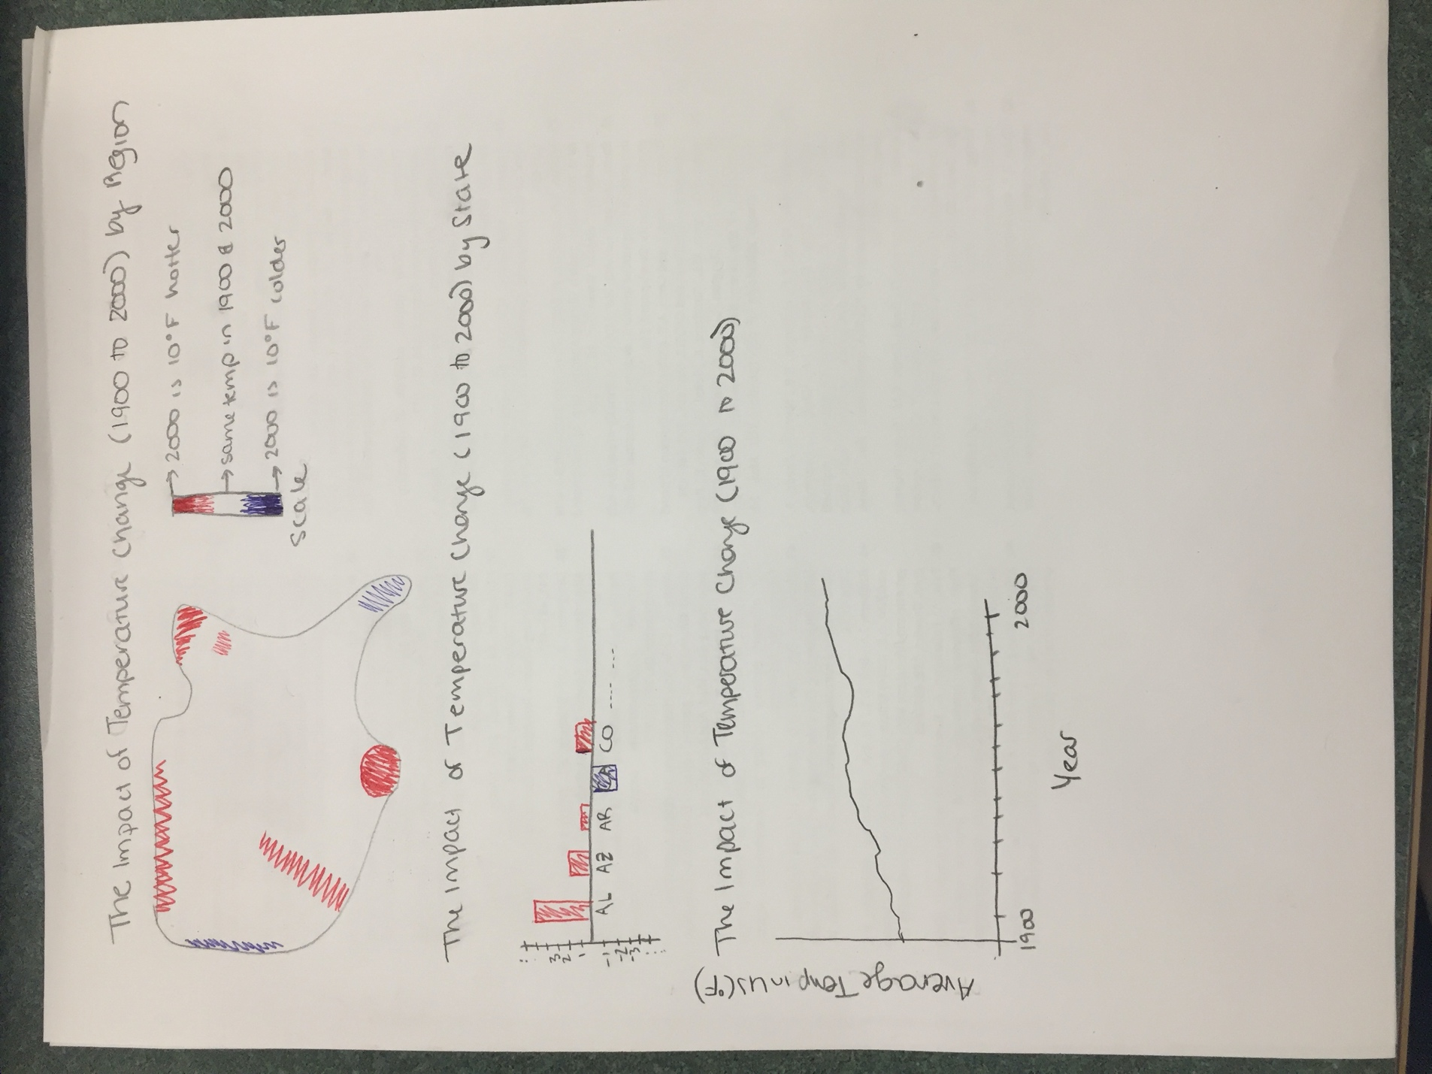

2/21 Xu’s work:

I found some interesting datasets that I think might be useful:

1. US Drought Data(2000-2018)

<https://www.kaggle.com/pavansanagapati/usdroughtdata>

This dataset has local reports from more than 350 expert observers around the country and it has five key drought indicators.

Someone has made a cool graph by tableau

My idea is we could do the same thing but display drought trends in different years.

2.NYS Green Gas Emissions from Fuel Combustion

<https://www.kaggle.com/new-york-state/nys-greenhouse-gas-emissions-from-fuel-combustion>

This dataset has data of CO2 emission and all kinds of fossil fuels consumption in NYS during 2010-2016

<https://data.ny.gov/>

This official webpage provides all kinds of data.

3. International Greenhouse Gas Emissions (1990-2017)

The Greenhouse Gas (GHG) Inventory Data contains the most recently submitted information, covering the period from 1990 to the latest available year, to the extent the data have been provided.

<https://www.kaggle.com/unitednations/international-greenhouse-gas-emissions>

Maybe it can help us to compare greenhouse gas emissions of different countries.

4. Climate Change : Earth Surface Temperature Data

<https://www.kaggle.com/berkeleyearth/climate-change-earth-surface-temperature-data#GlobalLandTemperaturesByCountry.csv>

This is a quite big datasets and it has Global Average Land Temperature by Country, Global Average Land Temperature by State (world), Global Land Temperatures By Major City, Global Land Temperatures By City. It’s data even starts from the eighteenth century.

5. Global Temperatures

<https://www.kaggle.com/schedutron/global-temperatures>

This dataset has data of mainly land temperature and average temperature of land and ocean.

It’s starts from 1800s.

The last 3 datasets are quite comprehensive, I think we could make 2~3 plots. One is the climate changes in America and one is that in the world. We draw these two plots on the real map. The third plot could be bar chart showing global warming trend in the world or comparing greenhouse gas emissions of different countries.

Or, we could just focus on America and NYS.

We could refer to projects in <https://observablehq.com/collection/@d3/d3-geo> to create our map plots.

Lily MacCormick-- Project 1 Milestone 2

Final project dataset ideas

1. Sea level rise data (can choose which coastal states to get data from)
   1. <https://coast.noaa.gov/slrdata/>
2. Daily weather records
   1. <https://www.ncdc.noaa.gov/cdo-web/datatools/records>
3. Trends in atmospheric carbon dioxide
   1. <https://datahub.io/core/co2-ppm>

Design Ideas

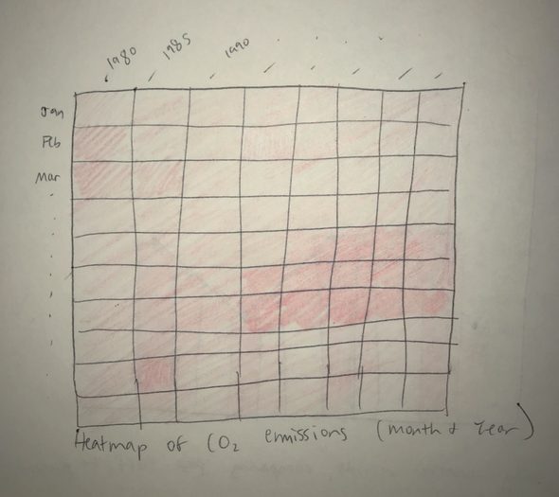

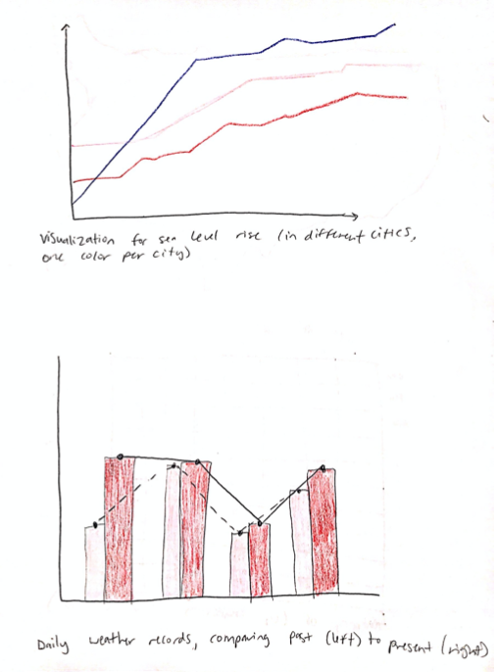Lily’s contributions this week:

* Came up with three new datasets we can potentially use for our visualizations.
* Drew three visualization design ideas.

**Tasks for Next Week**

Lily

* Choose (finalize) datasets
* Make a “rough draft” of the visualization in code

Xu

* Choose (finalize) datasets
* Make a “rough draft” of the visualization in code

Natalie

* Choose (finalize) datasets
* Make a “rough draft” of the visualization in code

All of us:

* Meet with TA