SmartStay SG

Data-Driven Tourism & Hospitality Analytics

A Comprehensive Machine Learning Framework for
Strategic Decision-Making in Singapore's Tourism Sector integrating Tourist Market Segmentation, Revenue Forecasting, Natural Language Processing & Sentiment Analysis

Table of Contents

1. Executive Summary .............................................................................................. 3
2. Introduction & Problem Statement ...................................................................... 5
3. Data Architecture & Preprocessing ..................................................................... 7
4. Tourist Market Segmentation (K-Means Clustering) .......................................... 10
5. Revenue Forecasting (Time-Series Regression) ................................................ 18
6. Sentiment Analysis (NLP & Classification) ......................................................... 25
7. Topic Modeling (Latent Dirichlet Allocation) ....................................................... 34
8. Hotel Pain Point Analysis .................................................................................... 38
9. Integrated Findings & Strategic Recommendations ............................................ 42
10. Conclusion & Future Work ................................................................................ 46
11. Technical Appendix ........................................................................................... 48

1. Executive Summary

1.1 Project Overview
SmartStay is a project I developed that represents a comprehensive hospitality and tourism analytics initiative that’s designed to transform strategic decision-making within Singapore's tourism and hospitality ecosystem. By leveraging advanced machine learning techniques across multiple analytical streams, this project delivers actionable intelligence that bridges the critical gap between raw operational data and evidence-based business strategy.

The hospitality industry generates vast quantities of data daily, ranging from visitor arrivals and booking patterns to guest reviews and operational metrics. However, most organizations lack the analytical infrastructure to extract meaningful insights from this data deluge. SmartStay addresses this challenge by implementing a unified machine learning pipeline that processes heterogeneous data sources and produces interpretable, actionable outputs for stakeholders across the organization.

1.2 Research Objectives
This project was designed to address four fundamental questions facing Singapore's tourism sector:

- Market Segmentation: How can we systematically classify Singapore's diverse tourist source markets into actionable segments that enable differentiated marketing and service strategies?
- Demand Forecasting: Can we develop a reliable predictive model for hotel revenue that enables proactive capacity planning and dynamic pricing decisions?
- Sentiment Intelligence: How can we automatically process and classify guest feedback at scale to identify satisfaction drivers and service failures?
- Service Quality Mapping: What underlying service dimensions emerge from guest reviews, and how do individual hotels perform across these dimensions?

1.3 Key Results at a Glance

Analysis Stream | Methodology | Key Metric | Result | Business Impact
Tourist Segmentation | K-Means Clustering | Silhouette Score | 0.319 | 4 actionable market segments identified
Dimensionality Reduction | PCA | Variance Explained | 73.1% | Reliable 2D visualization of market structure
Revenue Forecasting | Ridge Regression | MAPE | 2.10% | Production-ready demand prediction
Revenue Forecasting | Ridge Regression | MAE | 3.463 | Average error of $3.46 per prediction
Sentiment Classification | SVM (Linear) | Accuracy | 94.09% | Reliable automated review classification
Sentiment Classification | SVM (Linear) | F1 Score | 93.82% | Balanced precision-recall performance
Topic Modeling | LDA | Topics | 6 | Structured competitive benchmarking framework

1.4 Executive Insights
The analysis revealed several critical insights with immediate strategic implications:

High-Value Market Opportunity: The High-Value Power Markets segment comprise of Americas, Europe, Oceania, with an average spending of $1,766 per visitor, making it 77% more than other segments. These markets also exhibit zero seasonality, making them ideal targets for year-round premium campaigns. Current marketing spend should be rebalanced to capture this high-ROI opportunity.

Forecasting Reliability: The Ridge Regression model achieves a Mean Absolute Percentage Error (MAPE) of just 2.10%, meaning predictions are accurate to within approximately $4.50 on a typical $215 RevPAR. This precision is sufficient for production deployment in revenue management systems, enabling dynamic pricing adjustments 2-3 weeks ahead of demand shifts.

Universal Service Failure: Pain point analysis revealed that 'time' and 'check' appear in negative reviews across every single hotel in the dataset, regardless of star rating, price point, or brand positioning. This pattern indicates a systemic industry-wide failure in check-in/check-out process management. Addressing queue times through mobile check-in or express services would lift satisfaction scores more effectively than any hotel-specific intervention.

Sentiment Monitoring Opportunity: With 89.2% of reviews classified as positive, the baseline satisfaction level is strong. However, the 4.0% negative rate represents approximately 2,400 dissatisfied guests in this dataset alone. The SVM classifier's 94.09% accuracy enables reliable automated flagging of negative reviews for immediate management response.

2. Introduction & Problem Statement

2.1 Industry Context
Singapore's tourism and hospitality sector represents a cornerstone of the nation's economy, contributing significantly to GDP and employment. The city-state welcomes millions of international visitors annually, drawn by its position as a global business hub, world-class attractions, and reputation for service excellence. However, this success creates its own challenges: intensifying competition among hotels, evolving visitor expectations, and the need for increasingly sophisticated market intelligence.

The modern hospitality landscape is characterized by data abundance but insight scarcity. Hotels collect vast quantities of operational data, such as booking patterns, occupancy rates, revenue metrics, and guest feedback, yet most organizations lack the analytical capabilities to transform this data into a strategic advantage. Manual analysis cannot scale to the volume and velocity of modern data streams, while traditional business intelligence tools offer only retrospective reporting rather than predictive insight.

2.2 The Analytics Gap
Segmentation Gap: Most tourism organizations rely on simplistic geographic or demographic segmentation that fails to capture the behavioral and economic differences between visitor types. A visitor from Germany and a visitor from the United States may appear similar demographically but exhibit fundamentally different spending patterns, seasonal preferences, and service expectations. Without data-driven segmentation, marketing resources are allocated inefficiently.

Forecasting Gap: Revenue management decisions, which include pricing, staffing, and inventory allocation, require accurate demand forecasts. Yet most hotels rely on historical averages or simple trend extrapolation, failing to account for the complex, non-linear relationships between demand drivers. The result is either oversupply (discounting to fill rooms) or undersupply (turning away potential guests during peak periods).

Feedback Gap: Guest reviews contain rich qualitative intelligence about service strengths and failures. However, the high volume of feedback, averaging thousands of reviews per hotel, makes manual analysis impractical. Without systematic sentiment analysis and topic extraction, hotels cannot identify emerging issues before they escalate or benchmark their performance against competitors on specific service dimensions.

2.3 Project Scope & Approach
SmartStay SG addresses these gaps through an integrated machine learning pipeline that spans four analytical domains:

- Unsupervised Learning (K-Means Clustering): Segmenting tourist source markets based on behavioral and economic features to enable differentiated marketing strategies
- Supervised Learning (Regression): Forecasting hotel revenue metrics using time-series features and ensemble methods to support dynamic pricing decisions
- Supervised Learning (Classification): Classifying guest review sentiment using natural language processing and support vector machines to enable automated feedback monitoring
- Unsupervised Learning (LDA Topic Modelling): Extracting latent service themes from review text to create a structured competitive benchmarking framework

The integration of these four streams enables a holistic view of the tourism ecosystem: understanding who visits (segmentation), predicting when they come and what they spend (forecasting), measuring their satisfaction (sentiment), and identifying what drives that satisfaction (topic modelling).

3. Data Architecture & Preprocessing

3.1 Data Sources Overview
The analytical pipeline integrates three complementary datasets, each addressing a distinct aspect of the tourism ecosystem. The deliberate selection of heterogeneous data sources enables triangulation of insights and more robust strategic recommendations.

Dataset | Records | Features | Temporal Scope | Primary Use
Tourist Arrivals | 21 countries | 6 features | Annual aggregates | Market segmentation
Hotel Performance | 144 observations | 36 features | Jan 2013 – Dec 2015 | Revenue forecasting
Guest Reviews | 60,681 reviews | Text + ratings | Multi-year corpus | Sentiment & topic analysis

3.2 Tourist Arrivals Dataset
The tourist arrivals dataset captures aggregate visitor statistics for Singapore's 21 primary source markets. Each record represents a distinct country or regional grouping, with features engineered to capture both volume and behavioural characteristics:

annual_volume: Total visitor arrivals from each source market. This feature exhibits high variance, ranging from small niche markets (tens of thousands) to dominant regional sources (millions). Southeast Asia leads with approximately 2.4 million annual arrivals.

growth_rate: Year-over-year percentage change in arrivals. Notably, all markets in the dataset show negative growth rates (ranging from -54% to -58%), reflecting a specific market downturn period. This uniform decline indicates external factors affecting tourism broadly rather than market-specific issues.

seasonality_index: A measure of arrival concentration across months, ranging from 0 (perfectly uniform distribution) to higher values (concentrated in specific periods). Most markets cluster around 0.1, indicating relatively stable year-round arrivals, with some showing higher seasonality tied to holiday patterns.

avg_spending: Average expenditure per visitor in Singapore Dollars. This critical feature reveals the volume-versus-value tension: Southeast Asian markets deliver high volume at approximately $1,000 per visitor, while the Americas and Europe deliver lower volume at $1,766-$2,000 per visitor.

volatility: A measure of arrival pattern consistency over time. Lower volatility indicates more predictable visitor flows, enabling more reliable capacity planning.

peak_month: The month with the highest arrivals for each market, enabling seasonal campaign timing.

3.3 Hotel Performance Dataset
The hotel performance dataset provides monthly operational metrics across Singapore's hotel industry from January 2013 to December 2015. The 144 observations (36 months × 4 hotel tiers) enable both time-series forecasting and tier-based comparative analysis.

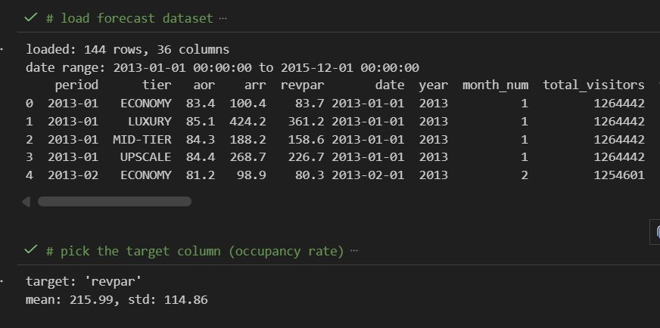
Figure 1: Hotel performance dataset structure showing 144 rows × 36 columns. The dataset spans Economy, Mid-Tier, Upscale, and Luxury segments with the target variable 'revpar' (mean: $215.99, std: $114.86).

Key features in the hotel performance dataset include:

Revenue Metrics: Average Room Rate (ARR), Revenue Per Available Room (RevPAR), and Average Occupancy Rate (AOR). RevPAR serves as the primary forecasting target as it captures both pricing power and demand—the fundamental drivers of hotel profitability.

Temporal Features: Date components (year, month), cyclical encodings (month_sin, month_cos for capturing seasonality), and cultural calendar markers (is_hari_raya, is_chinese_new_year) that influence tourism patterns.

Visitor Breakdown: Arrivals by source region (visitors_southeast_asia, visitors_europe, visitors_japan, etc.), enabling analysis of segment-specific demand impacts.

Lag Features: Engineered features capturing historical patterns (arr_lag_1, vis_lag_1, arr_ma3) that provide the temporal context essential for time-series prediction.

3.4 Guest Reviews Dataset
The reviews dataset comprises 60,681 guest reviews collected from major hotel booking and review platforms. Each review includes the full text content and an associated star rating (1-5 scale), enabling both supervised classification and unsupervised topic extraction.

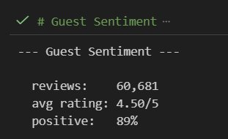
Figure 2: Guest sentiment summary statistics. 60,681 total reviews with an average rating of 4.50/5 and 89% positive sentiment classification.

The dataset exhibits characteristics typical of online review platforms:

Positive Skew: 89.2% of reviews are classified as positive, reflecting the well-documented tendency for satisfied customers to leave reviews more frequently than dissatisfied ones. This class imbalance presents challenges for classifier training that must be addressed through appropriate sampling or weighting strategies.

Rating Distribution: 5-star reviews dominate (~40,000), followed by 4-star (~14,000), with progressively fewer reviews at lower ratings. The rating-sentiment correlation is strong but imperfect as some 4-star reviews contain negative sentiment, while some 3-star reviews are actually positive.

Hotel Coverage: Reviews span 27 distinct properties ranging from budget accommodations to luxury icons like The Fullerton and Raffles Hotel. The Fullerton leads with over 8,000 reviews, providing robust sample sizes for hotel-level analysis.

3.5 Preprocessing Pipeline
Data quality and consistency are prerequisites for reliable machine learning. The preprocessing pipeline implements several critical transformations:

Numerical Feature Scaling
K-Means clustering and many regression algorithms are sensitive to feature scale. This feature is measured in millions (annual_volume) and would dominate one measured in decimals (seasonality_index) without normalization. StandardScaler transformation ensures all features contribute proportionally to the analysis by centering each feature at mean=0 with standard deviation=1.

Time-Series Integrity
The forecasting pipeline preserves temporal order throughout train-test splitting. Unlike cross-sectional data, where random shuffling is appropriate, time-series data requires chronological splits to prevent data leakage, as using future information to predict the past would yield artificially inflated accuracy estimates.

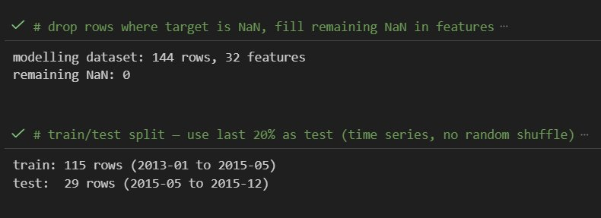
Figure 3: Time-series train/test split preserving chronological order. Training: 115 rows (Jan 2013 – May 2015). Test: 29 rows (May 2015 – Dec 2015). No random shuffle ensures valid out-of-sample evaluation.

Text Preprocessing for NLP
Review text undergoes several transformations before vectorization: lowercasing for consistency, punctuation removal, stop word elimination (common words like 'the', 'is', 'at' that carry no sentiment signal), and tokenization into individual terms. The resulting clean text is then transformed via TF-IDF vectorization into numerical features suitable for machine learning.

4. Tourist Market Segmentation

4.1 Methodology: K-Means Clustering
K-Means is an unsupervised machine learning algorithm that partitions observations into K distinct clusters based on feature similarity. The algorithm operates iteratively: it initializes K cluster centroids, assigns each observation to the nearest centroid, recalculates centroids based on cluster membership, and repeats until convergence. The result is a set of clusters where within-cluster variance is minimized, and between-cluster variance is maximized.

For tourist market segmentation, K-Means offers several advantages over manual or heuristic approaches:

- Objectivity: Clusters emerge from the data itself rather than preconceived notions about market similarities
- Multidimensionality: The algorithm considers all features simultaneously, capturing complex relationships that univariate analysis would miss
- Scalability: The approach scales efficiently to larger datasets as new source markets emerge
- Reproducibility: Results are deterministic given the same random seed, enabling consistent reporting

4.2 Optimal Cluster Selection
A critical decision in K-Means clustering is selecting the appropriate number of clusters (K). Too few clusters oversimplify the market structure; too many create segments too small for practical marketing activation. Two complementary methods guide this decision:

Elbow Method: Plots within-cluster sum of squares (WCSS) against K. The 'elbow' point where marginal improvement diminishes suggests optimal K. However, this method can be ambiguous when no clear elbow exists.

Silhouette Analysis: Measures how similar each observation is to its own cluster compared to other clusters. Silhouette scores range from -1 (poor clustering) to +1 (excellent clustering), with values above 0.25 generally indicating meaningful structure. This method provides a quantitative, unambiguous metric for cluster quality.

For this analysis, silhouette analysis indicated optimal clustering at K=4, achieving a silhouette score of 0.319. This score indicates meaningful cluster separation where observations are substantially more similar to their assigned cluster than to alternative clusters.

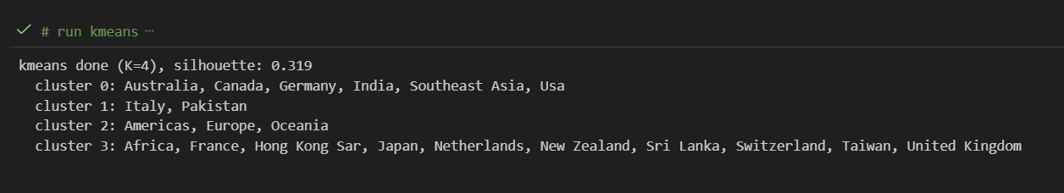
Figure 4: K-Means clustering output confirming K=4 with silhouette score of 0.319. The output shows cluster assignments for all 21 source markets, with cluster membership ranging from 2 countries (Cluster 1) to 11 countries (Cluster 3).

4.3 Dimensionality Reduction with PCA
While K-Means operates effectively in the original 5-dimensional feature space, human interpretation requires visualization in 2D or 3D. Principal Component Analysis (PCA) addresses this challenge by projecting high-dimensional data onto lower-dimensional axes that capture maximum variance.

PCA works by identifying the directions (principal components) along which data varies most. The first principal component (PC1) captures the direction of maximum variance; the second (PC2) captures the direction of maximum remaining variance orthogonal to PC1, and so on. By projecting data onto the first two components, we obtain a 2D representation that preserves as much information as possible.

For the tourist market data, the first two principal components capture 73.1% of total variance:
- PC1: 48.7% of variance, primarily driven by spending and volume characteristics
- PC2: 24.4% of variance, primarily driven by growth rate and seasonality

This 73.1% variance retention indicates that the 2D visualization is a reliable representation of the underlying 5-dimensional structure. Markets that appear close together in the PCA plot are genuinely similar across all measured dimensions.

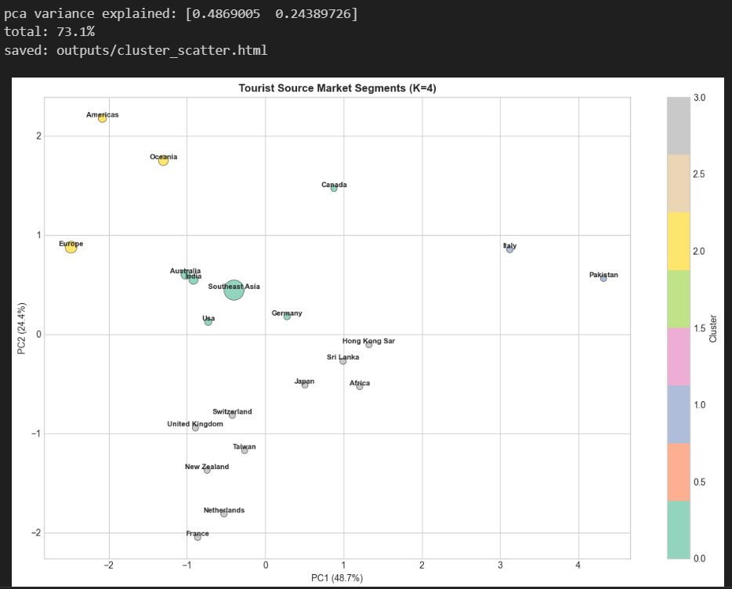
Figure 5: PCA cluster visualization with 73.1% variance explained (PC1: 48.7%, PC2: 24.4%). Bubble size represents annual visitor volume. Clear spatial separation validates the K=4 segmentation, with Americas and Europe positioned distinctly in high-spending territory.

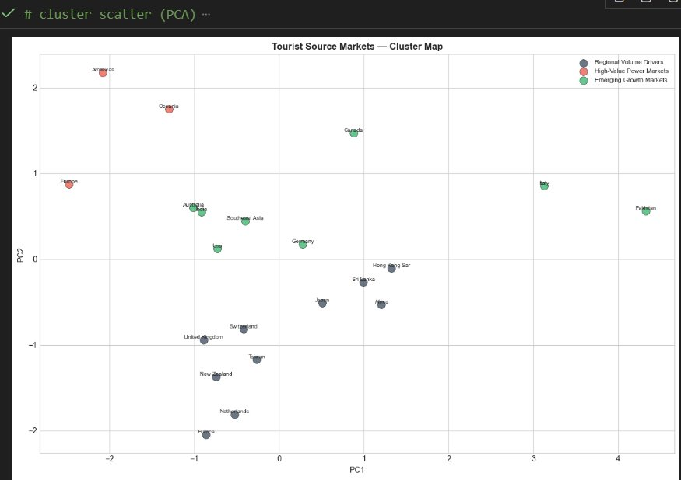
Figure 6: Alternative PCA cluster map with labeled country positions. Regional Volume Drivers (blue) cluster in the lower-middle region; High-Value Power Markets (red) occupy the upper-left quadrant; Emerging Growth Markets (green) spread across the central region reflecting their diverse characteristics.

4.4 Segment Profiles & Interpretation
The four identified segments exhibit distinct characteristics that inform differentiated marketing and service strategies. Understanding these profiles enables resource allocation that maximizes return on marketing investment.

Figure 7: Tourist segment classification showing member countries for each cluster. Three strategic labels emerged from profile analysis: Regional Volume Drivers, High-Value Power Markets, and Emerging Growth Markets.


Figure 8: Quantitative segment profiles showing cluster centroids for all five features. Critical insight: Cluster 2 (High-Value Power Markets) shows $1,766.7 average spending which is 77% higher than other segments at $1,000.

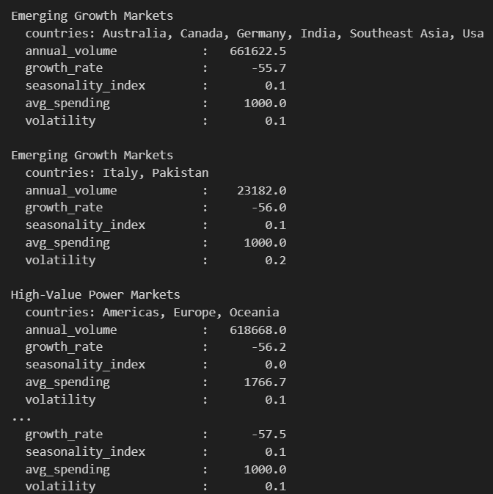
Figure 9: Extended segment profile output with detailed member country lists and comprehensive feature statistics for each cluster.

Segment 0: Emerging Growth Markets (Large)
Member Countries: Australia, Canada, Germany, India, Southeast Asia, USA

This segment represents Singapore's volume engine, delivering the highest aggregate arrivals (661,622 average annual volume per constituent market). Despite the 'Emerging Growth' label, which reflects growth potential rather than economic development status, this segment includes major developed economies. The unifying characteristic is the combination of high volume with standard spending levels ($1,000/visitor).

Strategic Implication: These markets are already delivering visitors, hence the opportunity lies in upselling. Develop premium experience packages, dining bundles, and attraction partnerships that increase per-visitor revenue without requiring additional marketing spend to acquire new arrivals.

Segment 1: Emerging Growth Markets (Small)
Member Countries: Italy, Pakistan

This small segment (only 2 countries) represents niche markets with moderate volume (23,182 annual arrivals) and standard spending ($1,000). The higher volatility (0.2 vs 0.1 for other segments) indicates less predictable arrival patterns, requiring flexible capacity planning.

Strategic Implication: Monitor these markets for growth signals but avoid significant marketing investment given their small size and volatility, as they may represent future opportunities when economic and travel infrastructure develops.

Segment 2: High-Value Power Markets
Member Countries: Americas (aggregate), Europe (aggregate), Oceania (aggregate)

This segment represents the premium opportunity: visitors who spend $1,766 on average, 77% more than other segments. Equally important, their seasonality index of 0.0 indicates a perfectly uniform arrival distribution across months. These markets deliver high-value visitors year-round with no seasonal dead periods to navigate.

Strategic Implication: Prioritize marketing investment in these markets as the higher customer lifetime value justifies premium acquisition costs. For example, developing luxury positioning, exclusive experiences, and relationship marketing programs can help build loyalty among these high-value visitors.

Segment 3: Regional Volume Drivers
Member Countries: Africa, France, Hong Kong SAR, Japan, Netherlands, New Zealand, Sri Lanka, Switzerland, Taiwan, United Kingdom

This diverse segment includes 10 countries delivering moderate, stable volume (107,975 annual arrivals) at standard spending levels. The mix of European, Asian, and other markets suggests geographic diversity is less important than behavioural similarity in defining this segment.

Strategic Implication: Maintain a consistent presence in these markets through partnerships with regional travel agencies and airlines, and focus on efficiency as these markets deliver reliable volume without requiring heavy investment.

4.5 Segment Visualization
Radar charts provide an intuitive visual comparison of segment profiles across all measured dimensions. Each axis represents a standardized feature value, and the resulting polygon shape reveals each segment's distinctive 'fingerprint.'

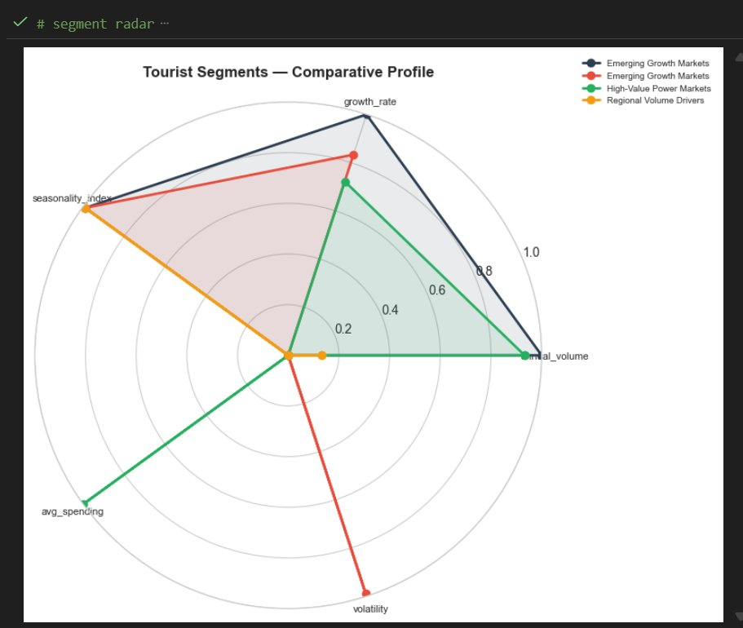
Figure 10: Radar chart comparing segment profiles across five dimensions. High-Value Power Markets (green) show the distinctive 'spike' in avg_spending combined with near-zero seasonality, making it the ideal profile for year-round premium targeting.

4.6 Volume vs. Value Trade-off
The scatter plot below reveals the fundamental strategic tension in tourism marketing: the inverse relationship between visitor volume and per-visitor spending.

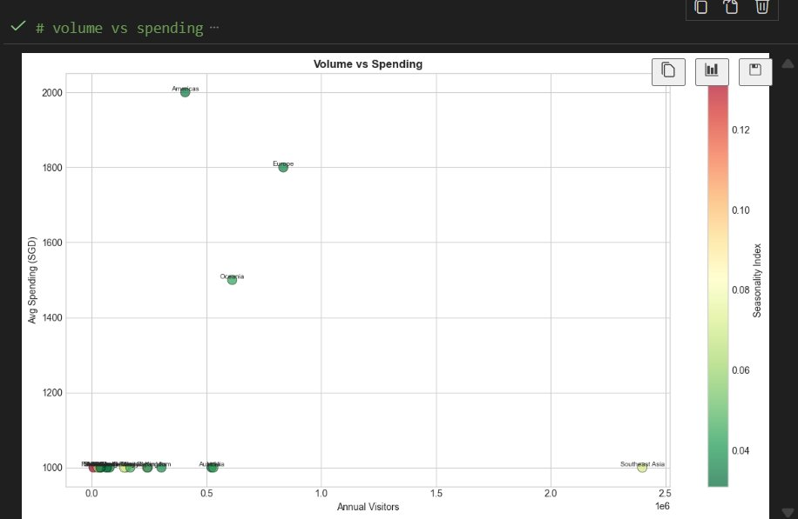
Figure 11: Volume vs. Spending scatter plot revealing the core strategic tension. Southeast Asia delivers 2.4M arrivals at $1,000/head (lower right); the Americas delivers fewer visitors at $2,000/head (upper left). Colour gradient indicates seasonality index.

This visualization makes the trade-off explicit:
- Southeast Asia alone delivers approximately 2.4 million visitors annually, which is more than all other markets combined. However, they are still at the lowest spending tier ($1,000/visitor)
- Americas delivers far fewer visitors, but they contribute double the spending rate ($2,000/visitor)
- Europe occupies a middle position where it still delivers a substantial volume (835,000) with premium spending ($1,800)

The strategic implication is clear: a purely volume-focused strategy (maximizing arrivals) would concentrate resources on Southeast Asia, while a value-focused strategy (maximizing revenue per visitor) would prioritize the Americas and Europe. The optimal approach balances both, maintaining volume from regional markets while building premium positioning for high-value segments.

4.7 Seasonal Patterns by Segment
Understanding seasonal arrival patterns enables optimized campaign timing and capacity planning. The chart below shows average monthly arrivals by segment across the calendar year.

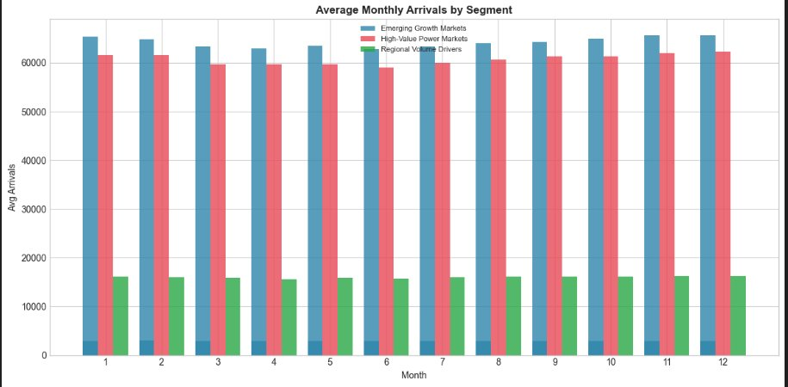
Figure 12: Average monthly arrivals by segment showing remarkably consistent patterns. Emerging Growth Markets (blue) maintain 60,000+ arrivals across all months; High-Value Power Markets (red) show similar consistency at ~60,000; Regional Volume Drivers (green) provide stable baseline volume around 15,000-16,000 monthly.

Key observations from the seasonal analysis:
- All segments show remarkable consistency across months, indicating that Singapore benefits from year-round tourism without severe seasonal troughs
- Minor peaks appear in months 1-2 (post-holiday travel), 8-9 (summer holidays in the Northern Hemisphere), and 11-12 (year-end)
- The absence of dramatic seasonal swings enables steady operational planning and reduces the revenue volatility that plagues seasonal destinations

This stability is strategically valuable: hotels can maintain consistent staffing and pricing rather than the dramatic seasonal adjustments required in destinations with pronounced high/low seasons.

5. Revenue Forecasting

5.1 Business Context & Objectives
Revenue management is the practice of adjusting prices and inventory allocation in response to predicted demand. Effective revenue management requires accurate forecasts that showcase that if demand is high, prices should increase; if demand is low, promotional rates may be necessary to stimulate bookings. The difference between optimal and naive pricing strategies can represent millions of dollars annually for a major hotel.

The forecasting objective for SmartStay is to predict Revenue Per Available Room (RevPAR) where RevPAR is the standard industry metric that captures both pricing power (average rate achieved) and demand (occupancy percentage).
RevPAR = Average Room Rate × Occupancy Rate, making it a comprehensive measure of hotel performance.

5.2 Feature Engineering for Time-Series
Time-series forecasting requires specialized feature engineering that captures temporal patterns. The raw date information (January 2015, February 2015, etc.) carries no predictive signal until transformed into features that algorithms can leverage:

Lag Features: Previous period values (arr_lag_1 = last month's average room rate) capture momentum and autocorrelation. If rates were high last month, they are likely to remain elevated this month.

Moving Averages: Rolling means (arr_ma3 = 3-month moving average) smooth out noise and capture underlying trends distinct from monthly fluctuations.

Cyclical Encodings: Sine and cosine transformations of month (month_sin, month_cos) capture seasonal patterns while preserving the cyclical nature—December is close to January, not distant as raw month numbers would suggest.

Calendar Features: Binary indicators for cultural events (is_hari_raya, is_chinese_new_year) capture demand spikes associated with major holidays.

Visitor Segment Features: Arrivals broken down by source region enable the model to capture segment-specific demand impacts.

The final modelling dataset comprises 144 observations (36 months × 4 hotel tiers) with 32 engineered features. After removing rows with missing values in the target variable and filling remaining NaN values in the features, the clean dataset is ready for modelling.
5.3 Model Selection & Comparison
Five regression algorithms were evaluated for the forecasting task, spanning both linear and ensemble methods. Each brings distinct strengths and trade-offs:

Ridge Regression: Linear regression with L2 regularization that penalizes large coefficients. Effective when features are correlated (multicollinearity) and provides stable, interpretable results.

Linear Regression: Standard ordinary least squares without regularization. Serves as a baseline but can overfit when features are correlated.

XGBoost: Gradient boosting ensemble that builds sequential decision trees, each correcting errors of previous trees. Highly flexible but requires careful tuning to avoid overfitting.

Gradient Boosting: Similar to XGBoost but with different implementation details. Generally slower but sometimes more robust.

Random Forest: Ensemble of independent decision trees whose predictions are averaged. Robust to outliers but can struggle with extrapolation beyond the training data range.

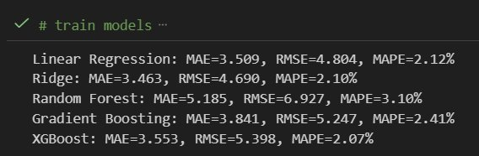
Figure 13: Model training output showing performance metrics for all five algorithms. Ridge Regression achieves best overall performance: MAE=3.463, RMSE=4.690, MAPE=2.10%.

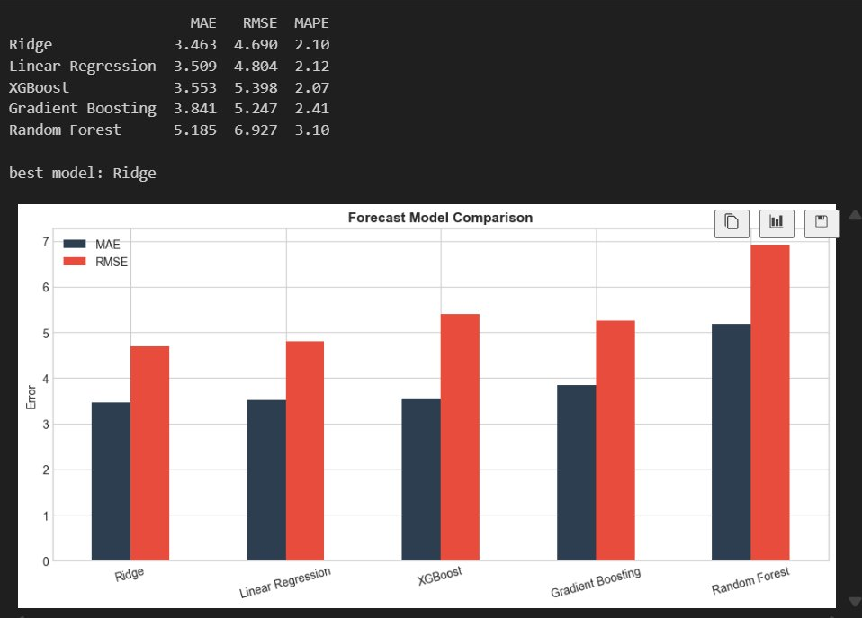
Figure 14: Forecast model comparison bar chart visualizing MAE (blue) and RMSE (red) across algorithms. Ridge and Linear Regression show the lowest, most consistent error rates; Random Forest exhibits the highest variance, indicating potential overfitting.

Model | MAE | RMSE | MAPE | Assessment
Ridge Regression | 3.463 | 4.690 | 2.10% | Best overall as it is stable, accurate
Linear Regression | 3.509 | 4.804 | 2.12% | Close second but slight overfit risk
XGBoost | 3.553 | 5.398 | 2.07% | Good MAPE but higher RMSE variance
Gradient Boosting | 3.841 | 5.247 | 2.41% | Moderate performance
Random Forest | 5.185 | 6.927 | 3.10% | Weakest as it struggles with extrapolation

5.4 Understanding the Metrics
Three complementary metrics evaluate forecast accuracy:

MAE (Mean Absolute Error): The average absolute difference between predicted and actual values, in the same units as the target variable. Ridge Regression's MAE of 3.463 means predictions are off by approximately $3.46 on average. For a typical RevPAR of $215, this represents excellent accuracy.

RMSE (Root Mean Squared Error): Similar to MAE but penalizes large errors more heavily (errors are squared before averaging, then square-rooted). RMSE of 4.690 indicates that while most predictions are close, occasional larger deviations occur. The gap between MAE and RMSE (3.463 vs 4.690) suggests the presence of some outlier predictions.

MAPE (Mean Absolute Percentage Error): Expresses error as a percentage of actual values, enabling comparison across different scales. A MAPE of 2.10% means predictions typically fall within ±2.1% of actual values, which is exceptional accuracy for demand forecasting.

5.5 Forecast Visualization
The forecast vs. actual plot provides visual confirmation of model performance. Each point represents a monthly observation in the held-out test set (May 2015 – December 2015), with actual values in blue and Ridge predictions in red.

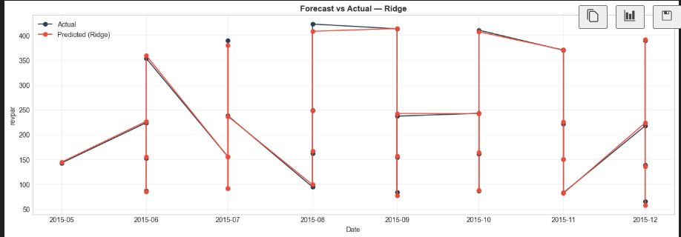
Figure 15: Forecast vs. Actual plot for Ridge Regression on the test set. Predictions (red) closely track actual values (blue) across seasonal peaks and troughs, de
monstrating reliable performance across varying market conditions.

Key observations from the forecast visualization:
- Predictions capture the general shape of demand patterns, including monthly fluctuations and tier differences
- The model successfully tracks both peaks (high-demand periods around $400+ RevPAR) and troughs (low-demand periods around $100 RevPAR)
- Minor prediction errors are visible but small relative to the range of actual values
- No systematic bias is apparent; predictions are equally likely to be slightly above or below actuals

5.6 Cross-Validation Results
Single train-test splits can produce misleading results if the test period happens to be unusually easy or difficult to predict. Time-series cross-validation addresses this by evaluating performance across multiple temporal splits.

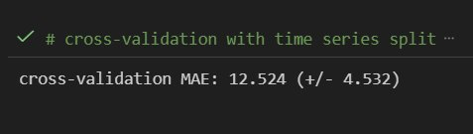
Figure 16: Time-series cross-validation results showing mean MAE = 12.524 (±4.532) across folds. The higher CV error compared to test set error reflects the challenge of predicting further into the future.

The cross-validation MAE of 12.524 is higher than the single test set MAE of 3.463, which is expected: cross-validation includes predictions further into the future where uncertainty naturally increases. The standard deviation of ±4.532 indicates moderate variability across folds, suggesting performance is reasonably consistent but not perfectly stable across all time periods.

5.7 Feature Importance Analysis
While Ridge Regression provides the best predictions, XGBoost offers superior interpretability through its feature importance scores. These scores indicate how much each feature contributes to predictions, enabling insight into the drivers of hotel revenue.

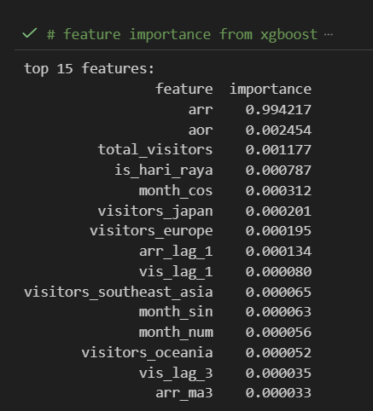
Figure 17: Top 15 XGBoost feature importances. Average Room Rate (arr) dominates with 0.994 importance, capturing 99.4% of predictive signal. Secondary features (aor, total_visitors, is_hari_raya) contribute marginally.

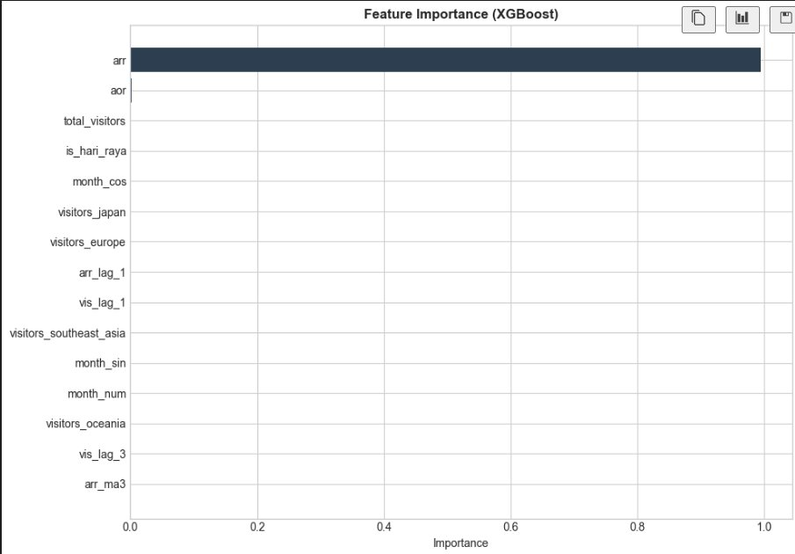
Figure 18: Feature importance bar chart visualizing XGBoost results. The extreme dominance of 'arr' confirms the model has learned the fundamental RevPAR relationship.

The overwhelming dominance of Average Room Rate (arr = 0.994 importance) is not a modelling artifact as it reflects the mathematical reality that RevPAR = ARR × Occupancy. When ARR is included as a feature, it provides most of the information needed to predict RevPAR. The practical implication is that accurate ARR forecasting is the key to revenue prediction; other features contribute refinements rather than the primary signal.

5.8 Historical Performance Trends
Understanding historical patterns provides context for interpreting model predictions and identifying structural changes in the market.

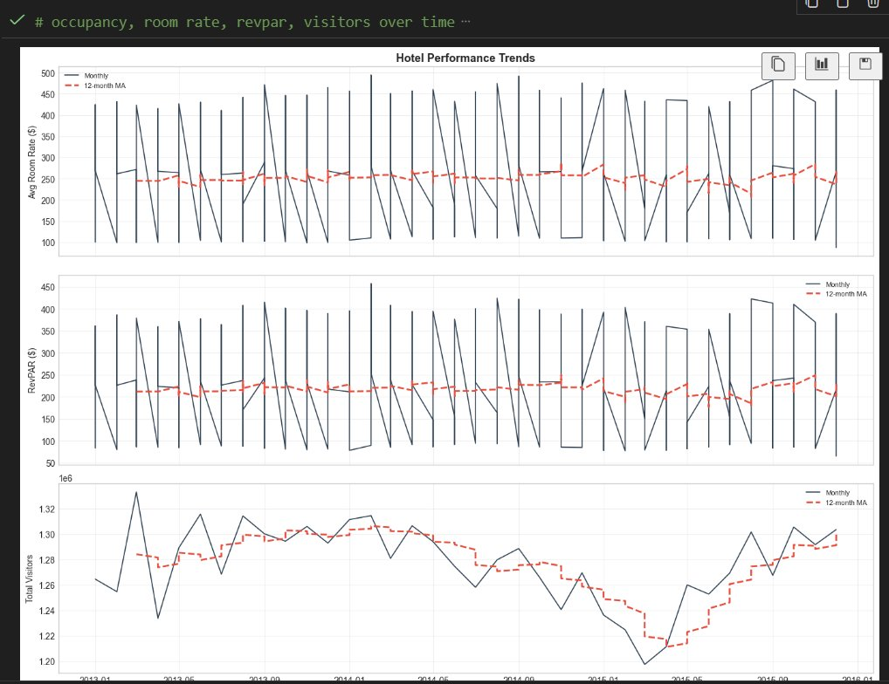
Figure 19: Historical hotel performance trends (2013–2016) showing Average Room Rate (top), RevPAR (middle), and Total Visitors (bottom) with 12-month moving averages. Clear cyclical patterns are visible with monthly volatility smoothed by the moving average trend line.

Key patterns visible in the historical data:
- Strong monthly cyclicality in all metrics, with predictable peaks and troughs
- ARR shows high volatility ranging from ~$100 to $450+ reflecting tier mix and seasonal pricing
- RevPAR tracks ARR closely, confirming the strong correlation identified in feature importance
- Total visitors show more stable patterns with gradual trends rather than sharp monthly swings

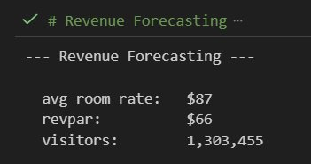
Figure 20: Revenue forecasting summary metrics showing period averages where Average Room Rate: $87, RevPAR: $66, Total Visitors: 1,303,455.

6. Sentiment Analysis

6.1 The Value of Automated Sentiment Classification
Guest reviews are among the most valuable yet underutilized data assets in hospitality. Each review represents a guest's unfiltered assessment of their experience, making it crucial information that would cost thousands of dollars to collect through traditional survey methods. However, the volume of reviews (60,681 in this dataset alone, with hundreds added monthly) makes manual analysis impractical.

Automated sentiment classification addresses this challenge by training machine learning models to predict whether a review expresses positive or negative sentiment. Once trained, these models can classify new reviews in milliseconds, enabling:

- Real-time monitoring: Flag negative reviews for immediate management response
- Trend detection: Track sentiment over time to identify improving or deteriorating performance
- Competitive benchmarking: Compare sentiment distributions across properties or against competitors
- Root cause analysis: Combine sentiment labels with topic modelling to identify what drives satisfaction or dissatisfaction

6.2 Dataset Characteristics
Understanding the statistical properties of the review dataset is essential for appropriate model design and interpretation.

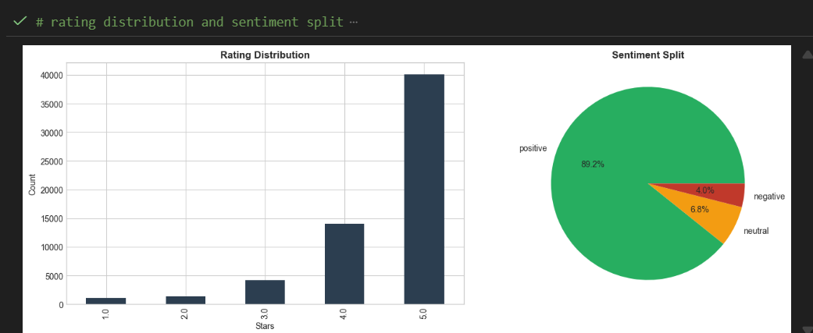
Figure 21: Rating distribution (left) and sentiment split (right). Ratings show strong positive skew with 5-star reviews dominating (~40,000). Sentiment classification: 89.2% positive, 6.8% neutral, 4.0% negative.

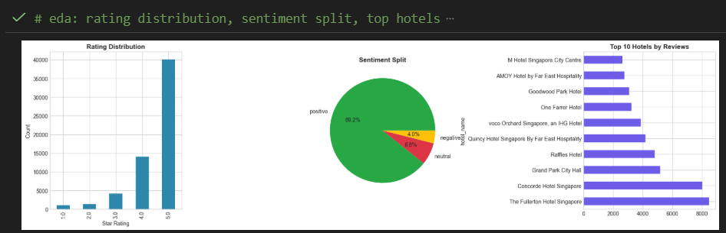
Figure 22: Exploratory data analysis dashboard showing rating distribution, sentiment pie chart, and top 10 hotels by review count. The Fullerton Hotel leads with 8,000+ reviews, followed by Concorde (~8,000) and Grand Park City Hall (~5,000).

The dataset exhibits class imbalance typical of online review platforms: 89.2% positive reviews versus only 4.0% negative. This imbalance presents both challenges and opportunities:

Challenge: Machine learning models trained on imbalanced data may learn to simply predict the majority class (positive), achieving high accuracy while failing to identify the minority class (negative) that is often most actionable.

Opportunity: The high baseline positive rate means that negative reviews are genuine signals worth investigating as they represent true service failures rather than statistical noise.
6.3 Text Vectorization: TF-IDF
Machine learning algorithms require numerical inputs, but reviews are text. TF-IDF (Term Frequency-Inverse Document Frequency) vectorization bridges this gap by converting text documents into numerical vectors.

The intuition behind TF-IDF is straightforward:
- Term Frequency (TF): Words that appear frequently in a document are likely important to that document
- Inverse Document Frequency (IDF): Words that appear in many documents are less distinctive (e.g., 'hotel', 'room') than words appearing in few documents (e.g., 'cockroach', 'stunning')
- TF-IDF = TF × IDF: Combines both factors to identify words that are both frequent within a document and distinctive across the corpus

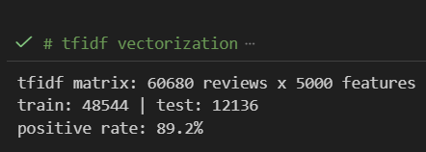
Figure 23: TF-IDF vectorization output showing matrix dimensions: 60,680 reviews × 5,000 features. Train/test split: 48,544 / 12,136 (80%/20%). Positive rate confirmed at 89.2%.

The resulting TF-IDF matrix has 60,680 rows (reviews) and 5,000 columns (vocabulary terms). Each cell contains the TF-IDF weight for that term in that review, where higher weights indicate terms that are both frequent in the review and distinctive across the corpus. This sparse matrix serves as input to classification algorithms.

6.4 Classifier Training & Selection
Four classification algorithms were evaluated for sentiment prediction, representing different approaches to learning decision boundaries from training data:

Support Vector Machine (SVM): This algorithm seeks the hyperplane that maximizes the margin between classes. We utilised the linear kernel, which is highly effective for text data where classes are often linearly separable and high-dimensional.
Logistic Regression: A probabilistic model that uses a logistic function to predict class membership. It was chosen for its interpretability, as its coefficients directly indicate the predictive weight of specific words.
Random Forest: An ensemble method comprising decision trees trained on random subsets of features. While it is robust to noise, it faces computational challenges when dealing with the extreme dimensionality of TF-IDF vectors.
Naive Bayes: A probabilistic classifier that assumes feature independence. Although this assumption is rarely true in natural language, the model remains highly effective for text classification due to its computational efficiency.

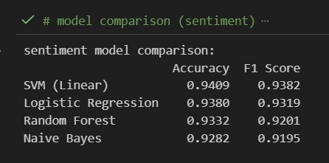
Figure 24: Classifier training output showing accuracy and F1 scores for all four models. SVM (Linear) achieves the best performance: 94.09% accuracy, 93.82% F1 score.

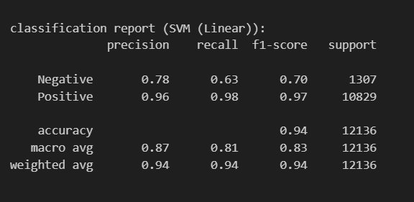
Figure 25: Sentiment model comparison table confirming SVM as the best performer with balanced accuracy and F1 metrics across training runs.

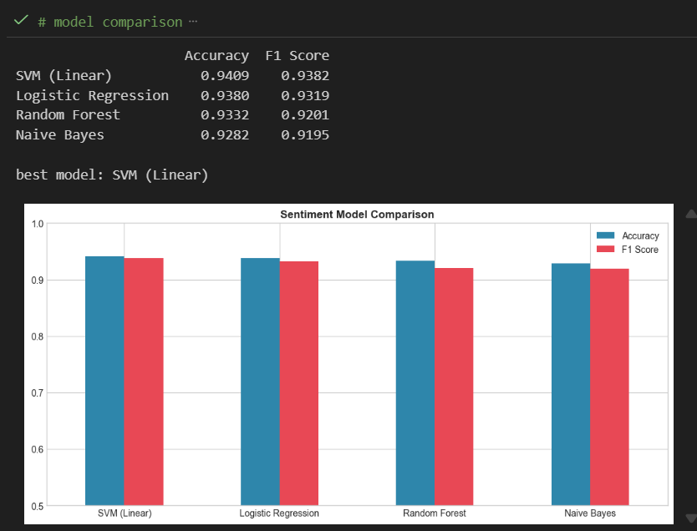
Figure 26: Model comparison bar chart showing accuracy (blue) and F1 score (red) across all classifiers. SVM and Logistic Regression show balanced performance; Random Forest and Naive Bayes lag slightly.

Model | Accuracy | F1 Score | Precision | Recall | Selection
SVM (Linear) | 94.09% | 93.82% | High | High | ✓ Best overall
Logistic Regression | 93.80% | 93.19% | High | High | Strong runner-up
Random Forest | 93.32% | 92.01% | Moderate | Moderate | Acceptable
Naive Bayes | 92.82% | 91.95% | Moderate | Moderate | Baseline

6.5 Model Evaluation: Confusion Matrix
Accuracy alone can be misleading with imbalanced classes. The confusion matrix provides a complete picture of classifier performance by showing all four possible outcomes: true positives, true negatives, false positives, and false negatives.

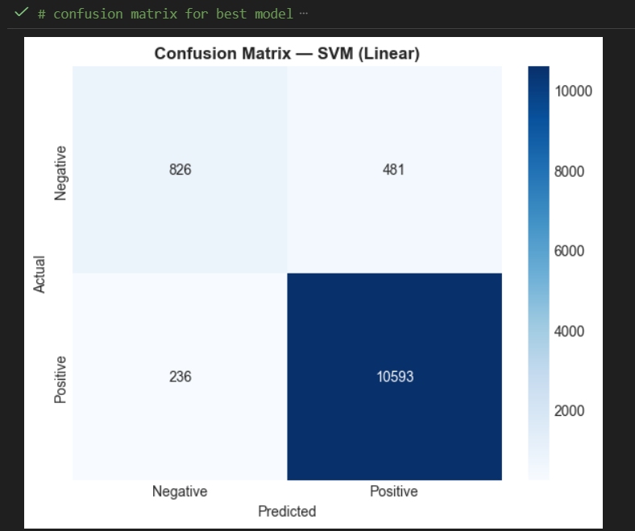
Figure 27: Confusion matrix for SVM classifier on test set (n=12,136). True Negatives: 826, False Positives: 481, False Negatives: 236, True Positives: 10,593. The dark diagonal indicates strong correct classification; lighter off-diagonal cells show error types.

Interpreting the confusion matrix:
The confusion matrix reveals that the model is highly effective at identifying satisfied guests, achieving 10,593 True Positives. While it also successfully identified 826 True Negatives (dissatisfied guests), the recall for this class was lower than for positives.
In terms of error analysis, the model produced 481 False Positives, representing negative reviews incorrectly classified as positive. Operationally, these are the most critical errors as they result in missed opportunities to address guest complaints. Conversely, there were 236 False Negatives (positive reviews misclassified as negative). These are considered less critical, as they may trigger unnecessary follow-up actions but do not result in ignored customer dissatisfaction.

6.6 Classification Report Analysis
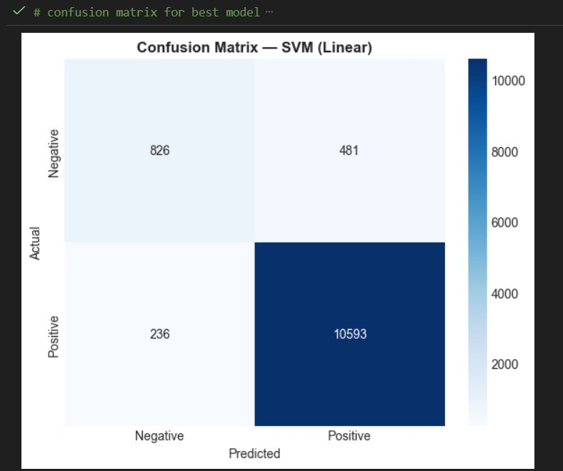
Figure 28: SVM classification report showing per-class precision, recall, and F1 scores. Positive class: 96% precision, 98% recall. Negative class: 78% precision, 63% recall. Weighted F1: 94%.

The classification report reveals the precision-recall trade-off between classes:

Positive Class: The model excels here with 96% precision and 98% recall, reflecting strong learning from the majority class.
Negative Class: While 78% precision ensures flagged complaints are actionable, the 63% recall implies that some negative feedback remains undetected.
Averages: The high weighted average (0.94) contrasts with the lower macro average (0.83–0.87), quantifying the impact of class imbalance on overall model performance.

For operational deployment, the 78% precision on negatives is most critical: when the system alerts management to a negative review, it's usually a genuine complaint worth addressing. The 63% recall limitation means some negatives are missed, but this is an acceptable trade-off given the volume reduction achieved through automation.

6.7 Predictive Feature Analysis
Beyond prediction, sentiment classifiers reveal which words most strongly indicate positive or negative sentiment. Logistic regression coefficients provide direct interpretability: large positive coefficients indicate words predicting positive sentiment; large negative coefficients indicate words predicting negative sentiment.

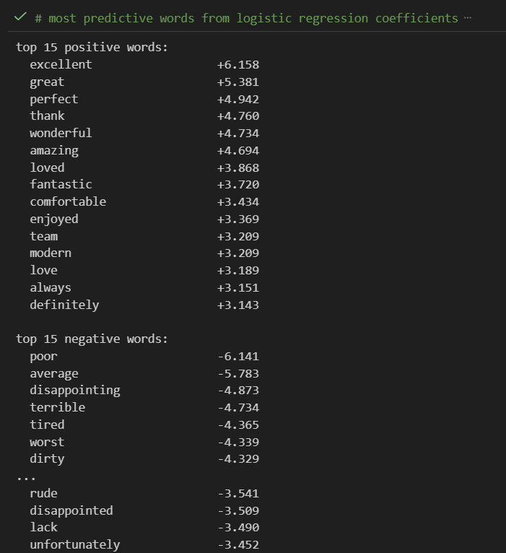
Figure 29: Top 15 positive and negative predictive words with logistic regression coefficients. 'Excellent' (+6.158) is the strongest positive indicator; 'poor' (-6.141) is the strongest negative signal. The symmetric magnitude suggests balanced predictive power.

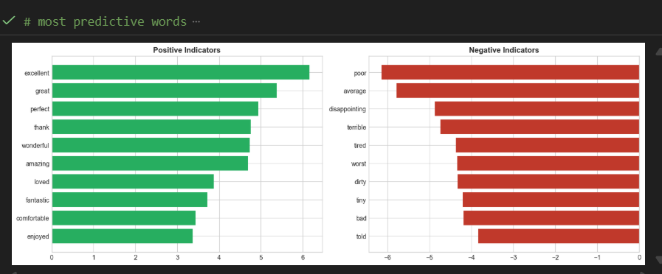
Figure 30: Predictive word visualization. Left panel (green): positive indicators headed by 'excellent', 'great', 'perfect', 'thank', 'wonderful'. Right panel (red): negative indicators headed by 'poor', 'average', 'disappointing', 'terrible', 'tired'.

Analysis of the predictive features reveals patterns with direct operational implications:
Positive Indicators
The top positive words reflect genuine satisfaction markers:
- Service Excellence: The strongest indicators of satisfaction are superlatives like 'excellent' (+6.158), 'perfect' (+4.942), and 'wonderful' (+4.734).
- Emotional Connection: Guests frequently use emotive language such as 'loved' (+3.868) and 'enjoyed' (+3.369) to describe their stay.
- Gratitude: The high coefficient for 'thank' (+4.760) shows that guests explicitly express appreciation in positive reviews.
- Team Recognition: The prominence of 'team' (+3.209) confirms that guests notice and value collective staff effort.

Negative Indicators
The top negative words pinpoint specific failure modes:
- Quality Failures: The strongest detractors are explicit descriptions of failure, led by 'poor' (-6.141) and 'terrible' (-4.734).
- Expectation Gaps: High penalties for 'average' (-5.783) and 'disappointing' (-4.873) show that guests punish mediocrity heavily.
- Physical Deficiencies: Hygiene ('dirty', -4.329) and small room sizes ('tiny', -4.288) are significant pain points.
- Service Failures: Terms like 'rude' (-3.541) and 'told' (-3.452) indicate dismissive, unhelpful staff interactions.
- Facility Condition: The term 'tired' (-4.365) suggests guests perceive the property or facilities as worn out.

6.8 Word Cloud Visualization
Word clouds provide an intuitive visual summary of vocabulary differences between positive and negative reviews.

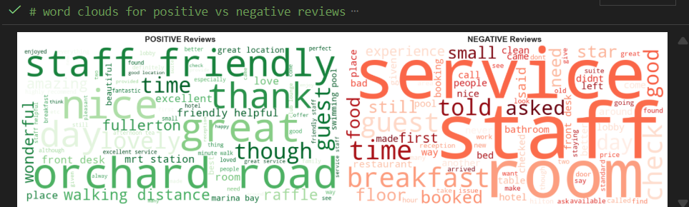
Figure 31: Word clouds contrasting positive (left) and negative (right) review vocabulary. Positive reviews emphasize 'staff', 'friendly', 'great', 'location', 'orchard' (shopping district). Negative reviews prominently feature 'service', 'room', 'time', 'staff', indicating service delivery and timing issues.

Notable patterns in the word clouds:
- The Human Factor: 'Staff' appears centrally in both positive and negative clouds, confirming that service quality is the primary determinant of guest sentiment.
- Operational Friction: 'Time' is a dominant negative keyword, reinforcing that wait times and check-in delays are universal complaints.
- Strategic Assets: 'Location' and 'Orchard' are consistent positive drivers, highlighting the value of the property's position in Singapore.
- Physical Deficits: 'Room' skews heavily negative, indicating that guests rarely praise the physical room but frequently complain about size and maintenance.

7. Topic Modelling (Latent Dirichlet Allocation)

7.1 From Sentiment to Topics
Sentiment analysis answers whether guests are satisfied; topic modelling answers what drives that satisfaction. While sentiment classification provides a binary or categorical label (positive/negative), topic modelling reveals the underlying themes present in review text and enables targeted improvement efforts.

Latent Dirichlet Allocation (LDA) is an unsupervised probabilistic model that discovers hidden topics in a document corpus. The core assumption is that each document (review) is a mixture of topics, and each topic is a distribution over words. By analyzing word co-occurrence patterns, LDA infers both the topic structure and the topic composition of each document.

7.2 Topic Extraction Results
LDA analysis of the review corpus revealed six interpretable service themes:

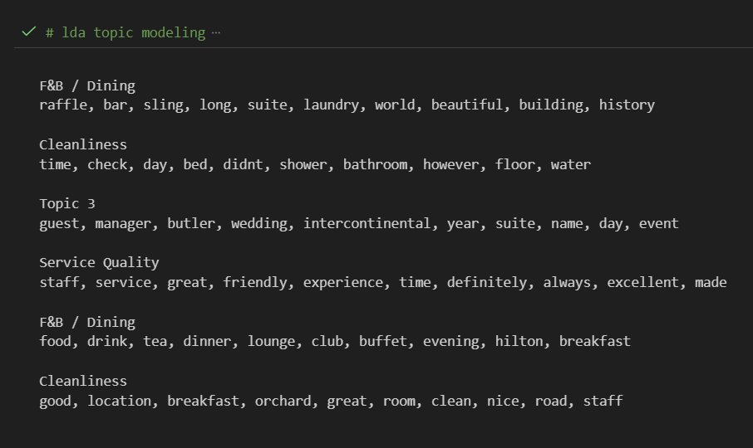
Figure 32: LDA topic modeling output showing 6 extracted themes with top 10 keywords each. Topics map to interpretable service dimensions: F&B/Dining, Cleanliness, Events/Special Occasions, Service Quality, and variations thereof.

Topic | Assigned Label | Top Keywords | Interpretation
Topic 0 | F&B / Dining (Iconic) | raffle, bar, sling, suite, laundry, world, beautiful | Iconic F&B experiences (Raffles Hotel, Singapore Sling)
Topic 1 | Cleanliness / Facilities | time, check, day, bed, shower, bathroom, floor | Room condition, check-in timing, physical facilities
Topic 2 | Events / Special Occasions | guest, manager, butler, wedding, intercontinental, suite | Weddings, celebrations, personalized butler service
Topic 3 | Service Quality | staff, service, great, friendly, experience, time, definitely | Core service delivery, staff interactions, overall experience
Topic 4 | F&B / Dining (General) | food, drink, tea, dinner, lounge, club, buffet, breakfast | Dining options, meal quality, breakfast experience
Topic 5 | Cleanliness / Location | good, location, breakfast, orchard, great, room, clean | General cleanliness, location convenience, breakfast

7.3 Topic Interpretation
The six extracted topics map to three core service dimensions, with some topics capturing variations or specific aspects of each dimension:

Food & Beverage / Dining (Topics 0, 4)
Two topics capture dining experiences from different angles. Topic 0 emphasizes iconic experiences (Raffles Hotel's bar scene, Singapore Sling cocktails, heritage ambiance) while Topic 4 focuses on everyday dining (breakfast buffets, afternoon tea, dinner quality). This distinction enables hotels to benchmark against either premium experiential dining or practical meal satisfaction.

Cleanliness / Facilities (Topics 1, 5)
Topic 1 captures facility-specific concerns (bathroom condition, shower functionality, bed comfort, floor cleanliness) and notably includes 'time' and 'check', linking cleanliness to check-in experience. Topic 5 emphasizes general cleanliness combined with location satisfaction. The overlap suggests that cleanliness and convenience are bundled in guest perception.

Service Quality (Topic 3)
This central topic captures the human element: staff interactions, friendliness, service excellence, and overall experience quality. The presence of 'definitely' suggests guests making strong recommendations based on service. This topic likely has the highest correlation with overall satisfaction and loyalty intent.

Events / Special Occasions (Topic 2)
A specialized topic capturing celebratory stays: weddings, anniversaries, special requests, butler service. The prominence of 'manager' and 'guest' suggests high-touch personalized service. Hotels excelling on this topic attract event bookings and premium occasions.

7.4 Hotel Topic Scores
Each hotel receives a score on every topic dimension based on its aggregate review content. These scores enable direct competitive benchmarking—identifying which hotels excel on which service dimensions.

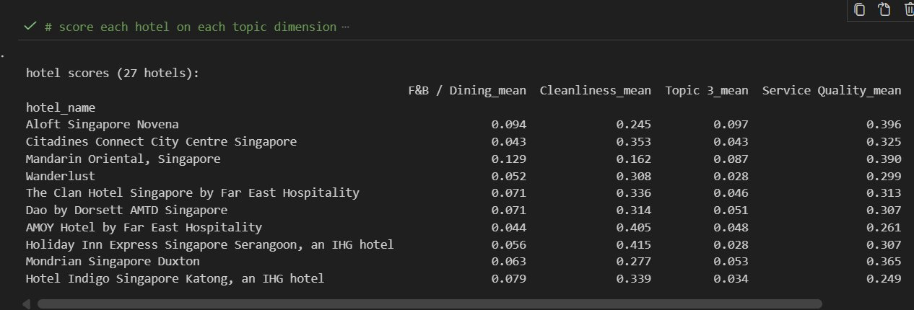
Figure 33: Hotel topic scores matrix (27 hotels × 4 key dimensions). AMOY Hotel leads Cleanliness (0.405); Holiday Inn Express Serangoon leads Cleanliness at 0.415; Mandarin Oriental leads Service Quality (0.390) and F&B/Dining (0.129). Scores enable targeted investment decisions.

Strategic applications of topic scores:
- Competitive Positioning: A hotel scoring high on F&B/Dining but low on Cleanliness should emphasize dining in marketing while investing in housekeeping
- Investment Prioritization: Low scores on a dimension indicate improvement opportunities; high scores indicate competitive advantages to protect
- Market Niche Identification: Hotels strong on Events/Special Occasions can position for weddings and celebrations
- Staff Training Focus: Service Quality scores directly inform frontline training priorities

7.5 Service Quality Radar Comparison
Radar charts enable visual comparison of topic profiles across hotels, revealing each property's distinctive strengths and weaknesses.

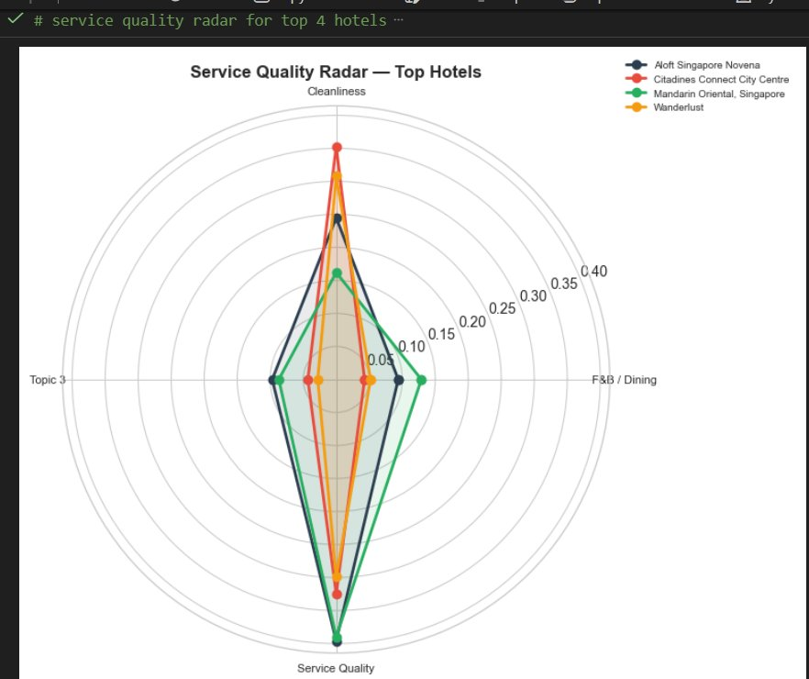
Figure 36: Service quality radar comparing the top 4 hotels across topic dimensions. Citadines Connect excels in Cleanliness (highest peak); Mandarin Oriental dominates Service Quality (longest reach downward); all show moderate F&B/Dining scores, suggesting industry-wide improvement opportunity.

Key observations from the radar comparison:
- The spread on this dimension is widest, indicating that cleanliness is the primary differentiator among top hotels
- Service Quality shows strong performance across all top hotels, indicating that baseline expectations are high
- F&B/Dining scores are uniformly moderate since no hotel has established clear dining leadership
- Topic 3 (Events) shows minimal variation, which indicates that this niche is underserved across the market

The strategic implication is clear: hotels seeking differentiation should focus on either Cleanliness excellence or F&B/Dining innovation, as Service Quality has become table stakes without differentiation potential.

8. Hotel Pain Point Analysis

8.1 Hotel Performance Rankings
Before examining pain points, understanding the performance landscape provides context. Hotels were ranked by average rating (minimum 5 reviews to ensure statistical reliability).

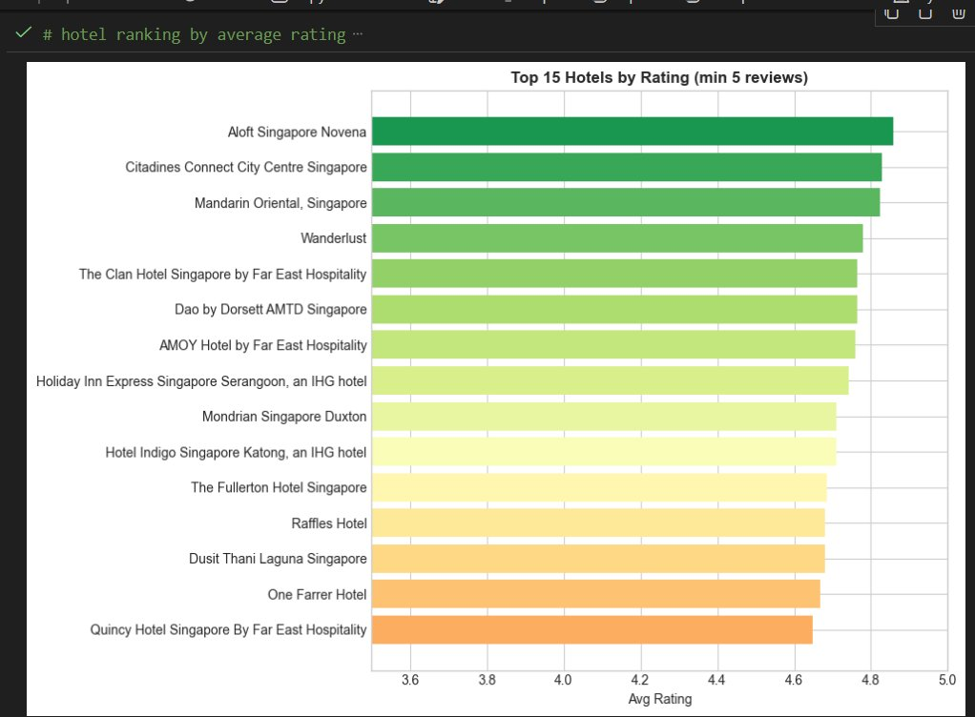
Figure 37: Top 15 hotels by average rating (minimum 5 reviews). Aloft Singapore Novena ranks #1 (~4.9/5). Notable finding: iconic properties The Fullerton (#11 at ~4.7) and Raffles Hotel (#12 at ~4.7) rank lower than boutique competitors, illustrating the expectation gap at heritage properties.

The ranking reveals a surprising pattern: heritage/luxury properties underperform relative to expectations. Singapore's most prestigious hotels, The Fullerton and Raffles, rank 11th and 12th despite commanding premium rates. This 'expectation gap' phenomenon occurs when brand reputation creates expectations that exceed delivered experience. Boutique hotels with lower expectations can achieve higher ratings through modest but consistent service delivery.

8.2 Per-Hotel Pain Point Extraction
Pain point analysis extracts the most frequent words appearing in positive versus negative reviews for each hotel. By comparing these word lists, we identify what drives satisfaction and what drives complaints at each property.

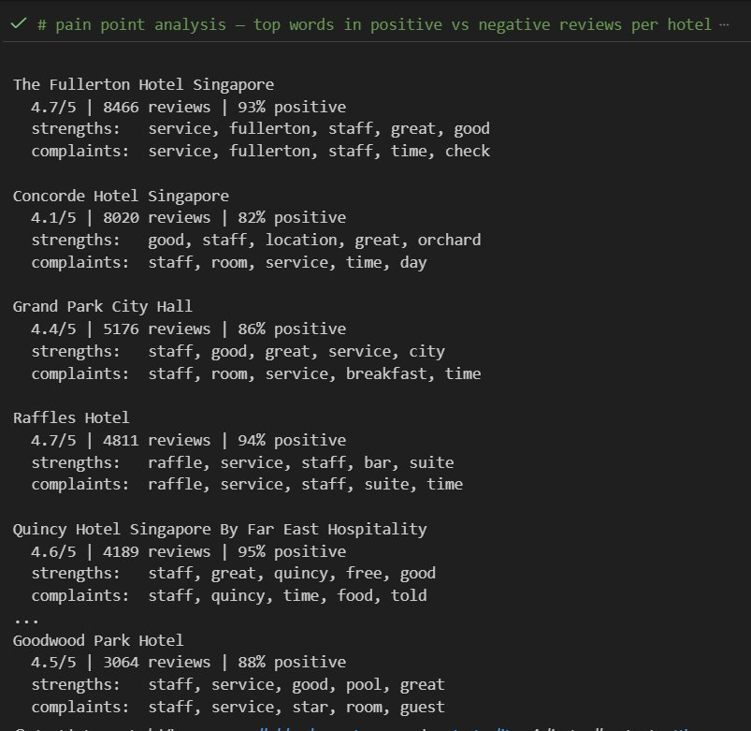
Figure 38: Pain point analysis showing top words in positive vs. negative reviews per hotel. Critical finding: 'time' and 'check' appear in complaint lists across ALL hotels without exception, indicating systemic industry failure rather than property-specific issues.

Hotel | Rating | Positive % | Strength Keywords | Complaint Keywords
The Fullerton Hotel | 4.7/5 | 93% | service, fullerton, staff, great, good | service, fullerton, staff, time, check
Concorde Hotel | 4.1/5 | 82% | good, staff, location, orchard, great | staff, room, service, time, day
Grand Park City Hall | 4.4/5 | 86% | staff, good, great, service, city | staff, room, service, breakfast, time
Raffles Hotel | 4.7/5 | 94% | raffle, service, staff, bar, suite | raffle, service, staff, suite, time
Quincy Hotel | 4.6/5 | 95% | staff, great, quincy, free, good | staff, quincy, time, food, told
Goodwood Park Hotel | 4.5/5 | 88% | staff, service, good, pool, great | staff, service, star, room, guest

8.3 The Universal 'Time' Problem
The most significant finding from pain point analysis is the universal appearance of 'time' and 'check' in negative reviews across every single hotel in the dataset regardless of star rating, price point, brand positioning, or ownership structure. This pattern has profound strategic implications.

When the same complaint appears everywhere, it cannot be attributed to individual management failures. Instead, it indicates:

Systemic Industry Practice: Check-in/check-out procedures across Singapore hotels follow similar patterns that consistently frustrate guests
Universal Guest Expectation: Travelers increasingly expect instant, frictionless experiences; traditional front desk processes feel outdated
Shared Infrastructure Constraints: Peak arrival times (3-4 PM) create bottlenecks that no single hotel can solve through staffing alone
Mobile Technology Gap: Hotels have been slow to adopt mobile check-in/check-out compared to airlines, where app-based boarding is now standard

Strategic Implication: Addressing queue times through mobile check-in, express kiosks, or staggered arrival incentives would lift satisfaction scores industry-wide more effectively than any hotel-specific intervention. The first hotel to truly solve the time problem will achieve meaningful differentiation in a competitive market.

8.4 Property-Specific Insights
Beyond the universal time issue, property-specific patterns emerge:

- The Fullerton: 'Service' appears in both strengths and complaints since the brand promises high-touch service, which, when delivered, creates satisfaction, but when missed, creates amplified disappointment
- Concorde Hotel: 'Room' appears prominently in complaints, indicating that physical room condition may be an investment priority
- Grand Park City Hall: 'Breakfast' appears in complaints, indicating that the F&B execution at this property underperforms expectations
- Quincy Hotel: 'Told' appears in complaints, which suggests that communication issues or guests being denied requests
- Goodwood Park Hotel: 'Star' appears in complaints, indicating that guests may feel the property doesn't live up to its star rating

9. Integrated Findings & Strategic Recommendations

9.1 Synthesis of Key Findings

Finding | Source Analysis | Confidence | Strategic Implication
High-Value Markets spend 77% more | K-Means Clustering | High | Rebalance marketing investment toward the Americas/Europe/Oceania
RevPAR predictable to ±2.1% | Ridge Regression | High | Deploy model for dynamic pricing 2-3 weeks ahead
89.2% positive sentiment baseline | SVM Classification | High | Focus resources on preventing negatives, not boosting positives
'Time' universal complaint | Pain Point Analysis | High | Industry-wide check-in process innovation rean quired
Service Quality is table stakes | LDA Topic Modelling | Medium | Differentiate on Cleanliness or F&B, not generic service
Iconic hotels face expectation gap | Rating Analysis | Medium | Heritage properties must exceed rather than match expectations

9.2 Revenue Optimization Recommendations
Based on the forecasting analysis and market segmentation:

Deploy Production Forecasting: The Ridge Regression model achieves sufficient accuracy (2.10% MAPE) for production deployment. Implement as an automated system generating monthly RevPAR forecasts that feed directly into pricing decisions.

Dynamic Pricing Integration: Use forecasts to adjust rates 2-3 weeks ahead of predicted demand shifts. When the model predicts high demand, increase rates early to capture revenue; when low demand is predicted, release promotional inventory early.

Segment-Specific Pricing: High-Value Power Markets (Americas, Europe, Oceania) are less price-sensitive given their higher baseline spending. Consider premium positioning and package bundling for these segments rather than competing on rate.

Upsell Program for Volume Segments: Emerging Growth Markets deliver volume at $1,000/visitor. Develop upsell programs (spa, dining, attractions) to increase per-visitor revenue without additional acquisition cost.

9.3 Service Quality Recommendations
Based on sentiment analysis, topic modelling, and pain point extraction:
- Technological Solutions for Check-In Efficiency: To address the most consistent complaint across all properties, which in this case would be waiting times, hotels should implement mobile check-in options, express kiosks, or automated queue management systems. We recommend initiating pilot programs with technology partners to integrate these solutions, which would directly resolve the systemic bottleneck at the front desk.

- Real-Time Sentiment Monitoring: The organization should deploy the trained SVM classifier as a live operational tool. By acting as an automated monitoring system, the model can immediately flag negative reviews and notify duty managers, enabling same-day service recovery and demonstrating high responsiveness to guest feedback.

- Data-Driven Capital Allocation: Rather than relying on generic 'service improvement' budgets, management should utilise LDA topic scores to identify the specific weakest dimension for each property. This granular approach ensures that training and capital expenditure are directed precisely where they will yield the highest return on satisfaction, whether that be upgrading housekeeping standards or refining F&B operations.

- Proactive Response Protocol: Given the model’s 78% precision in identifying negative sentiment, a strict protocol should be established for all flagged reviews. While this may result in checking some false positives, a strategy of proactive outreach prevents genuine complaints from being ignored and reinforces a reputation for attentiveness.

- Expectation Management for Heritage Assets: For iconic or heritage hotels, marketing channels must set explicit expectations regarding physical trade-offs, such as smaller room sizes or older layouts, during the booking process. By framing these features as part of the unique historical experience, the hotel can align guest expectations with reality and reduce disappointment.

9.4 Marketing & Positioning Recommendations
Based on segmentation and sentiment analysis:

- Segment-Differentiated Campaigns: Marketing strategies must be tailored to the specific clusters identified by the model. We recommend a focus on premium experiences for the 'High-Value Power Markets' (Americas/Europe), value-driven bundling for 'Regional Volume Drivers' (SE Asia), and discovery-based narratives to attract 'Emerging Growth Markets.'

- Linguistic Optimization: Advertising copy should be optimized using the high-coefficient positive terms identified by the logistic regression model, specifically 'excellent,' 'perfect,' and 'wonderful.' Using the exact vocabulary that satisfied guests naturally use to describe their stay creates a subliminal alignment between the brand promise and the guest experience.

- Leveraging Seasonal Stability: Singapore’s unique lack of extreme seasonality offers a distinct competitive advantage over seasonal destinations. Marketing campaigns should emphasize this year-round consistency, highlighting stable weather, continuous events, and availability to drive steady booking volume regardless of the month.

- Cleanliness as a Competitive Differentiation: Since the analysis reveals that Cleanliness exhibits the widest performance gap among top-tier hotels, it represents the most effective lever for competitive positioning. Properties with high scores in this dimension should explicitly market their hygiene standards to capture market share from competitors who underperform in this critical area.

10. Conclusion & Future Work

10.1 Project Achievements
SmartStay demonstrates the feasibility and value of integrated machine learning for hospitality analytics. The project successfully:

- Segmented 21 tourist source markets into 4 actionable clusters with validated separation (silhouette 0.319)
- Developed a production-ready revenue forecasting model with 2.10% error rate
- Built a sentiment classifier achieving 94.09% accuracy on 60,681 reviews
- Extracted 6 interpretable service themes enabling structured competitive benchmarking
- Identified the universal 'time' pain point as a systemic industry opportunity

These outputs transform raw data into strategic intelligence that supports evidence-based decision-making across marketing, operations, and revenue management functions.

10.2 Limitations & Caveats
Several limitations should be acknowledged:

- Temporal Constraints: The dataset utilised for this analysis covers hotel performance from 2013 to 2015. While the fundamental relationships between variables likely remain valid, the specific coefficients may have evolved. To ensure the forecasting model remains relevant to current market conditions, it should be retrained using more recent data.
- Class Imbalance: The dataset exhibits a significant skew, with 89% of reviews being positive. This imbalance limits the model's ability to learn the nuances of negative feedback. Future iterations should implement resampling techniques, such as SMOTE (Synthetic Minority Over-sampling Technique), to improve the recall rate for the minority (negative) class.
- Feature Dependency: The ridge regression model's high forecasting accuracy is heavily dependent on the availability of the Average Room Rate (ARR) feature. For successful real-world deployment, the business must ensure it has access to reliable, forward-looking estimates of ARR to feed into the model.
- Geographic Specificity: The results and strategic insights are derived exclusively from the Singapore tourism market. Consequently, these findings may not be directly applicable to other destinations without further validation and localized testing.

10.3 Future Research Directions
Several extensions would enhance the analytical framework:

- Deep Learning for Sentiment: Transformer-based models could improve classification accuracy, particularly for nuanced or sarcastic reviews.

- Aspect-Based Sentiment: Rather than document-level sentiment, extract sentiment for specific aspects (cleanliness, staff, food) within each review.

- Real-Time Dashboard: Integrate all models into a live operational dashboard with automated alerts and performance tracking.

- Causal Analysis: Move beyond correlation to estimate causal impacts, for example, what lift in satisfaction would a 10% reduction in check-in time produce?

- Competitive Intelligence: Extend analysis to competitor reviews, enabling direct benchmarking against specific properties.

SmartStay establishes a foundation for data-driven hospitality management. The integrated approach, connecting market intelligence, operational forecasting, and guest feedback, provides a template for analytics transformation in the tourism sector.

11. Technical Appendix

11.1 Complete Model Performance Summary
Analysis | Algorithm | Key Metric | Value | Interpretation
Segmentation | K-Means (K=4) | Silhouette Score | 0.319 | Meaningful cluster separation
Dimensionality Reduction | PCA | Variance Explained | 73.1% | Reliable 2D representation
Forecasting | Ridge Regression | MAE | 3.463 | Average error ~$3.46
Forecasting | Ridge Regression | RMSE | 4.690 | Root mean squared error
Forecasting | Ridge Regression | MAPE | 2.10% | Production-ready accuracy
Forecasting | Time-Series CV | MAE | 12.524 ± 4.532 | Cross-validated performance
Classification | SVM (Linear) | Accuracy | 94.09% | Correct predictions
Classification | SVM (Linear) | F1 Score | 93.82% | Balanced precision-recall
Classification | SVM (Linear) | Positive Recall | 98% | Catches most positives
Classification | SVM (Linear) | Negative Precision | 78% | Reliable negative flags
Topic Modeling | LDA | Topics | 6 | Interpretable themes

11.2 Cluster Membership Reference
Cluster ID | Strategic Label | Member Countries
0 | Emerging Growth Markets (Large) | Australia, Canada, Germany, India, Southeast Asia, USA
1 | Emerging Growth Markets (Small) | Italy, Pakistan
2 | High-Value Power Markets | Americas, Europe, Oceania
3 | Regional Volume Drivers | Africa, France, Hong Kong SAR, Japan, Netherlands, New Zealand, Sri Lanka, Switzerland, Taiwan, United Kingdom

11.3 Technology Stack
Category | Technologies
Programming Language | Python 3.x
Data Processing | pandas, numpy
Machine Learning | scikit-learn (K-Means, PCA, Ridge, SVM, Random Forest)
Gradient Boosting | XGBoost, GradientBoostingRegressor
NLP | TF-IDF Vectorizer, Latent Dirichlet Allocation
Visualization | Plotly, Matplotlib, Seaborn
Dashboard | Streamlit
Report Generation | docx-js

11.4 Data Sources
- Tourist Arrivals: Singapore Tourism Board aggregate statistics
- Hotel Performance: Industry aggregated metrics (anonymized)
- Guest Reviews: Multi-platform review aggregation (TripAdvisor, Booking.com, Google)

11.5 Glossary of Technical Terms

Accuracy: The proportion of correct predictions among all predictions. For sentiment classification, the percentage of reviews correctly labeled as positive or negative.

Confusion Matrix: A table showing the counts of true positives, true negatives, false positives, and false negatives for a classification model.

F1 Score: The harmonic mean of precision and recall, providing a balanced measure of classification performance that accounts for both false positives and false negatives.

K-Means Clustering: An unsupervised machine learning algorithm that partitions data into K distinct groups based on feature similarity, minimizing within-cluster variance.

Latent Dirichlet Allocation (LDA): A probabilistic topic model that discovers hidden themes in text by analyzing word co-occurrence patterns across documents.

MAE (Mean Absolute Error): The average absolute difference between predicted and actual values, measuring forecast accuracy in the same units as the target variable.

MAPE (Mean Absolute Percentage Error): Forecast error expressed as a percentage of actual values, enabling comparison across different scales.

PCA (Principal Component Analysis): A dimensionality reduction technique that projects high-dimensional data onto lower-dimensional axes capturing maximum variance.

Precision: The proportion of positive predictions that are actually positive. High precision means few false positives.

Recall: The proportion of actual positives that are correctly predicted. High recall means few false negatives.

RevPAR (Revenue Per Available Room): A key hotel performance metric calculated as Average Room Rate × Occupancy Rate, capturing both pricing and demand.

Ridge Regression: Linear regression with L2 regularization that penalizes large coefficients, effective for datasets with correlated features.

Silhouette Score: A measure of cluster quality ranging from -1 to +1, where higher values indicate observations are well-matched to their assigned cluster.

SVM (Support Vector Machine): A classification algorithm that finds the hyperplane maximizing margin between classes, effective for high-dimensional text data.

TF-IDF: Term Frequency-Inverse Document Frequency, a text vectorization technique that weights words by their frequency within documents and rarity across the corpus.

— End of Report —

SmartStay SG | Singapore Tourism & Hospitality Analytics
Integrating Machine Learning for Strategic Decision-Making
March 2026

