Natalie Wang

Username: natalimw

INF3490 Assignment 2

Instructions for Running Program:

* Open terminal
* Navigate to my assignment folder ‘assigment_2’
* Run ‘python3 movements.py’
  + Note: running this will train and create confusion matrices for neural nets with 6, 8, 10, 12 hidden nodes

Answers to Questions:

1. Run the algorithm on dataset movements_day1-3.dat. You should test with at least three different number of hidden nodes (e.g 6, 8, 12). Report your findings and provide the resulting confusion tables with percentages, one for each net with different number of hidden nodes. How many nodes do you find sufficient for the network to classify well?

It seems like 10 nodes would be sufficient to classify well.

|  |  |
| --- | --- |
| Number of Nodes | Classification Accuracy |
| 6 | 0.748 |
| 8 | 0.838 |
| 10 | 0.847 |
| 12 | 0.793 |

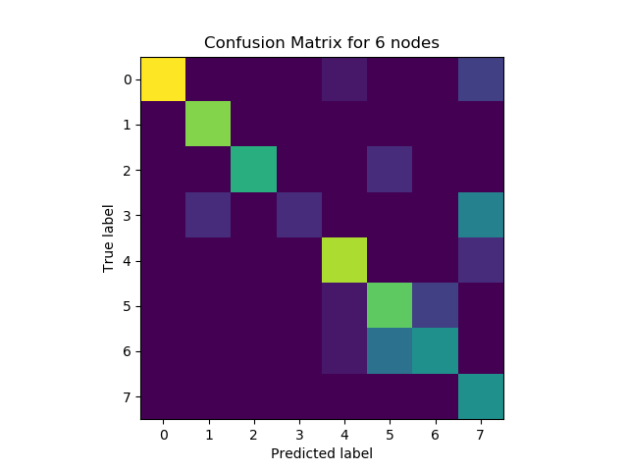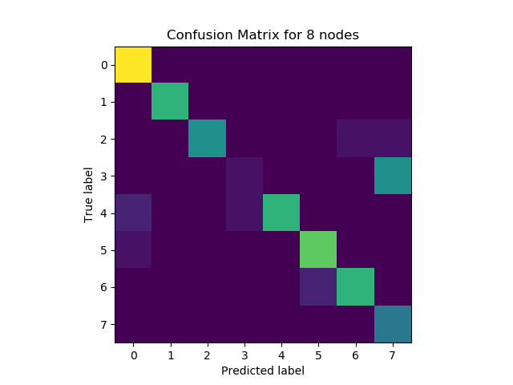Confusion Tables

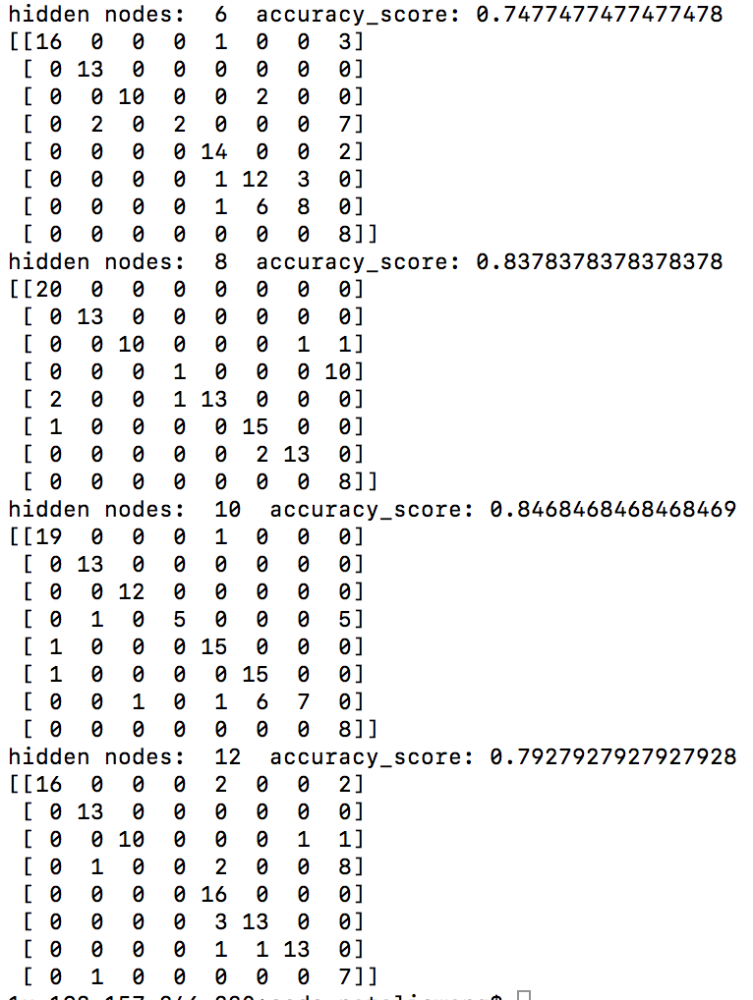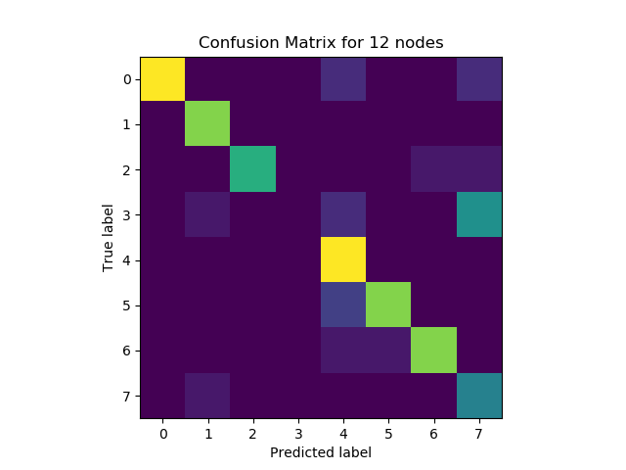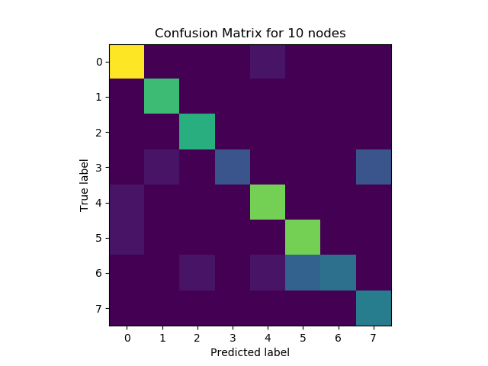

1. By only looking at your reported confusion tables, which classes where likely to be mistaken for each other?

It seems like class 3 and 4 get mistaken for class 7 a lot.

Brief Explanation of What I’ve Done:

For this assignment, I implemented an iterative version of a neural net by defining 4 main functions: earlystopping, train, forward, and confusion. Earlystopping trains the neural net but stops training one validation error begins increasing; it looks at the errors on the last three weights to insure it does not stop prematurely due to random noise in the data. Train trains the neural net with one hidden layer with a sigmoid activation function and a linear activation function for the output. It shuffles the training data then inputs one of the training vectors into the neural net, uses backpropagation to update weights and biases, then repeats for the rest of the training vectors. Forward returns the result of putting inputs into the current neural net and confusion creates and saves a confusion matrix for a set of inputs to the neural net.