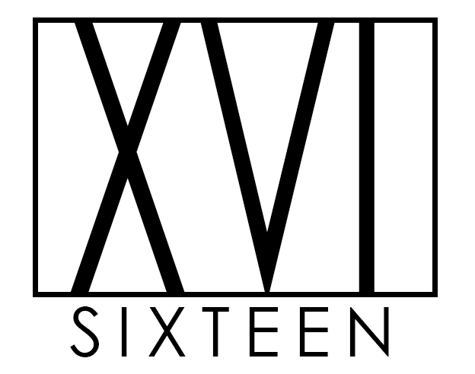

**Table of Contents**

1. Executive summary
2. Introduction
3. Meet team XVI (team name, personal information, Group Processes & Career plans)
4. Tools
5. Project: The SocialCare Chat
   1. Overview
      * Topic
      * Motivation
      * Landscaper
   2. Detailed Description
      * Aims
      * Plans & Progress
      * Roles
      * Scopes & Limits
      * Tools & Technologies
      * Testing
      * Timeframe
      * Risks
      * Group Processes & Communications
6. Skills & Jobs
7. Group reflection
8. References

**1. Executive summary**

This report provides background on all the members of XVI, the tools they have used, and their project, The SocialCare Chat. Along with this, XVI, reflect on their time together working as a team throughout the second phase of their group assignment.

Group XVI teamed up just over a month ago and previously participated in a range of tests in order to determine compatibility; you will also find a brief introduction on each member of the group.

Further on, XVI dive deeper into the plans for their project, scope, testing, risks and other important components regarding their project, The Social Care Chat. The aim is to allow the elderly or those with a disability to interact with their loved ones with ease.

Finally, in the group reflection, the team goes through what they have learned, what they found surprising throughout the process, how technology allows for effective online collaboration, and individual activity. This was done to determine what went well, what did not, and what we could do better next time.

**2. Introduction**

XVI collaborated through the use of technology to plan, allocate and discuss different components of the tasks at hand. The group decided to allocate various topics to different members to then have other team members review and provide feedback. This enabled the team to be on the same page and have a thorough understanding of what we wanted to achieve together. In doing all of this, XVI, were able to commence with detailed planning of The Social Care Chat project with the new learnings and understanding of web application development; enabling them to leverage off technology to achieve results more efficiently and effectively.

**3. Meet the team at XVI**

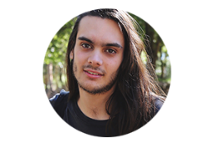I am Connor, ID s3866963, and I am a part of XVI. I was born 25 years ago in Ryde NSW and raised all over Australia by a single mother and technology. Currently living in Merriwa NSW with my fiancée and our giant sook of a furbaby Turbo. My passions include gaming, modding anything and everything to do with my PC, playing my guitar when I remember it exists, binge-watching whatever series has caught my attention for the week and travelling to find yummy new vegan foods and exciting new vaporizer juice flavours. I have had a very strong interest in IT for as long as I can remember, but the main things that have motivated me into studying it have been modding my gaming consoles, from the PS1 all the way through to the Switch, coding both mine and all my friends’ MySpace themes back in the day and just generally getting a PC, the openness and freedom of the PC platform just completely opened my mind after being on consoles for so long.

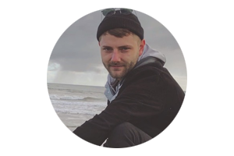I am Corbin, ID s3855159, and I am a part of XVI. Hailing from Melbourne City and originally from Country Victoria, I now live on the sunny Mornington Peninsula. My day job is in hospitality and tourism management but I am always pursuing a new side-hustle. I am an enormous music lover and spend most of my free time singing and playing guitar, reading a good book or involving myself in social or philosophical discussions. I have been a gamer for my whole life, and I do not really remember a time when I haven’t owned some sort of gaming console. My interest in IT was spurred when I took a short course in Python. Tech had always interested me but learning a small amount of code showed me that it was something I could learn and not as out-of-reach as it appeared. I am particularly interested in artificial intelligence and the future of computing.

****I am Natalie, ID s3505918, and I am a part of XVI. I am 24, Italian-Australian and I was born and bred in the northern suburbs of Melbourne. I enjoy modding my PC, playing video games, learning new skills, languages and watching RuPaul’s Drag Race. Since I can remember, I have always been in love with technology, from pulling apart electronics to hacking my game consoles and everything else in between. One of my big passions is making things and I consider myself a part of the maker community. I have taught myself to solder, 3D design and print and I enjoy woodworking. Recently, I designed and manufactured my own PCBs for a project in which I was modding a DS console to run inside an original Gameboy case. In the future, I would love to combine my love of design, making things and technology together as a career.

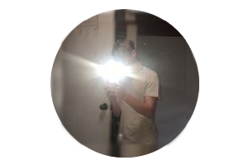I am Oliver, ID s3861675, and I am a part of XVI. I am 16 and was born in Australia. I enjoy playing video games, watching shows, going out with friends and using software such as Unity to explore cool ideas. I have always enjoyed using technology whether it was creating my own retro arcades with raspberry pies or making small fun games in Unity to mess around in with friends. I have never made a game with a serious intent to either sell it or release it but I have made multiple to share with friends and play together for the next week seeing who can get the highest score. IT leaves almost no limits to creativity and that is why I like it so much, I would love to get a job as a game developer in a company, but it has also been my goal to work either by myself or in a small team just having fun whether it is by YouTube or making Indie Titles.



I am Vanessa, ID s3864452, and I am a part of XVI. I am 28, born and raised in Australia in a cute little country town that goes by the name of Orange! I grew up dancing to rock ‘n’ roll music and singing Shania Twain, I am still quite the country girl to this day but living in the suburbs of Sydney with my boyfriend, Chris, and furbaby, Layla. Snowboarding is my passion, I enjoy being outdoors but seriously love being a homebody as well. Throughout my time working in the tech space, I have been involved in various projects that have allowed me to be a part of the changes in our product and ultimately improve the experience for the end-user. I have become very passionate about technology which is why I am looking to develop my skills and knowledge in order to pursue a career in Software Engineering.

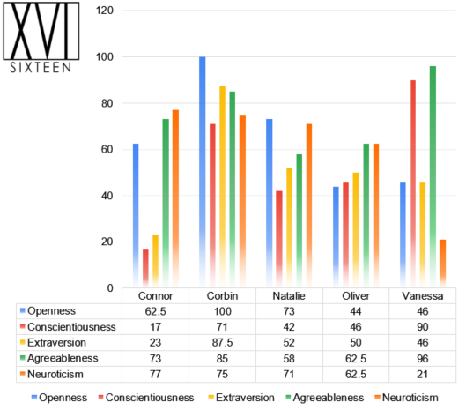

The members of XVI participated in three tests each to determine the strengths, weaknesses and compatibility of the group. The tests performed included The Myers-Briggs Personality Test, The Big Five Personality Test, and The Learning Style Quiz.

From the chart above, you can view the results of each individual from their Big 5 Personality Test and from the chart below, you are looking at a combined result of The Myers-Briggs Personality Test and The Learning Style Quiz. It is evident from these tests that the members of the group are a combination of all personality traits. The group’s personality type is different across the board with no same individual, as well as their learning styles with the exception of Connor and Vanessa both being reflectors.

The traits from each member complement one another and allow the group to leverage of the skills and strengths of other individuals in the team. Working with a variety of personality types also allowed us to learn from each other, as the team continues to collaborate, the dynamic of the team will likely change.

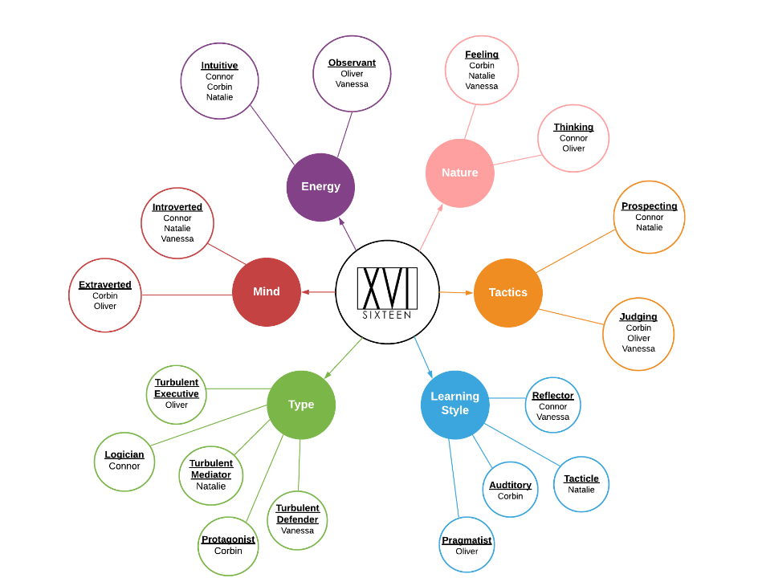

**Group Processes**

Teamwork plays an extremely vital part to make the performance of a group or organisation efficient which ensures they are able to succeed. Teamwork requires participation from everyone who is part of that specific team. Forming a good team is not an easy task…

A team is a group of people with a full set of complementary skills required to complete a task, job or project. Team members often operate with high amounts of interdependence and share authority and responsibility for self-management. They are all accountable for the collective performance, and work toward a common goal for a shared reward. A team becomes more than just a group of people when a strong sense of mutual commitment creates synergy, thus generating performance greater than the sum of the performance of its individual members.

Team XVI’s ability to work together was outstanding. Every team member was able to work reliably. Some members were able to show great amounts of leadership which played a massive role in group XVI’s ability to work together. Everyone chose their own parts to work on and deadlines were set which assisted in assuring individuals completed their set tasks. For parts that required input from more than one person, it was reassuring to know that after sending out a request, it would be actioned by the day.

Team XVI held two group catchup calls each week where we would set out our goals for the week and then towards the end of the week, we would see how every is progressing and provide help were needed. This made sure that all parts could be completed by a certain deadline which allowed time for others to look over and provide feedback, as well as complete as many tasks as possible within a certain time frame. Team XVI used Google docs to lay out all the tasks that have been or need to be completed and who is doing them by what date. This allowed everyone to offer help if they had time to and allowed everyone to see how others are tracking.

In conclusion team XVI is sticking with the same process for Assignment 3 as it worked well for us. We all knew what others were doing and could easily found out how they were going. Being able to rely on teammates to submit tasks created a great sense of reassurance within the team and removed a lot of unnecessary stress from each member.

**CHANGE TO CAREER PLANS!!! - Ollie**

**Connor -**

**Corbin –**

In the past few weeks, and through a large amount of additional research, I have come to realise that the scope of my initial career plan is a lot larger than the steps that make up its parts. Such a position requires earning merit through years of experience in previous, relevant, positions, a thorough idea of the entire field and an understanding of the dynamics of a workplace.

I believe it is more important to focus on every step of the ladder rather than just the top and if every step is sound, you will eventually make it there safely. I also believe that it remains important to be able to move the ladder when necessary. For example, if I were to choose to pursue employment entirely devoted to the installation and maintenance of local, cloud and database network solutions but my interests suddenly changed, which they already have dramatically, then I would only have specialised skills in one field.

I now see the importance of variety in experience and my previous beliefs in-regards-to employment have changed. If I were to get a job directly out of education, I would aim for either generic programming or AI programming as a software developer, software analyst or engineer. After a few years of refining my programming and software related skills, I would also like to work with databases or big data as either a developer or administrator. During schooling though, I have considered learning how to and offering to create web apps for people, mostly for experience, but I will refine my ability to do that and hopefully open doorways, maybe.

It appears that, in the world of tech, the career possibilities are ostensibly endless and one new path, or learned piece of knowledge, can change that trajectory in a moment. That is why I can see that fundamental and mutable skills are more important in the long term and my current idea of future employment is very different from where it began.

**Natalie –**

Originally, I had chosen game UI designer as my ideal job. However, over the past 10 weeks I’ve had a change of mind. Although I would love to be a part of the game industry as video games are a big part of my life.

Through the Intro to IT course, I have made three websites, and I have enjoyed the process. I also made and designed our group’s logo, app assets and the app logo.   
In the past, I’ve edited HTML themes for sites like MySpace and later Tumblr. I always liked making changes to suit my style. This, along with research and the Burning Glass data from A2 made me realise I would really enjoy being a web developer and graphic designer.

Completing the Bachelor of Information Technology at RMIT is my number one aim at the moment. While completing my Bachelor, I am aiming to build up a portfolio of web design and development. Following my studies, I hope to work remotely, freelancing web development and design. I see this as more of a possibility rather than working for a company as the ‘gig economy’ is massive in the field of design.

**Oliver -**

I have always wanted to be a Game Developer/Software Engineer. However, after working on projects for the past few weeks, I have decided that maybe the professional scene is not for me right now. As I am currently only 16, I still have not completely decided what I want to do. Video games have always been around me ever since I can remember, but even now I find myself playing games less and less to spend time doing other things.

Throughout completing the Intro to IT course, I have seen more of the work that is required to create a successful career in IT. I have created many small games over the past few years and have enjoyed it, but I liked the entertainment I had while working on them together with friends as we tried to make them as weird or crazy as possible, not following a deadline, set plan or any plans of releasing the games to the public.

I believe I would enjoy doing things such as Game Development as a hobby or more as a side job. A lot of people have interest in how games are made, and some content creators can capture the fun parts and make it entertain to their audience. I have always wanted to create content on platforms such as YouTube and I may find myself creating content on Game Development.

For now, I am going to complete this course and the traineeship for a certificate in business I am completing at work. I have been guaranteed a job once I turn 18 and will take that and decide whether I want to return to studies.

**Vanessa –** Becoming a software engineer will require years of study, I will need to complete a Bachelor of Information Technology, as well as a Graduate Certificate in Computer Science. It’s possible that I will consider getting a Masters in Computer Science also.

Throughout my time studying, I hope to gain first hand work experience/learning from my employer with the transition into an IT specific role that will enable to me to learn on the job and leverage of my new-found knowledge. This will rule out the need of internship.

I will start my career path as a Software Engineer, building quality software, launch and debug applications whilst having learnt various programming languages, operating systems, algorithms and databases. After a few years’ experience, I would likely look to transition into a Senior Software Engineer role where I would continue to build software and coach other engineers/developers. I would see to have basic architecture skills and advanced code design skills. From there I would aim to gain a promotion as Tech Lead where I would oversee a team and be responsible for the planning, execution and success of the software solution. I would require advanced architecture and system design skills and project management ability.

Having been successful as Tech Lead, I would look to move into an Engineering Management role where I would look to build processes for teams, champion product thinking and provide technical leadership. After approx. 12-18 years’ experience, I may look to get a role as the CTO where I would oversee the organisation’s technical needs and R&D.

**Career Plans –**

Throughout the process of completing both A1 and A2, we have been given the chance to put more research into the ideal jobs of each group member, and how they are seen by demand form employers, and what required skills are ranked by demand from employers. This allows us to see how our ideal jobs are ranked in the view of employers and can help us adjust our ideal jobs if needed.

Team XVI members have all had this chance to review their career plans over the past few weeks, allowing time to re-think any potential issues they may find with their ideal jobs and plans.

Software Engineer was chosen as an ideal job both by members Vanessa and Oliver. The Burning Glass Technologies data provided in A2 had every team member looking at how their job was ranked by employers. Software Engineer was in a reliable position at 11th most demanded job by employers. Along with the skillset required for a software engineer, it is easily seen how a successful career could me found by looking to become a software engineer. Both Vanessa and Oliver have decided to continue into the Software Engineering pathway.

Systems Manager is a position that can take many years of hard work and experience to get. Corbin has realized this after completing A1 and A2 and has thought hard about changing his career plans accordingly. Still wanting to work with databases or big data as a developer or administrator, he has divided his career plan into steps to make it look and be more achievable. After already noticing a slight change of interest in databases, he sees the importance of variety and had decided to potentially pursue more generic programming or development related job titles. This allows him to pursue a career in technology and have a variety of experience instead of only working with databases and he was to lose interest.

Natalie’s career path has differed the most from the original. Originally wanting to work in the game industry as a UI Designers, after completing A1 and A2 and working on multiple websites and logo designs, Natalie has found an interest in web development and graphic design. This has changed her original plans of working as a UI Game Designer and has shifted her interest into freelance web development and design as a possibility rather than working for a company.

After studying the Burning Glass Technologies data provided in A2, Connor who aspired to be a multiplayer gameplay engineer has found two job titles that fit similarly into the category. Connor has noticed they both are ranked high and have similar skill sets, thus reassuring him that multiplayer gameplay engineer is still his ideal job.

Majority of Team XVI members are completing Introduction to Information Technology and Introduction to Programming to then start a Bachelor of IT. This is a major part of every member’s career plan as a Bachelor of IT can help find employment in the IT Industry early on, which can provide years of experience opening group members to more career opportunities.

The career plans vary across the group, but most start with completing the Bachelor of IT. Some want to continue their careers and try go freelance while others are looking into going directly into work at major companies. Every group member has had their career plans affected by studying the Into to IT course, but this allows them to find what they really want to do and help layout a career plan to most effectively get them to their ideal jobs.

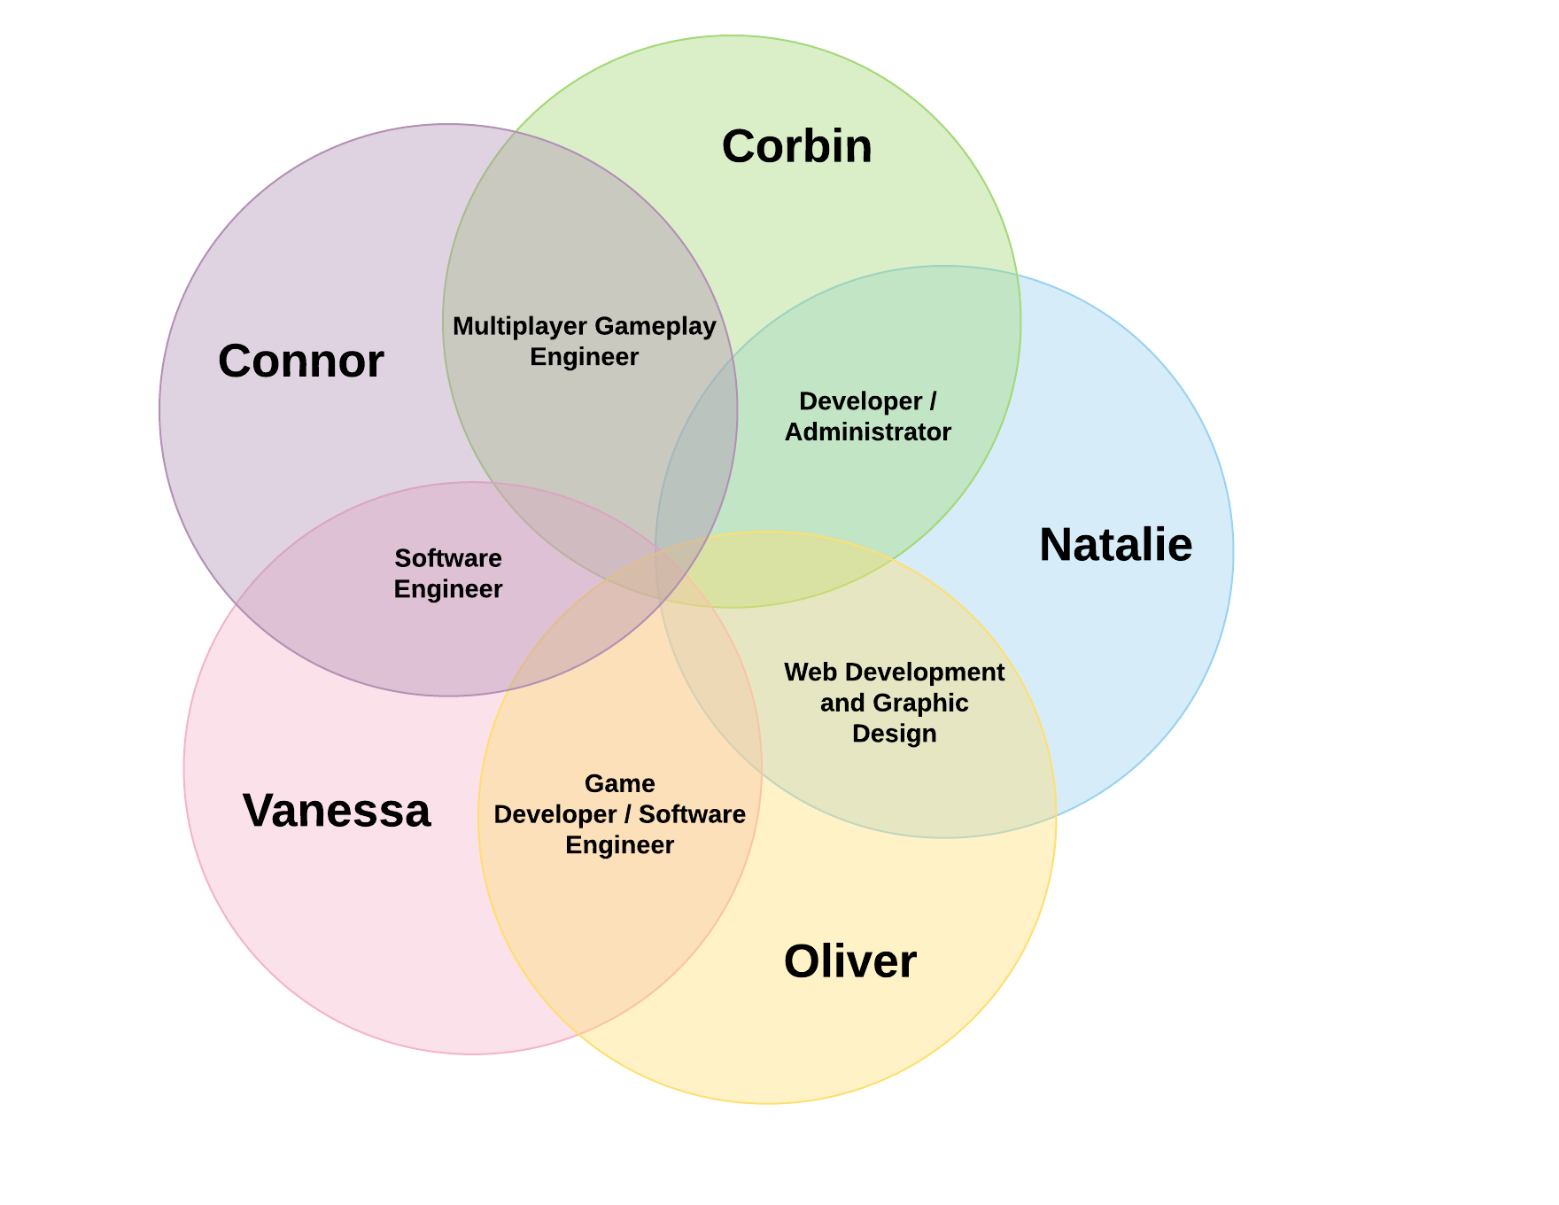

**4. Tools**

Website: <https://teamxvi.tk/index.html>

GitHub: <https://github.com/nataliecursio/XVI_A3.git>

As a group, we have used a variety of tools in order to complete the tasks required. We have collaborated daily via Discord chat and caught up frequently via Discord voice chat. In doing so, this has enabled the team to continue engaging throughout the course of the assignments but also keep on track with full transparency of progress.

We continued to use Google Sheets to keep track of tasks and who they are assigned to, expected completion date and actual completion date. We continued to use GitHub and commit our work to the repository using Microsoft Word. A couple of the members of the team used GitBash to push to the repository.

Visual Studio Code was to create our website by using .html and .css. Adobe Photoshop and Illustrator to create our logo, Adobe XD to create our app demo, ~~Lucidchart and Microsoft Excel were used to create our graphs~~ as well as using FreeNom.com to reserve the website’s free .tk domain name and for DNS management.

We used Canva and Google Docs for our storyboard… and used “ XX ” for our video presentation.

11 years of research of Tech Trends prepared by **Delloitte.**

*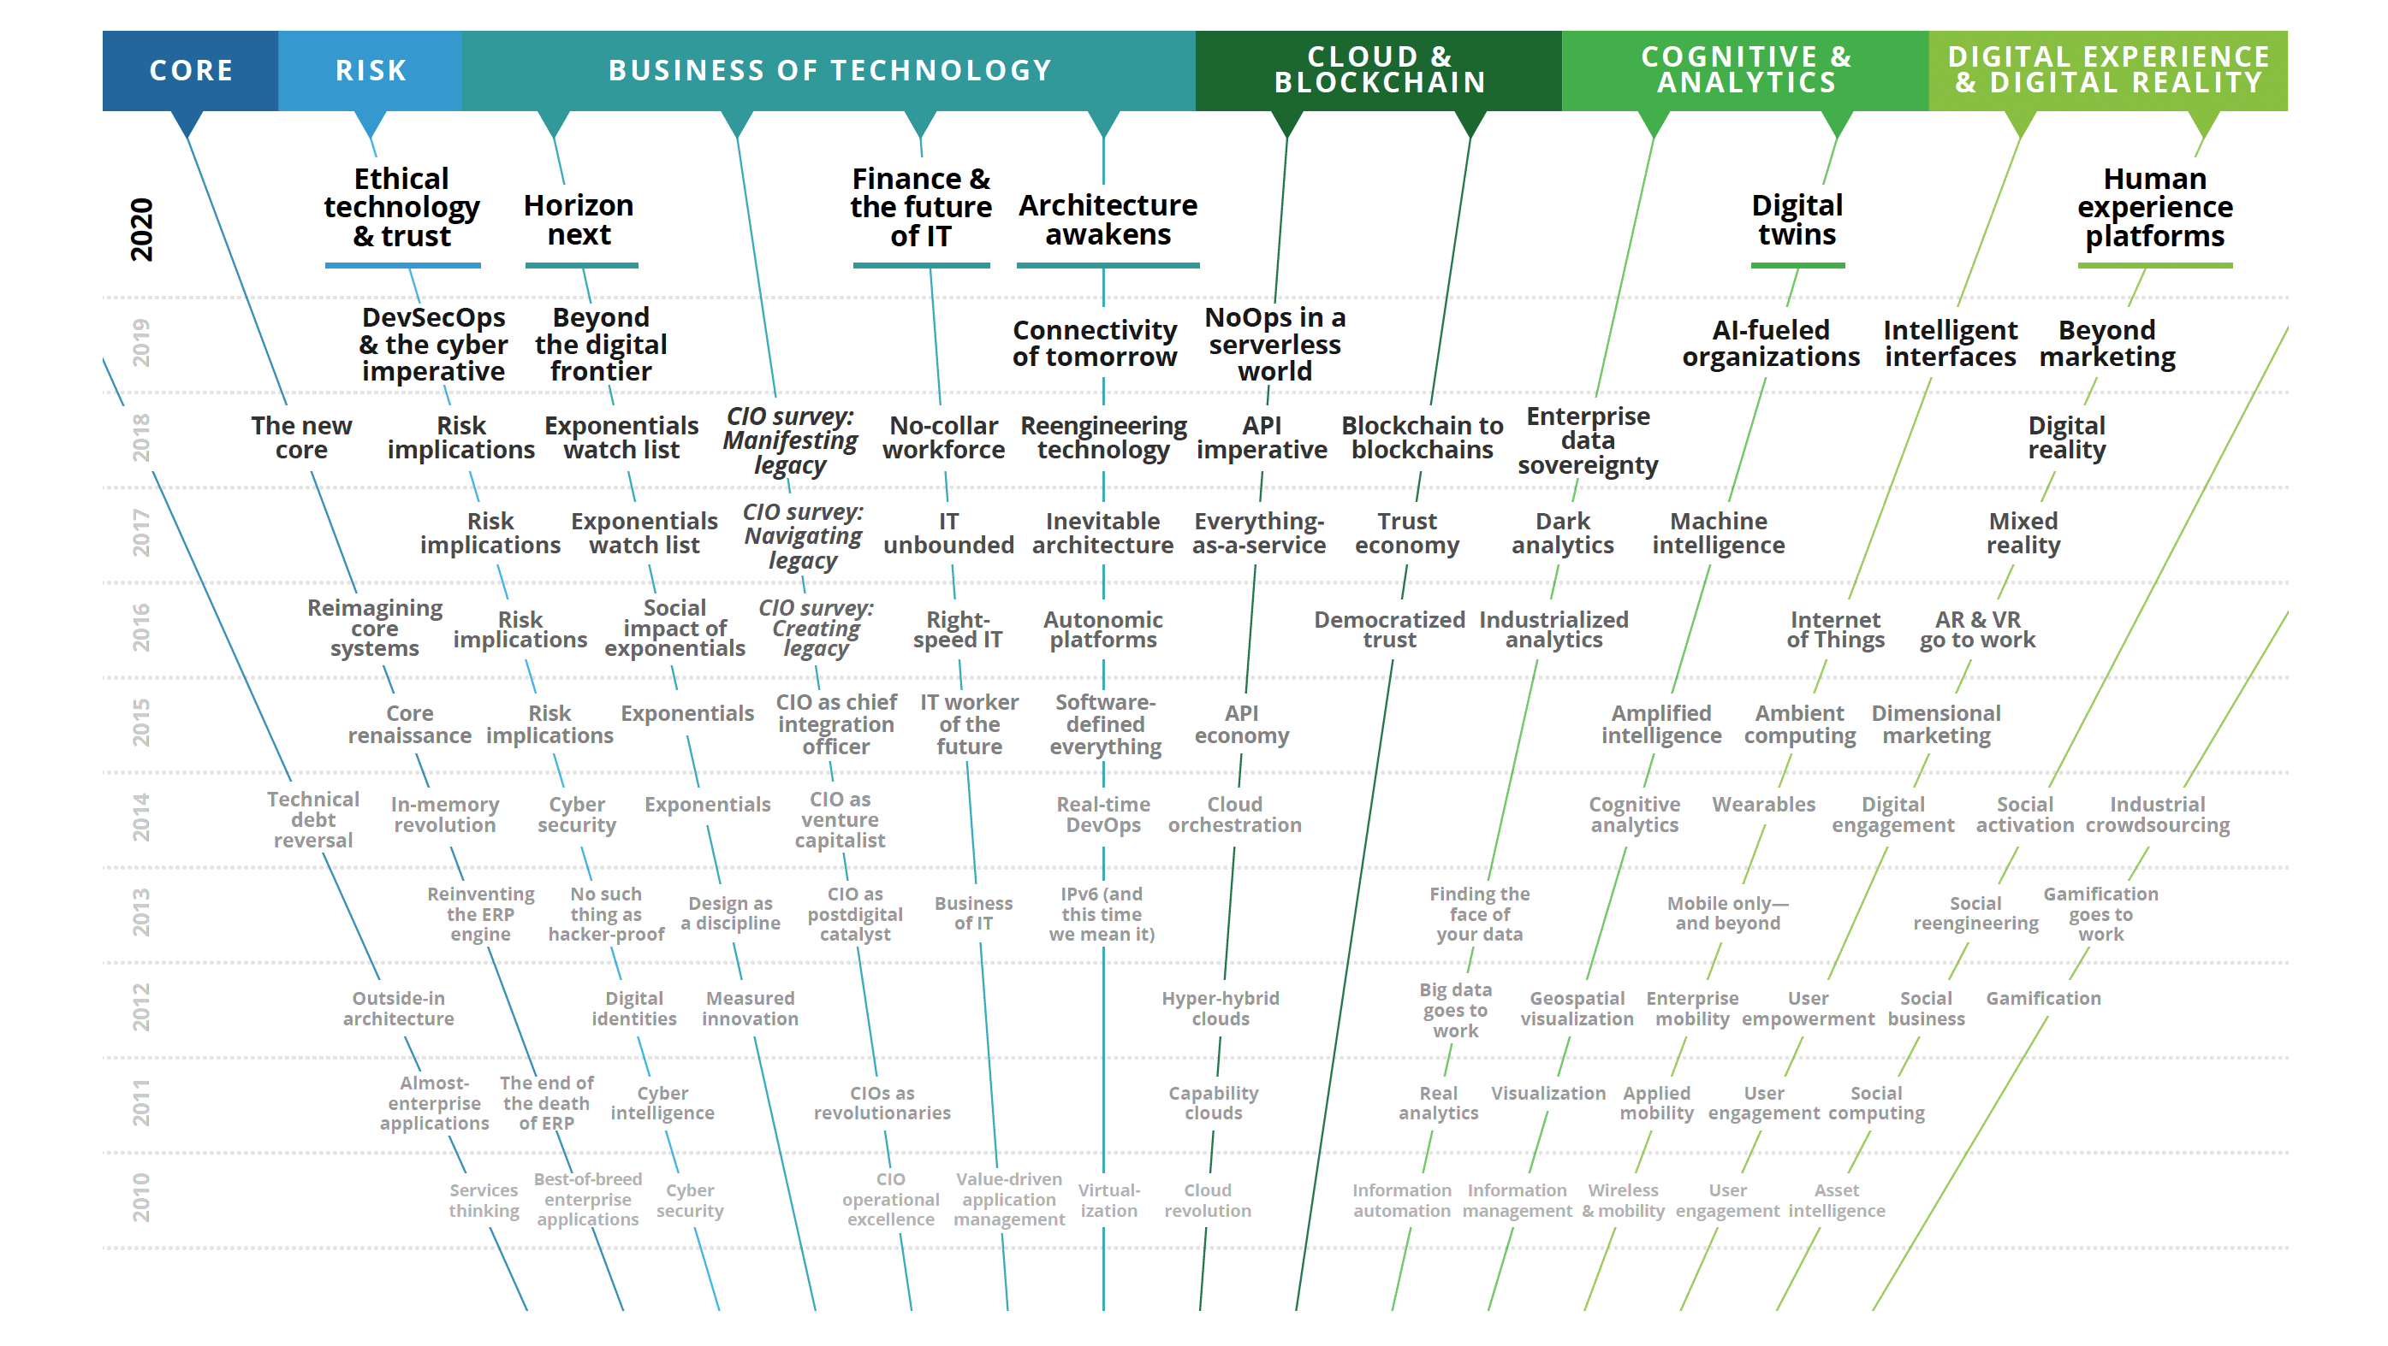“Deloitte’s 11th annual Tech Trends report provides insights and inspiration you will need for the digital journey ahead. Several of this year’s trends are responses to persistent IT challenges. Others represent technology-specific dimensions of larger enterprise opportunities. All are poised to drive significant change and transform business in unpredictable ways.”*

**5. XVI Project: The SocialCare Chat**

** add logo **

*** add some text here ***



**5.1. Overview**

# Topic – ***Vanessa to add from this to plans and progress***

The SocialCare Chat project is a software developed by XVI to make digital communication easier for the elderly. With the current climate of COVID-19 having many care facilities in lockdown, and residents unable to have physically communication with family, software such as this would allow the elderly to be able to easily communicate with their loved ones. The platform will be developed with a focus on how to make digital communicate easier for those who may struggle with using it. The SocialCare Chat won’t only focus on voice communication, it will also give users to ability to video call, play games together, and share multimedia – with further developments to come in the future.

The big picture for The SocialCare Chat is that it will be widely distributed among care facilities around Australia, and in the future distributed worldwide. Our software will be available on a range of different devices, and able to be easily installed at elderly care facilities by our technicians. This software also has the potential to be developed around the needs of those with a disability. The SocialCare Chat will be a great starting platform for the elderly that are unfamiliar with the use of digital communication, and may also help reduce any anxiety that they may feel when using technology. XVI’s main focus for this software is to help the elderly feel more confident in their ability to use technology, and feel more connected with their loved ones.

# Motivation

The motivation behind this project came from one of the XVI team members, who wanted to make digital communication with his grandfather easier. This software is important because it has the potential to help with any feelings of loneliness that the elderly may feel, especially those who are in care facilities, as they will be able to communicate with their loves ones whenever they want to. This fits into the current IT trends as with the current climate the world is in, face to face communication is something that is becoming more limited every day, making digital communication essential. This software would show any future employers that we can code and develop communication software. Further, this would show any future employers that we care about making software that will make a difference and have a positive impact on the users' life.

# Landscape

There are several similarly developed software and applications that allow users to communicate digitally, examples of these products include the likes of Skype, Facebook Messenger, WhatsApp and FaceTime on iOS devices. In contrast to these competitors, we at XVI are focusing on and designing our product around the needs of elderly users, keeping ease and accessibility at the forefront of our development focus. Transparency, privacy and security are integral to the ethics and morals of XVI – we take user privacy and security seriously, and will endeavor to focus on protecting users and their data, unlike other companies that potentially seek financial gain from exploiting user data on software such as this.

**5.2. Detailed Description**

Aims – Natalie

Plans & Progress – Vanessa : Almost finished, just under review

*******************

From the Royal Melbourne Institute of Technology University, a group of five individuals, XVI, have come together to expand on an idea that was born during these unprecedented times we face through the COVID-19 pandemic, introducing The SocialCare Chat.

The SocialCare Chat will connect the elderly or those with a disability, to their loved ones and allow them to engage through the use of technology. All members from XVI have such fond memories with their grandparents, some members also have close family members with a form of disability. Experiencing firsthand the struggles our loved ones go through has given us the motivation to create an application specifically designed for them, so they too can be connected.

The COVID-19 pandemic has caused us to be disconnected and isolated. The only way to connect is through technology. The focus of this application is to make digital contact with family and friends uncomplicated for those that may struggle with technology, we will also incorporate brain teasers for those that enjoy games.

We are filled with passion and determination to develop our application. Although the depth of creating a web application was not initially realized, we have taken a step back to plan the development of the application first, designed for the elderly. As time progresses, we will look to expand on a mobile application and to develop a design for those with a disability too, initially focusing on a web application to ensure accessibility for everyone. It is important that we get this right and cater to our market accordingly.

*******************

The SocialCare Chat project will require various technical skills to successfully create and launch. The team at XVI worked really hard over 6 weeks with the hope of having a beta product. XVI was unable to meet the demands of creating a web application due to the extensive work that is required, therefore they predict their beta product will be ready by September 2020.

The SocialCare Chat application is intended to be in the form of a web application that is intuitive and user-friendly for our beloved elderly initially. For The SocialCare Chat, we aim to have voice-operated commands, a navigational layout that is simple to understand, along with the use of buttons.

We intend to use clear and concise language that steers clear from jargon and any form of millennial language. Ideally, we hope to implement different language options as we work to cater our application to as many people as possible. Languages will be analyzed to determine the most common language in our Australian elderly population, as well as considering the depth of the language. Languages we will consider implementing in due course will be Italian, Greek, Arabic and Mandarin/Cantonese.

We wanted to understand the psychology of colours and utilize such colours that will resonate with the elderly generation and have a positive influence. The colour scheme we have chosen will be that of a simple setting with a blue and white theme; we have chosen blue as it calls to mind feelings of calmness and serenity.

The SocialCare Chat will consist of few features as we aim to solve a specific need, which is connecting the elderly with their loved ones; this will be through the use of text, phone and video chat.

As a starting point, the home page will have a login or sign up option, there are two options when signing up depending on your age. We have designed The SocialCare Chat specifically like this so the end-user experience will be catered to them specifically. For example, the design of the elderly interface will be clear and simplified. Whereas the alternate interface will have additional functionalities and a slightly different interface. This is to ensure every one of all ages can use the application and those that require additional support can get it.

**The elderly interface**

Connect with loved ones:

The text function will be a simple design for ease of use and will ideally have various language options so those who may not understand the English language as well as their own native language, can still connect with their loved ones with ease. Our beloved elderly will also be able to send and receive photos through the text interface (provided their phone supports it).

The device function will essentially be used exactly as a standard device keypad is designed, however, the difference is that they do not need to search for names and numbers, they can identify their loved one through a photo. The aim is to minimize any sort of confusion and overwhelming feelings they may encounter when attempting to go through the phone's address book. To make the call, they will need to locate their loved one by their photo (and name), simply select call and choose between voice call or video call.

The video interface will also be very simple, there will not be additional functionalities such as filters. Only the option to change what way the camera is looking.

The final feature of The SocialCare Chat is the games! It is important to keep the brain as active as possible and to exercise the muscle, so we aim to have a variety of the games that our elderly generation may find interesting enough to get involved. Initially, we will look to include games such as chess and checkers, and cards and continue to add games and brain teasers as time progresses.

All aspects of the application are important and have a pivotal role. We must design the web application to be user-friendly and intuitive. We will roll out the application directly to the web for ease of access.

*******************

There are three main online application development tools: Amazon Web Services (AWS), Google App Engine and Microsoft Azure. We intend to create a web application that can also be accessed in a mobile format. After careful consideration at XVI, we have decided to go with Microsoft Azure in conjunction with Eclipse IDE as our development suite, storage warehouse and launching platform.

Microsoft Azure offers extensive testing and DevOps tools, expansive middleware, an enormous data staging ground that scales with usage, virtual machines to use as containers and simple compatibility with Eclipse for front-end support as well as an unimaginable amount of other functions.

We can use Java to code the back end and JavaFX for the front-end in Eclipse. Both offer fantastic platforms to work off and have shared functionality between the two. After the development of our application, we can perform containerized testing against massive, pre-structured data-pools created by Microsoft, also in Azure, that replicate devices in real-world situations. This ensures we can perform thorough testing without having to establish real-world scenarios, expanding the scope of our testing, and allowing us to ready ourselves for the market. These tests will then allow us to go into alpha-testing in isolated, situationally specific, environments like aged-care facilities and schools.

As SocialCare Chat grows, so will the staging ground set by Microsoft Azure. With extra data availability and future development capabilities always at-the-ready Social-Care Chat, like the market and our families, never has to stop growing.

***********************

Upon launching our application, we will need to commence with the marketing of The SocialCare Chat. We know that our target market will be generation X, Y, and Z as they will be the ones to decide if it is right for their loved one and create interest with their elderly friend or family member.

The first stage of the XVI advertising and launch plan for The SocialCare Chat will focus on creating brand awareness through the likes of social media such as Facebook, Instagram, and YouTube. We will aim to attend various age care facilities and demonstrate our application to the elderly, their family and friends that are visiting as well as the workers. We know that our application will thrive through word of mouth marketing therefore it is imperative we show them the product, how easy it is to use and the benefits.

The second stage of our advertising plan for The SocialCare Chat application will be through using print media, radio and television advertising to create further brand awareness around our application that aims to solve the current disconnection. A variety of promotional content will be required, such as images of individuals using our application, and a short informational video that can be used for television. The advertisements will all focus on the benefits of The SocialCare Chat, the ease of use, our contact information, and how to download the application.

We are looking to invest heavily in our marketing; therefore, we must ensure that we market correctly by sourcing professionals. Throughout all of this, we will gather and analyze data from all aspects of marketing we invest to better understand what marketing approach performs effectively so we can continue to invest our time and money in the right areas.

***********************

XVI wants to create a web application designed specifically for the elderly and those with a disability. Together, we devised a plan on how we will go about creating our beta application. Initially, we explored and compared Microsoft Azure, Amazon Web Services and Google Engine. We ultimately decided to use Microsoft Azure. The entire team signed up and proceeded to learn Microsoft Azure, only realizing how extensive the platform is. It became a little overwhelming for all and with little time, the team was starting to stress.

Whilst attempting to learn Microsoft Azure, we were also working through how we were going to develop the desired applications. We investigated the use of a third party such as Flutter or Appy Pie however, we were not satisfied with these options because we would not own our data. We also considered learning a new code language and developing the application/s from scratch.

As a team, we decided to do it manually as we would learn more from the experience and develop our newfound skills. More investigation of a range of software and code languages was done to decide on what we would use for this component. As half the team was comfortable with Eclipse, we decided to continue using this software and coached the others how to download it if they were interested in potentially learning. The language we chose was Java as half the team is currently learning something similar in RMIT’s Introduction to Programming, so we thought we may be able to easily transfer what we have been taught and learn along the way. We opted to use JavaFX as this allowed us to put together an application GUI and Java would code such an application, without us being able to source code online. We thought this would be the easiest and most effective way of developing our applications. We also chose to use JavaSE 8, Java JDK, e(fx)clipse and Gluon Scene Viewer as plug-ins, languages and development kits.

The team decided it would be useful to start learning Java and JavaFX through the use of YouTube, we found a channel that had 68 videos at approx. 13 minutes on average. The team felt quite overwhelmed however began watching Java tutorials.

It was at this point that a team member put their hand up to say they could not take this huge project on over the coming weeks due to work commitments. It was then another member from the team reached out to the group's tutor to discuss actual requirements of assignment 3 as we felt maybe we were being too ambitious; after this conversation took place, we realized we were. The team rejoined and reevaluated what needed to be done and instantly felt like they were back on track with a clear understanding of what needs to be done.

The next steps the team took was creating a storyboard for the mobile application we intend to make. We took on different research topics that allowed us to deeply understand what we needed to do, the skills and time required to achieve our project.

* Phase one: Launching a web application specifically for the elderly.
* Phase two: Develop our application to include an interface designed /catered to those with a disability.
* Phase three: Develop our mobile application for both elderly and those with a disability on both platforms.

*******************

The SocialCare Chat is quite a big project so rather than focusing on the development of the applications, we proceeded to focus on what our desired result will be exactly, how we will achieve it, what we will need for it to be successful and when do we want it ready by.

We began by creating a storyboard of how we want our web application to look, covering design and functionality features including the following:

XVI aims to have an application that is user friendly...

* + - We will do this by using big buttons and clear, simple text
    - We also want the elderly to know we have designed the application for them specifically so we will use images and colours that will hopefully resonate with them.

Functionality:

* + - When signing up to SocialCare, there will be an option for those 65 and above
      * Here they will register their main contact
      * This connects their loved one directly and allows them to assist and control settings
    - Once signed up, the interface is simple and straightforward
    - The next screen will have four options for the user to choose from including:
      * Chat
      * Games
      * People
      * HELP
    - The chat option allows them to decide between:
      * Text chat
      * Video chat
      * Voice chat
    - Through the games button, they will have access to play a range of games and brain teasers
    - They can also opt into challenges and compete against their connections
    - The use of photos is there for the elderly to be able to identify their connections with ease
      * Once they select their connection, they can decide to chat with them or play games with them directly (without having to search)
    - They will also be able to view who has requested to connect with them and approve/decline accordingly
    - The HELP function allows them to notify their main contact that they are having issues
      * We plan to collate data of what the main concerns would be and intend to have a few options they can choose from, however, to begin with, we will look to only have a password help option
    - Those 64 and under will have a separate login and will not need to register the main contact
    - Their layout will be similar however will have an expandable navigation bar on the left
      * This is where they will be able to access the controls of their elderly user
        + Assist when they require HELP
        + Update setting preferences etc.
      * Manage their main connections (they can have multiple)
      * Notifications
      * Access games and chat features
      * They also have the ability to “add connections”

Roles – Vanessa

XVI began planning their project 6 weeks ago and together they have collaborated and extensively researched requirements for The SocialCare Chat. There are many vital roles that contribute to the what, how, why, and when in order to successfully design and develop a successful, game changing application.

Due to the depth of our application we are not at the stage of having specified roles as such. Each member has contributed to different aspects of our application which has allowed us to further develop a plan for our project.

* Connor, Corbin and Vanessa focused on research and requirements regarding The SocialCare Chat application
* Ollie focused on team analysis
* Natalie focused on the designs for The SocialCare Chat website, as well as the app demo and video presentation
* Vanessa also focused on the final report and management of the team

We found that having this set up worked best for our team as there was still a lot of discovery and collaboration required. The team did this on topics throughout and managed to align their thoughts on the desired result and flesh out what we think will and will not work.

Moving forward, based on strengths of each individuals and roles that are vital to success, we would see each member taking responsibility for the following roles.

Designer – Natalie

* Natalie has a creative side and thoroughly enjoys the formatting and design aspect. Natalie will look to take on design requirements from the planning phase through to execution. Having a designer is imperative as it is the part the end-user experiences, they play a significate role with ensuring the design is intuitive. The final result may sway the end-user to stay or uninstall the application.

Developer – Corbin

* Corbin thoroughly enjoys coding and developing programs, he has picked it up quickly and aims to further his current knowledge quickly. Corbin will look to take on the development aspect of The SocialCare Chat. Having a developer goes without saying, we need to ensure we have the technical skill and mind to develop a fully functional application, as well as debug. They also have a significant role with ensuring the application is efficient and effective.

IT Security and Cybersecurity – Connor

* Connor is very protective of his personal information and data, he already has an extensive understanding of the space. Connor will look to oversee the IT security and cybersecurity element. Having sufficient security is of utmost importance for the business, as well as our customers.

1

Project management and QA analyst– Vanessa

* Vanessa has experience in managing people and project phases, Vanessa will look to take on the project planning and testing of our application. It is essential to adhere to timelines, project phases, and budgets and ensure team expectations are clear. A crucial piece to our application being successful is the testing of The SocialCare Chat, documenting issues and overseeing that errors and bugs are corrected.

Marketing and data analysis – Ollie

* Oliver is also creative which is why he will look to take ownership of the marketing facet, as well as collection and analysis of data. Marketing is just as important as any other element of the project phase, we will need to have a creative and unique approach in order to increase our brand awareness. The analysis of data is very important, we can study our customer’s behaviour and look to ensure the design of the application is what the customers want to guarantee they keep using it.

Scopes & Limits - Corbin

Through diligent research and heavy discussion by the team, we have been able to lay out the process required to publish a fully operational, ready to launch web application. Although achieving this is beyond the time allocated to us in this assignment, we have a clear vision on what is achievable with the time given.

Team XVI have decided to produce a product pitch and a presentation describing the future invocation of our application. This presentation will involve a concise explanation of the features we plan to add to the final version, our philosophy that led us to make this decision, what the future version of the application may look like and how we believe there is a need, especially right now, for our product in the current market.

Although we do not intend to achieve a fully deployable web application, we have a clear idea of what is required including how to write it, which programs, plug-ins and languages to use, how we eventually host it on an online IaaS and the what timeline to launch will look like. We have covered front-end, GUI development, back-end, server-side hosting and development and extensive testing procedures.

We have also spoken about where we intend to take The SocialCare Chat from here in terms of testing and how we would focus our tests to maximize reviewable data, eventual marketing, which groups of people we would aim to involve in both of these processes and, one day, how it would look amongst the other leading apps in the market.

There are obvious legal and social implications of an application such as The SocialCare Chat. The main concerns are marketing ourselves to people in aged-care facilities, the likely connection to the healthcare industry, ensuring the people connected are suitable to maintain a high standard of dignity and professionalism on our application (no NSFW) and that it is a platform to generate real and lasting benefit towards a cause that truly needs it, now more than ever.

Given the right amount of time, we are confident that we could achieve a web application that is indistinguishable from any other of the market leading products. We believe in our ability to execute it to a high standard, we believe in XVI and, most of all, we believe in The SocialCare Chat.

Tools & Technologies – Corbin : Almost finished

Testing - Vanessa

We will run our web and mobile applications through a range of key tests to ensure the application is functionally correct, easy to use, responsive, compatible and most importantly, security testing.

All testing phases are imperative and we need to ensure they all come back with a positive result in order to proceed. Some tests may indicate bugs, however, such tests may allow us to proceed and continue with the following test, while debugging the issues that have arisen in previous tests. This will ensure that time is being utilised effectively and the team continues to work efficiently throughout the process.

We will know that we are succeeding as we proceed through the tests rapidly and continue to debug and overcome hurdles as they arise.

The most important testing phases is certainly the design and layout as we need to ensure that it’s exactly how we intend on it to be and look to overcome such hurdles that we are highly likely to face; we will align testing to coincide with development.

Upon the completion of all testing phases, we will proceed to do crowd testing which will involve a select number of people to use the application to provide insight and unnoticed issues. We will commence with the family and friends of XVI. After which we look to undergo paid crowd testing with individuals that hold a range of skillsets.

We may also consider doing crowd testing as we proceed to update our application in future as we look to solve a need for those with disabilities.

Below you will find a detailed list of tests we will run and why they are important.

**Web application**

1. **Functionality Testing** ensures the web application is functionally correct. This will check the database connection, links to the web pages, cookies, and any forms used to submit and/or gain information from the user.
2. **Usability Testing** is a combination of functionality with the overall user experience.
3. **Interface Testing** checks whether or not all interactions between the servers are running smoothly. It will also determine whether interruptions by the server or by the user are handled properly.
4. **Compatibility Testing** is to ensure it suits all kinds of screen displays on a range of device types.
5. **Performance Testing** checks the performance of the app under a heavy load as well as testing under a range of internet speeds throughout standard and peak periods.
6. **Security Testing** tests the applications security in order to identify weak points to improvement them as much possible.
7. **Crowd Testing** is done through a select number of people to execute tests that will unravel many unnoticed defects.

**Mobile application**

1. **Installation testing:** Tests need to conduct installation testing to ensure that the user can smoothly install or uninstall the application, this also includes application updates. Ensuring the app does not crash throughout any of these processes.
2. **Target Device and OS testing:** Testing a range of mobile devices and operating systems.
3. **UI and UX testing:** It is important to test the UI and UX, as it is essential to review the look and feel of the application. This testing has to be done from the users’ perspective to ensure that the application is intuitive, easy to use, and has industry-accepted interfaces.
4. **Functionality Testing:** Tests the functional behavior of the application to ensure that the application is working according to the specified requirements. This checks the interactions of the end-user to ensure the app is actually functioning as designed and able to multitask.
5. **Interrupt testing:** Ensuring that users can be interrupted with calls, SMS, MMS, messages, notifications, network outage, device power cycle notification etc. when using the application.
6. **Data network testing:** To provide useful functionalities, mobile apps rely on network connectivity. This ensures the app continues to perform at optimal state with varying network speeds and handle network transitions.
7. **Hardware keys testing:** Checking the hardware and sensors used within the application are working efficiently. For example; gyroscope sensors, proximity sensors, location sensors, touchless sensors, ambient light sensors etc. and hardware features such as camera, storage, microphone, display etc.
8. **Performance Testing:** This involves the testing of load conditions, network coverage support, and identification of application and infrastructure bottlenecks, response time, memory leaks, and application performance when only intermittent phases of connectivity are required. This ensures the application continues to perform optimally.
9. **Load testing:** To test the application performance in light of sudden traffic surges, and ensure that high loads and stress on the application does not cause it to crash.
10. **Security testing:** Involves gathering all the information regarding the application and identifying threats and vulnerability for the application using static and dynamic analysis of mobile source code.
11. **Crowd testing:** is done through a select number of people to execute tests that will unravel many unnoticed defects.

Timeframe – Corbin

Risks - Corbin

There have been many challenges that we at XVI have faced in the pursuit of producing a fully-fledged web application. In the beginning we saw the monolithic effort of creating The SocialCare Chat as something we could achieve in a mere few weeks, even as an early representation of itself, but we quickly realised that was wrong.

When we understood the size of the venture before us, we devoted our efforts to producing early version artefacts that would one day make up The SocialCare Chat. This presented its own set of challenges in trawling through the enormous library of information on web application development software and the many possible paths we could have taken with development, hosting, and platform compatibility.

Our main concerns were:

* **Finding the correct development suite:** There are innumerable options when it comes to making an application that is accessible from any device, from anywhere. Amazon, Google and Microsoft are the market leaders in hosting and development but there are countless other PaaS solutions like Flutter, or platform contextual SDK’s like Android’s development suite.

Through research we ended up deciding on Eclipse, Java, JavaFX, and Azure for hosting.

* **Our ability to use the software:** Only a few of us are learning how to program, and of that few, we are still beginners. This suggested that learning to write in the required frameworks for dynamic web application creation was something that we were all basically learning from scratch and would be highly unlikely to achieve in the time given.
* **The time we had:** With only a few weeks at best, the realistic possibility of writing, debugging and testing The SocialCare Chat before being able to successfully launch something we could vaguely call a reasonable web application was incredibly small. Our only hope was to produce smaller artefacts that would one day make up a whole, but even that would be a prospect.
* **The need to invest our own money:** We arrived at the point that if we wanted to push on with creating The SocialCare Chat, we would need to invest our own money., as a subscription service, specifically in-regards-to hosting and user data accessibility. Some of these costs may end up being substantial, with no guarantee of return on investment.

These were very real concerns to us, and heavily influenced our choices with how we would move forward. Our target has been to be as realistic as possible and produce something in line with that scope. Weighing the risks has directly led us deciding to make a presentation of a future incarnation of The SocialCare Chat, while developing the body of the application alongside.

To only look at right now would be foolish and although short term problems have led to short term decisions, we have also discussed future possible ramifications of application development. An applcaiton is something that grows relative to user interaction, and that is a largely unpredictable force that we would have to have accurate plans to combat.

In setting ourselves up for success we discussed the following future possibilities:

* **The competition:** There are many other key players in the world of peer-to-peer video chat on familiar platforms that many people already have downloaded. We saw that there is a need to distinguish ourselves from the others by creating an application that is niche and easily accessible for elderly people that also develops a medium to facilitate a connection between specific people.
* **Unforeseen costs:** Hosting, testing and development time are expensive and time consuming. As The SocialCare Chat grows larger than we can manage, we would also need to hire employees, introducing wages, superannuation, and additional management requirements.
* **Data breaches and malware:** Protecting our data and preventing access to unwanted third parties is a new concept for us. There is no easily accessible rule book to this and takes study and experience to master, especially in large scale web applications, something we are not yet accomplished in.
* **Our choice to launch on the web:** The conventional way of accessing apps for the general user has been through a smartphone, on the OS-specific app store. There are many web applications, and it has been the major player in delivering apps to customers since the conception of the internet but is largely considered the exception today, despite claims that mobile app popularity is on the decline (Lance NG, 2018). Ultimately, we decided to go with a web app as we believe that in the long run it is more accessible for elderly people and is likely to grow in popularity as people realize the widespread benefits.
* **Continuous marketing:** Marketing is akin to the chicken and the egg question; the continuous stream of marketing required to build and maintain public interest in our app is too massive a cost to legitimize without previous interest. Unfortunately, it is the cost required to generate interest in The SocialCare Chat and therefore must be paid out beforehand. Through expansion this cost would increase and could potentially become massive, and necessary, before The SocialCare Chat has developed the coffers to afford it.

Above all else the most important issue to place our attention on is what exactly The SocialCare Chat is and how people would realistically use it. We aim to create and app that actively and directly facilitates the connection between two people, one young and one old. Although we can have a lot of control over exactly who ends up being a user on our app, people are people, and anything could happen.

There are many issues directly related to The SocialCare Chat:

* **Awkwardness:** If the app does not flow and feel engaging for the users it will affect their conversations. Also, people can be incredibly awkward, especially when first meeting each other. We believe it is important that The SocialCare Chat has a good human-interface and to involve “break-the-ice” features like questions or games. We are hoping that traditional games are a good way for both players to bond but for the young to also learn from the wise masters.
* **Technical ability:** The older generations are not necessarily known for their tech-savvy, but the younger is. To combat this, we have decided to involve two “sides” two The SocialCare Chat. The elderly log in would be streamlined and involve bigger buttons and straight forward navigation. We would likely disable most settings, game set up and chat room functions to the older person and leave those to the younger person as it is considered common knowledge for them now.
* **Opinions:** Most Xenniels and younger hold very different values that the elderly did in their time. We now have huge differences of opinion, lifestyle, moral values, and visions of the world. Colloquially known as being “gapped”, this is a very real problem. It is important that The SocialCare Chat helps users find conversational topics that they may see eye-to-eye on and “facilitates” conversations between the two people rather than just throwing a millennial and a boomer into a chat room and letting them go wild. We may need to permanently ban “okay Boomer”.
* **Poor health:** As people get older, their health declines. There will likely be periods when two people have developed a bond but unfortunately the elderly person’s health afflictions increase, putting them in periods of long hospitalization or, in worst-case but highly likely scenarios, them passing. We would need to give the younger person the tools to deal with this and even possibly how to look for early signs of poor health and seek attention for them from a professional. We have even considered the possibility of the users eventually entering a “buddy” system wherein the younger person is alerted to critical health issues of the elderly person like falls or strokes.
* **NSFW:** Let us be honest, this can go both ways. People are unpredictable and putting them on video chat together has traditionally led to a variety of things you would not discuss over dinner with the family. We made the choice to not make it possible to enable NSFW, but it is still going to happen. It will be necessary to develop functions to catch “bad” content, a good public relations process for “reported” content and strong methods to remove, suspend and ban users if they break the rules.

Confident in that we have assessed the most likely risks involved with making The SocialCare Chat, we believe that we have the information required to make the right choices moving forward and have given ourselves the best shot at making something we once considered impossible. The nature of anything customer facing and associated with business is that the challenges it faces will constantly evolve and must be reassessed relentlessly. We are prepared to do this and have a plan-of-action on how we will likely face most expected problems as they arise.

Group Processes & Communications - Vanessa

Over the past 9 weeks, team XVI have kept frequent contact throughout the entire process. In the first week, everyone appeared to be a little apprehensive. The assignment was new and we didn’t know our team members.. However, as soon as one member started conversation, the whole team got involved and since we have had incredible communications throughout our time working together, consisting of jokes, memes, personal information, other university topics, and specifically the assignment at hand.

The team decided to schedule regular weekly catch ups after our webinar with Thomas, this allowed the team to actually catch up weekly in the first 4 weeks through Discord via voice chat and proceeded to chat almost every day regarding the assignment to some extent. All members of the team felt comfortable with each other’s abilities therefore any form of micromanagement wasn’t required. At times, there were members that were difficult to get in touch with as they had other commitments such as work, which also meant they missed weekly catch ups. This meant we had to adjust and ensure all members were kept up to date on progress and next steps. This enabled the team to effectively complete assignment 2.

Throughout assignment 3 and 5, the team kept the scheduled weekly catch up to Thursdays but added another session as we felt it was required; the team continued to chat almost daily through Discord as well. As there were some sessions missed by members due to different reasons (being unwell or working), we continued to keep everyone informed of progress and action items. It also meant we needed to approach things slightly differently in regards to action items for those missing catch ups regularly. This did not affect the way the team worked, it actually helped as everyone understood what was going on and who was doing what.

In any case where members did not respond straight away, within a 12 hour time frame they generally would. There were members in the team that were shyer than others so speaking directly to an individual at times was much easier.

The dynamic of the XVI appeared to change as part of the team struggled with their own hurdles due to different reasons. Towards the end of A3 & A5 the team became quiet and activity dropped, the team worked far more independently with limited communication.

*… more to add after week 11 & 12 collab.*

**6. Skills & Jobs**

Employing people to work at a company is expensive, but the amount of benefits hiring the correct people with the right experience can easily surpass the cons. Being able to have an increased workflow as you have multiple jobs being done by people who have devoted countless hours into that field allows your business have a more polished and complete product. Being approached by a Investor who is willing to fund a project for the next 6 months can cause a huge leap in progress towards a finished product. If an investor provided the funding to employ more people, it could change the entire outcome of an idea.

To take the project to the next phase, 4 different positions deemed appropriate for the project have been chosen. Finding what skills are appropriate for this task is important to ensure the best use of investors’ money, and the best outcome of the project.

Generic skills are an important factor in a good employee. For this project, it requires a strong amount of communication, teamwork and time-management to make the project as successful as it can be.

The most demanded generic skill we would need is communication. Good verbal and written communication skills are essential in order to deliver and understand information quickly and accurately. Being able to communicate effectively is a vital life skill and should not be overlooked. To communicate well is to understand and be understood. Being able to have this quick sharing of information between the team members would mean problems could not go overlooked as the team can easily share this information with one another as soon as they realise it.

Teamwork is an essential skill I would look for in an employee. Not being able to work in a team could leave the group working on the project worse off than without that person. Businesses thrive when they have a diverse team of people who can contribute individual ideas. Teamwork helps solve problems. By working together, teams can find the solutions that work best.

Good time management allows you to accomplish more in a shorter period of time, which leads to more free time, which lets you take advantage of learning opportunities, lowers your stress, and helps you focus, which leads to more career success. Being able to have a full team of people who can manage their time well creates a team you can trust and rely on one another for, which helps create strong teamwork and improve motivation towards the finished project.

The first specialized role to be selected for this team would be a Researcher. A researcher is somebody who performs research, independently as a principal investigator, the search for knowledge or in general any systematic investigation to establish facts. Researchers can work in academic, industrial, government, or private institutions. A Researcher should contain a strong amount of curiosity, commitment and the ability to stay calm, these three skills allow the researcher to look further into topics and find more crucial information that could be missed by others. the researcher will be to bring the team together to identify the main goal of the project and make a road map on how we will achieve this. The researcher will complete an investigation into similar applications and competition. They will also lead the brainstorm into features the team identifies and how to implement them.

Another position offered on the project would be a Designer, more specifically someone with experience in creating products that use UI’s like apps, games and other technologies. User interface design or user interface engineering is the design of user interfaces for machines and software, such as computers, home appliances, mobile devices, and other electronic devices, with the focus on maximizing usability and the user experience. UX Designers need to possess strong C/C++ Programming skills, and Object-Oriented design skills. UX Designers also need to feature a good understanding of common UI design patterns such as MVC and MVVM. The designer will focus on the design of the user-interface and will oversee creating a style guide that the rest of the application will be built on. They will work with the rest of the team to develop a basic mock-up application.

A developer is a computer programmer, sometimes called a software developer, a programmer or more recently a coder, is a person who creates computer software. The term computer programmer can refer to a specialist in one area of computers, or to a generalist who writes code for many kinds of software. Software Engineers are required to have an extensive knowledge in usually multiple coding languages to appeal to more employers. C++ or similar languages is one of the common skills looked for in Software Engineers, but other languages also include HTML, PHP, Java, JavaScript, Perl and Python. The developer should aim to identify the elements of the application and what route will be taken to achieve them. For example, the developer will research ways to implement the communication element, whether it is voice, text or video and how we will make it happen.

One of the most important positions we would need on the team is a market researcher and tester. Market research is an organized effort to gather information about target markets and customers: know about them, starting with who they are. It is a very important component of business strategy and a major factor in maintaining competitiveness. Having someone research our target audience will allow us to create strong marketing strategies to push the product out and reach as many people as possible in the best possible audience. Marketing and testing will firstly work alongside the code. once the alpha is developed, testing the app. They will then decide how to market the app and reach the target audience. Key skills for market research analysts include the ability to cope with fast-paced and pressured work. Accuracy. Strong attention to detail and a strong analytical mind and the ability to notice patterns within statistics.

In conclusion, it is decided that for the project, it is believed that if 4 positions were to be opened, a researcher, designer, developer and marketer/tester would create a good team. All potential employees would need to possess strong teamwork skills, communication skills and great time management skills. Having these 3 skills create a strong team environment and help the project reach a new phase.

**7. Group Reflection**

**8. References**