**A Brief Look at SocialCare code:**

In this document I will be briefly describing our progress so far in terms of development of the ScoialCare Chat. There is much more to do, but as you can see, we have made progress towards the basic framework.

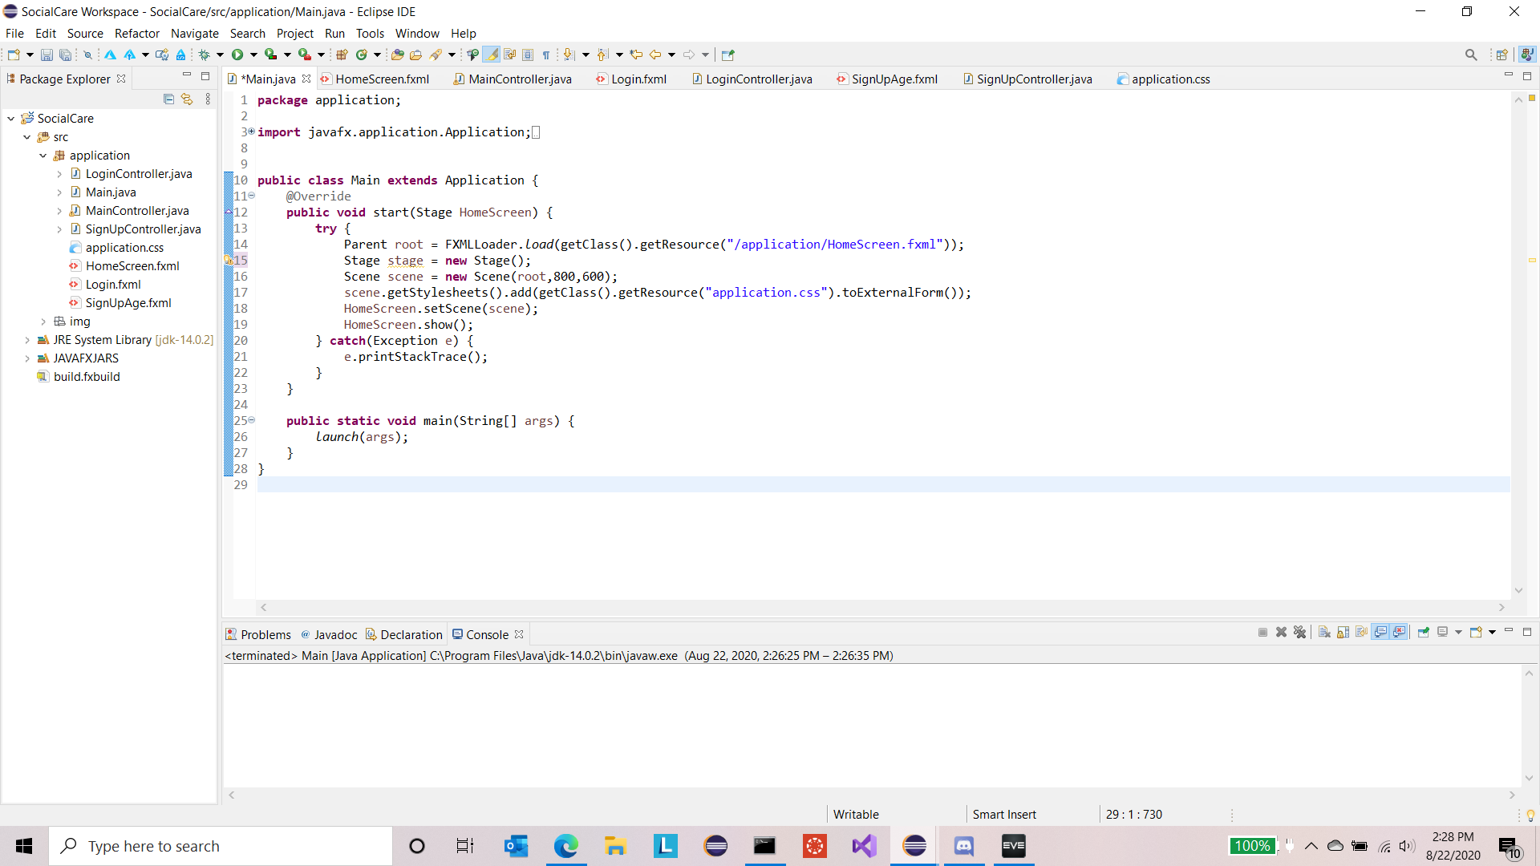1) Here you can see the main class. This class launches the application and sets the initial scene (page).

2) This is the code for the .fxml file, the file that allows us to dynamically create GUI pages in Gluon Scene Builder. This one is for the home screen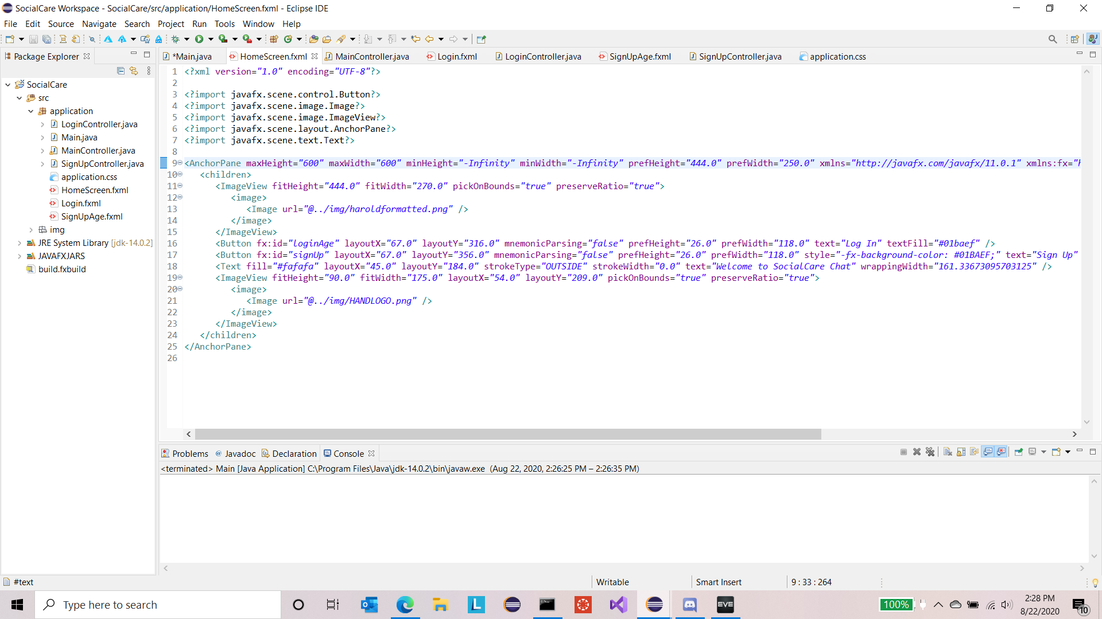

3)Every .fxml file needs a Controller.java file and this one is for the homepage. You can see some progress towards allowing navigation to the loginAge and signUp windows.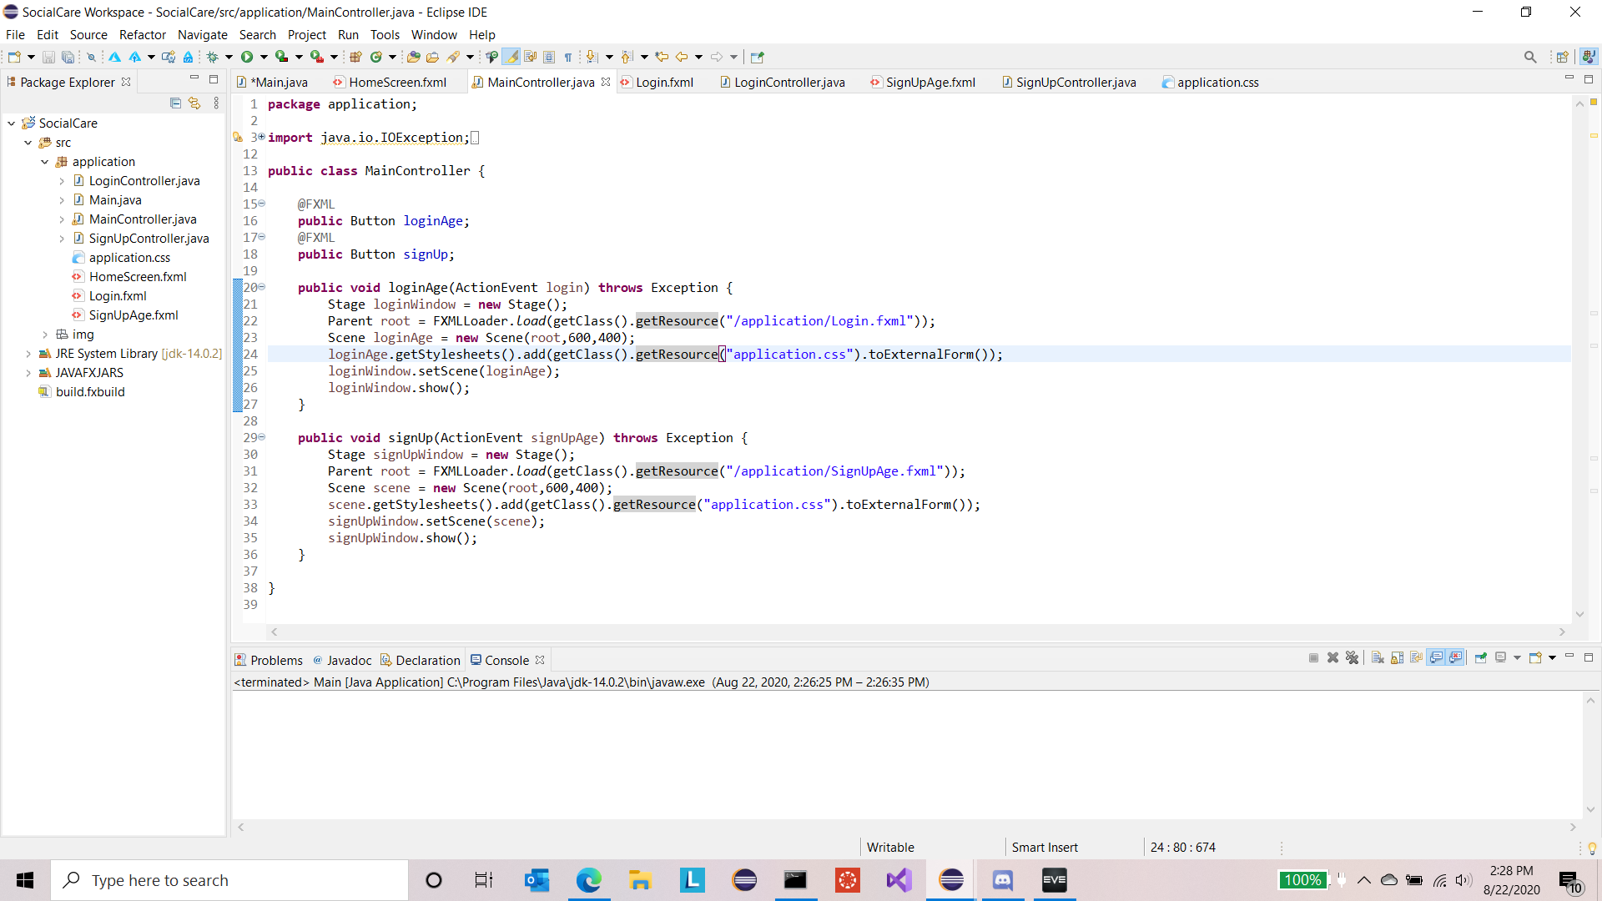

4) The Login .fxml file.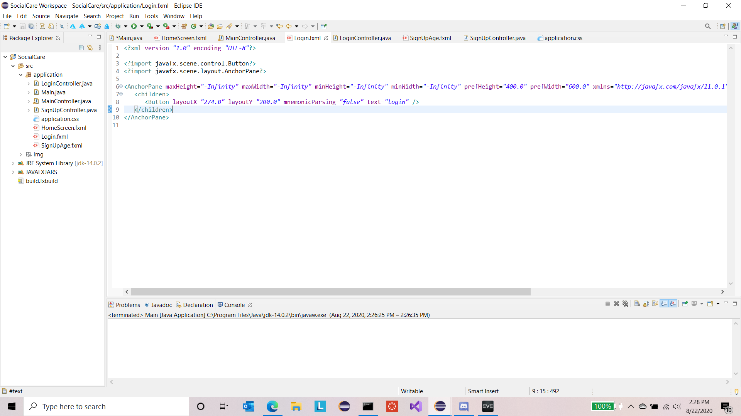

5) And its controller.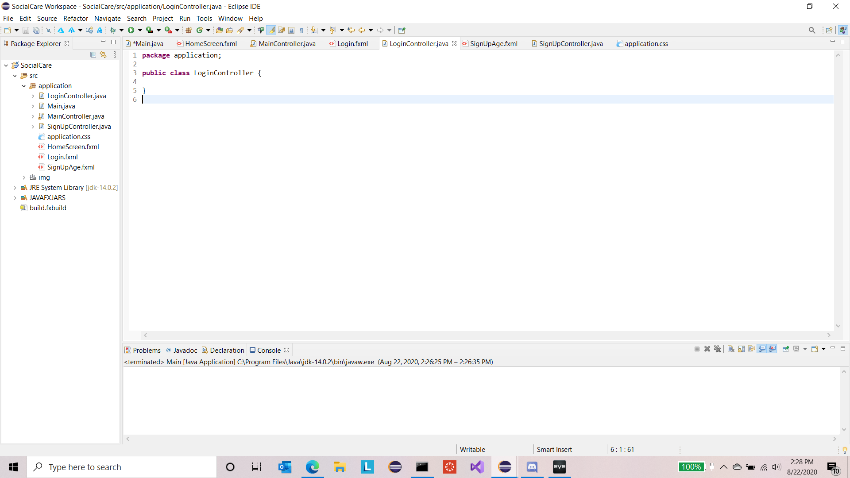

6) The SignUpAge window that will allow users to select between 65+ and other.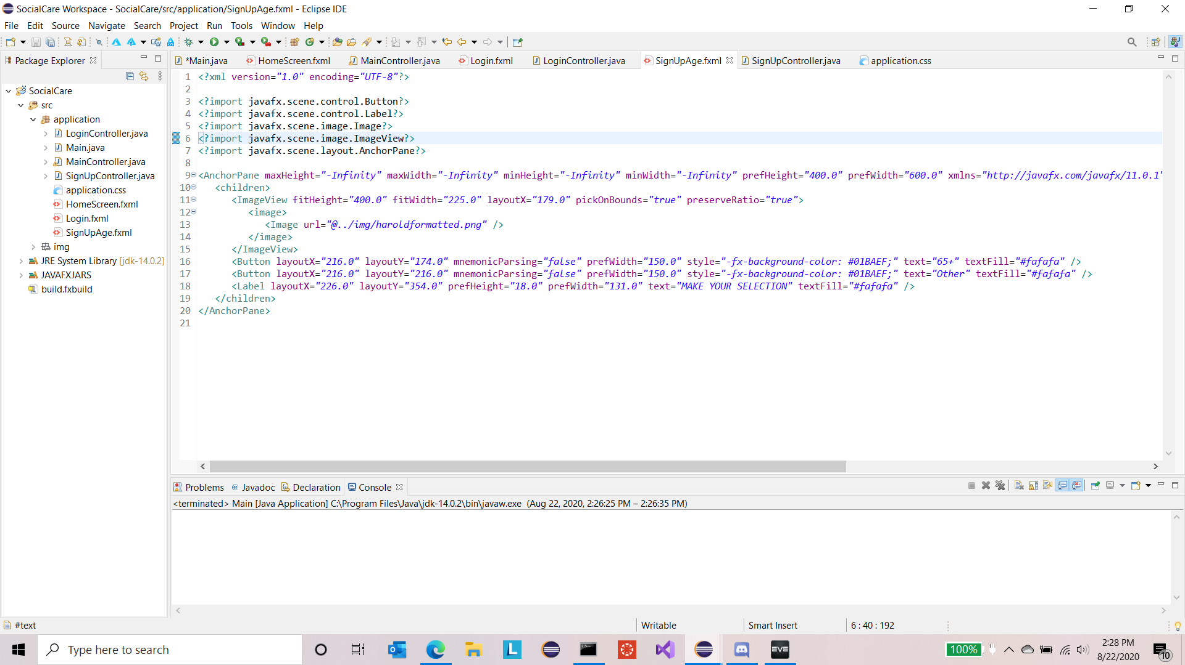

7) Its controller.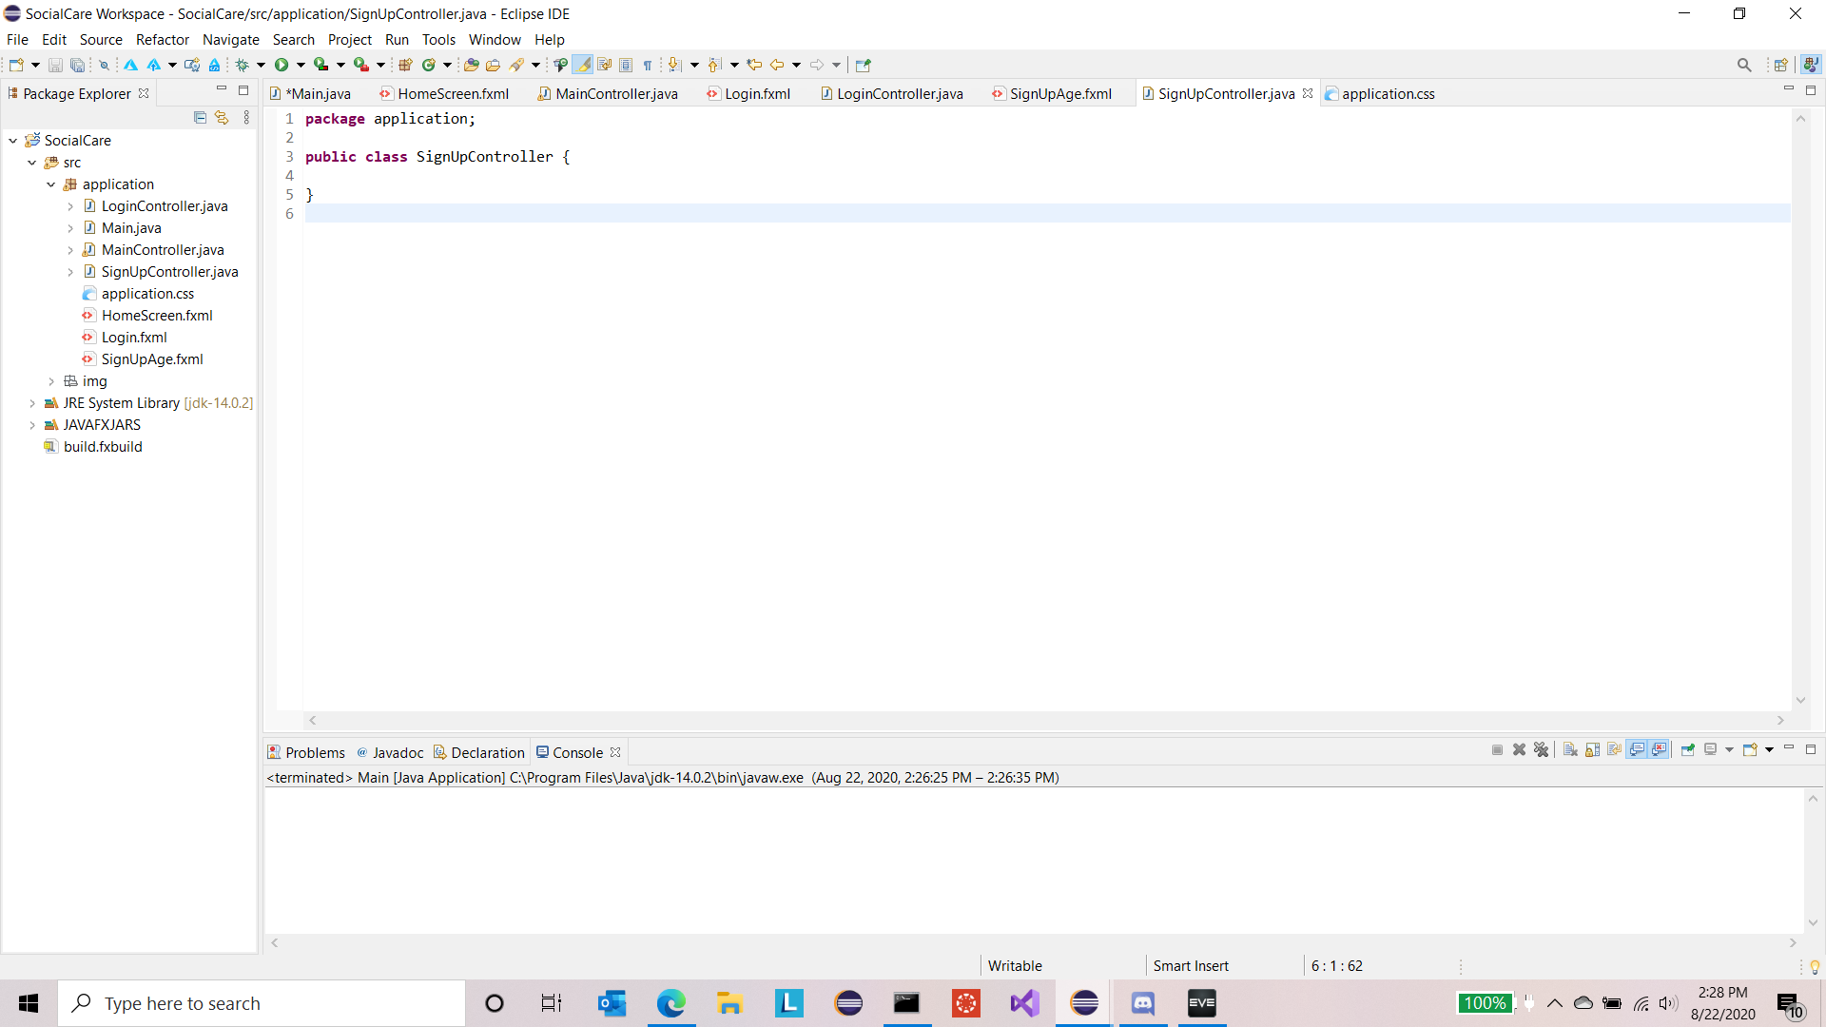

8) This is Homescreen.fxml open in Scene Viewer. You can see the parts of the window in the bottom left drop-box and you can see the “loginAge” method for the Log In button set in the top right under fx:id.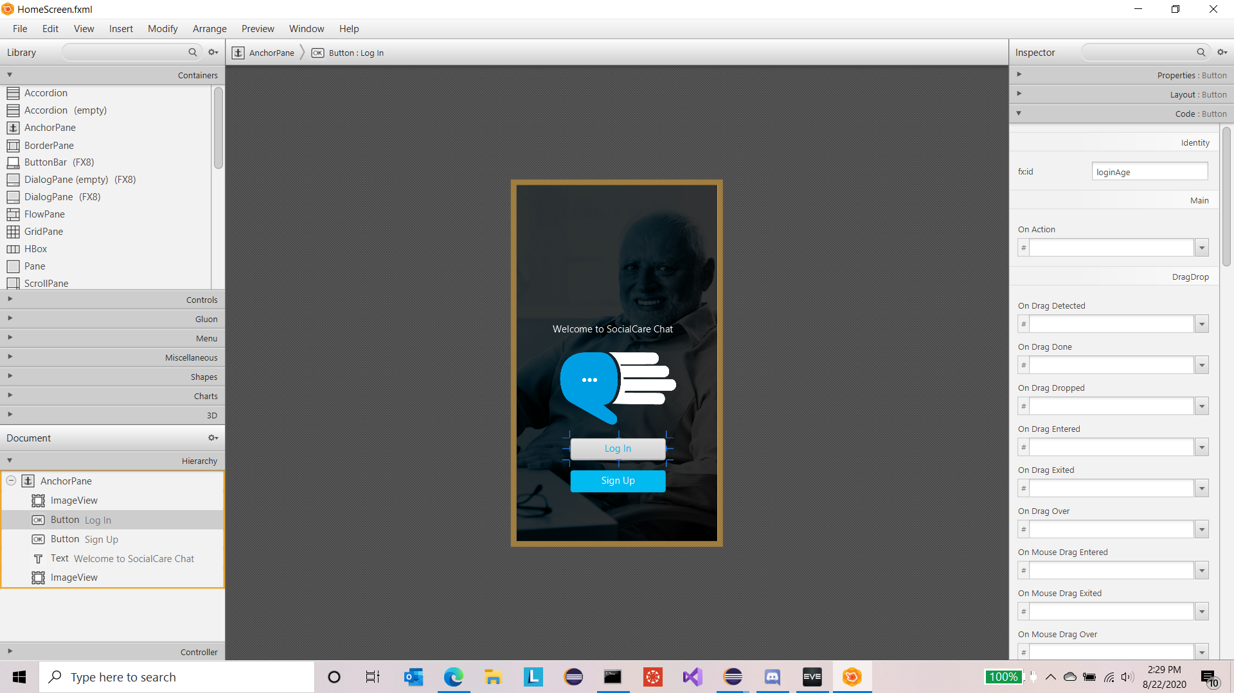

9) This is an early version of the LoginAge window. No methods have been added to it yet, so it is solely a GUI with two unusable buttons.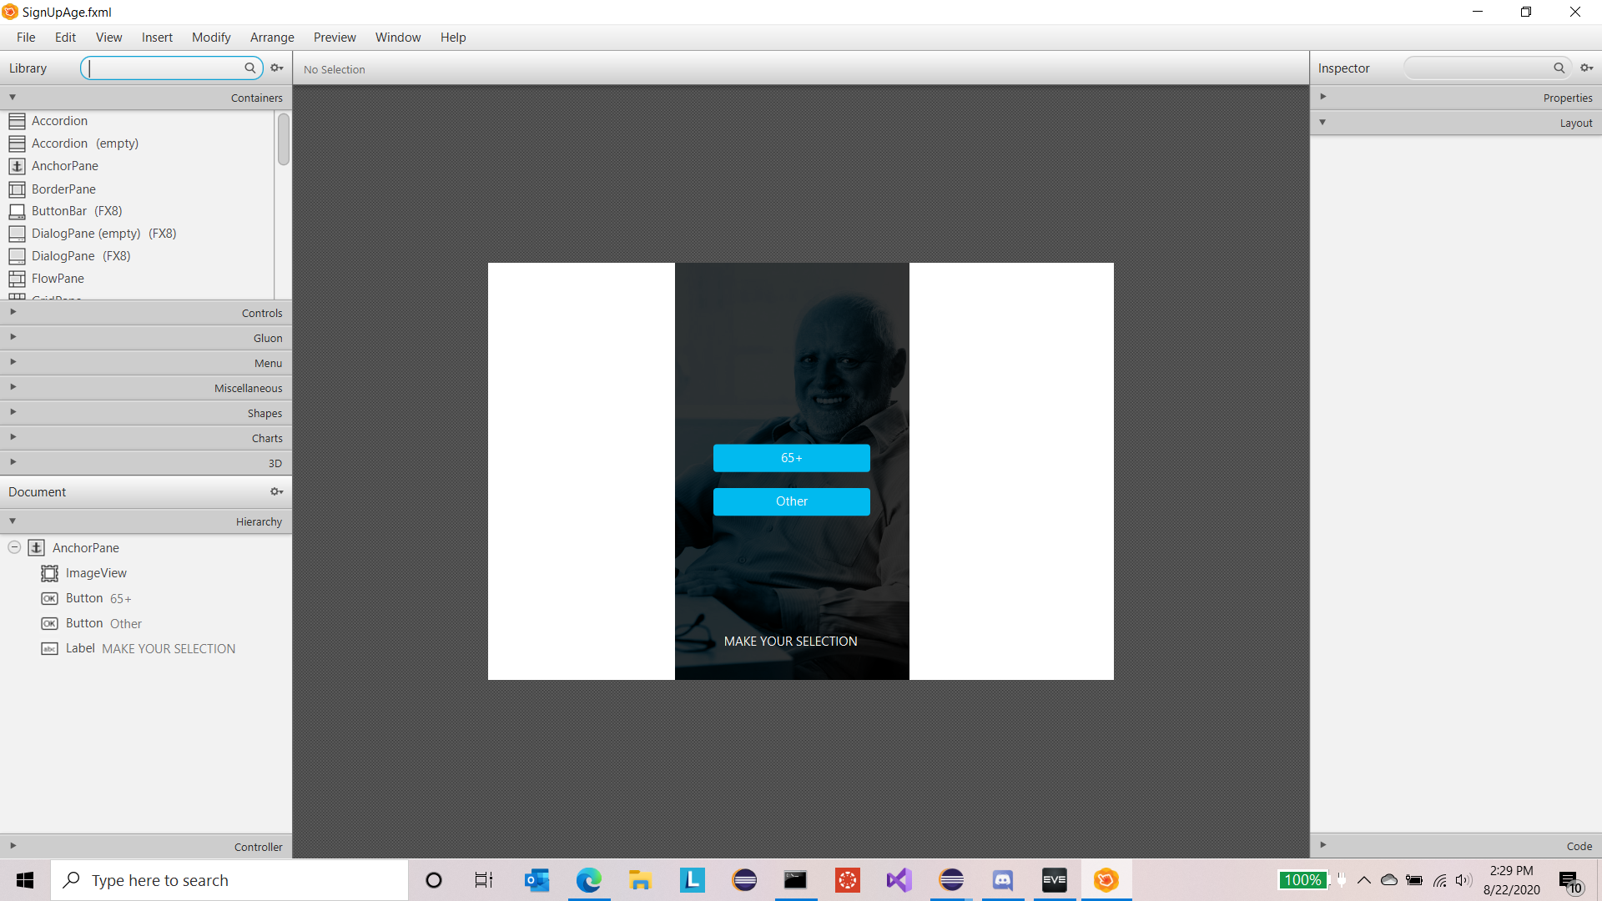

10) This is SocialCare chat running locally. Formatting must be done to allow it to scale to desktop size when accessed via the internet, but this is it, running, in its infancy. 