# Pymaceuticals Inc. – Observations based on data

Pymaceuticals Inc. is a company specialising in anti- cancer pharmaceuticals. The company has been screening for potential treatments for squamous cell carcinoma (SCC), which is a common type of skin cancer. Over 45 days, 248 mice were tested on to compare the effects of 10 different drug regimens.

The data featured an even distribution of male and female data so little bias can be assumed based on mice gender.

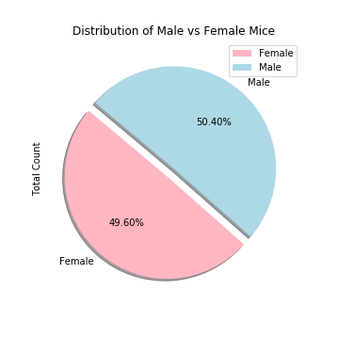

The four most promising treatments revealed to be Infubinol, Ceftamin, Capomulin and Ramicane. Ramicane and Capomulin provided the most promising data with the average tumour volumes sitting between 45mm3 to 50mm3.

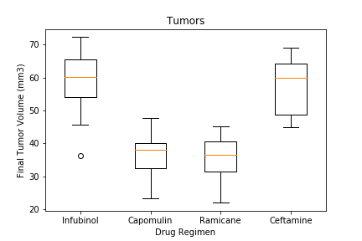

Mouse R944 was selected at random to show the effect of Capomulin over the 45 days. From the data, we can assume that the Capomulin started to take effect at decreasing the tumour volume at around the 15th day. There is a steep decline for 10 days. The tumour then seems to fluctuate between 40mm3 to 42mm3 for the remaining of the study. This may signify that Capomulin is effective at reducing the size of the tumour, but further intervention may be needed to cure the tumour.

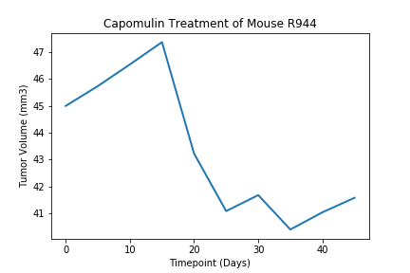

Mouse weight has a positive correlation with average tumour volume for the Capomulin regimen. In general terms, we noticed a trend that the heavier the mouse, the larger tumour volume..

