Message field has asterisk denoting it’s required, but the code isn’t checking that it’s filled.

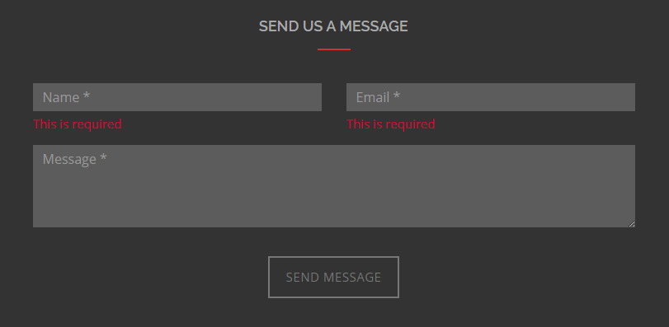

Image in content is overflowing in the X on mobile.



SVG animation doesn’t work on IE.

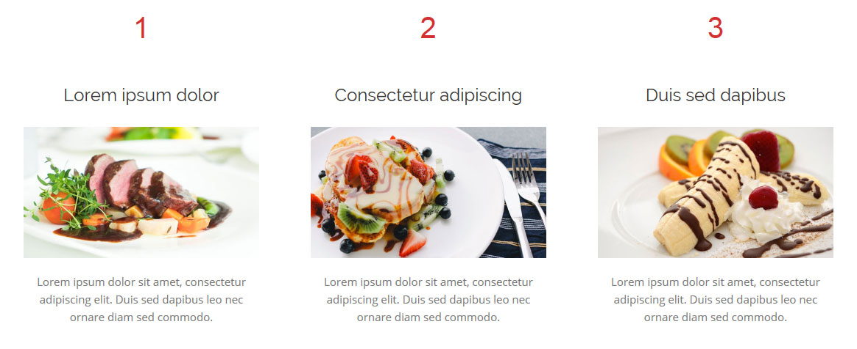

(IE) Console error logged (Unable to get property 'toLowerCase' of undefined or null reference).

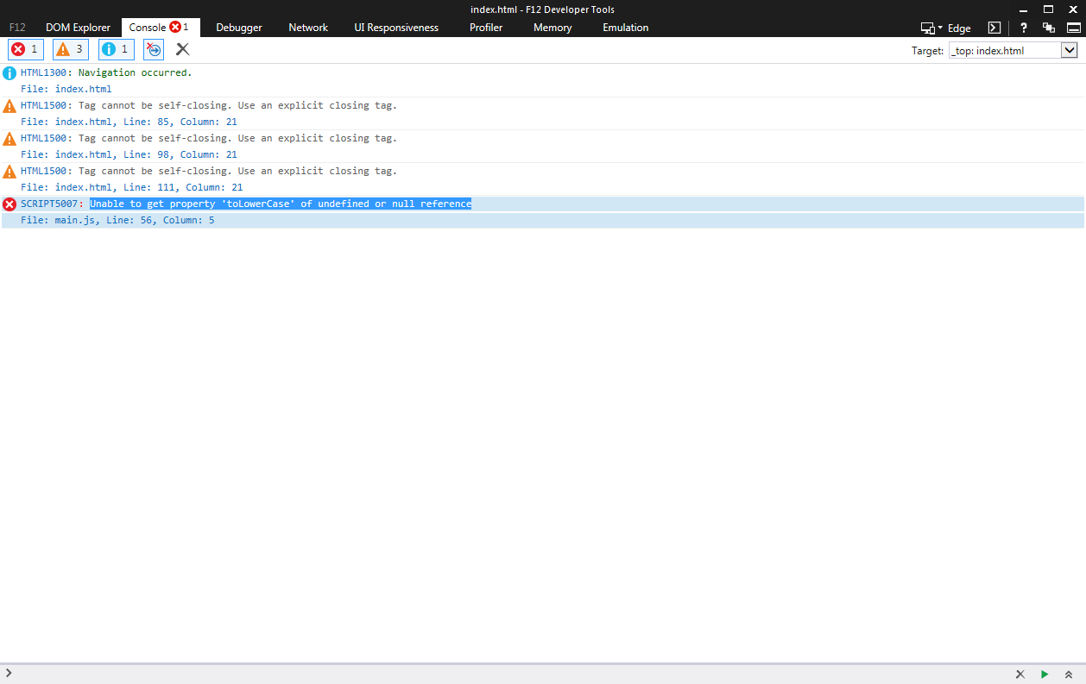

No favicon



Message left in console.

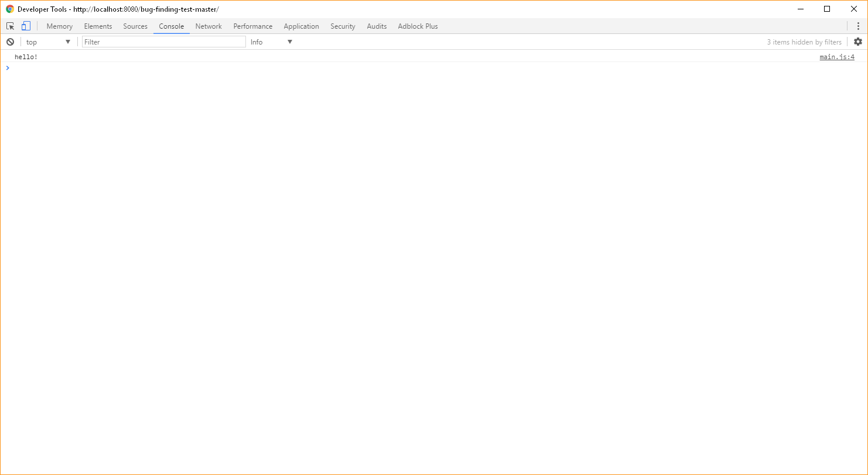

No robots.txt file

No Google Analytics added to the site.

Animation on gallery causes first image to move outside of its wrapper.

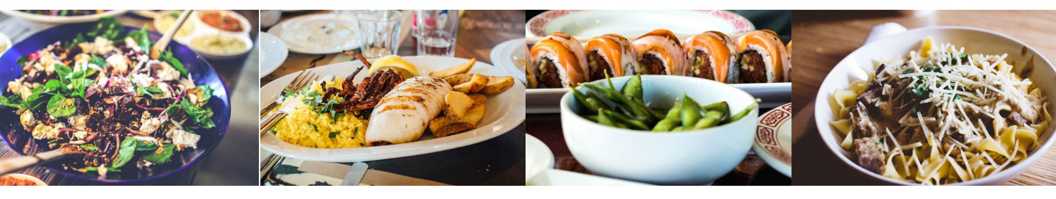

At 375px, menu item "Mongolian Shrimp & Broccoli" name overlaps price.

