**ITEC 4261 JAVA Programming**

**2024 Spring**

**Assignment #6**

(Due date: Apr. 12, 23:59pm EST)

**Important Notes:**

1. Write a program of each question and **submit all source code files (.java files) of each question.** If you do not submit the source code files (.java files), you will have 0 points.
2. **Submit screen captures of each program outputs** using Microsoft Word document. Name the assignment as *Lastname.Firstname_Assgnment1* (e.g. Joobum.Kim_Assignment1.docx) **Problems:**
3. Solve the following question below. (50 points)

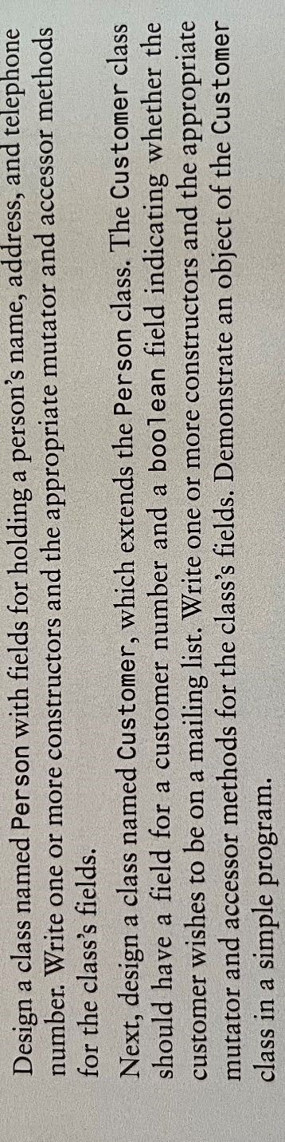

1. Solve the following question below. (50 points)

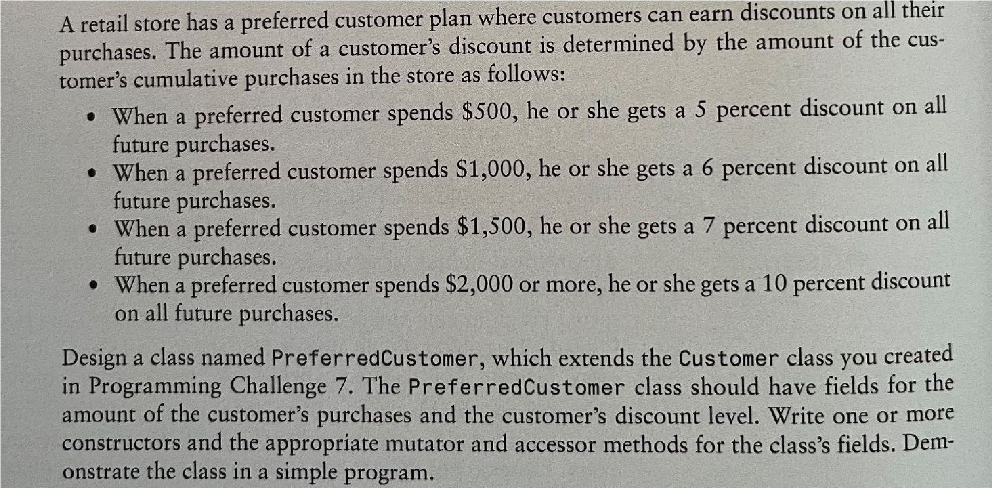above question

output with no discount:

Discount for 10%

