Purpose
The purpose of this document is to define the technical scope and requirements of the game project student’s will be creating in CPSC 340 this semester.

If you have any questions on the requirements within this document make sure you check in with the instructor ahead of any relevant due dates.

Version History
Version | Date | Change
1.0 | 9-12-23 | Initial

Software Requirements
- Game Engine - Unity 2022.3.7f1
- Version Control - Unity Version Control
- IDE - Rider

Project Requirements
- Platform: PC
- Input: Keyboard and Mouse.
  - If you plan on developing for a different controller, it must be instructor approved.
- Screen Resolution: 1920:1080
- All games/levels must be able to be completed within 10 minutes of gameplay.
  - If the game contains levels, this means each level must be able to be completed within this time limit.
- All games will include a main menu and title screen. It must contain the following information and functionality.
  - The game title and author’s name.
  - Start Game - Starts the game module.
  - Tutorial - Provides instructions on how to interact with the game and the player’s objective(s).
    - This will be a panel that can be toggled (on or off) with a button press.
  - Quit - Closes the game application.

Programming Requirements
- All CPSC Standards must be adhered to.
- Use comments and code blocks in every script.
- Refactor class and variable names throughout development.
- Use of design patterns and organized classes with specific responsibilities and behavior.
- In-class code reviews.
- We share the responsibility as a class of validating each project is as well coded as possible. I am not expecting perfection, but your best effort.
- Folder Structure
  - Name of Game
    - Prefabs
    - Scripts
    - Scenes
    - Art
    - Sounds

User Interface (Canvas) Requirements
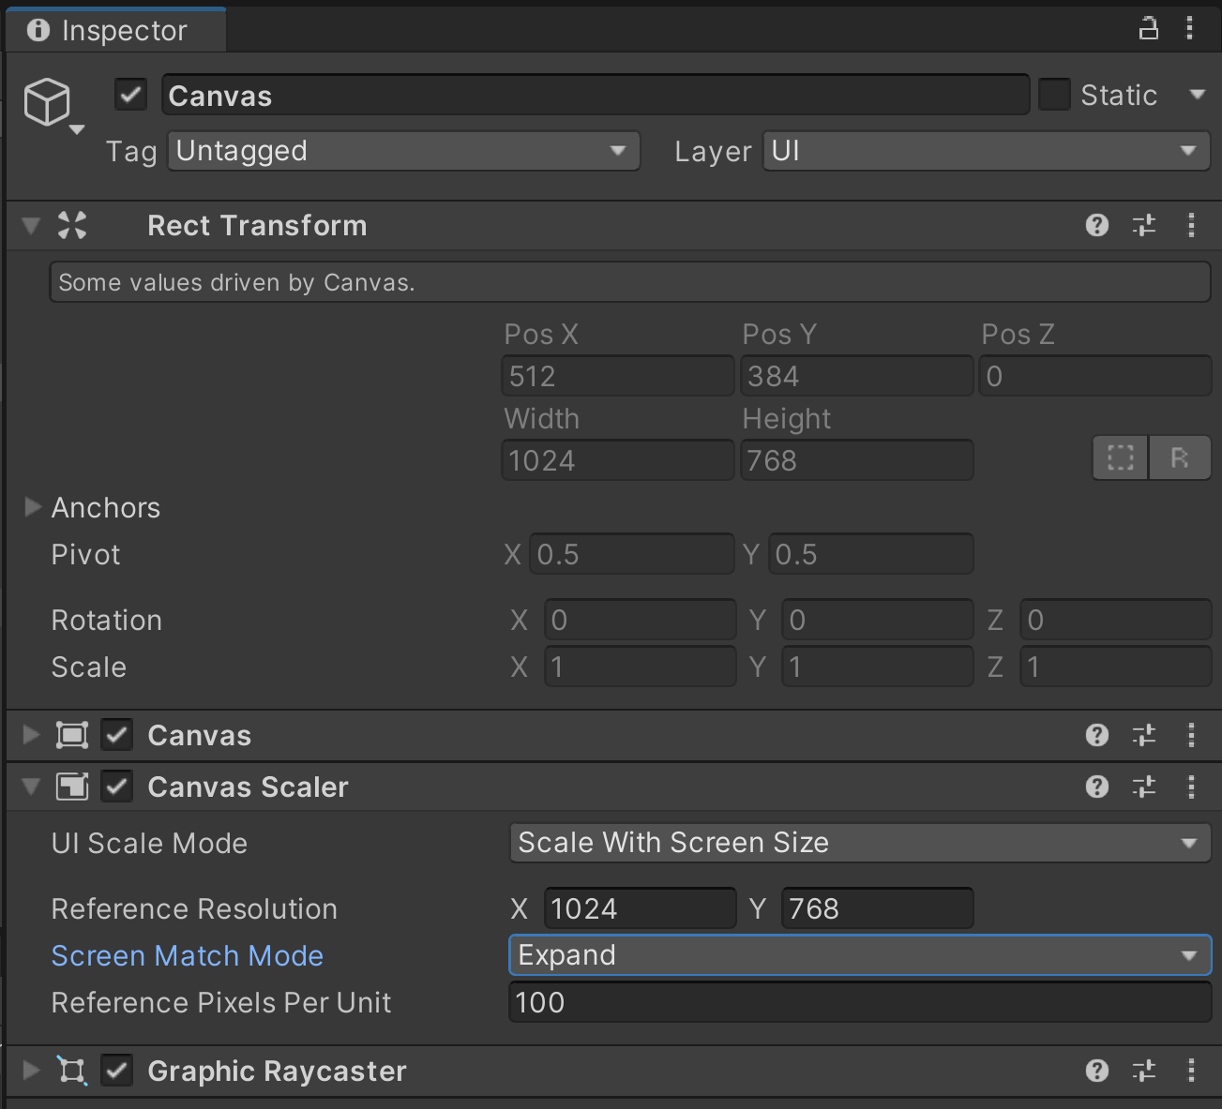
Every Canvas object needs to match the above Canvas Scaler properties, with the exception of the screen size being 1920:1080.

File Naming Conventions
All projects will use the following naming conventions:

Scripts
- Script namespaces must be added and used. This is essential for scripts that have the same names to note override each-other when Unity Packages are imported into existing projects.
- Scripts must be commented and include CPSC standards.

Scenes
- Main Menu scene must be named in the following format:
  - MM_(FirstInitialLastName)
  - Ex: MM_DPrate
- Game/Level scene must be named in the following format:
  - Game_(FirstInitialLastName)
  - Ex: Game_DPrate for a game or Level1_DPrate for a game with multiple levels.

Project Milestones

Milestone (Sprint) Deliverables
Students will submit individual milestones, in the form of a zipped folder. This folder must contain the following:
- Build executable and dependencies. These are files that are generated by Unity when you build for Windows. They must be sent along with the .exe for your program to run properly.
- Scripts folder. All scripts written by you must be included and follow CPSC Standards.
- Readme text file. This is a readme that provides basic information about your program and how to run it. The files listed here should be represented in your folder.

Milestones Overview
Milestone 1
- Setup Version Control Repository
- Implement Base Project functionality
- CPSC Standards
- Characters
- Camera
- Controls
- Art/Sounds (temp)
Milestone 2
- Level Mockups
- UI
- Opening Sequences
- Design Patterns (States, Events)
- Level Controller/Manager
- Animations/Art/Sounds (temp)
Milestone 3
- Level Iteration
- Core Mechanics
  - Specific Actions Unique to your game (AI, enemies, etc).
- UI
- Animations/Art/Sounds (temp)
Milestone 4
- Art/Sounds (final)
- Results Screen
- Extra screens
- Tutorial Instructions
- Balancing
- Animations/Art/Sounds
- Game Icon
- Main Menu Art updates
If core game functionality is not present by the end of the fourth milestone, the project will be scrapped and a simple two-milestone project will be assigned.
Milestone 5
- Game Build

Final Milestone Requirements
As part of the final milestone of CPSC 340, students will be responsible for demonstrating functionality in front of class during a live presentation.

