In The Pipes

Title Ideas: On the Run, On the Swing, Spider Pipes, In the Pipes, Spider Survival, Runaway Spider, Sewer Run
Target Platform: PC Target Audience: Ages 8-25
Target Rating: PG Expected Shipping Date: May 17, 2024

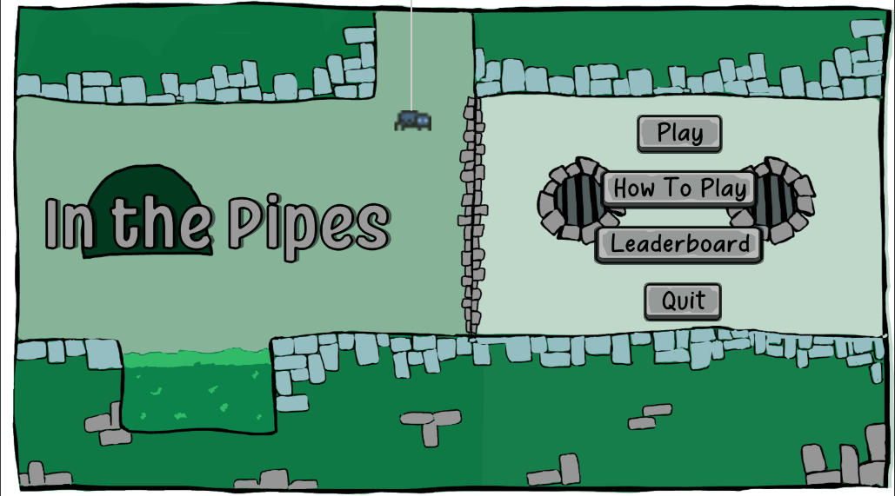
Dev Team:
Natalie Huante Team Lead / Programmer huante@chapman.edu
Brian Byrd Art / Video bbyrd@chapman.edu
Mo Hijazi Level Design / Art mhijazi@chapman.edu
Max Starreveld Programmer starreveld@chapman.edu

Spring 2024 Design Doc

Story and Gameplay

Level Design Ideas
- i think we should plan max 3 levels and we can merge the current 2 that are made so make just 1 NYC level
- Levels will be in different cities
  - NYC → current
    - Statue of liberty, times square, empire state
  - Japan → pink/clean/nice
    - Cherry blossoms, bullet trains, kimonos
  - Rome → pillars
    - Colosseum, ancient buildings, pizza
  - Paris → catacombs
  - Island
  - Aliens → UFO theme

Storyline

Storybook Scenes
Intro Lobby Scene (before lobby loads)
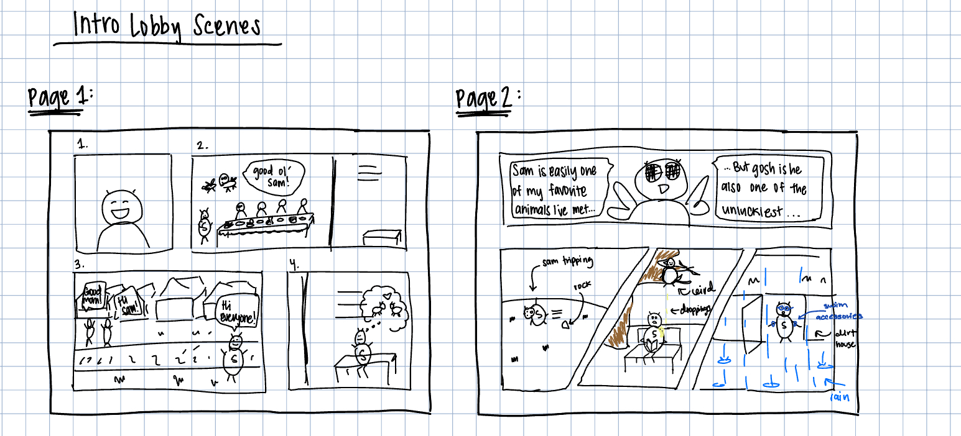
  - Page 1: Introducing Sam the Spider. Sam lives in a dirt home and is the most loved spider in the community (he is also the only spider in the community, but that is beside the point). He is friends with all the local flies and always hosts dinner parties and get-togethers with them. He does, however, always dream about what it would be like to have another spider as his friend, he’s never met someone like him in his whole life after all. [main message here is that sam is just a lovable, genuine, cute little guy]
    - Frame 1: Sam the Spider is introduced. He's in his cozy dirt home, surrounded by a warm atmosphere with soft lighting. Sam is shown smiling.
    - Frame 2: Sam is hosting a dinner party for his insect friends (mostly flies) in his dirt home, The insects are shown laughing and enjoying themselves, emphasizing Sam's popularity and warm-heartedness. Sam is on the left of the long table, smiling or laughing as his home is filled with friends.
    - Frame 3: Sam is walking down the neighborhood street and is greeting everyone he comes across, and given his popularity and lovable personality, everyone responds so happy to see and say hi to Sam.
    - Frame 4: Sam sits alone in his home, with a slightly melancholic expression, as he thinks about what it would be like to have another spider to be friends with, hinting at his desire for companionship with another spider.
- Page 2: Despite his popularity, Sam has the worst luck ever. There is probably no unluckier spider than him. Let’s look at the past few weeks just to prove this. He has tripped and rolled down hills, been pooped on by birds, and the other day he was ready to walk out the door for a pool day when it started pouring outside. [we are not too attached to any of these bad luck scenarios, the main message here is that this poor guy never seems to catch a break]
  - Frame 1: One of Sam’s fly friends is giving his opinion on Sam and shares that he is one of his favorite friends, but also has terrible luck.
  - Frame 2, 3, 4: Three instances of Sam’s bad luck just in the past week are shown side by side. First, sam is shown tripping and rolling down a hill. Then, a bird is shown perched above Sam and with a comical expression as it poops on him. Last, Sam is shown as he is about to leave his dirt home excited and prepared for a pool day, only to be disappointed as it starts pouring rain outside.
1.1 Scene Group 1 (Played before Level 1, Part 1)
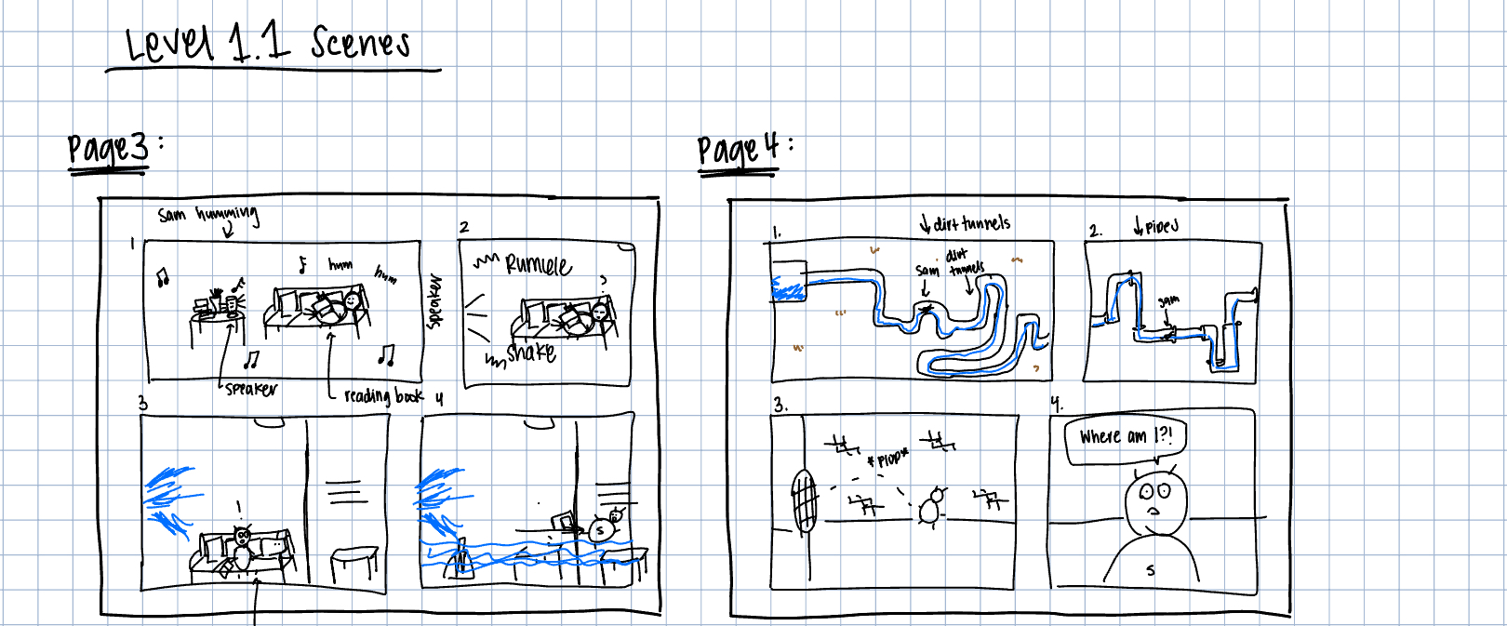
- Page 3: one rainy day, Sam is in his little dirt apartment as he calmly reads a book and enjoys the coziness of his home, music playing on his speaker and all. when he hears and feels this great rumbling sound coming from one of the walls (the left side of the screen). What could that possibly be? Before he can make a move or prepare himself, a puzzled Sam sits at his desk and stares at the wall when it bursts open right in the center.
  - Frame 1: Sam is sitting at home, happily surfing the iWeb (the internet) on his leaf computer. He has some music playing on his speaker and he is humming along, just enjoying his day.
  - Frame 2: Sam hears a rumble coming from the left wall of his dirt home and temporarily pauses to turn and look, suspicious as to what the noise might be. He is confused.
  - Frame 3: Sam is still sitting at his computer when the same wall that rumbled bursts open and water begins to gish everywhere. Sam is shocked at what is happening.
  - Frame 4: Sam’s home is getting flooded as water continues to rush in from the broken wall. Sam has now also been picked up by the water and is being pulled to the right by the direction of the water.
- Page 4: Water gushing everywhere and very quickly flooding his home. As he is quite the opposite of a strong swimmer, Sam is swept up in the motion of the water and through another hole in the wall to the right, which is somehow connected to a network of dirt tunnels. Down he goes, swept away, until he somehow ends up being sucked into some pipes, and ultimately plopped out into the underground sewer system of New York.
  - Frame 1: Sam is shown being carried through the dirt tunnels by the rushing water. He is both scared and still in shock at what is happening.
  - Frame 2: Sam is sucked into a series of pipes, showing a chaotic journey through twisting and turning passages
  - Frame 3: Sam is launched out of the pipes and into the underground sewer system of New York City, his expression bewildered as he lands in an unfamiliar environment
  - Frame 4: Close up on Sam’s face, he is wide-eyed and in disbelief at where he is at and how he got there. He is clearly in a bit of a pickle too, so he is both concerned and shocked. He asks “Where am I?!”
1.2 Scene Group 2 (Played after Level 1, Part 1 and before Level 1, Part 2)
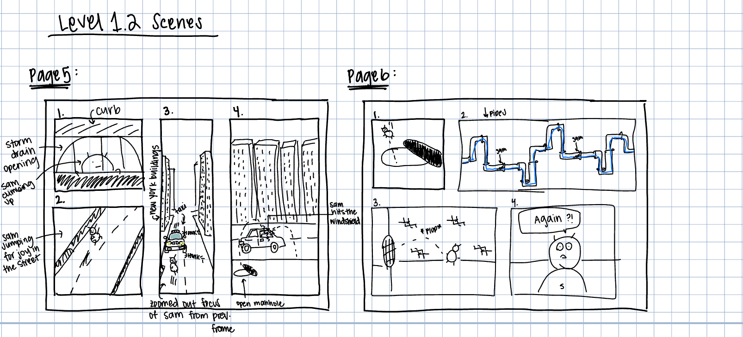
- Page 5: Sam thinks he has found a way out as he makes it closer and closer to the surface. He climbs out of a storm drain into a busy nyc street. Finally, he is out of danger’s way, he is so excited. Jumping out of joy, he doesnt even think to take a look around his and see what’s going on. Before Sam has the chance to do anything, there is suddenly loud, multiple honking coming from the left-hand side. A yellow taxi, who has now slammed on the brakes, tires screeching, is coming straight for Sam. Wide eyed, he just watches the taxi in shock.
  - Frame 1: Sam is peeking out of the storm drain under the curb, seeing if this is could be a way out. He is curious, and hopeful.
  - Frame 2: Seeing that this opening leads to the outside world, Sam leaps for joy, so excited that he is unable to hold his emotions in.
  - Frame 3: given his excitement, Sam fails to look around and assess the safety of his surroundings. We get a different angle here of him mid leap of joy, and notice he is in the middle of a busy New York St. A taxicab is honking and zooming towards him.
  - Frame 4: Sam collides with the windshield of a taxi cab, and bounces out, landing straight into an open manhole on the sidewalk. We can see his path of motion from his leap to the manhole here.
- Page 6: Of course, the taxi drives right by, throwing sam off balance, and sends the little guy down another storm drain and back into the sewer.
  - Frame 1: here we see a close-up of Sam falling right into the manhole, which is conveniently left uncovered on the sidewalk.
  - Frame 2: referencing his first journey through the pipe, Sam is again washed through a chaotic journey of twists and turns through the pipes of the New York sewer system
  - Frame 3: just like before, he is plucked out from the storm drain that leads to the underground sewers. It is almost comedic how similar he is being popped back into the sewer. Again, a reference to his bad luck.
  - Frame 4: A close-up of Sam, as he realizes where he has landed yet again. He is both still shocked, and annoyed at how this could’ve happened. All he has left to say is ”Again?!”
Win Scene Group 4 (Played after Level 1, Part 2 is complete)
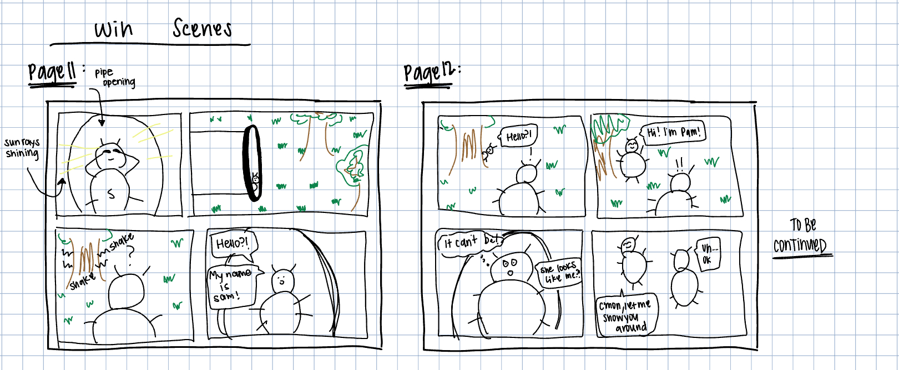
- Page 7: Sam has found another pipe that might be a way out. Sam climbs up the pipe and is met with a blinding ray of sun. Shielding his eyes from the sun, Sam tries to focus his eyesight on what is outside the pipe and sees something he never would have expected.He finds himself looking at a beautiful small park.
- Page 8: He hears a squeak come from behind a nearby tree. “Hello?! My name is Sam, what’s yours?” We see someone come out from behind the tree, and we hear, “Hi, I’m Pam!” Another spider?! It can’t be. Maybe this trip wasn’t so unlucky after all, now Sam finally has another spider friend. Fade out, to be continued…

Death Scenes
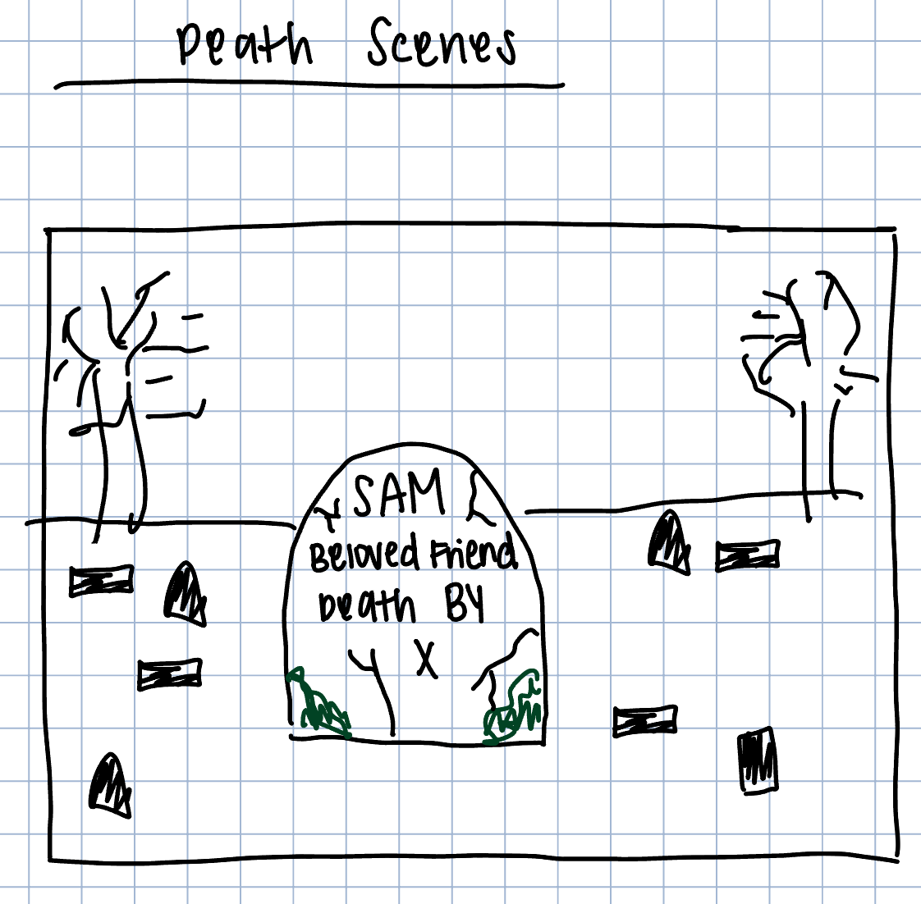
If we choose to do a similar death scene for all deaths…
When Sam dies, the player will be prompted to this death screen to indicate that the game is over. This scene will only be one comic image rather than several. It will be of Sam’s headstone in a graveyard and on the headstone it will read “SAM death by X” with X being one of the options below. The overall vibe of the graveyard we are a bit flexible with, as long as it ties to the whole theme of the story and game so far. We would like to tie in some comedy to this part, almost like Sam is still have bad luck, post-death. Each type of death will have a similar picture with the tombstone as the focus, but with some small element that hints towards how Sam died, almost comedically. For example, the Death by Snake can have a snake hissing and slithering by the tombstone. The Death by Bat can have a bat squeaking and flying by in the background. The Death by Skeleton can have the hand of a skeleton sticking up out of the ground (you know like those zombie movies sorta vibe). The Death By Rat can have a rat squeaking and standing atop the tombstone. Death by Fall can have the tombstone a little lopsided or fallen over on its side. Death by Toxic Water can have the tombstone be dripping in greenish, ooze (similar to what the toxic water looks like in-game).

Death by Fall
Death by Snake
Death by Bat
Death by Rat
Death by Skeleton
Death by Toxic Water

Game Flow
As the player progresses through the sewer pipes, it will become increasingly more difficult to continue progressing. These increasing difficulties will be as follows:
- There may be more enemies to avoid during a smaller amount of time
- There will be more difficult obstacles to get past
These will begin as the player reaches a new level and will be introduced through the same comic-strip-like scenes. This will make sure the player will be aware of such changes in a brief and entertaining way.
Throughout the entirety of the game, the player will also be collecting coins in order to increase their score. The collection of these will not be required to complete any of the levels, but will be recorded so the player can later use them to buy customizations to their character in the shop. The shop can be accessed through the lobby. The amount of time the player used to complete the level will also be recorded. These times will then be used to award the player certain achievements. The player’s time will reset each level, while their coins count will carry over. Each collectible will add 10 points to the player’s score.
As the player progresses through the game, they will also be able to collect some power-ups. They will only be temporary powerups and last only a few second. Although these could offer benefits to the player, they will have to strategically collect them as some will also offer disadvantages. Some of these possible power-ups are as follows:
- Slowing down player movement
- Speeding up player movement
- Coin Multiplier
- Double jump available
- Extra Heart

Character(s) and Controls
Player: The player will control the main character (Sam the Spider) as he tries to navigate through the sewer pipes and make it to safety while avoiding and fighting enemy sewer animals. In this game, the player can use keyboard controls to walk and jump as well as mouse controls to use their web to swing through the pipes. This swinging control will mimic a pendulum movement and the player will have to use momentum to swing back and forth. All of the player’s movements will be as follows:
- Move Left/Right: A and D keys
- Jump: Space Bar
- Web Swinging/Grappling: Left Mouse Click
- Wall Slide/Grab/Climb: TBD
- Wall Jump: TBD
- Shoot Web Nugget: TBD
The player plays as the same spider throughout the entirety of the game.
The player will be able to act offensively and shoot web nuggets towards enemies to take them out. The control key for this mechanic is TBD, but once pressed, it will trigger a web nugget to shoot in the direction of the player’s aim. Once the nugget hits an enemy, it will deal damage to it and the nugget will disappear. Otherwise, it will disappear once it hits anything else, like a wall or water).

Main Gameplay Concepts and Platform Specific Features
The player’s main form of play will be walking, jumping, and swinging through a 2d side-scrolling view. The gameplay is platform-based in some areas of the level where the player will have to avoid falling through the gaps to avoid dying. The sequence of play is broken up by levels, each of which will have a short story-sequence between them to introduce new or increased difficulty of play. For the scope of this project, we are planning on having two total levels in the game. Each level will have the same core game mechanics and core gameplay. Considering the scope of our timeline, this will be enough to allow us to showcase all of our mechanics and features. We also wanted to place an emphasis on making the levels detailed and fully complete and developed by our final date, so we decided to only make tow levels to allow us to do so. The unique selling point of this game will be the addition of the swinging mechanic to the player’s control as well as the lobby intro room.

Game World
The gameplay takes place in the dark, underground sewers of the world. While the story also takes place in locations such as the spider’s home (the lobby area), smaller water pipes, etc. the gameplay will mainly take place in the different underground systems of the world. Our first level takes place in the sewers of NYC, so it’s environment includes assets such as running water, open pipes, graffiti, broken boxes, etc. Our second level will take place in the catacombs of Paris. Here you will see assets such as skull heads, skeleton bones, etc. While in play, the environment will evoke a slightly spooky and gloomy atmosphere. Given that the spider is an unfamiliar environment, the sewer should present as a dark and solitary place that the player should naturally feel like they should find their way out of. Although this is the main mood communicated to the player, it is meant to be softened and not to be too gloomy or scary as this game is targeted to younger players. Therefore, it should fit into the story as being an unfamiliar, gloomy environment but not interfere with the gameplay.

Below we include a sample of how the cutscenes will be connected with gameplay.

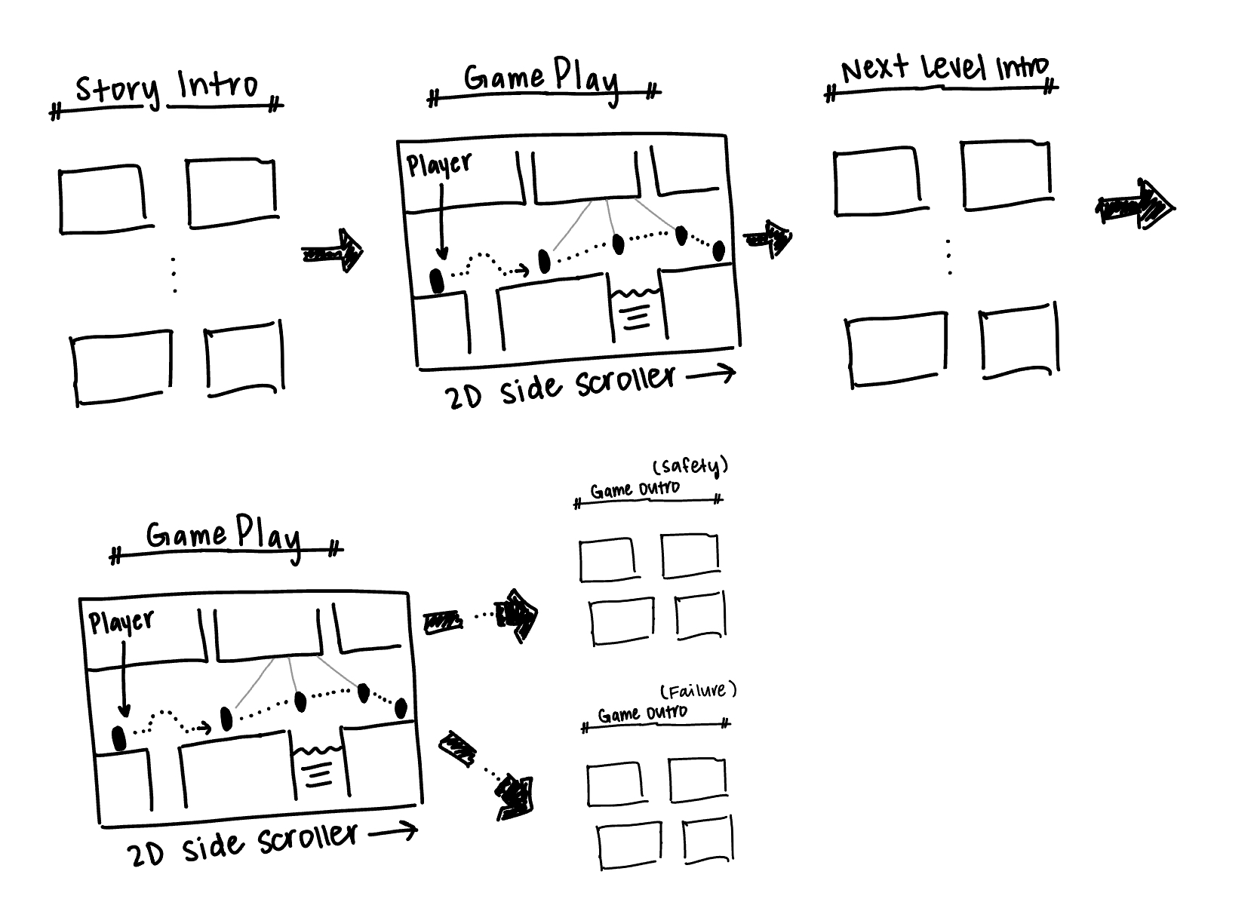

Interface

Below I include a layout of how our current interface menus are connected. However, we will be updating the format of them to be accessed through the lobby and to be integrated with lobby assets such as the map, bookshelf, and computer screen.
- The level select screen will be accessed through the map
- The shop, how to play, and credits will be accessed through the computer
- The achievements will be accessed through the bookshelf
- The pause menu will be accessed by “P” during gameplay only

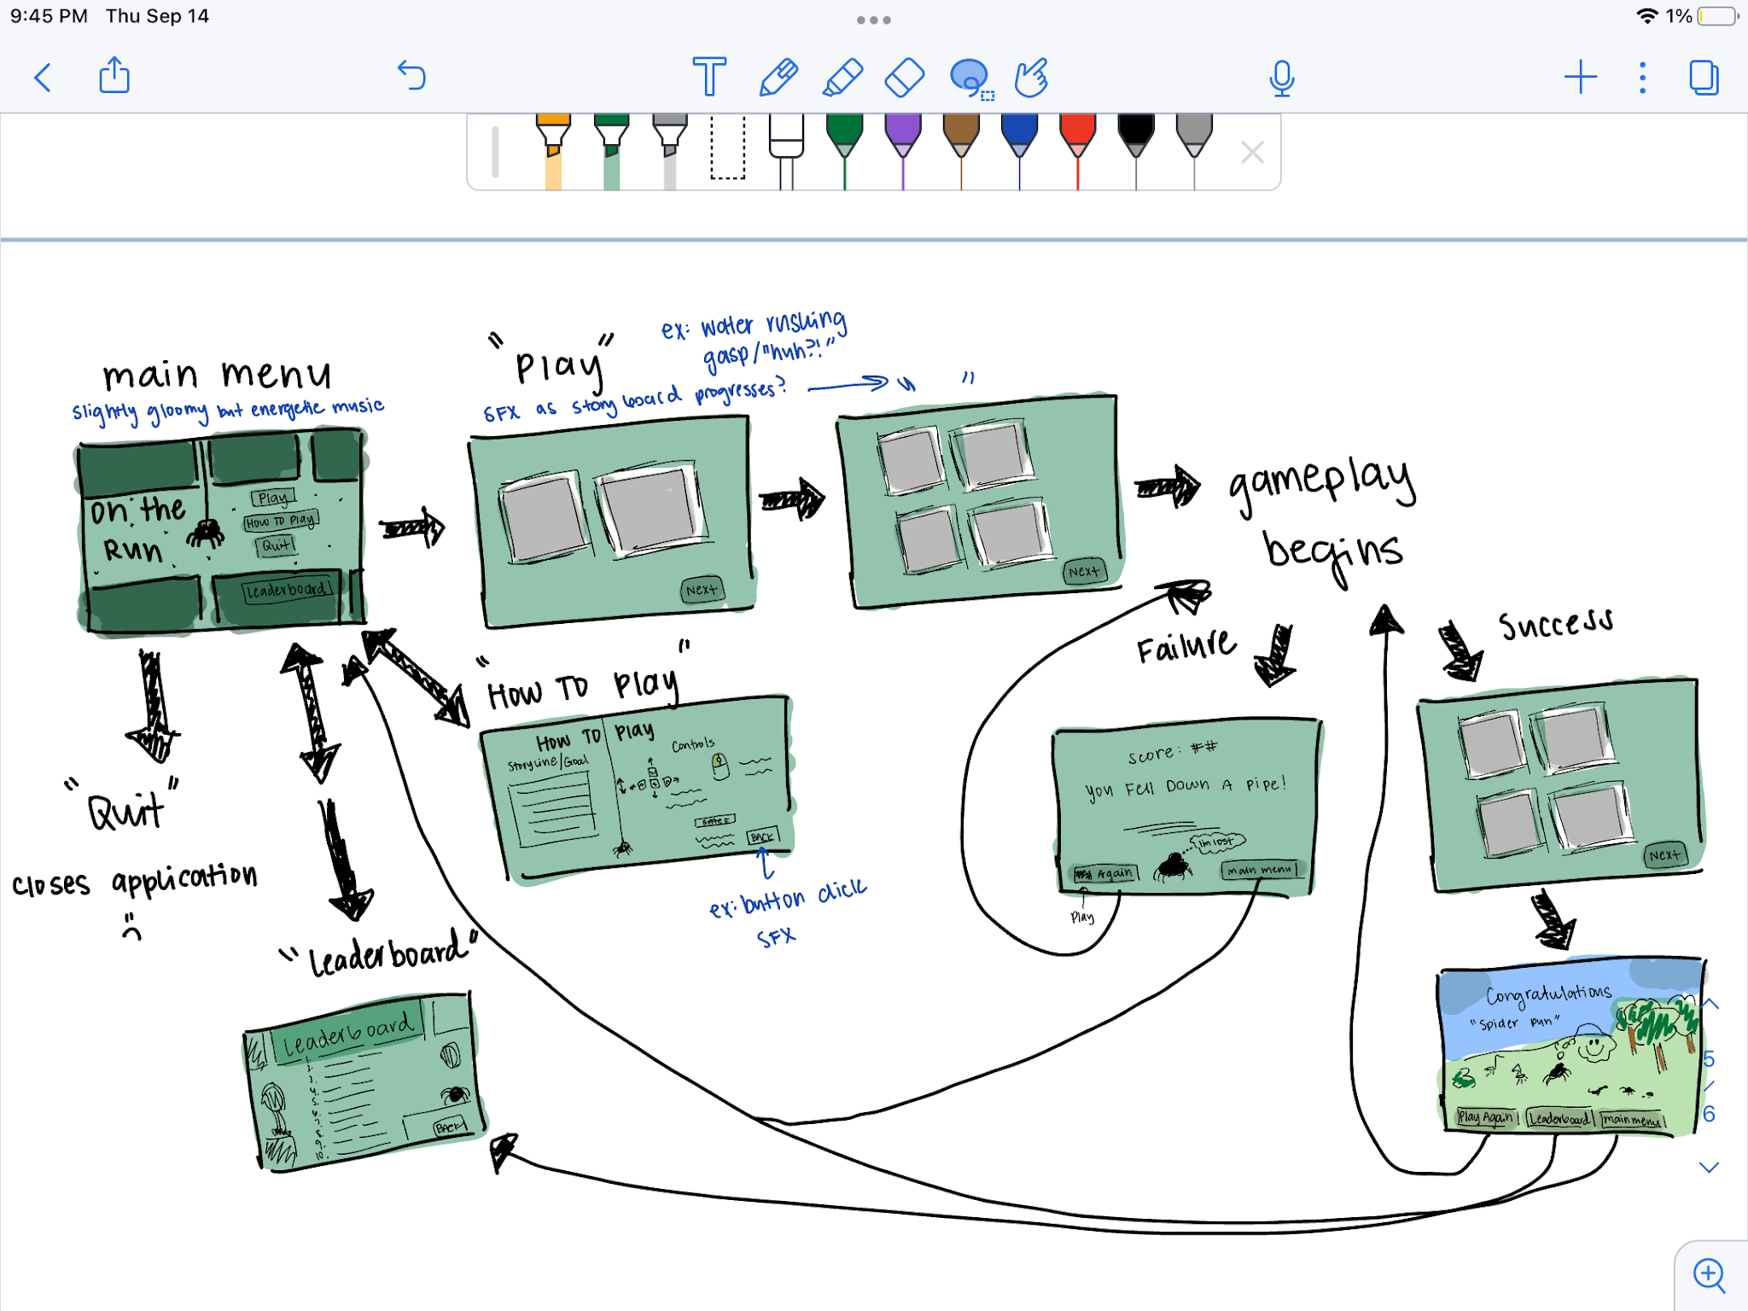

Mechanics and Power Ups
- Character Controls
  - Move Left/Right: A and D Keys
  - Jump: Space Bar
  - Web Swinging: Hold Left Mouse Button
    - While swinging…
      - Swing Bigger Left/Right: A and D Keys
      - Shorten/Extend Web: W and S Keys
  - Shoot Web Nugget: TBD KEY
  - Wall Slide/Grab/Climb: TBD KEY
  - Wall Jump: TBD KEY
  - Character movement will be used to avoid enemies and progress through the level, jump/swing over dangerous sewer water or holes or platforms
- Power-ups will automatically be activated upon collection and affect the environment or the player themselves. They will last no more than 10 seconds before deactivating automatically. Examples include:
  - Slowing down player movement
  - Speeding up player movement
  - Coin Multiplier
  - Double jump available
  - Extra Heart
- Coins can be collected by the player to increase their score by 10 points per collectible. Coins will be used in conjunction with level progression to buy customizations to the player. Customization examples include: buying spider clothes like boots, hats, etc. applying a color or material to their web (ex: rope, web, rainbow. etc). The shop can be accessed through the lobby.

Enemies and Bosses
- Sewer Rats: getting bit by a rat will decrease the player’s health by one heart. If killed by a rat, a short story scene where the rat will take you away into the depths of the sewer, leaving you with no chance of finding your way to safety. You are now forever one of the rats. Rats can be found on platforms or on the ground and may rush towards the player if they are nearby.
- Sewer Bats: bumping into a bat will decrease the player’s health by one heart. If killed by a bat, you will be stuck running from them forever and ever, deeper into the sewer than ever. Bats will be found flying up and down in a vertical pattern.
- Sewer Snakes: getting bit by a bat will decrease the player’s health by one heart. If killed by a snake, they will eat you. And you are, therefore, unable to make it to safety. Snakes can be found slithering around in small spaces of the sewers.
There are no boss characters, at least for the scope of this semester’s project. All enemies may appear at any level regardless of their difficulty. They will, however appear in higher frequencies and in larger groups in more difficult levels. The player must avoid getting killed by all three in order to successfully pass each level.

Cutscenes, Bonus Material, and Comps
The cutscenes will be presented:
- Before gameplay, aka as an introduction to the first level
- Between each level to develop the storyline and provide a transition between levels
- At failure of a level
- At the success of the final level, aka as an outro to the game story
They will all be in a comic-strip-like presentation. They appear one comic square at a time. Each comic square will be a still drawing.
The incentive for the player to play again will be to earn a faster time and earn achievements as well as to collect more coins and buy customizations to their character and/or environment. The player may also want to explore the levels in a different way, so they might go back with the focus on exploring the level rather than on beating their previous time.

Other games that may be competition upon market release include 2d side-scrollers such as Jetpack Joyride and Stickman Hook. However, In the Pipes offers mechanics and features that these games do not as well as a new aesthetic, theme, and story.

Sprint Milestones

Visit This Page For Sprints Roadmap && Sprint Tasks Detailed

Cited References

- Formal Brainstorm Doc
- Grappling:
  - https://www.kodeco.com/312-make-a-2d-grappling-hook-game-in-unity-part-2
  - https://www.kodeco.com/348-make-a-2d-grappling-hook-game-in-unity-part-1/page/2
  - https://www.youtube.com/watch?v=P-UscoFwaE4
  - https://www.youtube.com/watch?v=HdhrJcNn63I
  - https://docs.unity.cn/560/Documentation/Manual/class-DistanceJoint2D.html#:~:text=If%20enabled%2C%20the%20Distance%20Joint,between%20the%20GameObjects%20is%20fixed.
  - https://www.youtube.com/watch?v=dnNCVcVS6uw&t=22s
- Stop sticking on walls when movement input: https://www.youtube.com/watch?v=fmGdDzKuJVk
- Player walk on walls/state machine (the long video) https://www.youtube.com/watch?v=hKMjG3Lyf5c
- (viking wall grab and slide example): https://www.youtube.com/watch?v=YeHhVlDMVKY
- (variable jump with 2d platformer) https://www.youtube.com/watch?v=j111eKN8sJw
- Starting fsm for player controller video: https://www.youtube.com/watch?v=78PLsHnRXiE&list=PLy78FINcVmjA0zDBhLuLNL1Jo6xNMMq-W&index=21
- Camera Movement: https://www.youtube.com/watch?v=_QnPY6hw8pA, https://www.youtube.com/watch?v=ZBj3LBA2vUY, https://www.youtube.com/watch?v=9dzBrLUIF8g
- New Input System: https://gamedevbeginner.com/input-in-unity-made-easy-complete-guide-to-the-new-system/#input_system_get_mouse_position, https://community.gamedev.tv/t/getting-the-mouse-position-using-the-new-input-system/232210, https://forum.unity.com/threads/the-name-mouse-does-not-exist-in-the-current-context.1227435/
- https://playground.com/search?q=ancient+rome+pixel+tiles+for+2D+game
- Pixel Art Online Editor: https://www.pixilart.com/draw?ref=home-page#
- Find Game Objects With Tag: https://forum.unity.com/threads/how-to-find-a-gameobject-by-tag.172188/

Reflections

Fall 2023 Design Doc

CPSC 340 - Game Development
Natalie Huante

Story and Gameplay
The story begins with a comic-strip storytelling. A spider is lounging at his spider house having a relaxing afternoon when he hears a rumbling coming from a distance. This spider house of his is placed at the bottom of an abandoned water pipe. As he listens to the rumbling, it starts to get louder and louder as if approaching his house. All of a sudden, the spider is alarmed, realizing that the rumbling must be water rushing down through the abandoned pipes. This can only mean one thing…the water is coming!!! Before he has a chance to think of a plan or act upon it, there is water rushing through his house. He is swooshed up by all the water, swept into one of the many pipe openings in his home, and washed up into the sewer pipes.

Dazed and confused, the spider makes his way to his feet and looks around at the unfamiliar sewer. There are smells, dirty water, and so many flies. Before he can finish making his assessment of what to do next, he hears it again. The rumbling. He can’t risk being washed down even further into the sewer without being lost in the pipes forever. There is only one option left. He must swing, run, and jump just way through the pipes before the water reaches him! **This is where the player will begin gameplay**. The player will play as the spider and use keyboard and mouse controls to make their way through the pipes towards safety. As the player makes their way through the pipes, the water will be constantly approaching. If they slow down, they will see the waves of water approaching from the left side of the screen, washing them away if they get too close. The player will also encounter flies that they can pickup for points and obstacles they will have to traverse around. For instance, the player might have to avoid enemy rats that could eat them or a pool of dirty, sticky sewer water that will trap them in place. If the player successfully navigates through the pipes…**continue story mode**

The spider has made his way through the sewer and has successfully avoided all the possible obstacles and threats. He makes his way up an empty pipe hoping that the light he sees up above will mean an end to his disaster of a day. He climbs and climbs up, quickly approaching the light. He peeks out of the top of the pipe, scared as to what he might be walking out into and he is finally free! He crawls out into the middle of a park where the grass is green and there are all these other animals walking about. The perfect place for a young spider to build his life. And what are the odds, as he turns to the right he sees a web house for sale. You could even call it fate. All is well in this spider’s life.

Game Flow
As the player progresses through the sewer pipes, it will become increasingly more difficult to continue progressing. These increasing difficulties will be as follows:
- The water approaches the player quicker, meaning the player will have less of an opportunity to recover from a fall/mistake and less time to get past obstacles
- There may be more enemies to avoid during a smaller amount of time
- There will be more difficult obstacles to get past
These will begin as the player reaches a new level and will be introduced through the same comic-strip-like scenes. This will make sure the player will be aware of such changes in a brief and entertaining way.
Throughout the entirety of the game, the player will also be collecting flies/coins in order to increase their score. The collection of these will not be required to complete any of the levels, but will be recorded on a leaderboard that the player can play repeatedly to try and finish with a higher score. The player’s score will carry over to the next level (if they advance) and will reset upon failure of a level or success of the final level. Each collectible will add 10 points to the player’s score.
As the player progresses through the game, they will also be able to collect some environment power-ups. Therefore, the player themselves will not unlock new abilities but rather the environment will change or be altered. They will only be temporary powerups and last at most 5 seconds. Although these could offer benefits to the player, they will have to strategically collect them as some will also offer disadvantages. Some of these possible power-ups are as follows:
- Freezing the entire game, everything including the player’s movement and the waves of approaching water will be slowed down % slowed down tbd
- Speeding up the entire game, everything including the player’s movement and the waves of approaching water will be sped up % sped up tbd
- Double the amount of collectibles available for pickup
- No collectibles available for pickup
- Double jump available

Character(s) and Controls
The player will control the main character (spider) as he tries to navigate through the sewer pipes and make it to safety before the oncoming waves of water reach him first. In this game, the player can use keyboard controls to walk and jump as well as mouse controls to use their webs to swing through the pipes. This swinging control will mimic a pendulum movement and the player will have to use momentum to swing back and forth.
The player plays as the same spider throughout the entirety of the game.
The player does not have any offensive actions they can use against enemies, so they must instead use their movement controls to navigate around them and avoid any threats to their escape.

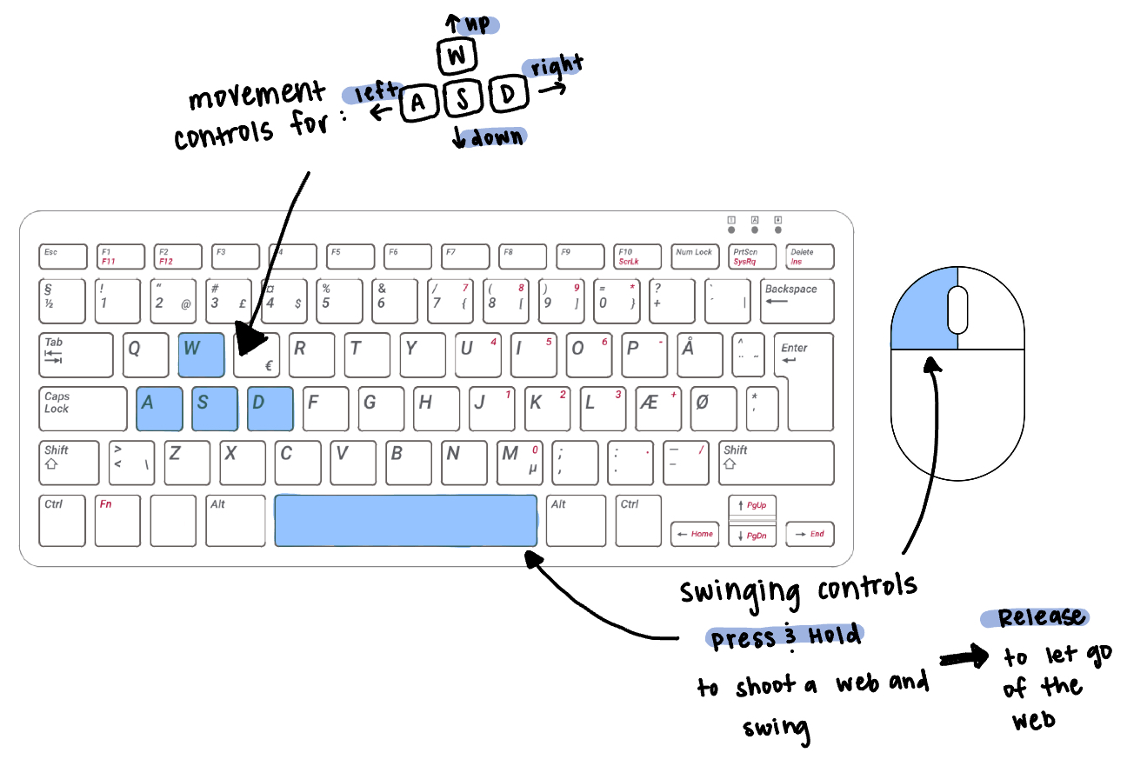

Main Gameplay Concepts and Platform Specific Features
The player’s main form of play will be walking, jumping, and swinging through a 2d side-scrolling view. The gameplay is not a platform-based game, but there will be gaps between the floor that, if fallen into, will cause the player to fail the level. The sequence of play is broken up by levels, each of which will have a short story-sequence between them to introduce new or increased difficulty of play. For the scope of this project, I am planning on having three total levels in the game. Each level will have the same core game mechanics and core gameplay. The unique selling point of this game will be the addition of the swinging mechanic to the player’s control.

Game World
The gameplay takes place in the dark, wet sewer. While the story also takes place in locations such as the spider’s home and in smaller water pipes, the gameplay will only take place in the main sewer lines. While in play, the sewer environment will evoke a slightly spooky and gloomy atmosphere. Given that the spider is an unfamiliar environment, the sewer should present as a dark and solitary place that the player should naturally feel like they should find their way out of. Although this is the main mood communicated to the player, it is meant to be softened and not to be too gloomy or scary as this game is targeted to ages 6-18. Therefore, it should fit into the story as being an unfamiliar, gloomy environment but not interfere with the gameplay.

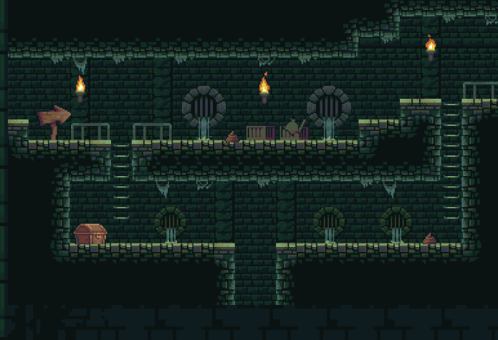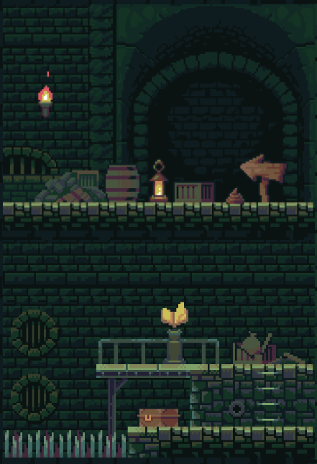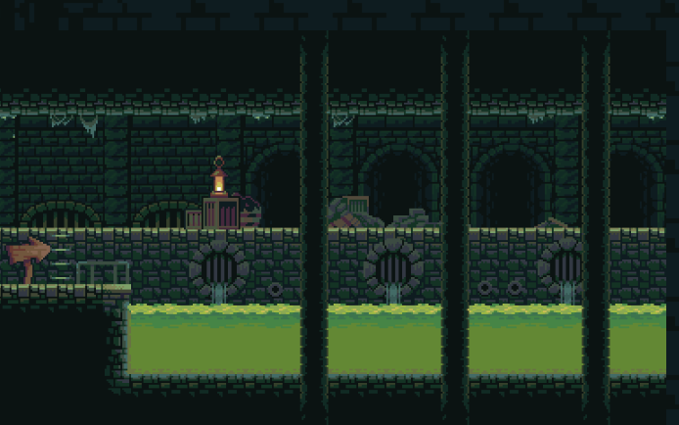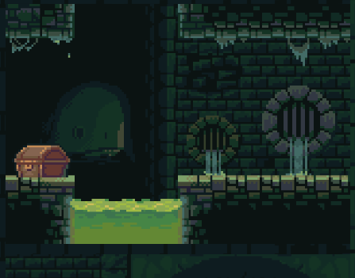

Interface



Mechanics and Power-Ups
- Character movement
  - Wasd controls: left, right, jump, down
  - Space/Left Mouse: shoot a web and hold on as you swing (on release of button releases web in-game)
  - Character movement will be used to avoid enemies, jump/swing over dangerous sewer water or holes or platforms
- Power-ups will automatically be activated upon collection and affect the environment or the player themselves. They will last no more than 10 seconds before deactivating automatically. Examples include:
  - Elimination of coins for pickup
  - Double coins available for pickup
  - Slowed down environment & controls
  - Sped up environment & controls
  - Double jump
  - Half jump
- Flies/Coins can be collected by the player to increase their score by 10 points per collectible. The top ten scores will be displayed on the leaderboard. They can either their name upon failure or success of the level in order to be considered for the leaderboard. The leaderboard can be accessed from the main menu or after completing all levels.
  - **Down the road** Collectibles can be used to customize your character and your environment. Examples: spider clothes, web string, platforms, water, background, etc.

Enemies and Bosses
- Rats: bumping into a rat will trigger a short story scene where the rat will take you away into the depths of the sewer, leaving you with no chance of finding your way to safety. You are now forever one of the rats. (will only be on the ground waiting for the player to run into them, may be found in groups)
- Crocodiles: falling into an area with crocodile-infested sewer water will trigger a short story scene where you will be jumping back and forth between the crocodile snouts, unable to make it to safety (may move up and down above the water’s surface so the player must jump or swing over high enough to avoid the croc)
- Snakes: colliding into a snake will trigger a short story scene where they eat you. That is all. And you are, therefore, unable to make it to safety (may be hanging from the ceiling, moving up and down, or be on the ground waiting for the player to run into them)
There are no boss characters. All enemies may appear in any level regardless of their difficulty. They will however appear in higher frequencies and in larger groups in more difficult levels. The player must avoid all three of these in order to successfully escape the sewer.

Cutscenes, Bonus Material, and Comps
The cutscenes will be presented:
- Before gameplay aka as an introduction to the first level
- Between each level to introduce a heightened difficulty
- At failure of a level
- At success of final level aka as an outro to the game story
They will all be in a comic-strip-like presentation. They appear one comic-square at a time. Each comic square will be a still drawing.
The incentive for the player to play again will be to earn a highscore on the leaderboard. Next semester, the hope is to include a mechanism to allow player to customize the environment (see page 8) with the collectibles earned throughout gameplay. The player may also want to see what the different outcomes of failure present, given that they each prompt a different end scene.

Other games that may be competition upon market release include 2d side-scrollers such as Jetpack Joyride and Stickman Hook.

Sprint Milestones
- See the board at: Miro Board Milestones
[Green] - Less than 30 minutes/Will require no or minimal research to complete
[Yellow] - Between 30 minutes - 1 hour/May require some research to complete
[Red] - More than 1 hour of work/ Will require research to complete
[Blue] - More than 3 hours of work/ Will require research to complete
estimate the total time requirement needed for the project and each milestone.

Character
Keyboard Movements (WAD/SPACE)
Mouse Movements (Left Click)
Web Swinging Mechanic
Camera Follow

Enemy Characters
Snake
Hanging from the ceiling (moving up and down as a snake does), if you bump into them, you will be eaten, you will see a storyboard, trigger lose state
Rat
Sitting in your path / on the ground, if you bump into them they will adopt you as one of their own, you will see a storyboard, trigger lose state
Crocodile
Floating in holes with water, if you fall in you will see a storyboard, trigger lose state

Level Design
Ground/Ceiling
Level 1 Geometry
Level 2 Geometry
Level 3 Geometry
Win/Lose States (what triggers them & what do they cause to happen)
Level Transitions (loading next level, in between story transitions)
Score System (collectibles)
Leaderboard [if time allows] (storing scores, how to display leaderboard, loading scores
Oncoming Water Wave (triggers lose state, wave art hmm)

Interface
Main Menu
Pause Menu
How to Play Menu
Leaderboard [if time allows]
Quit Button
Play Button
Intro Story Scene
Level Transitions Scenes
Lose Screen
Win Screen
Credits [if time allows]

Sounds/Music (the blue refers to it as a collective, i know i will need time to look for these, it is always a long process of finding the right sounds that mesh well together)
Menu Music
Narrative Music/SFX
Gameplay Music
Gameplay SFX
Jump
Shoot Web
Approaching Water
Falling Down a Hole
Lose Music or SFX
Win Music or SFX
Button Click SFX
New Story Square Light SFX

Final Art (same situation as with sounds/music above)
Spider Character (running?)
Web
Incoming Wave
Rat Enemy
Snake Enemy
Crocodile Enemy
Level Background
Level Assets (Crates, Water, etc.)
Menus (Buttons, Background, Font)
Storyboards (Intro, Level Transitions, Ways to Lose, Win)

Cited References
- UI Button Not Clickable
- Debug.Log().
- Load Scene with Global Variable
- Load Scene
- DontDestroyOnLoad().
- Switch Statements
- Banana Moon Pie Font
- Input.GetAxis
- Rigidbody.mass
- PlayerController
- ForceMode.Force
- CharacterMovement
- Jump Too Floaty
- Camera Follow
- Sprite Editor
- Sorting Layers
- SpriteRenderer FlipX
- Destroy Gameobject
- OnTriggerEnter()
- Build, Build
- Animations, Animations
- Error: Hides Inherited Components, use keyword new
- Swinging Youtube Video
- Joint.massScale
- Vector3.lerp
- SpringJoint
- Prefab Issues
- Canvas Image
- Sprite Renderer Enable
- Arrays and Lists, Lists
- Strings
- Getting Object Direction
- Vector3.MoveTowards()
- Converting to a Float
- Hiding an Image

Reflections

What went well:
- Overall, the development of the game went pretty well. Of course, there were weeks where I was able to accomplish more work than others and there were some functions that had to be pushed to another sprint, but I think I stayed on track for the most part. I think this was a key component in being able to develop the game as far as I was able to this semester. In terms of what helped with this success, I would say definitely is the emphasis I tried to keep on keeping things organized. There were some features that were quick and easy to implement because I had already build the foundation behind it. This also helped connect different scripts and scenes together as well.

Challenges:
- Unity bugs: During the middle of the semester, Unity suddenly decided to throw me every error it could possibly think of, and they weren’t bugs I could fix. Some of these errors, I came to realize, were issues with the version of Unity I was operating in, so I had to just do the best I could with what it was giving me at the time. These eros have somewhat gone away. I still get a consistent warning of a memory leak, but as of late, this hasn’t been an issue.
- Staying organized: it was very difficult sometimes to keep track of things and take my time to organize and go back and refactor code, but, as i mentioned, it was one of the most helpful things once I had enough code in the game.
- There were a lot of issues that came up with the player movement. Suddenly, any player input was not being used and the player would just sit there until the wave caught it. The problem ended up being an issue with when the playerController script was listening for input and the conditions it would run before making that decision. For example, it takes into account things like is the player swinging, have they touched the ground, are they in the wave, and so on.

What Would I Do Differently:
- Stay organized 100%, it helps so so much
  - This is a consistent effort and doesn’t mean you shouldn’t have some flexibility. It is more about the discipline of going back once you have commented and uncommented line after line and your mechanic is working and refactoring to make it easier to understand when you go to look back on it later.
Future Additions / Ideas:
- Allowing the player/spider to attack
  - Could pick up different weapons along the way
    - Ex: driftwood, fly zapper, fly swatter, pipe, baseball bat
    - Weapon strength bar
    - Weapon health bar
  - Could shoot webs bc they’re a spider
- There is one section of somewhat duplicated code that I would like to fix with inheritance (this occurs in the horizontalMover script and the verticalEnemy script because they both manage some enemy behavior depending on what their movement pattern is.
- Better art and sounds (I tried but it could be so much better)
  - Along with this, there is no art for the background. It currently is a shade of blue, as the camera is set to have a solid color as its background.
- Polishing the collisions between the player and the enemies
  - There can sometimes be an effect when they collide if at the right angle and speed where either one is sent soaring out of the level and they float away for infinity. This needs to be fixed. I am thinking if we make the enemies triggers rather than colliders than this should fix the issue. If implemented along with the knockback effect, then the player shouldn’t even be able to notice that they are never actually colliding with a physical object.

