IEEE GameSIG Showcase 2024 Submission Form (rev. B)
Game Name: In The Pipes Date: April 14th, 2024

Our team will be attending [X] in person [ ] virtually (check one)
Division [X] University Undergrad [ ] Post-Graduate [ ] High School (check one)

When complete, email to gamesigshowcase@gmail.com.

One-Sentence Description | In The Pipes is a 2d platformer where you play as Sam, a lovable yet unlucky spider who gets stuck in the NYC sewer system, and your goal is to find a way back to the surface as you explore the pipes and face obstacles along the way.
List of Team Members and Their Schools | Main: Team Lead / Lead Programmer  - Natalie Huante, Chapman University, huante@chapman.edu, (714) 914-4323, Discord: nat_1129 or NAT#5733  Team Members:  - Level Design / Artist: Mo Hijazi, Chapman University, (714) 746-0123, mhijazi@chapman.edu  - Level Design / Artist: Brian Byrd, Chapman University, (949) 981-4183, bbyrd@chapman.edu,  - Programmer: Max Starreveld, Chapman University, (650) 772-1476, starreveld@chapman.edu,
Target Platform & Audience/Age | Windows platform and web browsers, players of ages 5-18 who enjoy platformers, and a bit of a fun, comical storyline. We want children and young adults to be able to enjoy this feel-good game and access it through their computers.
One-Paragraph Summary of Gameplay and Objectives | The player, aka Sam the Spider, loads into the hub (their new, underground spider home). They can practice their moves and access shops. Once they start the level, the player looks back into Sam’s memories and must use their spidey skills to navigate and escape the underground sewers that he has found himself falling into! You can run, jump, walk up walls, and swing on Sam’s web as you try to stay alive! Watch out for enemies! Sewer rats, snakes, and bats are lurking, ready to charge as soon as they spot you! Good for you, Sam can shoot webs at his enemies as a form of attack as well as destroy wooden crates to reveal hidden items. Keep exploring and try to find your way back to the surface. The more you play, the more levels you’ll progress through, and the closer you will get to finally reaching safety. Keep collecting coins so you can customize your web and buy costumes for Sam to wear! Unlock new levels to uncover new comic book sequences filled with laughs, sorrows, and surprises about Sam’s quirky spider life!
Key Features | - Spider Abilities (walk on walls, web swinging/rappelling, web-shooting, wall bouncing)  - Hand-drawn custom storybook sequences for in-game storytelling  - Customizations – unlock items and use coins buy items in the lobby shops  - Leaderboard – stores the top ten scores players across startups of the game  - Handcrafted maps – each level is custom-made to encourage exploration and offer unique challenges and interactions with NPCs and enemies
Thumbnails of Game Art | 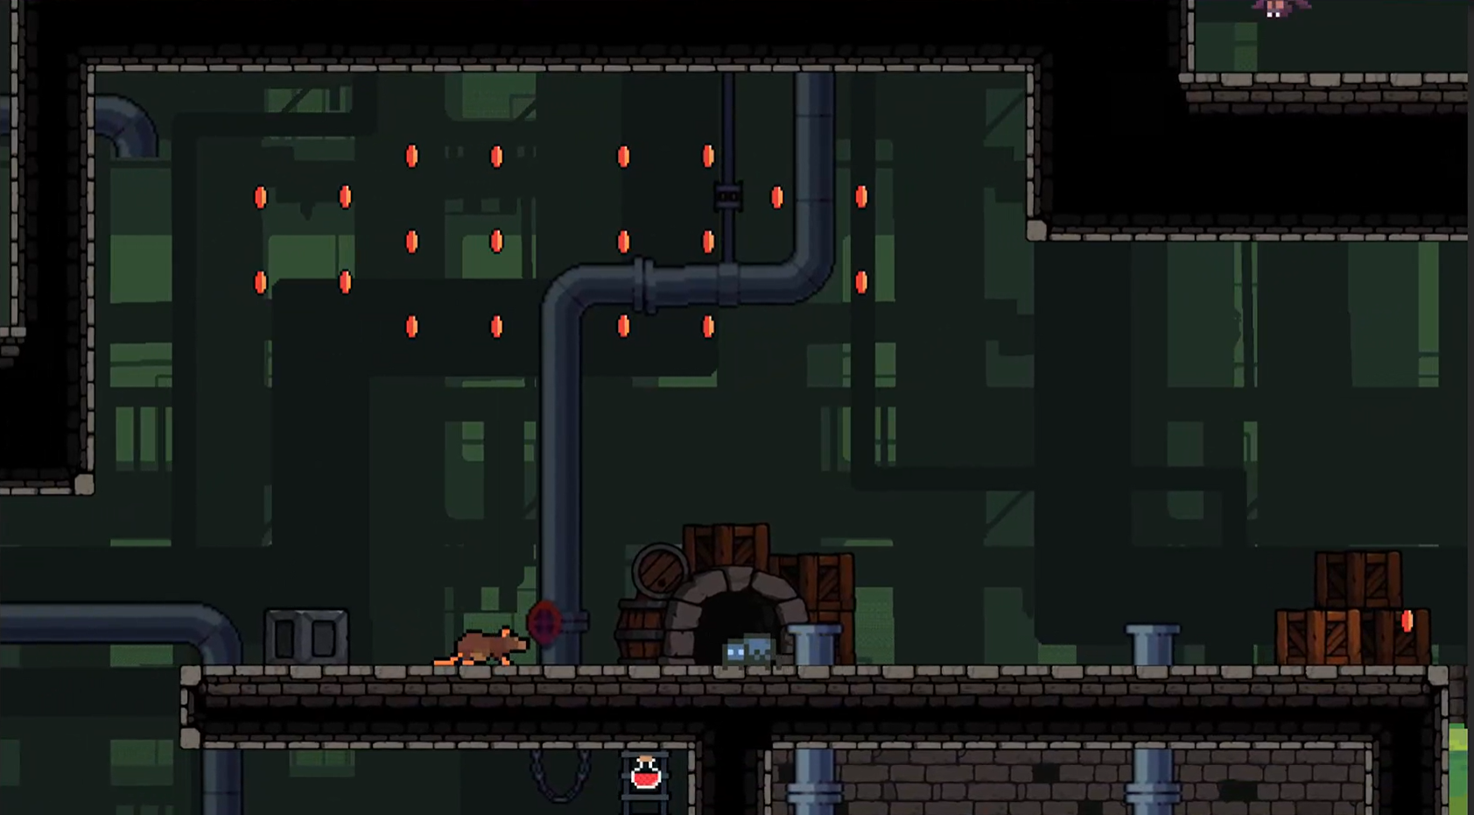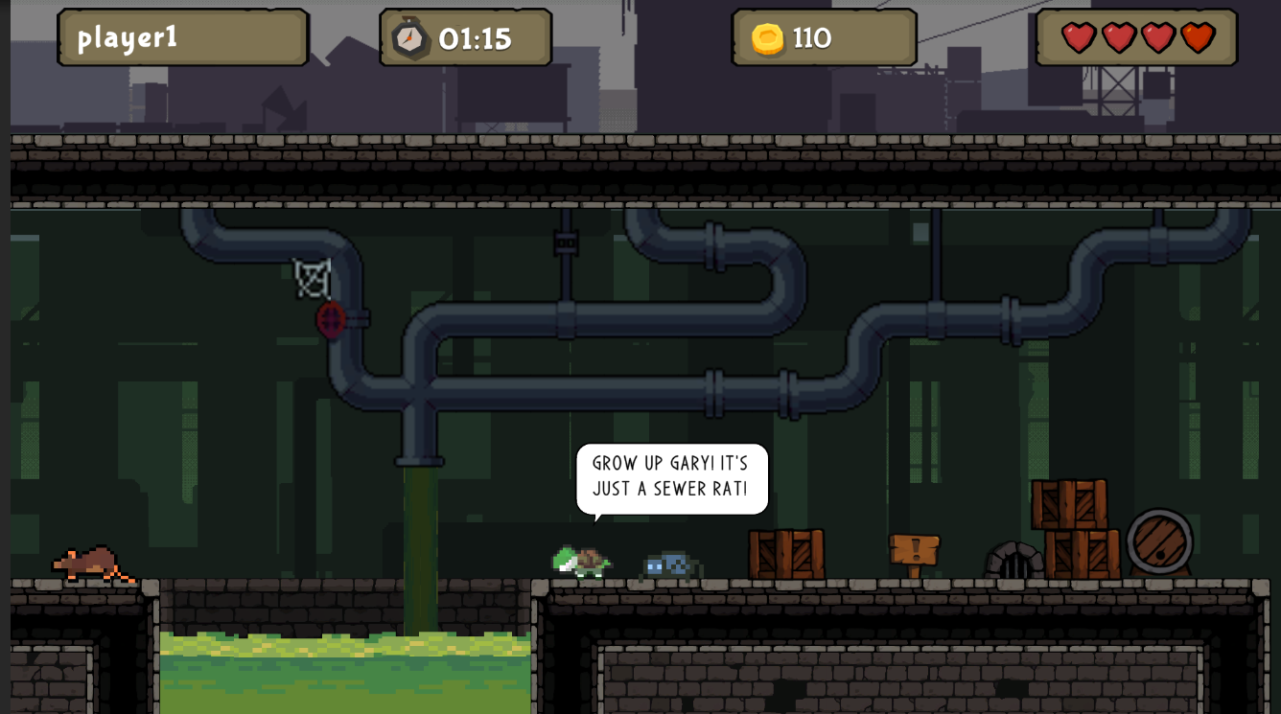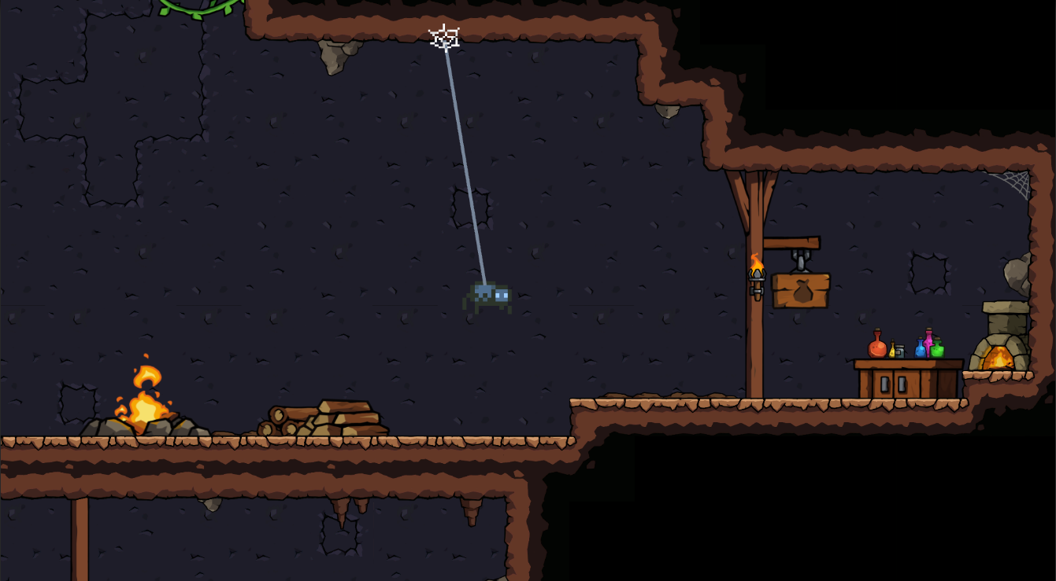
Software Libraries and Packages Used | Unity Game Engine, Unity Dev Ops, Pixilart.com for custom pixel art, Adobe Photoshop App for modifying assets/art, Notability App for comics, Premier for trailer
Third-Party and Ready-Made Asset Credits | Please see list on next page
Faculty Member Name & Contact Information | Derek Prate, Chapman University, prate@chapman.edu
YouTube Link | https://youtu.be/5gz01U9xEAU?si=nv3KGEZWlIMb0lmH
Misc. Notes
Submitted by: Natalie Huante, huante@chapman.edu, Discord: NAT#5733

Name or brief description | Source (ideally both URL and creator’s name) | If modified by team, explain how.
lobby art, level walls/ground, some of the UI for menus | https://assetstore.unity.com/packages/2d/environments/2d-platformer-tileset-173155, Creator: Danil Chernyaev
rat pixel art | https://craftpix.net/freebies/free-street-animal-pixel-art-asset-pack/?num=1&count=1475&sq=2d%20pixel%20animals&pos=4
snake pixel art | https://free-game-assets.itch.io/forest-enemies-pixel-art-sprite-sheet-pack
bat pixel art | https://ome6a1717.itch.io/simple-enemies-bat | added hurt sprite
npc turtle pixel art | https://elthen.itch.io/2d-pixel-art-turtle-sprites, Creator: Elthen’s Pixel Art Shop
spider pixel art | https://elthen.itch.io/2d-pixel-art-spider-sprites, Creator: Elthen’s Pixel Art Shop
water sprites | https://gfragger.itch.io/the-sideroller-sewer-assets-pack, Creator: GFragger
pipes art | https://craftpix.net/product/lab-tileset-pixel-art/?num=1&count=8&sq=pipes&pos=0
speech bubble sprites | https://assetstore.unity.com/packages/2d/environments/2d-atlas-speech-bubbles-alphabet-numbers-88398, Creator: RAFMANIX
Pipes in the background | https://free-game-assets.itch.io/sewerage-platformer-tileset-pixel-art | recolored completely & assembled
city background | https://free-game-assets.itch.io/free-scrolling-city-backgrounds-pixel-art | recolored completely & assembledLexic
Lexica - Tiger (music) | https://www.youtube.com/watch?v=8oKG0c-PuxY
XtremeFreddy - Bit Beats 6 (music) | https://pixabay.com/music/video-games-bit-beats-6-171021/

What were the top technical challenges that you encountered in the project? | We had issues when expanding the functionality of both the player and the enemies; it was getting harder to maintain and expand upon. So, we made a complete switch to new state machines. One for the player. And one for each enemy entity, which involved a lot of inheritance and scriptable objects for state data. Recently, we switched to Unity’s new input system to accommodate the new state machines. Making sure the player mechanics were compatible with this led to a re-structure of our code. Our team decided to incorporate Unity’s tilemap tool to help with level design. This required us to restructure the game since it was initially made with 3d components. The tilemap tools only interact with 2d objects/components, meaning we had to adjust existing assets and systems to align with this requirement. Developing the web mechanics was also challenging and involved various testing stages. We wanted them to feel natural and as if the player was really moving about like a spider. So, we tried different methods of aiming and managing the web. We ended up using a distance joint, given its versatility for swinging, rappelling, and grappling.
How did the design evolve during development? What changed, and what didn’t? | The level design, art theme, and storyline aspects have changed a couple of times since starting the development of the game. Although the foundation of the story has remained, including Sam’s character, his background, and his mission, other aspects have been rethought and re-evaluated. We wanted to encourage players to really explore and navigate around the sewers to find new rooms and challenges, which led us to pivot from a side-scroller to, ultimately, a platformer. The player can now move and explore in both the horizontal and vertical directions. We also had a bit of a hiccup with our art. Initially, we were developing and editing partially AI-generated assets for our tilesets. Three weeks before submission, we became aware that this was not an option for eligibility, so we had to redo all of our assets for level design completely. Originally, Sam would travel to the different sewer systems of the world, but due to time constraints, we had to shift our focus and find different asset packs that we could piece together. That being said, most of the assets we used have been hand-picked from various packs and edited to create one cohesive and aesthetic art theme. These two design shifts are what led to our biggest changes during development. However, the story of who Sam is, his story, and the player’s mission have remained the same throughout.

