1. Start MariaDB

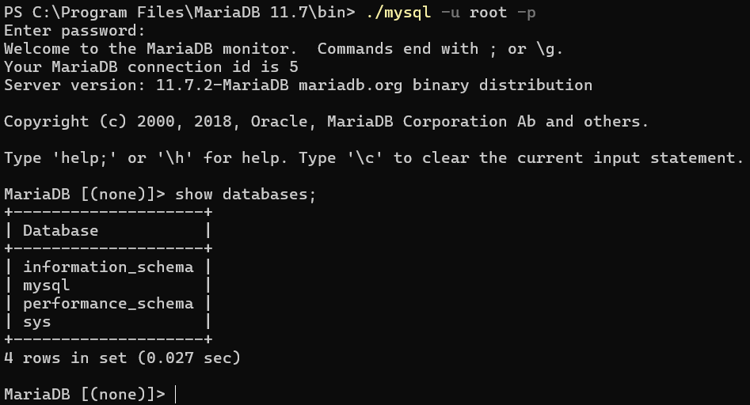

1. Create Tables and Insert Data

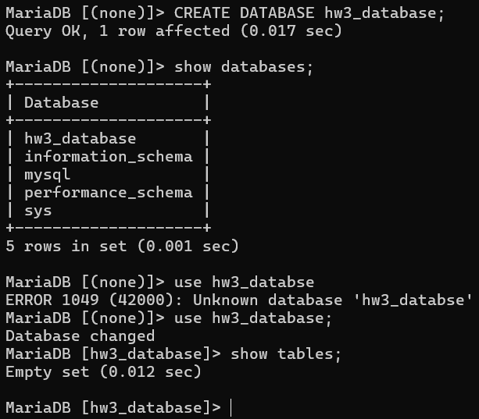

* 1. Schema: Create the necessary tables

|  |  |
| --- | --- |
| SQL Statements | Output |
| CREATE TABLE Booking (  agent VARCHAR(50),  traveler_ssn INTEGER,  trip_id INTEGER,  PRIMARY KEY (agent, traveler_ssn, trip_id)  ); |  |
| CREATE TABLE TravelAgent (  name VARCHAR(50),  years_experience INTEGER,  phone VARCHAR(50),  PRIMARY KEY (name)  ); |  |
| CREATE TABLE Traveler (  name VARCHAR(50),  ssn INT,  dob DATE,  PRIMARY KEY(name)  ); |  |
| CREATE TABLE Trip(  id INTEGER,  start_location VARCHAR(50),  end_location VARCHAR(50),  start_date DATE,  end_date DATE,  PRIMARY KEY (id)  ); |  |

* 1. Insert Sample Data

|  |  |
| --- | --- |
| SQL Statements | Output |
| INSERT INTO TravelAgent (name, years_experience, phone)  VALUES  ('Alice Brown', 12, '123-456-7890'),  ('John Smith', 8, '234-567-8901'),  ('Michael Johnson', 5, '345-678-9012'),  ('Sarah Williams', 15, '456-789-0123'),  ('Daniel Lee', 20, '567-890-1234'),  ('Rachel Green', 3, '678-901-2345'); |  |
| INSERT INTO Traveler (name, ssn, dob)  VALUES  ('David Harris', 101, '1985-06-12'),  ('Sarah Connor', 102, '1992-03-05'),  ('Mike Johnson', 103, '1998-09-17'),  ('Laura White', 104, '1995-04-23'),  ('James Miller', 105, '2000-08-14'),  ('Emma Watson', 106, '1997-11-30'),  ('Chris Evans', 107, '1993-06-21'),  ('Sophia Brown', 108, '1999-02-25'); |  |
| INSERT INTO Trip (id, start_location, end_location, start_date, end_date)  VALUES  (201, 'New York', 'Paris', '2025-07-10', '2025-07-20'),  (202, 'Tokyo', 'Sydney', '2025-08-01', '2025-08-15'),  (203, 'London', 'Rome', '2025-09-05', '2025-09-15'),  (204, 'Miami', 'New York', '2025-06-15', '2025-06-20'),  (205, 'San Francisco', 'Berlin', '2025-10-01', '2025-10-10'),  (206, 'Chicago', 'Los Angeles', '2025-09-10', '2025-09-12'),  (207, 'Boston', 'Dubai', '2025-07-05', '2025-07-18'),  (208, 'New York', 'Dubai', '2025-09-10', '2025-09-15'); |  |
| INSERT INTO Booking (agent, traveler_ssn, trip_id)  VALUES  ('Alice Brown', 101, 201),  ('John Smith', 102, 202),  ('Michael Johnson', 103, 203),  ('Sarah Williams', 104, 204),  ('Daniel Lee', 105, 205),  ('Alice Brown', 106, 206),  ('Rachel Green', 107, 207),  ('John Smith', 108, 201),  ('Alice Brown', 101, 208); |  |

1. SQL Query Exercises

|  |  |  |
| --- | --- | --- |
| # | SQL Query | Screenshot of SQL Query and Query Output |
| 1 | SELECT name, phone, 'Experienced Agent' AS Experience  FROM TravelAgent  WHERE years_experience > 10; |  |
| 2 | SELECT start_date, end_date  FROM Trip  WHERE start_location = 'New York'; |  |
| 3 | SELECT *  FROM Trip  WHERE start_location = 'New York' AND end_location = 'Paris'; |  |
| 4 | SELECT *  FROM Trip  WHERE start_location = 'New York' OR start_location = 'Miami'; |  |
| 5 | SELECT *  FROM Trip  WHERE start_date > '2025-08-01'; |  |
| 6 | SELECT traveler_ssn, trip_id  FROM Booking  WHERE agent = 'Alice Brown'; |  |
| 7 | SELECT *  FROM Traveler  WHERE name LIKE '_a%'; |  |
| 8 | SELECT *  FROM Traveler  WHERE name NOT LIKE 'David Harris'; |  |
| 9 | SELECT *  FROM TravelAgent  WHERE phone LIKE '456-___-____'; |  |
| 10 | SELECT *  FROM Trip  WHERE start_date BETWEEN '2025-07-01' AND '2025-09-30'; |  |