PROBLEMS ENCOUNTERED
No problems encountered throughout the lab.
INTRODUCTION
This laboratory introduces SPICE circuit simulation using LTspice and explores the key differences between ideal and real-world non-ideal components. Through DC operating point analysis, parameter stepping, and Monte Carlo statistical simulations, we quantify oscilloscope probe loading effects and resistor tolerance variations on node voltages.
DISCUSSION

Objective
The objective of the laboratory is to introduce students to SPICE (Simulation Program with Integrated Circuit Emphasis) and illustrate the differences between real and ideal components.

Materials
- Laptop with LT Spice

Introduction
For the purposes of this class, LTspice (current Windows version is 24.1.0) will be used. It is a free version of spice that’s supported by Linear Technology (recently acquired by Analog Devices). It can be downloaded from Linear Technologies’ website here.
There are useful resources provided in the Lab 3 Canvas folder with Lab 3 tips and LTspice keyboard shortcuts.
If possible, use LTspice on Windows for the best experience. The Mac version looks bare bones compared to the Windows version, but all the same functionalities exist, it’s just hidden in sub menus.
Below are some videos to help you get familiar with the software.
- LT - LTspice IV Overview
- LT - Schematic Editor
- LT - Waveform Viewer
- LT - Stepping Parameters

Pre-Lab Requirements
Install LTspice, work through the tutorials, and complete the following.

Modeling Simple Circuits
A resistor ladder is shown in Figure 3.1.
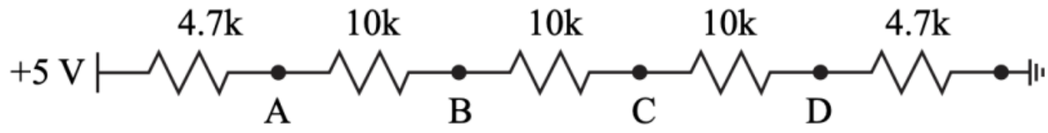
Figure 3.1: Resistor Ladder Example
- Using LTspice, layout the circuit in Figure 3.1 and run a DC operating point simulation (.op) to generate the node voltages at nodes A, B, C, and D. Table the node voltages.

Current (I) = $\frac{Vin}{Rtotal}= \frac{5V}{4.7 KΩ+10 KΩ+10 KΩ+10 KΩ+4.7 KΩ}= 0.127 mA$

Node | Expected Voltage (V) | Measured Voltage (V) | Percent Error
A | 4.40355 | 4.40355 | 0%
B | 3.13452 | 3.13452 | 0%
C | 1.86548 | 1.86548 | 0%
D | 0.596447 | 0.596447 | 0%
Table 1: Node Voltages at Nodes A, B, C, and D, Expected Voltage (V) = V - Current (I) * Resistance (R)
- When measuring the node voltages in real life, an oscilloscope is used. The scope probes have a finite input resistance of 1 MΩ. Re-simulate the node voltages with a 1 MΩ resistor at nodes A through D, Figure 3.2 (a) through (d). There should be a total of 4 simulations with node voltages A through D for each simulation. Table the values.

R_{down,A} = 10KΩ + 10 KΩ + 10 KΩ + 4.7 KΩ = 34.7 KΩ
R_{node,A} = R_{down,A} || 1 MΩ = 34.7 KΩ || 1 MΩ = $\frac{34.7 KΩ*1 MΩ}{34.6 KΩ+1 MΩ}$ = 33.5363 KΩ
R_{total,A} = 4.7 KΩ + R_{node,A} = 4.7 KΩ + 33.5363 KΩ = 38.2363 KΩ
I_{total,A} = $\frac{Vin}{Rtotal}=\frac{5V}{38.2362 KΩ}=0.131 mA$
I_{down,A} = $\frac{VA}{Rdown,A}= \frac{4.3854V}{34.7 KΩ}$ = 0.126 mA
Node | Expected Voltage (V) | Measured Voltage (V) | Percent Error
A | 5V – (I_{total,A} * R_{A}) =  5V – (0.131mA * 4.7KΩ) = 4.3854 | 4.3854 | 0%
B | V_{node,A} – (I_{down,A} * R_{B}) = 4.39V – (0.126mA * 10KΩ) = 3.126V | 3.1216 | 0%
C | V_{node,B} – (I_{down,A} * R_{C}) = 4.12V – (0.126mA * 10KΩ) = 1.85779V | 1.85779 | 0%
D | V_{node,C} – (I_{down,A} * R_{D}) = 1.85779V – (0.126mA * 10KΩ) = 0.593988V | 0.593988 | 0%
Table 2: Figure 3.2 a with 1 MΩ at node A
R_{down,B} = 10 KΩ + 10 KΩ + 4.7 KΩ = 24.7 KΩ
R_{node,B} = R_{down,B} || 1 MΩ = 24.7 KΩ || 1 MΩ = $\frac{24.7 KΩ*1 MΩ}{24.6 KΩ+1 MΩ}$ = 24.1046 KΩ
R_{total,B} = 4.7 KΩ + 10 KΩ + R_{node,B} = 4.7 KΩ + 10 KΩ + 24.1046 KΩ = 38.8046 KΩ
I_{total,B} = $\frac{Vin}{Rtotal}=\frac{5V}{38.8046 KΩ}=0.129 mA$
I_{down,B} = $\frac{VB}{Rdown,B}= \frac{3.1059V}{24.7 KΩ}$ = 0.126 mA
Node | Expected Voltage (V) | Measured Voltage (V) | Percent Error
A | 5V – (I_{total,B} * R_{A}) =  5V – (0.129mA * 4.7KΩ) = 4.3944 | 4.3944 | 0%
B | V_{node,A} – (I_{total,B} * R_{B}) = 4.39V – (0.129mA * 10KΩ) = 3.1059V | 3.1059 | 0%
C | V_{node,B} – (I_{down,B} * R_{C}) = 3.11V – (0.126mA * 10KΩ) = 1.84845V | 1.84845 | 0%
D | V_{node,C} – (I_{down,B} * R_{D}) = 1.85V – (0.126mA * 10KΩ) = 0.591000347V | 0.591 | 0%
Table 3: Figure 3.2 a with 1 MΩ at node B
R_{down,C} = 10 KΩ + 4.7 KΩ = 14.7 KΩ
R_{node,C} = R_{down,C} || 1 MΩ = 14.7 KΩ || 1 MΩ = $\frac{14.7 KΩ*1 MΩ}{14.6 KΩ+1 MΩ}$ = 14.487 KΩ
R_{total,C} = 4.7 KΩ + 10 KΩ + + 10 KΩ + R_{node,C} = 4.7 KΩ + 10 KΩ + 10 KΩ + 14.487 KΩ = 39.187 KΩ
I_{total,C} = $\frac{Vin}{Rtotal}=\frac{5V}{39.187 KΩ}=0.128 mA$
I_{down,C} = $\frac{VB}{Rdown,B}= \frac{1.84845V}{14.7 KΩ}$ = 0.126 mA
Node | Expected Voltage (V) | Measured Voltage (V) | Percent Error
A | 5V – (I_{total,C} * R_{A}) =  5V – (0.128mA * 4.7KΩ) = 4.4031 | 4.40031 | 0%
B | V_{node,A} – (I_{total,C} * R_{B}) = 4.4031V – (0.128mA * 10KΩ) = 3.12438V | 3.12438 | 0%
C | V_{node,B} – (I_{total,C} * R_{C}) = 3.12V – (0.128mA * 10KΩ) = 1.84845V | 1.84845 | 0%
D | V_{node,C} – (I_{down,C} * R_{D}) = 1.85V – (0.126mA * 10KΩ) = 0.591000347V | 0.591 | 0%
Table 4: Figure 3.2 a with 1 MΩ at node C
R_{down,D} = 4.7 KΩ
R_{node,D} = R_{down,D} || 1 MΩ = 4.7 KΩ || 1 MΩ = $\frac{4.7 KΩ*1 MΩ}{4.6 KΩ+1 MΩ}$ = 4.67801 KΩ
R_{total,D} = 4.7 KΩ + 10 KΩ + + 10 KΩ + 10 KΩ + R_{node,D} = 4.7 KΩ + 10 KΩ + 10 KΩ + + 10 KΩ + 4.678 KΩ = 39.378 KΩ
I_{total,D} = $\frac{Vin}{Rtotal}=\frac{5V}{39.378 KΩ}=0.127 mA$
I_{down,D} = $\frac{VB}{Rdown,B}= \frac{0.593988V}{4.7 KΩ}$ = 0.126 mA
Node | Expected Voltage (V) | Measured Voltage (V) | Percent Error
A | 5V – (I_{total,D} * R_{A}) =  5V – (0.127mA * 4.7KΩ) = 4.40322 | 4.40322 | 0%
B | V_{node,A} – (I_{total,D} * R_{B}) = 4.40322V – (0.127mA * 10KΩ) = 3.13348V | 3.13348 | 0%
C | V_{node,B} – (I_{total,D} * R_{C}) = 3.13V – (0.127mA * 10KΩ) = 1.86373V | 1.86373 | 0%
D | V_{node,C} – (I_{total,D} * R_{D}) = 1.86V – (0.127mA * 10KΩ) = 0.5939887V | 0.593988 | 0%
Table 5: Figure 3.2 a with 1 MΩ at node D
- Save the tabled values to submit to Canvas as part of the pre-lab.
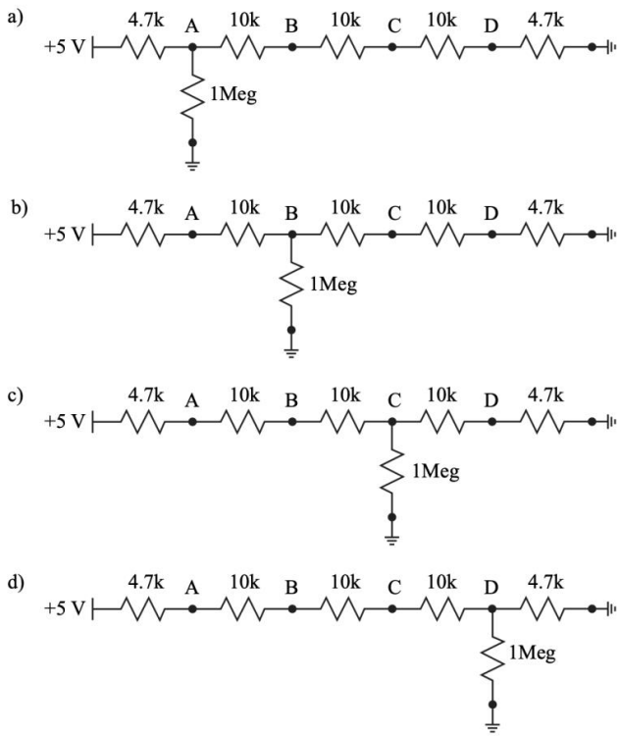
Figure 3.2: Resistor ladder with a 1 MΩ resistor attached at nodes A through D ((a) through (d)).

LTspice Variables
There is clearly an effect caused by the input resistance of the oscilloscope, often called the “loading effect”. Using LTspice, quantify the effect as a function of resistance by completing the following:
- Layout the circuits in Figure 3.3 in LTspice on the same schematic. Use the variable {R} for resistor values, set the source voltage to 5 V DC and label each output node.
- Use the following spice directive in conjunction with a DC operating point simulation (.op) to sweep the resistors in both voltage dividers.
.step param R list 10 100 1k 10k 100k 1Meg 10Meg
- Plot the voltages at Vout1 and Vout2 and set the x axis to logarithmic by right clicking on the x axis. Save the results into a document, include your circuit image and simulation results, which will be submitted to Canvas as part of the pre-lab.
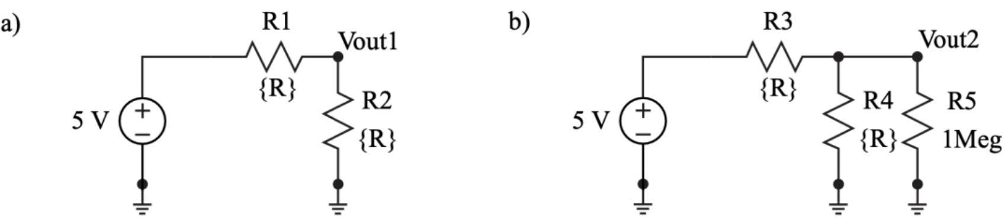
Figure 3.3: Two circuits to test the loading effect of one of the o-scope probes. The first circuit is a simple voltage divider that is not loaded (a) while the second circuit has a 1 MΩ resistor in parallel with R4 (b).
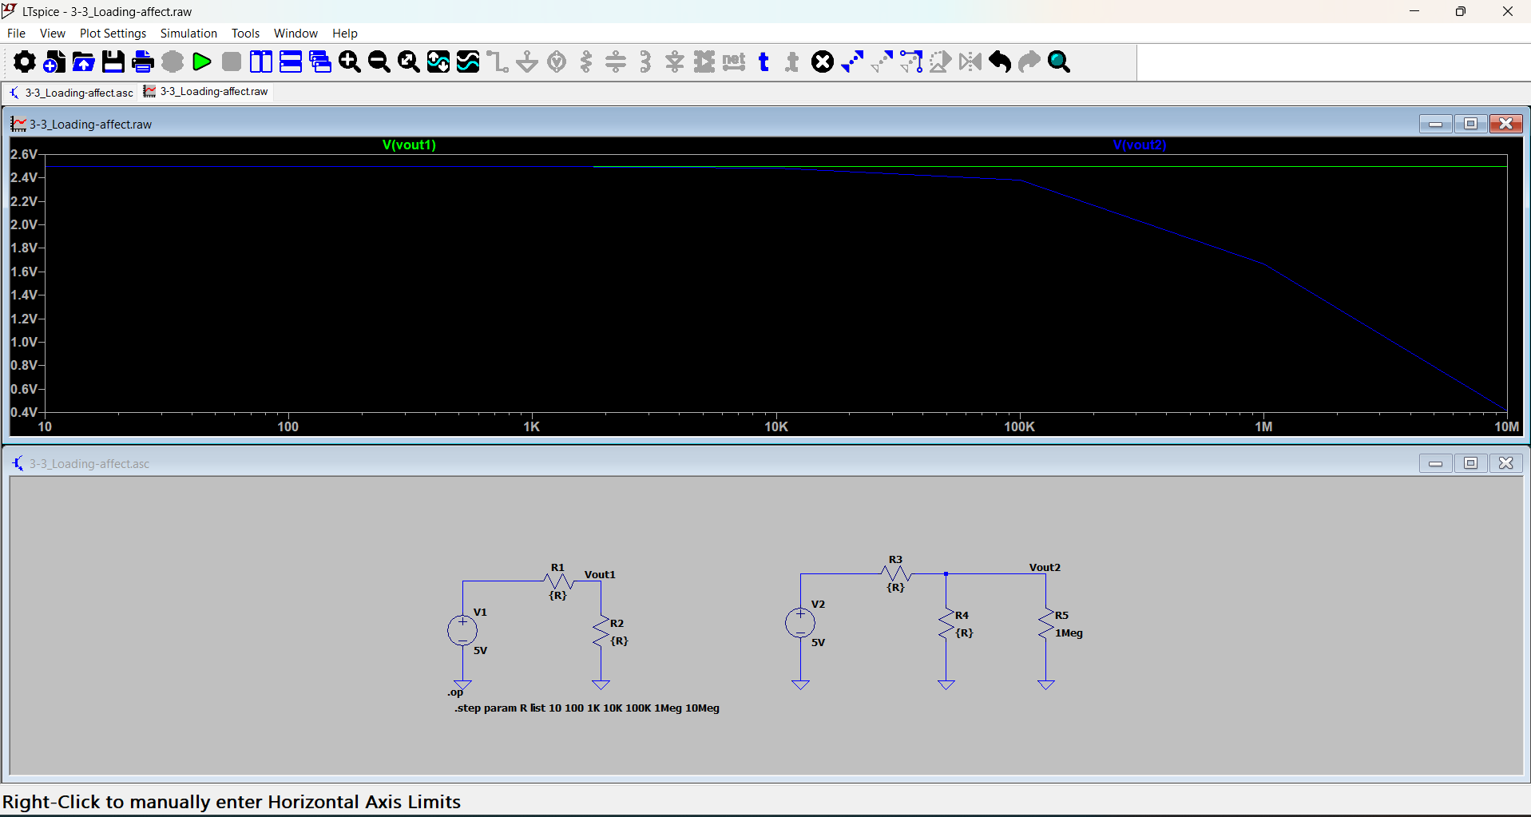
Screenshot 1: Exercise 3.3 – Image of Circuit and Simulation Results. The first circuit is a simple voltage divider that is not loaded (1) while the second circuit has a 1 MΩ resistor in parallel with R4 (2)

Monte Carlo Simulations
Resistors have tolerances for their values which can vary from 10% for generic through hole resistors to as low as 0.005% for laser trimmed resistors. There is never a guarantee that a resistor has a resistance exactly equal to its value.
LTspice has a Monte Carlo function, {mc(x,y)}, that will randomize a number x with a tolerance of y between x*(1+y) and x*(1-y) with a uniform distribution.
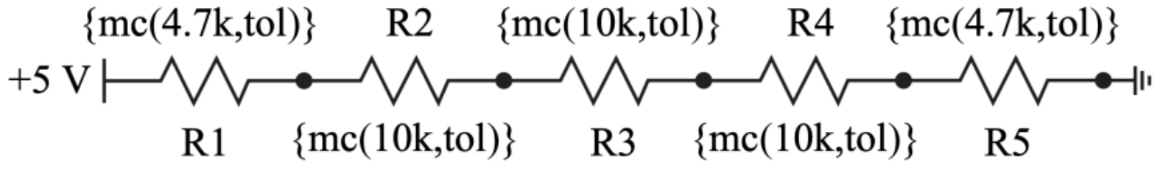
Figure 3.4: Resistor ladder with the values replaced by the LTspice Monte Carlo function.
Complete the following:
- Layout the circuit in Figure 3.4, setting the resistor values to call the mc function.
- Use the following spice directive in conjunction with a DC operating point simulation to randomize all the resistor values for 1000 trials with a 5 percent tolerance using the two directives below.
.param tol=0.05
.step param run 1 1k 1
- Plot all the node voltages, A-D, on separate plot planes in one graph to view how the voltage at each node varies for each trial. Table the voltage ranges (Vmax and Vmin) for each node.
- Save the results into a document, include your circuit image and simulation results, which will be submitted to Canvas as part of the pre-lab. Use " .meas " spice directive to measure the voltage range (Vmax and Vmin) of nodes. To view the node voltages and currents, open the Spice Error Log under the View tab. Depending on your LTspice version, you may have to scroll all the way down to view the values (use the side scrolling bar).

However, if your LTspice “.meas” directive does not work (i.e., the maximum and minimum values display as the same), you will need to manually determine the values. To do this, hover your cursor over the plot panes in the simulation results and read the Y-axis values to identify the maximum and minimum points.

Below is an example of using the “.meas” directive to find the maximum voltage at node A:
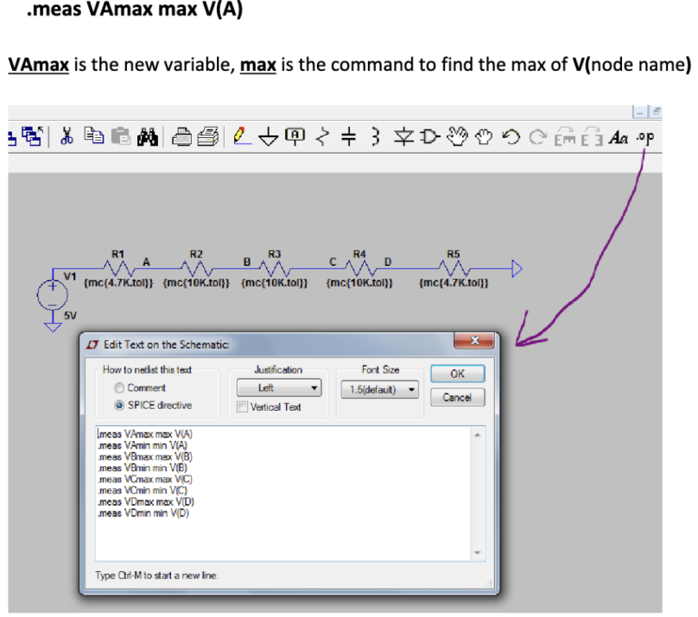
Figure 3.5: Example of using the max measure directive.
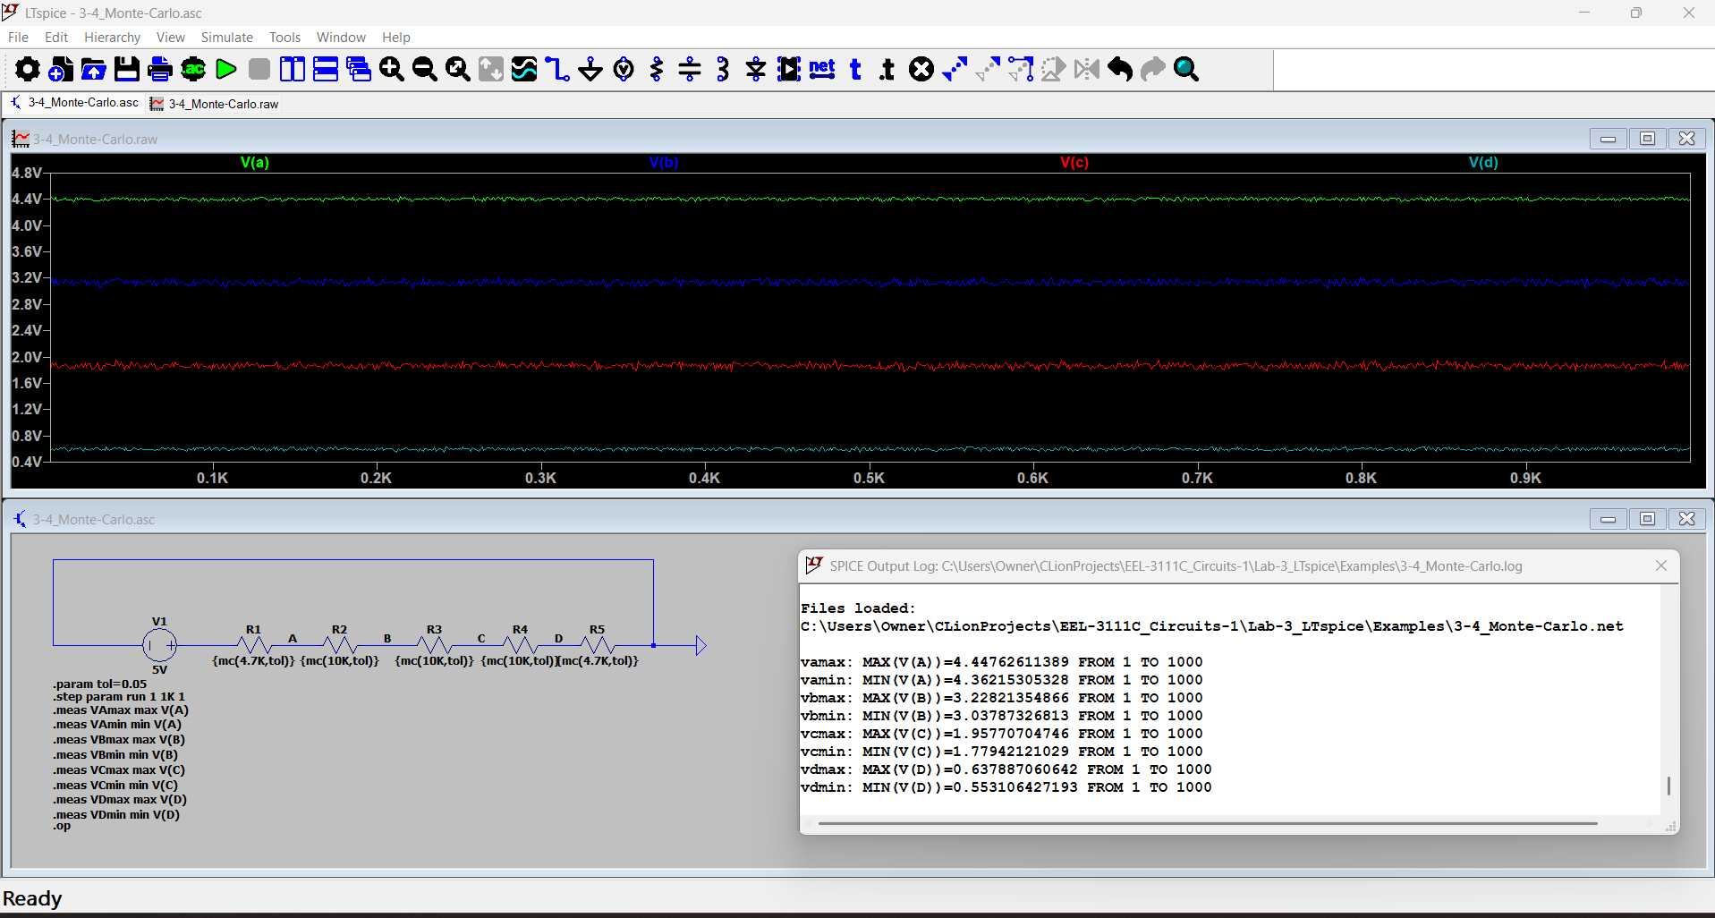
Screenshot 2: Exercise 3.4 - Image of Circuit and Tabled Voltages and Simulation Results. Resistor ladder with the values replaced by the LTspice Monte Carlo function.
Node | Max (V) | Min (V)
A | 4.44762611389 | 4.36215305328
B | 3.22821354866 | 3.03787326813
C | 1.95770704746 | 1.77942121029
D | 0.637887060642 | 0.553106427193
Table 6: Exercise 3.4 - Max/Min output Voltages

In-Lab Requirements
The following must be completed and submitted to Canvas before the start of lab.
- Section 3.4.1 - Tabled voltages (note: four sets for 3.4.1.2).
  - Table 1
  - Table 2
  - Table 3
  - Table 4
  - Table 5
- Section 3.4.2 - Image of circuit and simulation results.
  - Screenshot 1
- Section 3.4.3 - Image of circuit and tabled voltages and simulation results.
  - Screenshot 2
  - Table 6
Complete the following items in lab.

Equivalent Resistance
An 8-bit R-2R ladder is a digital-to-analog converter (DAC) designed to convert an 8-bit binary input into a corresponding analog voltage. It uses a repeating pattern of resistors with values of R and 2R to create a voltage divider network. The binary input determines which switches in the ladder are activated, generating a proportional analog output. R-2R ladders are widely used in applications requiring accurate and efficient digital-to-analog conversion, such as audio devices and microcontroller-based systems.
When building the below circuit in spice, instead of assigning each resistor value to 470, give them the value " Ra " and create a spice directive " .param Ra=470 ". This will allow you to then change the directive’s value from 470 to 500 afterwards and then rerun it to complete the experiment. This is a much more effective method.
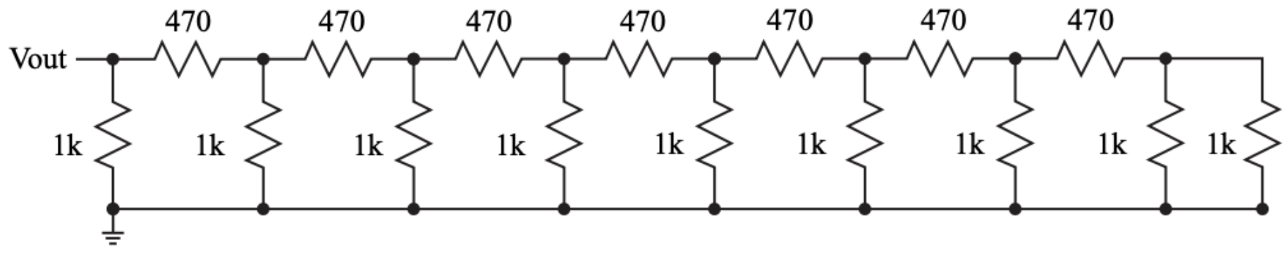
Figure 3.6: An 8-bit R-2R ladder with all the digital input bits tied to ground.
- Using a 1 V test source at Vout run a DC operating point simulation and calculate the equivalent resistance using Ohm’s Law. Save the equivalent resistance value.
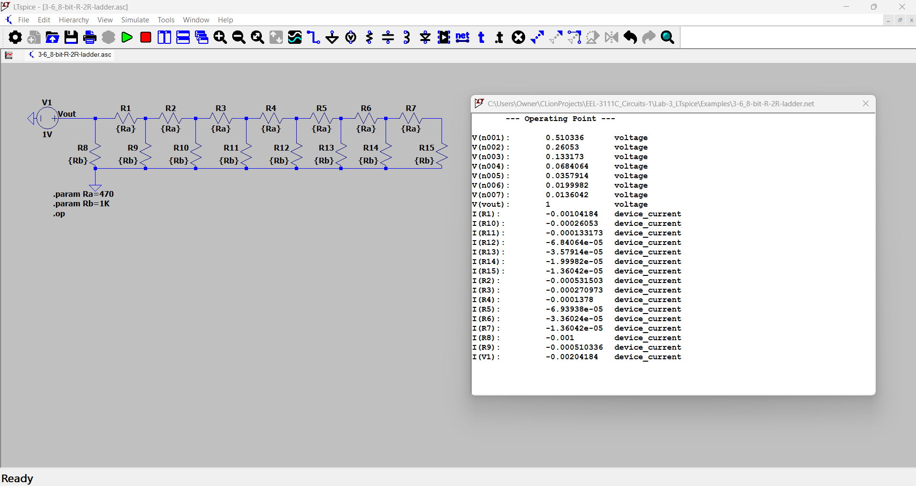
R_{eq} = $\frac{Vout}{I(Vout)}=\frac{1V}{0.00204184A}=489.754339Ω$
- Change 470 Ω resistors to 500 Ω resistors and confirm that the equivalent resistance is 500 Ω.
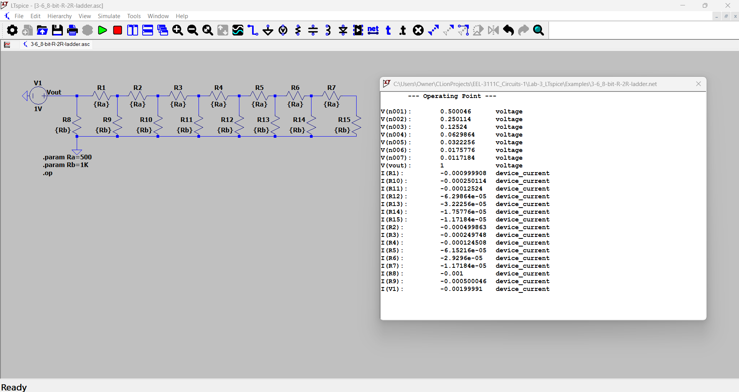
R_{eq} = $\frac{Vout}{I(Vout)}=\frac{1V}{0.00199991A}=500.02250Ω$

Monte Carlo with Difference Tolerances
Repeat the Monte Carlo simulations from Section 3.4.3 using the following tolerances. Table the voltage ranges at each node.
- 1%
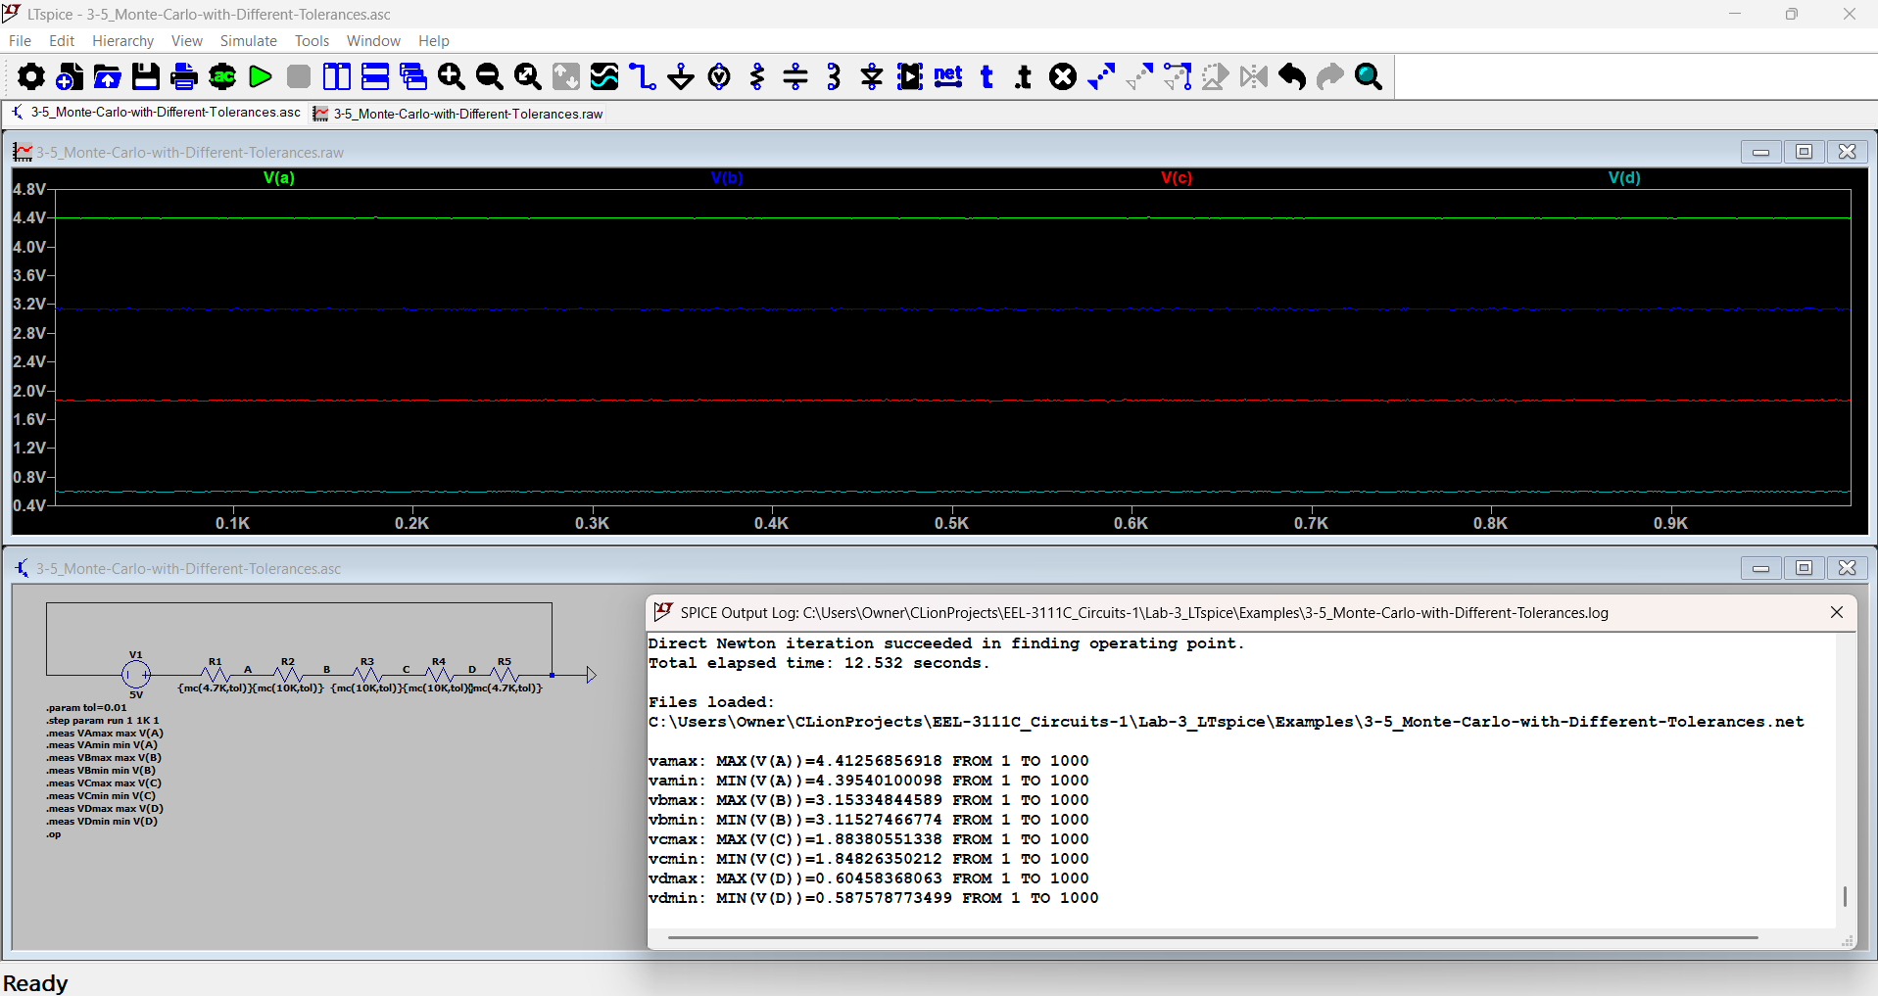
Node | Max (V) | Min (V)
A | 4.41256856918 | 4.39540100098
B | 3.15334844589 | 3.11527466774
C | 1.88380551338 | 1.84826350212
D | 0.60458368063 | 0.587578773499

- 0.05%
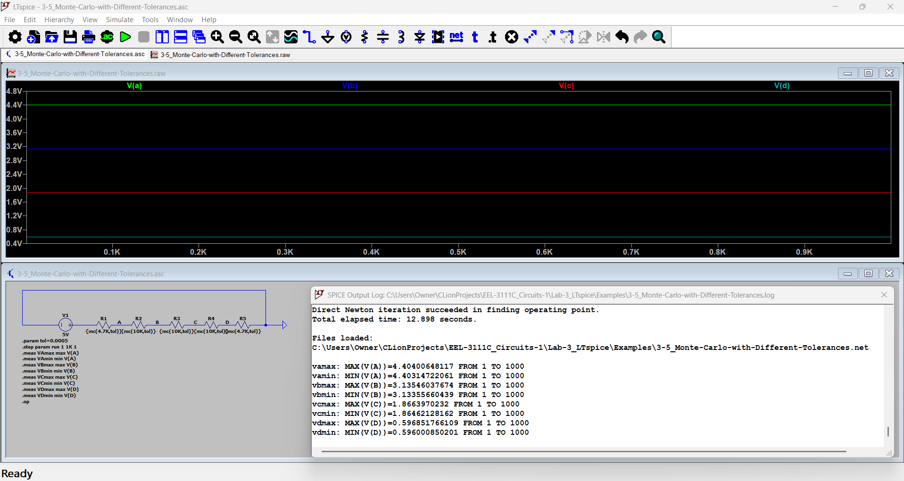
Node | Max (V) | Min (V)
A | 4.40400648117 | 4.40314722061
B | 3.13546037674 | 3.13355660439
C | 1.8663970232 | 1.86462128162
D | 0.596851766109 | 0.596000850201

- 0.005%
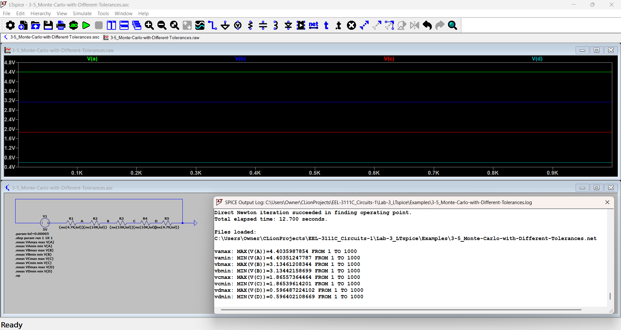
Node | Max (V) | Min (V)
A | 4.4035987854 | 4.40351247787
B | 3.13461208344 | 3.13442158699
C | 1.86557364464 | 1.86539614201
D | 0.596487224102 | 0.596402108669

Resistor Costs
While tighter resistor tolerances are desirable for improved accuracy, they often come at a higher cost. Using DigiKey, determine the lowest total cost of constructing the 8-bit R-2R ladder shown in Figure 3.6, considering only the cost of resistors (500 Ω and 1 kΩ). Use the price listed for a quantity of 1 for each resistor. Search for Through Hole Resistors, in-stock, 0.25 Watt for the tolerances listed below: (If the item is out of stock, you may use another website such as Mouser.)
- 1% - MFR25SFBE52-500R, MFR-25FBF52-1K
- 0.1% - RN60C5000BRE6, 1613634-5
- 0.05% - PTF65500R00AXR6, PTF651K0000AXR6
Tolerance | Typical Unit Price (R=500Ω) | Typical Unit Price (2R=1kΩ) | Calculation | Lowest Total Cost
1% | ~$0.10 | ~$0.10 | (7 x $0.10) + (9 x $0.10) | $1.60
0.1% | ~$0.65 | ~$0.65 | (7 x $0.65) + (9 x $0.65) | $10.40
0.05% | ~$3.16 | ~$3.16 | (7 x $3.16) + (9 x $3.16) | $50.56

Write Ups
Include the following in the write up (use the report template file in Canvas).
- Two equivalent resistor values from Subsection 3.5.1.
- Table of voltage ranges from Subsection 3.5.2.
- Table of cost ranges from Subsection 3.5.3.
Discussion Question: Discuss the impact of resistor variations on the R-2R ladder, including their influence on node voltages and overall equivalent resistance accuracy. Additionally, evaluate the tradeoffs between using resistors with tighter tolerances and their associated costs. Are there other characteristics that should be considered when buying components? If yes, list and discuss them.
The resistor variations disrupt the 2:1 resistance ratio for the R-2R ladder nodes, which introduces non-linearity, gain errors, and quantization errors in the DAC's analog output. In the Monte Carlos simulations, loose component tolerances increase the variance between Vmax and Vmin across all nodes. For instance, at a 1% tolerance, Node A varied across a range of approximately 17.16 mV (4.395 V to 4.413 V), whereas at 0.05% tolerance, the variance is reduced to 0.86 mV (4.4031 V to 4.4040 V). Additionally, the resistor tolerances cause the overall equivalent input resistance to deviate from the ideal target of 500 ohms, affecting impedance matching and signal loading.
Achieving higher circuit accuracy through tighter tolerances requires a financial tradeoff, as smaller tolerances increase in price. However, smaller-tolerance resistors make them impractical to use in budget-sensitive designs despite the maximized DAC linearity that is provided.
The other characteristics that should be required when buying components are temperature coefficient of resistance, power dissipation, parasitic inductance and capacitance, noise rating, and package size and form factor. Temperature coefficient of resistance (TCR) specifies the resistance drift from operating temperature changes; high DACs require low TCR values to maintain accuracy during thermal shifts. Power dissipation are when resistors must operate within their maximum wattage rating to prevent self-heating, which alters resistance or causes thermal destruction. Parasitic inductance and capacitance are component lead geometry and construction materials that introduce parasitic reactivity at high operating frequencies, which affect settling time. Noise rating are when resistor component affects thermal and current noise levels, which can degrade the SNR of sensitive analog outputs. Package size and form factors are physical dimensions that dictate thermal management, PCD layout density, and automated assembly options.
CONCLUSION
In this lab, LTspice was used to perform DC operating point analyses, quantify oscilloscope probe loading effects, and calculate the equivalent resistance of an 8-bit R-2R ladder network. Monte Carlo statistical simulations demonstrated how tighter resistor tolerances compress node voltage variances and improve output accuracy. Finally, component pricing comparisons highlighted the exponential cost trade-off required when selecting high-precision resistors for hardware construction.

