PROBLEMS ENCOUNTERED
When going through the two bit R-2R ladder for the pre-lab I didn't get similar values for the experimental values unlike when working with the regular ladder. Also, DAD was having trouble connecting with my computer.
INTRODUCTION
This laboratory introduces basic resistive circuits, series and parallel resistor combinations, and the practical implementation of resistor ladder networks. Using the Digilent Analog Discovery and WaveForms software, the performance of 2-bit and 3-bit R-2R digital-to-analog converters (DACs) was evaluated under dynamic switching conditions. Additionally, component tolerances were quantified using multimeter resistance measurements to assess real-world impacts on voltage division accuracy

DISCUSSION

Objective
The objective of the laboratory is to introduce basic resistive circuits, the effect of resistors in series and parallel, applications of simple resistor ladders, and the effects of real world resistors.

Materials
- Laptop with Waveforms
- Digilent Analog Discovery
- Breadboard
- Wiring kit
- Lab parts kit

Introduction
Resistors are a fundamental part of all electronic circuits. Understanding how they work and
how to apply them is a basic requirement for any electronics course.

Resistor Combinations
Resistors in series will always add together:
$$R_{Total}=R_{1}+R_{2}…R_{N} (4.1)$$
while resistors in parallel combine as the addition of reciprocals:
$$\frac{1}{R_{Total}}= \frac{1}{R_{1}}+\frac{1}{R_{21}}…\frac{1}{R_{N}} (4.2)$$
Series resistances are straight forward, add one resistor to the other, but the parallel combination leads to different results based on the values of the resistors in parallel. For instance, a large resistor in parallel with a small resistor gives an equivalent resistance approximately equal to the small resistor. Similarly, two resistors of the same value in parallel gives an equivalent resistance equal to half of either resistor.

Voltage and Current Dividers
Resistors are commonly used to create voltage and current dividers, with the choice depending on the application. They are often employed to generate a smaller voltage from a larger voltage or to produce a smaller current from a larger current.
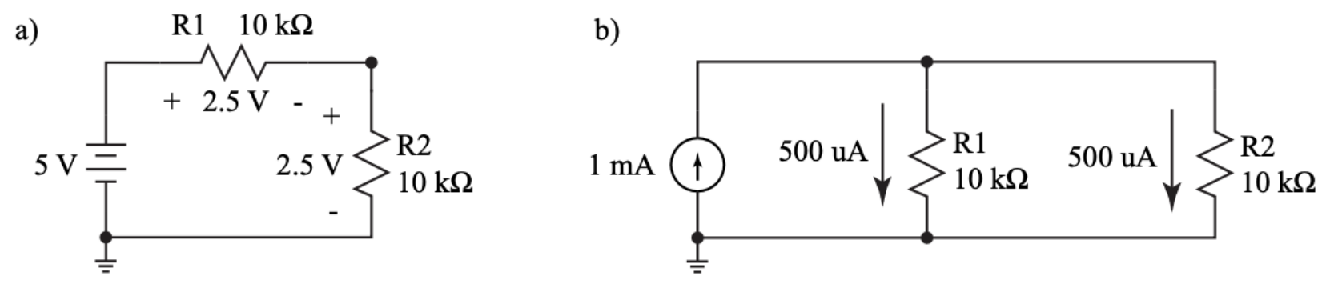
Figure 1: Examples of a voltage divider (a) and a current divider (b)
The output of a voltage divider can be simply calculated as:
$$V_{out}=\frac{R_{2}}{R_{1}+R_{2}}V_{in} (4.3)$$
In the example shown in (a), the output voltage is 2.5 V, which corresponds to the voltage across R2. This result is obtained by applying the voltage divider equation. Since the values for R1 and R2 are equal, the voltage drop across R1 is also 2.5 V.
$$\left(\frac{10 kΩ}{10 kΩ+10 kΩ}\right)5 V=2.5 V (4.4)$$
Similarly, a current divider is calculated in the same way where:
$$I_{out}=\frac{R_{2}}{R_{1}+R_{2}}I_{in} (4.5)$$
and the resulting current in each resistor is 500 µA which is again found by plugging in to the equation. Because the values for R1 and R2 are the same, the current through R1 is also 500 µA.
$$\left(\frac{10 kΩ}{10 kΩ+10 kΩ}\right)1 mA=500 μA (4.6)$$
Note that a voltage divider applies to resistors in series while a current divider applies to resistors in parallel.

Resistor Ladders
Resistors are often used in a string or ladder configuration to generate reference voltages with a specific spacing. Typical applications of a resistor ladder are analog to digital conversion where the input voltage is compared to voltages on the resistor ladder or digital to analog conversion where digital bits (1s and 0s) are converted to an analog voltage.
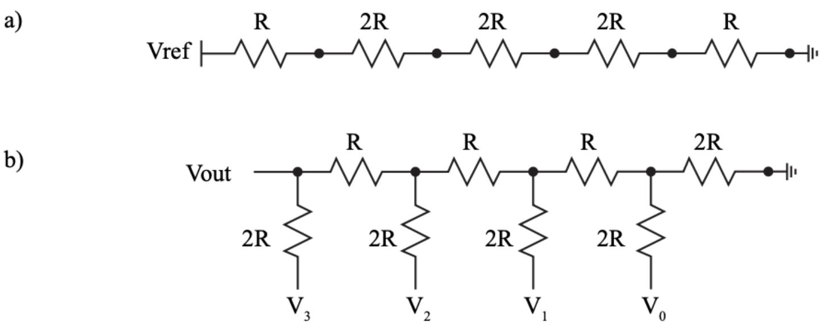
Figure 2: A simple resistor ladder where the resistor values set the voltages at each node (a) and a 4-bit R-2R ladder where digital bits, represented as voltages V0 through V3 are converted to an analog voltage, Vout.

Measuring Voltage and Current
In the past, separate meters were required to measure voltages and currents. Today, however, analog meters have been replaced by digital multimeters (DMMs). A typical DMM can perform various measurements, including AC and DC voltage, AC and DC current, resistance, and continuity. For this experiment, the focus will be on measuring DC voltage and current.

Resistor Color Code
There are a variety of resistor in the course kit and while it’s possible to measure all the values individually, learning how to read the color codes will make identifying individual resistors much easier. See the look up table below.
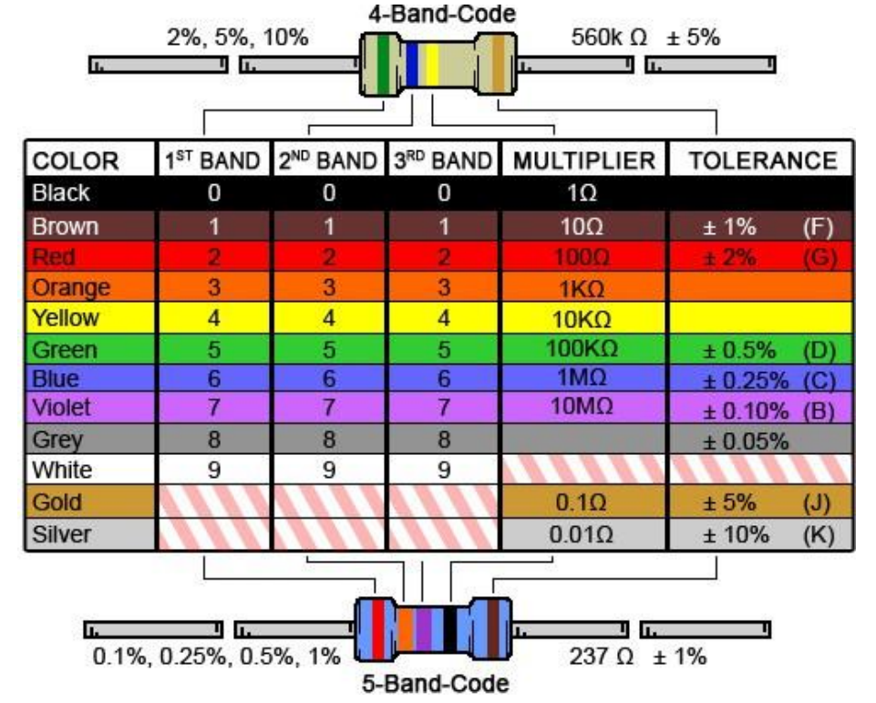
Figure 3: Resistor color code look up table.

Big Picture
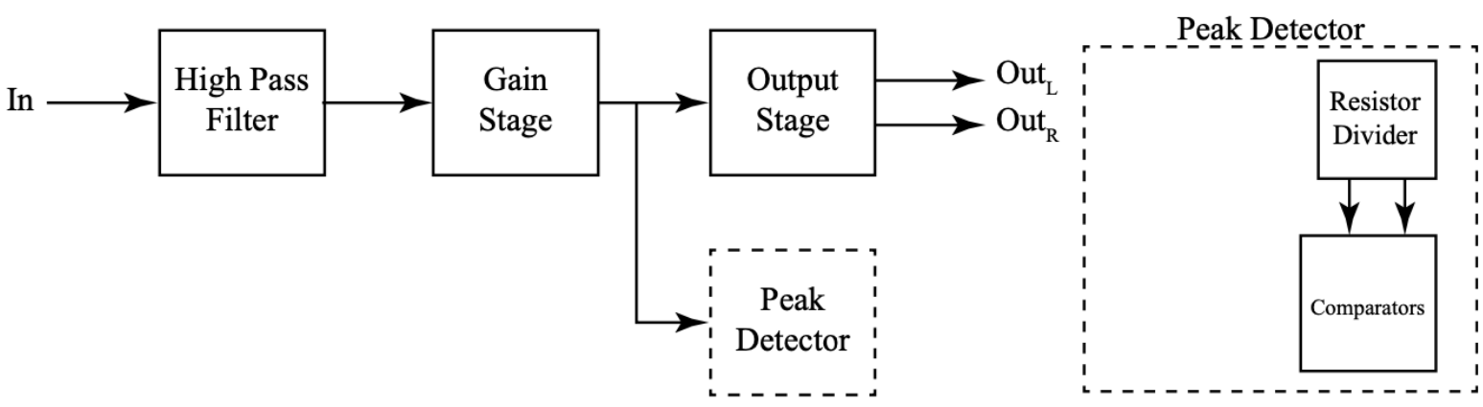
Figure 4: Big picture with emphasis on the peak detector.
This lab focuses on basic resistor circuits which will help to form the resistor divider used to set the threshold voltages in the peak detector for the final project.

Pre-Lab Requirements
Complete the following before coming to lab.

Resistor Ladders
- Using the circuit in Figure 4.5, calculate the ideal voltages for nodes A, B, C, and D. Table the values for future comparison.

$R_{Total}=R_{1}+R_{2}+R_{3}+R_{4}+R_{5}=4.7 kΩ+10 kΩ+10 kΩ+10 kΩ+4.7 kΩ=39.4 kΩ$
$$I_{Total}=\frac{V_{in}}{R_{Total}}=\frac{5 V}{34.9 kΩ}≈0.126904 mA$$

$V_{A}=V_{in}\left(\frac{R_{2}+R_{3}+R_{4}+R_{5}}{R_{Total}}\right)=5 V\left(\frac{34.7 kΩ}{39.4 kΩ}\right)≈4.40355 V$

$V_{B}=V_{in}\left(\frac{R_{3}+R_{4}+R_{5}}{R_{Total}}\right)=5 V\left(\frac{24.7 kΩ}{39.4 kΩ}\right)≈3.13452 V$

$V_{C}=V_{in}\left(\frac{R_{4}+R_{5}}{R_{Total}}\right)=5 V\left(\frac{14.7 kΩ}{39.4 kΩ}\right)≈1.86548 V$

$V_{D}=V_{in}\left(\frac{R_{5}}{R_{Total}}\right)=5 V\left(\frac{4.7 kΩ}{39.4 kΩ}\right)≈0.596447 V$

$Percentage Error= \left(\frac{Experimental Value-Actual Value}{Actual Value}\right)100$
Node | Expected Voltage (V) | Measured Voltage (V) | % Error
A | 4.40 | 4.403 | 0.012566
B | 3.13 | 3.1341 | 0.01333
C | 1.86 | 1.8673 | 0.097347
D | 0.60 | 0.6101 | 2.23788
Table 1: Pre-lab Resistor Ladder Node Voltages (5V Supply)
- Construct the circuit in Figure 4.5 and measure the actual voltages using the oscilloscope. Table the values.
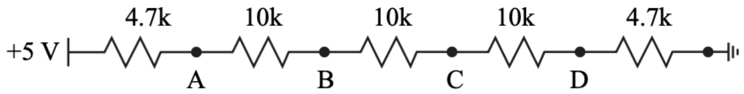
Figure 5: Resistor ladder example

Two-Bit R-2R Ladder
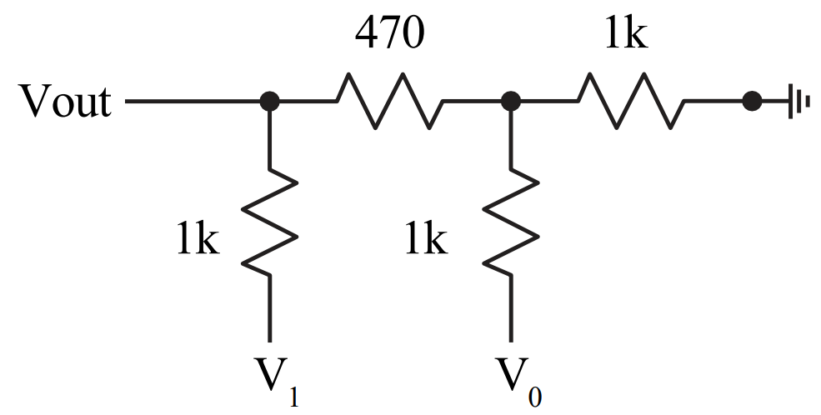
Figure 6: Two-bit R-2R ladder.
- Using the circuit in Figure 4.6, calculate the ideal output voltages for the following combination of voltages and table the values:
$$V_{out}=V_{Ref}\left(\frac{V_{1}}{2^{1}}+\frac{V_{0}}{2^{2}}\right)$$
  - V0 = 0 V and V1 = 0 V – Binary values
$$V_{out}=5 V\left(\frac{0}{2^{1}}+\frac{0}{2^{2}}\right)=0.00 V$$
  - V0 = 5 V and V1 = 0 V
$$V_{out}=5 V\left(\frac{0}{2^{1}}+\frac{1}{2^{2}}\right)=1.25 V$$
  - V0 = 0 V and V1 = 5 V
$$V_{out}=5 V\left(\frac{1}{2^{1}}+\frac{0}{2^{2}}\right)=2.50 V$$
  - V0 = 5 V and V1 = 5 V
$$V_{out}=5 V\left(\frac{1}{2^{1}}+\frac{1}{2^{2}}\right)=3.75 V$$
Node  (V₀, V₁) | Expected Voltage (V) | Measured Voltage (V) | % Error
(0 V, 0 V) | 0.00 | 0.07807 | N/A
(5 V, 0 V) | 1.25 | 1.3337 | 6.27577
(0 V, 5 V) | 2.50 | 2.5408 | 1.60579
(5 V, 5 V) | 3.75 | 3.8141 | 1.68061
Table 2: 2-Bit R-2R Ladder Output Voltages (R = 470 Ω, 2R = 1 kΩ)
- Construct the circuit in Figure 4.6 and measure the output voltage using the oscilloscope and table the values. To generate the changesin voltages,set:
  - Wavegen 1 (V0) to a 1 Hz square wave with a 2.5 V amplitude, a 2.5 V offset, and a 180 phase offset.
  - Wavegen 2 (V1) to a 500 mHz square wave with a 2.5 V amplitude, a 2.5 V offset, and a 180 phase offset.
  - Make sure the Wavegen signals are set to synchronized.
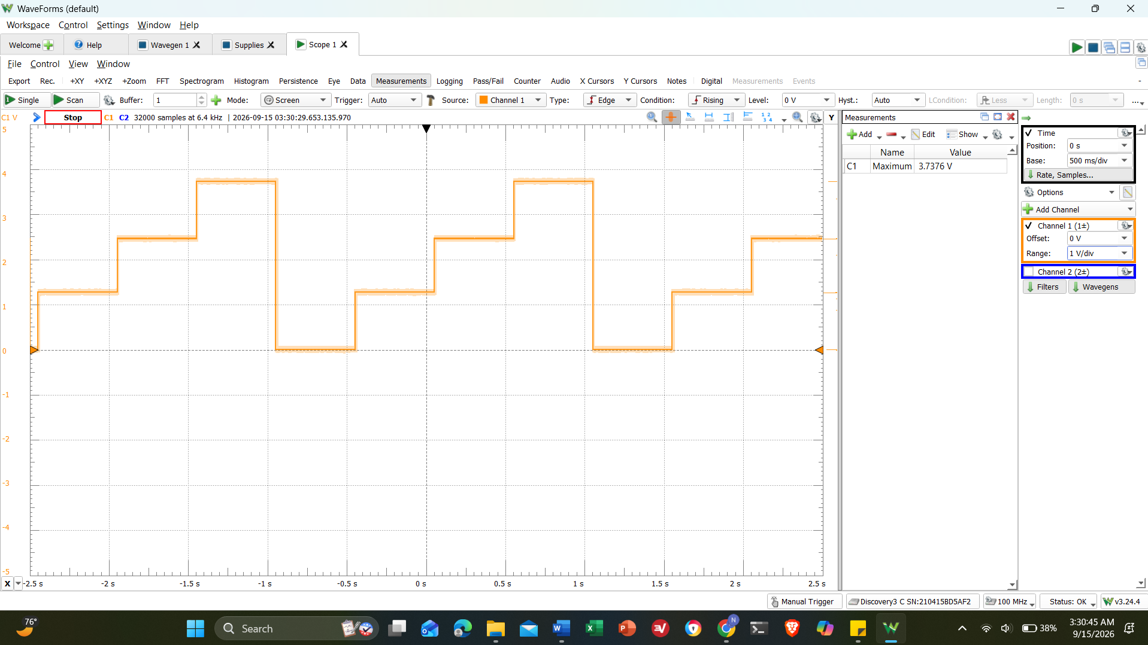
Screenshot 1: DAD waveform output
- Save the circuit and Wavegen settings to demo to your lab instructor.
  - The output should look like the Scope image in Figure 4.7. In this circuit, V0 and V1 serve as digital inputs, switching between on (5 V) and off (0 V). As you “count” from 0 to 3 in binary, the resistor network creates proportional voltage steps at the output. This meansthat the output voltage represents the binary input as an analog voltage level between ground and 5 V, with each step increasing based on the weighted contributions of V0 and V1.
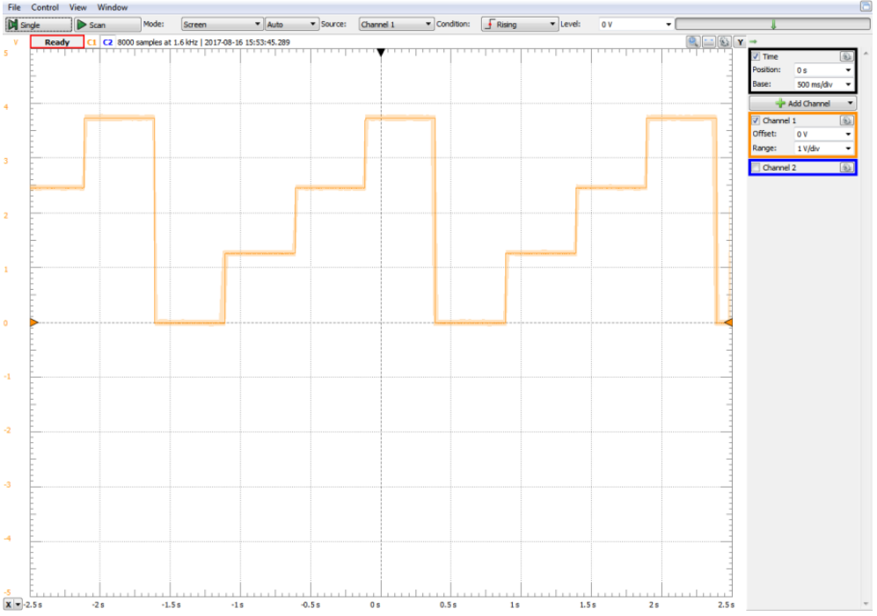
Figure 7: The desired output for the R-2R ladder circuit with the appropriate inputs.

In-Lab Requirements
The following items must be ready at the start of lab.
- Submit the table of voltages for the resistor ladder and the R-2R ladder to Canvas in a document.
- Demo the output of the R-2R ladder as V0 and V1 change.

Resistor Tolerances
There is no such thing as a perfect resistor. All resistors have tolerance about their specified value. For example, a 10k Ω resistor with a ±5% tolerance will have a value between 10k Ω − 5% ≤ R ≤ 10k Ω + 5%.
- Using the multimeter, measure the resistance of the resistors in the ladder from Subsection 4.5.1. Remember to remove the resistorsfrom the breadboard so that they can be measured independently. Table these values.
- Re-calculate the ideal voltages using the measured resistances from the previous step and table the values.
- Using the multimeter, measure the resistance of the resistors used in the R- 2R ladder from Subsection 4.5.2. Remember to remove the resistors from the breadboard so that they can be measured independently.
- Re-calculate the ideal voltages using the measured resistances from the previous step and table the values.
Node | Actual Resistance (Ω) | Percentage Error (%)
A (4.7 kΩ) | 4.59 kΩ | 2.39651
B (10 kΩ) | 9.70 kΩ | 3.09278
C (10 kΩ) | 9.65 kΩ | 3.09278
D (10 kΩ) | 9.70 kΩ | 3.09278
(4.7 kΩ) | 4.55 kΩ | 3.09278
470 Ω  (0 V, 0 V) | 461 Ω | 1.95228
1 kΩ  (0 V, 5V) | 975 Ω | 2.5641
1 kΩ  (5 V, 0 V) | 974 Ω | 2.5641
1 kΩ  (5 V, 5 V) | 975 Ω | 2.5641
Table 3: Nominal vs. DMM Measured Resistor Values – Resistance Ladder
Node | Remeasured Expected Voltage (V) | Actual Voltage (V)  Pre-Lab | Percentage Error (%)
A (4.7 kΩ) | 4.40482 | 4.403 | 0.041335
B (10 kΩ) | 3.13319 | 3.1341 | 0.029035
C (10 kΩ) | 1.86812 | 1.8673
D (10 kΩ) | 0.596487 | 0.6101 | 2.23127
470 Ω  (0 V, 0 V) | 0.00 | 0.07807 | N/A
1 kΩ  (0 V, 5V) | 1.25 | 1.3337 | 6.27577
1 kΩ  (5 V, 0 V) | 2.50 | 2.5408 | 1.60579
1 kΩ  (5 V, 5 V) | 3.75 | 3.8141 | 1.68061
Table 4: Nominal vs. DMM Measured Voltage Values – Resistor Ladder

Tree-Bit R-2R Ladder
Find someone in the lab to form a team of two. If there is an odd number of students, allow for a team of three where necessary. Complete the following:
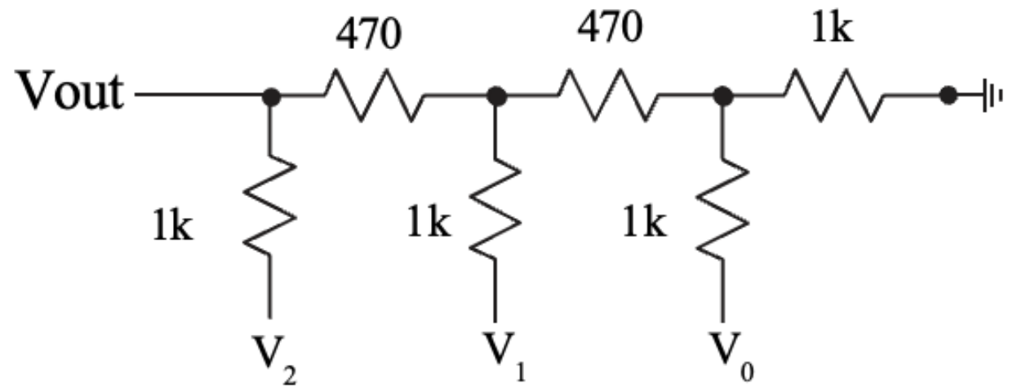
Figure 8: Three-bit R-2R ladder.
- Construct the circuit in Figure 4.8 and measure the output voltage using the oscilloscope and table the values. To generate the changes in voltages, set:
  - Wavegen 1 (V0) to a 1 Hz square wave with a 2.5 V amplitude, a 2.5 V offset, and a 180 phase offset.
  - Wavegen 2 (V1) to a 500 mHz square wave with a 2.5 V amplitude, a 2.5 V offset, and a 180 phase offset.
  - Make sure the Wavegen signals are set to synchronized.
  - Since there is no third Wavegen wire, you will use the DAD’s V+ wire (red) and ground wire (black) for V2.
(V0, V1, V2) | Measured Voltage (V)
(0 V, 0 V, 0 V) | 57.547
(5 V, 0 V, 0 V) | 0.68255
(0 V, 5 V, 0 V) | 1.3029
(5 V, 5 V, 0 V) | 1.9484
(0 V, 0 V, 5 V) | 2.5287
(5 V, 0 V, 5 V) | 3.1630
(0 V, 5 V, 5V) | 3.7712
(5 V, 5 V, 5 V) | 4.3757
Table 5: Node Voltages Recalculated with Measured Resistance Values
- Take a screenshot of the waveform of Vout, measure the values of each step, and record them in a table for the following cases:
  - V2 = 0 V.
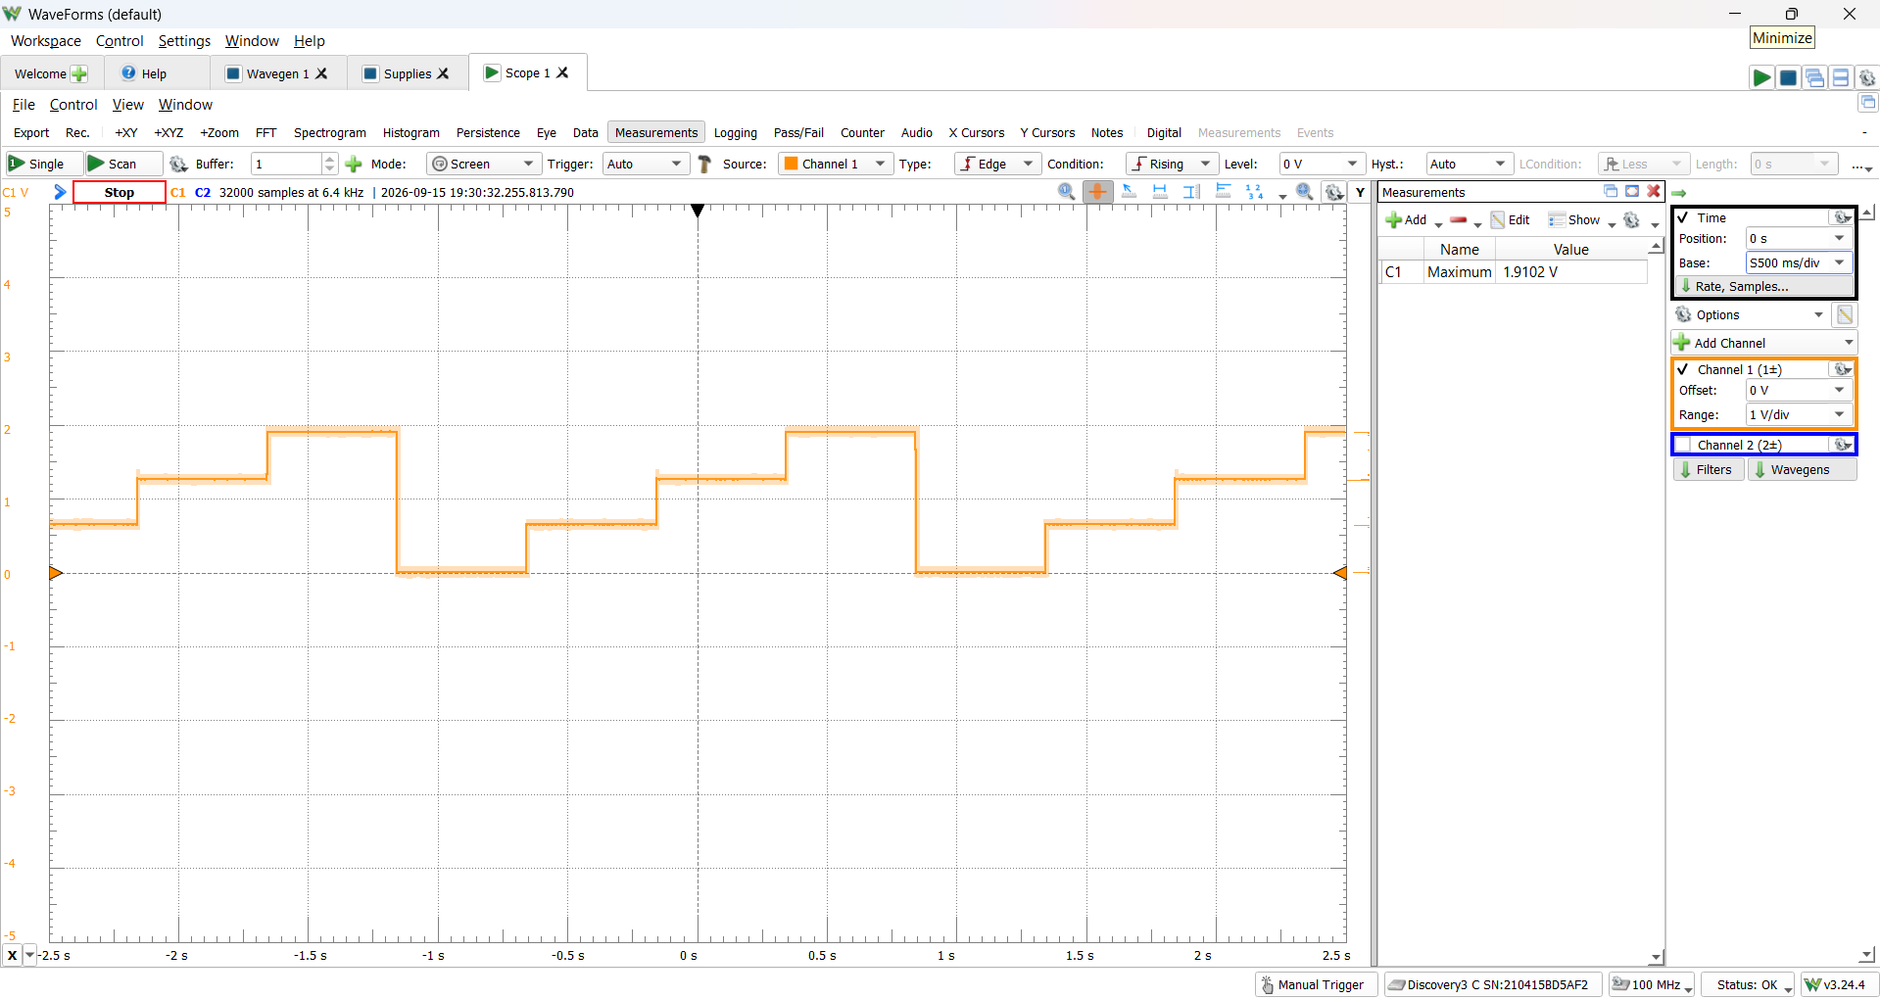
  - V2 = 5 V.
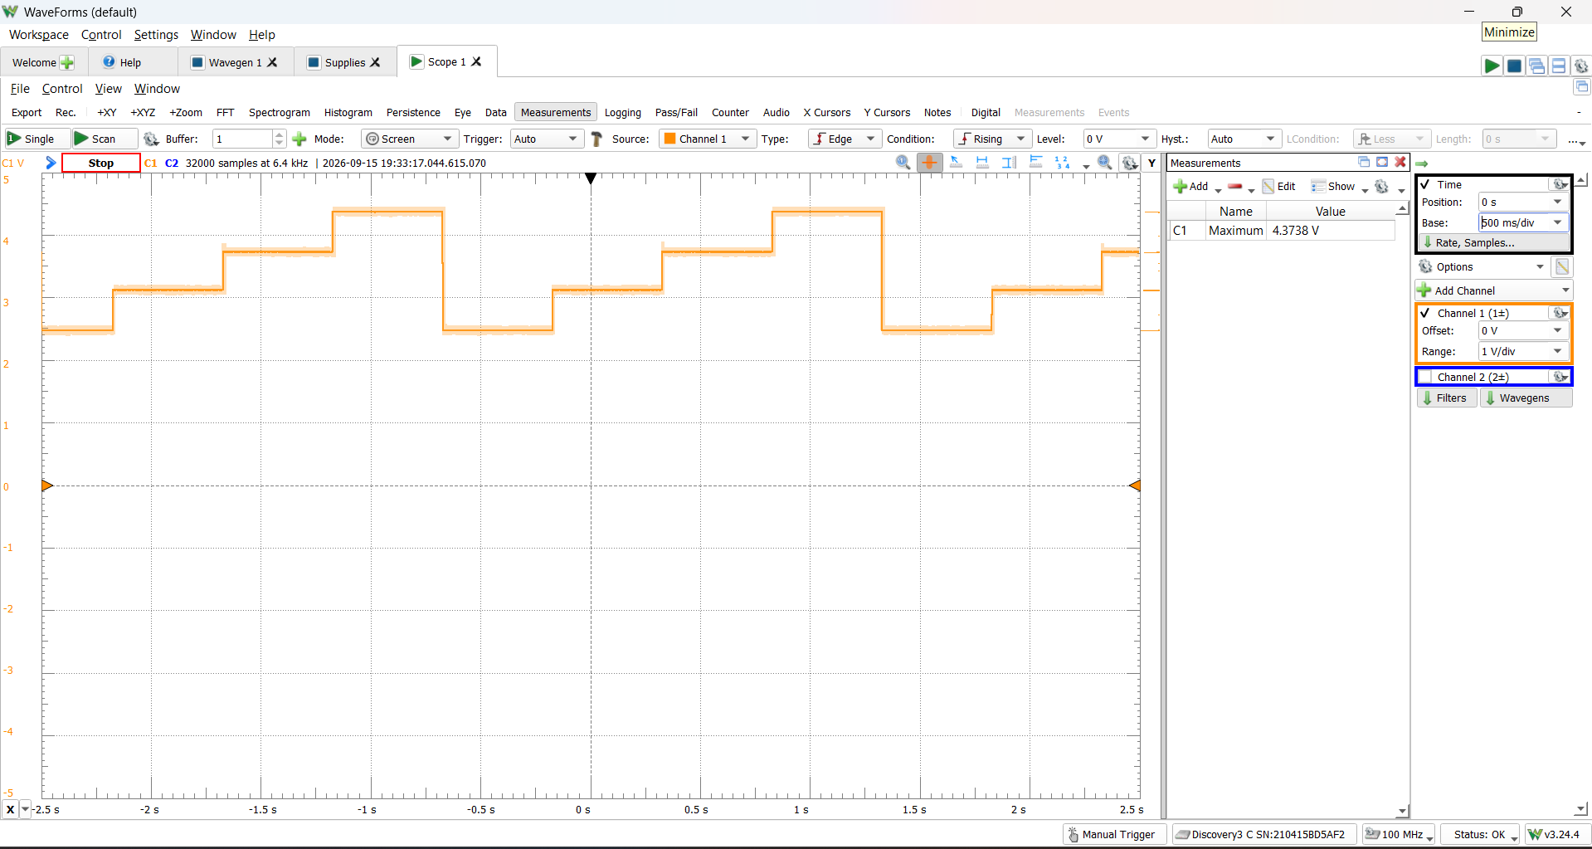
- Answer the questions listed in the Write up Section. Include the name of your teammate(s).

Write-Up
Detail the effects of the resistance tolerances on the two different resistor ladders. Include the tabled values for both circuits and calculate the percent error using the experimentally measured values from the prelab and the values calculated from the measured resistors. You should have two tables: one for voltage values and their percent errors, and another for the resistor values and their percent errors.
The resistance tolerances slightly alter the expected node voltages compared to the ideal calculations based on nominal values. As shown in Tables 3 and 4 of the data, the actual resistor values deviated by 1.9%-3.1% from their nominal 470 Ω, 1 kΩ, 4.7 kΩ, and 10 kΩ values. When the theoretical voltages were recalculated using the physically measured resistances, the percentage error between the expected and actual measured node voltages dropped to nearly zero (mostly below 0.05%), demonstrating that real-world component tolerances are the primary source of deviation in voltage and current dividers.
Discussion Question:
- What did you learn from the teamwork section in terms of communication and collaboration?
During the teamwork section, effective communication was essential for dividing tasks; for example, someone made the ladder, and the other configured Waveforms. Collaboration made sure we double-checked each other's wiring connections, prevented placement mistakes, and saved time during the measurement phase.
- How would you rate your team’s performance using a scale of 1 to 5, with 5 being the best? Discuss any errors your team might have had and how you corrected them.
I would rate the performance a 5. There were no errors.
- How is a three-bit ladder different than the two-bit ladder constructed in the prelab? What are some possible applications for the three-bit ladder?
A three-bit ladder incorporates an additional input node (V₂), allowing it to generate eight (2³) distinct analog voltage levels, whereas the two-bit ladder only generates four (2²) distinct levels. This increase in bits provides higher resolution for digital-to-analog conversion. Common applications for a three-bit R-2R ladder include simple digital-to-analog converters (DACs) for audio signal generation, digital volume controls, and generating specific reference voltages from a microcontroller.

CONCLUSION
In this lab, basic resistive circuits were successfully reconstructed and analyzed, including a standard voltage ladder and both 2-bit and 3-bit R-2R resistor ladders. By comparing nominal mathematical calculations with multimeter measurements, the experiment verified that real-world resistor tolerances directly impact the accuracy of analog voltage outputs. Ultimately, the dynamic measurements collected via the Digital Analog Discovery demonstrated how parallel and series resistor combinations can effectively perform digital-to-analog conversion through proportional voltage stepping.

