PROBLEMS ENCOUNTERED
N/A
INTRODUCTION
The Purpose of this lab is to introduce operational amplifiers through the ideal op amp model, spice op amp model, and practical circuit configurations. By constructing virtual and physical voltage followers and inverting amplifiers using the TLV272 chip, we will evaluate key amplifier characteristics, including offset voltage, slew rate, maximum output swing, and effective gain.

DISCUSSION

Objective
The purpose of this lab is to introduce operational amplifiers through the ideal op amp model, spice op amp model, and practical applications of op amps in common configurations.

Materials
- Laptop with LTspice
- Analog Discovery
- Breadboard
- Wiring kit
- Lab parts kit with TLV272

Introduction
There is a large variety of op amp and specialized amplifiers. For this lab the more recent TLV272 is used, a dual op amp, which contains two op amps in a single chip.

The Ideal Op Amp
Recall that an ideal op amp will have the following properties.
- Zero input current, often called the input bias current and represented as IB or IIB.
- Zero input offset voltage, represented as either V_{IO} or V_{OS}.
- Infinite input resistance, represented as R_{in} or r_{i}.
- Zero output resistance, represented as R_{out} or r_{o}.
- Infinite gain, represented as A or α and often called the open loop gain.
These quantities are represented in Figure 5.1.
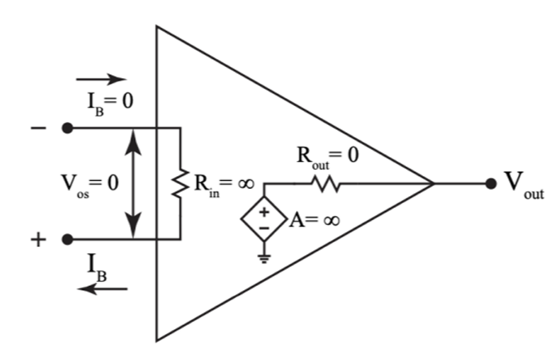
Figure 1: Basic op amp model.
However, as should be expected, practical op amps do not have these ideal quantities. For example, Texas Instrument’s TLV272 has finite values for all the ideal properties. Note that these values vary and depend on productions variation, temperature, and supply voltage.
- Finite input bias current, typically 1 pA.
- Finite input offset voltage, typically 0.5 mV.
- Finite input resistance, typically 1,000 GΩ differential input resistance.
- Finite gain, typically 115 dB (563k)

Common Configurations
There are a variety of configurations op amps can be used for but there are a few common configurations that form the basis of more complicated op amp circuits.
Inverting Amplifier
An inverting configuration, Figure 5.2 (a), takes its name from the inversion that happens from input to output, giving a output voltage proportional to R2 and R1 independent of the actual op amp properties.
$$V_{out}= -\frac{R_{2}}{R_{1}}V_{in} (5.1)$$
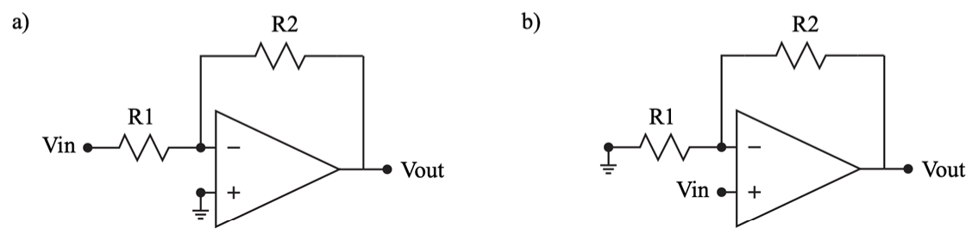
Figure 2: Different op amp configurations: inverting amplifier (a) and non-inverting amplifier (b)
Non-Inverting Amplifier
Similar to the inverting case, Figure 5.2 (b), this configuration results in an output voltage proportional to R2 and R1 but without an inversion and always has a gain of at least 1.
$$V_{out}= \left(1+\frac{R_{2}}{R_{1}}\right)V_{in} (5.2)$$
There is also a special case of the non-inverting amplifier where it is connected as a voltage follower or unity gain amplifier as show in Figure 5.3.
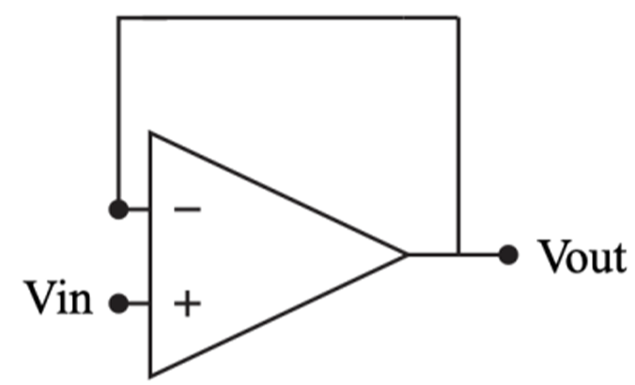
Figure 3: A non-inverting amplifier configured as a unity gain buffer.
The output is related directly to the input where:
$$V_{out}=V_{in} (5.3)$$
and while this configuration may seem redundant, it has the advantage of providing a large input impedance to the source (Vin), minimizing loading effects, and a small output impedance to the load (Vout), ensuring efficient signal transfer.

Op Amp Pins
A pinout is a connection diagram for an integrated circuit, showing how its pins connect to the internal op amp terminals. It should not be confused with the pins in a spice simulation. Op amps typically have a standardized pinout, allowing chips to be easily swapped out. Figure 5.4 shows the pinout for the TLV272 with the op amp diagram drawn within.
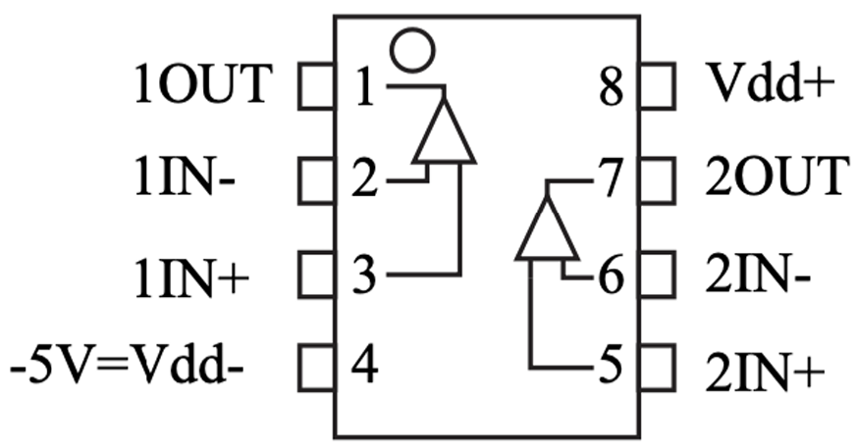
Figure 4: Pinout for TI’s TLV272. Note that two op amps are contained, often called a dual op amp, within a single chip.
Name | Number | Description
1OUT | 1 | Output of the first op amp
1IN- | 2 | Inverting input of the first op amp
1IN+ | 3 | Non-inverting input of the first op amp
Vdd- | 4 | Negative supply
2IN+ | 5 | Non-inverting input of the second op amp
2IN- | 6 | Inverting input of the second op amp
2OUT | 7 | Output of the second op amp
Vdd+ | 8 | Positive supply
Table 1:Pin descriptions from the TLV272 datasheet.
The pins are numbered from 1 to 8, counting counterclockwise starting in the upper left. Descriptions of each pin are provided in Table 5.1. Most of the pins should be familiar from class.
Polarity, or the orientation of the chip, is determined by a circle or indentation on the chip itself. The TLV272 has a small circle indentation in the upper left hand corner to indicate polarity and the position of pin 1.
The LTspice pinout differs from the physical chip’s pinout, which is specified in the subcircuit .LIB file. Table 5.2 provides the corresponding pin descriptions for reference.
Number | Description
1 | Non-inverting input
2 | Inverting input
3 | Positive supply
4 | Negative supply
5 | Output
Table 2: Pin descriptions from the TLV272 .LIB LTspice file.

Big Picture
This lab focuses on op amps which will be used in the gain and outputs stages of the final project.
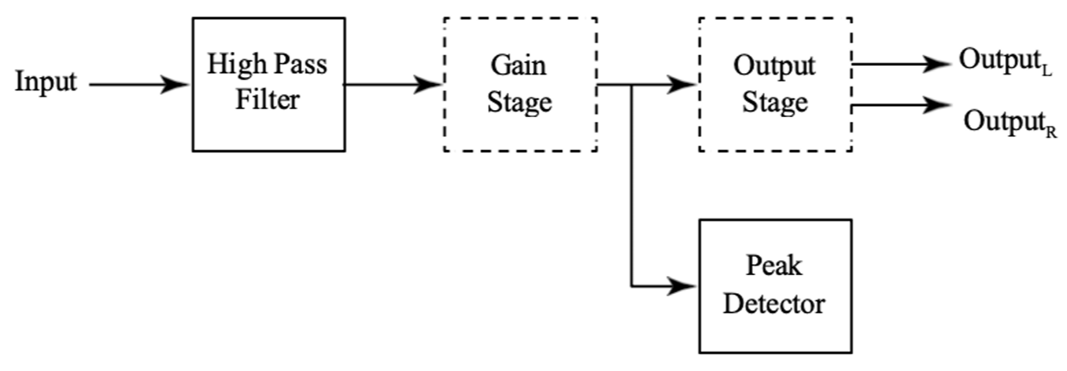
Figure 5: Big picture with emphasis on the gain and output stages.

Pre-Lab Requirements
Complete the following before coming to lab.

LTspice TLV272 Op Amp Model
Complete the following using the TLV271 spice model, always power the op amp with ± 5 V for V_{dd+} and V_{dd-}.
- Obtain the TLV2 spice model from TI’s website. Note that this is the model for the TLV271 which is the same op amp that’s duplicated in the TLV272. If you have trouble accessing the zip file using the link, the file can also be accessed from the lab 5 folder on canvas.
- Import the model in to LTspice using the “LTspice Component Import” documents in the canvas lab folder. Video instructions can be found here. The pin numbers in the spice model correspond to the numbers in Table 5.2, not the numbers in Table 5.1.
- Familiarize yourself with the TLV272 datasheet. Make note that pin 4 should be connected to -5 V, NOT ground. It is also recommended to use the schematic in Figure 5.4 rather than the schematic in the datasheet to avoid confusion when constructing your physical circuits.
- Using the voltage follower configuration in Figure 5.3, run a DC operating point simulation (.op) and determine the V_{out} when V_{in} is zero volts; effectively calculating the offset voltage, table the value.
$$Input Offest Voltage \left(V_{OS}\right)= V_{out}- V_{in}=0.500 mV-0 V=0.500 mV$$
$$Slew Rate= \frac{∆V}{∆t}=\frac{1 V}{0.417 μs} ≈2.4\frac{V}{μs}$$
$$Maximum Output Swing (V_{out, max} / V_{out, min})= \frac{∆V}{∆t}$$
$$V_{out}= -\left(\frac{R_{2}}{R_{1}}\right)V_{in}=-\left(\frac{10 kΩ}{1 kΩ}\right)\left(0.1 V\right)= -1.0 V$$
$$Effective Gain= \frac{-V_{out}}{V_{in}}= \frac{-\left(-1.0 V\right)}{0.1 V}=10$$

Parameter | Unit | Theoretical / SPICE Model
Input Offset Voltage (V_{os}) | mV | 0.500
Slew rate (SR) | V/µs | 2.40
Max Output Voltage (_{Vout, max}) | V | +4.92
Min Output Voltage (_{Vout, min}) | V | -4.92
Peak-to-Peak Ouput Swing (V_{p-p}) | V | 9.84
Effective Closed-Loop Gain (A_{v,eff}) | V/V | 10.00
Table 3: All the theoretical parameters from Subsection 5.5.1 tabled
- With the same voltage follower configuration, set V_{in} to a 1 V amplitude pulse. Vinitial(V): 0, Von(V): 1, Tdelay(s): 0.5m, Ton(s): 10s, Ncycle: 100. Leave any remaining variables blank. Run a transient analysis with a stop time of 1m (.tran 1m). Plot the input and output voltage from 495 us to 505 us and then find the time it takes for the output to reach 1 V; the time should be on the order of micro seconds. This is a measure of slew rate in V/us, table the value. Save an image of the circuit and the plot of the input and output voltage for submission to canvas.
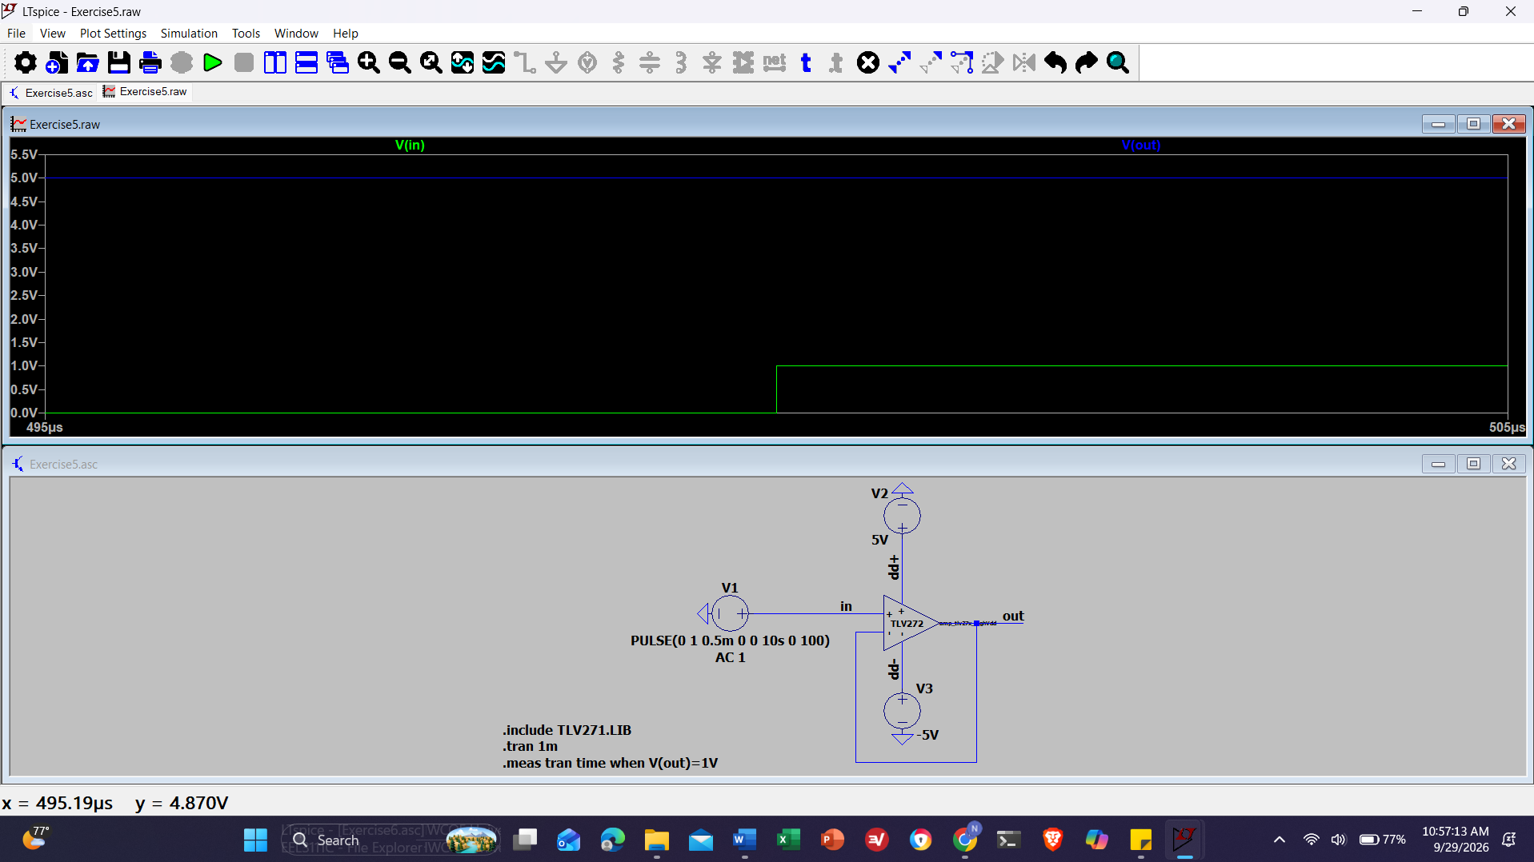
Screenshot 1: With the same voltage follower configuration, set Vin to a 1 V amplitude pulse. Vinitial(V): 0, Von(V): 1, Tdelay(s): 0.5m, Ton(s): 10s, Ncycle: 100. Leave any remaining variables blank.
- Configure an inverting amplifier, Figure 5.2 (a), with a gain of 10 by setting R₂ = 10k and R₁ = 1k. Set the input voltage to a sine wave with the following parameters, DC offset(V): 0, Amp(V): 1, Freq(Hz): 1k, and the remaining variables blank.
Run a transient analysis with a stop time of 1m (.tran 1m). Plot the input and output voltage and record the max and min values of V_{out}, this is a measure of the maximum output swing, table the value. Save an image of the circuit and the plot of the input and output voltage for submission to canvas.
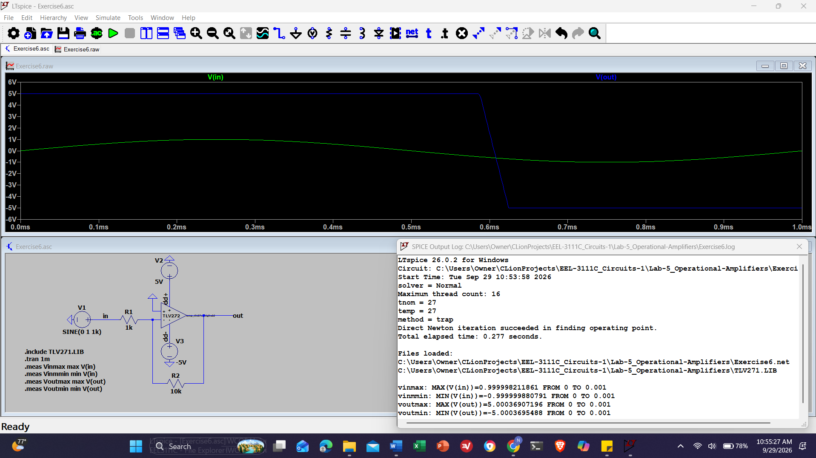
Screenshot 2: Configure an inverting amplifier, Figure 5.2 (a), with a gain of 10 by setting R2 = 10k and R1 = 1k. Set the input voltage to a sine wave with the following parameters, DC offset(V): 0, Amp(V): 1, Freq(Hz): 1k, and the remaining variables blank.
- Using the same inverting configuration, set V_{in} to a 0.1 V DC source and run a transient analysis with a stop time of 1m (.tran 1m). Plot −V (vout)/V (vin), this is a measure of the effective gain, table the result. Save an image of the circuit and the plot of effective gain for submission to canvas.
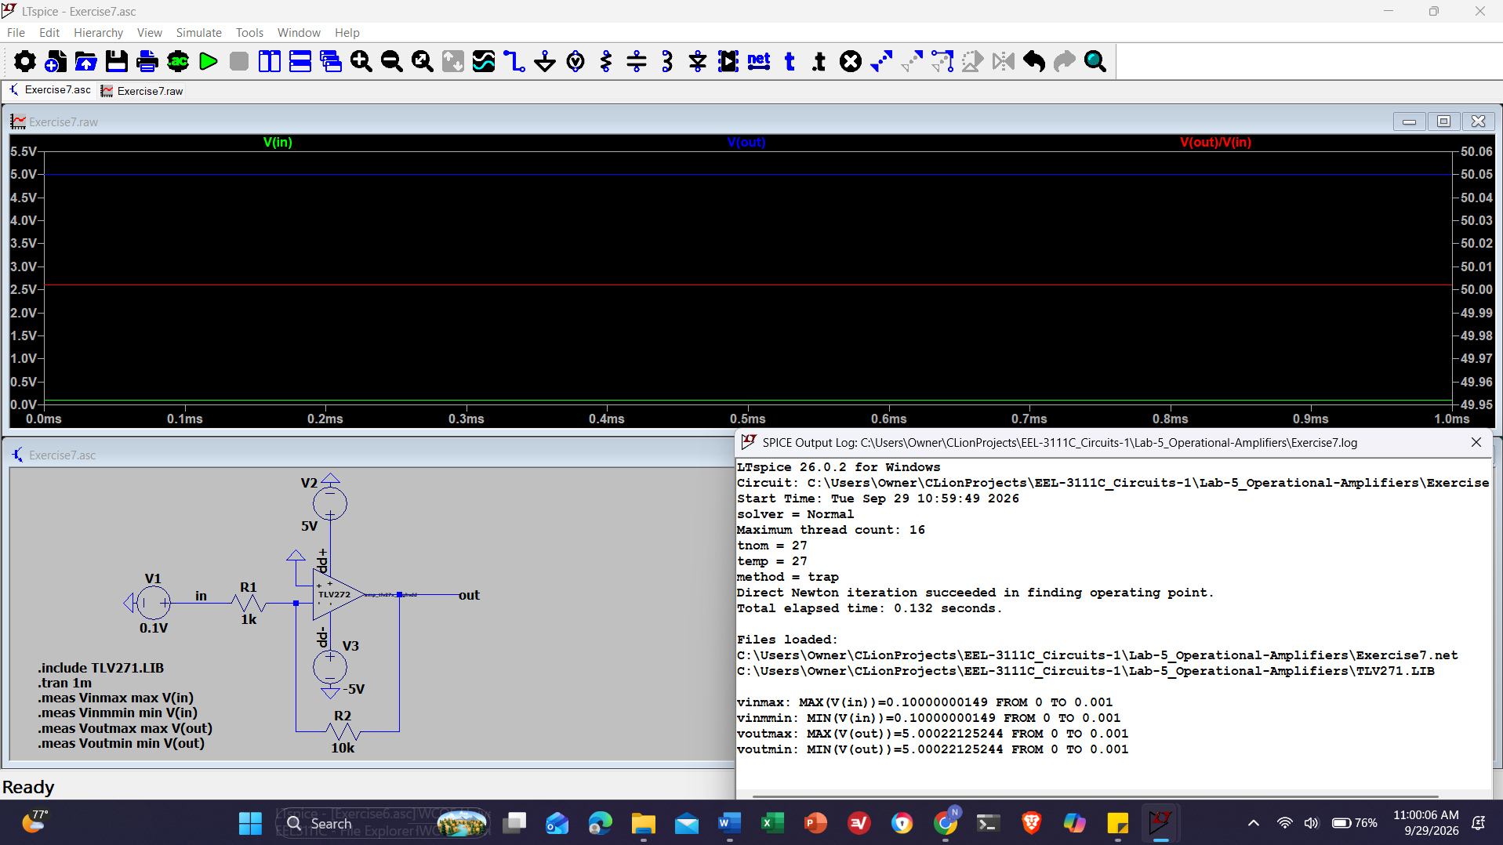
Screenshot 3: Using the same inverting configuration, set Vin to a 0.1 V DC source and run a transient analysis with a stop time of 1m (.tran 1m). Plot −V (vout)/V (vin), this is a measure of the effective gain, table the result. Save an image of the circuit and the plot of effective gain for submission to canvas.

Op Amp Construction
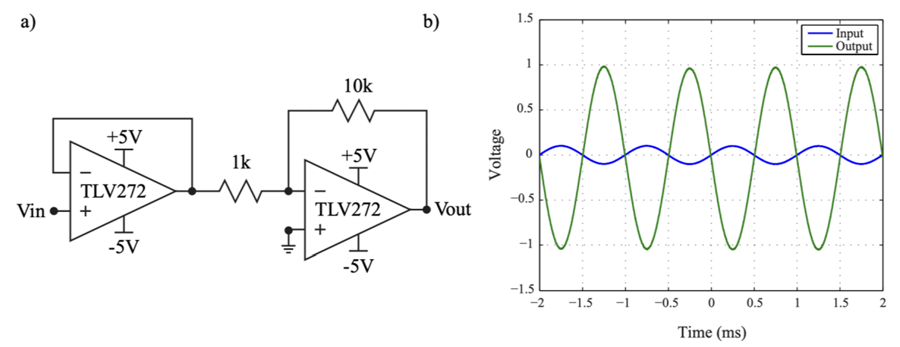
Figure 6: Schematic for the demo circuit, a voltage follower followed by an inverting amplifier with a gain of 10 (a) and the resulting output (b)
- Using only one of the TLV272 op amp in your lab parts kit, build the circuit in Figure 5.6 (a) on a breadboard. Set the voltage supplies to ± 5 V and scope channel 1 to Vin and scope channel 2 to Vout. Configure the Wavegen to supply a 1 kHz sine wave with a 0.1 V amplitude. Your waveform should look like Figure 5.6 (b).
The demo circuit in Figure 5.6 consists of a voltage follower and an inverting amplifier with a gain of -10. The voltage follower ensures high input impedance and low output impedance, preventing loading while maintaining Vout = Vin.
This buffered signal then feeds into the inverting amplifier, where the gain is set by Vout = -10Vin, resulting in an amplified and inverted output. As shown in Figure 5.6 (b), a sinusoidal input produces a larger, inverted sinusoid.

Pre-lab Checklist
The following must be completed at the start of lab.
- All the theoretical parameters from Subsection 5.5.1 tabled:
  - Offset voltage.
  - Slew rate.
  - Maximum output swing (min and max output voltages).
  - Effective gain.
- Images of the output and circuits from Subsection 5.5.1 tabled:
  - Item 5: Image of the circuit and the plot of the input and output voltage.
  - Item 6: Image of the circuit and the plot of the input and output voltage.
  - Item 7: Image of the circuit and the plot of effective gain.
- Op amp configurations from Subsection 5.5.2 built on a breadboard and working.

In-Lab Requirements
Complete the following during lab.

Experimental Op Amp Measurements
Using the pre-built op amp configurations, complete the following.
- Using the voltage follower, Figure 5.3, input a 0 V DC voltage from the Wavgen and record the offset voltage. Choose an appropriate voltage scale, the voltage is on the order of mV. Save a screenshot of the waveform scope.
- Using the voltage follower again, Figure 5.3, input a 0.5 V amplitude square wave with a 0.5 V offset from the Wavegen. Set the appropriate trigger and determine the slew rate in V/us. Save a screenshot of the waveform scope.
- Using the inverting amplifier, Figure 5.2 (a), input a 1k Hz sine wave with a 1 V amplitude from the Wavegen. Determine the maximum output voltage swing by finding the maximum and minimum voltages.
- Using the inverting amplifier again, Figure 5.2 (a), input a 0.1 V DC from the Wavegen. Determine the effective gain by dividing the output and input voltages. Choose an appropriate voltage scale for the input and output voltages.
- Table all of values calculated in this subsection.

Write-Up
Include the following in the write up.
- Table of experimental parameters.
- Screenshots of scope output plots.
- Percent error, using the prelab values as the theoretical and the in-lab values as experimental.
Discuss the differences between the ideal op amp model, spice TLV272 model, and the physical op amp focusing on the quantities calculated for this lab: offset voltage, slew rate, output voltage range, and effective gain. Touch on the following in your discussion.
- When is it appropriate to use one model over the other?
- How accurate should the spice model for an op amp be?
For all lab write up submissions and reports, the backgrounds for LTspice and Waveforms should be changed from dark background to light background to make them readable for grading.
If the prelab simulation is incorrect, do not compare the in-lab results to wrong values. Correct numbers and circuit schematics should be used in the write-up report.

Discussion Question:
CONCLUSION
klkl

