PROBLEMS ENCOUNTERED
N/A
INTRODUCTION
This lab introduces semiconductor diodes and their key circuit applications, including half-wave and full-wave rectification, AC-to-DC conversion using smoothing capacitors, and threshold clip detection using voltage comparators. We also explore forward-bias diode characteristics, potentiometer voltage dividers, and simulation techniques in LTspice alongside physical breadboard implementations.

DISCUSSION

Objective
The objective of this lab is to introduce diodes and a few of their applications.

Materials
- Laptop with LTSpice
- Analog Discovery
- Breadboard
- Wiring kit
- Lab parts kit

Introduction
Diodes are a fundamental circuit element whose one-directional current flow has a variety of applications. Diodes can be used as indicators (light emitting diodes (LEDs)), voltage protection elements, and rectification.

Diode Operation
Each diode has an anode and cathode, Figure 7.1 (a), and conducts current one way once the voltage across the diode has reached the forward voltage, often called forward bias, VF ≈ 0.7 V. A diode can also conduct current in the opposite direction when the voltage across the diode is negative, often called reverse bias, where the breakdown voltage, VBR, is large, usually -50 V or less. There is often a small current that flows when a diode is reverse bias, but we will neglect that effect for the purposes of this lab. The schematic symbol for an LED is similar, Figure 7.1 (b), but indicates that light is generated when the diode is operating with a forward bias. And the I-V curve for a typical diode, Figure 7.1 (c).
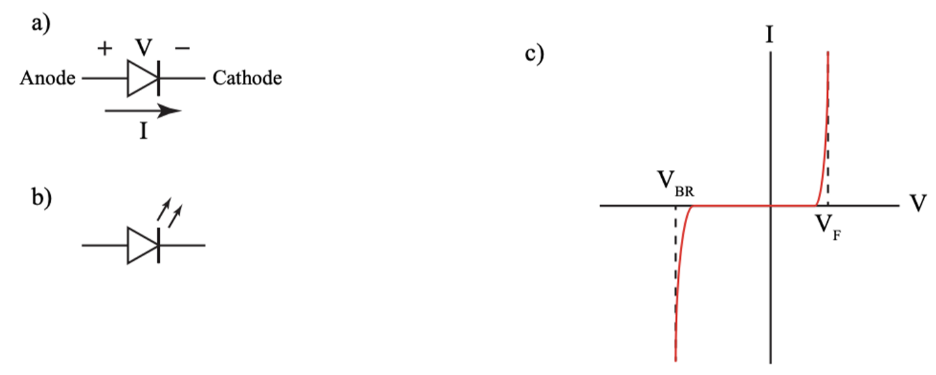
Figure 1: Diode schematic symbol with the anode and cathode labeled (a), schematic symbol for an LED (b), and the I-V curve for a diode (c).

Applications
There are a variety of applications for diodes and this lab will focus on only a few, rectifications, and clip detection.
Rectifiers
Half-Wave Rectifier
Signal rectification is the process of converting an alternating signal in to its positive or negative components. Figure 7.2 is an example of a simple half-wave rectifier. After the input sine wave passes the diodes forward bias voltage, ≈ 0.7 V, the diode conducts and passes the positive half of the sine wave but doesn’t pass the negative half of the sine wave because the diode is reverse bias and does not conduct.
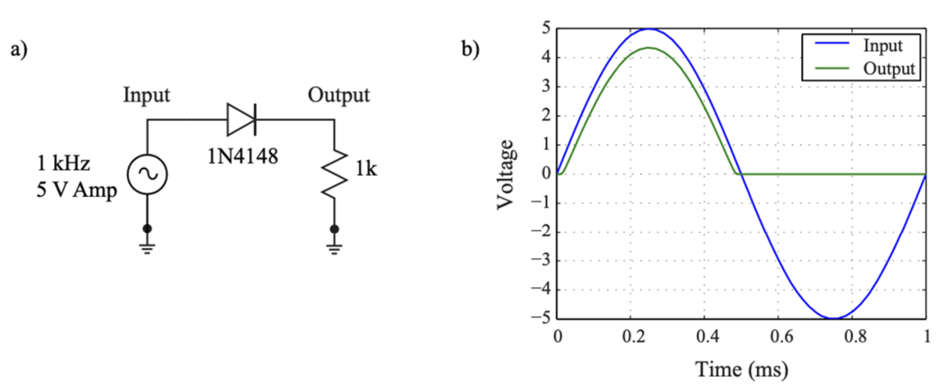
Figure 2: A simple half-wave rectifier (a) and the resulting input and output signals (b).
Simply adding a capacitor to the half-wave rectifier results in an AC to DC converter, Figure 7.3. The circuit initially behaves as it did previously, once the input sine wave reaches the forward bias voltage, the output follows the input. However, once the sine wave starts to decrease, the output then discharges as a function of an RC time constant, the process then repeats. For higher input frequencies and capacitances, the output cap be approximated as a DC source.
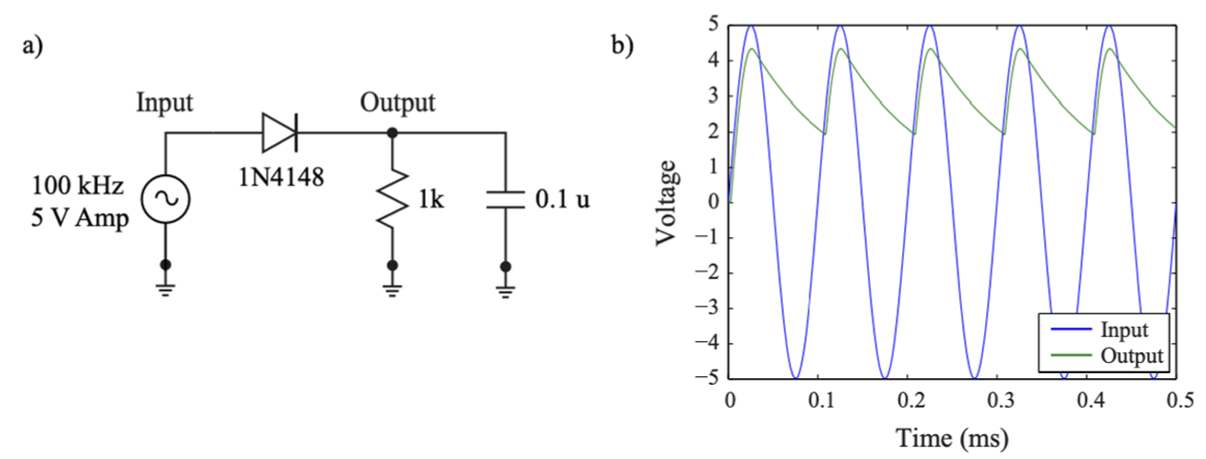
Figure 3: A simple half-wave rectifier but with a capacitor at the output (a) and the resulting input and output signals (b).
Full-Wave Rectifier
A full-wave (also called full-bridge) rectifier uses four diodes so that both halves of a sinusoidal input are routed to the load with the same polarity, producing a positive output for each half of the input. Because two diodes conduct in series on each half-cycle, the load voltage is reduced by about twice the diode forward drop. See Figure 7.4 for the schematic and waveforms.
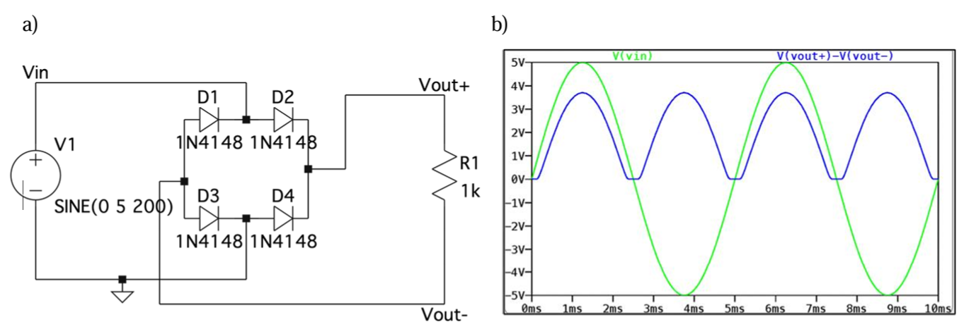
Figure 4: A full-bridge rectifier circuit (a) and it’s resulting input and output signals (b).
Clip Detection
There are often cases where the input or output of a system isn’t easily accessible for test equipment. A variety of dials, indicators, and display panels are often used to report on the status of a system, examples include current draw, internal voltages, and clip detection.
Clip detection is the process of determining if a signal is clipping or not. A signal that is clipped, unless desired, can degraded the performance of the system. A clipping detection circuit is able to indicate that the output of the op amp is clipping without viewing the output on an o-scope, but instead through an LED.
Figure 7.5 is an example of a clipping detector. If the input is higher, or lower, than the reference voltage VA, or VB, the LED D1, or D2, illuminates indicated that the input voltage is above, or below, the reference voltage. Note that this circuit does not use op amps, but comparators. Comparators, as the name implies, compares the input at both terminals and produces a digital output, either a 1 (5 V) or 0 (0V), if the positive terminal input is larger than the negative terminal input.
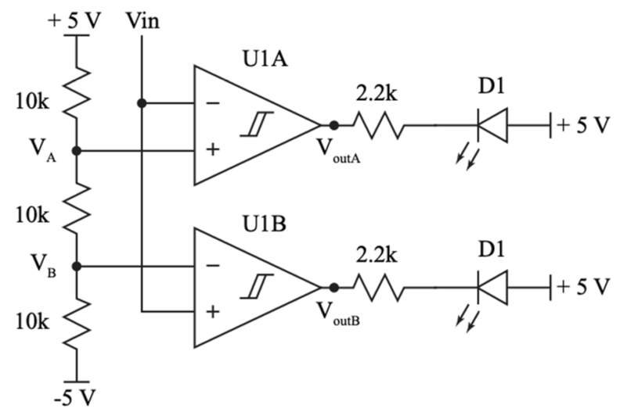
Figure 5: A clipping detection circuit. The input is compared to fixed voltages, V_{A} and V_{B}, by U1A and U1B respectively. If the input voltage is greater, or less, than the reference voltage, the output is pulled low and LED is illuminated.

Potentiometers
A potentiometer (or “pot”) is a three terminal resistor as shown in Figure 7.6. The total resistance between terminals 1 and 3 is fixed and matches the potentiometer’s rated value. Terminal 2 is connected to a sliding contact called the wiper, which moves along the resistive path inside. By adjusting the wiper, the resistance between terminals 2 and 1 or between 2 and 3 changes.
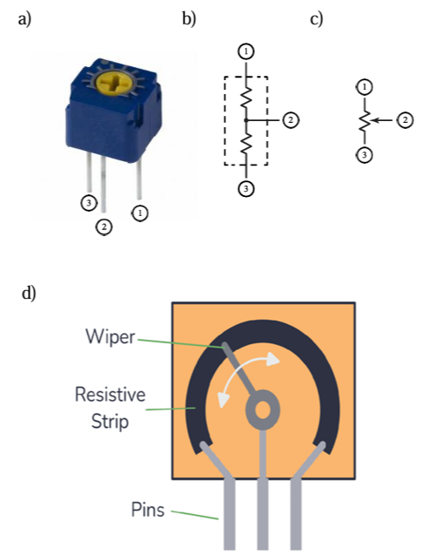
Figure 6: A picture of a practical potentiometer with the appropriate pins labeled (a), an equivalent circuit diagram of a potentiometer with the wiper in a fixed position (b), the common circuit schematic representation for a potentiometer (c), and a visual aid to help understand how the wiper adjusts the resistance (d).
To use a potentiometer on a breadboard, you can treat it like a standard two-terminal resistor by connecting only the center terminal (wiper) and one of the outer terminals. This allows the potentiometer to function as a variable resistor by adjusting the knob. The third unused pin can be left with no connection, do not try to bend it.
You can also use the potentiometer as a voltage divider. To do this, you would connect all three terminals: one outer terminal to Vcc, the other outer terminal to GND, and the center terminal becomes the adjustable voltage output.
In LTspice, a potentiometer is modeled using a resistor with a variable resistance. Instead of a dedicated component, you can define a resistor’s value as {R_total * w}, where R_total is the max resistance (10k) and w (ranging from 0 to 1) represents the wiper position. For example, if you want the pot to be 5kΩ, the value of w would be 0.5 and the spice directive would be:
.param w=0.5
You can also calculate the resistance you need and just assign that value to the resistor in your schematic. To recall how variables work in LTspice, look back to the Monte Carlo simulations in Lab 2 where we define resistor tolerances.

Big Picture
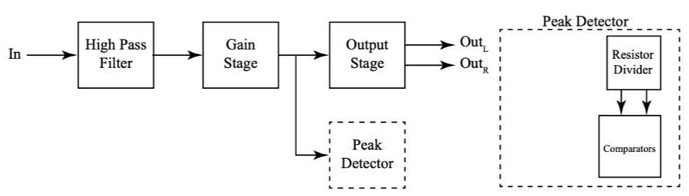
Figure 7: Big picture with emphasis on the peak detector.
This lab focuses on diode circuits which will help to form the comparator circuits used in the peak detector for the final project.

Pre-Lab Requirements
Complete the following before coming to lab.

LTspice Simulations
Using LTspice, complete the following.
- Build the circuit in Figure 7.2 (a). Set the input to a 1 kHz, 5 V amplitude sine wave and run a transient simulation with a stop time of 1m (.tran 1m) and plot the input and output. To use the 1N4148 diode model, right click on the diode after placing it, Pick New Diode, and then choose the 1N4148 model (Mfg. OnSemi). Save an image of the circuit and the plot of the input and output voltage.
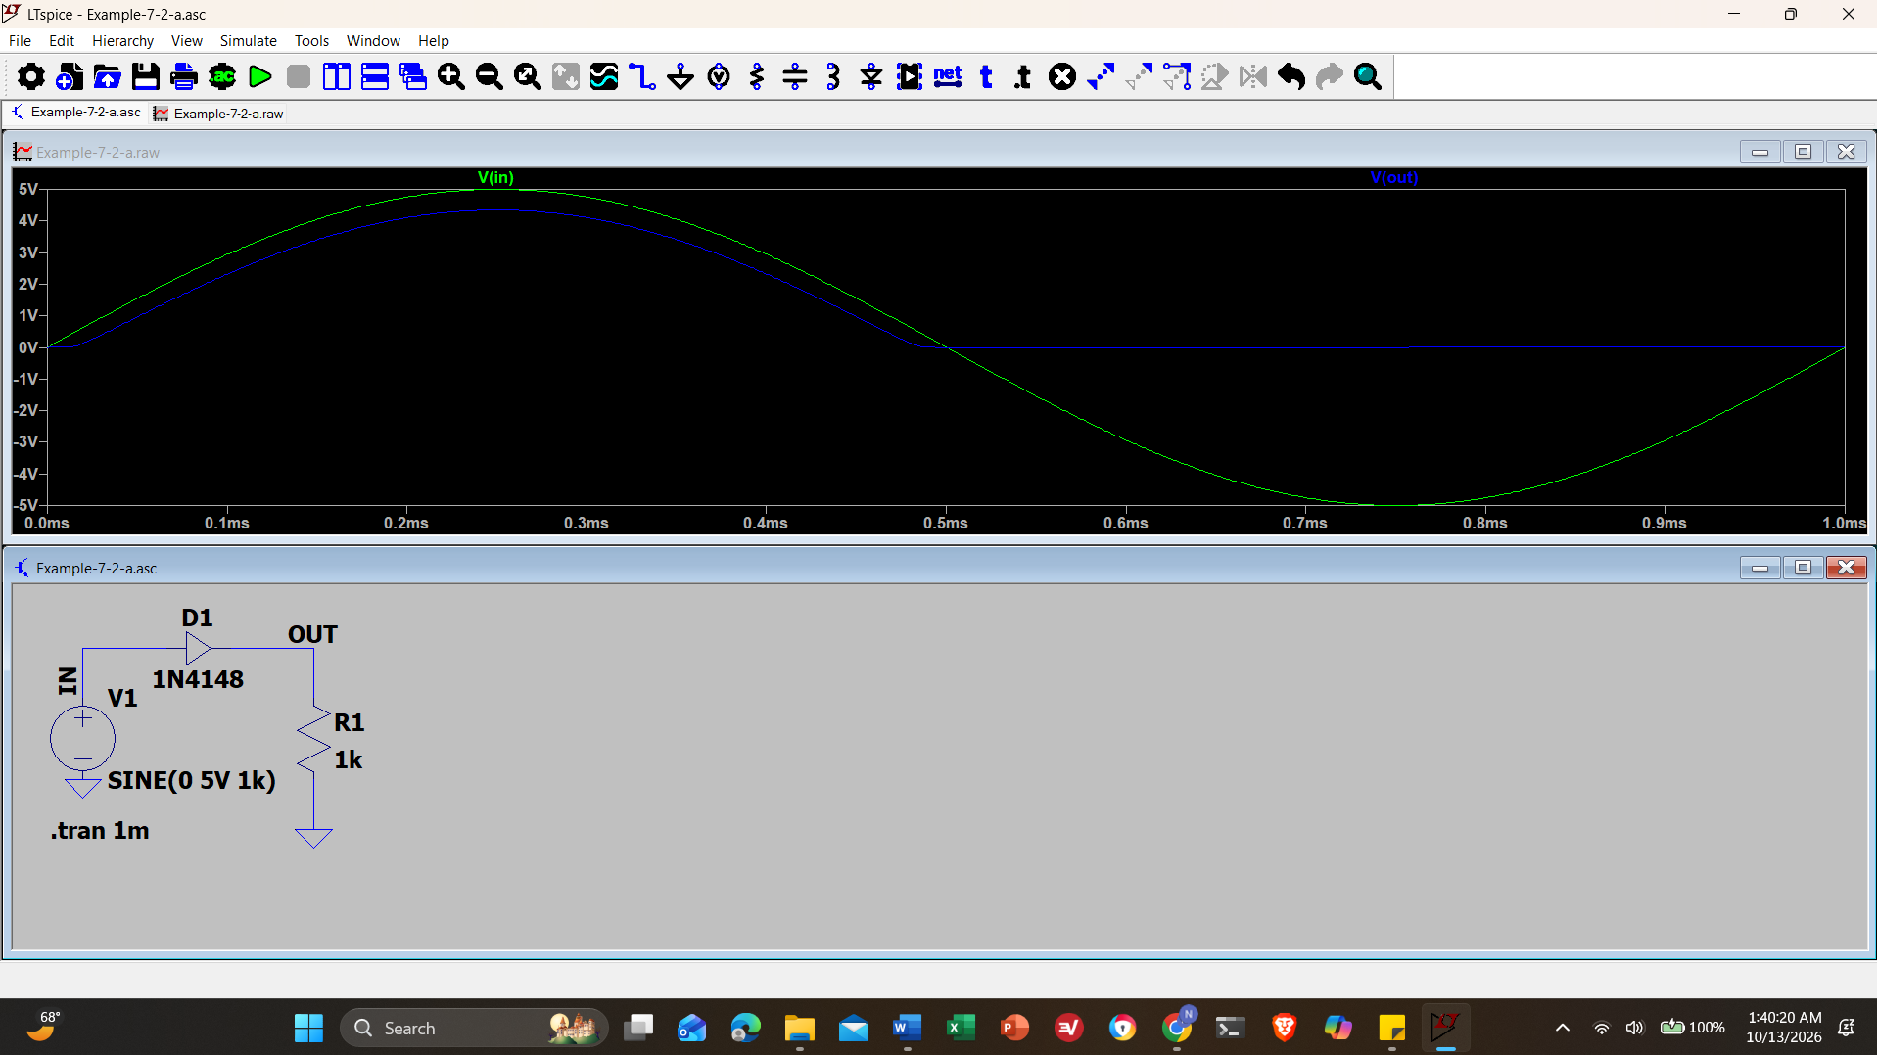
Screenshot 1: Circuit in Figure 7.2 (a). Set the input to a 1 kHz, 5 V amplitude sine wave and run a transient simulation with a stop time of 1m (.tran 1m) and plot the input and output.
- Build the circuit in , Figure 7.3 (a). Set the input to a 100 kHz, 5 V amplitude sine wave and run a transient simulation with a stop time of 50u (.tran 50u) and step through possible capacitor values using the following spice directive:

.step param C list 0.001u 0.01u 0.1u 1u

Save an image of the circuit and the plot of the input and output voltage.
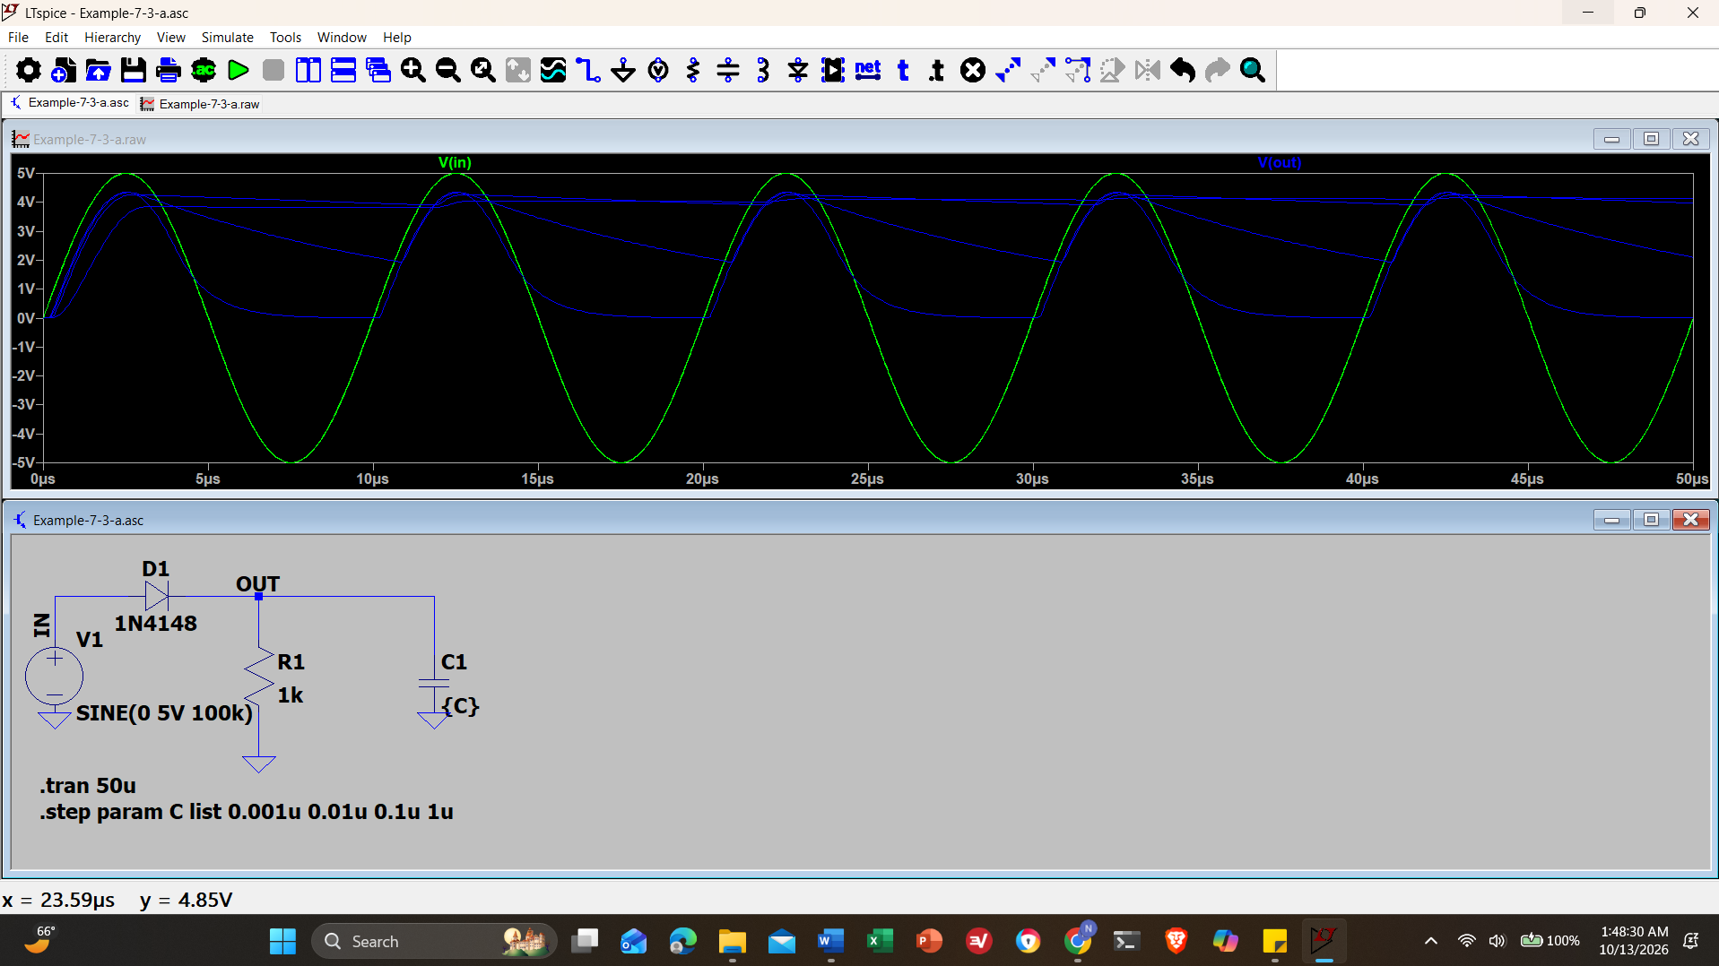
Screenshot 2: Circuit in Figure 7.3 (a). Set the input to a 100 kHz, 5 V amplitude sine wave and run a transient simulation with a stop time of 50u (.tran 50u) and step through possible capacitor values
- Rebuild the circuit in Figure 7.4 (a) in LTspice and plot the input and output voltages. Use the 1N4148 diode and a sinusoidal input volage with 0 V offset, 5 V amplitude, and 200 Hz frequency. When plotting the output voltage, you must plot the difference between the two nodes of the load, just like in Figure 7.4 (b). Use .tran 10m for simulation. Take screenshots of the schematic and voltage waveforms.
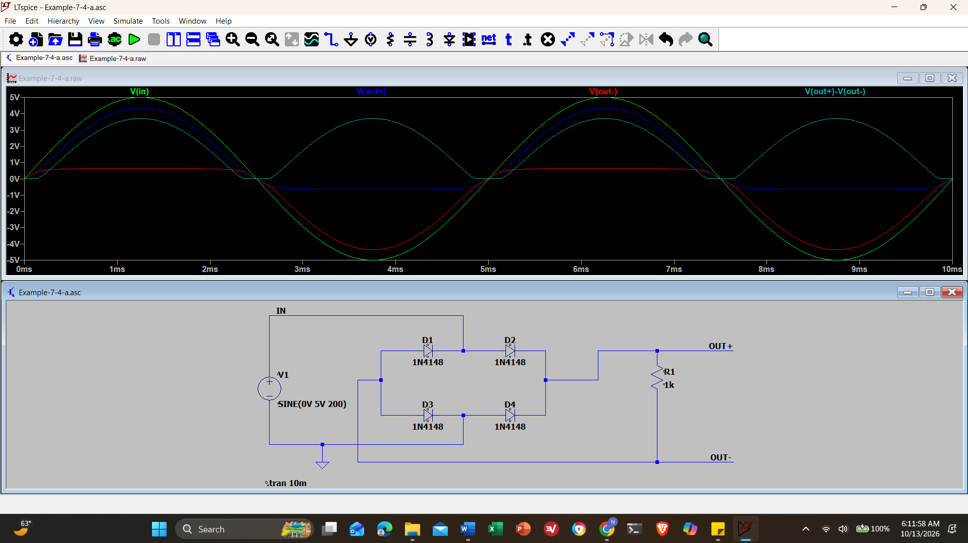
Screenshot 3: Circuit in Figure 7.4 (a) in LTspice and plot the input and output voltages. Use the 1N4148 diode and a sinusoidal input volage with 0 V offset, 5 V amplitude, and 200 Hz frequency. With Vin and Vout plotted
- Build the circuit in Figure 7.5. Use the default LED model in LTSpice, and download "slcj016.zip" file from Lab 7 folder for the LM393 comparator model. Ensure the unzipped file ends correctly by opening it in a text editor. The final line should be “.ENDS” with no extra characters following it. If any exist, remove them, save the file, then proceed to import to LTspice.

Import the model into LTspice using the “LTspice Component Import” documents in the lab folder. You can also find video instructions here. You don’t need to adjust the component shape; it could lead to potential errors.

Power the LM393 with ±5 V. Set the input voltage to a 1 kHz, 5 V amplitude sine wave and run a transient solution with a stop time of 2m (.tran 2m). Plot the input voltage and the current through each diode. Save an image of the circuit and the plot.
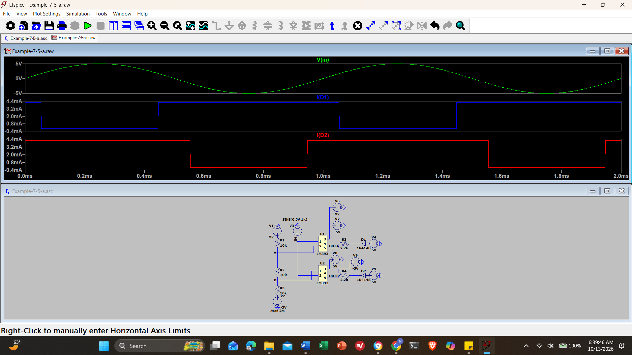
Screenshot 4: Circuit in Figure 7.5. Power the LM393 with ±5 V. Set the input voltage to a 1 kHz, 5 V amplitude sine wave and run a transient solution with a stop time of 2m (.tran 2m). Plot the input voltage and the current through each diode.
- Build the circuit in Figure 7.8. Power the LM393 and TLV272 with ±5 V. Set the input voltage to a 1kHz, 0.1 V amplitude sine wave and run a transient solution with a stop time of 2m. Choose the value for R1, 10k pot, (vary the ‘w’ parameter or just hard code the value) so that the diodes conduct current and illuminate. Plot the input voltage, output of the op amp, positive and negative inputs to the comparator, and the current through both LEDs. (6 items total). Save an image of the circuit and the plots.
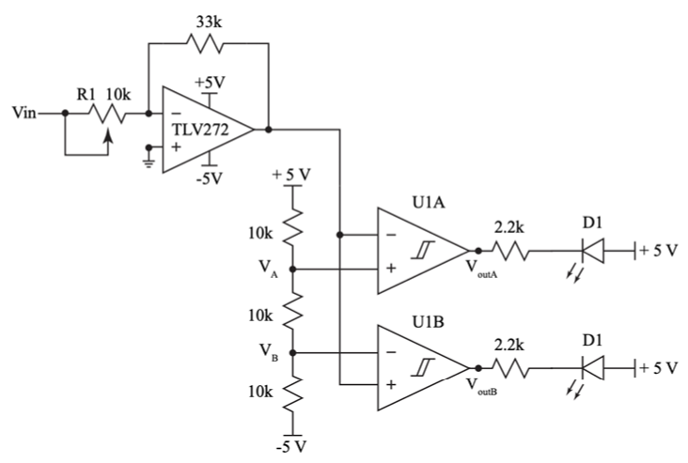
Figure 8: A variable gain amplifier, R1 is a potentiometer that can be varied, where the output is checked for clipping.
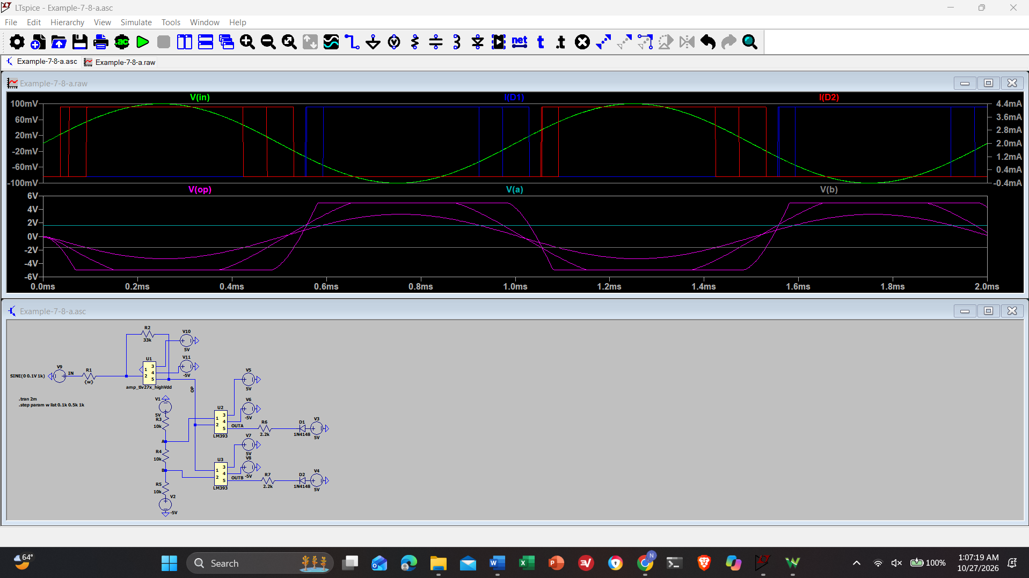Screenshot 5: Circuit in Figure 7.8. Power the LM393 and TLV272 with ±5 V. Set the input voltage to a 1kHz, 0.1 V amplitude sine wave and run a transient solution with a stop time of 2m. Plot the input voltage, output of the op amp, positive and negative inputs to the comparator, and the current through both LEDs.

Breadboard Implementation
- Read the datasheet for the LM393, the pinout for the chip is on page 3.
- Build the circuit in Figure 7.5 on a breadboard. It is important to note that the pinout for the comparator chip is the same as the op amp. It works differently but should be connected the same as the op amp. This means you should still connect pin 8 to +5V and pin 4 to -5V (not GND) just as you have done with the op amp.

Set the input to a 0.5 Hz, 5 V amplitude sine wave. Use the two red LEDS in your lab kit, they’re bagged separately. The anode for the LEDs is the longer of the two leads. The diodes will illuminate whenever the input voltage is above or below the reference voltage and should appear to blink in turn. Save the circuit to show your lab instructor at the start of lab.
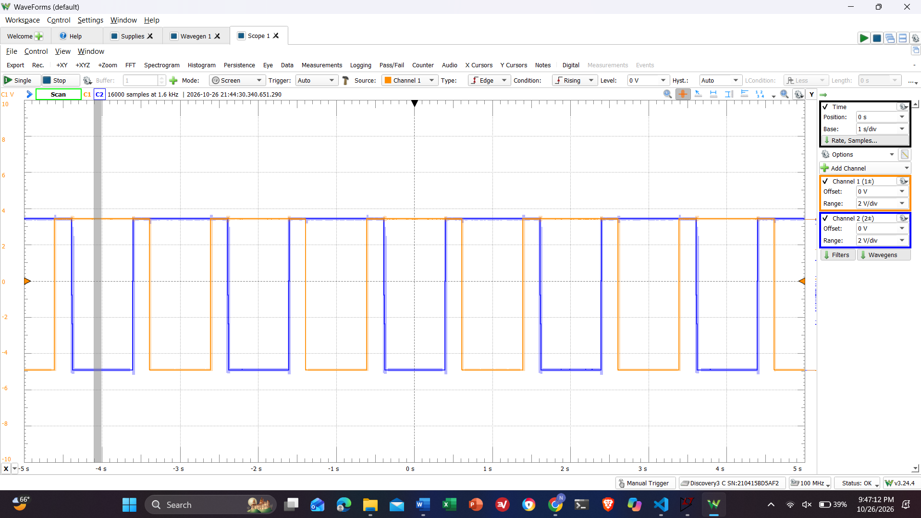
Screenshot 6: Circuit in Figure 7.5 on a breadboard. Set the input to a 0.5 Hz, 5 V amplitude sine wave.

Pre-Lab Checklist
The following must be completed at the start of lab.
- Section 8.5.1
  - Item 1: Half-wave rectifier, image of the circuit and the plot of the input and output voltage.
  - Item 2: Half-wave rectifier with output smoothing, image of the circuit and the plot of the input and output voltage.
  - Item 3: Full-wave rectifier, image of the circuit and plot of the input and output voltage.
  - Item 4: Clipping circuit, image of the circuit and the plot.
  - Item 5: Variable gain amplifier with clip detector, image of the circuit and the plot.
- Section 8.5.2
  - Item 2: Operational clipping circuit demo.

Breadboard Implementation
- Plot the input voltage and the voltage at the output of either comparator, Figure 7.5, on the o-scope and save an image of the display.
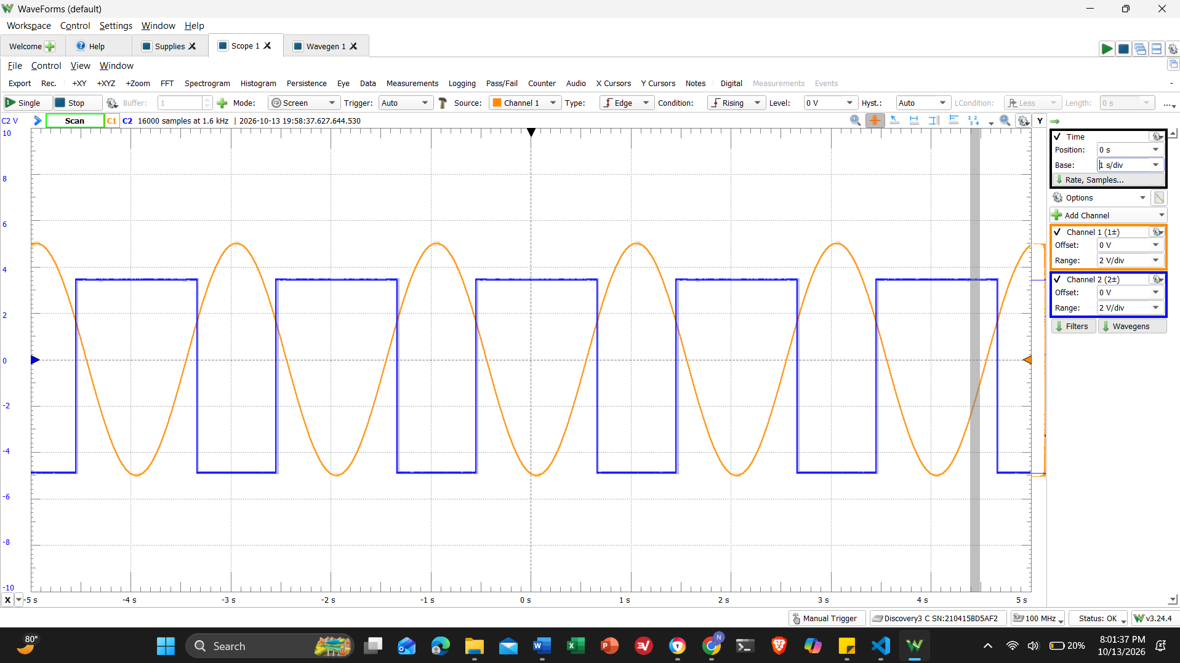
Screenshot 7: Figure 7.5 Breadboarded. CH1+ is the input, CH2+ is OutA
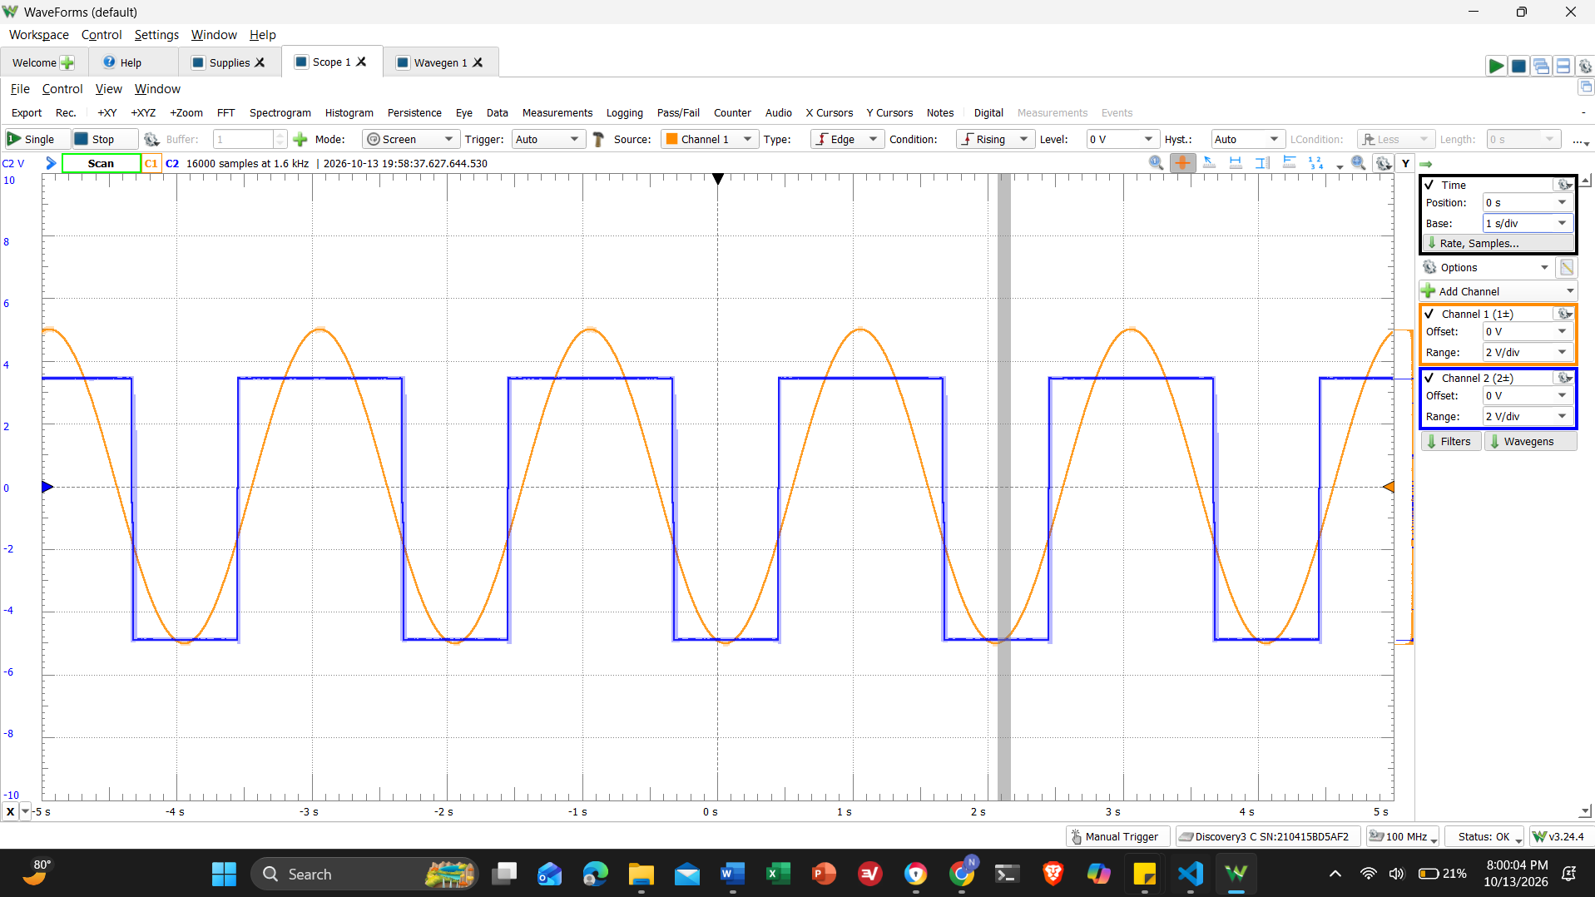
Screenshot 8: Figure 7.5 Breadboarded. CH1+ is the input, CH2+ is OutB
- Build the circuit from Section 8.5.1 - Item 1. Plot the input and output on the o-scope and save an image of the display.
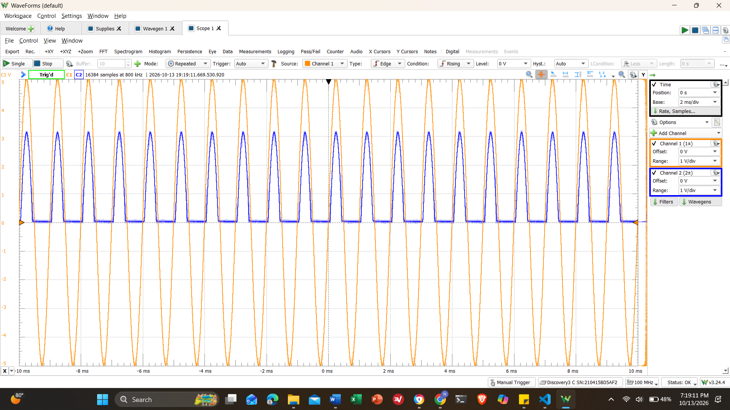
Screenshot 9: Circuit from Section 8.5.1 - Item 1, CH1+ is the input, CH2+ is the output.
- Build two versions of the circuit from Subsection 8.5.1 - Item 2, one with where the 8 capacitance is 0.1 uF and the other is 0.01 uF. Plot the outputs of both circuits on the oscope and save an image of the display.
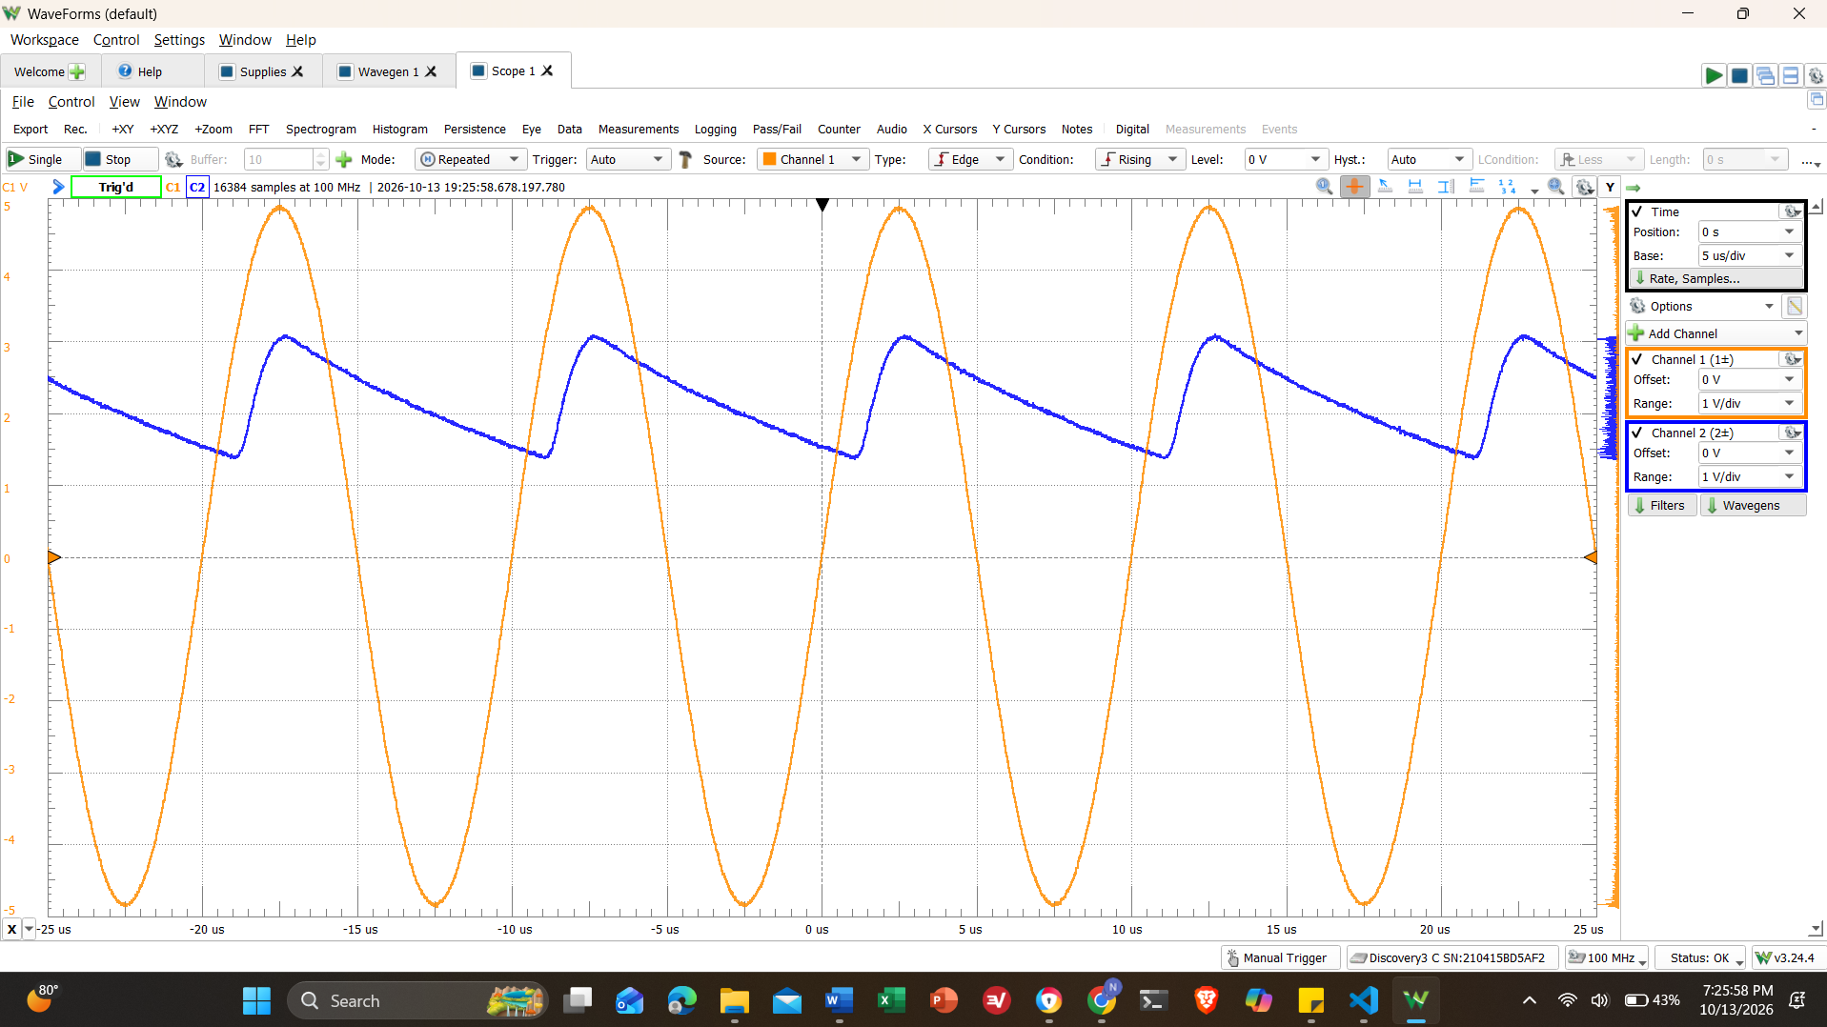
Screenshot 10: Circuit from Subsection 8.5.1 - Item 2. With capacitance of 0.01 uF
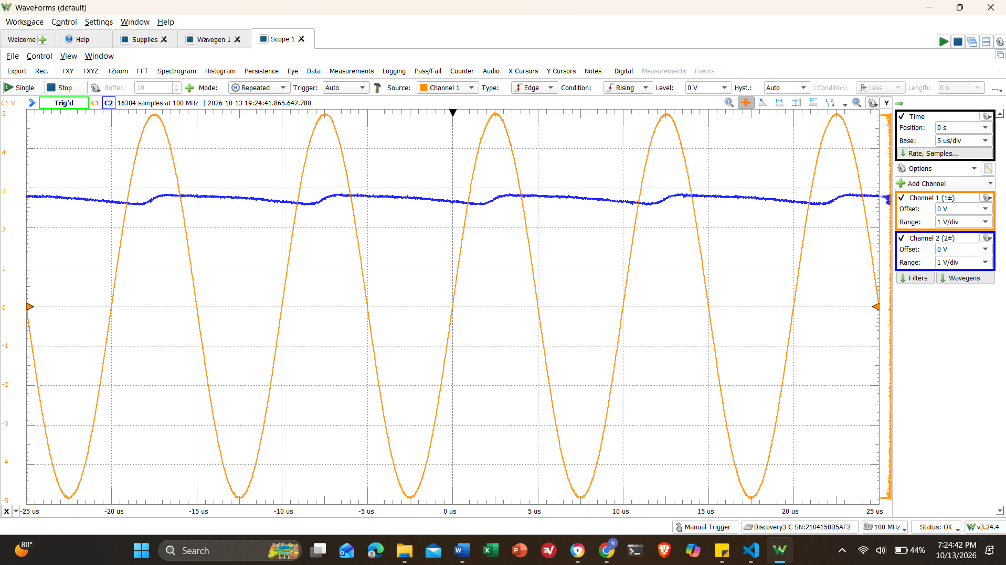
Screenshot 11: Circuit from Subsection 8.5.1 - Item 2. With capacitance of 0.1 uF
- Implement the full-bridge circuit from Subsection 8.5.1 - Item 3. Set Wavegen 1 to a 200 Hz, 5 V amplitude sine wave. When measuring the output, connect Scope 2+ to Vout+ and Scope 2- to Vout- to get the differential signal. Plot the outputs of both circuits on the oscope and save an image of the display.
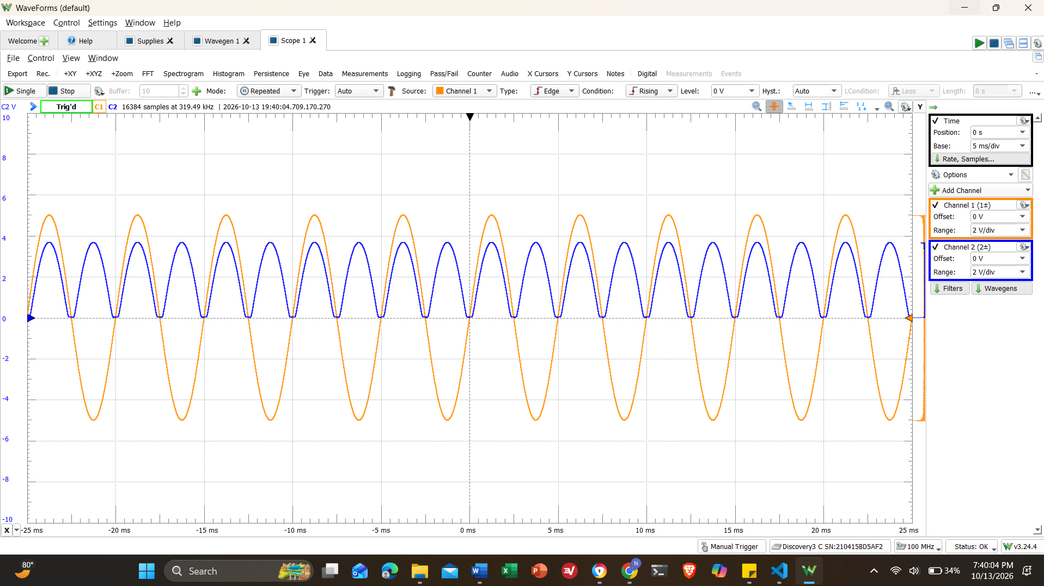
Screenshot 12: Full-bridge circuit from Subsection 8.5.1 - Item 3. Set Wavegen 1 to a 200 Hz, 5 V amplitude sine wave. When measuring the output, connect Scope 2+ to Vout+ and Scope 2- to Vout- to get the differential signal.
- Build the circuit from Subsection 8.5.1 - Item 5. Set the input to a 0.5 Hz, 0.1 V amplitude sine wave. Vary the potentiometer, increase the gain, so that the LEDs illuminate when the op amp output is greater than the reference voltages. Plot the output of the gain amplifier and the output of either comparator on the o-scope and save an image of the display.
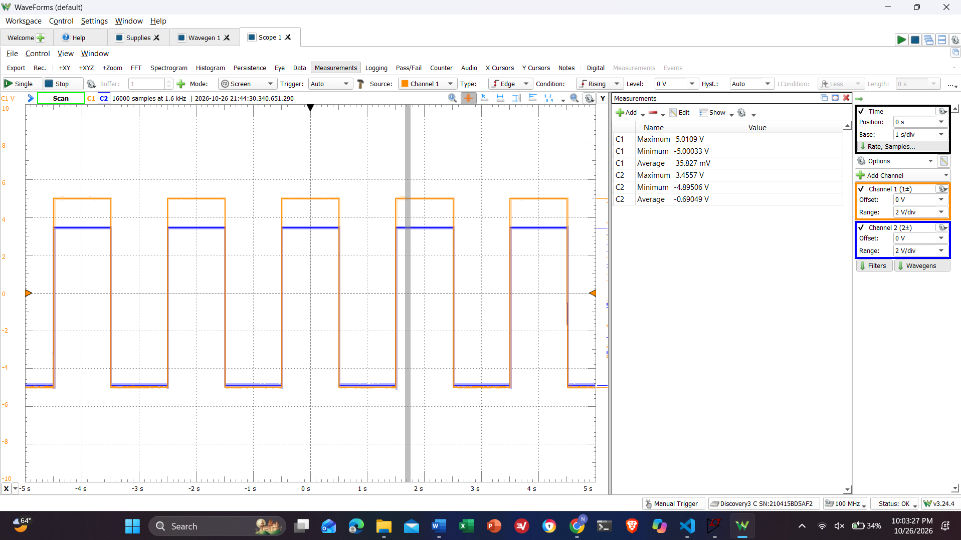
Screenshot 13: Circuit from Subsection 8.5.1 - Item 5. Set the input to a 0.5 Hz, 0.1 V amplitude sine wave. CH1+ is gain amplifier output, CH2+ is OutA.
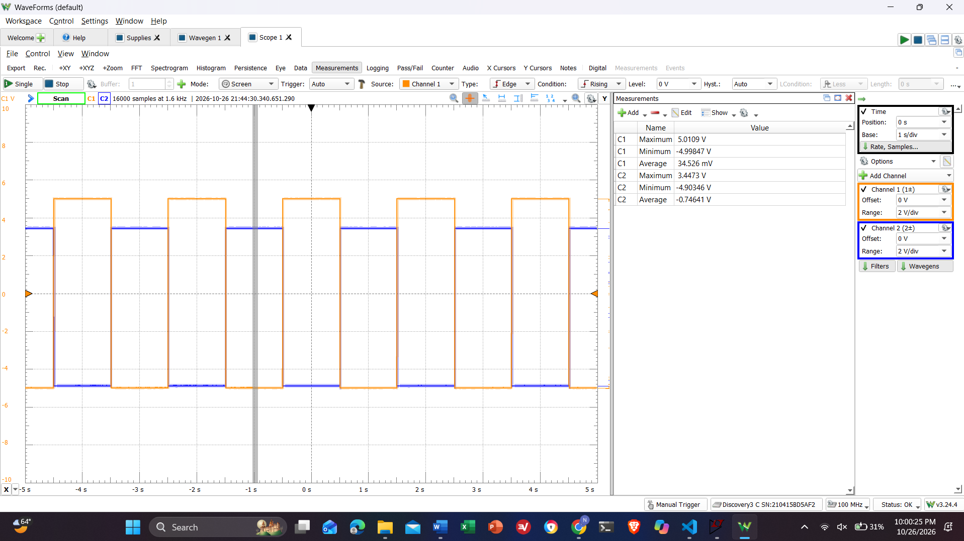
Screenshot 14: Circuit from Subsection 8.5.1 - Item 5. Set the input to a 0.5 Hz, 0.1 V amplitude sine wave. CH1+ is gain amplifier output, CH2+ is OutB
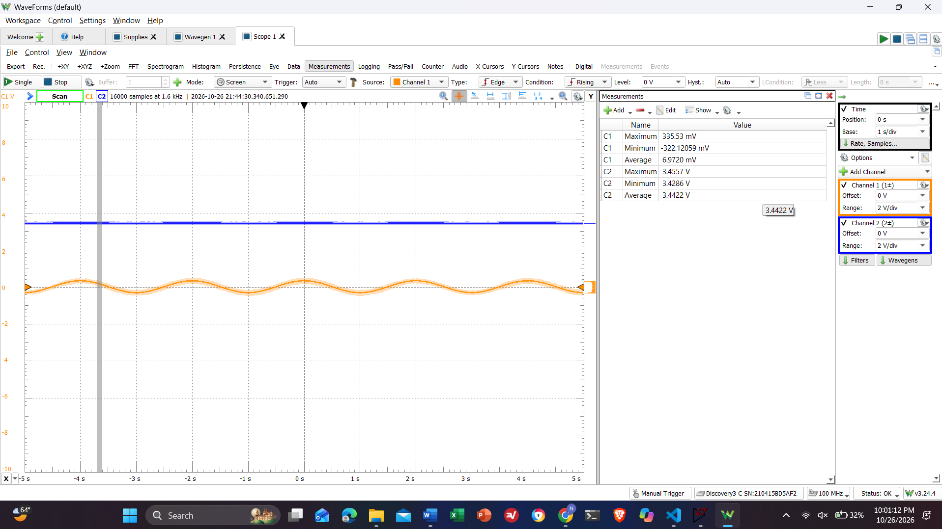
Screenshot 15: Circuit from Subsection 8.5.1 - Item 5. Set the input to a 0.5 Hz, 0.1 V amplitude sine wave. CH1+ is gain amplifier output, CH2+ is OutB

Write Up
Discussion Question:
Discuss the functionality and operation of each circuit built in lab, include your captured waveforms and corresponding LTspice schematics. By this point, you have worked with both op amps and comparators. Compare their similarities and differences. When would you choose an op amp over a comparator, and vice versa, based on application?
Functionality and Operation of Lab Circuits
Diodes enforce a single directional current flow. Half-wave and full-bridge rectifiers convert bipolar AC input waveforms into positive pulsating DC signals. The full-bridge configuration uses four diodes to invert the negative half-cycles of the AC input, doubling the ripple frequency and increasing average output power.
The TLV272 op-amp acts as an inverting gain stage to amplify small input signals. The amplified signal feeds into a window comparator built with an LM393 dual comparator and a 3-resistor voltage divider ladder. When the amplified output crosses the upper (V_{A}) or lower (V_{B}) reference thresholds, the comparator outputs pull low to sink current through the 2.2kΩ current-limiting resistors, illuminating the LEDs to visually show signal clipping.
Op-Amp vs. Comparator:
Both devices are differential high-gain voltage amplifiers with non-inverting and inverting inputs. Both evaluate the difference between their input terminals. However, Op-amps are optimized for linear operations with negative feedback. They feature internal frequency compensation to prevent oscillation in closed-loop configurations and push-pull output stages that drive continuous analog voltages. Comparators are designed more for open-loop non-linear switching, so they do not have internal phase compensation. This allows for extremely fast propagation delays and rapid switching times. They are usually used for their open-collector outputs, requiring an external pull-up resistor to define logic states.
You would choose an op-amp for linear signal processing, like amplification, filtering, buffering, level shifting, or mathematical operations where continuous proportional outputs are required. Comparators would be chosen for threshold detection, zero-crossing detection, window detection, or driving digital logic/LED indicators where fast, sharp binary state transitions are needed.
Refer back to the clipping detection circuit in Figure 7.5. For the final project, you will be asked to design a circuit where one LED turns on when the input voltage exceeds 1 V and the other LED turns on when the input voltage exceeds 4 V to indicate clipping. Calculate the resistor values needed to set the correct reference voltages using either ± 5 V supply or +5 V and GND supply for the three-resistor ladder. You do not need to get exactly 1 V and 4 V, get as close as you can only using 3 resistors. Explain your reasoning.
To generate strictly positive reference voltages at 1V and 4V, using a single +5V and GND supply for the 3-resistor ladder is the most efficient choice. Connecting a voltage divider between 5V and 0V inherently constrains all intermediate node voltages within the 0V to 5V range without requiring negative offsets.
+5V-R1=4V-R2-VB-1V-R3-GND
Let the current flowing down the resistor ladder be I. The target node voltages are V_{A} = 4V and V_{B} = 1V:
Voltage Across Bottom Resistor (R₃): V_{B} – 0V = 1V -> I * R₃ = 1V
Voltage Across Middle Resistor (R₂): V_{A} – V_{B} = 4V – 1V = 3V -> I * R₂ = 3V
Voltage Across Top Resistor (R₁): 5V – V_{A} = 5V-4V=1V -> I * R₁ = 1V
Dividing the equations yields the required resistance ratios: R₁/R₃ = 1V/1V = R₁=R₃; R₂/R₃ = 3V/1V = 3 = R₂ = 3R3
Selecting the standard Parts. R3 = 10 kΩ, R1= 10 kΩ, R2 = 33kΩ (since it's closest to 30 kΩ)

CONCLUSION
This lab successfully demonstrated the application of operational amplifiers for signal conditioning tasks. By simulating and constructing buffer circuits, level shifters, and difference amplifiers, the ability to isolate circuit stages, manipulate DC offsets, and extract differential signals while rejecting common-mode noise was validated.

