PROBLEMS ENCOUNTERED
N/A
INTRODUCTION
The objective of this lab is to introduce the design, frequency response, and performance analysis of active and passive analog filters. Key concepts include cutoff frequency (f₀ or f_{C}), bandwidth, attenuation, passbands, and stopbands in the frequency domain. By constructing passive RC circuits and active op-amp topologies (such as Sallen-Key low-pass and high-pass filters), we analyze how signals are selective passed or attenuated based on frequency.

DISCUSSION

Objective
The objective of this lab is to introduce the concept of filters and explore their applications through examples of passive, active, and cascaded filters.

Materials
- Laptop with LTSpice
- Analog Discovery
- Breadboard
- Wiring kit
- Lab parts kit

Introduction
Time Domain vs Frequency Domain
Up to this point, the labs have focused on signals in the time domain. In the time domain, we observe how a signal varies over time using an oscilloscope. For example, if a signal has a specific frequency, you see it as a repeating waveform on the screen, with the timing set appropriately.
When we move into the topic of filters, we start looking at signals in the frequency domain. In this domain, we no longer ask “what does the signal look like over time?” but instead, “which frequencies does the signal contain, and how does the circuit affect them?” In other words, we care about how a system responds to different frequencies, not how the signal looks versus time.
A helpful analogy is to think of a filter like a colored lens:
- In the time domain, you might describe how bright or dim a light is changing over time.
- In the frequency domain, you think about which colors (frequencies) the lens lets through, and which does it block.
Filter Types
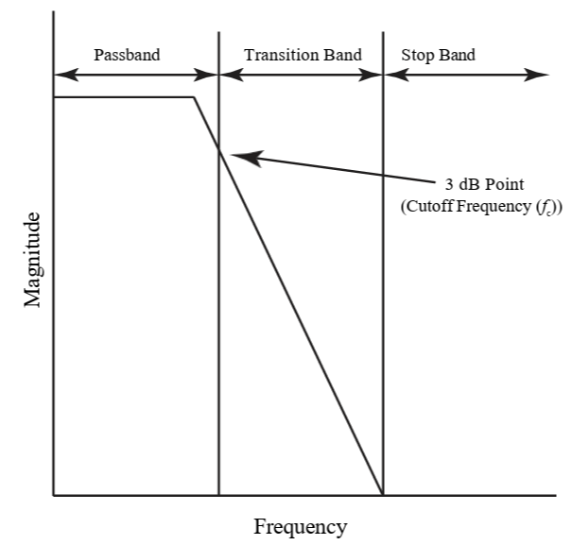
Figure 1: Example of response for a generic lowpass filter. The filter passes low frequencies, thus the name, and attenuates higher frequencies.
Figure 8.1 shows a typical lowpass filter response in the frequency domain. As the name suggests, a lowpass filter allows low-frequency signals to pass through, while higher frequency signals are gradually attenuated as they enter the transition and stop bands.
A highpass filter works the opposite way, it attenuates low-frequency signals while allowing highfrequency signals to pass through with little to no attenuation.
Other common filter types include band-pass filters, which only pass signals within a specific frequency range and attenuate frequencies outside that range, and notch (band-reject) filters, which block a specific range of frequencies while allowing frequencies above and below that range to pass. Lastly, an all-pass filter passes all frequencies but alters the phase of the signal without affecting its amplitude. For more information on these filters, you are encouraged to read about them here in Section 8.2.
Cutoff Frequency
The point where the filter begins to noticeably attenuate the signal is called the cutoff frequency or 3 dB point, the frequency where the output drops to 70.7% (or -3 dB) of its maximum value. This cutoff frequency is chosen based on the design requirements to control how much attenuation occurs at a specific frequency.
It is important to note that the cutoff frequency is not always located at exactly -3 dB on the plot. The -3 dB point is a relative measurement, defined as the frequency where the gain drops by 3 dB below the maximum gain of the filter. For instance, if an active filter has a maximum gain of 10 dB, the cutoff frequency will be found where the gain falls to 7 dB, not at -3 dB. This relative rule applies regardless of whether the filter is passive or active.

Passive First Order RC Filters
Figure 8.2 shows two simple resistor-capacitor (RC) filter configurations and their resulting frequency responses. These are passive filters, meaning they do not contain active components like transistors or op amps and do not require an external power supply to function. Additionally, they are first order filters since each circuit contains only one RC pair.
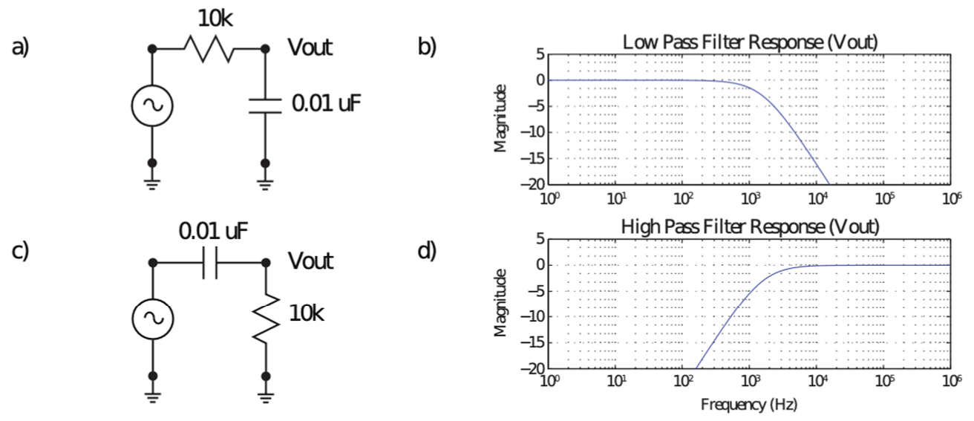
Figure 2: An example of a simple RC low pass filter (a) and the resulting frequency response (b). Also, a simple RC highpass filter (c) and the resulting frequency response (d).
The behavior of these circuits becomes clearer when considering how capacitors respond at different frequencies:
- At low frequencies, a capacitor behaves like an open circuit because it’s impedance 𝑍𝑐 = 1/𝑗𝜔𝐶 is large when 𝜔 = 2𝜋𝑓 is small.
- At high frequencies, a capacitor acts like a short circuit because 𝑍𝑐 decreases as 𝜔 increases.
With this in mind, it should make sense why lowpass filters allow lower frequencies to pass. As the frequency increases, the capacitor creates a stronger connection between ground and Vout. This prevents less of the input signal to reach the output, thus attenuating it. The same principles can be applied to the highpass filter.
Rather than working through the full transfer function for filter design and analysis, we will focus on key characteristics, such as the cutoff frequency. This is the frequency at which the filter begins to significantly attenuate signals. For a simple RC filter, the cutoff frequency is determined by:
$$f_{C}=\frac{1}{2πRC} (8.1)$$
For the examples in Figure 8.2 (a) and (c), the 3 dB point is calculated to be:
$$f_{C}=\frac{1}{2π(10k)(0.01u)}=1.5916 kHz (8.1)$$
Which matches the frequency response for both configurations.

Active RC Filters
There are a variety of active filter topologies, but a simple implementation is to use an appropriately placed capacitor in conjunction with a typical inverting amplifier configuration, Figure 8.3 (a) and (b).
Aside from requiring an external power supply, active filters differ from passive filters in their amplitude response. In passive filters, the output amplitude can never exceed the input amplitude, meaning the maximum gain is 1 or less. In contrast, active filters use an op amp to provide amplification, allowing the output to be greater than the input amplitude. This means active filters not only shape the frequency response but can also amplify the signal at the same time.
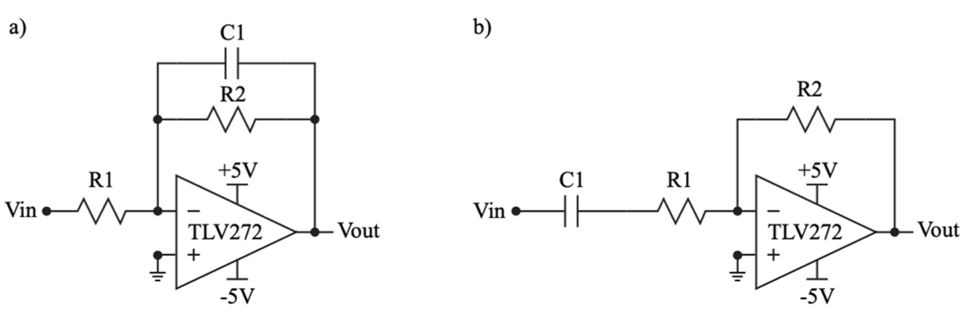
Figure 3: An example of an active RC low pass filter (a) and an active RC high pass filter (b).
The design of either the active RC low pass or high pass is also fairly simple for the first order case. A low pass filter has the following equations:
$$\frac{V_{out}}{V_{in}}=-\frac{R_{2}}{R_{1}}\left(\frac{1}{jwC_{1}R_{2}+1}\right)$$
$$H_{0}=-\frac{R_{2}}{R_{1}}$$
$$f_{0}=\frac{1}{2πC_{1}R_{2}}$$
where H₀ is the passband gain and f₀ is the 3dB frequency. Similarly, the high pass filter has the following equations:
$$\frac{V_{out}}{V_{in}}=-\frac{R_{2}}{R_{1}}\left(\frac{jwC_{1}R_{2}}{jwC_{1}R_{2}+1}\right)$$
$$H_{0}=-\frac{R_{2}}{R_{1}}$$
$$f_{0}=\frac{1}{2πC_{1}R_{2}}$$

Cascaded Filters
While single-stage (first order) filters are useful, they often do not attenuate unwanted frequencies fast enough for many practical applications. To achieve a sharper transition between the passband and stopband, or to build more complex frequency responses, multiple filter stages can be connected in series—a technique known as cascading.
When filters are cascaded, the output of the first stage serves directly as the input to the second stage. The overall transfer function of 𝑁 non-interacting cascaded stages is the product of their individual transfer functions:
$$H_{total}\left(ω\right)=H_{1}\left(ω\right)∙H_{2}\left(ω\right)∙…{∙H}_{N}\left(ω\right)$$
Connecting two passive RC filters directly in series creates a loading effect. The input impedance of the second stage draws current from the first stage, altering its effective RC time constant. As a result, the cutoff frequency shifts away from its calculated theoretical value. Active filters built with op amps overcome loading issues entirely. Because an op amp has very high input impedance and extremely low output impedance, it acts as a buffer between stages. This prevents stage-tostage loading, ensuring each filter stage operates independently and predictably. Below is an example of cascaded high-pass filters using the passive RC topology shown above.
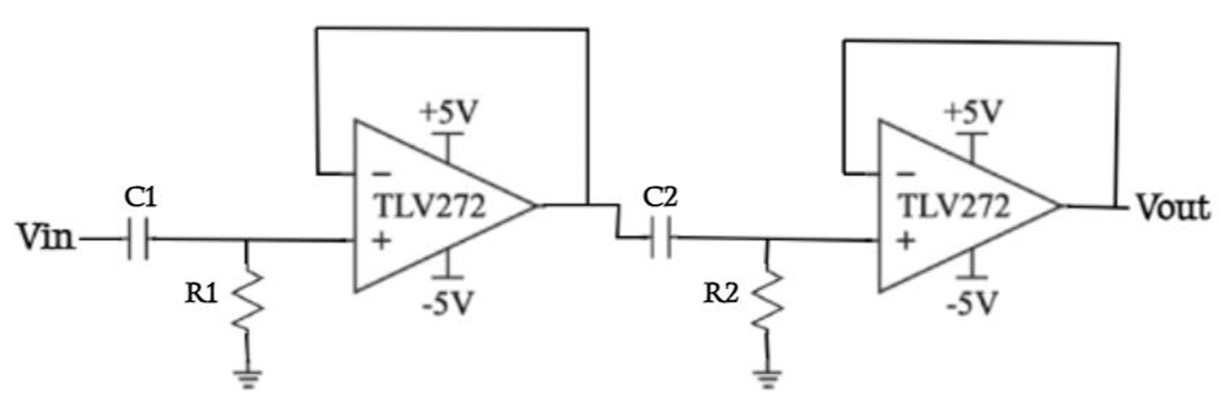
Figure 4: An example topology of a cascaded RC high-pass filter.

Big Picture
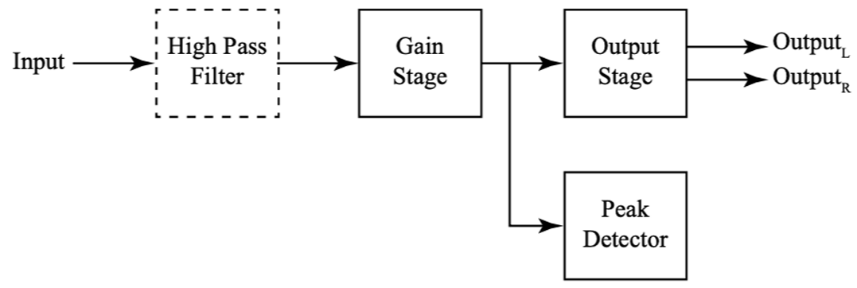
Figure 5: Big picture with emphasis on the high pass filter.
This lab focuses on filter circuits which will help to create the high pass filter used in the final project used to remove the large DC offset in the source signal.

Pre-Lab Requirements
Complete the following before coming to lab.

LTspice Simulations
Complete the following using the TLV271 spice model, always power the op amp with ± 5 V for V_{dd+} and V_{dd-}.
- Review the LTspice tutorial for AC Analysis. Also please note that the component values in the example image in 8.3.1 are different than the values needed for the following instructions. For your reference: 0.001 µF = 102 J, 0.01 µF = 103 J, 0.1 µF = 104 J, 0.033 µF = 333 J, 0.047 µF = 473 J.
- Build a simple lowpass filter, Figure 8.2 (a), but set R = 10 kΩ and C = 0.001 µF. Set the voltage source to an AC amplitude of 1 and run an AC analysis with the following settings: Decade, 100, 1, 1Meg. Save an image of the circuit, a plot of the output, and table the 3 dB frequency.
$$-3dB=20\log_{10}\left(\frac{V_{out}}{V_{in}}\right)$$
$$\frac{V_{out}}{V_{in}}={10}^{-\frac{3}{20}}≈0.707946$$
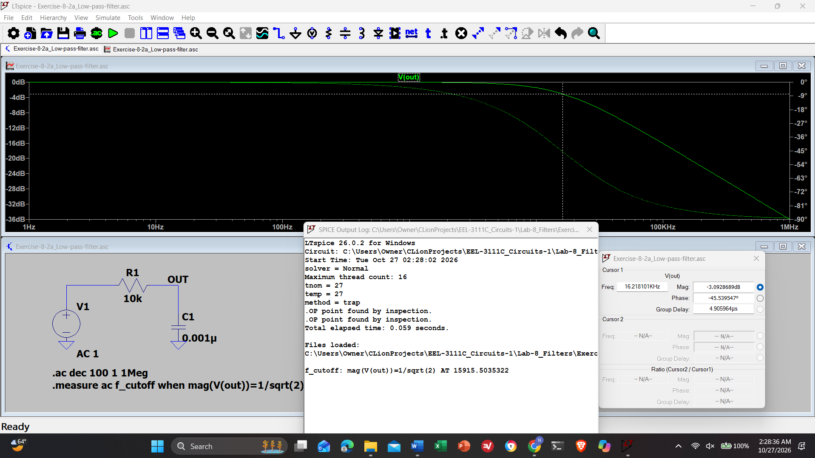
Screenshot 1: Simple lowpass filter, Figure 8.2 (a), but set R = 10 kΩ and C = 0.001 µF. Set the voltage source to an AC amplitude of 1 and run an AC analysis with the following settings: Decade, 100, 1, 1Meg.
Intensity | Frequency
-3dB | 16kHz
Table 1: Lowpass Filter Frequency at -3dB
- Build an active RC highpass filter, Figure 8.3 (b). Set C1 = 0.1µF and determine the resistor values for a gain of 10 (20 dB) and a f₀ = 482.3 Hz using only values in your lab kit. Set the voltage source to an AC amplitude of 1 and run an AC analysis with the following settings: Decade, 100, 1, 1Meg. Table the 3 dB frequency. Save an image of the circuit, a plot of the output, and table the 3 dB frequency (3 dB from the passband) for submission to Canvas.
$$f_{0}=\frac{1}{2πC_{1}R_{2}}=>R_{2}=\frac{1}{2πC_{1}f_{0}}$$
$$R_{2}=\frac{1}{2πC_{1}f_{0}}=\frac{1}{2π\left(0.1 uF\right)\left(482.3 Hz\right)}≈3299.92 Ω$$
$$H_{0}=-\frac{R_{2}}{R_{1}}=>30dB=\frac{3299.92}{R_{1}}=>R_{1}=\frac{3299.92 Ω}{30dB}=109.997 Ω$$
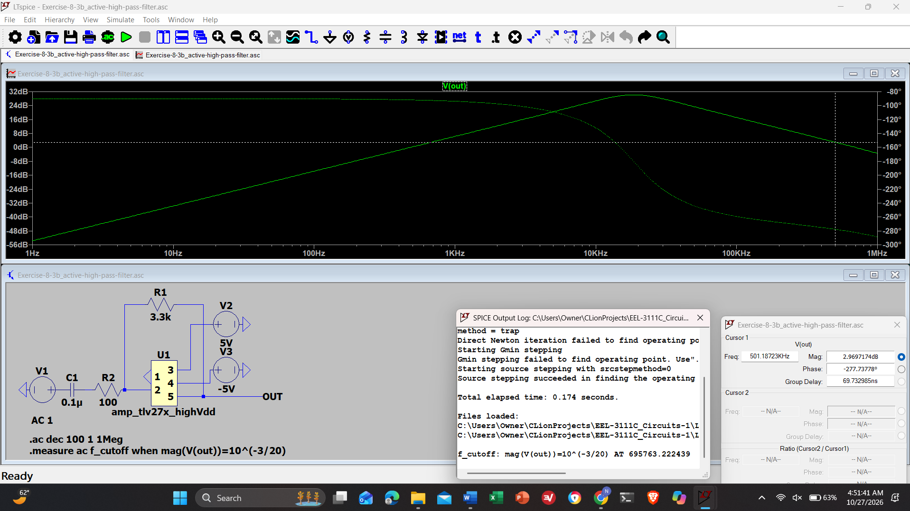
Screenshot 2: Active RC highpass filter, Figure 8.3 (b). Set C1 = 0.1µF and determine the resistor values for a gain of 10 (20 dB) and a f₀ = 482.3 Hz using only values in your lab kit. Set the voltage source to an AC amplitude of 1 and run an AC analysis with the following settings: Decade, 100, 1, 1Meg.
Intensity | Frequency
3dB | 70kHz
Table 2: Active Highpass filter at 3dB
- Build cascaded RC highpass filters as shown in Figure 8.4. Choose resistor and capacitor values from your parts kit to attenuate 240Hz noise. Note you should have the same resistor and capacitor values in both stages of the filter, meaning R1 should be the same as R2 and C1 should be the same as C2. In the first stage of the filter 240Hz should be attenuated by at least -3dB, and in the final output, the attenuation should be double of the first stage. Keep the cutoff frequency below 1KHz to preserve the audio signal. Table your resistor and capacitor values as well as the expected attenuation at 240Hz in each stage. Set the voltage source to an AC amplitude of 1 and run an AC analysis with the following settings: Decade, 100, 1, 100k. When plotting the bode plots, display the output of the first stage and the second stage on the same plot. Add a cursor to each plot trace to clearly show the attenuation at 240Hz. Save an image of the circuit and a plot of the output. (You can use the following links to determine what resistors and capacitors you should choose: https://www.calculator.net/resistor-calculator.html, https://www.digikey.com/en/resources/conversion-calculators/conversion-calculator-low-pass-and-high-pass-filter
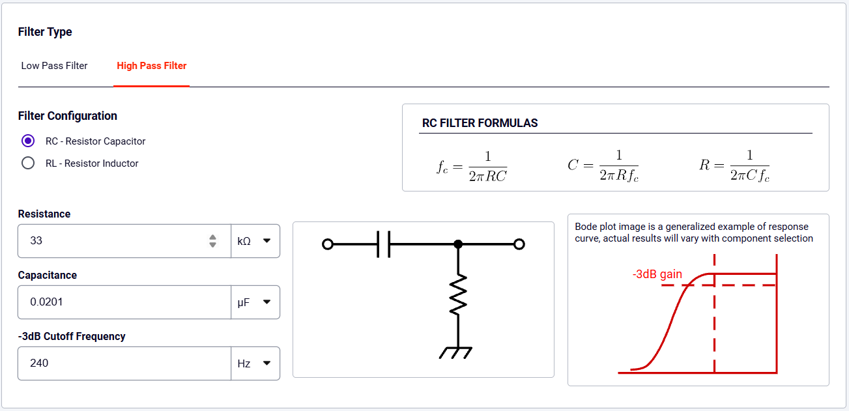
Screenshot 3: Calculator to get resistor and capacitor values
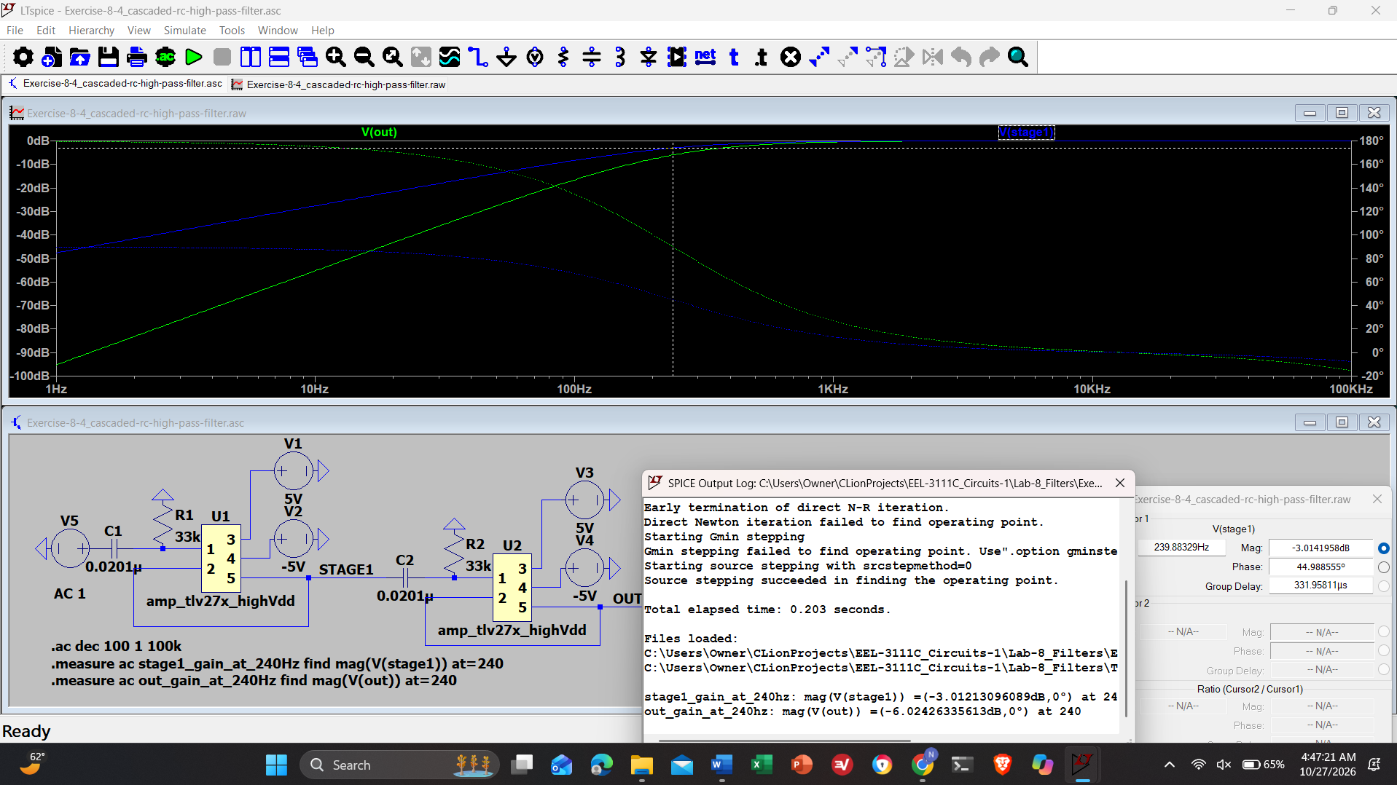
Screenshot 4: Cascaded RC highpass filters as shown in Figure 8.4. Keep the cutoff frequency below 1KHz to preserve the audio signal. Set the voltage source to an AC amplitude of 1 and run an AC analysis with the following settings: Decade, 100, 1, 100k. Showing Cursor at V_{STAGE1}
 | Resistor | Capacitor | Intensity
Stage 1 | 33kΩ | 0.0201 uF | -3.012dB
Output | 33kΩ | 0.0201uF | -6.024dB
Table 3: Table your resistor and capacitor values as well as the expected attenuation at 240Hz in each stage.
- Use the schematic below (Figure 8.6) to build a RC band reject filter. Once again, choose resistor and capacitor values from your parts kit to attenuate 240Hz by at least -3dB. Use 8.2kΩ resistors for R3, R4, and R5. Table your chosen resistor and capacitor values as well as the expected cutoff for the low-pass and the high-pass stages. Set the voltage source to an AC amplitude of 1 and run an AC analysis with the following settings: Decade, 100, 1, 100k. Add a cursor to the trace to clearly show the attenuation at 240Hz. Save an image of the circuit and a plot of the output. (Hint: For the high pass component, choose a cutoff frequency at least 80 Hz above the target frequency, and for the low pass component choose a cutoff frequency at least 80 Hz below the target frequency). Note: Your bode plot might not be the most attenuated at 240Hz. That is okay! Your only goal is to ensure 240Hz is attenuated by at least -3dB while frequencies significantly lower or higher than 240Hz are in the passband.
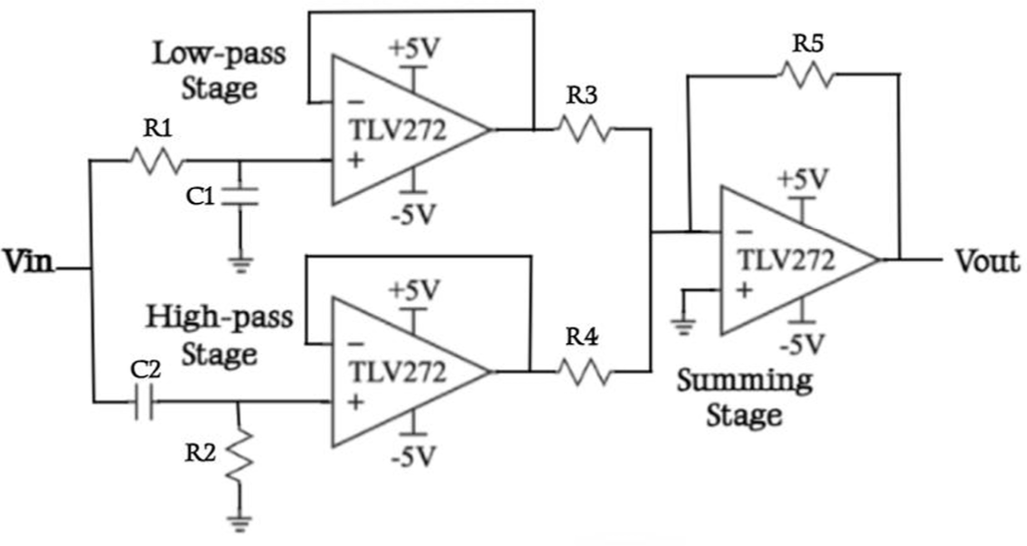
Figure 6: Topology for a band reject filter.
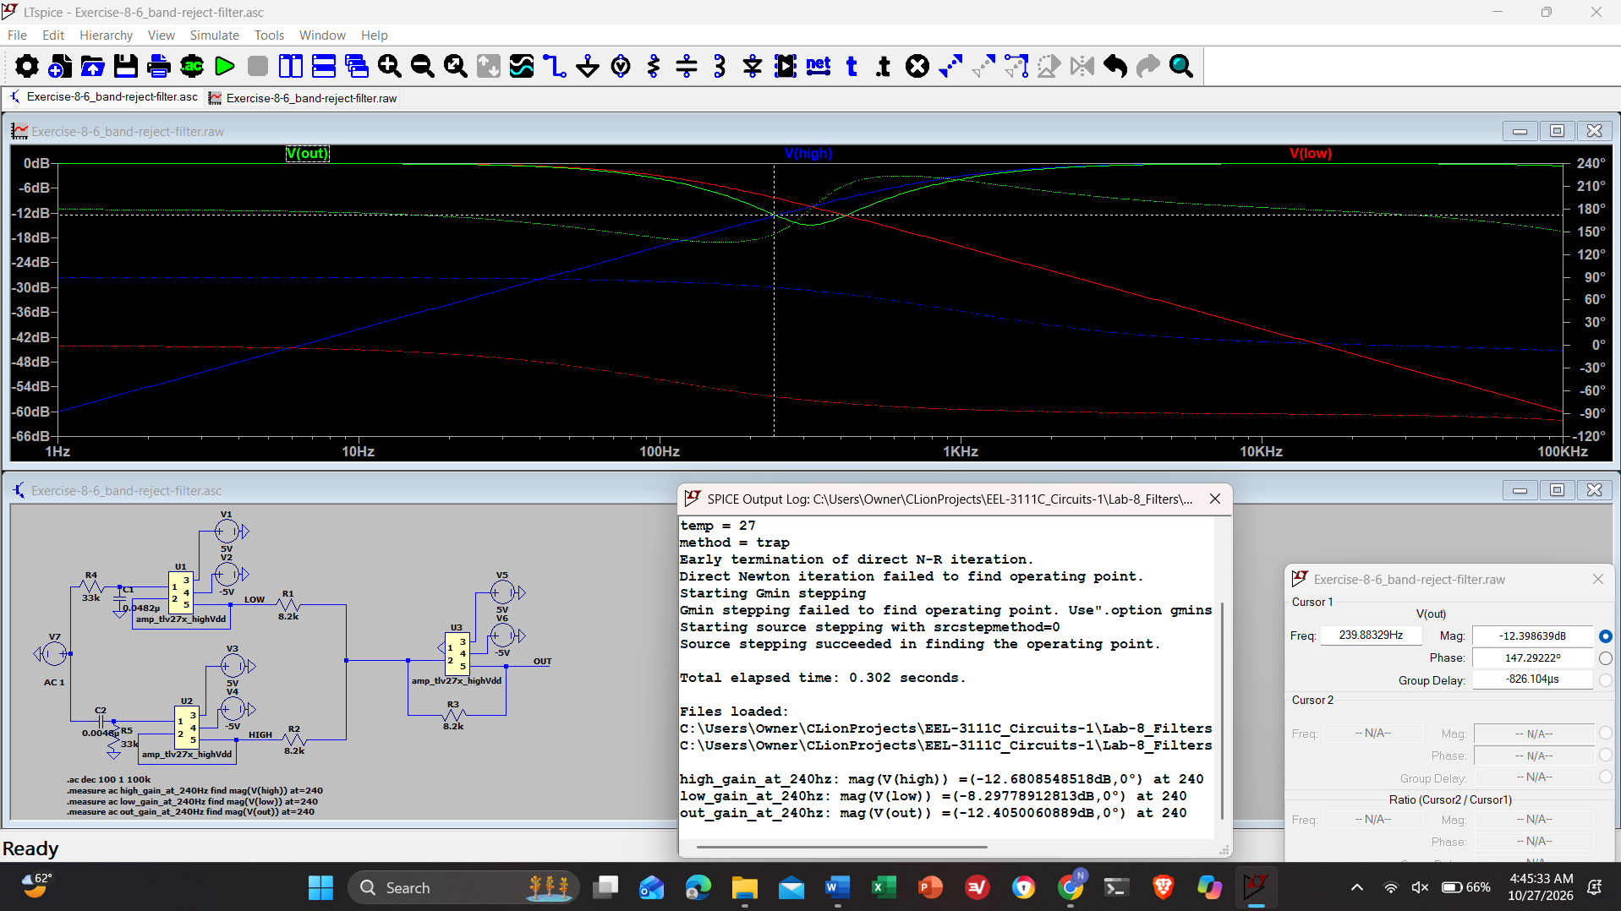
Screenshot 5: RC band reject filter. Use 8.2kΩ resistors for R3, R4, and R5. Set the voltage source to an AC amplitude of 1 and run an AC analysis with the following settings: Decade, 100, 1, 100k.
Resistor | Capacitor | Cutoff
33kΩ (Low) | 0.0482 uF | 100Hz
33kΩ (High) | 0.0048 uF | 1kHz
Table 4: Table your chosen resistor and capacitor values as well as the expected cutoff for the low-pass and the high-pass stages

Breadboard Implementation
- Review the Digilent tutorial for the Network Analyzer tool.
- Build the active RC high pass filter from Section 8.5.1 - Item 3 on a breadboard. Use a TLV272 op amp and power it with ± 5 V rails and wire up the Analog Discovery to use the network analyzer tool. Connect CH1+ and W1 to the input and CH2+ to the output.
- Set the start frequency to 100 Hz, stop frequency to 100 kHz, and the steps or samples to about 100. Set the amplitude to 100mV from 1V and the top to 30dB for this case. Click run once to generate the filter’s frequency response. Save the circuit to show your lab instructor at the start of lab.

Pre-Lab Checklist
The following must be completed at the start of lab.
- Section 8.5.1
  - Table of 3 dB frequencies (two values).
Filter | Frequency
Low | 16 kHz
High | 70 kHz
Table 5: Table of 3dB frequences from high and low pass filters
  - Item 2: Simple RC lowpass filter - image of the circuit and a plot of the output.
  - Item 3: Active RC highpass filter - image of the circuit and a plot of the output.
  - Item 4: Cascaded RC highpass filter - image of the circuit and a plot of the output.
  - Item 5: RC band reject filter - image of the circuit and a plot of the output.
  - Table of resistor values, capacitor values, and expected cutoff frequencies for the cascaded filter and the band reject filter.
Filter | Resistor | Capacitor | Cutoff | Intensity
Cascaded (Stage 1) | 33kΩ | 0.0201 uF | 240 Hz | -3.012 dB
Cascaded (Out) | 33kΩ | 0.0201 uF | 240 Hz | -6.024 dB
Band-Reject (Low) | 33kΩ | 0.0482 uF | 100 Hz | -8.298 dB
Band-Reject (High) | 33kΩ | 0.0048 uF | 1k Hz | -12.681 dB
Band-Reject (Out) | 33kΩ | N/A | N/A | -12.405 dB
Table 6: Table of resistor values, capacitor values, and expected cutoff frequencies for the cascaded filter and the band-reject filter.
- Section 8.5.2
  - Item 3: Active RC highpass filter - image of the circuit and a plot of the output.

In-Lab Requirements
For all active circuits, use a TLV272 op amp and power it with ± 5 V rails. Remember to use the RC values as indicated in the instructions, not the images.
- Set the number of samples to 1000 and re-run the network analyzer for the demo active highpass filter. Save an image of the output and measure the 3 dB frequency.
- Build the simple lowpass filter from Section 8.5.1 - Item 2 (10kΩ resistor and 0.001µF capacitor). Run the network analyzer with an amplitude of 1V and top set to 10dB, measure the 3 dB frequency, and save an image of the output.
- Build the cascaded highpass filter from Section 8.5.1 – Item 4. Use the resistor and capacitor values from the prelab. If you chose a higher cutoff frequency, the noise will be more attenuated, but so will the “bassy” components of the audio file.
- First, use the output of the first stage in the filter as the Vout for the network analyzer and run a network analyzer from 10 Hz to 100 kHz with 150 steps first to verify your plot and then with 1000 steps while leaving the rest of the settings as default (amplitude of 1V and offset of 0V). Take a screenshot of the Network analyzer showing the 240Hz frequency using a vertical measurement line. Table this value.
- Now use the output of the entire cascaded filter as the Vout for the network analyzer. Take a screenshot of the Network analyzer from 10 Hz to 100 kHz with 150 steps first to verify your plot and then with 1000 steps while leaving the rest of the settings as default (amplitude of 1V and offset of 0V). Make sure to showcase the steeper roll-off of the cascaded filter and add a vertical measurement line to show the attenuation at 240Hz. Once again table this value.
- Connect the Vout to the audio jack from the parts kit. When connecting the audio jack, make sure the Vout signal is connected to the left and right pins, while the middle pin is connected to ground. Download “clean.wav” (from Canvas Lab manual’s Lab 8 folder) and play it to a speaker with the audio jack without the cascaded filters. To play a “.wav” file with Waveforms, use the Wavegen and change the Enable setting to “Play” from “Simple”. Then click on import and click on the desired file while leaving all other settings as default.
- Once you hear “clean.wav”, change the imported audio file to “noisy.wav” and once again play the audio file without running the signal through the cascaded filter (connect the input directly to the audio jack). Now you should know what the normal audio file and the noisy audio file sound like.
- Run the “noisy.wav” audio file through the cascaded filter (connect the output to the audio jack) and listen if you can hear a difference in the noise level!
- Build the band reject filter from Section 8.5.1 – Item 5. Use the resistor and capacitor values from the prelab. Take a screenshot of the Network analyzer tool with a vertical measurement line at 240Hz that shows at least -3 dB attenuation and also table this value. Change the Network analyzer to start at 10 Hz to 100 kHz with 150 steps first to verify your plot and then with 1000 steps while leaving the rest of the settings as default (amplitude of 1V and offset of 0V). Also, change the magnitude bottom to -10 dB while leaving the top at 10 dB. Note: Your bode plot might not be the most attenuated at 240Hz. That is okay! Your only goal is to ensure 240Hz is attenuated by at least -3dB while frequencies significantly lower or higher than 240Hz are in the passband.

Write Up
Include the following in the write up.
- 1 Table of experimental 3 dB frequencies and their associated percent errors when compared to the pre-lab.
- Network analyzer images for each circuit including vertical measurement lines at 240Hz for the cascaded filter and the band reject filter.
- 1 Table of attenuation at 240Hz for the cascaded filter and the band reject filter.
Suppose you’re working with a system to measure a small bio-signal (such as an ECG or EMG) where accurate observation of the signal is critical. However, you notice that your measurements are contaminated with 60 Hz power line noise, making it difficult to clearly see the bio-signal.
- What type of filter would you design to suppress the 60 Hz interference while still preserving the desired signal? What cutoff frequency would you choose?
- Would you choose a passive or active filter, and why?
Filters can be treated like circuit building blocks and, much like resistors or capacitors, can be placed in series or parallel to create more complex behavior.
- What are the potential effects of combining filters in this way?
- What happens when a signal passes through a lowpass filter followed by a highpass filter? How does this combination affect the overall frequency response?
Think about how the individual cutoff frequencies of each filter might interact, and what type of overall filter this could resemble depending on how the filters are configured.
Discussion Question:
CONCLUSION
kllllk

