PROBLEMS ENCOUNTERED
N/A
INTRODUCTION
The purpose of this lab is to explore the applications of operational amplifiers, utilizing them as foundational building blocks for more complex circuits. More specifically, this lab demonstrates how op-amps can be configured for buffering to prevent loading effects, level shifting to adjust signal voltage ranges, and converting differential signals into single-ended outputs with improved noise performance.

DISCUSSION

Objective
The purpose of this lab is to delve into the applications of operational amplifiers. There is an endless number of applications, the possibilities are often not intuitively obvious for students seeing them for the first time.

Materials
- Laptop with LTSpice
- Analog Discovery
- Breadboard
- Wiring kit
- Lab parts kit with TLV272

Introduction
There are several standard op amp configurations. While Lab 5 demonstrated the simple inverting and non-inverting cases, this lab expands the scope to include both a summing amplifier and a difference amplifier.
Summing Amplifier
A summing amplifier, Figure 6.1 (c), is effectively the same configuration as an inverting amplifier but has multiple inputs that allow for a weighted output voltage.
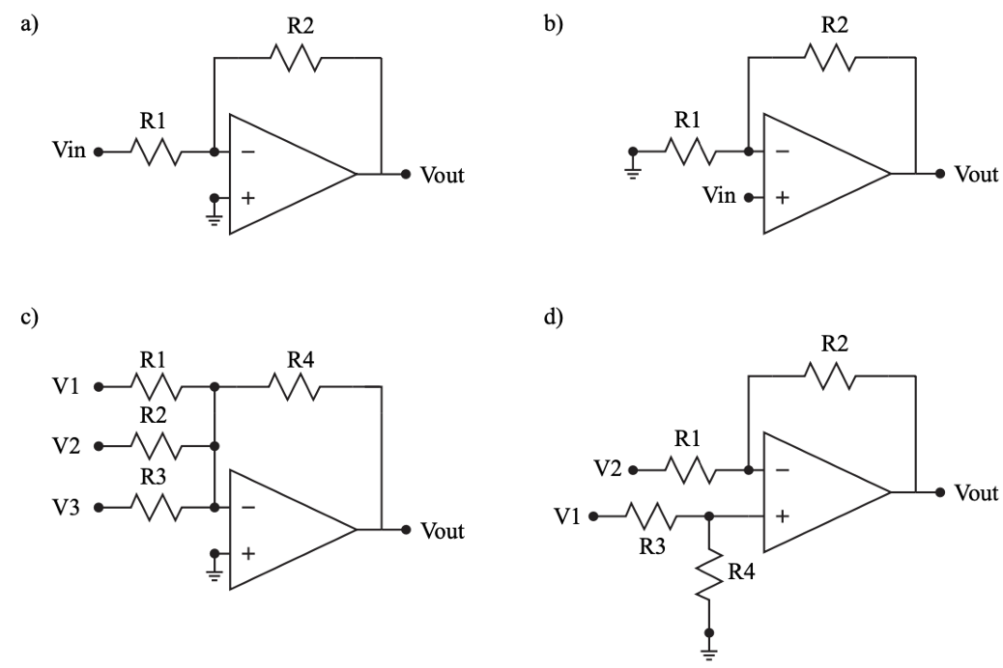
Figure 1: Different op amp configurations: inverting amplifier (a), non-inverting amplifier (b), summing amplifier (c), and difference amplifier (d).
$$V_{out}=-\left(\frac{R_{4}}{R_{1}}V_{1}+\frac{R_{4}}{R_{2}}V_{2}+\frac{R_{4}}{R_{3}}V_{3}\right) (6.1)$$
When the resistors R₁, R₂, R₃, and R₄ are equal, the output voltage is an equal combination of the input voltages. However, the resistors can be adjusted to assign different weights to the input voltages based on the application.
Difference Amplifier
Difference amplifiers, Figure 6.1 (d), takes the difference between two input voltages, with the output determined by the resistor value ratios.
$$V_{out}=V_{1}\left(\frac{R_{2}}{R_{1}{+R}_{2}}\right)\left(\frac{R_{3}+R_{4}}{R_{3}}\right)-V_{2}\frac{R_{4}}{R_{3}} (6.2)$$
When the resistors R₁ = R₃ and R₂ = R₄ the output voltage simplifies to:
$$V_{out}=\left(V_{1}-V_{2}\right)\frac{R_{2}}{R_{1}} (6.2)$$

Big Picture
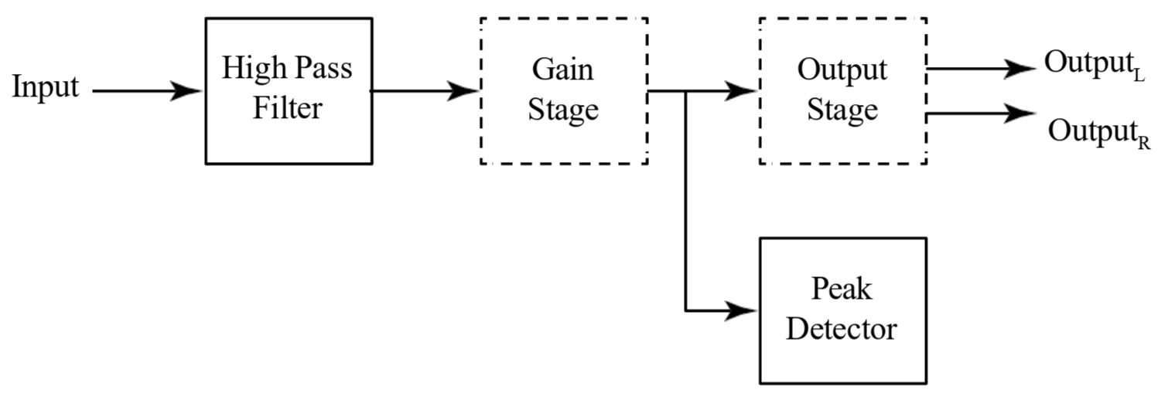
Figure 2: Big picture with emphasis on the gain and output stages.
This lab once again focuses on op amps, using them as building blocks to create more complicated circuits. The final project is about as complicated as the final circuit in this lab.

Pre-Lab Requirements
Complete the following before coming to lab.

Buffering
Buffering is a key op amp application that addresses loading effects, which resistive circuits cannot easily solve. Op amp buffers provide high input impedance and low output impedance, preserving signal integrity across various applications.
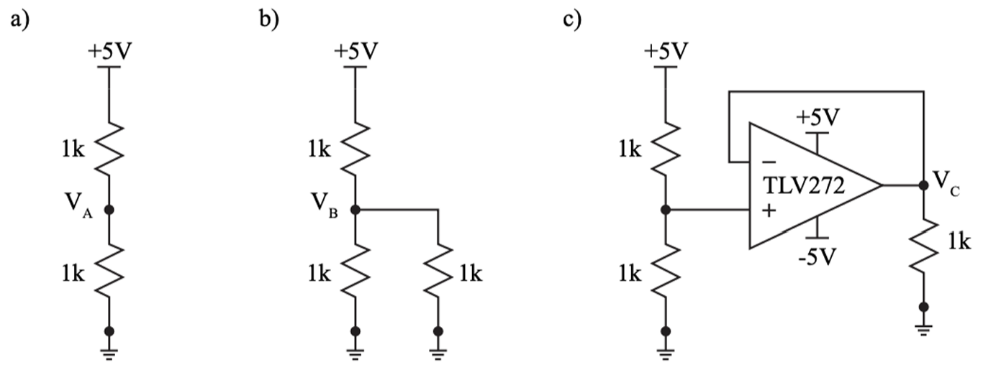
Figure 3: A simple voltage divider (a), voltage divider with a load (b), and a voltage divider with a voltage follower between the output and the load (c).
- Simulate all three circuits in Figure 6.3 using a DC operating point (.op). Keep all the circuits on the same schematic and table the voltages V_{A}, V_{B}, and V_{C}. Table your values and include images of your circuits.
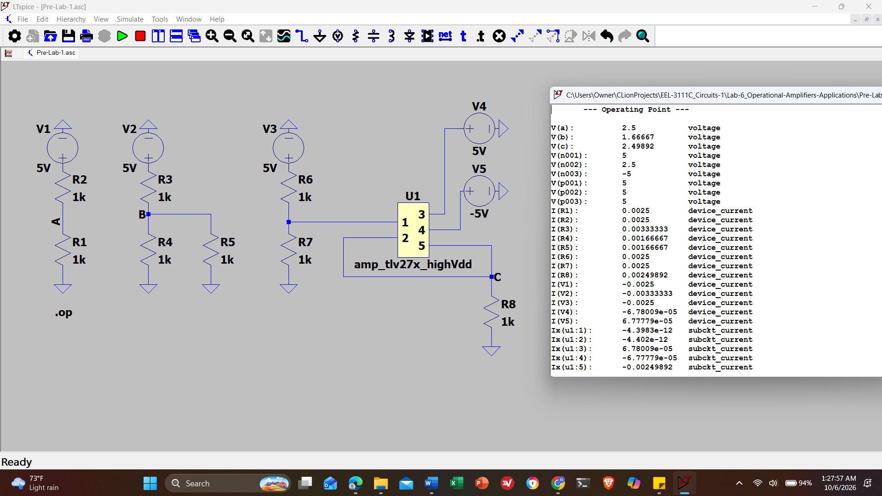
Screenshot 1: All three circuits in Figure 6.3 using a DC operating point (.op).
Node | Expected Voltage (V)
V_{A} | 2.50000
V_{B} | 1.66667
V_{C} | 2.49892
Table 1: Tabled Values of Figure 6.3 LTspice circuits
- Discuss why two of the voltages are approximately 2.5 V but one is not.
The Voltages V_{A} and V_{C} are about 2.5V because V_{A} is a perfect unloaded divider, and V_{C} is buffered by the op-amp, which draws negligible current and prevents the 1k load from pulling down the voltage. V_{B} is 1.67 V because the 1kΩ load is parallel with the bottom 1kΩ resistor of the divider, creating an equivalent resistance of 500Ω and so it draws more current from the top half of the divider.

Level Shifting
Level shifting in electronic circuits is the process of changing the supply rails from one range to another. For example, when preparing a signal for analog to digital conversion, the signal may be bi-polar (+/-) and must be converted to a single voltage rail. So, instead of a sine wave that swings to +2.5V and -2.5V, 2.5V is added so that the sine wave swings from +5V to 0V with the same amplitude.
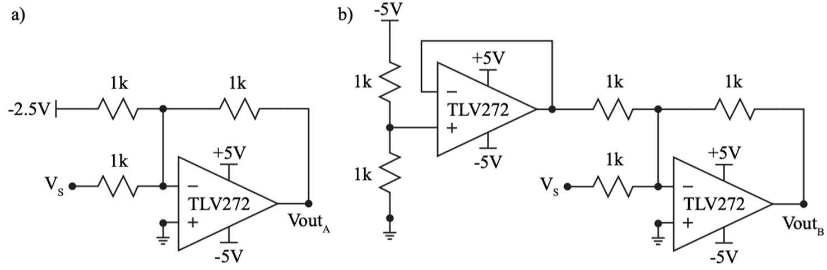
Figure 4: A summing amplifier used to add 2.5V to −VIN (a) and the same configuration where the -2.5V source has been replaced with a buffered voltage divider (b).
- Simulate the circuit in Figure 6.4 (a) using a transient analysis with a stop time of 1m (.tran 1m). Set V_{S} to a sine wave with a 0 V DC offset, 2 V amplitude, and a 1 kHz frequency. Save an image of the circuit and a plot of the input and output voltage.
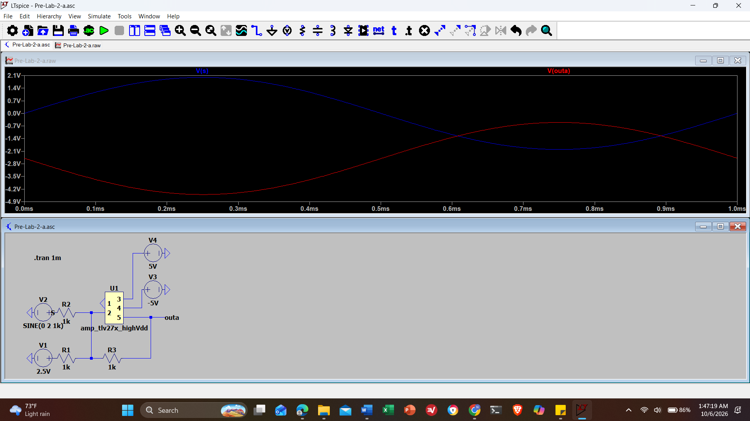
Screenshot 2: Figure 6.4 (a) using a transient analysis with a stop time of 1m (.tran 1m) with plotted input and output voltages
- Explain why the resistor divider in Figure 6.4 (b) uses -5 V instead of 5 V.
The resistor divider in Figure 6.4 (b) uses -5V instead of 5V because the circuit is an inverting summing amplifier configuration. In order to have a positive DC shift at the output, a negative reference voltage must be fed into the inverting input.
- Practically, a 2.5 V reference may not be available for use and instead must be selfgenerated. Simulate the circuit in Figure 6.4 (b) using a transient analysis with a stop time of 1m (.tran 1m). Set V_{S} to a sine wave with a 0 V DC offset, 2 V amplitude, and a 1 kHz frequency. Save an image of the circuit and a plot of the input and output voltage.
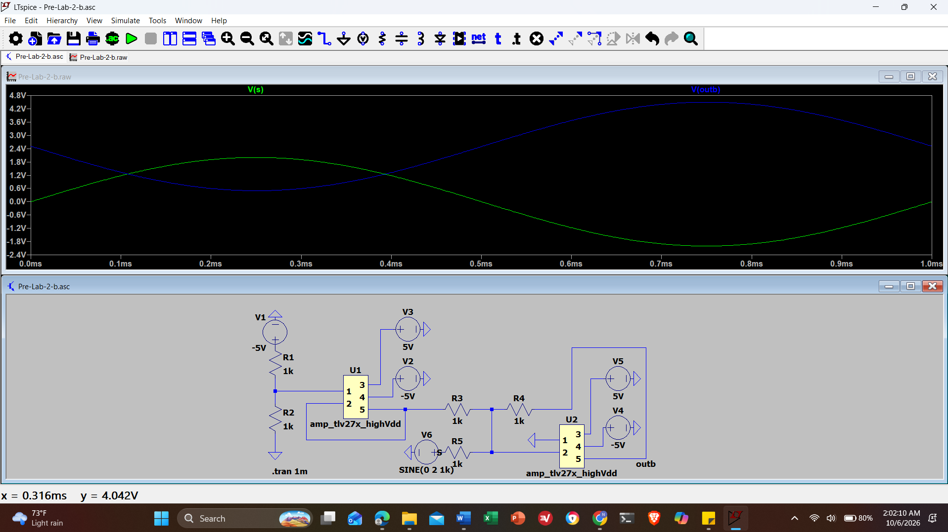
Screenshot 3: Figure 6.4 (b) using a transient analysis with a stop time of 1m (.tran 1m). Set V_{S} to a sine wave with a 0 V DC offset, 2 V amplitude, and a 1 kHz frequency with plotted input and output voltages.
- Construct the circuit in Figure 6.4 (b) on a breadboard. Configure the Wavegen to generate a sine wave at 1 kHz with a 2 V amplitude and a 0 V offset. Plot the input and output on the Scope and save the circuit to demo at the start of lab. If you see clipping at your output, change the three 1kΩ resistors in the summing op amp to 33kΩ.
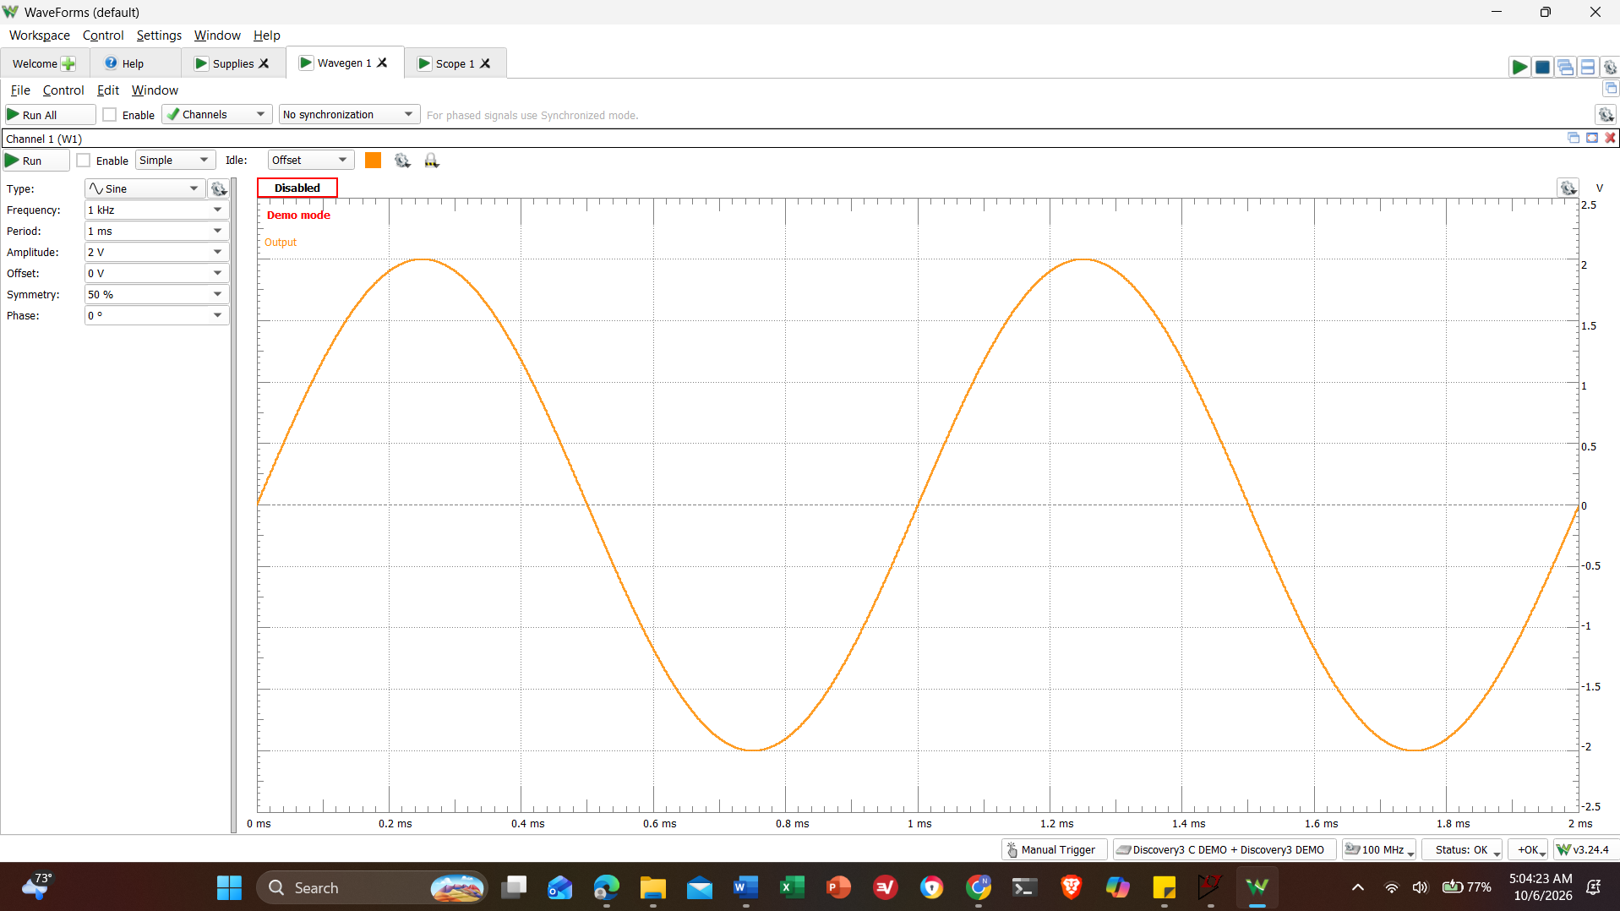
Screenshot 4: Figure 6.4 (b) on a breadboard. Configure the Wavegen to generate a sine wave at 1 kHz with a 2 V amplitude and a 0 V offset. Wavegen Window
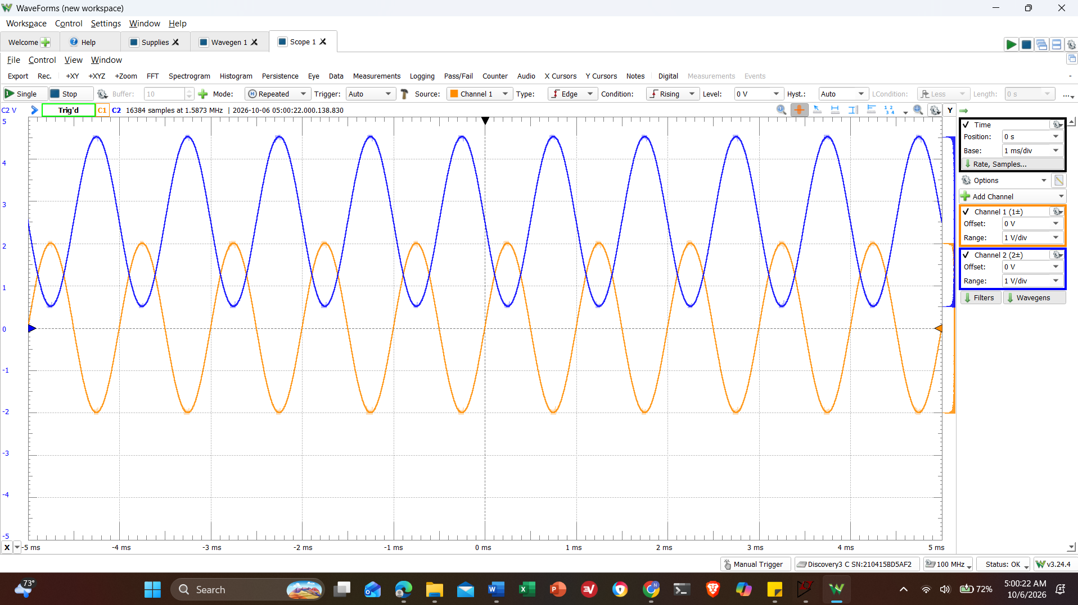
Screenshot 5: Figure 6.4 (b) on a breadboard. Configure the Wavegen to generate a sine wave at 1 kHz with a 2 V amplitude and a 0 V offset. CH1 is input CH2 is output
- In the more general case, the full range of input must be accounted for. Simulate the circuit in Figure 6.5 using a transient analysis with a stop time of 1m (.tran 1m). Set V_{IN} to a sine wave with a 0 V DC offset, 5 V amplitude, and a 1 kHz frequency. Save an image of the circuit and a plot of the input and output voltage.

This circuit uses 3 op amps to convert a +/- 5 V sine wave into a +5/0 V sine wave. The top op amp generates a -2.5 V offset, while the bottom op amp buffers half of the input voltage. Both outputs are then fed into an (inverting) summing op amp to produce V_{outB}. In short, this circuits adds -2.5 V to half of a +/-5 V sine wave, then inverts it to obtain:
$$-\left[\left(\frac{-5}{2}\right)+\left(-2.5\right)\right]=5V and-\left[\left(\frac{5}{2}\right)+\left(-2.5\right)\right]=0V$$
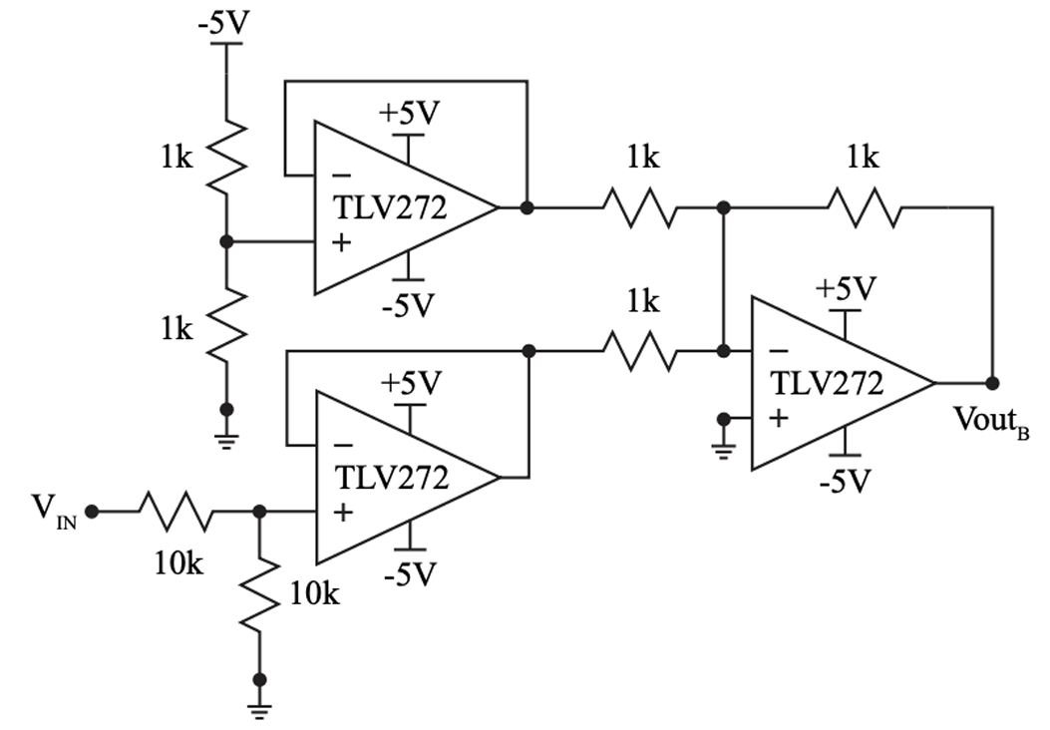
Figure 5: A DC level shifter configured to convert the full range of +/-5 V to +5/0 V.
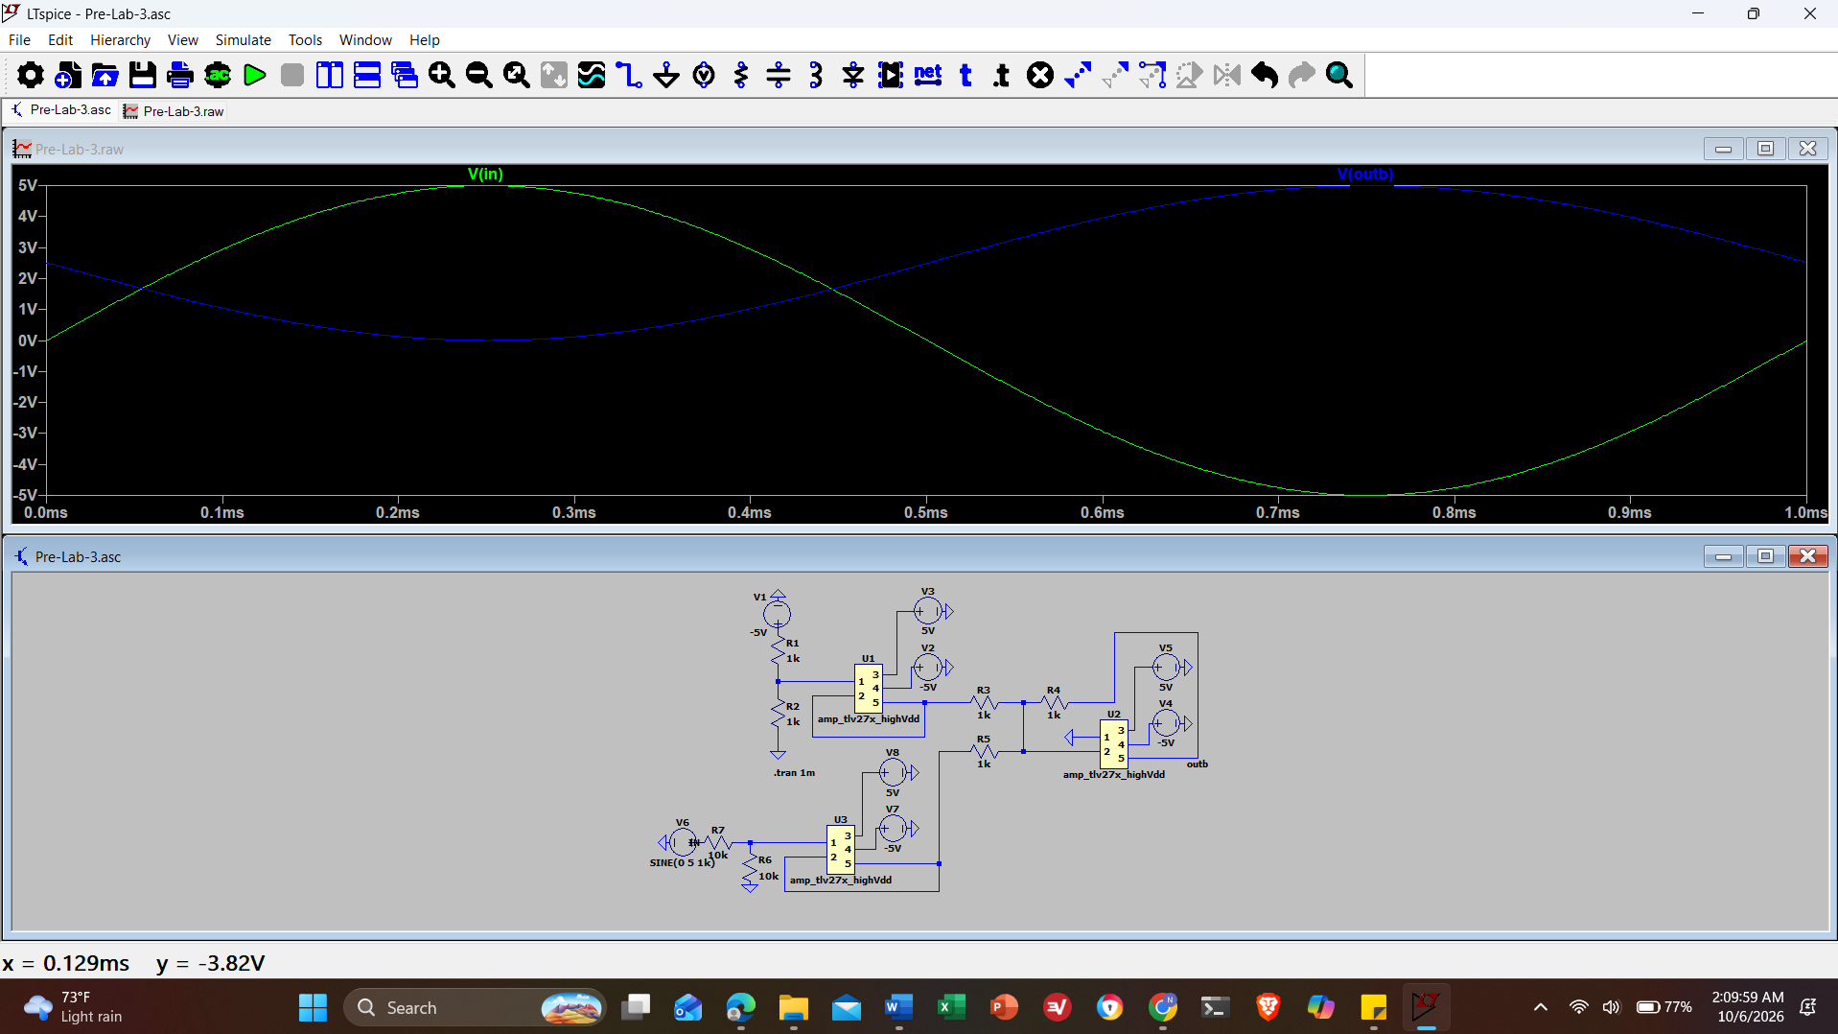
Screenshot 6: Figure 6.5 using a transient analysis with a stop time of 1m (.tran 1m). Set V_{IN} to a sine wave with a 0 V DC offset, 5 V amplitude, and a 1 kHz frequency with plotted input and output voltages

Differential to Single Ended Conversion
Differential signals, which are two signals 180 degrees out of phase, offer improved noise performance because any interference affecting both signals in the same way cancels out when they are combined. In other words, only the difference between the signals is measured, removing unwanted noise. A difference amplifier can be used to convert the differential signal into a single-ended output.
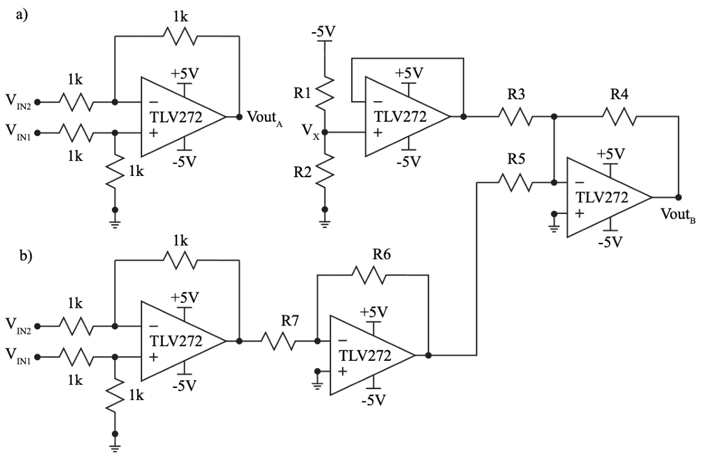
Figure 6: A difference amplifier that converts a differential signal to single ended (a) and a combination of the level shifter and differential to single ended converter (b).
- Simulate the circuit in Figure 6.6 (a) using a transient analysis with a stop time of 1m (.tran 1m). Set V_{IN1} to a sine wave with a 0 V DC offset, 0.5 V amplitude, and a 1k Hz frequency. Set V_{IN2} to a sine wave with a 0 V DC offset, 0.5 V amplitude, a 1k Hz frequency, and a phase of 180 degrees. Save an image of the circuit and a plot of V_{IN1}, V_{IN2}, and V_{outA}.
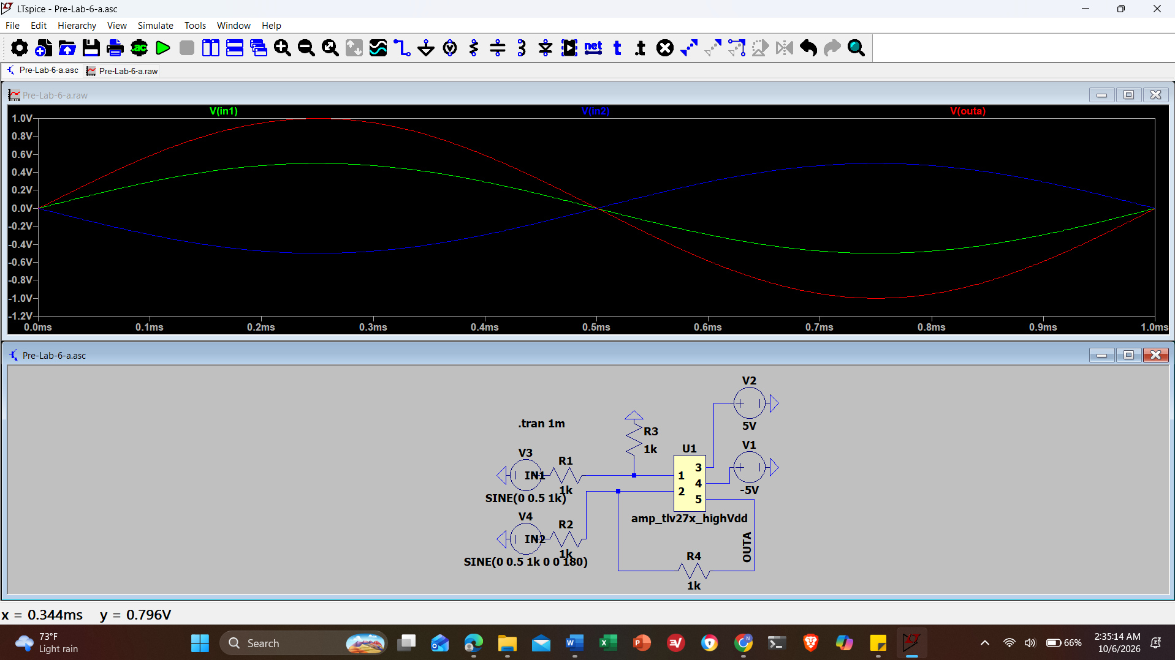
Screenshot 7
- Determine the resistor values for R₁ through R₇, recall that there are limited quantities in the lab kit. Choose R₁ and R₂ so that V_{X} is 2.5 V, R₃, R₄, and R₅ so that both voltages are added equally, and R₆ and R₇ so that the output, V_{outB} utilizes as much of the full range, 0 to 5 V, as possible without clipping. You do not need to use resistors in parallel/series combinations to get an exact value.
R₁ = 10kΩ, R₂ = 10kΩ, R₃ = 33kΩ, R₄ = 33kΩ, R₅ = 33kΩ, R₆ = 2.2kΩ, R₇ = 1kΩ.
R₁ and R₂:
$$V_{X}=-5V\left(\frac{R_{2}}{R_{1}+R_{2}}\right)=> -2.5V= -5V\left(\frac{R_{2}}{R_{1}+R_{2}}\right)=>R_{1}= R_{2}$$
R₃, R₄, R₅:
$$V_{out}=-R_{f}\left(\frac{V_{1}}{R_{IN1}}+\frac{V_{2}}{R_{IN2}}\right)=>\frac{R_{f}}{R_{IN}}=1$$
Values R₃₋₅ must be greater than 1kΩ to avoid clipping.
R₆ and R₇:
$$V_{out}=V_{in} \frac{R_{f}}{R_{in}}$$
- Simulate the circuit in Figure 6.6 (b) using a transient analysis with a stop time of 1m (.tran 1m). Set V_{S1} and V_{S2} to their previously defined values. Save an image of the circuit and a plot of V_{IN1}, V_{IN2}, and V_{outB}.
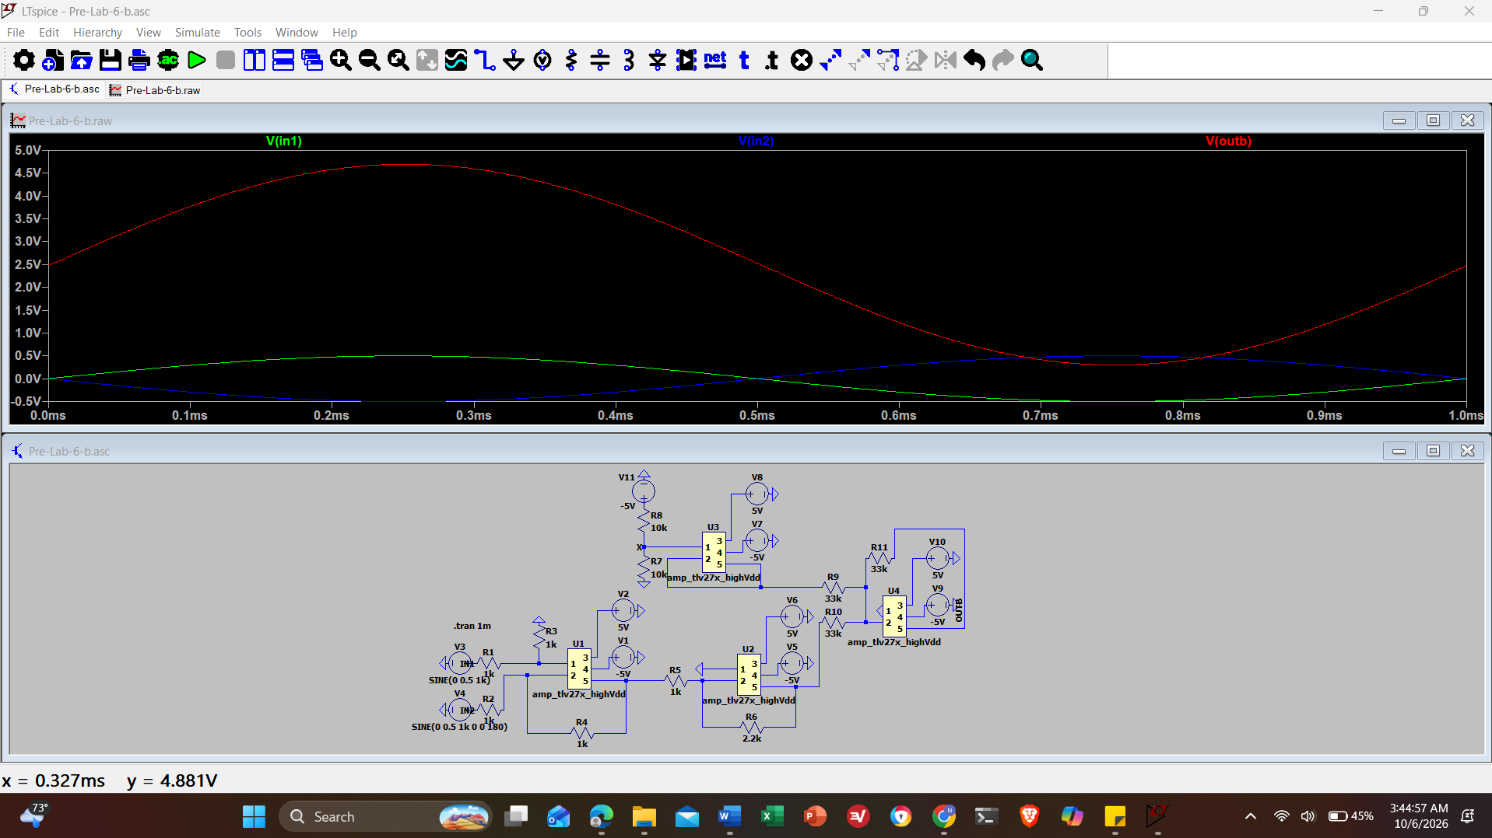
Screenshot 8: Figure 6.6 (b) using a transient analysis with a stop time of 1m (.tran 1m) with inputs and output plotted
- Explain how the circuit in Figure 6.6 (b) works in a few sentences, discussing the purpose of each op amp.
The first op-amp in the bottom left takes the two different input signals and outputs the voltage difference between them to convert the differential signal into a single-ended signal while rejecting noise. The next op-amp in the bottom middle takes the single-ended output from the difference amplifier and applies a gain based on the R₆ to R₇ ratio to amplify the AC signal amplitude so the output has a 0V-5V range without clipping. The next op-amp in the top middle is a voltage buffer configured as a voltage follower that is used to isolate the voltage divider network (R₁ and R₂) from the rest of the circuit to provide a stable, high-current DC reference voltage (V_{X}) derived from a -5V supply without loading effects. The final op-amp on the right is an inverting summing amplifier that combines the amplified AC signal from the inverting amplifier and steady DC offset from the voltage buffer to add them together and invert them to produce the final level-shifted output that operates cleanly within the voltage bounds.

Pre-Lab Checklist
The following must be completed at the start of lab.
- Section 6.5.1
  - Item 1: Image of the circuit and a table of output voltages.
  - Item 2: Answer to question.
- Section 6.5.2
  - Item 1: Image of the circuit and a plot of the input and output voltages.
  - Item 2: Answer to question.
  - Item 3: Image of the circuit and a plot of the input and output voltages.
  - Item 4: Plot of the input and output voltages and a circuit demonstration.
  - Item 5: Image of the circuit and a plot of the input and output voltages.
- Section 6.5.3
  - Item 1: Image of the circuit and a plot of the input and output voltages.
  - Item 3: Image of the circuit and a plot of the input and output voltages.
  - Item 4: Answer to question.

In-Lab Requirements
Complete the following in lab.

Construction
- Construct the circuit from Section 6.5.2 Item 5. Set Wavegen 1, V_{IN} to a sine wave with a 5 V amplitude, 0 V offset, and a frequency of 1 kHz.
- Plot the input and output voltages, save an image of the plot. 3. Construct the circuit from Section 6.5.3 Item.
- Set Wavegen 1 to V_{IN1} and Wavegen 2 to V_{IN2}. Synchronize Wavegen 1 and Wavegen 2 using the dropdown in the wavegen tab of waveforms. It is located two tabs to the right of "Run all" and is defaulted to "No synchronization".
- Plot the input (differential) and the output voltages, then save an image of the plot. Typically, scope wire 2 (with the white stripe) is connected to ground because scopes measure voltages relative to another signal. In this case, however, you connect scope wire 1 to Wavegen 1 and scope wire 2 to Wavegen 2, allowing the scope to measure the difference between them.

Write Up
Include the following in the write up.
- Section 6.6.1
  - Item 1: LTspice schematic of the circuit.
  - Item 2: Plot of the input and output voltages.
  - Item 3: LTspice schematic of the circuit with all calculated resistors.
  - Item 4: Plot of the input and output voltages.
Discussion Question: Discuss the two circuits constructed in lab, DC level shifter and differential to single ended converter. Explain how each circuit works at the block level and how resistor tolerance could or could not influence the output. Also explain the design choices for the circuit, Section 6.5.3 Item 3, constructed in lab. Which resistors were chosen and why?
CONCLUSION
fdsfsd

