PROBLEMS ENCOUNTERED
When filling out this template, DELETE all highlighted text before submitting.
Use this template to submit your pre-lab and write-up on Canvas.
For the pre-lab submission, include only the Problems Encountered, Introduction, and Discussion sections, along with your completed work from the lab instructions.
For the write-up submission, expand on your pre-lab by adding your in-lab work. Be sure to revise or correct any parts of the pre-lab as needed to avoid losing points again. In addition, complete the Discussion and Conclusion sections of the document.
The final write-up submission for each lab should be a complete document that includes all your work (prelab + in-lab) for the lab.
As you go through the lab, bullet point any issues you had during the lab, so essentially any parts of the lab you had trouble understanding or getting to work correctly. This is helpful for us in helping you debug your circuits, and for you in fixing any future problems you have when putting the lab modules together for your final project.

INTRODUCTION
In two to four sentences, write a brief but descriptive introduction summarizing the purpose and key concepts of the lab.

DISCUSSION
Guidelines:
- For every value listed, include the appropriate units.
- Include 2-3 significant figures for your values.
- Label and caption all images and tables as shown below.
- The grader should be able to tell that the writer understands the subject material.
- The cleaner everything is organized, the easier it is for your TA to grade.

Objective
The objective of the laboratory is to introduce students to SPICE (Simulation Program with Integrated Circuit Emphasis) and illustrate the differences between real and ideal components.

Materials
- Laptop with LT Spice

Introduction
For the purposes of this class, LTspice (current Windows version is 24.1.0) will be used. It is a free version of spice that’s supported by Linear Technology (recently acquired by Analog Devices). It can be downloaded from Linear Technologies’ website here.
There are useful resources provided in the Lab 3 Canvas folder with Lab 3 tips and LTspice keyboard shortcuts.
If possible, use LTspice on Windows for the best experience. The Mac version looks bare bones compared to the Windows version, but all the same functionalities exist, it’s just hidden in sub menus.
Below are some videos to help you get familiar with the software.
- LT - LTspice IV Overview
- LT - Schematic Editor
- LT - Waveform Viewer
- LT - Stepping Parameters

Pre-Lab Requirements
Install LTspice, work through the tutorials, and complete the following.

Modeling Simple Circuits
A resistor ladder is shown in Figure 3.1.
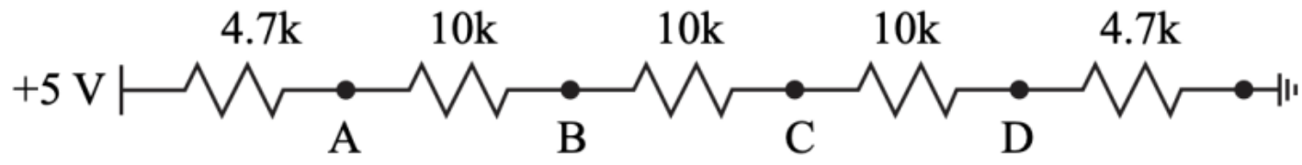
Figure 3.1: Resistor Ladder Example
- Using LTspice, layout the circuit in Figure 3.1 and run a DC operating point simulation (.op) to generate the node voltages at nodes A, B, C, and D. Table the node voltages.
Node | Expected Voltage (V) | Measured Voltage (V) | Percent Error
A |  | 4.40355
B |  | 3.13452
C |  | 1.86548
D |  | 0.596447
Table 1: Node Voltages at Nodes A, B, C, and D
- When measuring the node voltages in real life, an oscilloscope is used. The scope probes have a finite input resistance of 1 MΩ. Re-simulate the node voltages with a 1 MΩ resistor at nodes A through D, Figure 3.2 (a) through (d). There should be a total of 4 simulations with node voltages A through D for each simulation. Table the values.
Node | Expected Voltage (V) | Measured Voltage (V) | Percent Error
A |  | 4.3854
B |  | 3.1216
C |  | 1.85779
D |  | 0.593988

Node | Expected Voltage (V) | Measured Voltage (V) | Percent Error
A |  | 4.3944
B |  | 3.1059
C |  | 1.84845
D |  | 0.591

Node | Expected Voltage (V) | Measured Voltage (V) | Percent Error
A |  | 4.40031
B |  | 3.12438
C |  | 1.84845
D |  | 0.591

Node | Expected Voltage (V) | Measured Voltage (V) | Percent Error
A |  | 4.40322
B |  | 3.13348
C |  | 1.86373
D |  | 0.593988

- Save the tabled values to submit to Canvas as part of the pre-lab.
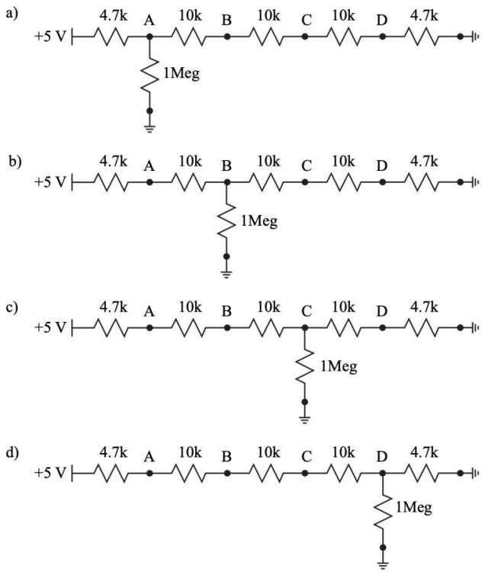
Figure 3.2: Resistor ladder with a 1 MΩ resistor attached at nodes A through D ((a) through (d)).

LTspice Variables
There is clearly an effect caused by the input resistance of the oscilloscope, often called the “loading effect”. Using LTspice, quantify the effect as a function of resistance by completing the following:
- Layout the circuits in Figure 3.3 in LTspice on the same schematic. Use the variable {R} for resistor values, set the source voltage to 5 V DC and label each output node.
- Use the following spice directive in conjunction with a DC operating point simulation (.op) to sweep the resistors in both voltage dividers.
.step param R list 10 100 1k 10k 100k 1Meg 10Meg
- Plot the voltages at Vout1 and Vout2 and set the x axis to logarithmic by right clicking on the x axis. Save the results into a document, include your circuit image and simulation results, which will be submitted to Canvas as part of the pre-lab.
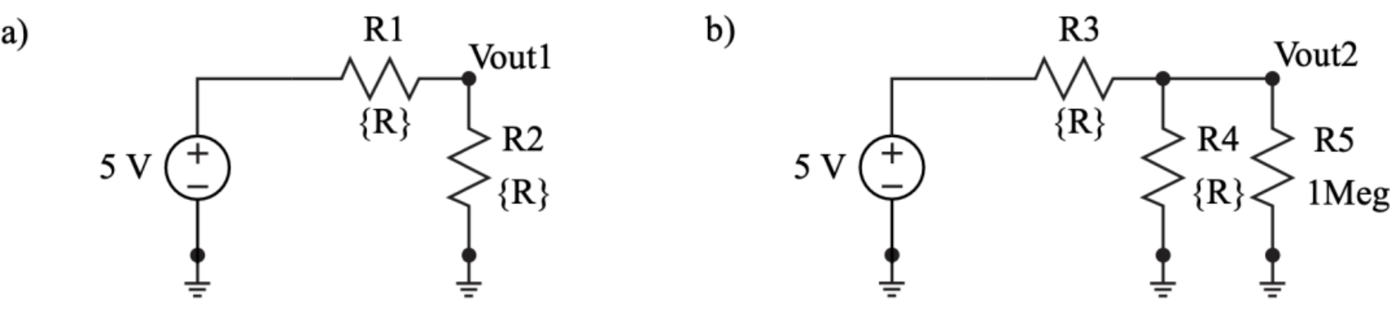
Figure 3.3: Two circuits to test the loading effect of one of the o-scope probes. The first circuit is a simple voltage divider that is not loaded (a) while the second circuit has a 1 MΩ resistor in parallel with R4 (b).

Monte Carlo Simulations
Resistors have tolerances for their values which can vary from 10% for generic through hole resistors to as low as 0.005% for laser trimmed resistors. There is never a guarantee that a resistor has a resistance exactly equal to its value.
LTspice has a Monte Carlo function, {mc(x,y)}, that will randomize a number x with a tolerance of y between x*(1+y) and x*(1-y) with a uniform distribution.
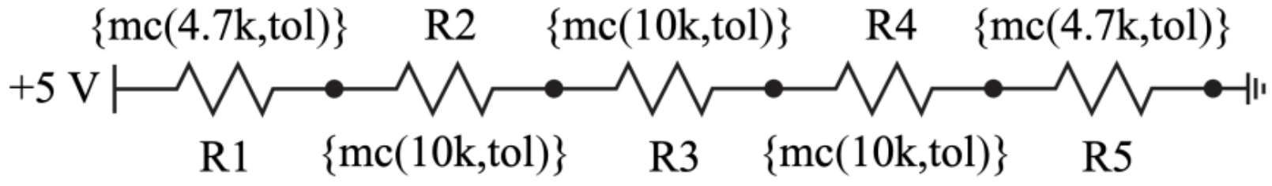
Figure 3.4: Resistor ladder with the values replaced by the LTspice Monte Carlo function.
Complete the following:
- Layout the circuit in Figure 3.4, setting the resistor values to call the mc function.
- Use the following spice directive in conjunction with a DC operating point simulation to randomize all the resistor values for 1000 trials with a 5 percent tolerance using the two directives below.
.param tol=0.05
.step param run 1 1k 1
- Plot all the node voltages, A-D, on separate plot planes in one graph to view how the voltage at each node varies for each trial. Table the voltage ranges (Vmax and Vmin) for each node.
- Save the results into a document, include your circuit image and simulation results, which will be submitted to Canvas as part of the pre-lab. Use " .meas " spice directive to measure the voltage range (Vmax and Vmin) of nodes. To view the node voltages and currents, open the Spice Error Log under the View tab. Depending on your LTspice version, you may have to scroll all the way down to view the values (use the side scrolling bar).

However, if your LTspice “.meas” directive does not work (i.e., the maximum and minimum values display as the same), you will need to manually determine the values. To do this, hover your cursor over the plot panes in the simulation results and read the Y-axis values to identify the maximum and minimum points.

Below is an example of using the “.meas” directive to find the maximum voltage at node A:
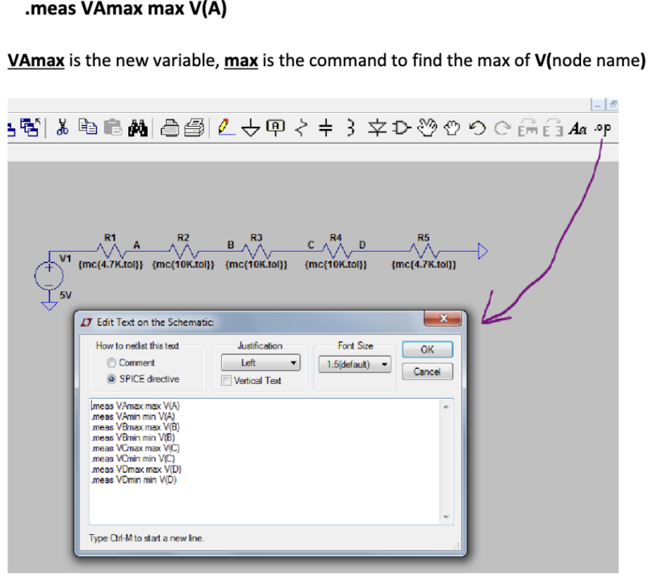
Figure 3.5: Example of using the max measure directive.

In-Lab Requirements
The following must be completed and submitted to Canvas before the start of lab.
- Section 3.4.1 - Tabled voltages (note: four sets for 3.4.1.2).
- Section 3.4.2 - Image of circuit and simulation results.
- Section 3.4.3 - Image of circuit and tabled voltages and simulation results.
Complete the following items in lab.

Equivalent Resistance
An 8-bit R-2R ladder is a digital-to-analog converter (DAC) designed to convert an 8-bit binary input into a corresponding analog voltage. It uses a repeating pattern of resistors with values of R and 2R to create a voltage divider network. The binary input determines which switches in the ladder are activated, generating a proportional analog output. R-2R ladders are widely used in applications requiring accurate and efficient digital-to-analog conversion, such as audio devices and microcontroller-based systems.
When building the below circuit in spice, instead of assigning each resistor value to 470, give them the value " Ra " and create a spice directive " .param Ra=470 ". This will allow you to then change the directive’s value from 470 to 500 afterwards and then rerun it to complete the experiment. This is a much more effective method.
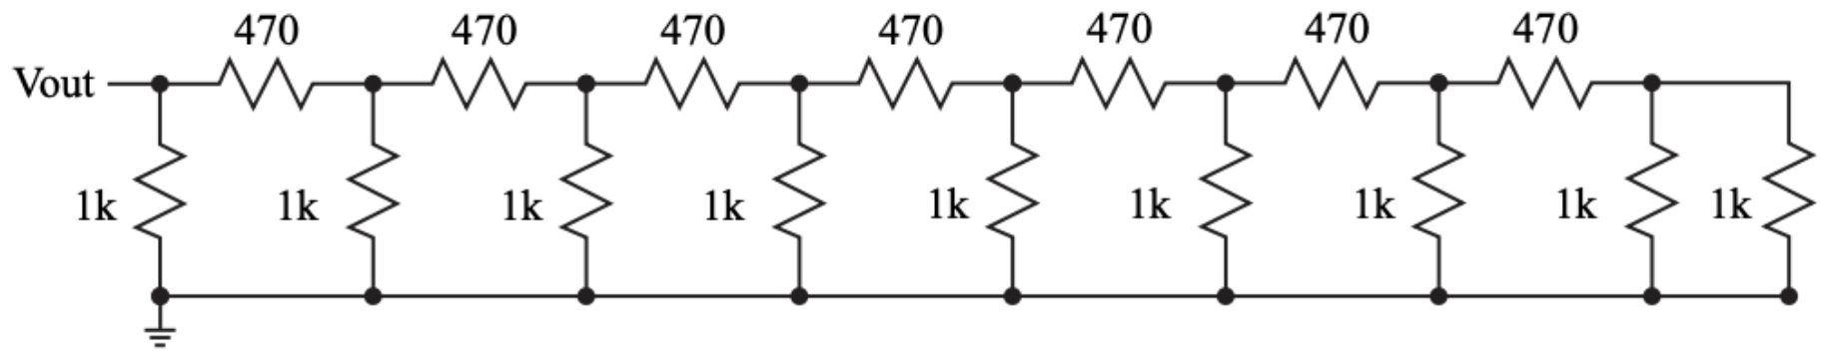
Figure 3.6: An 8-bit R-2R ladder with all the digital input bits tied to ground.
- Using a 1 V test source at Vout run a DC operating point simulation and calculate the equivalent resistance using Ohm’s Law. Save the equivalent resistance value.
- Change 470 Ω resistors to 500 Ω resistors and confirm that the equivalent resistance is 500 Ω.

Monte Carlo with Difference Tolerances
Repeat the Monte Carlo simulations from Section 3.4.3 using the following tolerances. Table the voltage ranges at each node.
- 1%
- 0.05%
- 0.005%

Resistor Costs
While tighter resistor tolerances are desirable for improved accuracy, they often come at a higher cost. Using DigiKey, determine the lowest total cost of constructing the 8-bit R-2R ladder shown in Figure 3.6, considering only the cost of resistors (500 Ω and 1 kΩ). Use the price listed for a quantity of 1 for each resistor. Search for Through Hole Resistors, in-stock, 0.25 Watt for the tolerances listed below: (If the item is out of stock, you may use another website such as Mouser.)
- 1%
- 0.1%
- 0.05%

Write Up
Include the following in the write up (use the report template file in Canvas).
- Two equivalent resistor values from Subsection 3.5.1.
- Table of voltage ranges from Subsection 3.5.2.
- Table of cost ranges from Subsection 3.5.3.
Expected Voltage (V) | Measured Voltage (V) | % Error
5.00 | 4.87 | 2.6
4.50 | 4.26 | 5.3
Table 2: Node voltages and the percentage error of the circuit. (Table is here as an example. Include units, and titles as needed for each section).

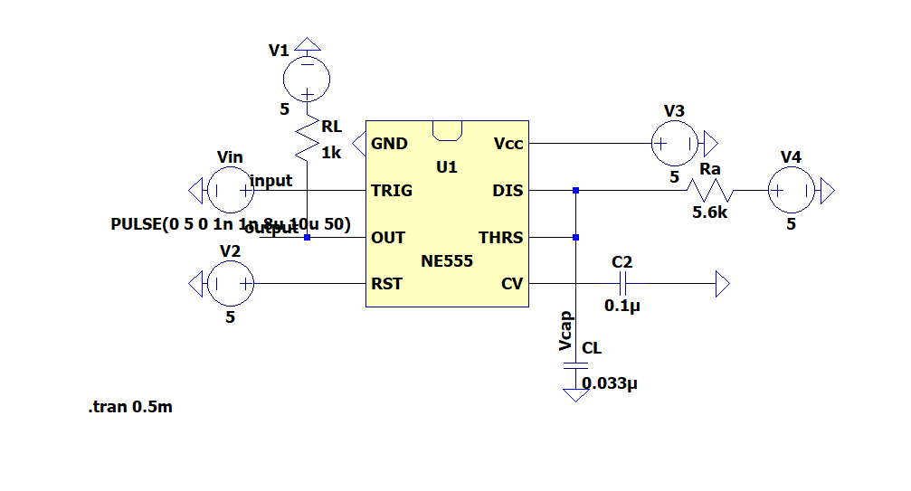
Figure 7: Mono-stable circuit of NE555 Timer. (Example circuit used to demonstrate how to include images in the template. Include a short description of the circuit).

Discussion Question: Discuss the impact of resistor variations on the R-2R ladder, including their influence on node voltages and overall equivalent resistance accuracy. Additionally, evaluate the tradeoffs between using resistors with tighter tolerances and their associated costs. Are there other characteristics that should be considered when buying components? If yes, list and discuss them.

CONCLUSION
sdsas

