**REQUIREMENTS NOT MET**

N/A

**PROBLEMS ENCOUNTERED**

N/A

**HOMEWORK EXERCISES**

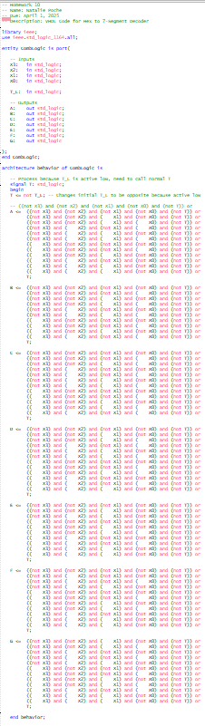

Figure : Homework 10 - VDHL of Code for Combinational Logic Block for Hex to 7-Segment Decoder

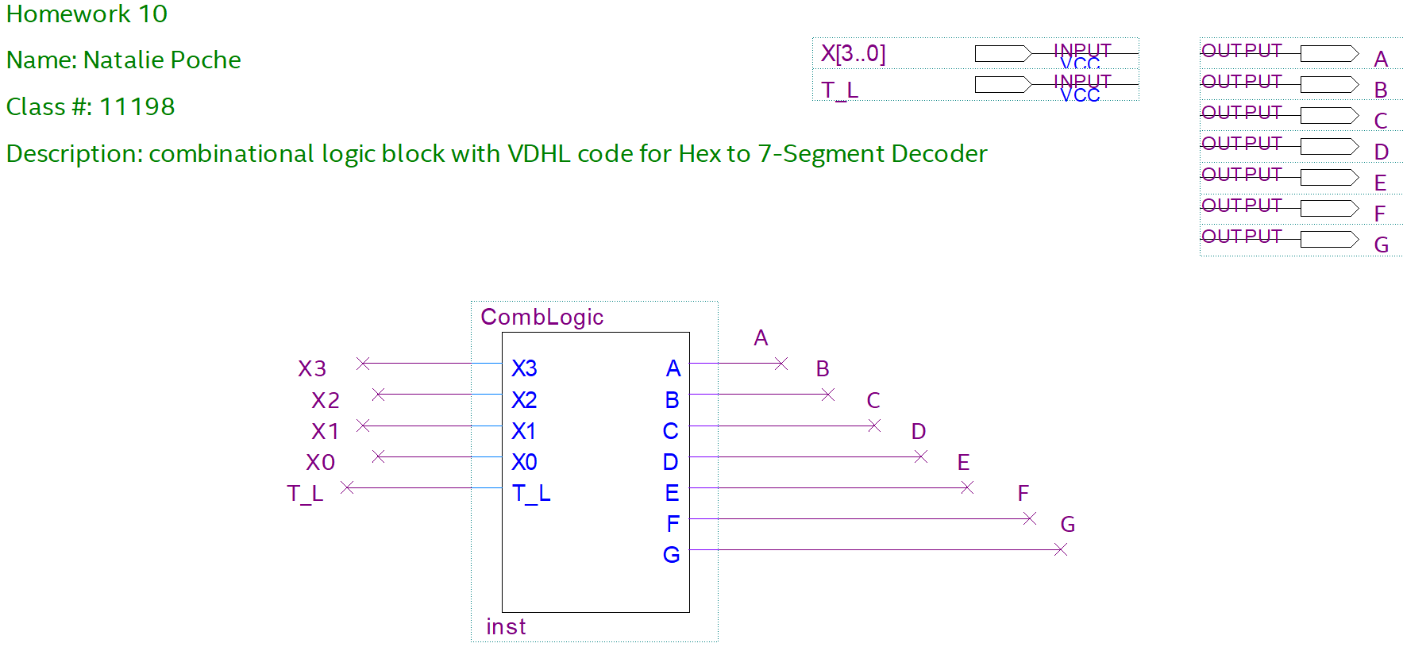Figure : Homework 10 - BDF of Combinational Logic Block for Hex to 7-Segment Decoder

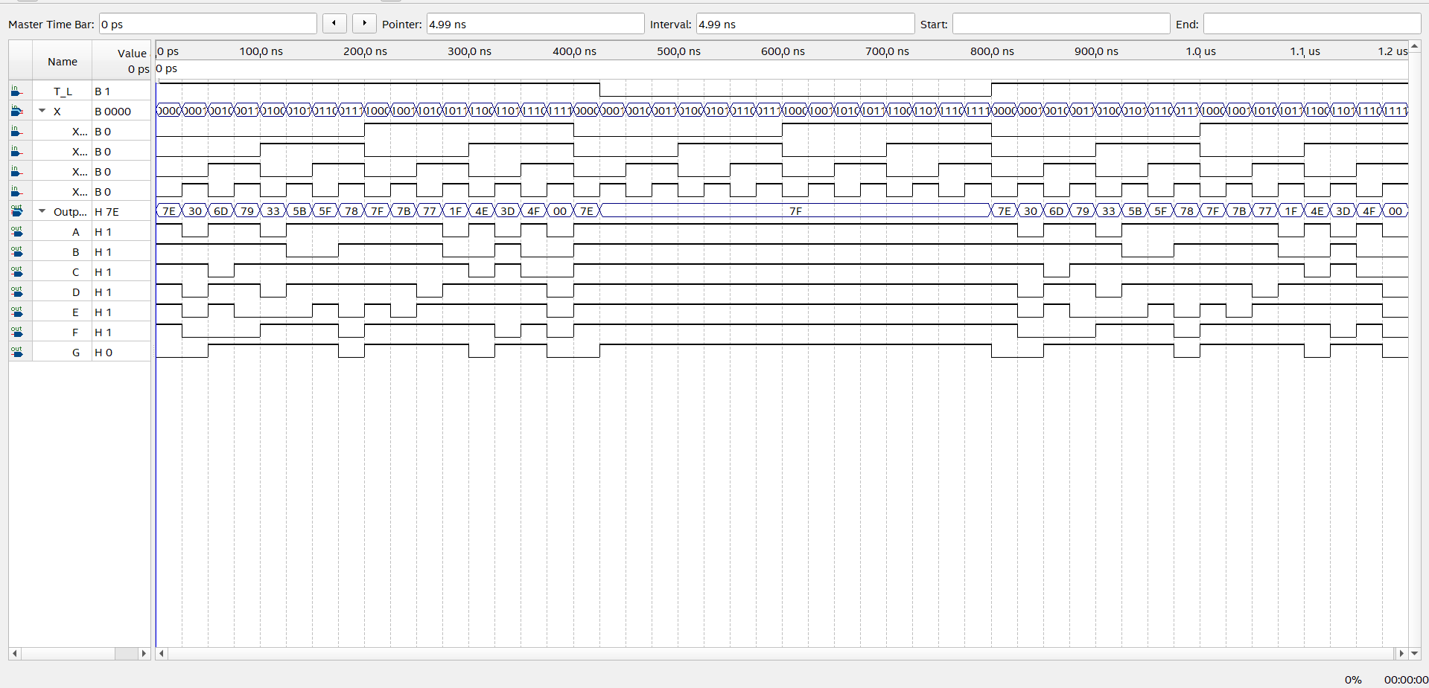

Figure : Homework 10 - Functional Simulation of Hex to 7-Segment Decoder