**REQUIREMENTS NOT MET**

N/A

**PROBLEMS ENCOUNTERED**

Had trouble with the De10 and DAD connecting to my computer, additionally had problems initially figuring out how to connect the DAD and De10. Additionally, have issues with 74’02 where it gave opposite outputs.

**HOMEWORK EXERCISES**

1. Complete Exercises in DAD WaveForms Tutorial
   1. Exercise 1: Simple Circuit using Switches and LEDs

|  |  |  |
| --- | --- | --- |
| **A** | **B** | **C** |
| 0 | 0 | 1 |
| 0 | 1 | 0 |
| 1 | 0 | 0 |
| 1 | 1 | 0 |

Table : Exercise 1 - NOR Gate Truth Table, C = /(A + B)

|  |  |  |
| --- | --- | --- |
| **A(H)** | **B(H)** | **C(H)** |
| L | L | H |
| L | H | L |
| H | L | L |
| H | H | L |

Table : Exercise 1 - NOR Gate Voltage Table, C = /(A + B)

|  |
| --- |
|  |

Table : Exercise 1 - Static I/O Results from NOR Gate

* 1. Exercise 2: Pattern Generator

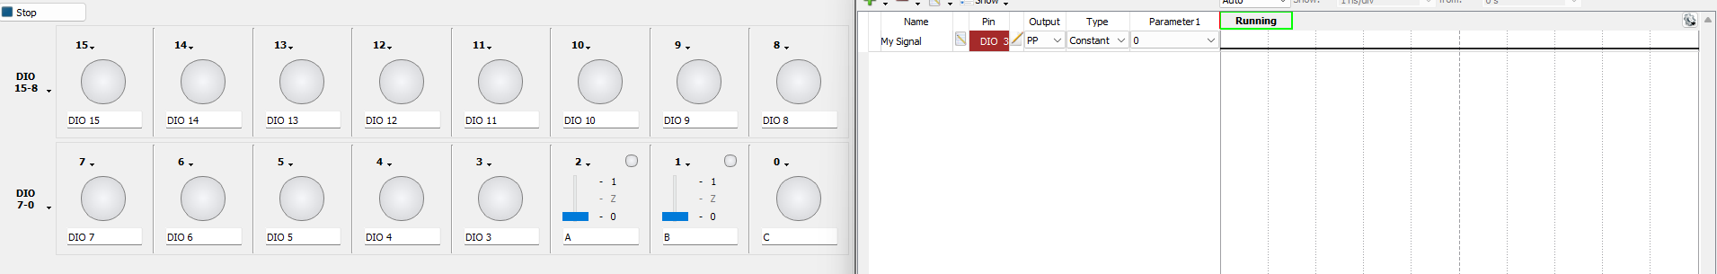

Table : Exercise 2 - Results from Pattern Generator Input 0

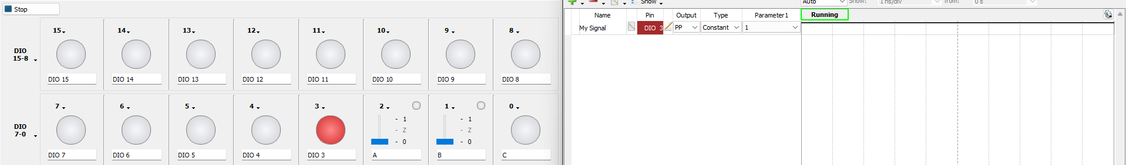

Table : Exercise 2 - Results from Pattern Generator Input 1

* 1. Exercise 3: Buses

|  |  |  |
| --- | --- | --- |
| **A** | **B** | **C** |
| 0 | 0 | 1 |
| 0 | 1 | 0 |
| 1 | 0 | 0 |
| 1 | 1 | 0 |

Table : Exercise 3 - NOR Gate Truth Table, C = /(A + B)

|  |  |  |
| --- | --- | --- |
| **A(H)** | **B(H)** | **C(H)** |
| L | L | H |
| L | H | L |
| H | L | L |
| H | H | L |

Table : Exercise 3 - NOR Gate Voltage Table, C = /(A + B)

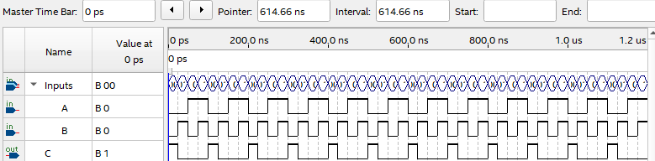

Table : Exercise 3 - Quartus Functional Simulation of NOR Gate

* 1. Logic Analyzer

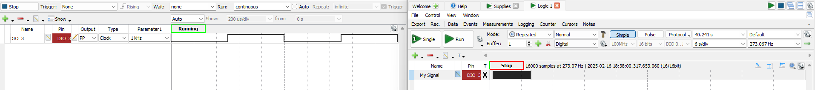

Table : Logic Analyzer for Output 3

* 1. Setting Up a Bus

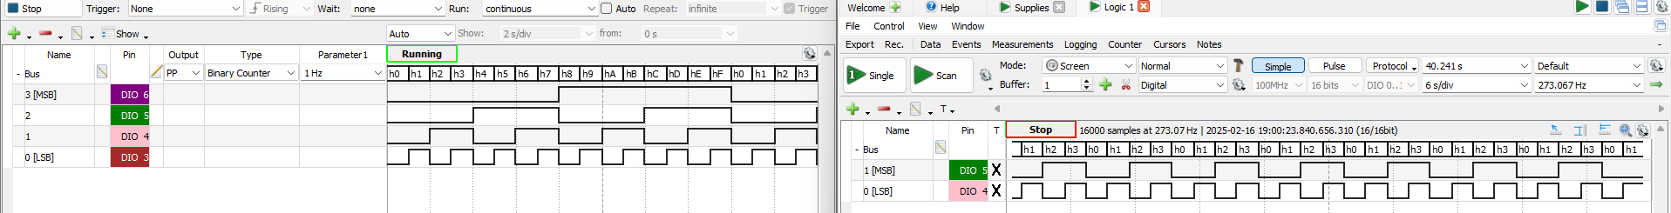

Table : Exercise 4 - Pattern Generator in Binary Count and Logic Analyzer with no Clock or Enable

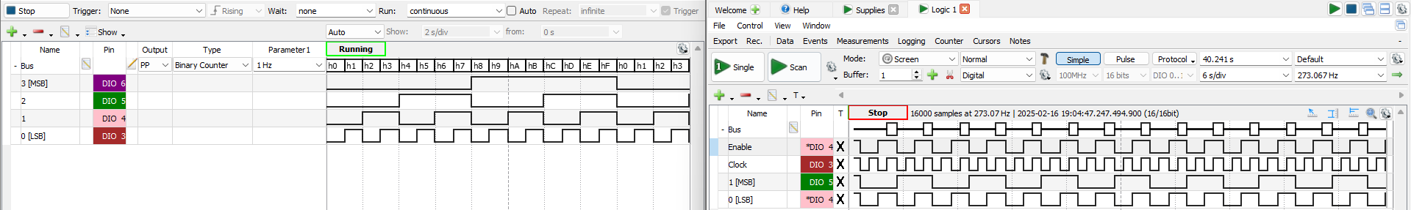

Table : Exercise 4 - Pattern Generator in Binary Count and Logic Analyzer with Clock DIO4 High and Enable DIO3 Rising

* 1. Pattern Generator Bus and Logic Analysis Bus

|  |  |  |
| --- | --- | --- |
| **A** | **B** | **C** |
| 0 | 0 | 1 |
| 0 | 1 | 0 |
| 1 | 0 | 0 |
| 1 | 1 | 0 |

Table : NOR Gate Truth Table, C = /(A + B)

|  |  |  |
| --- | --- | --- |
| **A(H)** | **B(H)** | **C(H)** |
| L | L | H |
| L | H | L |
| H | L | L |
| H | H | L |

Table : NOR Gate Voltage Table, C = /(A + B)

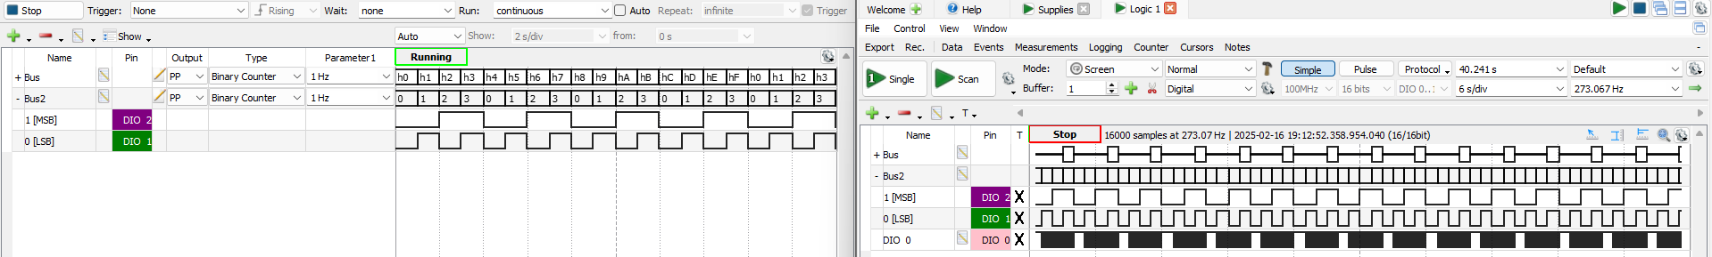

Table : Logic Analysis of NOR Gate

* 1. Kk;l

1. Quartus
   1. 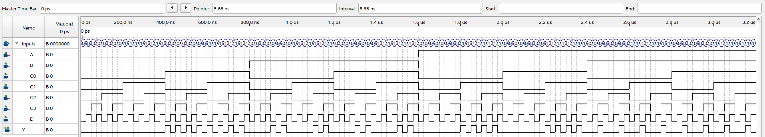

Table : Quartus Functional Smulation of MUX

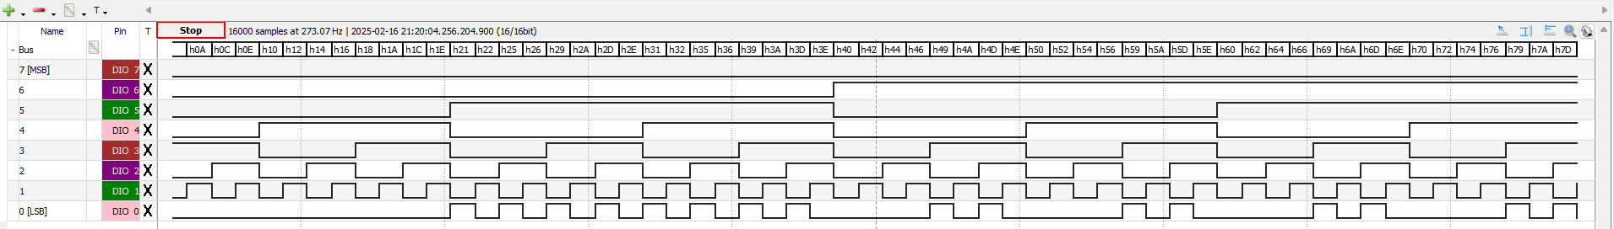

Table : WaveForm Logic Analysis of MUX

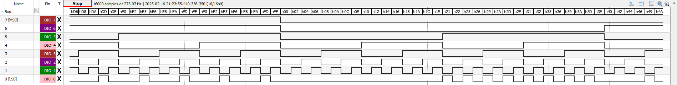

Table : Waveform Logic Analysis of MUX

* 1. 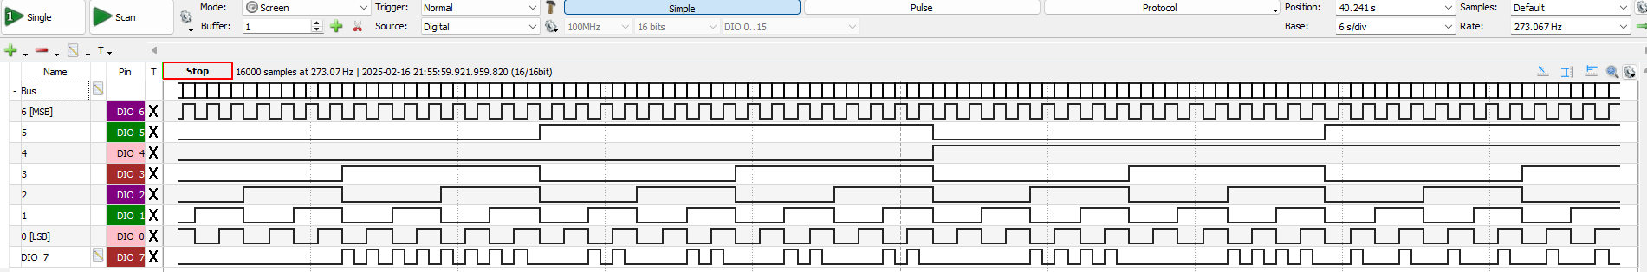

Table : MUX Logic Analysis of MUX with specified inputs

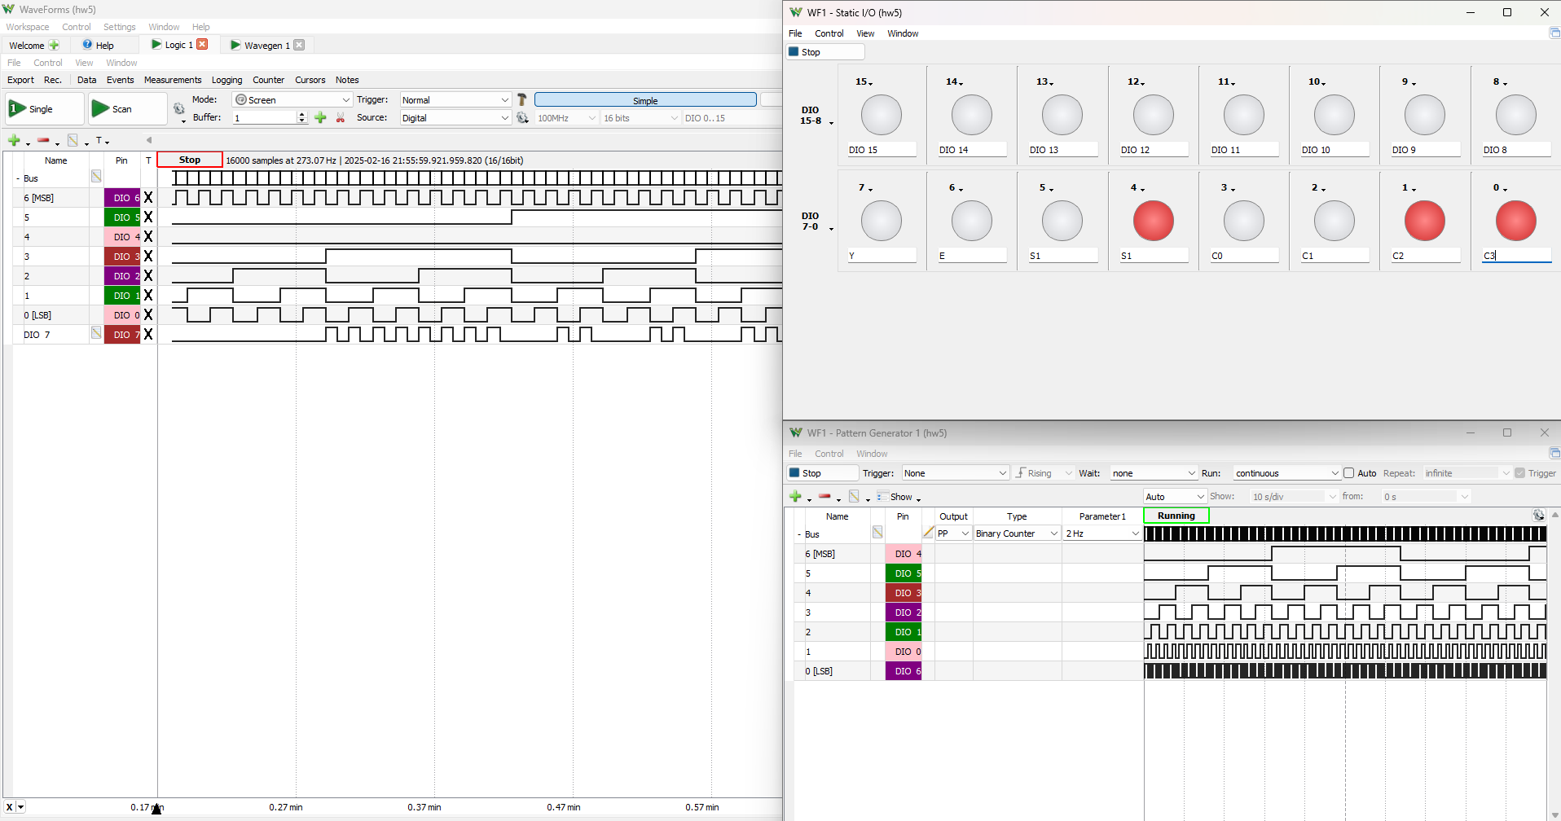

Table : MUX Logic Analysis of MUX with More of the Setup