**REQUIREMENTS NOT MET**

N/A

**PROBLEMS ENCOUNTERED**

N/A

**HOMEWORK EXERCISES**

1. Use a Quartus Simulation to Show that an S-R latch can be made using two NAND gates.
   1. 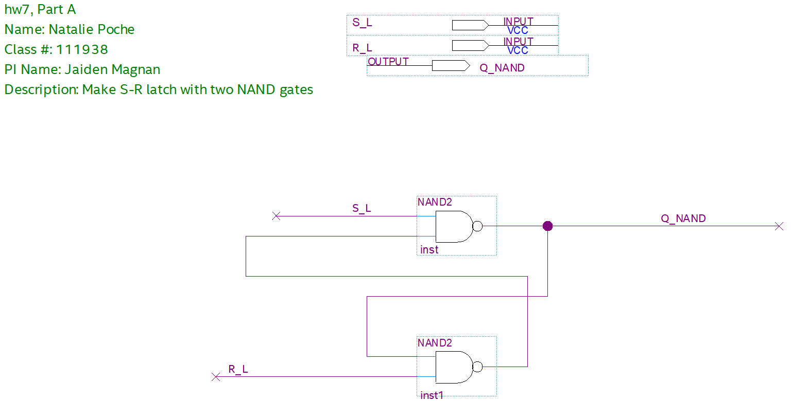

Figure 1: Homework 7 - Part 1: BDF of S-R latch with Two NAND gates

* 1. 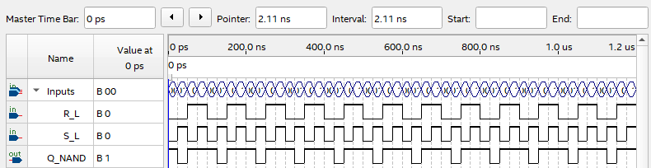

Figure 2: Homework 7 - Part 1: Functional Simulation of S-R latch with two NAND gates

1. Use a Quartus Simulation to Show that an S-R latch can be made using two NOR gates.
   1. 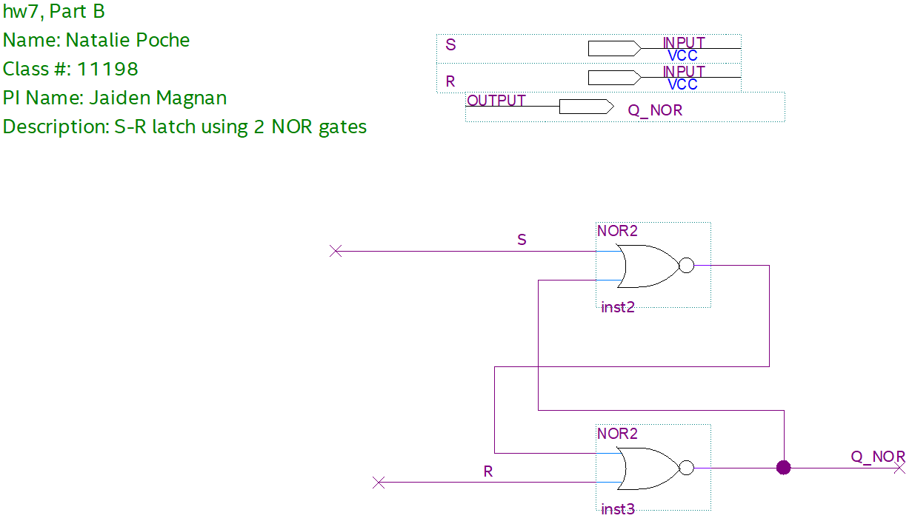

Figure 3: Homework 7 - Part 2: BDF of S-R latch with Two NOR gates

* 1. 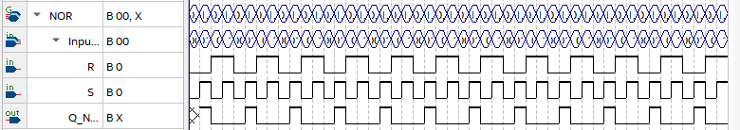

Figure 4: Homework 7 - Part 2: Functional Simulation of S-R latch with Two NOR gates

1. Derive the characteristic equations and excitation tables for each type of flip-flop.

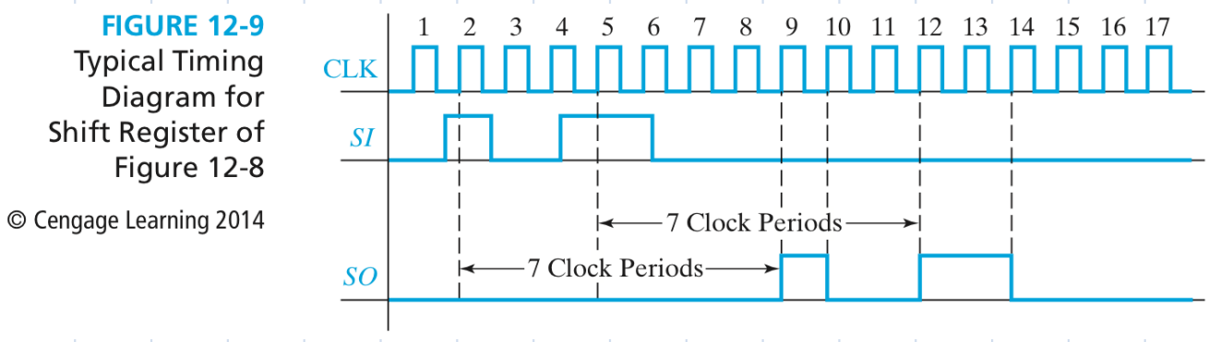

|  |  |  |  |  |  |  |  |  |  |  |  |  |  |  |  |  |  |  |  |  |  |  |  |  |  |  |  |  |  |  |  |  |  |  |  |  |  |  |  |  |  |  |  |  |  |
| --- | --- | --- | --- | --- | --- | --- | --- | --- | --- | --- | --- | --- | --- | --- | --- | --- | --- | --- | --- | --- | --- | --- | --- | --- | --- | --- | --- | --- | --- | --- | --- | --- | --- | --- | --- | --- | --- | --- | --- | --- | --- | --- | --- | --- | --- |
| D Flip Flop   |  |  | | --- | --- | | D | Q+ | | 0 | 0 | | 1 | 1 |   Q+ = D | D-FF Excitation Table   |  |  |  | | --- | --- | --- | | Q | Q+ | D | | 0 | 0 | 0 | | 0 | 1 | 1 | | 1 | 0 | 0 | | 1 | 1 | 1 | | T Flip Flop   |  |  | | --- | --- | | T | Q+ | | 0 | Q | | 1 | /Q |   Q+ = T*/Q + /T*Q | T-FF Excitation Table   |  |  |  | | --- | --- | --- | | Q | Q+ | T | | 0 | 0 | 0 | | 0 | 1 | 1 | | 1 | 0 | 1 | | 1 | 1 | 0 | |
| SR Flip Flop   |  |  |  | | --- | --- | --- | | R | T | Q+ | | 0 | 0 | Q | | 0 | 1 | 0 | | 1 | 0 | 1 |   Q+ = S + /R*Q | SR-FF Excitation Table   |  |  |  |  | | --- | --- | --- | --- | | Q | Q+ | S | R | | 0 | 0 | 0 | X | | 0 | 1 | 1 | 0 | | 1 | 0 | 0 | 1 | | 1 | 1 | X | 0 | | JK Flip Flop   |  |  |  | | --- | --- | --- | | J | K | Q+ | | 0 | 0 | Q | | 0 | 1 | 0 | | 1 | 0 | 1 | | 1 | 1 | /Q |   Q+ = J*/Q + /K*Q | JK-FF Excitation Table   |  |  |  |  | | --- | --- | --- | --- | | Q | Q+ | J | K | | 0 | 0 | 0 | X | | 0 | 1 | 1 | X | | 1 | 0 | X | 1 | | 1 | 1 | X | 0 | |

1. 7th edition Roth Textbook Problem 11.26