AI Use Declaration Form
Course: Introduction to Artificial Intelligence
Lab Title: Lab 1 Part A — Uninformed Search Algorithms
Student Name: ______Natalie Rose Andzie-Mensah____________
Student ID: ____________42502028__________________________________________
GitHub Repository Link: _____https://github.com/natalierose-am/ai-course-lab0.git______
Date Submitted: _________________________5th June, 2026_________________________

1. AI Use Summary
Question | Student Response
Did you use any AI tool for this lab? | Yes
Estimated percentage of the work influenced by AI | 20%
Did you attach evidence of AI use where applicable? | Yes

2. Details of AI Use
Complete the table below for each AI tool used. Add more rows where necessary.
Name of AI Tool Used | Purpose for Using the Tool | Prompt or Instruction Given to the Tool | Part(s) of the Work Influenced by the Tool | How I Verified, Edited, or Improved the AI Output
ChatGPT | Assistance in setting up git for Mac | 2.3 Basic Git Workflow Cloning a Repository # Clone an existing repository git clone https://github.com/username/repository-name.git cd repository-name Creating Your First Repository # Create a new directory and initialize Git mkdir lab0-git-practice cd lab0-git-practice git init # Create a README file echo "# Lab 0: Git Practice" > README.md echo "This is my first Git repository for the AI course." >> README.md # Stage and commit the file git add README.md git commit -m "Initial commit: Add README" # Create a .gitignore file for Python echo "__pycache__/" > .gitignore echo "*.pyc" >> .gitignore echo ".DS_Store" >> .gitignore echo "ai_env/" >> .gitignore git add .gitignore git commit -m "Add Python .gitignore" Pushing to GitHub # Create a repository on GitHub first, then: git remote add origin https://github.com/your-username/lab0-git-practice.git git branch -M main git push -u origin main Essential Git Commands Cheatsheet git status # Check repository status git add <file> # Stage changes git add . # Stage all changes git commit -m "message" # Commit with message git push # Push to remote git pull # Pull latest changes git log --oneline # View commit history git diff # See unstaged changes explain this | Setting up the git and understanding the commands | Trial and error of the various commands to see what works best
ChatGPT | Assistance with the exercises | Exercises 4 to 7 | Code | Reprompting to understand the code

3. Attachment of AI Output Evidence
Where required, attach evidence of AI use. Tick all that apply. Add more rows where necessary.
Evidence Type | Attached? (Yes, No, N/A) | File Name
AI-generated draft
Prompt history
Screenshot of AI interaction | Yes | 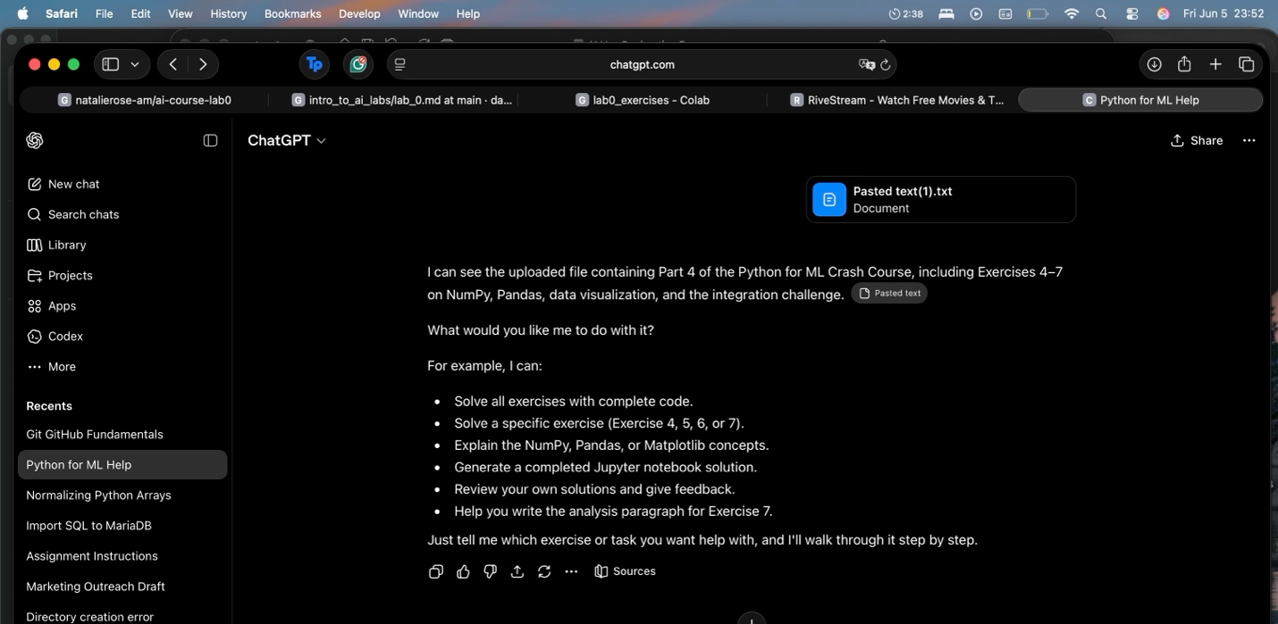
Exported AI conversation
AI-generated code snippet
Revised version showing student input

4. Student Declaration
I declare that:
Declaration Statement | Response (Yes/No)
The submitted work is my own work. | Yes
Any use of AI tools has been clearly declared in this form. | Yes
The prompts, instructions, and AI-generated outputs have been disclosed where applicable. | Yes
I reviewed, tested, edited, and improved any AI-generated content before submission. | Yes
My AI usage does not exceed 25% of the entire work. | Yes
I understand that undeclared or excessive AI use may be treated as academic misconduct. | Yes

Student Signature: _____________________NRAM______________________
Date: ____________5TH June, 2026_______________________________

