Software Requirements Specification (SRS)
Project: Smart Parking Platform
Version: 7.0
Date: 10/29/2026
1. Introduction
1.1 Purpose
This document defines the requirements for the Smart Parking Platform, a system designed to help drivers locate, reserve, and pay for parking spaces in real time. It also provides parking operators with tools to monitor occupancy and manage pricing efficiently.
1.2 Scope
The Smart Parking Platform will include web and mobile applications for drivers and operators. It will provide real-time parking data, reservations, payments, and analytics.
Out of scope: physical sensor installation, parking enforcement, and hardware manufacturing.
2. Overall description
Users:
- Drivers and vehicle owners
- Parking facility operators
- City transportation departments
- System administrators
System Environment:
- Web-based mobile applications
- Integration with mapping and payment APIs
Constraints:
- Must comply with city data privacy laws
- Must integrate with third-party APIs for maps and payments
Assumptions:
- Users have internet access and GPS-enabled devices
- Parking facilities have sensors or data feeds for occupancy
User Stories:
US-1 As a Driver, I want to create an account so that I can reserve parking spaces.
US-2 As a Driver, I want to view available parking spots on a map so that I can quickly find parking near my destination.
US-3 As a Driver, I want to reserve a parking spot in advance so that I am guaranteed parking when I arrive.
US-4 As a Driver, I want to pay through the app so that I do not need to pay at a kiosk.
US-5 As a Driver, I want to receive notifications before my reservation starts and ends so that I can manage my parking time.
US-6 As a Driver, I want to view my reservation history and receipts so that I can track past transactions.
US-7 As an Operator, I want to add and manage parking locations so that users can access accurate parking information.
US-8 As an Operator, I want to adjust parking prices so that I can optimize revenue and occupancy.
US-9 As an Operator, I want to view occupancy analytics so that I can make business decisions using real-time data.
US-10 As an Administrator, I want to manage user accounts so that the platform remains secure and organized.
3. Functional requirements
FR1: The system shall allow users to register and log in securely.
FR2: The system shall display available parking spaces in real time.
FR3: The system shall allow users to reserve and pay for parking spots.
FR4: The system shall send notifications for reservation start and end times.
FR5: The system shall allow users to view reservation history and receipts.
FR6: The system shall allow operators to view occupancy analytics.
FR7: The system shall allow operators to adjust pricing dynamically.
FR8: The system shall integrate with external mapping services.
FR9: The system shall allow admins to manage user accounts.
FR10: The system shall generate weekly occupancy reports.
FR11: The system shall allow users to cancel reservations.
FR12: The system shall allow operators to add or remove parking locations.
FR13: The system shall support multiple payment methods.
FR14: The system shall provide customer support chat.
FR15: The system shall allow operators to export data to CSV.
4. Non-Functional requirements
NFR1: The system shall provide 99.99% uptime.
NFR2: The map shall update within 2 seconds.
NFR3: The system shall support 10,000 concurrent users.
NFR4: The mobile app shall load within 3 seconds.
NFR5: The system shall encrypt all payment data.

5. Use Case Example
5.1 Title: Register a New User
Actor: Driver
Precondition: User opens the app.
Steps:
1. User enters email and password.
2. System validates input.
3. System creates account and sends confirmation.
Postcondition: User account is active.
5.2 Title: Log In
Actor: Driver
Precondition: User has an existing account.
Steps:
1. User enters credentials.
2. System verifies login.
3. System redirects to dashboard.
Postcondition: User is logged in.
5.3 Title: View Available Parking Spots
Actor: Driver
Precondition: User is logged in and location services are enabled.
Steps:
1. User opens the app.
2. System retrieves nearby parking data.
3. System displays available spots on the map.
Postcondition: User sees real-time parking availability.

5.4 Title: Cancel a Reservation
Actor: Driver
Precondition: User has an active reservation.
Steps:
1. User opens reservation history.
2. User selects “Cancel Reservation.”
3. System confirms cancellation and updates availability.
Postcondition: Spot becomes available for other users.
5.5 Title: Pay for Parking
Actor: Driver
Precondition: User has selected a parking spot and duration.
Steps:
1. User chooses payment method.
2. System processes payment securely.
3. System sends confirmation and receipt.
Postcondition: Payment is recorded and reservation confirmed.
5.6 Title: View Reservation History
Actor: Driver
Precondition: User has completed at least one reservation.
Steps:
1. User opens “My Reservations.”
2. System displays past reservations and receipts.
Postcondition: User can view and download receipts.
5.7 Title: Receive Notification for Reservation Start
Actor: Driver
Precondition: User has an upcoming reservation.
Steps:
1. System checks reservation time.
2. System sends push notification before start time.
Postcondition: User is reminded to arrive on time.
5.8 Title: Update Payment Method
Actor: Driver
Precondition: User has an account.
Steps:
1. User opens “Payment Settings.”
2. User enters new card or PayPal info.
3. System verifies and saves changes.
Postcondition: Payment method updated successfully.
5.9 Title: Add New Parking Garage
Actor: Operator
Precondition: Operator is logged in with admin privileges.
Steps:
1. Operator selects “Add Garage.”
2. Operator enters location, capacity, and pricing info.
3. System saves and displays new garage.
Postcondition: Garage is available for reservations.
5.10 Title: Adjust Parking Rates
Actor: Operator
Precondition: Operator has access to pricing dashboard.
Steps:
1. Operator selects a garage.
2. Operator updates hourly or daily rates.
3. System applies new rates immediately.
Postcondition: Updated pricing visible to users.
5.11 Title: View Occupancy Analytics
Actor: Operator
Precondition: Garage has active reservations.
Steps:
1. Operator opens analytics dashboard.
2. System displays occupancy trends and revenue data.
Postcondition: Operator reviews performance metrics.
5.12 Title: Generate Weekly Report
Actor: Admin
Precondition: System has collected weekly data.
Steps:
1. Admin selects “Generate Report.”
2. System compiles reservation and payment data.
3. System emails report to stakeholders.
Postcondition: Weekly report archived and distributed.
5.13 Title: Export Data to CSV
Actor: Operator
Precondition: Operator has access to analytics dashboard.
Steps:
1. Operator selects “Export Data.”
2. System converts analytics to CSV format.
3. File downloaded to operator’s device.
Postcondition: Operator has local copy of data.

5.14 Title: Contact Customer Support
Actor: Driver
Precondition: User is logged in.
Steps:
1. User opens “Help Center.”
2. User starts chat or submits ticket.
3. Support agent responds through system interface.
Postcondition: Issue logged and resolved.
5.15 Title: Admin Manage User Accounts
Actor: Admin
Precondition: Admin is logged in.
Steps:
1. Admin opens “User Management.”
2. Admin views list of users.
3. Admin edits or deactivates accounts as needed.
Postcondition: User database updated successfully.

Work Breakdown Structure (WBS) – Smart Parking Platform
1. Authentication
1.1 User Registration
1.1.1 Input validation
1.1.2 Account creation
1.1.3 Confirmation email
1.2 Login
1.2.1 Credential verification
1.2.2 Session management
1.2.3 Error handling
1.3 Security
1.3.1 Password encryption
1.3.2 Multi-factor authentication
1.3.3 Session timeout
2. User & Operator Management
2.1 User Profiles
2.1.1 View profile
2.1.2 Edit profile
2.1.3 Delete account
2.2 Operator Setup
2.2.1 Create operator account
2.2.2 Assign garage permissions
2.2.3 Operator dashboard access
2.3 Admin Controls
2.3.1 Manage users
2.3.2 Manage operators
2.3.3 System roles & permissions
3. Garage Management
3.1 Garage Setup
3.1.1 Add garage
3.1.2 Edit garage details
3.1.3 Remove garage
3.2 Parking Space Monitoring
3.2.1 Real-time occupancy feed
3.2.2 Sensor data integration
3.2.3 Availability display
3.3 Pricing Management
3.3.1 Set base pricing
3.3.2 Dynamic pricing rules
3.3.3 Update pricing
4. Parking & Payment
4.1 Find Parking
4.1.1 Map integration
4.1.2 Filter options
4.1.3 Spot details
4.2 Reservation
4.2.1 Select duration
4.2.2 Confirm reservation
4.2.3 Cancel reservation
4.3 Payment
4.3.1 Payment method setup
4.3.2 Payment processing
4.3.3 Receipt generation
5. Reporting
5.1 Occupancy Reports
5.1.1 Daily occupancy
5.1.2 Weekly occupancy
5.1.3 Export occupancy
5.2 Financial Reports
5.2.1 Revenue summary
5.2.2 Export CSV
5.2.3 Operator billing
5.3 Dashboard Visuals
5.3.1 Graphs
5.3.2 Charts
5.3.3 KPIs

WBS Item | Start | End | Duration | Dependency
1. Authentication | Sept 17 | Sept 24 | 1 week | —
2. User & Operator Management | Sept 24 | Oct 1 | 1 week | Authentication
3. Garage Management | Oct 1 | Oct 10 | 1.5 weeks | User/Operator
4. Parking & Payment | Oct 10 | Oct 24 | 2 weeks | Garage Management
5. Reporting | Oct 24 | Nov 3 | 1.5 weeks | Parking & Payment

Gantt Chart – Smart Parking Platform

Task Sept 17 → Oct 3 → Oct 17 → Nov 1
----------------------------------------------------------------
Authentication ███████
User & Operator Mgmt ███████
Garage Management █████████
Parking & Payment ████████████
Reporting █████████
Milestones:
- Authentication Complete – Sept 24
- User & Operator Setup Complete – Oct 1
- Garage Management Ready – Oct 10
- Parking & Payment Functional – Oct 24
- Reporting Complete – Nov 3
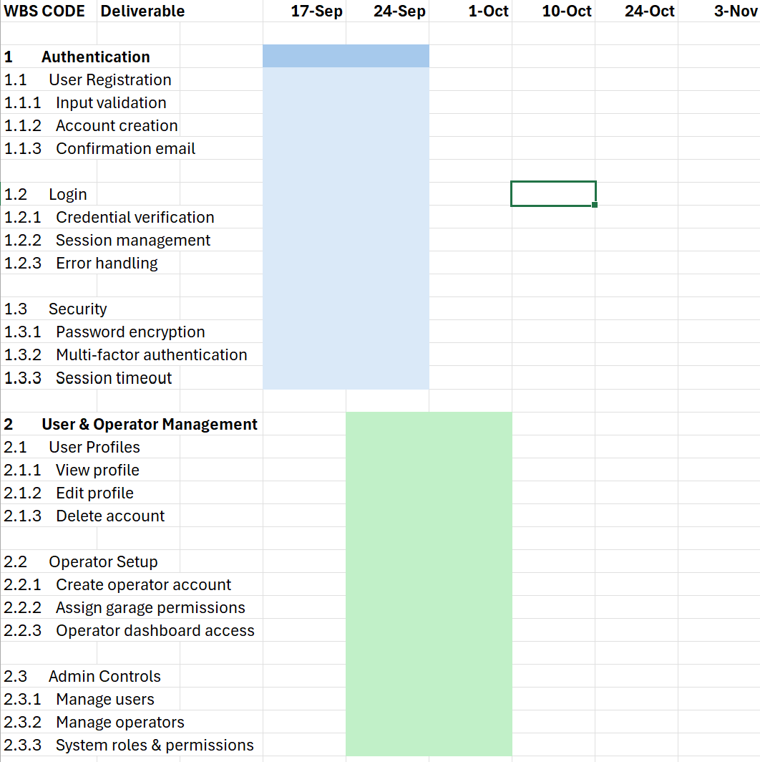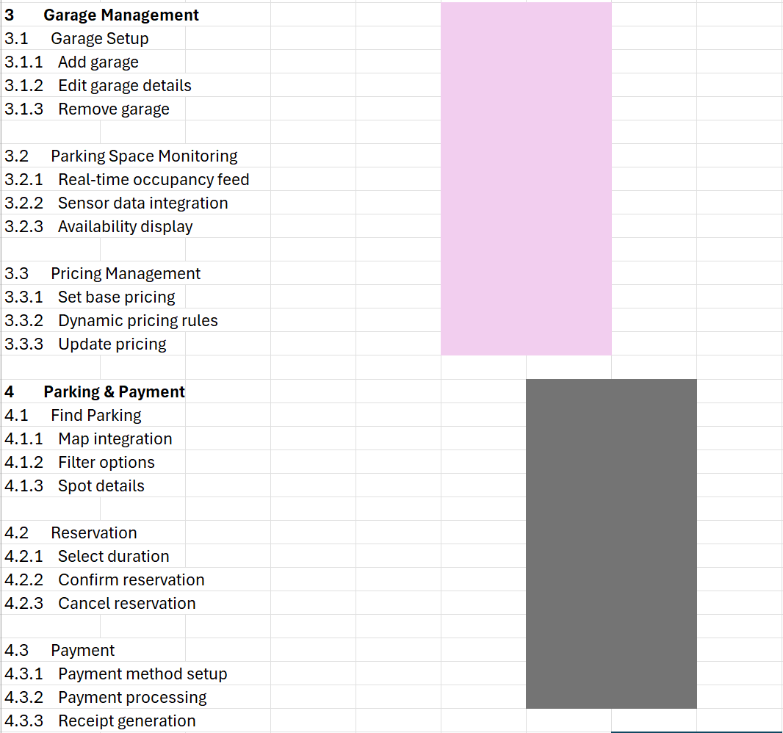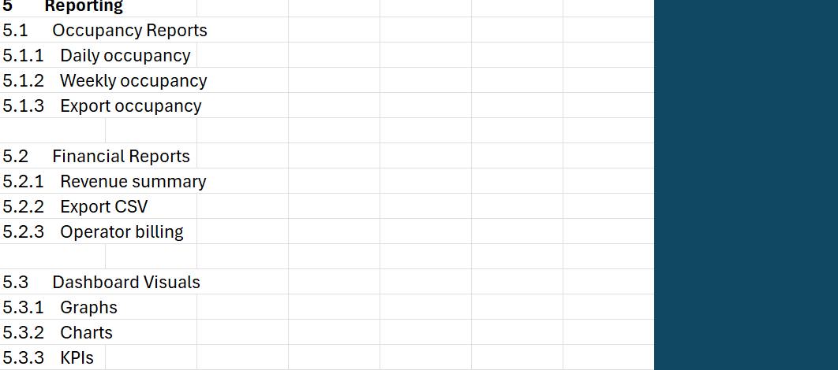

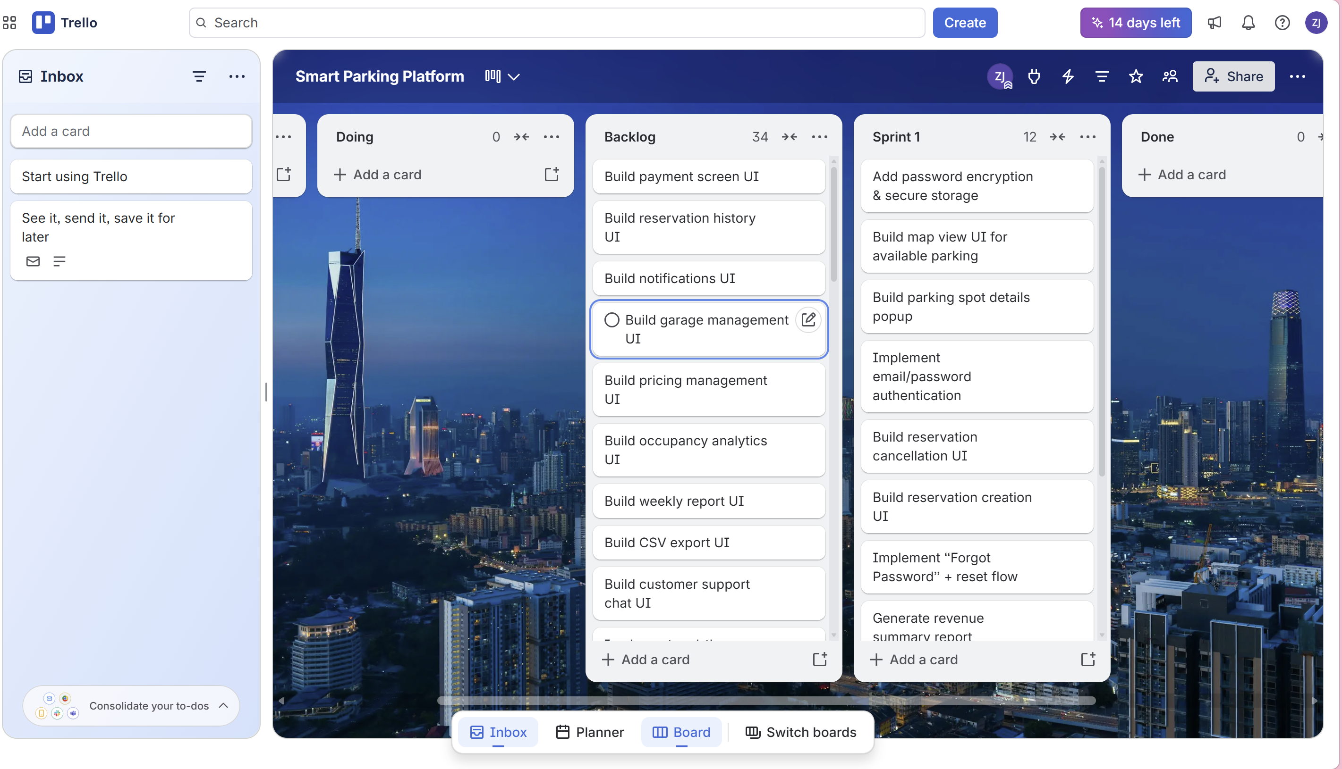
Login:
- Design login UI for drivers
- Design login UI for operators
- Implement email/password authentication
- Add password encryption & secure storage
- Implement “Forgot Password” + reset flow
UI for Operator & User:
- Create driver dashboard UI
- Create operator dashboard UI
- Build map view UI for available parking
- Build parking spot details popup
- Build reservation creation UI
- Build reservation cancellation UI
- Build payment screen UI
- Build reservation history UI
- Build notifications UI
- Build garage management UI (add/edit/remove)
- Build pricing management UI
- Build occupancy analytics UI
- Build weekly report UI
- Build CSV export UI
- Build customer support chat UI
Backend Processes
- Implement real-time occupancy API
- Integrate sensor/garage data feed
- Implement reservation API
- Implement reservation cancellation API
- Implement payment processing API
- Integrate payment gateway (Stripe/PayPal)
- Implement notification service
- Implement user profile management API
- Implement operator permissions system
- Implement garage creation API
- Implement pricing update API
- Implement dynamic pricing engine
- Integrate mapping API (Google Maps)
- Implement weekly report generator
- Implement CSV export backend
Reporting
- Generate daily occupancy report
- Generate weekly occupancy report
- Generate revenue summary report
- Generate operator billing report
- Create occupancy trend graphs
- Create revenue charts
- Create KPI dashboard
- Implement report email distribution
- Implement report archiving
- Implement report download feature

Technical Risks
- T1 – Sensor API failure: Magnetic sensors may not reliably detect cars.
- T2 – Mobile app crashes: App may freeze under high user load.
- T3 – Backend server overload: Real-time parking data may overwhelm servers.
- T4 – Integration issues with city systems: City database may not sync properly.
Schedule Risks
- S1 – Delayed sensor shipment: Hardware arrives late.
- S2 – Developer illness or absence: Key team member unavailable.
- S3 – Slow city approval process: Permits take longer than expected.
- S4 – Feature creep: Stakeholders request new features mid-project
Financial Risks
- F1 – Sensor hardware cost increases: Prices rise unexpectedly.
- F2 – Budget overrun due to overtime: Team needs extra hours.
- F3 – Funding cuts: Sponsor reduces project funding.
- F4 – App store fees or compliance costs: Unexpected publishing expenses.
People Risks
- P1 – Team turnover: Developer quits mid-project.
- P2 – Skill gaps: Team lacks experience with IoT sensors.
- P3 – Miscommunication between teams: Requirements misunderstood.
- P4 – Low morale: Team burnout during crunch periods.

ID | Description | Prob. | Impact | Owner | Response Strategy | Status/Notes
R1 | Sensor API fails to detect cars | High | Major | Backend Lead | Mitigate – add redundancy + testing | Monitoring
R2 | Mobile app crashes under load | Moderate | Major | App Dev Lead | Mitigate – stress testing | In progress
R3 | Backend server overload | Moderate | Moderate | Cloud Engineer | Mitigate – autoscaling | Planned
R4 | City approval delays | High | Moderate | PM | Avoid – submit early, follow-up | Active
R5 | Sensor shipment delays | Moderate | Major | Hardware Lead | Transfer – vendor contract | Watching
R6 | Hardware cost increases | Low | Moderate | Finance | Accept – small buffer | Low priority
R7 | Developer quits mid-project | Low | Major | PM | Mitigate – cross-training | Stable
R8 | Miscommunication between teams | High | Moderate | PM | Mitigate – weekly syncs | Active
R9 | Feature creep from stakeholders | Moderate | Major | PM | Avoid – strict scope control | Active
R10 | App store compliance issues | Low | Minor | App Dev Lead | Mitigate – early compliance check | Planned

Communication Cadence
- Daily Stand-up (10 min) Quick sync: blockers, progress, assignments.
- Weekly Development Meeting (45 min) Deep dive into tasks, bugs, sprint progress.
- Biweekly Stakeholder Review (30 min) Demo new features, discuss feedback.
- Monthly Executive Report High-level metrics: uptime, defect count, schedule status.
Reporting Methods
- Developers: Jira board, GitHub commits, Slack updates.
- Project Manager: Weekly status report + dashboard (risk matrix, burndown chart).
- Executives / Sponsors: Monthly slide deck + KPI summary.
- City Officials: Compliance documentation + integration test results.

1. Roles & Resources
Role | Name | Skill Level | FTE % | Estimated Hours (8-week project) | Hourly Rate | Cost
Project Manager | Alice R. | Mid-Senior | 0.25 | 80 hrs | $50/hr | $4,000
Lead Developer (Backend) | Marco L. | Senior | 0.50 | 160 hrs | $60/hr | $9,600
Frontend Developer | Jess T. | Mid | 0.40 | 128 hrs | $50/hr | $6,400
Mobile Developer | Ravi S. | Mid | 0.40 | 128 hrs | $50/hr | $6,400
QA Tester | Lena P. | Junior | 0.30 | 96 hrs | $35/hr | $3,360
UX/UI Designer | Sam K. | Mid | 0.20 | 64 hrs | $45/hr | $2,880
DevOps Engineer | Omar D. | Mid-Senior | 0.20 | 64 hrs | $55/hr | $3,520

Labor subtotal: 4,000+9,600+6,400+6,400+3,360+2,880+3,520= $36,160
2) Resource & Cost plan (bottom-up + monthly cashflow)
Infrastructure
Item | Cost
Cloud hosting (API + DB + load balancer) | $400/month × 2 months = $800
Monitoring & logging | $150/month × 2 = $300
Mapping API (Google Maps) | $100/month × 2 = $200
Payment gateway fees (Stripe/PayPal) | Estimated $300

Licenses & tools
Item | Cost
Dev tools (IDE, design tools) | $400
Testing tools | $200

Contingency (10%)
Lecture example uses 10%:
“Contingency (10%) = applied to total.”
$$\text{Subtotal}=36,160+1,600+600=38,360$$
$$\text{Contingency}=0.10×38,360=3,836$$
Total Project Cost
$$38,360+3,836=42,196$$
Monthly cashflow (2-month development cycle)
Month | Labor | Infra | Tools | Contingency | Total
Month 1 | $20,000 | $800 | $600 | $2,140 | $23,540
Month 2 | $16,160 | $800 | $0 | $1,696 | $18,656
Total | 36,160 | 1,600 | 600 | 3,836 | 42,196

RACI Matrix
Task / Deliverable | PM | Lead Dev | Frontend Dev | Mobile Dev | QA | UX | DevOps
Requirements & Scope | A | C | I | I | I | C | I
Architecture & System Design | A | R | C | C | I | C | C
Authentication Module | C | R | R | R | C | I | I
Parking Map UI | I | C | R | C | C | A | I
Reservation & Payment Backend | C | R | I | I | C | I | C
Mobile App Screens | I | C | C | R | C | A | I
Pricing & Analytics | C | R | C | I | C | I | C
Testing & QA | I | C | C | C | A/R | I | I
Deployment & CI/CD | I | C | I | I | I | I | A/R
Weekly Reports & Admin Tools | A | R | C | C | C | I | C

Power-Interest grid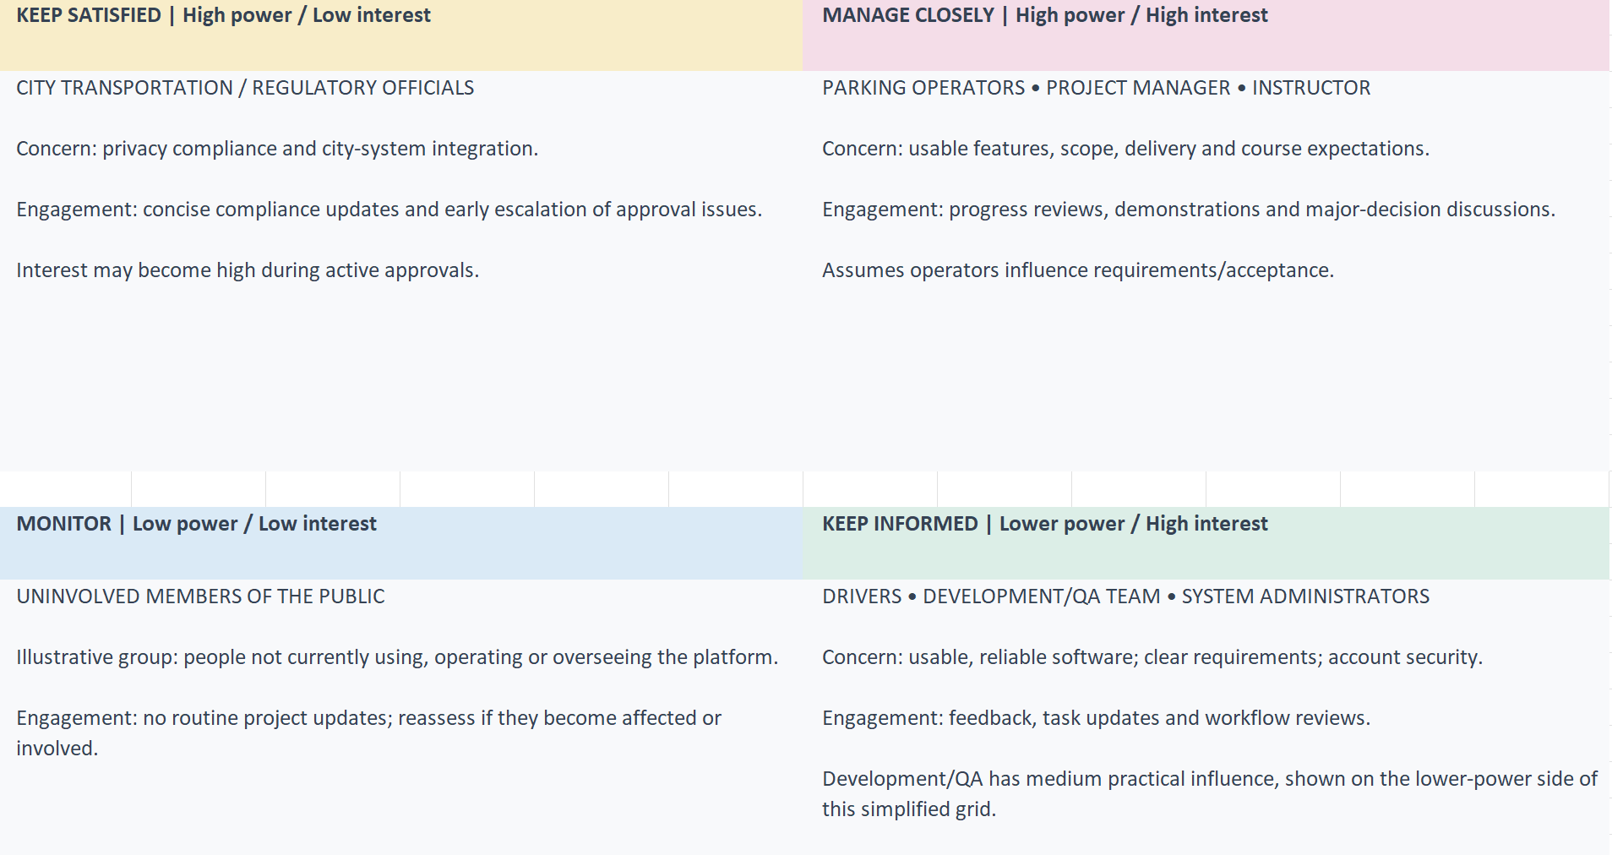
Team Chart
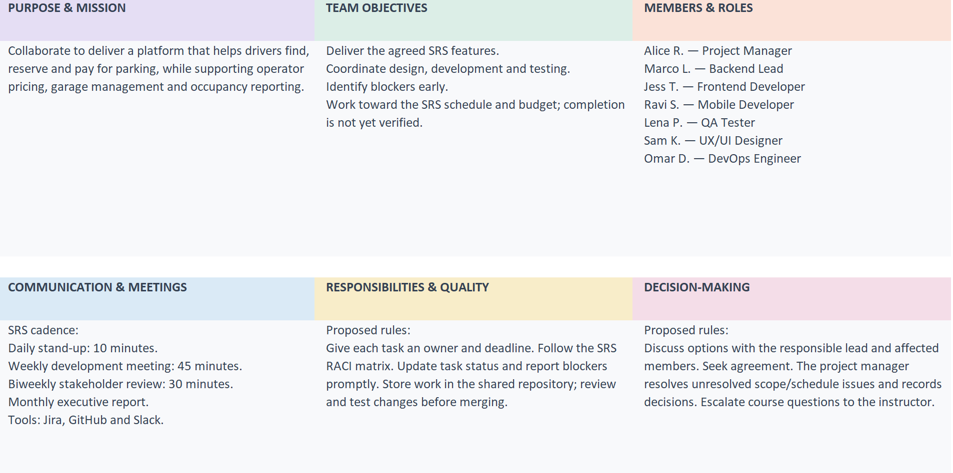
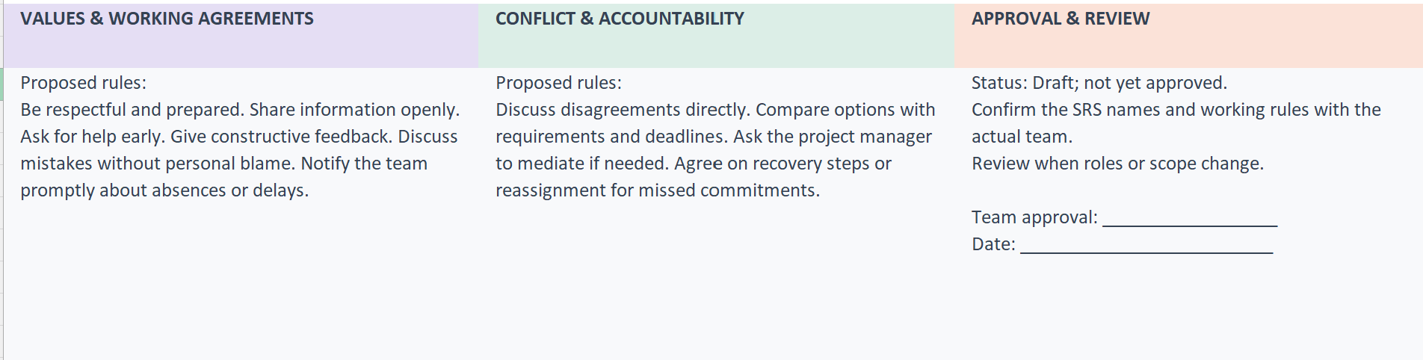
Project charter
