# Grupa 2.

IfStatement → if ( RelExpression ) :

Expression ElsePart   
ElsePart → else : Expression

RelExpression → Term > Term | Term   
Expression → Expression * Term | Term   
Term → ID | CONST

I → if( RE): E EP

RE→ T>T

RE→ T

E→ E * T

E→ T

EP→ else : E

T → ID

T→ CONST

1.

*l* 0:

*I’* → . *I*

*I* → . if( *RE*): *E EP*

*RE*→ .*T*>*T*

*RE*→ .*T*

*E*→ .*E* * *T*

*E*→ .*T*

*EP*→ .else : *E*

*T* → .ID

*T*→ .CONST

*l* 1=goto(*l* 0, *I*)

*I’*=*I*.

*l* 2=goto(*l* 0, if)

*I’* → *I*.

*I* → if.( *RE*): *E EP*

*l* 3=goto(*l* 2, ( )

*I* → if( .*RE*): *E* *EP*

*RE* → .*T*>*T*

*RE*→ .*T*

*E*→. *E* * *T*

*E*→ .*T*

*EP*→ .else : *E*

*T* → .ID

*T*→ .CONST

*l* 4=goto(*l* 3, *RE*)

*I* → if( *RE .*): *E* *EP*

*l* 5=goto(*l* 4, ) )

*I* → if( *RE* ). : *E* *EP*

*l* 6=goto(*l* 5 , : )

*I* → if( *RE* ): . *E* *EP*

*E*→. *E* * *T*

*E*→ .*T*

*EP*→ .else : *E*

*T* → .ID

*T*→ .CONST

*l* 7=goto(*l* 6 , *E*)

*I* → if( *RE* ): *E*. *EP*

*E*→ *E* . * *T*

*l* 8=goto(*l* 7, EP)

*I* → if( *RE* ): *E* *EP.*  Redukciono stanje za smenu 1.

*l* 9=goto(*l* 7 , * )

*E*→ *E* * . *T*

*T* → .ID

*T*→ .CONST

*l* 10=goto(*l* 9, *T*)

*E*→ *E* * *T*. Redukciono stanje za smenu 4

*I* → if( *RE* ): *E.* *ER*

*l* 11=goto(*l* 6, *T*)

*E*→ *T* . Redukciono stanje za smenu 5

*I* → if( *RE* ): *E.* *ER*

*l* 12=goto(*l* 7, else)

*I* → if( *RE* ): *E* *else. : E*

*EP*→else : . E

*E*→. *E* * *T*

*E*→ .*T*

*T* → .ID

*T*→ .CONST

*l* 13=goto(*l* 17, : )

*I* → if( *RE* ): *E* *else : . E*

*EP*→else : . E

*E*→. *E* * *T*

*E*→ .*T*

*T* → .ID

*T*→ .CONST

*l* 14=goto(*l* 13 , *E*)

*I* → if( *RE* ): *E* *else : E.* Redukciono stanje za smenu 6

*E*→ *E* . * *T*

*l* 15=goto(*l* 14, * )

*E*→ *E* * . *T*

*T* → .ID

*T*→ .CONST

*l* 16=goto(*l* 15, T)

*E*→ *E* * *T*.

*I* → if( *RE*): *E* *EP* .

*l* 17=goto(*l* 13, T)

*E*→ *T* .

*I* → if( *RE*): *E* *EP* .

*l* 18=goto(*l* 3, *T*)

*RE* → *T*. >*T*

*RE* → *T*. Redukciono stanje za smenu 3

*T* → ID .

*T*→ CONST.

*l* 19=goto(*l* 18, >)

*RE* → *T*> . *T*

*T* → .ID

*T*→ .CONST

*l* 20=goto(*l* 19, *T*)

*RE* → *T*> *T* . Redukciono stanje za smenu 2

*l* 21=goto(*l* 3, ID) *l* 21=goto(*l* 6, ID) *l* 21=goto(*l* 9, ID) *l* 21=goto(*l* 13, ID) ) *l* 21=goto(*l* 15, ID) ) *l* 21=goto(*l* 19, ID)

*T* → ID. Redukciono stanje za smenu 7

*l* 22=goto(*l* 3, CONST) *l* 22=goto(*l* 6 , CONST) *l* 22=goto(*l* 9, CONST) *l* 22=goto(*l* 13, CONST) *l*22=goto(*l* 15, CONST) *l* 22=goto(*l* 19, CONST)

*T*→ CONST . Redukciono stanje za smenu 8

2.

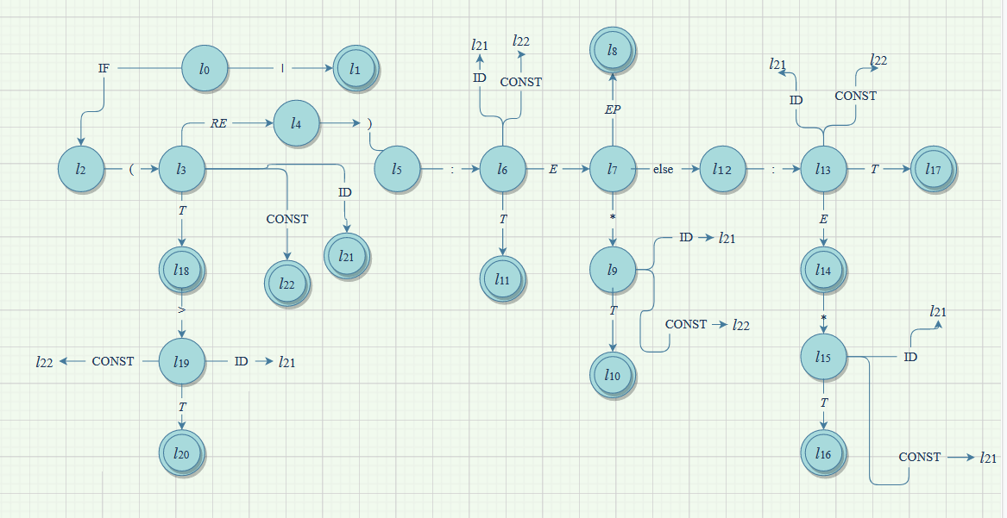

3.

|  |  |  |  |  |
| --- | --- | --- | --- | --- |
| Redni broj smene | Redukciono stanje | L $→$ R | FOLLOW(L) | FIRST(R) |
| 0. | l1 | I’ I | **#** | **if** |
| 1. | l3 | I **if(** *RE***):** *E EP* | **#** | **if** |
| 2. | l4 | RE T**>**T | **# )** | **ID, CONST** |
| 3. | l5 | RE T | **# )** | **ID, CONST** |
| 4. | l6 | E E**\***T | **# else \*** | **ID, CONST** |
| 5. | l9 | E T | **# else \*** | **ID, CONST** |
| 6. | l11 | EP **else:** E | **#** | **else** |
| 7. | l12 | T ID | **# else * ) >** | **ID** |
| 8. | l13 | T CONST | **# else * ) >** | **CONST** |

**LR sintaksna tabela**

**Akcije Prelazi**

|  |  |  |  |  |  |  |  |
| --- | --- | --- | --- | --- | --- | --- | --- |
|  |  | |  | | | | |
|  | **if** | **(** | | **>** | **)** | **:** | **\*** | | **else** | **ID** | **CONST** | **#** | *I* | *RE* | *E* | *EP* | *T* |
| 0 | s2 |  | |  |  |  |  | |  |  |  |  | 1 |  |  |  |  |
| 1 |  |  | |  |  |  |  | |  |  |  | acc |  |  |  |  |  |
| 2 |  | s3 | |  |  |  |  | |  |  |  |  |  |  |  |  |  |
| 3 |  |  | |  |  |  |  | |  | s21 | s22 |  |  | 4 |  |  | 18 |
| 4 |  |  | |  | s5 |  |  | |  |  |  |  |  |  |  |  |  |
| 5 |  |  | |  |  | s6 |  | |  |  |  |  |  |  |  |  |  |
| 6 |  |  | |  |  |  |  | |  | s21 | s22 |  |  |  | 7 |  | 11 |
| 7 |  |  | |  |  |  |  | | s12 |  |  |  |  |  |  | 8 |  |
| 8 |  |  | |  |  |  |  | |  |  |  | r1 |  |  |  |  |  |
| 9 |  |  | |  |  |  |  | |  | s21 | s22 |  |  |  |  |  | 10 |
| 10 |  |  | |  |  |  | r4 | | r4 |  |  | r4 |  |  |  |  |  |
| 11 |  |  | |  |  |  | r5 | | r5 |  |  | r5 |  |  |  |  |  |
| 12 |  |  | |  |  | s13 |  | |  |  |  |  |  |  |  |  |  |
| 13 |  |  | |  |  |  |  | |  | s21 | s22 |  |  |  | 14 |  | 17 |
| 14 |  |  | |  |  |  | s15 | |  |  |  | r6 |  |  |  |  |  |
| 15 |  |  | |  |  |  |  | |  | s21 | s22 |  |  |  |  |  | 16 |
| 16 |  |  | |  |  |  |  | |  |  |  | r1 |  |  |  |  |  |
| 17 |  |  | |  |  |  |  | |  |  |  | r1 |  |  |  |  |  |
| 18 |  |  | | s19 | r3 |  |  | |  |  |  | r3 |  |  |  |  |  |
| 19 |  |  | |  |  |  |  | |  | s21 | s22 |  |  |  |  |  | 20 |
| 20 |  |  | |  | r2 |  |  | |  |  |  | r2 |  |  |  |  |  |
| 21 |  |  | | r7 | r7 |  | r7 | | r7 |  |  | r7 |  |  |  |  |  |
| 22 |  |  | | r8 | r8 |  | r8 | | r8 |  |  | r8 |  |  |  |  |  |