Musimilar

Table of Contents
MongoDb 3
Request/Response: Artist 3
Request/Response: User 4
Request/Response: Song 4

Funkcionalnosti:

- CRUD za Song – MongoDB
Osim READ operacije koji može da kostisi bilo logovani korisnik, sve ostale moze da kostisti samo Admin.
- CRUD za Artist – Neo4j
Osim READ operacije koji može da kostisi bilo logovani korisnik, sve ostale moze da kostisti samo Admin.
- LogIn I Registracija – MongoDB
- Pretrazivanje slicnih muzicara na osnovu zanrova koji ih povezuju – Neo4j
Muzicar (Artist) se cuva kao cvor u Neo4j-u I povezan je vezom PLAYS sa svim svojim žanrovima. Slični muzičari se nalaze na udaljenosti 2 od odabranog muzičara.
- Pravljenje Playlist-e na osnovu unete pesame od strane korisnika – MongoDB
Korisnik unosi pesmu kao primer za pravljenje liste pesama i broj pesama, po default-u je 5. Na osnovu AudioFeatures-a pesme, pretražuju se slične pesme njoj. Korisnik čuva predloženu listu pesama ili deo.
- CRUD za Playlist (User) – MongoDB
Korisnik može da dodaje ili brise pesme u vec postojece liste pesama ili da pravi nove.
- Nove Playlist-e se publish-uju na kanal I brisu ako nisu u top 10 po lajkovima nakon 2 dana

MongoDb

Request/Response: User

GET api/User/{id}
POST api/User
PUT api/User/{id}
DELETE api/User/{id}
User
{
"objectId": "asad",
"name": "Smara",
"username": "marastankovic",
"password": "61b3580fd95216debb851df3",
"playlists": {
"name": "Happy",
"songs": [
{ "name": "MANGO", "artist": "KAMAUU" },
{ "name": "The Brand New Heavies",
"artist": "Dream On Dreamer" }, {…}]
}
}

RegistrationRequest
{
"username": "Smara",
"password": "61b3580fd95216debb851df3"
}

POST api/User/login

LoginRequest

{
"username": "Smara",
"password": "61b3580fd95216debb851df3"
}

Request/Response: Song

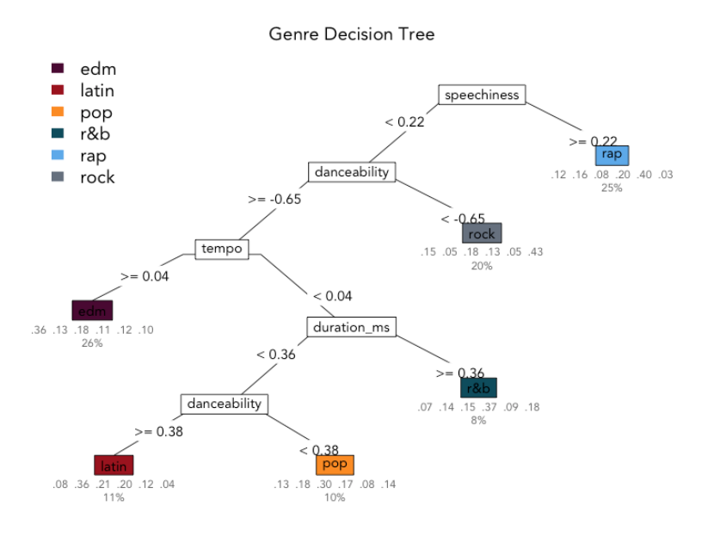

energy
Energy is a measure from 0.0 to 1.0 and represents a perceptual measure of intensity and activity. Typically, energetic tracks feel fast, loud, and noisy. For example, death metal has high energy, while a Bach prelude scores low on the scale. Perceptual features contributing to this attribute include dynamic range, perceived loudness, timbre, onset rate, and general entropy.
valence
A measure from 0.0 to 1.0 describing the musical positiveness conveyed by a track. Tracks with high valence sound more positive (e.g. happy, cheerful, euphoric), while tracks with low valence sound more negative (e.g. sad, depressed, angry).

GET api/Song/{id}
GET api/Song/{name}
POST api/Song
PUT api/Song/{id}
DELETE api/Song/61b3580fd95216debb851df3
{
"objectId": "61b3580fd95216debb851df3",
"name": "LA",
"artist": "Boy Harsher",
"genre": "edm",
"audioFeatures": {
"acousticness" : 0.5,
"energy" : 1,
"instrumentalness" : 0.5,
"timeSignature" : 0.5,
"valence" : 1
}
}

Neo4j

Nodes: ArtistNode, GenreNode

Relationships: plays

ArtistNode

- GET api/Artist/{name}
  - Errors: pogresno uneseno ime, Artist ne postoji u bazi
- GET api/Artist/genre/{genreName}
  - Errors: pogresno uneseno ime ili zanr ne postoji
- GET api/Artist/similar/{artistName}
  - Errors: pogresno uneseno ime, Artist ne postoji u bazi, ne postoji slican
- DELETE api/Artist/{artistName}
  - Errors: pogresno uneseno ime, Artist ne postoji u bazi
- POST api/Artist
  - Errors: Artist vec postoji
  - Request:
{
"name": "Fleetwood Mac",
"genres": ["chillsynth", "spacewave"],
"image": "https://i.scdn.co/image/ab67616d00001e020b0bd8a215dec9f663439ac7",
}

GenreNode
{
"name": "chillsynth"
}

