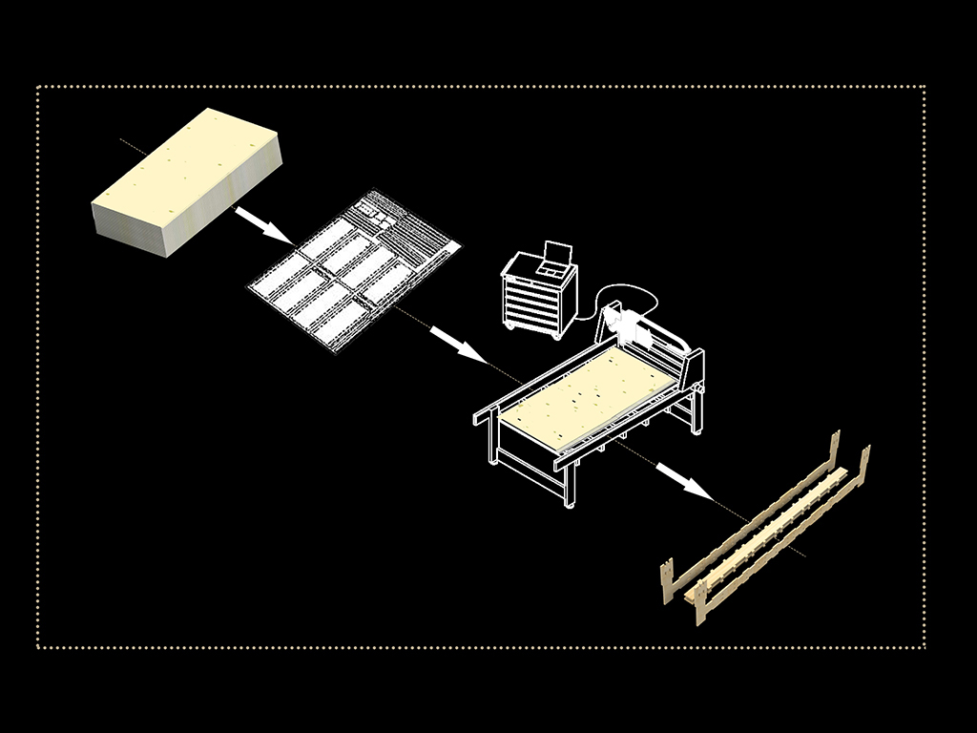

Step 1:

Make sure you have all the files required.

1. Manual modulo 1
2. Manual modulo 2
3. Template files
4. A CNC machine
5. List materials

Step 2:

Get access to a CNC machine.

Step 3:

Take all the components of modulo 1 and modulo 3.

Step 4:

Follow the manuals to assemble the modulo1 and modulo 2.