**Схема в ErWin**

**Задание.** Разработать модель базы данных в среде ERWIN.

Logical: (Логическая схема)

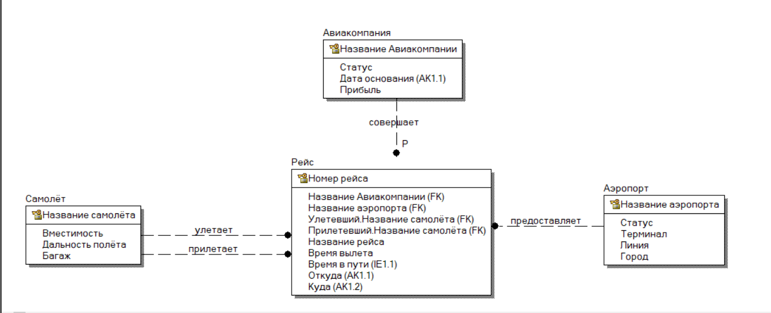

Physical: (Физическая схема)

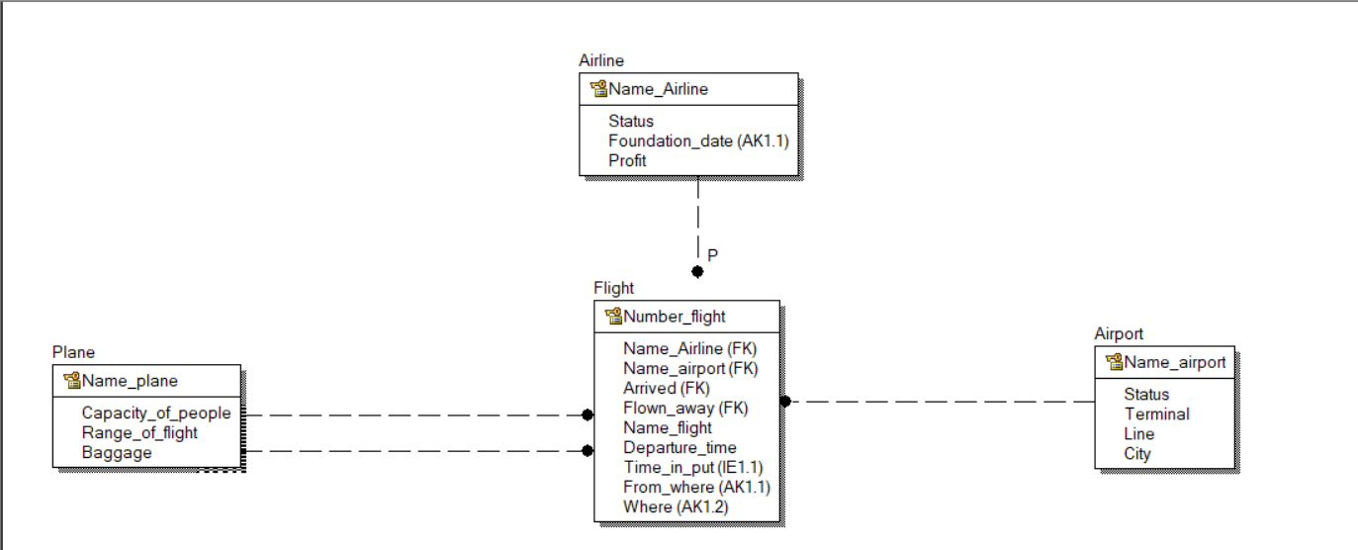

Компиляция:

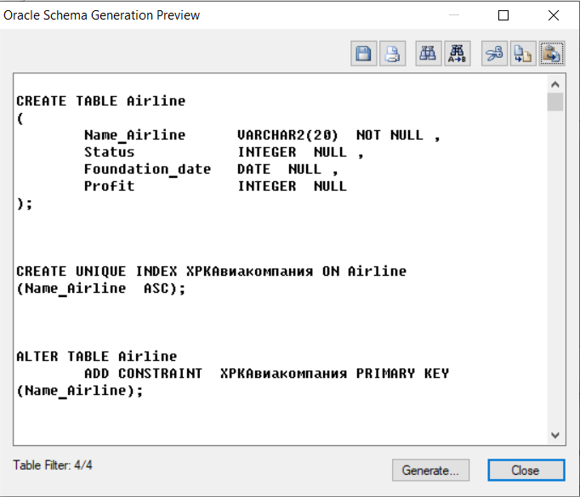

CREATE TABLE Airline

(

Name_Airline VARCHAR2(20) NOT NULL ,

Status INTEGER NULL ,

Foundation_date DATE NULL ,

Profit INTEGER NULL

);

CREATE UNIQUE INDEX XPKАвиакомпания ON Airline

(Name_Airline ASC);

ALTER TABLE Airline

ADD CONSTRAINT XPKАвиакомпания PRIMARY KEY (Name_Airline);

CREATE UNIQUE INDEX XAK1Авиакомпания ON Airline

(Foundation_date ASC);

CREATE TABLE Airport

(

Name_airport VARCHAR2(20) NOT NULL ,

Status INTEGER NULL ,

Terminal INTEGER NULL ,

Line INTEGER NULL ,

City VARCHAR2(20) NULL

);

CREATE UNIQUE INDEX XPKАэропорт ON Airport

(Name_airport ASC);

ALTER TABLE Airport

ADD CONSTRAINT XPKАэропорт PRIMARY KEY (Name_airport);

CREATE TABLE Flight

(

Name_Airline VARCHAR2(20) NOT NULL ,

Name_airport VARCHAR2(20) NOT NULL ,

Name_plane VARCHAR2(20) NOT NULL ,

Number_flight INTEGER NOT NULL ,

Name_flight VARCHAR2(20) NULL ,

Departure_time DATE NULL ,

Time_in_put DATE NULL ,

From_where VARCHAR2(20) NULL ,

Where VARCHAR2(20) NULL

);

CREATE UNIQUE INDEX XPKРейс ON Flight

(Number_flight ASC);

ALTER TABLE Flight

ADD CONSTRAINT XPKРейс PRIMARY KEY (Number_flight);

CREATE UNIQUE INDEX XAK1Рейс ON Flight

(From_where ASC,Where ASC);

CREATE INDEX XIE1Рейс ON Flight

(Time_in_put ASC);

CREATE TABLE Plane

(

Name_plane VARCHAR2(20) NOT NULL ,

Range_of_flight INTEGER NULL ,

Baggage INTEGER NULL ,

Capacity_of_people INTEGER NULL

);

CREATE UNIQUE INDEX XPKСамолёт ON Plane

(Name_plane ASC);

ALTER TABLE Plane

ADD CONSTRAINT XPKСамолёт PRIMARY KEY (Name_plane);

ALTER TABLE Flight

ADD (CONSTRAINT R_1 FOREIGN KEY (Name_Airline) REFERENCES Airline(Name_Airline));

ALTER TABLE Flight

ADD (CONSTRAINT R_4 FOREIGN KEY (Name_airport) REFERENCES Airport(Name_airport));

ALTER TABLE Flight

ADD (CONSTRAINT R_2 FOREIGN KEY (Name_plane) REFERENCES Plane(Name_plane));

ALTER TABLE Flight

ADD (CONSTRAINT R_3 FOREIGN KEY (Name_plane) REFERENCES Plane(Name_plane));

CREATE TRIGGER tD_Airline AFTER DELETE ON Airline for each row

-- ERwin Builtin 27 сентября 2020 г. 3:42:55

-- DELETE trigger on Airline

DECLARE NUMROWS INTEGER;

BEGIN

/* ERwin Builtin 27 сентября 2020 г. 3:42:55 */

/* Airline R/1 Flight on parent delete restrict */

/* ERWIN_RELATION:CHECKSUM="0000dfc1", PARENT_OWNER="", PARENT_TABLE="Airline"

CHILD_OWNER="", CHILD_TABLE="Flight"

P2C_VERB_PHRASE="R/1", C2P_VERB_PHRASE="",

FK_CONSTRAINT="R_1", FK_COLUMNS="Name_Airline" */

SELECT count(*) INTO NUMROWS

FROM Flight

WHERE

/* %JoinFKPK(Flight,:%Old," = "," AND") */

Flight.Name_Airline = :old.Name_Airline;

IF (NUMROWS > 0)

THEN

raise_application_error(

-20001,

'Cannot delete Airline because Flight exists.'

);

END IF;

-- ERwin Builtin 27 сентября 2020 г. 3:42:55

END;

/

CREATE TRIGGER tU_Airline AFTER UPDATE ON Airline for each row

-- ERwin Builtin 27 сентября 2020 г. 3:42:55

-- UPDATE trigger on Airline

DECLARE NUMROWS INTEGER;

BEGIN

/* ERwin Builtin 27 сентября 2020 г. 3:42:55 */

/* Airline R/1 Flight on parent update restrict */

/* ERWIN_RELATION:CHECKSUM="00010a14", PARENT_OWNER="", PARENT_TABLE="Airline"

CHILD_OWNER="", CHILD_TABLE="Flight"

P2C_VERB_PHRASE="R/1", C2P_VERB_PHRASE="",

FK_CONSTRAINT="R_1", FK_COLUMNS="Name_Airline" */

IF

/* %JoinPKPK(:%Old,:%New," <> "," OR ") */

Airline.Name_Airline <> Airline.Name_Airline

THEN

SELECT count(*) INTO NUMROWS

FROM Flight

WHERE

/* %JoinFKPK(Flight,:%Old," = "," AND") */

Flight.Name_Airline = :old.Name_Airline;

IF (NUMROWS > 0)

THEN

raise_application_error(

-20005,

'Cannot update Airline because Flight exists.'

);

END IF;

END IF;

-- ERwin Builtin 27 сентября 2020 г. 3:42:55

END;

/

CREATE TRIGGER tD_Airport AFTER DELETE ON Airport for each row

-- ERwin Builtin 27 сентября 2020 г. 3:42:55

-- DELETE trigger on Airport

DECLARE NUMROWS INTEGER;

BEGIN

/* ERwin Builtin 27 сентября 2020 г. 3:42:55 */

/* Airport R/4 Flight on parent delete restrict */

/* ERWIN_RELATION:CHECKSUM="0000daa9", PARENT_OWNER="", PARENT_TABLE="Airport"

CHILD_OWNER="", CHILD_TABLE="Flight"

P2C_VERB_PHRASE="R/4", C2P_VERB_PHRASE="",

FK_CONSTRAINT="R_4", FK_COLUMNS="Name_airport" */

SELECT count(*) INTO NUMROWS

FROM Flight

WHERE

/* %JoinFKPK(Flight,:%Old," = "," AND") */

Flight.Name_airport = :old.Name_airport;

IF (NUMROWS > 0)

THEN

raise_application_error(

-20001,

'Cannot delete Airport because Flight exists.'

);

END IF;

-- ERwin Builtin 27 сентября 2020 г. 3:42:55

END;

/

CREATE TRIGGER tU_Airport AFTER UPDATE ON Airport for each row

-- ERwin Builtin 27 сентября 2020 г. 3:42:55

-- UPDATE trigger on Airport

DECLARE NUMROWS INTEGER;

BEGIN

/* ERwin Builtin 27 сентября 2020 г. 3:42:55 */

/* Airport R/4 Flight on parent update restrict */

/* ERWIN_RELATION:CHECKSUM="000107f9", PARENT_OWNER="", PARENT_TABLE="Airport"

CHILD_OWNER="", CHILD_TABLE="Flight"

P2C_VERB_PHRASE="R/4", C2P_VERB_PHRASE="",

FK_CONSTRAINT="R_4", FK_COLUMNS="Name_airport" */

IF

/* %JoinPKPK(:%Old,:%New," <> "," OR ") */

Airport.Name_airport <> Airport.Name_airport

THEN

SELECT count(*) INTO NUMROWS

FROM Flight

WHERE

/* %JoinFKPK(Flight,:%Old," = "," AND") */

Flight.Name_airport = :old.Name_airport;

IF (NUMROWS > 0)

THEN

raise_application_error(

-20005,

'Cannot update Airport because Flight exists.'

);

END IF;

END IF;

-- ERwin Builtin 27 сентября 2020 г. 3:42:55

END;

/

CREATE TRIGGER tI_Flight BEFORE INSERT ON Flight for each row

-- ERwin Builtin 27 сентября 2020 г. 3:42:55

-- INSERT trigger on Flight

DECLARE NUMROWS INTEGER;

BEGIN

/* ERwin Builtin 27 сентября 2020 г. 3:42:55 */

/* Airline R/1 Flight on child insert restrict */

/* ERWIN_RELATION:CHECKSUM="0004124a", PARENT_OWNER="", PARENT_TABLE="Airline"

CHILD_OWNER="", CHILD_TABLE="Flight"

P2C_VERB_PHRASE="R/1", C2P_VERB_PHRASE="",

FK_CONSTRAINT="R_1", FK_COLUMNS="Name_Airline" */

SELECT count(*) INTO NUMROWS

FROM Airline

WHERE

/* %JoinFKPK(:%New,Airline," = "," AND") */

:new.Name_Airline = Airline.Name_Airline;

IF (

/* %NotnullFK(:%New," IS NOT NULL AND") */

NUMROWS = 0

)

THEN

raise_application_error(

-20002,

'Cannot insert Flight because Airline does not exist.'

);

END IF;

/* ERwin Builtin 27 сентября 2020 г. 3:42:55 */

/* Plane R/2 Flight on child insert restrict */

/* ERWIN_RELATION:CHECKSUM="00000000", PARENT_OWNER="", PARENT_TABLE="Plane"

CHILD_OWNER="", CHILD_TABLE="Flight"

P2C_VERB_PHRASE="R/2", C2P_VERB_PHRASE="",

FK_CONSTRAINT="R_2", FK_COLUMNS="Name_plane" */

SELECT count(*) INTO NUMROWS

FROM Plane

WHERE

/* %JoinFKPK(:%New,Plane," = "," AND") */

:new.Name_plane = Plane.Name_plane;

IF (

/* %NotnullFK(:%New," IS NOT NULL AND") */

NUMROWS = 0

)

THEN

raise_application_error(

-20002,

'Cannot insert Flight because Plane does not exist.'

);

END IF;

/* ERwin Builtin 27 сентября 2020 г. 3:42:55 */

/* Plane R/3 Flight on child insert restrict */

/* ERWIN_RELATION:CHECKSUM="00000000", PARENT_OWNER="", PARENT_TABLE="Plane"

CHILD_OWNER="", CHILD_TABLE="Flight"

P2C_VERB_PHRASE="R/3", C2P_VERB_PHRASE="",

FK_CONSTRAINT="R_3", FK_COLUMNS="Name_plane" */

SELECT count(*) INTO NUMROWS

FROM Plane

WHERE

/* %JoinFKPK(:%New,Plane," = "," AND") */

:new.Name_plane = Plane.Name_plane;

IF (

/* %NotnullFK(:%New," IS NOT NULL AND") */

NUMROWS = 0

)

THEN

raise_application_error(

-20002,

'Cannot insert Flight because Plane does not exist.'

);

END IF;

/* ERwin Builtin 27 сентября 2020 г. 3:42:55 */

/* Airport R/4 Flight on child insert restrict */

/* ERWIN_RELATION:CHECKSUM="00000000", PARENT_OWNER="", PARENT_TABLE="Airport"

CHILD_OWNER="", CHILD_TABLE="Flight"

P2C_VERB_PHRASE="R/4", C2P_VERB_PHRASE="",

FK_CONSTRAINT="R_4", FK_COLUMNS="Name_airport" */

SELECT count(*) INTO NUMROWS

FROM Airport

WHERE

/* %JoinFKPK(:%New,Airport," = "," AND") */

:new.Name_airport = Airport.Name_airport;

IF (

/* %NotnullFK(:%New," IS NOT NULL AND") */

NUMROWS = 0

)

THEN

raise_application_error(

-20002,

'Cannot insert Flight because Airport does not exist.'

);

END IF;

-- ERwin Builtin 27 сентября 2020 г. 3:42:55

END;

/

CREATE TRIGGER tU_Flight AFTER UPDATE ON Flight for each row

-- ERwin Builtin 27 сентября 2020 г. 3:42:55

-- UPDATE trigger on Flight

DECLARE NUMROWS INTEGER;

BEGIN

/* ERwin Builtin 27 сентября 2020 г. 3:42:55 */

/* Airline R/1 Flight on child update restrict */

/* ERWIN_RELATION:CHECKSUM="00040325", PARENT_OWNER="", PARENT_TABLE="Airline"

CHILD_OWNER="", CHILD_TABLE="Flight"

P2C_VERB_PHRASE="R/1", C2P_VERB_PHRASE="",

FK_CONSTRAINT="R_1", FK_COLUMNS="Name_Airline" */

SELECT count(*) INTO NUMROWS

FROM Airline

WHERE

/* %JoinFKPK(:%New,Airline," = "," AND") */

:new.Name_Airline = Airline.Name_Airline;

IF (

/* %NotnullFK(:%New," IS NOT NULL AND") */

NUMROWS = 0

)

THEN

raise_application_error(

-20007,

'Cannot update Flight because Airline does not exist.'

);

END IF;

/* ERwin Builtin 27 сентября 2020 г. 3:42:55 */

/* Plane R/2 Flight on child update restrict */

/* ERWIN_RELATION:CHECKSUM="00000000", PARENT_OWNER="", PARENT_TABLE="Plane"

CHILD_OWNER="", CHILD_TABLE="Flight"

P2C_VERB_PHRASE="R/2", C2P_VERB_PHRASE="",

FK_CONSTRAINT="R_2", FK_COLUMNS="Name_plane" */

SELECT count(*) INTO NUMROWS

FROM Plane

WHERE

/* %JoinFKPK(:%New,Plane," = "," AND") */

:new.Name_plane = Plane.Name_plane;

IF (

/* %NotnullFK(:%New," IS NOT NULL AND") */

NUMROWS = 0

)

THEN

raise_application_error(

-20007,

'Cannot update Flight because Plane does not exist.'

);

END IF;

/* ERwin Builtin 27 сентября 2020 г. 3:42:55 */

/* Plane R/3 Flight on child update restrict */

/* ERWIN_RELATION:CHECKSUM="00000000", PARENT_OWNER="", PARENT_TABLE="Plane"

CHILD_OWNER="", CHILD_TABLE="Flight"

P2C_VERB_PHRASE="R/3", C2P_VERB_PHRASE="",

FK_CONSTRAINT="R_3", FK_COLUMNS="Name_plane" */

SELECT count(*) INTO NUMROWS

FROM Plane

WHERE

/* %JoinFKPK(:%New,Plane," = "," AND") */

:new.Name_plane = Plane.Name_plane;

IF (

/* %NotnullFK(:%New," IS NOT NULL AND") */

NUMROWS = 0

)

THEN

raise_application_error(

-20007,

'Cannot update Flight because Plane does not exist.'

);

END IF;

/* ERwin Builtin 27 сентября 2020 г. 3:42:55 */

/* Airport R/4 Flight on child update restrict */

/* ERWIN_RELATION:CHECKSUM="00000000", PARENT_OWNER="", PARENT_TABLE="Airport"

CHILD_OWNER="", CHILD_TABLE="Flight"

P2C_VERB_PHRASE="R/4", C2P_VERB_PHRASE="",

FK_CONSTRAINT="R_4", FK_COLUMNS="Name_airport" */

SELECT count(*) INTO NUMROWS

FROM Airport

WHERE

/* %JoinFKPK(:%New,Airport," = "," AND") */

:new.Name_airport = Airport.Name_airport;

IF (

/* %NotnullFK(:%New," IS NOT NULL AND") */

NUMROWS = 0

)

THEN

raise_application_error(

-20007,

'Cannot update Flight because Airport does not exist.'

);

END IF;

-- ERwin Builtin 27 сентября 2020 г. 3:42:55

END;

/

CREATE TRIGGER tD_Plane AFTER DELETE ON Plane for each row

-- ERwin Builtin 27 сентября 2020 г. 3:42:55

-- DELETE trigger on Plane

DECLARE NUMROWS INTEGER;

BEGIN

/* ERwin Builtin 27 сентября 2020 г. 3:42:55 */

/* Plane R/2 Flight on parent delete restrict */

/* ERWIN_RELATION:CHECKSUM="0001c204", PARENT_OWNER="", PARENT_TABLE="Plane"

CHILD_OWNER="", CHILD_TABLE="Flight"

P2C_VERB_PHRASE="R/2", C2P_VERB_PHRASE="",

FK_CONSTRAINT="R_2", FK_COLUMNS="Name_plane" */

SELECT count(*) INTO NUMROWS

FROM Flight

WHERE

/* %JoinFKPK(Flight,:%Old," = "," AND") */

Flight.Name_plane = :old.Name_plane;

IF (NUMROWS > 0)

THEN

raise_application_error(

-20001,

'Cannot delete Plane because Flight exists.'

);

END IF;

/* ERwin Builtin 27 сентября 2020 г. 3:42:55 */

/* Plane R/3 Flight on parent delete restrict */

/* ERWIN_RELATION:CHECKSUM="00000000", PARENT_OWNER="", PARENT_TABLE="Plane"

CHILD_OWNER="", CHILD_TABLE="Flight"

P2C_VERB_PHRASE="R/3", C2P_VERB_PHRASE="",

FK_CONSTRAINT="R_3", FK_COLUMNS="Name_plane" */

SELECT count(*) INTO NUMROWS

FROM Flight

WHERE

/* %JoinFKPK(Flight,:%Old," = "," AND") */

Flight.Name_plane = :old.Name_plane;

IF (NUMROWS > 0)

THEN

raise_application_error(

-20001,

'Cannot delete Plane because Flight exists.'

);

END IF;

-- ERwin Builtin 27 сентября 2020 г. 3:42:55

END;

/

CREATE TRIGGER tU_Plane AFTER UPDATE ON Plane for each row

-- ERwin Builtin 27 сентября 2020 г. 3:42:55

-- UPDATE trigger on Plane

DECLARE NUMROWS INTEGER;

BEGIN

/* ERwin Builtin 27 сентября 2020 г. 3:42:55 */

/* Plane R/2 Flight on parent update restrict */

/* ERWIN_RELATION:CHECKSUM="000212cb", PARENT_OWNER="", PARENT_TABLE="Plane"

CHILD_OWNER="", CHILD_TABLE="Flight"

P2C_VERB_PHRASE="R/2", C2P_VERB_PHRASE="",

FK_CONSTRAINT="R_2", FK_COLUMNS="Name_plane" */

IF

/* %JoinPKPK(:%Old,:%New," <> "," OR ") */

Plane.Name_plane <> Plane.Name_plane

THEN

SELECT count(*) INTO NUMROWS

FROM Flight

WHERE

/* %JoinFKPK(Flight,:%Old," = "," AND") */

Flight.Name_plane = :old.Name_plane;

IF (NUMROWS > 0)

THEN

raise_application_error(

-20005,

'Cannot update Plane because Flight exists.'

);

END IF;

END IF;

/* ERwin Builtin 27 сентября 2020 г. 3:42:55 */

/* Plane R/3 Flight on parent update restrict */

/* ERWIN_RELATION:CHECKSUM="00000000", PARENT_OWNER="", PARENT_TABLE="Plane"

CHILD_OWNER="", CHILD_TABLE="Flight"

P2C_VERB_PHRASE="R/3", C2P_VERB_PHRASE="",

FK_CONSTRAINT="R_3", FK_COLUMNS="Name_plane" */

IF

/* %JoinPKPK(:%Old,:%New," <> "," OR ") */

Plane.Name_plane <> Plane.Name_plane

THEN

SELECT count(*) INTO NUMROWS

FROM Flight

WHERE

/* %JoinFKPK(Flight,:%Old," = "," AND") */

Flight.Name_plane = :old.Name_plane;

IF (NUMROWS > 0)

THEN

raise_application_error(

-20005,

'Cannot update Plane because Flight exists.'

);

END IF;

END IF;

-- ERwin Builtin 27 сентября 2020 г. 3:42:55

END;

/