Readme

This program is a spellchecker that is supposed to test the concept of mutual exclusion, conditional variables and Networks. We implement this program by writing server side code in order for a client to send a word through that network in order for server to go through a dictionary words and to see if that word is in there and if that’s the case return the word with Ok to show that the word is correct or misspelled to indicate that there is no word that matches the given input.

The network portion of the program involves subparts which allows the client and server to communicate. We begin by creating a socket and preparing the sockaddr_in structure. The next step involves binding. After we bind has been successful, the server listens for incoming connections from clients to establish a connection. If an attempt is made the server accepts the connection sends a replay to the client that a connection has been established and ask for a word to check in the dictionary.

The multi-threaded nature off the program allows more than one client to connect to the server, letting it access shared date. The different threads that are used are the logger thread which logs the input and result of the input into the log file. Worker threads which remove socket descriptors from the work queue for processing and then there is the main thread that waits for clients to connect to the server and is responsible for creating all the above threads.

We used several functions to make this program work: These functions along with their descriptions are:

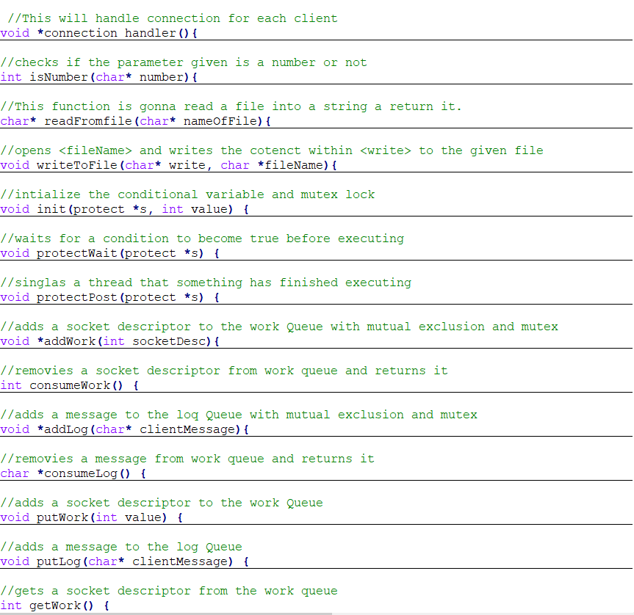

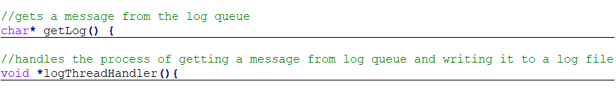

Test method

The test method used to run this program is accomplished by first creating a single client that can communicate with a server and return a message informing weather the sent message is in the file or not. After this has been accomplished we move on to making the program multi threadedness and Synchronization. These parts can be test by connecting several clients to the server and checking words to see if the log file and is able to record all without. This shows that buffer was able to by access without problem and there is Synchronization within the program.