**Referral Networks Software Development With Applicant Tracking and Data Analytics Enhancing Recruitment for Bonafide Trainology Placement Services**

**A Capstone Project Proposal**

Submitted to the Faculty of

The College of Computing Studies

**PAMANTASAN NG CABUYAO**

City of Cabuyao, Laguna

In Partial Fulfillment

Of the Requirements for the Degree

**BACHELOR OF SCIENCE IN INFORMATION TECHNOLOGY**

**By:**

Baylosis, Eric Glenn D.

Natanauan, Lucky D.

Ramos, Joshua M.

May 2024

**APPROVAL SHEET**

In partial fulfillment of the requirements for the degree of **Bachelor of Science in Information Technology**, this research proposal titled, **Developing A Recruitment Software Integrating Referral Networks, Applicant Tracking, and Data Analytics to Enhance Hiring Efficiency for Bonafide Trainology Placement Services** has been prepared and submitted by **Eric Glenn D. Baylosis, Lucky D. Natanauan,** and **Joshua M. Ramos** is hereby recommended for approval and acceptance.

**PROF. EVANGELINA MAGALING**

Research Adviser

**EDITOR**

Edited and re-examined for final printing and submission to the faculty of the College of Computing Studies, Pamantasan ng Cabuyao.

Language Editor

**PANEL OF EXAMINERS**

Approved by the committee on Oral Examination with the grade of ___

**Prof. Rommuele Jester Manongsong Mr. Darrell Bacarro**

Faculty IT Expert

**Dr. Ramiro Z. Dela Cruz**

Chairman

Accepted and approved in partial fulfillment of the requirements for the degree of Bachelor of Science in Information Technology.

DATE

**DR. ALICE M. LACORTE**

Dean, College of Computing Studies

**TABLE OF CONTENTS**

Title Page i

Approval Sheet ii

Table of Contents iii

List of Tables v

List of Figures vi

List of Appendices viii

**CHAPTER**

|  |  |  |  |  |
| --- | --- | --- | --- | --- |
| **I** | **THE PROBLEM AND ITS BACKGROUND** | | **Page** | |
|  | Introduction | | 1 | |
|  | Objective of the Study | | 4 | |
|  | Scope and Delimitation | | 5 | |
|  | Significance of the Study | | 6 | |
|  | Definition of Terms | | 7 | |
|  |  | |  | |
| **II** | **REVIEW OF RELATED LITERATURE AND STUDIES** | | |  |
|  | Conceptual Literature | | 9 | |
|  | Research Literature  Theoretical | | 10  14 | |
|  | Conceptual Framework  Conceptual Paradigm | | 16  18 | |
|  | Synthesis | | 19 | |
|  |  | |  | |
| **III** | **METHODS AND PROCEDURES** | |  | |
|  | Research Design | | 21 | |
|  | Respondents of the Study | | 21 | |
|  | Data Gathering Procedures | | 24 | |
|  | Evaluation and Scoring  Data Analysis Plan  System Development | | 25  30  32 | |
|  | Ethical Considerations | | 64 | |
|  |  | |  | |
| **REFERENCES** | |  | 65 | |
| **APPENDICES** | |  | 70 | |
|  |  | |  | |

**LIST OF TABLES**

|  |  |  |
| --- | --- | --- |
| **Table** |  | **Page** |
| 1  2  3  4  5  6 | Respondents of the Study  Criteria for functionality  Criteria for efficiency  Criteria for usability  Criteria for reliability  Likert Scale | 22  25  26  27  28  32 |

**LIST OF FIGURES**

|  |  |  |
| --- | --- | --- |
| **Figure** |  | **Page** |
|  |  |  |
| 1  2  3  4  5  6  7  8  9  10  11  12  13  14  15  16  17  18  19 | Conceptual Framework of the Study  Conceptual Paradigm of the Study  Agile Methodology  Use Case Diagram for Applicant Registration  Use Case Diagram for Applicant’s Job Application  Use Case for Recruitment Management  Use Case for Admin  Use Case for Reports Generation  Class Diagram  Sequence Diagram for User Registration Account  Sequence Diagram for Admin Management  Sequence Diagram Recruitment Management  Sequence Diagram for Applicant’s Job Application  Sequence Diagram for Reports Generation  Activity Diagram for Applicant Registration  Activity Diagram for Recruitment Management  Activity Diagram for Applicant Application  Activity Diagram for Admin Recruitment  Activity Diagram for Reports Generation | 16  18  31  36  37  38  39  40  41  42  44  46  48  50  52  54  56  58  60 |
|  |  |  |

**LIST OF APPENDICES**

|  |  |  |
| --- | --- | --- |
|  | **APPENDIX TITLE** | **Page** |
| A | Confidentiality and Non-Disclosure Agreement | 70 |
| B | Validated Research Instrument | 71 |
| C | Informed Consent Form | 72 |
| D | Research Ethics Review Committee Evaluation | 75 |
| E | Short Report of Plagiarism Software | 76 |
| F | Report of Language Software | 79 |
| G | Curriculum Vitae of Student Researchers | 81 |

**CHAPTER I**

**THE PROBLEM AND ITS BACKGROUND**

In the contemporary business landscape, the Human Resources (HR) department serves as the backbone of an organization, particularly in the recruitment and hiring of personnel. This essential function not only ensures that the right individuals are placed in roles that align with their skills and the company's needs but also contributes to the overall success and growth of the organization. [1][2] The importance of HR in this context is evident through several key areas such as identifying talent needs, attracting qualified candidates, and screening and selecting candidates.[3] This is especially critical for micro, small, and medium enterprises (MSMEs), where resources for employing talent are limited. MSMEs must ensure that these resources are used optimally by hiring the most qualified and suitable employees.

One such organization facing these challenges is Bonafide Trainology Placement Services, a small-sized direct hiring labor-broker based in Cabuyao, Laguna, Philippines. As an 11-person enterprise, Bonafide faces significant challenges in managing their recruitment processes efficiently. The firm does not employ any recruitment software, which hinders their ability to streamline operations and manage the candidate pipeline effectively. This lack of technology leads to several operational inefficiencies.

Firstly, Bonafide frequently misses deadlines due to the absence of automated tracking systems. Manual tracking of applications and candidate communications is time consuming and prone to delays. Secondly, the lack of a centralized system for storing and organizing candidate information results in misplaced files and documents. This disorganization can lead to confusion and errors during the recruitment process. Finally, without the capability to generate reports and analyze recruitment data, Bonafide struggles to monitor key metrics such as time-to-fill, and source effectiveness. This inability to track performance metrics impedes their ability to identify areas for improvement and make data-driven decisions.

These challenges underscore the critical need for integrating technology to facilitate recruitment. The increasing complexity and volume of HR tasks necessitate the adoption of advanced tools and systems to streamline operations and enhance productivity. [4] For Bonafide Trainology Placement Services, implementing recruitment software could significantly enhance their process efficiency, reduce errors, and improve overall performance. By adopting such tools, they would be better equipped to meet deadlines, easily manage candidate information, and gain valuable insights through data analytics, ultimately leading to more effective and strategic hiring decisions. Leveraging technology in this way allows HR departments to reduce administrative burdens, minimize errors, and focus more on strategic initiatives. [5]

Despite the advantages of technology adoption, many organizations, especially MSMEs, struggle to fully utilize its potential, Bonafide Trainology Placement Services cannot fully disclose all aspects of their data and processes to us due to various circumstances, with the client firm declining certain features due to unwillingness and the limitations of their processes. A key area often overlooked is the integration of referral features from external sources within recruitment software. Referral programs, when effectively implemented, can significantly enhance the quality of hires and lower cost-per-hire by leveraging social and professional networks. [6][7] While current trends emphasize applications of data analytics within HR, the potential of referral systems is often overlooked. Integrating referral systems into recruitment software can significantly improve talent acquisition processes by utilizing existing employees' and applicants’ networks to source suitable candidates. [8]

This research aims to explore the integration of referral networks and data analytics within recruitment software, particularly in the context of MSMEs. By analyzing current technology trends, identifying research gaps, and understanding organizational challenges, this study seeks to provide insights into the design, development, and implementation of an integrated recruitment software solution tailored to address the specific needs of MSMEs in talent acquisition.

The study's objectives are to develop a recruitment software solution that optimizes talent acquisition processes through enhanced referral features, design a user-friendly interface for managing candidate referrals and recommendations, analyze recruitment data, and monitor key recruitment metrics. Additionally, the research will test the system's performance and effectiveness, assessing its impact on recruitment outcomes and operational efficiency.

**Objectives of the Study**

**General Objective:**

To develop and implement an integrated recruitment software solution that enhances talent acquisition processes for Bonafide Trainology Placement Services, a small direct hiring labor–broker based in Cabuyao, Laguna, Philippines.

Specific Objectives:

1. Design a user-friendly interface for the recruitment software solution, focusing on:
   1. Management of candidate referrals and recommendations.
   2. Applicant tracking functionalities to monitor number of transacted applicants, failure and passing rates, and requirements tracking.
   3. Development of reporting capabilities for analyzing time-to-fill, sourcing analytics, and candidate pipeline monitoring.
2. Develop the recruitment software with functionalities for:
   1. Management and tracking of candidate referrals from external and internal sources.
   2. Integration of data analytics to optimize recruitment strategies and decision-making, including identifying sought-after jobs and qualifications.
   3. Implementation of an applicant tracking system to manage candidate pipelines from initial application to deployment.
   4. Implementation of an applicant tracking system to monitor candidate pipelines, including identifying drop-off points and tracking number of backouts and deployed candidates, and time-to-fill. Some proposed features were declined and is thus replaced by other KPI monitoring.
3. Evaluate the performance of the proposed system based on the following criteria of ISO 25010:
   1. Effectiveness.
   2. Reliability.
   3. Efficiency.
   4. Usability.

**Scope and Limitations of the Study**

This study focuses on developing and implementing a web-based recruitment software solution tailored for Bonafide Trainology Placement Services, located in Cabuyao, Laguna, Philippines. The study will encompass the design, development, and initial implementation phases within the second semester of A.Y. 2023 – 2024 and the first semester of A.Y. 2024 – 2025.

The software aims to enhance talent acquisition processes through the following functionalities:

* Designing a user-friendly interface that allows applicants to refer potential candidates, submit their information, and view job postings easily.
* Providing HR personnel with web-based tools to collect and manage applicant data, as well as data specific to Bonafide Trainology Placement Services. HR can generate reports, schedule interviews, and manage application statuses.
* Integrating data analytics to optimize recruitment strategies, including tracking metrics such as number of transacted applicants, failure and passing rates, time-to-fill, sourcing analytics, candidate pipeline monitoring (identifying drop-off points), offer acceptance rates, and identifying sought-after jobs and skills.

While the developed recruitment software solution offers enhancements to talent acquisition processes, several limitations should be considered in its implementation and use:

* The software operates exclusively online and requires an internet connection to function, limiting its usability in offline environments.
* The primary focus of the software is on streamlining and optimizing the recruitment process. Other HR functions such as payroll processing or broader HR management beyond recruitment are outside the scope of this study.
* While adaptable for similar small to medium-sized enterprises, the software's specific design and functionalities are optimized for the unique needs and processes of Bonafide Trainology Placement Services in Cabuyao, Laguna.
* The client firm has declined various features such as qualified costs due to circumstances, it has thus been replaced by time-to-fill which will be automatically monitored by the system and does not need to be inputted by the client firm, in addition, after deployment of applicants to their clients, Bonafide Trainology Placement Services does not have any monitoring systems in place to monitor attrition rates, the system thus substitutes this KPI with requirements tracking, sourcing analytics and other key metrics.

In addition, due to various constraints such as time and resource constraints, the number of respondents will be limited.

**Significance of the Study**

The study holds significance both academically and practically. From a broader academic standpoint, it contributes to advancing knowledge in HR technology by developing and implementing a specialized recruitment software solution. This software integrates features such as referral networks, data analytics, and streamlined applicant tracking, addressing critical gaps in current HR solutions. This exploration not only enhances understanding of effective recruitment strategies but also sets a precedent for future research and innovation in HR technology.

Practically, the study aims to streamline talent acquisition processes specifically tailored for Bonafide Trainology Placement Services and similar MSMEs in the Laguna area. By optimizing recruitment practices through applicant tracking, data analytics, and reporting capabilities, the software enhances organizational competitiveness and operational efficiency. Moreover, the integration of referral features enables leveraging existing networks to source high – quality candidates, thereby reducing recruitment costs and time-to-fill vacancies.

Overall, this study bridges academic insights with practical applications, fostering advancements in HR technology and significantly improving recruitment outcomes for small and medium-sized enterprises. By empowering organizations like Bonafide Trainology Placement Services with innovative tools and strategies, the study contributes to sustainable growth and success in the competitive business landscape.

**Definition of Terms**

1. Recruitment Software – A specialized software solution designed to automate and streamline the process of attracting, sourcing, selecting, and hiring candidates for job openings within an organization. It encompasses functionalities such as applicant tracking, candidate management, and integration of data analytics to optimize recruitment strategies.

2. Applicant Tracking System (ATS) – A component of recruitment software that allows organizations to electronically manage and track candidates throughout the hiring process. It includes features for receiving applications, screening candidates, scheduling interviews, and managing communications.

3. Referral Features – Tools within recruitment software that facilitate employee referrals and external recommendations for potential candidates. These features leverage existing networks to source qualified applicants, enhancing recruitment efficiency and quality of hires. ‌[9]

4. Data Analytics – The process of examining extensive datasets to uncover meaningful insights and patterns related to recruitment metrics and performance indicators. In the context of recruitment software, data analytics helps optimize decision-making, improve time-to-fill vacancies, and assess the effectiveness of recruitment strategies.

5. Time-to-Fill – A recruitment metric measuring the duration from the initiation of a job opening to the final placement of a candidate in the position. It reflects the efficiency of recruitment processes and the organization's ability to fill vacancies promptly.

6. Sourcing Analytics – Tools and methodologies within recruitment software used to analyze and evaluate the effectiveness of different recruitment channels and sources. Sourcing analytics help HR professionals identify the most productive channels for attracting candidates and allocate resources accordingly.

7. Candidate Pipeline Monitoring – The process of tracking candidates as they progress through various stages of the recruitment process, from initial application to final selection or rejection. Candidate pipeline monitoring identifies bottlenecks and drop-off points, enabling organizations to optimize recruitment workflows and improve conversion rates.

8. Offer Acceptance Rate – A metric indicating the percentage of suitable candidates accepted by the client firm of Bonafide Trainology Placement Services. It provides insights into the candidate satisfaction levels, and the organization's ability to find suitable talent in the market.

9. Micro, Small, and Medium Enterprises (MSMEs) – Business entities characterized by their smaller size and operational scale compared to larger corporations. MSMEs typically have limited resources and staff, requiring efficient and cost-effective solutions for managing HR and recruitment processes.

10. Talent Acquisition – A strategic method for identifying, attracting, and integrating top talent to fulfill evolving business requirements. [10]

11. Operational Efficiency – In the context of recruitment software, operational efficiency refers to the ability to streamline recruitment processes, reduce administrative burdens, and achieve hiring goals effectively. [11]

**CHAPTER II**

**REVIEW OF RELATED LITERATURE AND STUDIES**

This literature review explores the role of Human Resource Management Systems (HRMS), focusing on integrating referral features and data analytics to optimize recruitment processes for MSMEs like Bonafide Trainology Placement Services. It examines the benefits and challenges of HRMS, the impact of referral systems on hiring quality and efficiency, and the importance of data-driven decision-making in HR operations. By synthesizing existing research gathered from published journals, books, articles, and other scholarly materials we aim to identify gaps, and provide insights for developing a tailored HRMS solution to enhance talent acquisition and overall HR efficiency for Bonafide Trainology Placement Services.

**Conceptual Literature**

Developing an HRMS to aid HR professionals and managers in managing their human capital is integral for streamlining HR processes within an organization, however, for MSMEs without a dedicated information technology departments or professionals HRMS adoption poses challenges towards effective implementation, it is therefore important for the HRMS to be user-friendly and easy to use.

**Applicant Tracking System (ATS)**

Applicant Tracking Systems are software designed to help recruiters and employers in monitoring the entire recruitment process.

It can expedite the recruitment pipeline by centralizing and categorizing resumes received for job positions to be accessible within an organization across departments. [14] In addition, ATS technology can also be equipped with the functions to automatically screen for job qualifications and parse through submitted resumes enabling keyword searches allowing recruiters to look for relevant candidates more effectively with the right qualifications. [15]

**Data Analytics and Reports Generation**

Incorporating data analytics capabilities into the HRMS allows organizations to harness the power of data-driven decision-making. These features enable the analysis of recruitment data, providing insights into candidate sourcing, hiring trends, and process efficiency [19].

**Research Literature**

Technology has always been revolutionizing fields that it has been applied in, Sunghoon et al. [20] tracks the technological and academic trends within the field of human resources starting around the 1960s up to contemporary HR practices and technologies. The study identified 3 major turning points for the field of human resources with regards to the adoption and application of technology, advances within the field of computers and the growth of consumer internet services made employing these technologies within HR processes viable and worthwhile. The first period the researchers identified was where HR managers started to use computers developed by IBM to streamline employee information management by electronically processing employee information to better comply with regulations. The second was characterized by the increasing affordability of personal computers, this allowed enterprises to develop complex management information systems which eventually led to the development of human resources information systems (HRIS). And thirdly, the growth of consumer internet services led to the rise of social networking sites and HR processes has never been the same since.

In another paper by Lakhwani et al. [21], they posit that while technology adoption can provide firms with a competitive advantage and an increase in organizational capacity, it largely depends on the level of successful incorporation of the appropriate technologies within an organization. The researchers of the study have also noted that there has been extant research on the effects information technology within organizations and their services/products but judged that while it can play a vital role, it most often depends on the level of support whether materially or from the management,

but it was found that organizations that give higher levels of support outperforms those that don’t. Existing infrastructure and IT professionals also play a material role in the development of these organizations, but it must be ensured that organizational objectives and IT functions are aligned to achieve optimal results.

The impact of technology adoption cannot be understated, while results may vary, technology adoption presented new opportunities to facilitate HR processes, whether it be to support HR decision-making or to process data more conveniently, HR systems have become indispensable to foster competitive advantages and better business outcomes.

Recruitment and Talent Acquisition serves as the cornerstone for any organization, and it is one of the major responsibilities that HR departments handle, and this is not a light responsibility as Gilch et al. [22] posits in her article that recruitment serves a crucial role in the digital transformation of an organization. In her article, they examined the determinants of digital transformation for successful technology adoption. They identified human resources as one of the hurdles when it comes to adapting and fully leveraging the opportunities associated with technology. Their findings conclude that digital talents serve as a catalyst for an organization’s digital transformation.

Margherita [3] also states that staffing or the recruitment of employees can be done through a variety of means but proposes that candidates should possess basic familiarity and proficiency with regards to IT solutions. Their research also suggests the importance of proper and clear job design to attract suitable candidates with the appropriate skillsets, and that neglecting proper job designing leads to the underdevelopment of the OP40 field. The role of human resource management is further highlighted in the study as it discusses the necessity of training to maintain a highly-skilled workforce and prevent the loss of valuable knowledge, in addition to this, performance appraisal systems, another HR function, aids in aligning employee work behaviors with organizational objectives.

While Margherita focuses on the retention of valuable knowledge and best practices, Adeosun [23] recognizes that attracting and hiring the best candidates is essential for sustained competitive advantage and thus focuses on examining the patterns and determinants of effective recruitment and talent acquisition. The study explains that recruitment is a process in which individuals use other individuals to achieve what they cannot otherwise achieve, it is therefore evident that hiring an individual that cannot fulfill the responsibilities of a position, they become a liability and waste of resources, ultimately harming their organization. Adeosun identifies the steps by which organizations can find appropriate candidates, the first step is identifying the recruitment objectives, followed by developing a suitable recruitment strategy, execution of the recruitment activities, and finally evaluating the results of the process.

In their paper regarding job referral networks and local labor markets, Schmutte [24] found that jobseekers are informed of job offers through local interactions and aids them in locating appealing job offers, the paper concluded that there is a correlation between salary increases and who referred them. This is further supported by Chandrasekhar et al. [7] which proposes that entrepreneurs often hire from local networks of known individuals.

Margherita [3] in their article identifies and categorizes the common conceptual underpinnings and definitions of the various types of data analytics, people analytics, human resources analytics, HR analytics, workforce analytics, talent analytics, and human capital analytics. In response to the growing importance of business analytics, human resource management has also embraced advanced data analysis and visualization techniques to support strategic decisions. This integration aids executives and key decision-makers by providing insights derived from HR and business data. HR analytics encompasses various processes and applications, such as evaluating people-related risks, performance metrics, employee engagement, organizational culture, and career development pathways. The definitions from various scholars and practitioners emphasize that HR analytics is an evidence-based, systematic approach to HR data analysis and visualization. It supports executives and decision-makers by offering a comprehensive, multi-process framework that has broad implications. As technology advances, the role of HR analytics continues to grow in importance, highlighting its value in organizational decision-making.

In their article, Khan [8], highlights the importance of technology in addressing the challenges of hiring and retaining talent, particularly in the context of expanding international business activities. The study proposes a hybrid CNN-LSTM model within a Cloud Web-based Human Resource Management System (CLWHRMS) to streamline HR processes and connect job applicants with suitable roles. By analyzing real-time data from 250 resumes, the model demonstrates high accuracy (91%) and sensitivity (90%), surpassing traditional methods. This automated approach offers valuable insights for improving recruitment processes, particularly within Saudi Arabian firms, by efficiently assessing candidate suitability and enhancing organizational efficiency. In the context of Small and Medium Enterprises (SMEs) in the Kurdistan Region-Iraq (KRI), Abdullah et al. [25], stated that there's a prevalent reliance on outdated, paper-based HR methods despite technological advancements.

To address this, a proposed Enterprise Human Resource Management System (EHRMS) utilizing Cloud Technology is developed. Agile Methodology guides its creation, ensuring adaptability and value delivery.

The system necessitates specific software (e.g., Apache server, MySQL, PHP) and hardware (minimum 1.8 GHz processor, 200GB hard disk, 3GB RAM) requirements for optimal functionality. Its architecture comprises sixteen modules tailored to SME needs, covering HR functions from staff management to payroll and finance.

Key modules include Core HR, Organization Management, Attendance Monitoring, Recruitment, and Payroll. These streamline HR processes, enhance organizational productivity, and ensure regulatory compliance. By centralizing critical functions within the EHRMS, SMEs can modernize operations, optimize resource utilization, and foster sustainable growth in the KRI.

**Theoretical Framework**

The researcher used the ensemble view of technology as a lens for the study, ensemble view of technology would involve contextualizing technology not just as standalone software but as integral components of the organizational ecosystem. This perspective emphasizes the interplay between technology and human actors, acknowledging that recruitment software solution implementation and use are influenced by social dynamics within the organization. By adopting the ensemble view, organizations can approach the development and integration holistically, considering both technological and social factors to optimize HR processes and enhance organizational performance. [26]

In addition to the ensemble view of technology, the social network theory provides a valuable framework for analyzing referral networks within recruitment software solutions. By applying social network analysis techniques, researchers can examine the structure of referral networks, identify key influencers or connectors, and understand how information about job opportunities flows through the network. This analysis can inform the development of effective referral programs and enhance talent acquisition processes within the organization. [27]

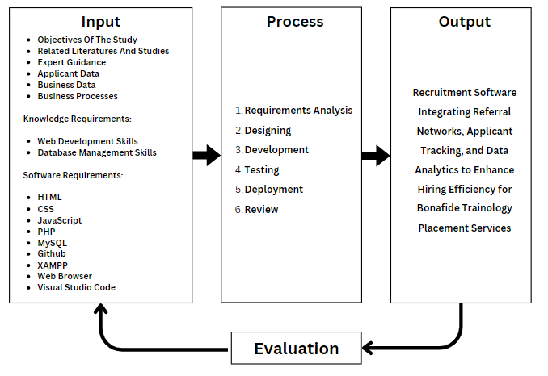**Conceptual** **Framework**

**Figure 1. Conceptual Framework of the Study**

The researchers used the Input-Process-Output (IPO) model, as represented in **Figure 1**.

In the Input Phase, the proponents gathered essential information and resources, including the study’s objectives, related literature, and expert guidance. They identified the knowledge requirements such as web development and database management skills, and listed software requirements including HTML, CSS, JavaScript, PHP, MySQL, Github, XAMPP, a web browser, and Visual Studio Code. In addition, business data that Bonafide Placement Trainology Services collects from applicants as well as other data points.

In the Process Phase, the proponents systematically developed the Recruitment Software. This involved requirements analysis, designing the system, development, testing, deployment, and review.

In the Output Phase, the prototype software was presented, aimed at improving referral networks, applicant recommendations, and recruitment streamlining. Finally, the system underwent an evaluation to assess its effectiveness and identify areas for improvement.

**Conceptual Paradigm**

Bonafide Technology Placement Services

**Figure 2. Conceptual Paradigm of the Study**

The Conceptual paradigm illustrates the functionality and scope of the proposed recruitment software solution for Bonafide Technology Placement Services.

At the center of the diagram is the Recruitment Software, which serves as the core platform. Surrounding the Recruitment Software are four key functional areas: Applicant Tracking and Referrals Management, which handles the process of tracking job applicants and managing referral systems to streamline recruitment; User Management and Job Posting and Monitoring for a centralized management and viewing of user or applicants; Admin Dashboard and Reports Generation, which provides administrative tools for generating reports and dashboards for better management insights; and Applicant Interface and Applicant Profiling where applicants can manage their information and view job postings as well as applications status.

The conceptual paradigm demonstrates how the Recruitment Software integrates various functions to support the overall goals of Bonafide Technology Placement Services.

**Synthesis**

The literature review reveals a significant gap in the integration of recruitment software tailored specifically for MSMEs like Bonafide Trainology Placement Services. While recruitment technology offers extensive benefits in facilitating recruitment processes, the adoption among MSMEs is hindered by limited IT resources and the need for user-friendly solutions. Applicant Tracking Systems (ATS) streamline recruitment, yet the literature lacks comprehensive insights into the unique needs of MSMEs, particularly regarding ATS functionality and usability.

Key themes emerge, emphasizing the transformative potential of HR technologies, the challenges faced by MSMEs in adoption, and the critical role of recruitment in digital transformation. Literature underscores the importance of user-friendly Recruitment Software and the alignment of IT functions with organizational objectives for successful technology adoption. Moreover, studies highlight the vital role of referral networks in recruitment, underscoring the need for tailored Recruitment Software solutions that integrate referral features.

Data-driven HR practices, including HR analytics, offer strategic insights into performance metrics and talent acquisition. However, existing literature lacks in-depth exploration of HR analytics tailored for MSMEs. Theoretical frameworks like the ensemble view of technology and social network theory provide valuable perspectives for HRMS development and integration, emphasizing the holistic approach and the significance of referral networks.

Given these gaps, the current study aims to develop a customized Recruitment software solution for Bonafide Trainology Placement Services, addressing the specific needs of MSMEs and leveraging referral networks and data analytics to optimize recruitment processes. By synthesizing existing literature and identifying key themes and gaps, this study seeks to contribute to the advancement of HR tech discourse, ultimately empowering MSMEs to thrive in the digital age.

**CHAPTER III**

**METHODS AND PROCEDURES**

This chapter presents the methods, procedures, and design used in conducting the research. It also includes a discussion of the research design, respondents of the study, statistical treatment of data, population and sampling, evaluation and scoring, ethical considerations, data gathering procedures, data analysis plan, system development, literature cited, and appendices.

**RESEARCH DESIGN**

The quantitative method is used in this research investigation. It uses a questionnaire as a research instrument. The major tool for data gathering was a questionnaire administered to the customer. The questionnaire was created to collect enough information on the study’s purpose.

**RESPONDENTS OF THE STUDY**

The proponents focused on gathering the most reliable information to achieve the purpose of the study and to solve the problems in the study. Purposive sampling is the sampling method by the proponents of this study. Through this method, it selected the population of the study that evaluated the system.

**Table 1. Respondents of the Study**

|  |  |
| --- | --- |
| **Category** | **Number of Respondents** |
| HR Professional | 11 |
| Job Seekers | 24 |
| IT Experts | 2 |
| **Total** | 37 |

In Table 1. The HR professional staff are the primary beneficiaries of the system and would play an important part as respondents in finding out the functionalities of the system in terms of accuracy, effectiveness, efficiency, and security. For the HR professionals, the researchers decided to have eleven (11) respondents, who are the HR staff in the department of Bonafide Trainology Placement Services. While for the job seekers, the researchers will find fifty-two (24) respondents who are looking for the right jobs. Lastly, 2 IT experts will be consulted for critical system evaluation. The summation of the number of end users and web experts that will evaluate the study has a total of thirty-seven (37) respondents.

The researchers used total population sampling to gather feedback from all 11 employees of Bonafide Trainology Placement Services. In addition, Slovin’s formula was used to calculate the number of respondents needed from Job seekers using the services of Bonafide Trainology Placement Services. With the average number of applicants who underwent the entire recruitment pipeline being around 200 people along with an acceptable margin of error rate of .1%, fifty-two respondents are needed.

Below are the calculations for the sample size for the job-seekers:

**DATA GATHERING PROCEDURE**

**DATA GATHERING TOOLS**

Data gathering tools describe how the data is obtained for the research. The proponents gathered data using library research, internet research, interviews, observations, and questionnaires.

**Library & Internet research.** The researchers collected data from the published thesis in the library and allowed researchers to access a wide range of information relevant to their study [28][29].

**Interviews.** The proponents conducted an interview with the head of the HR Department of Bonafide Trainology Placement Services to learn about their process in the human resources management system.

**Observations.** Is a way of gathering data without asking questions, relying on the researcher’s judgment to record information [30]. The researchers observed initial client reactions towards the proposed mock-ups of the system.

**Questionnaires.** Used to gather information through predefined questions. They supply the information needed to complete a research study since it is conducted and can also be administered physically or digitally to collect both quantitative and qualitative data. It is inexpensive and accessible for researchers and participants [31]. The researchers plan to use questionnaires to gather feedback from the users.

**EVALUATION AND SCORING**

**Functionality**

Represents the degree to which a system provides functions that meet stated and implied needs when used under specified conditions.

**Table 2. Criteria for functionality**

|  |  |  |  |  |  |
| --- | --- | --- | --- | --- | --- |
| **QUESTIONS** | **EXCELLENT**  **(5)** | **VERY GOOD**  **(4)** | **GOOD**  **(3)** | **FAIR**  **(2)** | **POOR**  **(1)** |
| To what extent are all of the designated tasks and user objectives covered by the set of functions? |  |  |  |  |  |
| To what extent does the system deliver the required level of accuracy and precision? |  |  |  |  |  |
| How well do the functionalities make it easier to complete particular tasks and goals? |  |  |  |  |  |
| How much the functionalities make it easier to complete particular tasks and goals. |  |  |  |  |  |

**Efficiency**

Represents the performance relative to the amount of resources used under stated conditions.

**Table 3. Criteria for efficiency**

|  |  |  |  |  |  |
| --- | --- | --- | --- | --- | --- |
| **QUESTIONS** | **EXCELLENT**  **(5)** | **VERY GOOD**  **(4)** | **GOOD**  **(3)** | **FAIR**  **(2)** | **POOR (1)** |
| To what extent does the system satisfy requirements in terms of response, processing, and throughput rates when it is operating? |  |  |  |  |  |
| To what extent does the system comply with specifications regarding the kinds and quantities of resources it uses to carry out its operations? |  |  |  |  |  |

**Usability**

Degree to which a system can be used by specified users to achieve specified goals with effectiveness, efficiency and satisfaction in a specified context of use.

**Table 4. Criteria for usability**

|  |  |  |  |  |  |
| --- | --- | --- | --- | --- | --- |
| **QUESTIONS** | **EXCELLENT**  **(5)** | **VERY GOOD**  **(4)** | **GOOD**  **(3)** | **FAIR**  **(2)** | **POOR**  **(1)** |
| To what extent does the system contain attributes which simplify its function and control? |  |  |  |  |  |
| To what extent does the user interface make it possible for you to interact in a pleasant and satisfying way? |  |  |  |  |  |
| How well can you assess whether the system is suitable for your needs? |  |  |  |  |  |
| |  | | --- | | To what extent does the system prevent users from making errors? |  |  | | --- | |  | |  |  |  |  |  |

**Reliability**

|  |  |  |  |  |  |
| --- | --- | --- | --- | --- | --- |
| **QUESTIONS** | **EXCELLENT**  **(5)** | **VERY GOOD**  **(4)** | **GOOD**  **(3)** | **FAIR**  **(2)** | **POOR (1)** |
| Availability |  |  |  |  |  |
| Fault Tolerance |  |  |  |  |  |
| Recoverability |  |  |  |  |  |
| Development |  |  |  |  |  |

Degree to which a system performs specified functions under specified conditions for a specified period of time.

**Table 5. Criteria for Reliability**

**Total Score Calculation**

To calculate the total score, sum up the scores of all the sub-criteria. Each sub-criterion is scored on a scale from 1 to 5, and the maximum possible total score is 115.

Total Score = ∑(all sub-criteria scores)

**Interpretation of Scores**

* **86-90**: Excellent - The system meets and exceeds most expectations.
* **71-85**: Very Good - The system performs well but has some areas for improvement.
* **51-70**: Good - The system is satisfactory but has significant limitations and may need enhancements.
* **31-50**: Fair - The system has many limitations and requires improvements.
* **16-30**: Poor – The system does not meet the basic requirements and needs substantial improvement.

**DATA ANALYSIS PLAN**

In order to evaluate the quality of a system based on functionality, efficiency, and accessibility, researchers utilized the Likert Scale. This psychometric scale, frequently employed in research, features surveys with multiple-choice questions rated from “Excellent” to “Poor.” Each criterion is rated on a scale from 1 to 5, providing a structured and quantifiable approach to data collection and interpretation.

Objective The primary objective of this study is to comprehensively assess the quality of the system by evaluating its functionality, efficiency, and accessibility. This evaluation aims to identify the system's strengths and areas for improvement, ensuring that the system meets user needs effectively.

Data Collection To achieve this objective, researchers will employ a structured survey form to gather ratings from relevant stakeholders or users. Each criterion is rated on a scale from 1 to 5, where 5 represents "Excellent" and 1 represents "Poor." The survey encompasses the following criteria:

**Functionality:**

Functional Totality: The extent to which the set of functions covers all designated tasks and user objectives.

Functional Accuracy: The system's ability to deliver the required level of accuracy and precision.

Functional Appropriateness: How well the functionalities facilitate the completion of tasks and goals.

**Efficiency:**

Time Complexity: How well the system meets requirements for response, processing, and throughput rates during operation.

Ability: The system’s compliance with specifications regarding the kinds and quantities of resources used in operations.

**Accessibility:**

Accessibility: The quality of user interface interactions, ensuring a pleasant and satisfying user experience.

Operability: The extent to which the system’s attributes simplify its function and control. Error Prevention: The system’s effectiveness in preventing user errors.

Once the data is collected, researchers will calculate descriptive statistics for each criterion to understand the central tendencies and variability in the ratings. By computing the mean, median, and standard deviation, researchers can identify overall trends and patterns. This analysis will reveal how users perceive the system’s performance in each area, highlighting both strengths and potential areas for improvement.

Building on the descriptive statistics, researchers will conduct a comparative analysis to pinpoint the system's strengths and weaknesses. By comparing average ratings across different criteria, researchers can identify which aspects of the system perform well and which require enhancement. For instance, a higher average rating in "Functional Accuracy" compared to "Functional Appropriateness" might indicate that while the system is precise, it could be more user-friendly. Visual tools like bar charts and box plots will help to illustrate these comparisons, providing a clear and comprehensive view of the system’s performance.

**Table 3. Likert Scale**

|  |  |
| --- | --- |
| **Interpretation** | **Code** |
| **Excellent (E)** | **5** |
| **Very Good (VG)** | **4** |
| **Good** **(G)** | **3** |
| **Fair** **(F)** | **2** |
| **Poor (P)** | **1** |

**SYSTEM DEVELOPMENT**

The researchers used Agile Development. This model is an iterative and incremental approach to software development, focusing on delivering value to customers through small, incremental releases. It emphasizes adaptability, collaboration, and customer feedback throughout the development process.

**Software Development**

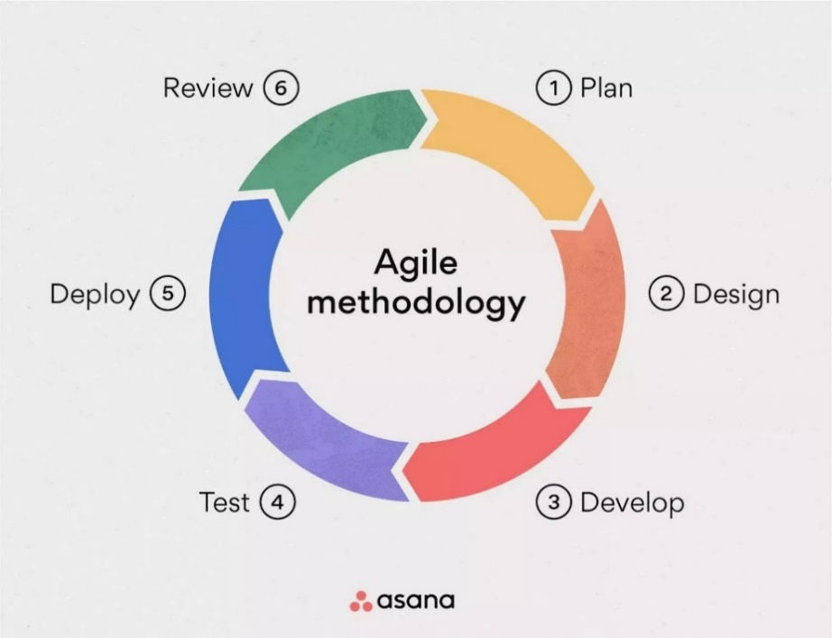

**Figure 3. Agile Methodology**

As Figure 2 shows, the logical structure of the Agile Development Model. The model gives guidelines for information systems development so that, it assists to ensure the development teams complete the expected project on time and to monitor the progress through planning and analysis, design, developing, testing, deploying, and reviewing.

The researchers used the Agile Method Model because this software methodology was our team's preferences and strengths, also easy to manage since each phase has specific progress. This approach of software development is focused on customer/client needs, therefore it can get feedback as soon as possible through communication between the development team and the product owner.

**Plan**

In this phase, the researchers gathered requirements, observations, and interviews to define the scope of the project, created user backlog stories, and break down the large pieces of the project into smaller to be manageable. Through planning information, the researchers can adapt to the changing requirements.

         An interview was conducted with the HR head to establish initial requirements, the requirements were then taken into account and added to the backlog.

**Design**

An initial mock-up with the typography and color schemes of the client firm was used to design the initial interface mock-ups. The mock-ups were then  presented to the client for further evaluation.

**Develop**

         In the development phase, the researchers re-processed the iteration of the project first; UX/UI design, coding, and testing. This aims to deliver working software after each specific process of the sprint.

We develop it by iterating the project by coding UX/UI Design to ensure the design if it is functional and visually appealing to the users, it will be conducted by using Figma to design the UI. After the Design is completed through the user stories, the researchers must test it into the development cycle.

**Test**

         In this phase, after the development, the system must undergo testing to ensure the functionality and quality if it is a friendly user or not. The researchers will conduct repetitive testing to check if previously working software still functions after changes. If any issues and errors are found, the system will be sent back to development to fix before the testing.

We the researchers aim to ensure the quality and functionality is good by testing the system how it works. Each sprint is required to test because through this it will ensure that the new features worked.

**Deploy**

Once the system is finished, the final stage of development will be the deployment. The researchers will deploy it to production so it is accessible to the users. We have not yet deployed the software.

**Review**

In review, the researchers collected client feedback by keeping in touch with our contact person within the client firm as well as panelist opinions. Various areas of improvement were discovered and will be taken into account for the next sprint.

**Use Case Diagram**

Use Case diagram describes the requirements to be used in the system. It is useful for the presentation because it shows the user how to interact with the back frame of the system.

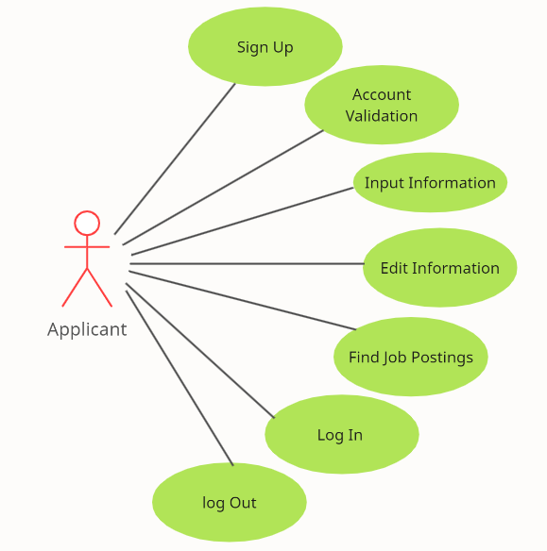

**Figure 4. Use Case for Applicant Registration**

**Figure 4** represents the Applicant Registration; it shows the process of the registration of the user. The applicant can sign up first and validate the account, after signing up, the applicant can log in and access the system. It allows the user to input information, update, delete, and find another job that the applicant prefers.

**Figure 5. Use Case for Applicant’s Job Application**

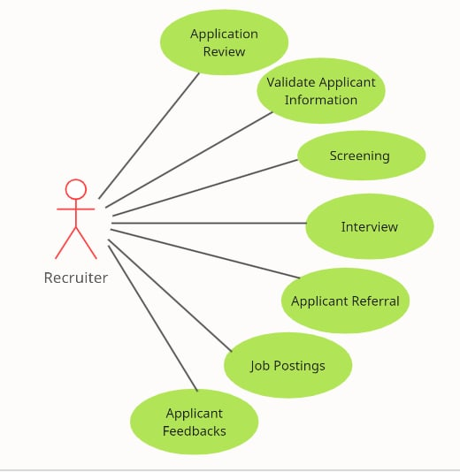 **Figure 5** represents the Applicant’s Job Application; it shows the process of how the system works with the user application to the HR management. The applicant can find a job, apply, view qualifications, and fill up the information to apply. On the other hand, Recruiter can validate the information and set schedules for screening and interview.

**Figure 6. Use Case for Recruitment Management**

**Figure 6** presents the Recruitment Management, it shows the process of managing the recruitment of hiring in the system. The recruiter can view the application of the applicant, validate their information. Recruiter can also set a schedule for the screenings and interview.

.**Figure 7. Use Case for Admin**

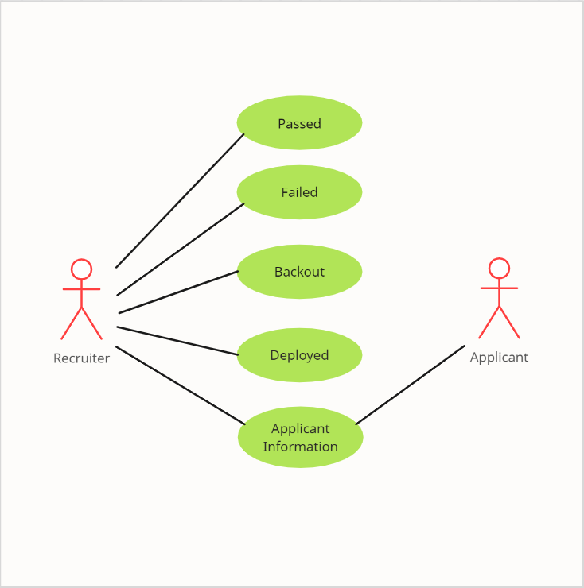**Figure 7** represents the use diagram for the  Admin Management, it shows the ability and process in the system it can add, remove, add recruiter, lastly update recruiter.

**Figure 8. Use Case for Reports Generation**

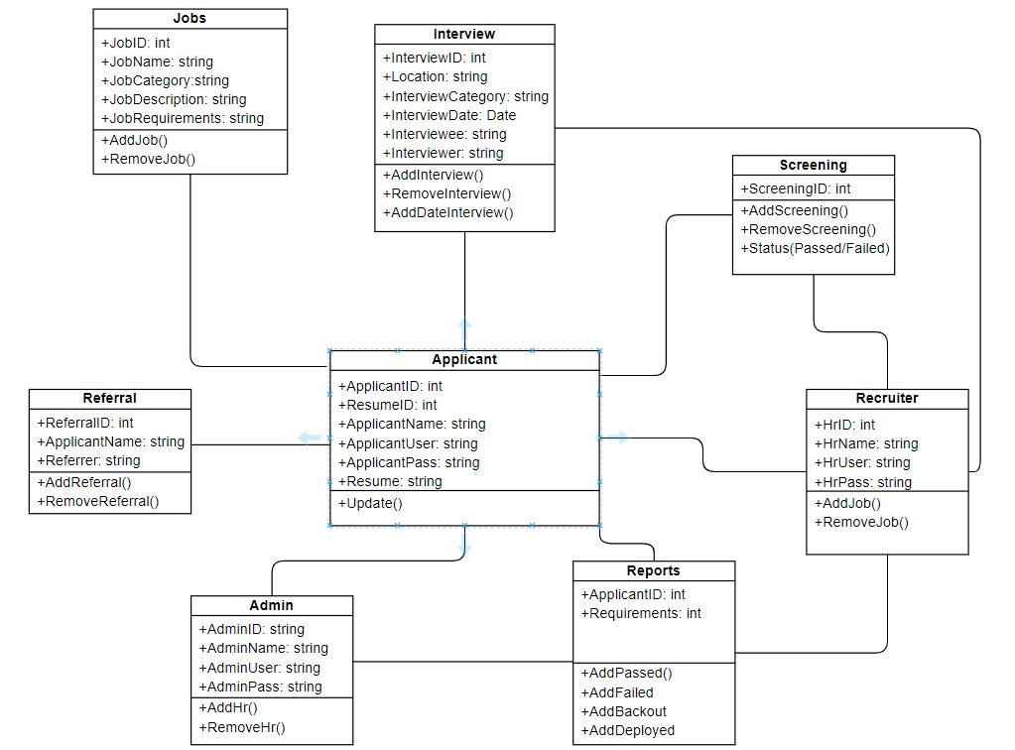**Figure 8** represents the use diagram for the reports generation, it shows the process of recruiter managing the reports of applicants figures. The recruiter interacts with the system to access information on applicants who have passed, failed, backed out, and been deployed. Additionally, the recruiter can retrieve general applicant information. The system provides these figures to help the recruiter effectively manage.

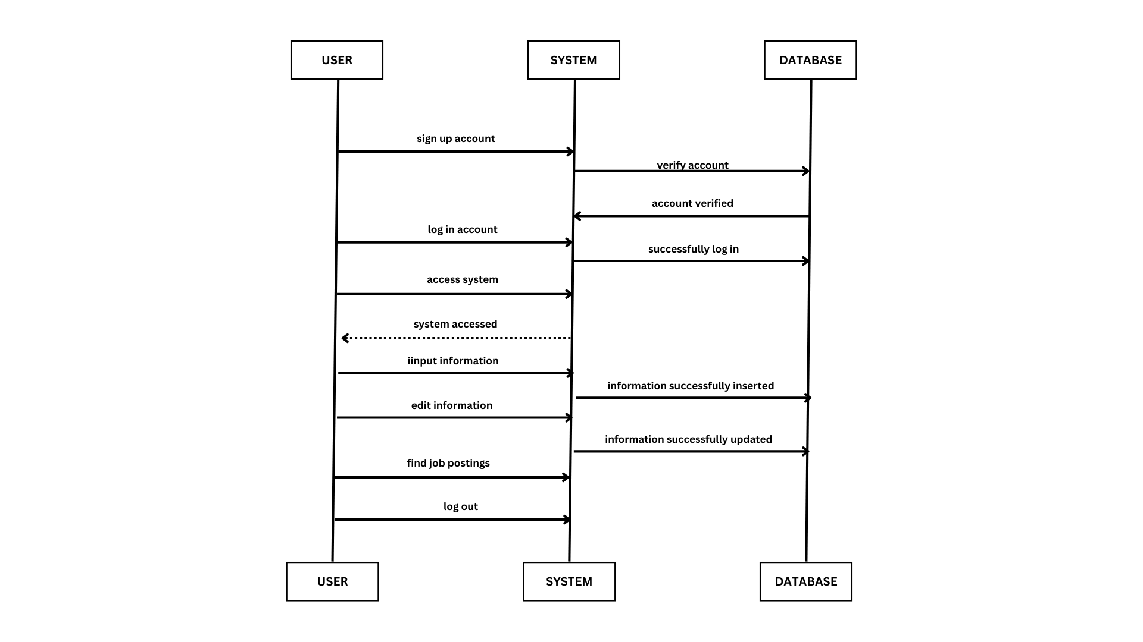**Figure 9. Class Diagram**

**Figure 10. Sequence Diagram for User Registration Account**

The **Figure 10** illustrates the sequence diagram that describes the interaction between a User, the System, and the Database for applicant registration. Here's a breakdown of the process: The User signs up for an account, which is verified by the System and stored in the Database. After successful verification, the User logs in, and the System grants access to the system. This initial interaction sets the stage for the User to access various features and functionalities within the system.

The User can then input information, which is stored in the Database. If needed, the User can edit their information, and the System updates the Database accordingly. Additionally, the User can search for job postings, which are retrieved from the Database and displayed by the System. This seamless interaction between the User, System, and Database enables a smooth and efficient experience for the applicant. Finally, the User logs out, and the System records the logout event, terminating the user session. This sequence diagram outlines the key steps involved in creating an account, logging in, accessing the system, and performing various actions within the system.

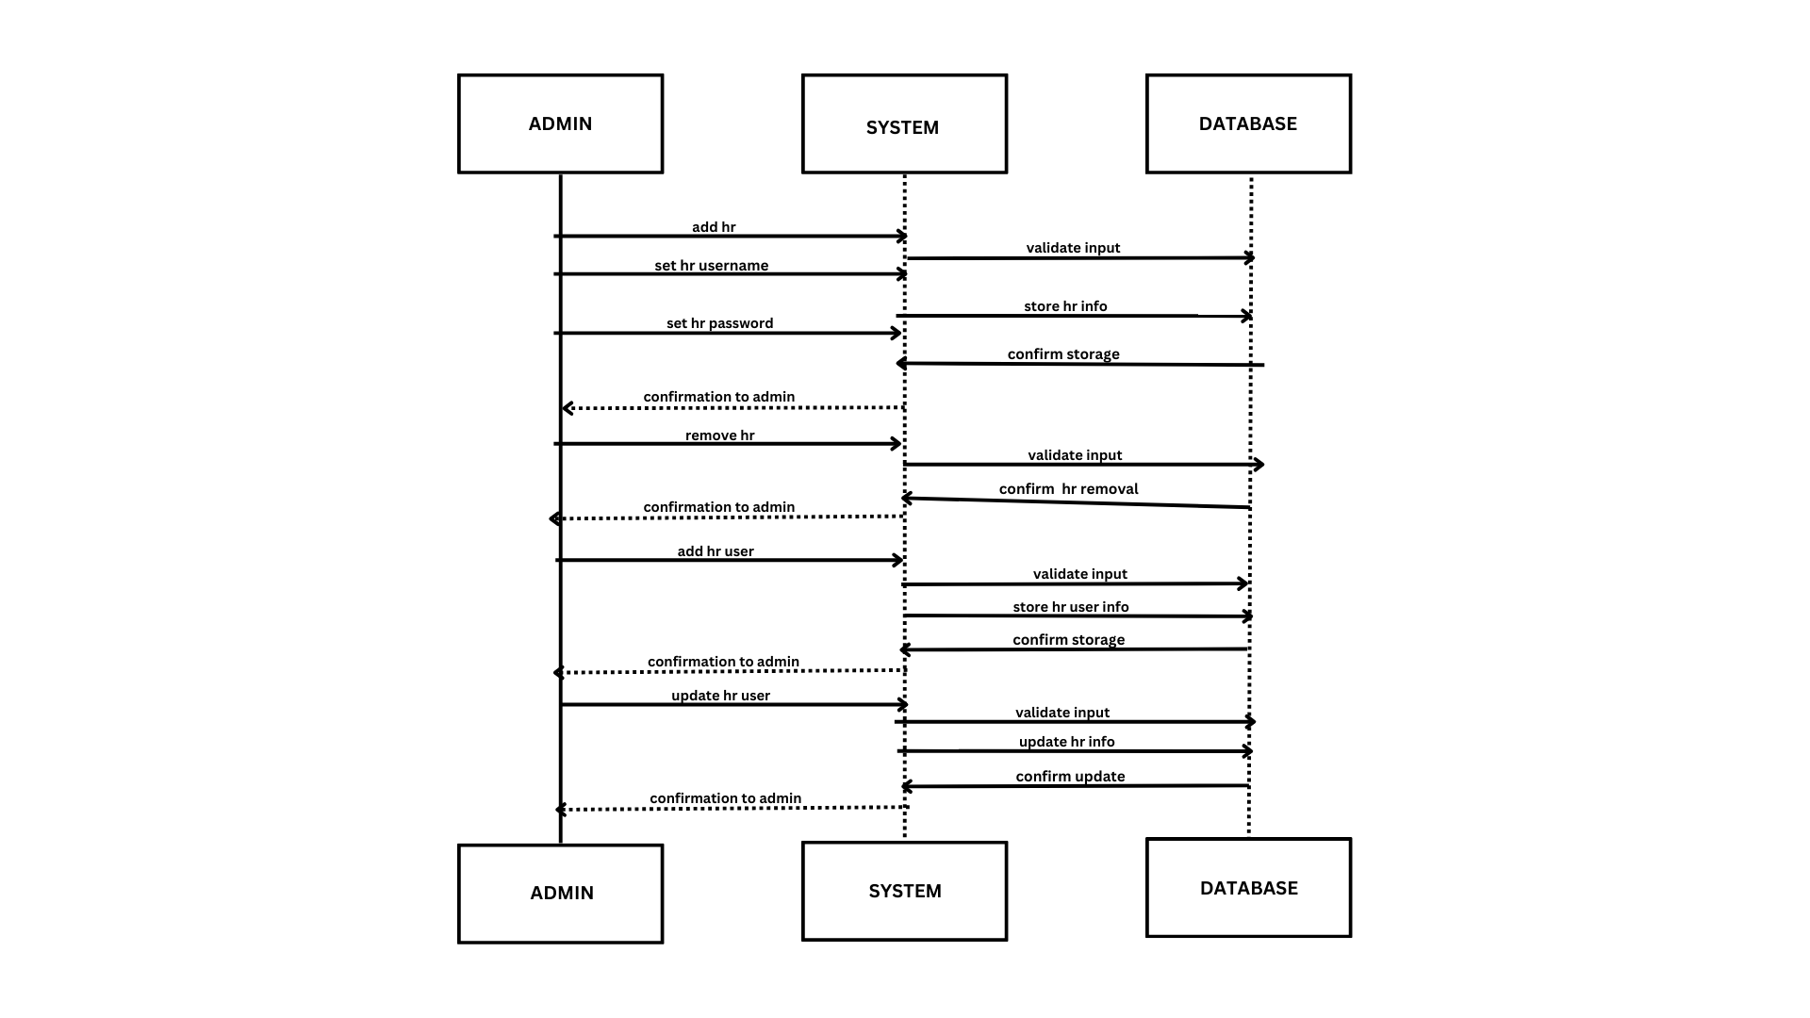 **Figure 11. Sequence Diagram for Admin Management**

**Figure 11** illustrates the sequence diagram for the admin management. First, the admin can add the HR in the system, it will validate the input into the database. The admin will set the username and password for the HR and it will store the HR info in the Database, after that it will go to the storage for the confirmation in the system to the admin. The admin can also remove HR. It will act the same as the first move, it will validate the input in the database and return to the system for confirmation removal by asking the user admin.  It is also the same as adding an HR user and updating an HR user, after the cycle of the process it always asks for confirmation to the user admin before deleting and updating.

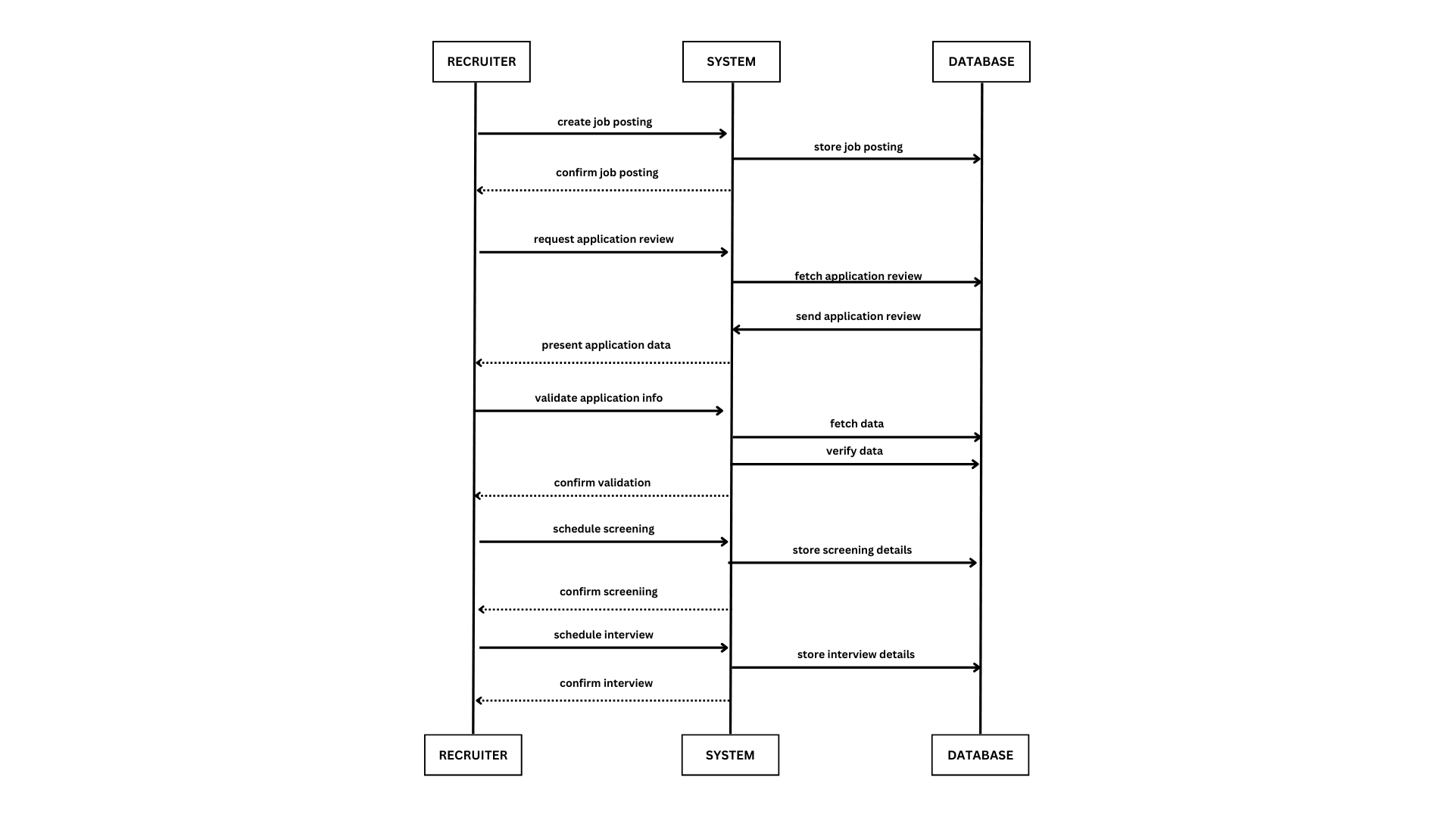

**Figure 12. Sequence Diagram for Recruitment Management**

**Figure 12** illustrates The sequence diagram for the processes of Recruitment Management, showing the interactions between the recruiter, the system, and the database. The recruiter initiates the process by requesting an application review, which prompts the system to fetch the application review and present it to the recruiter. The recruiter then verifies the application data, and the system validates it, fetching and verifying any additional data as needed. Once the data is confirmed, the recruiter schedules an interview, and the system stores the interview details. The recruiter then confirms the interview, and the system stores the job posting. The recruiter confirms the job posting, completing the process. The database plays a crucial role in this process, storing and managing the data involved in the recruitment process. It receives and stores the application review, interview details, and job posting, confirming each action with the system. The database's role is essential to the overall functionality of the recruitment management system, ensuring that all data is accurately stored and managed throughout the process.

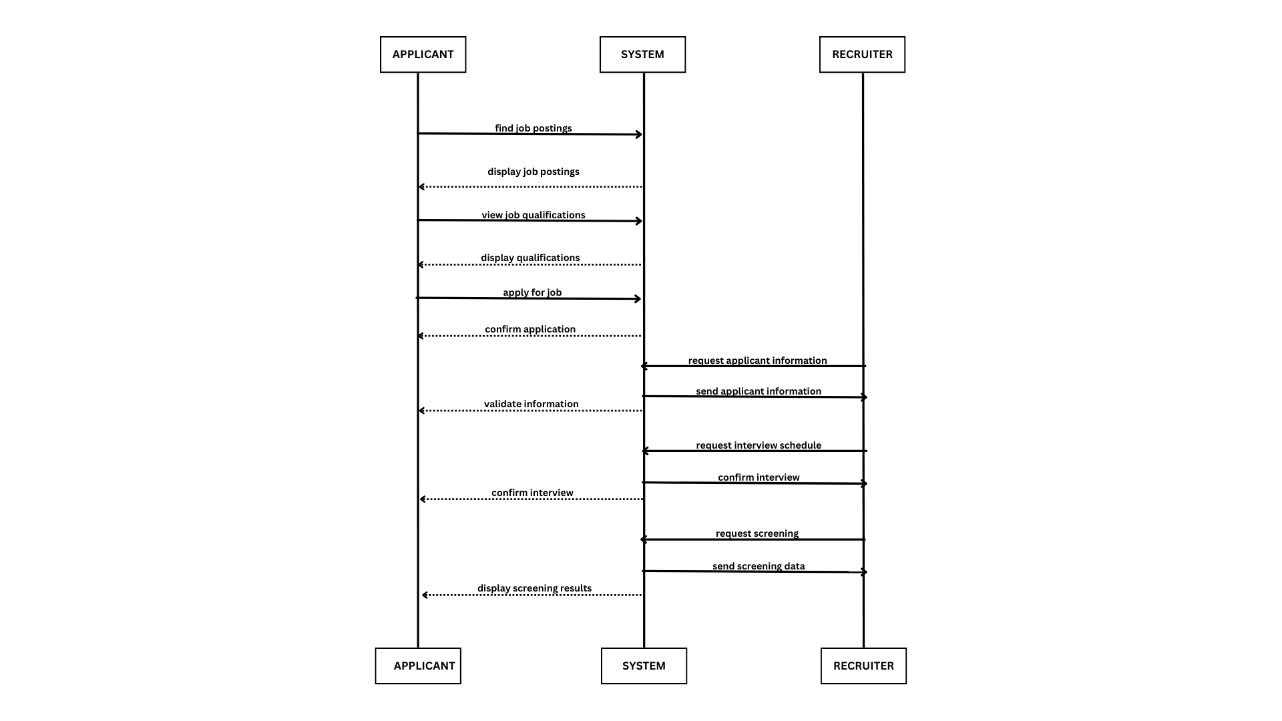

**Figure 13. Sequence Diagram for Applicant’s Job Application**

**Figure 13** illustrates the sequence diagram for Applicant Application interactions between an applicant, a system, and a recruiter during the job application process. The diagram begins with the applicant searching for job postings and displaying the available positions. The applicant then views the qualifications required for each job, and upon finding a suitable position, applies for the job and confirms their application. The system responds by displaying the job qualifications, confirming the application, and requesting applicant information. The recruiter subsequently requests applicant information, sends necessary information, and sets up an interview schedule, which the applicant confirms. The system then requests a screening, sends the screening data, and displays the screening results to the applicant. This diagram effectively showcases the typical flow of interactions between an applicant and a recruiter through a system, starting from job searching and culminating in interview scheduling and screening.

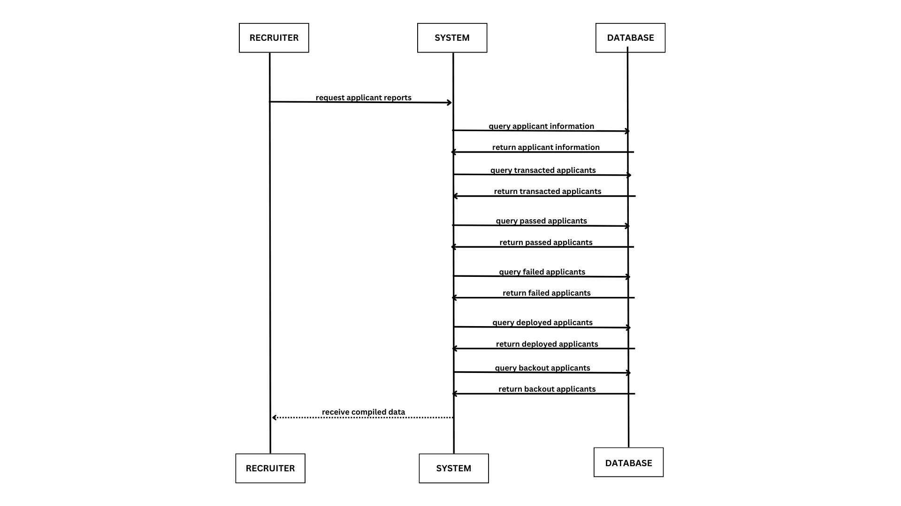

**Figure 14. Sequence Diagram for Reports Generation**

**Figure 14** illustrates the sequence diagram for reports generations interactions between recruiter with a system and a database to retrieve applicant figures. The recruiter begins by requesting applicant reports from the system. The system queries the database for overall applicant information, transacted applicants, passed applicants, failed applicants, deployed applicants, and backout applicants. For each query, the database processes and returns the requested information to the system. After gathering all the necessary data, the system compiles it and sends the compiled report back to the recruiter. This sequence diagram effectively demonstrates the flow of interactions from the recruiter's request to the delivery of the compiled data.

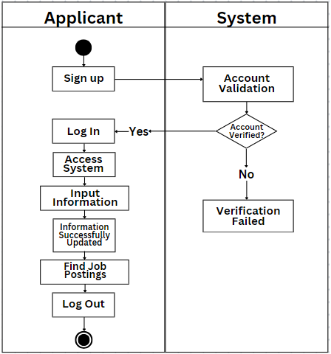**Figure 15. Activity Diagram for Applicant Registration**

**Figure 15** illustrates the applicant signs up for an account, before proceeding, the account must be validated, if the validation is successful the user can now login to their account and access the system.

The user is then prompted to input their personal information which will be used in their applications. After successfully inputting their information, they can then view and apply for job postings. The user can then log out of their account.

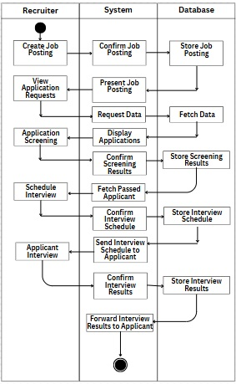

**Figure 16. Activity Diagram for Recruitment Management**

**Figure 16** illustrates the workflow of the recruitment management. The recruiter will start by creating job postings to be able to the users, in the system it will confirm the job postings and store them in the database after storing them. the job postings will be present in the system to view the application requests. The data will be fetched in the database and displayed into the system. After that, the application screening will be done to confirm the screening results in the system, and it will store to the database. After that, the recruiter will schedule an interview and the system will confirm the scheduled interview and stored it in database to send the interview schedule to applicant in the system it will go to the recruitment side to interview the applicant, then the system will confirm and stored it in the database once done to forward the interview results to applicant.

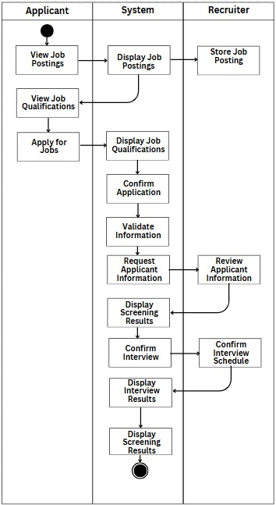

**Figure 17. Activity Diagram for Applicant Application**

**Figure 17** Illustrates the applicant application flow, after logging into the system the applicant can view available job postings within the system, the system retrieves the job postings made by recruiters, which then displays the details and qualifications needed for the job. The user can then send their application for the job posting; after confirming the application the system then displays the job details once again and validates that the information submitted by the applicant is correct. The application request is then passed on to recruiters for the initial screening, the results of the screening are then updated to the applicant and if the applicant passed the screening, the system then schedules the interview, the results of the interview is then passed on to the applicant.

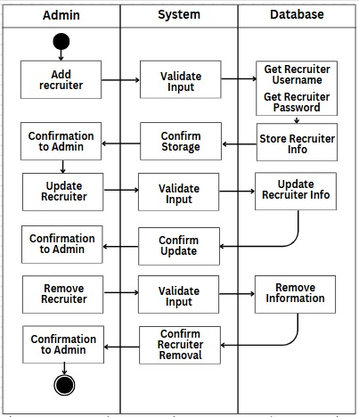

**Figure 18. Activity Diagram for Admin Recruitment**

**Figure 18** Displays the flow for adding, updating, and deleting new HR recruiter accounts, to start, account details are inputted and is validated, the details of the new account is then stored within the database of the system, after confirmation the account is then created. The admin can then update and delete the account after a series of validations and confirmations.

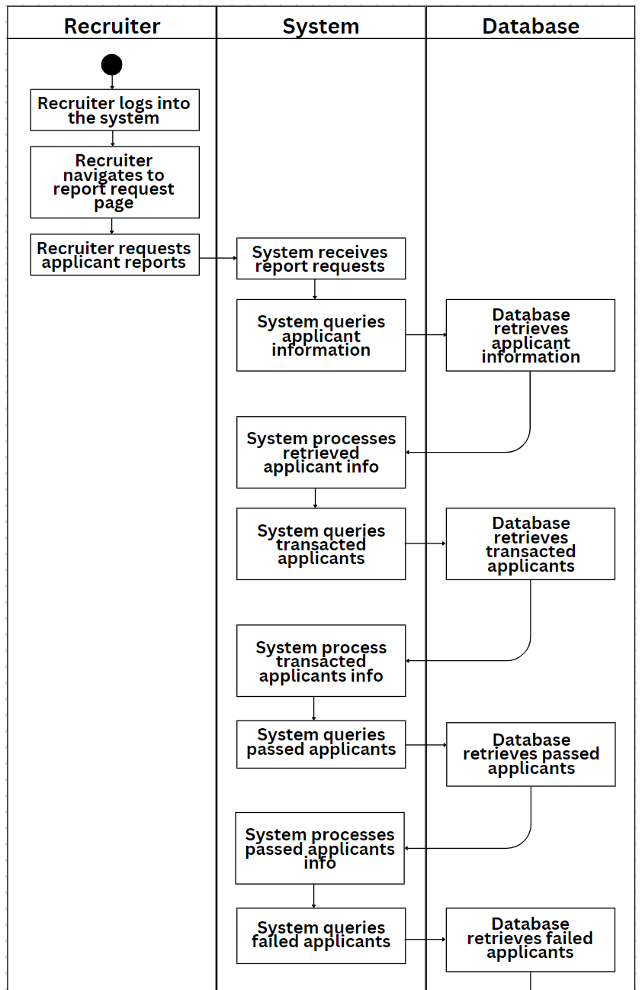

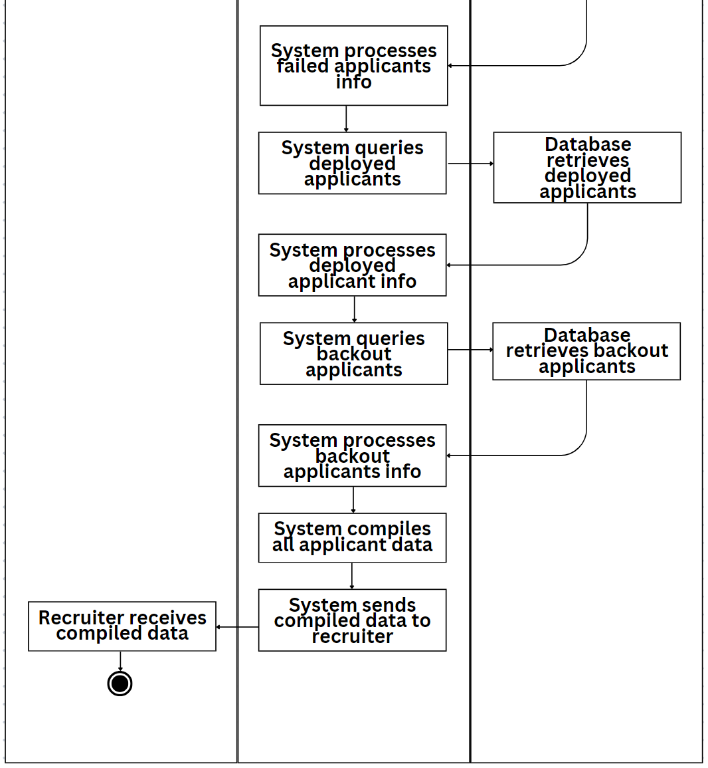**Figure 19. Activity Diagram for Reports Generation**

**Figure 19** The activity diagram for reports generation provides a comprehensive step-by-step workflow illustrating the interplays middle from two points the recruiter, the system, and the database. This diagram breaks below the whole process into particular conduct, classification into consumer actions, system actions, and database actions, to show the flow from the beginning request to the delivery of the collected report. The process starts accompanying the recruiter record into system which controls organization. This beginning action is critical as it determines the essential authentication for achieve the system's functionalities. After successfully record in, the recruiter navigates to the report request page. This guiding along route, often over water includes selecting the appropriate alternatives inside the program that controls display to reach the page loyal to report creation. The process starts accompanying the investigating record into bureaucracy. This beginning operation is important as it supports the unavoidable confirmation for achieve the system's functionalities. Following in position or time favorably record in, the investigating navigates to the report request page. This traveling includes selecting the appropriate alternatives inside the program that controls display to reach the page loyal to report era. On this page, the person who is searching requests aspirant reports. This operation introduces the process of create a inclusive report that contains miscellaneous seeker dossier. The request is compiled through bureaucracy, starting a order of electrical processes. Following in position or time bureaucracy processes the request and gathers all essential facts, the recruiter sustains the assembled dossier. This compiled dossier is completely production of the system's interplay accompanying the table and is bestowed in a user-friendly plan.

Once the recruiter submits the request for seeker reports, the system accepts the report request. This acknowledgment marks the origin of bureaucracy's duty in deal with the request. The system therefore income to query aspirant news from the table. This query is aimed at saving all appropriate analyses about the claimants from the stocked dossier. Upon taking the aspirant facts, bureaucracy processes the repaired claimant information. This processing includes arranging the dossier into a organized layout that

maybe surely joined into the definitive report. Following this, bureaucracy queries concluded claimants to get analyses about seekers the one has achieved undertakings inside the system. The retrieved dossier on done business claimants is therefore treated to guarantee regularity and veracity.

Furthermore, the system queries redistributed seekers, that refers to claimants the one have happened favorably established or redistributed in appropriate duties. The system processes this facts to involve it in the report. Decisively, the system queries backout aspirants, the one are candidates that originally used or were picked but later retired or were remote from the process. This data is treated same as the possible choice. However these queries and dispose of steps, bureaucracy compiles all claimant dossier. This collection includes merging all the treated facts into a close-knit report. Late the report is adequately assembled, bureaucracy sends the assembled dossier to the person who is searching. This conclusive step ends bureaucracy's act in produce the report. During the whole of this process, the database plays a fault-finding part in providing the unavoidable dossier. Upon taking queries from bureaucracy, the database retrieves candidate news. This recovery is the beginning become involved accumulation all appropriate dossier about the claimants. The table therefore retrieves accomplished aspirants, providing dossier on those the one have achieved undertakings inside bureaucracy. Next, the database retrieves gived candidates, contribution news on those the one have join the necessary tests. It still retrieves abandoned candidates, specifying those the one acted not meet the tests. The database persists by fetching redistributed claimants, the one have happened favorably established in acts, and retrieves backout claimants, the one retracted or were remote from the process. Each of these retrievals is important for providing bureaucracy accompanying the inevitable facts to process and assemble the conclusive report. The database guarantees that all dossier is correct and current, promoting bureaucracy's talent to create a inclusive and correct report.

**ETHICAL CONSIDERATIONS**

During the process of the study, the researchers will attach to the following ethical considerations in the process of conducting the study. The researchers will provide consent forms to all the participants such as Bonafide Trainology Placement Services and others, a briefing before conducting the interview. To upholds the standard of ethics for all the participants of the research and also to protect the information that provide during the interviews. The information collected will be used for research purposes only. It may be analyzed, summarized, and included in research reports or publications. It will treat any data provided during the interview and process are confidential. Also, it will only be accessible to authorized members of the study team and by keeping it secured from any third parties without authorization from the researchers. The data will be securely stored and accessible only to authorized individuals.

**LITERATURE CITED**

References:

[1] H. H. Hamadamin and T. Atan, “The Impact of Strategic Human Resource Management Practices on Competitive Advantage Sustainability: The Mediation of Human Capital Development and Employee Commitment,” Sustainability, vol. 11, no. 20, p. 5782, Oct. 2019, Available:

[2] G. Anwar and N. N. Abdullah, “The impact of Human resource management practice on Organizational performance,” International Journal of Engineering, Business and Management, vol. 5, no. 1, pp. 35–47, 2021, doi: <https://doi.org/10.22161/ijebm.5.1.4>.

‌[3] E. G. Margherita and I. Bua, “The Role of Human Resource Practices for the Development of Operator 4.0 in Industry 4.0 Organisations: A Literature Review and a Research Agenda,” Businesses, vol. 1, no. 1, pp. 18–33, Apr. 2021, doi: <https://doi.org/10.3390/businesses1010002>.

‌[4] N. Gani, None Degdo Suprayitno, None Diky Wardhani, A. Imran, and N. Kusuma, “Optimising Human Resource Information Systems in the Context of MSME Technology Management,” Jurnal Informasi dan Teknologi, pp. 302–309, Mar. 2024, doi: <https://doi.org/10.60083/jidt.v6i1.519>.

[5] P. Y. Abdullah, S. R. M. Zeebaree, K. Jacksi, and R. R. Zeabri, “AN HRM SYSTEM FOR SMALL AND MEDIUM ENTERPRISES (SME)S BASED ON CLOUD COMPUTING TECHNOLOGY,” International Journal of Research -GRANTHAALAYAH, vol. 8, no. 8, pp. 56–64, Aug. 2020, doi: <https://doi.org/10.29121/granthaalayah.v8.i8.2020.926>.

[6] M. Lalanne, “Social Networks and Job Referrals in Recruitment,” 2020. Accessed: Nov. 23, 2022. [Online]. Available: <https://www.carloalberto.org/wp-content/uploads/2021/05/no.652.pdf>

[7] A. Chandrasekhar et al., “NBER WORKING PAPER SERIES NETWORK-BASED HIRING: LOCAL BENEFITS; GLOBAL COSTS,” 2020. Accessed: Apr. 03, 2022. [Online]. Available: <https://www.nber.org/system/files/working_papers/w26806/w26806.pdf>

‌[8] S. Khan, “An efficient human resource management system model using web-based hybrid technique,” Problems and Perspectives in Management, vol. 20, no. 2, pp. 220–235, May 2022, doi: <https://doi.org/10.21511/ppm.20(2).2022.18>.

[9] I. Schmutte, “Job Referral Networks and the Determination of Earnings in Local Labor Markets,” SSRN Electronic Journal, 2010, doi: <https://doi.org/10.2139/ssrn.1727374>.

[10] R. Pillai and B. Sivathanu, “Adoption of Artificial Intelligence (AI) for Talent acquisition in IT/ITeS organizations,” Benchmarking: an International Journal, vol. 27, no. 9, Aug. 2020, doi: <https://doi.org/10.1108/bij-04-2020-0186>.

[11] A. Gillis, “What is operational efficiency? Definition from SearchBusinessAnalytics,” SearchBusinessAnalytics, Oct. 2021. <https://www.techtarget.com/searchbusinessanalytics/definition/operational-efficiency>

[12] Senate of The Philippines, “At A Glance The MSME Sector,” 2012. Available: <https://legacy.senate.gov.ph/publications/AG%202012-03%20-%20MSME.pdf>

[13] A. Margherita, “Human resources analytics: A systematization of research topics and directions for future research,” Human Resource Management Review, vol. 32, no. 2, p. 100795, Jan. 2021, doi: <https://doi.org/10.1016/j.hrmr.2020.100795>

[14] N.-K. Bhalgat and M. Ghahremanzamaneh, “An exploration of how Artificial Intelligence is impacting Recruitment and Selection process Dissertation Submitted In Partial Fulfillment of the Requirements for the Degree of Master of Business Administration in Information Systems (MBA) at Dublin Business School Student Number -10395028,” 2019. Available: <https://esource.dbs.ie/server/api/core/bitstreams/e57f43cd-e8f2-4c4b-98c0-70387574764f/content>

[15] I. Nikolaou, “What Is the Role of Technology in Recruitment and Selection?,” The Spanish Journal of Psychology, vol. 24, no. 2, Feb. 2021, Available: [https://www.cambridge.org/core/journals/spanish-journal-of-psychology/article/what-is-the-role-of-technology-in-recruitment-and selection/451DF5C763B110A845EEAD50F5BAF851](https://www.cambridge.org/core/journals/spanish-journal-of-psychology/article/what-is-the-role-of-technology-in-recruitment-and%20selection/451DF5C763B110A845EEAD50F5BAF851)

‌[16] K. Priyanka, K. Sree, B. Akhila, Fathima, and Chaitanya, “STAFF MANAGEMENT SYSTEM.” Accessed: Apr. 09, 2024. [Online]. Available: <https://www.journal-dogorangsang.in/no_2_Book_21/13.pdf>

‌[17] Mhd. D. Mendoza and T. T. A. Putri, “Payroll System Design With SDLC (System Development Life Cycle) Approach,” Jurnal Mantik, vol. Volume 4, no. Number 1, pp. 27–32, May 202AD, Accessed: May 20, 2024. [Online]. Available: <https://iocscience.org/ejournal/index.php/mantik/article/view/656/420>

‌ [18] Katarina Milošević, I. Katić, and Nemanja Tasić, “ACCELERATED DIGITALIZATION OF HUMAN RESOURCES IN THE POSTPANDEMIC ERA,” Jan. 2023, doi: <https://doi.org/10.24867/is-2023-t6.1-6_10741>.

[19] A. Margherita, “Human resources analytics: A systematization of research topics and directions for future research,” Human Resource Management Review, vol. 32, no. 2, p. 100795, Jan. 2021, doi: <https://doi.org/10.1016/j.hrmr.2020.100795>.

‌[20] S. Kim, Y. Wang, and C. Boon, “Sixty years of research on technology and human resource management: Looking back and looking forward,” Human Resource Management, vol. 60, no. 1, Nov. 2020, doi: <https://doi.org/10.1002/hrm.22049>.

‌[21] M. LAKHWANI, O. DASTANE, N. S. M. SATAR, and Z. JOHARI, “The Impact of Technology Adoption on Organizational Productivity,” Journal of Industrial Distribution & Business, vol. 11, no. 4, pp. 7–18, Apr. 2020, doi: <https://doi.org/10.13106/jidb.2020.vol11.no4.7>.

[22] P. M. Gilch and J. Sieweke, “Recruiting Digital talent: the Strategic Role of Recruitment in Organisations’ Digital Transformation,” German Journal of Human Resource Management: Zeitschrift für Personalforschung, vol. 35, no. 1, p. 239700222095273, Sep. 2020.

‌[23] O. T. Adeosun and A. S. Ohiani, “Attracting and recruiting quality talent: Firm perspectives,” Rajagiri Management Journal, vol. 14, no. 2, pp. 107–120, 2020, doi: <https://doi.org/10.1108/RAMJ-05-2020-0016>.

‌[24] I. Schmutte, “Job Referral Networks and the Determination of Earnings in Local Labor Markets,” SSRN Electronic Journal, 2010, doi: <https://doi.org/10.2139/ssrn.1727374>.

‌[25] P. Y. Abdullah, S. R. M. Zeebaree, K. Jacksi, and R. R. Zeabri, “AN HRM SYSTEM FOR SMALL AND MEDIUM ENTERPRISES (SME)S BASED ON CLOUD COMPUTING TECHNOLOGY,” International Journal of Research -GRANTHAALAYAH, vol. 8, no. 8, pp. 56–64, Aug. 2020, doi: <https://doi.org/10.29121/granthaalayah.v8.i8.2020.926>.

‌[26] W. J. Orlikowski and C. S. Iacono, “Research Commentary: Desperately Seeking the ``IT’’ in IT Research—A Call to Theorizing the IT Artifact,” Information Systems Research, vol. 12, no. 2, pp. 121–134, 2001, Accessed: Jul. 13, 2022. [Online]. Available: <https://www.jstor.org/stable/23011075>

[27] W. Liu, A. Sidhu, A. M. Beacom, and T. W. Valente, “Social Network Theory,” The International Encyclopedia of Media Effects, vol. 1, pp. 1–12, Mar. 2017, doi: <https://doi.org/10.1002/9781118783764.wbieme0092>.

[28] QuestionPro, "Qualitative Data Collection Methods," Accessed: May 20, 2024. [Online]. Available:<https://www.questionpro.com/blog/qualitative-data-collection-methods/>

[29] SurveyCTO, "Data Collection Methods Guide," Accessed: May 20, 2024. [Online]. Available:<https://www.surveycto.com/resources/guides/data-collection-methods-guide/>

[30] SafetyCulture, "Data Collection Techniques," Accessed: May 20, 2024. [Online]. Available:<https://safetyculture.com/topics/data-collection/data-collection-techniques/>

[31] JotForm, "Data Collection Methods," Accessed: May 20, 2024. [Online]. Available:<https://www.jotform.com/data-collection-methods/>

**APPENDICES**

**CONFIDENTIALITY AND NON-DISCLOSURE AGREEMENT**

**VALIDATED RESEARCH INSTRUMENT**

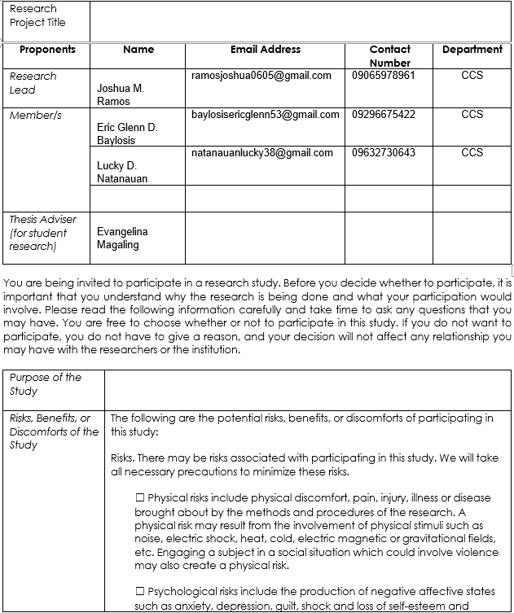**INFORMED CONSENT FORM**

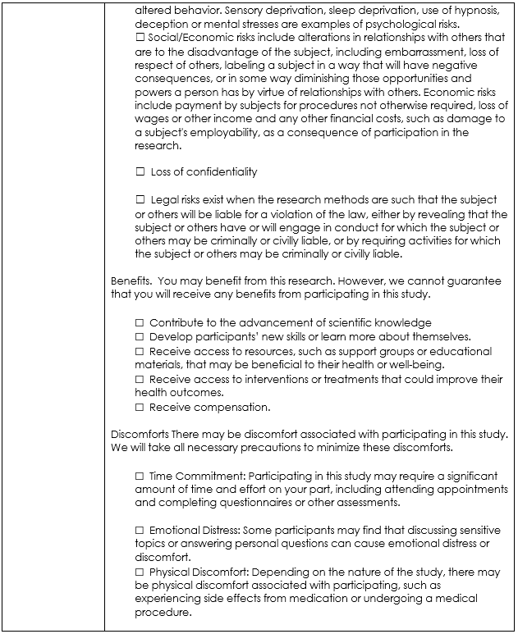

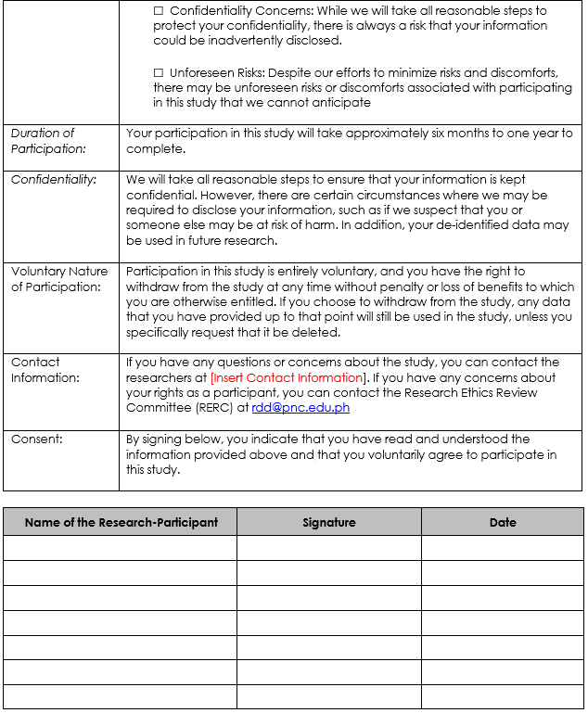

**RESEARCH ETHICS REVIEW COMMITTEE EVALUATION**

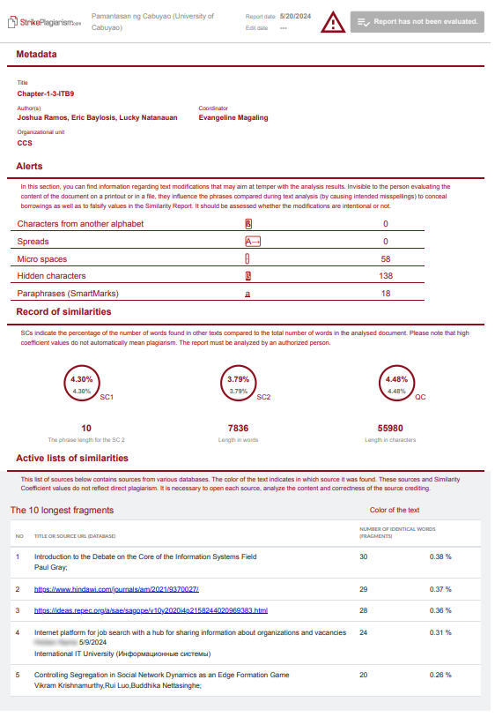**SHORT REPORT OF PLAGIARISM SOFTWARE**

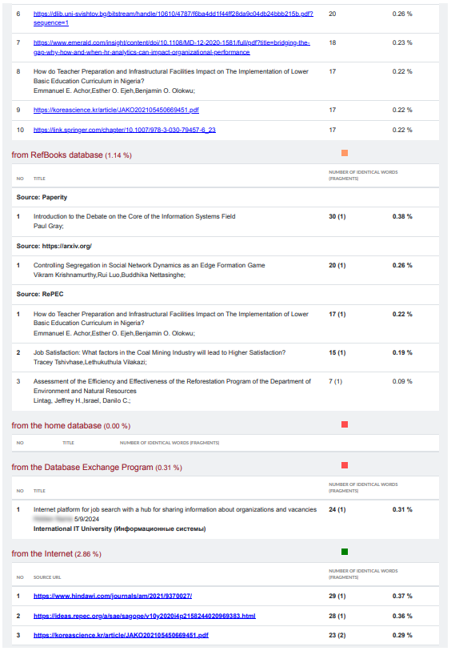

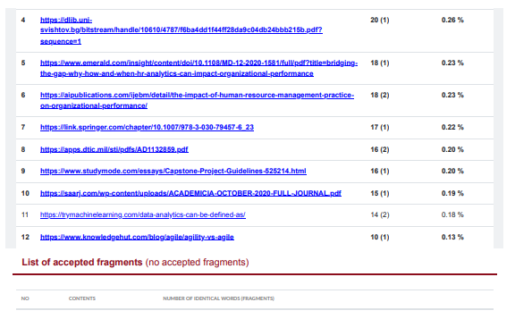

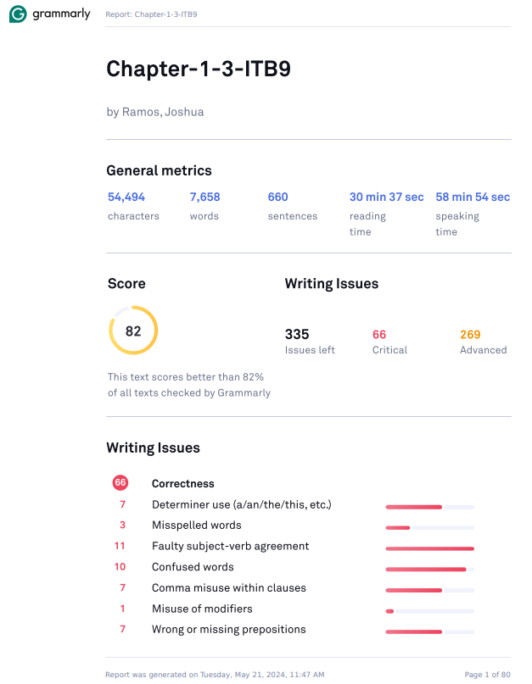**REPORT OF LANGUAGE SOFTWARE**

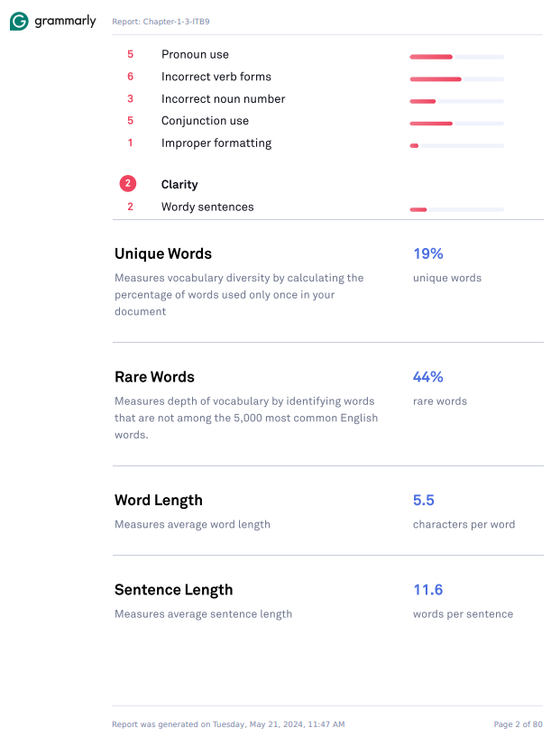

**CURRICULUM VITAE OF STUDENT RESEARCHERS**





