JAVA TUTORIAL
Submitted by:
CHAITHYA GS: 1TD25AI018
ANAGHA B: 1TD25AI006
NATANIA MARTIN: 1BY25AI151

STEP:1
The complete Java program is entered, containing the Product, Electronics and Clothing classes. It demonstrates encapsulation, inheritance, constructor chaining using super() and method overloading.
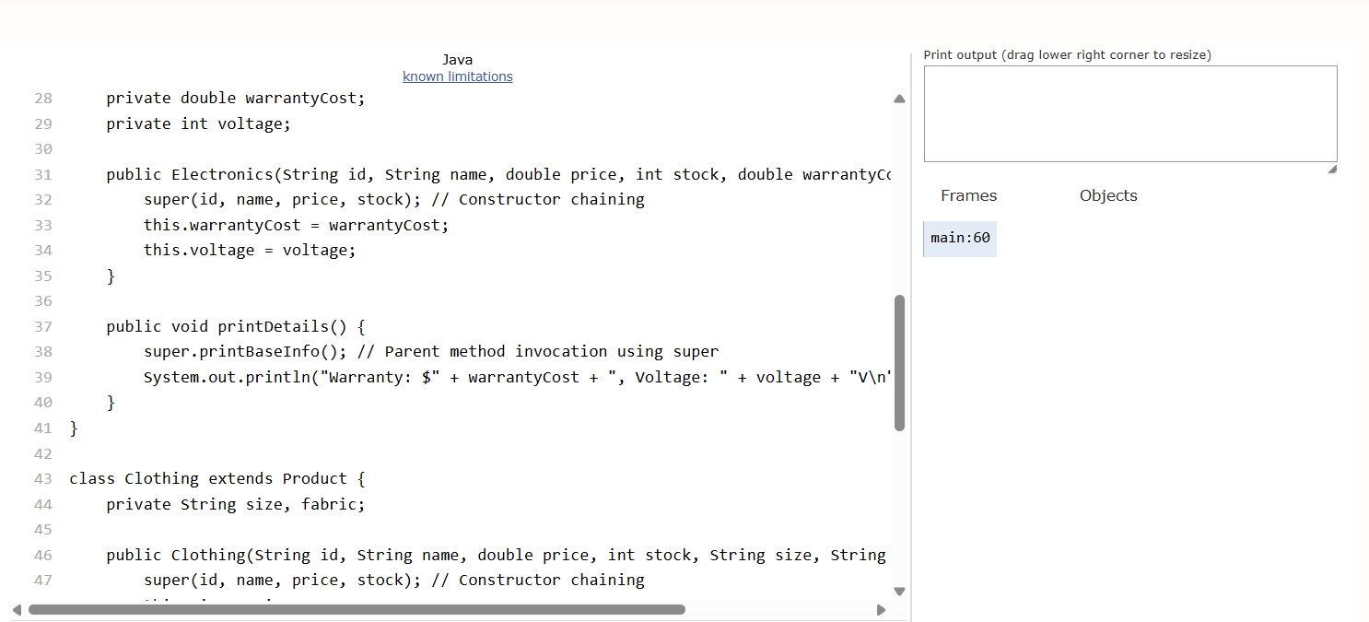
STEP:2
The main function starts creating electronic object called LAPTOP. Constructor receives product id, name, price, stock, warrentycost, voltage as arguments
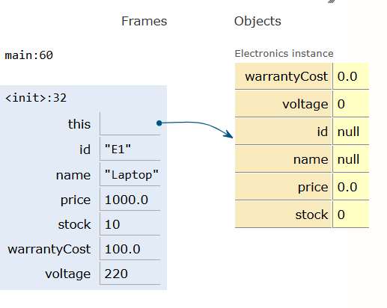
STEP:3
The Electronics constructor is invoked. The object receives the initial values, and the constructor begins executing the super() statement to initialize the inherited properties.
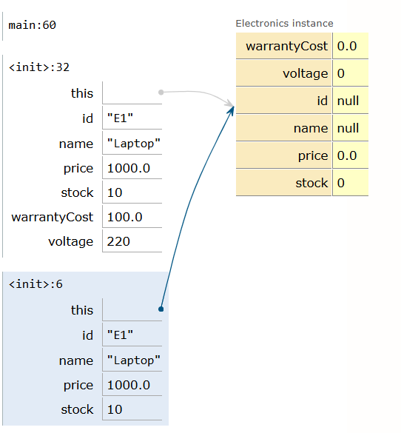
STEP:4
The super() statement calls the Product class constructor and passes the ID, name, price and stock quantity to it.
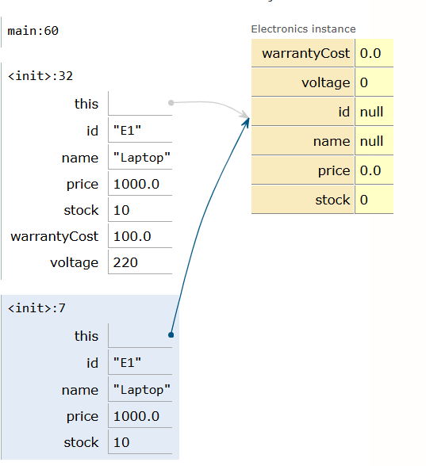
STEP:5- The Product constructor begins assigning the received values to its corresponding instance variables using the this keyword
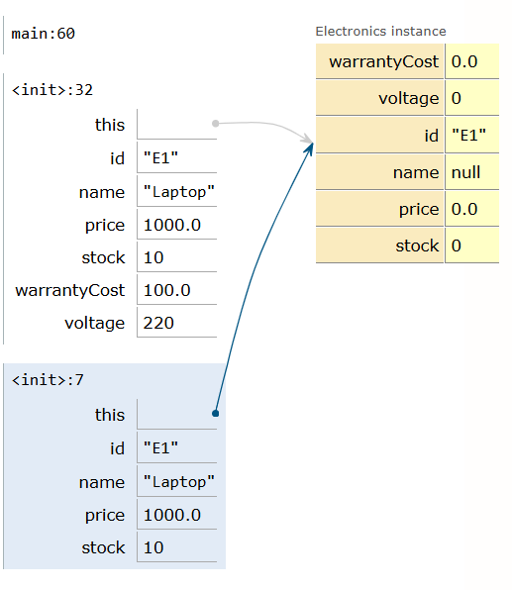
STEP:6
The product ID value "E1" is assigned to the ID variable of the Product object through the parent constructor.
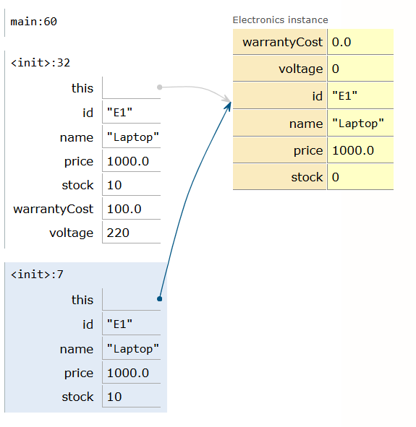

STEP:7
The name "Laptop" is assigned to the name variable of the Product object.
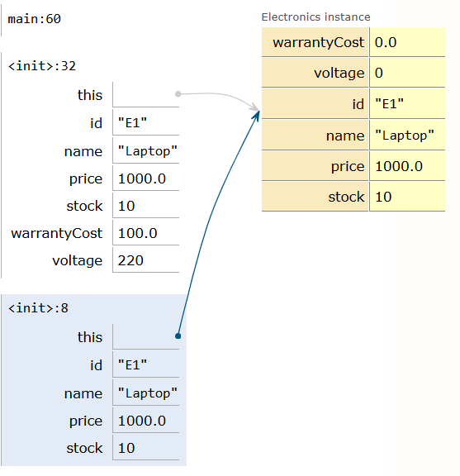
STEP:8
The value 1000.0 is assigned to the price variable, initializing the laptop's base price.
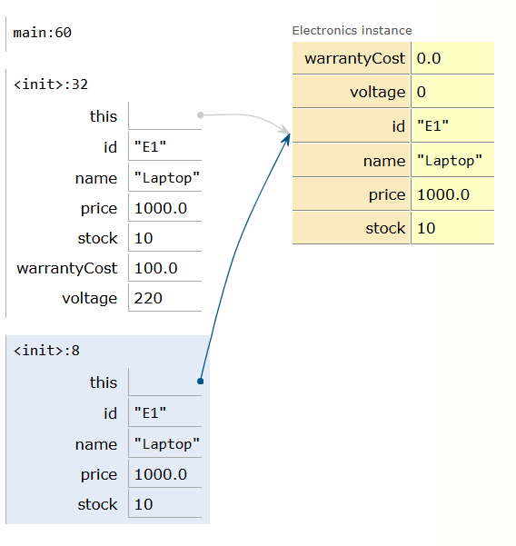
STEP:9
The stock quantity is initialized to 10. The parent constructor has now assigned all four common product properties.
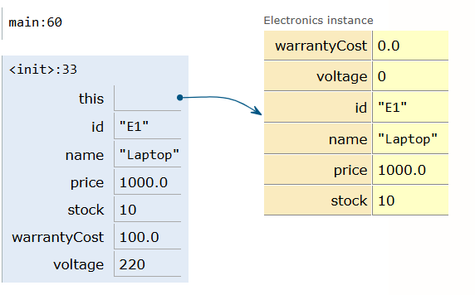

STEP:10
After the parent constructor finishes, execution returns to the Electronics constructor, where the warranty cost is assigned the value 100.0.
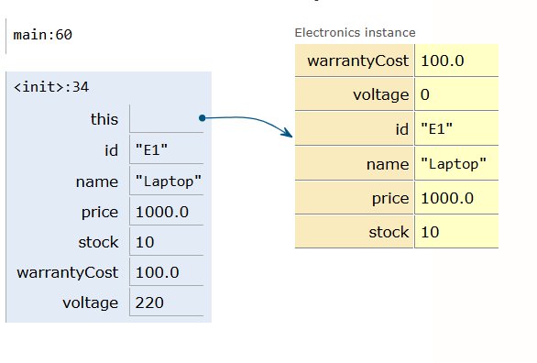
STEP:11
The voltage variable is assigned the value 220. The Electronics constructor completes, and the laptop object is successfully initialized.
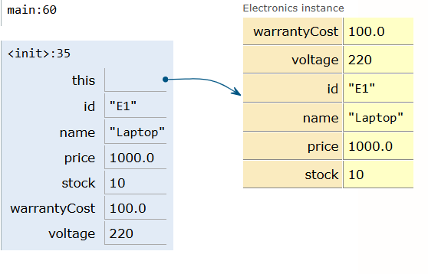
Step 12 – Clothing object creation
The main method proceeds to create a Clothing object named shirt. The constructor is called with the product ID, name, price, stock quantity, size and fabric.

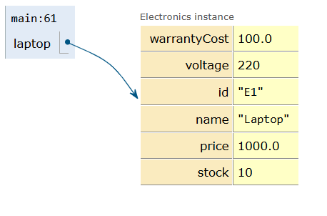
STEP:13
The Clothing constructor is invoked with the supplied arguments. The object is created, and its constructor begins executing the super() statement to initialize the inherited properties.
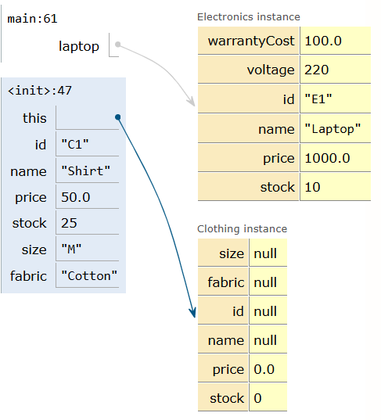

STEP:14
The super() statement calls the Product constructor and passes the common product details: ID, name, price and stock quantity.
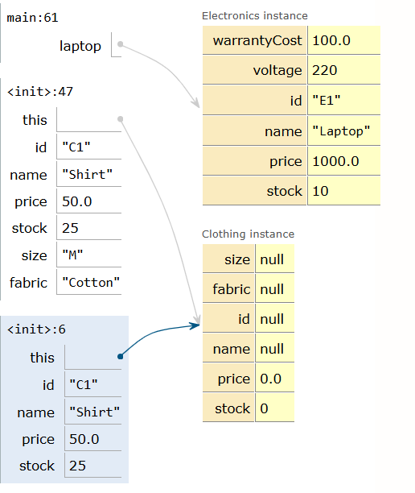

STEP:15
The Product constructor begins executing and assigns the received values to the corresponding parent-class instance variables.
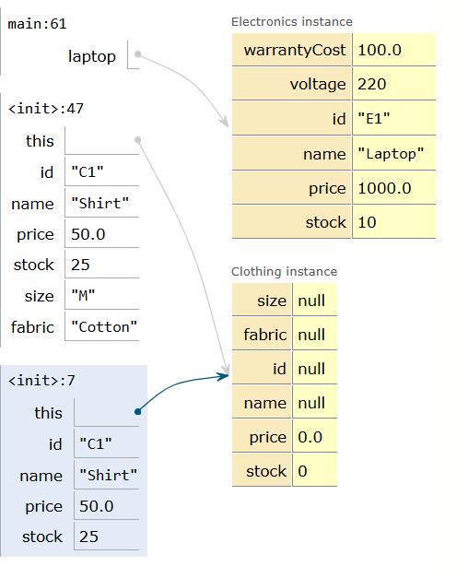
STEP:16
The product ID "C1" is assigned to the ID variable of the Clothing object's inherited Product properties.
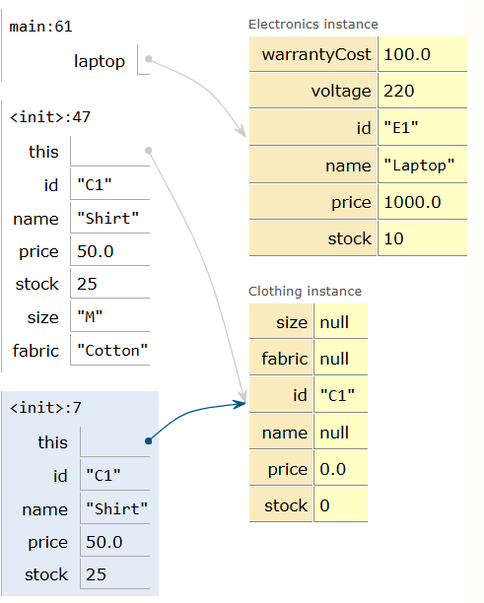

STEP:17
The name "Shirt" is assigned to the name variable of the Product class.
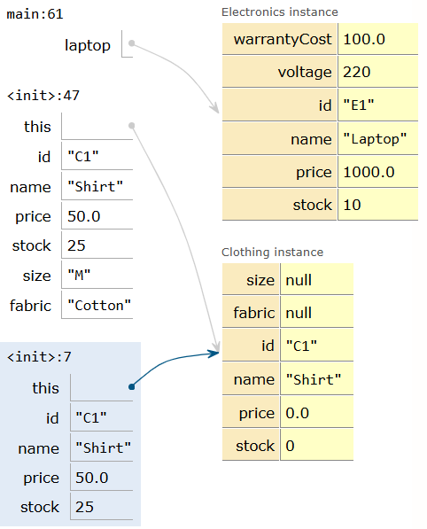

STEP:18
The price variable is initialized with the value 50.0, representing the shirt's base price.
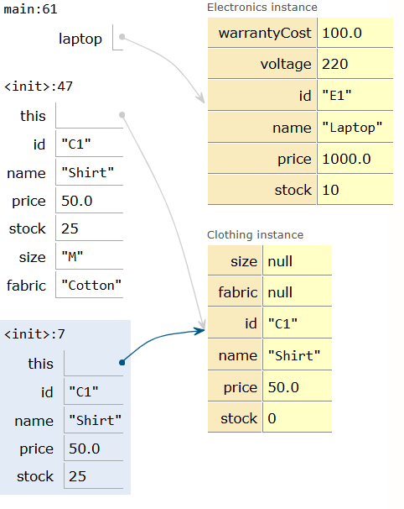

STEP:19
The stock quantity is assigned the value 25. All common Product properties have now been initialized.
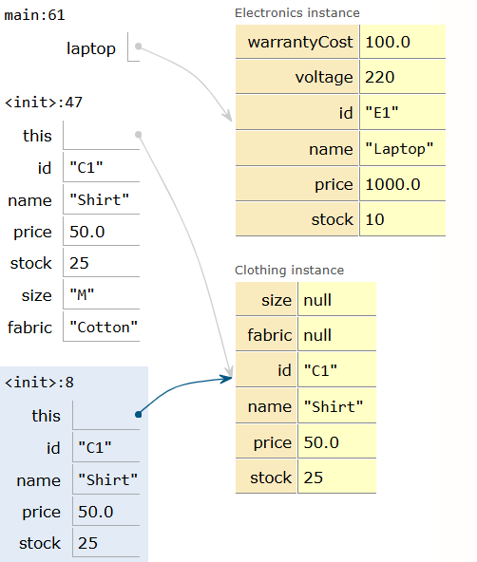
STEP:20
After the parent constructor finishes, execution returns to the Clothing constructor, where the size variable is assigned the value "M".
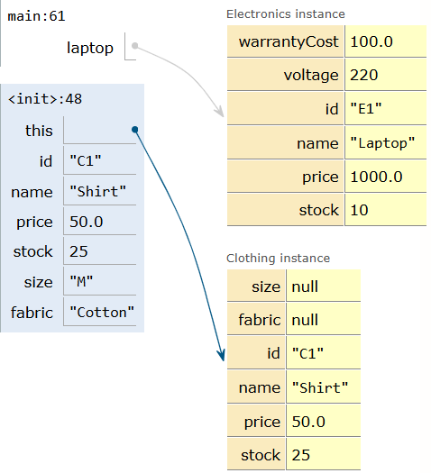
STEP:21
The fabric variable is assigned the value "Cotton", initializing the clothing-specific property.
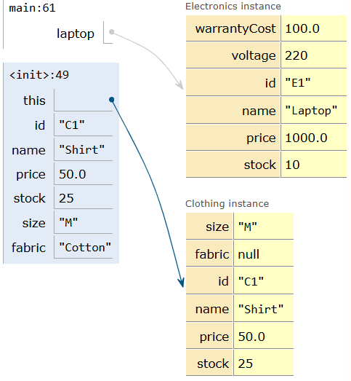
STEP:22
The Clothing constructor finishes execution. The shirt object now contains both inherited Product properties and its own specific properties, size and fabric.
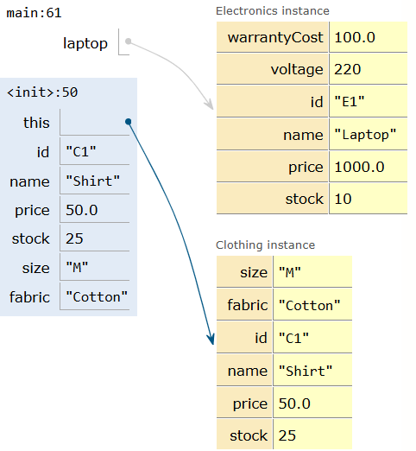
STEP:23
After creating both objects, the main method calls laptop.printDetails(). This invokes the printDetails() method of the Electronics class.
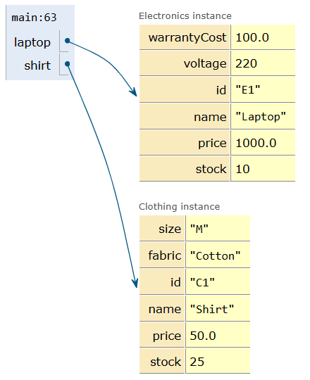
STEP:24
The Electronics printDetails() method begins execution. It uses super.printBaseInfo() to invoke the parent class's method for displaying common product information
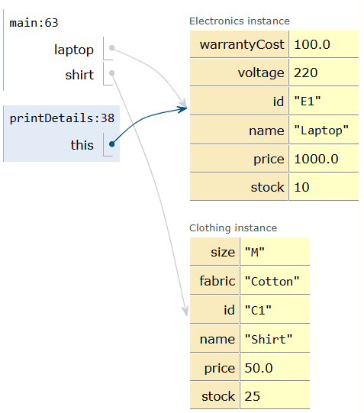
STEP:25
The super.printBaseInfo() statement transfers execution to the printBaseInfo() method in the Product class.
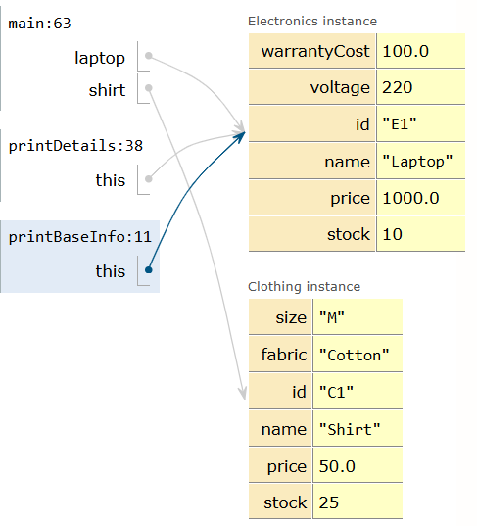
STEP:26
The Product class's printBaseInfo() method begins execution and accesses the laptop object's inherited product information
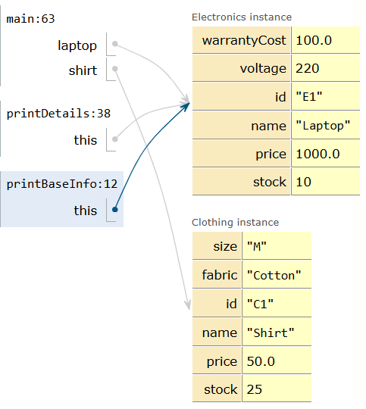
STEP:27
The parent method retrieves the ID, name, price and stock values of the laptop to prepare them for display
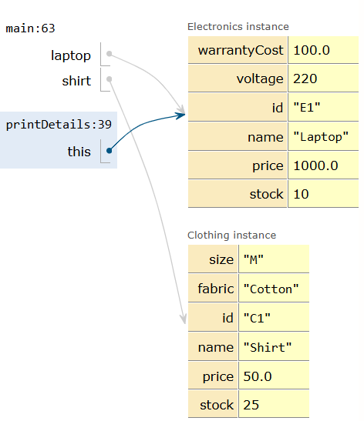
STEP:28
After executing the parent method, control returns to the Electronics printDetails() method to continue displaying the remaining details.
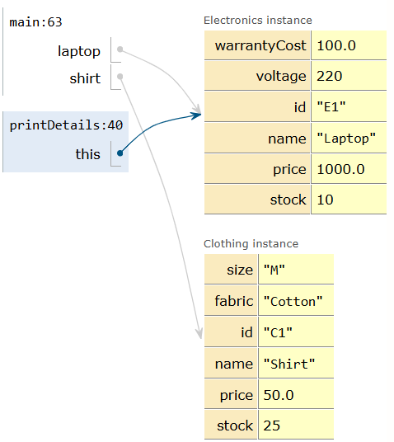

STEP:29
The Electronics method completes its execution by displaying the warranty cost and voltage along with the common product information.
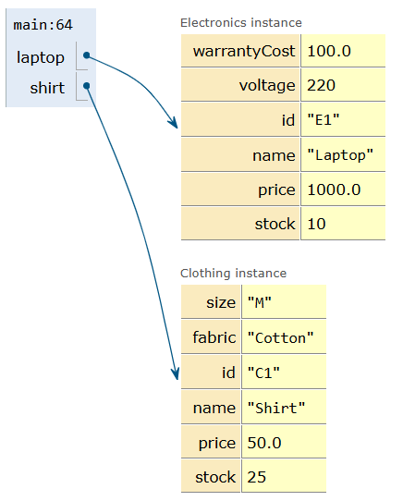
STEP:30
The main method proceeds to call shirt.printDetails(), invoking the printDetails() method of the Clothing class.
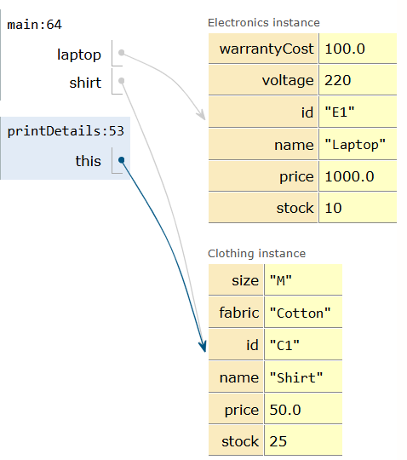
STEP:31
The Clothing printDetails() method executes super.printBaseInfo(), which calls the parent Product class's printBaseInfo() method.
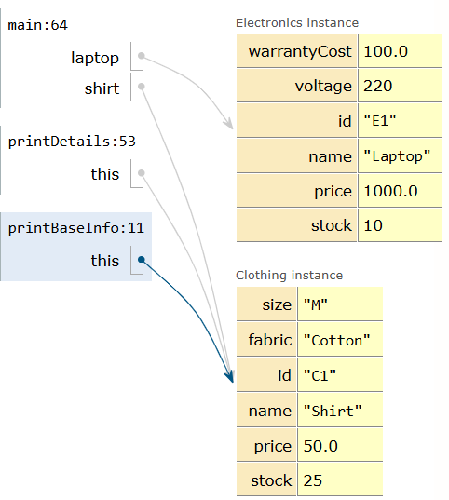

STEP:32
The Product class's printBaseInfo() method begins execution and accesses the common properties of the shirt object.
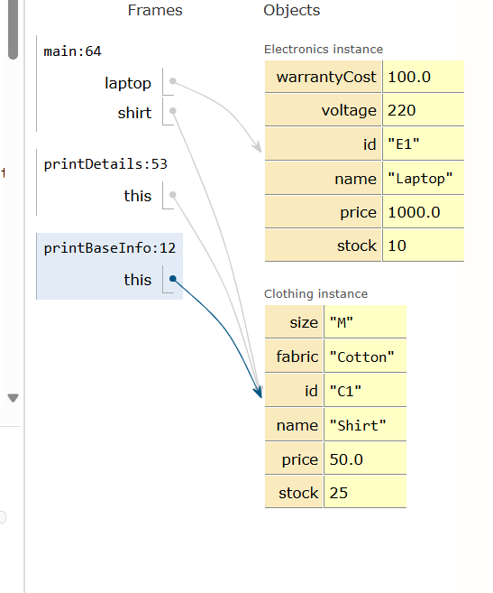

STEP:33
The parent method retrieves the shirt's ID, name, price and stock quantity for displaying the basic product information.
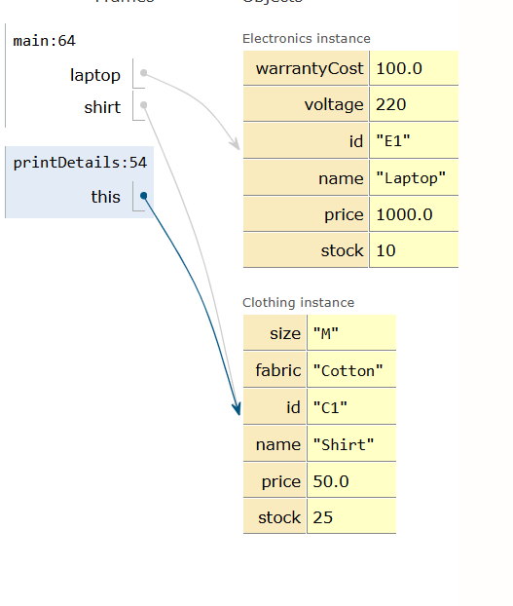
STEP:34
After the parent method finishes, control returns to the Clothing class. The size and fabric are displayed, completing the printing of the shirt's details.

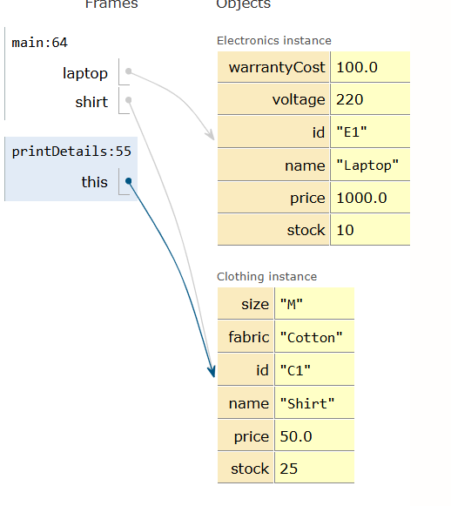
STEP:35
The main method calls laptop.applyDiscount(10.0), passing 10.0 as the percentage discount value.

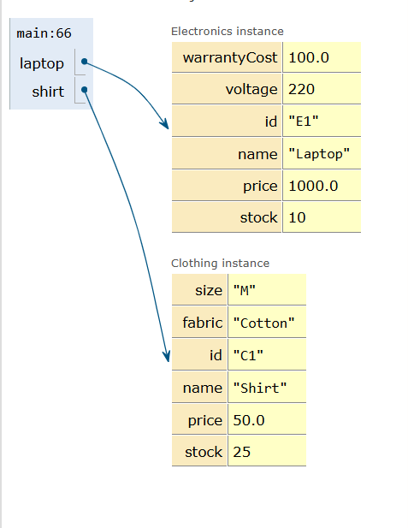
STEP:36
Java identifies the overloaded applyDiscount() method that accepts one double parameter. The percentage discount method begins execution.
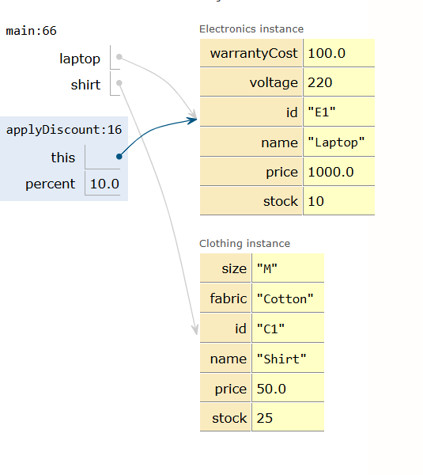
STEP:37
The method calculates 10% of the laptop's original price (1000.0), which equals 100.0, and subtracts it from the original price.
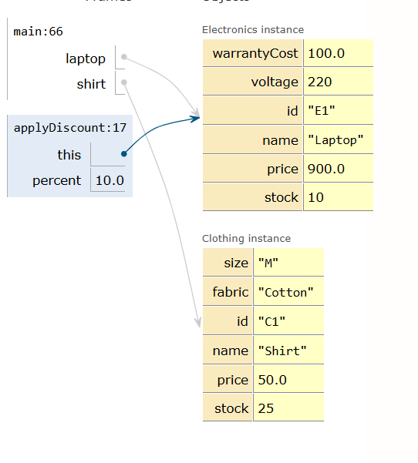

STEP:38
The laptop's price is updated to 900.0 after applying the 10% discount.
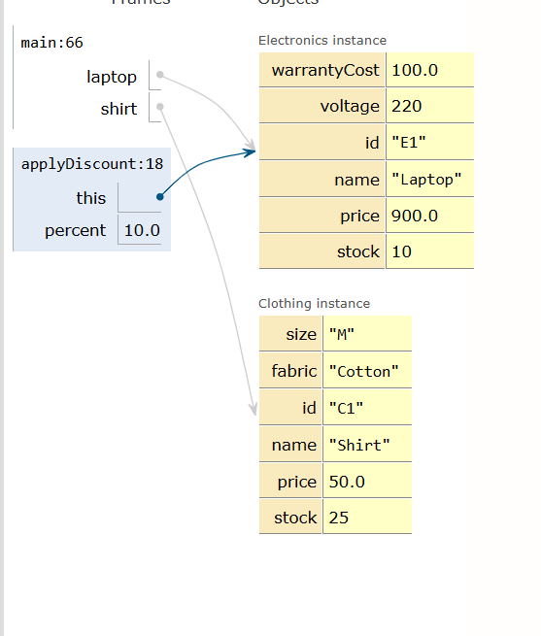

STEP:39
The percentage discount method finishes execution. The laptop's updated price is ₹900 (represented as $900.0 in the program).
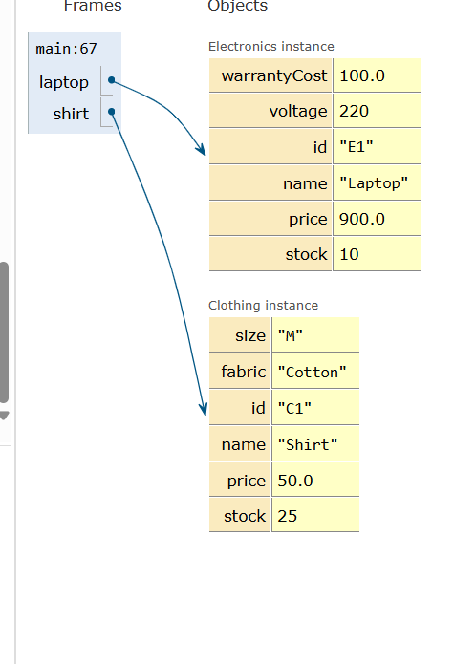

STEP:40
The main method calls shirt.applyDiscount(5.0, true), passing a flat discount amount of 5.0 and setting the seasonal flag to true.
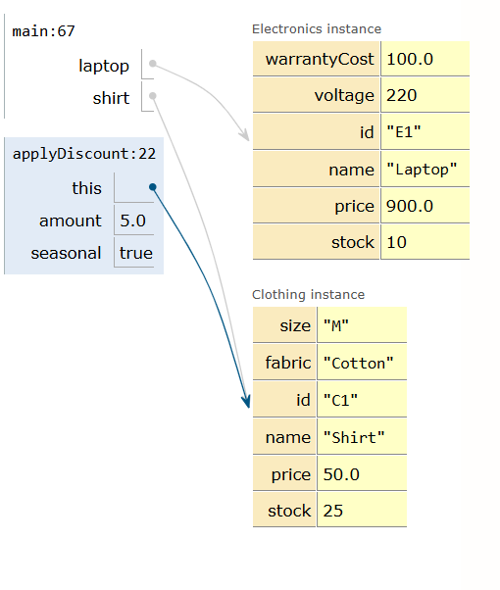
STEP:41
Java identifies the overloaded applyDiscount() method that accepts a double and a boolean parameter. The method subtracts the flat discount amount of 5.0 from the shirt's original price of 50.0.
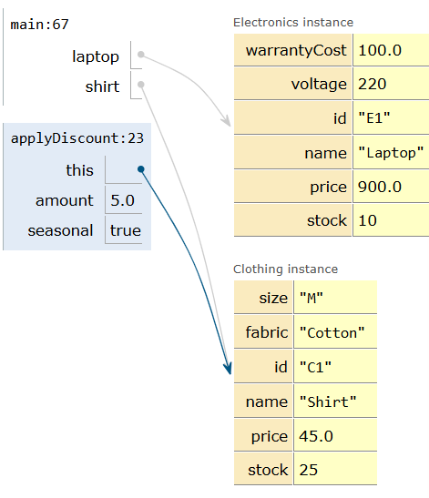

STEP:42
The shirt's price is updated to 45.0. Since the seasonal flag is true, the output also displays the [Seasonal] label, completing the discount operation.
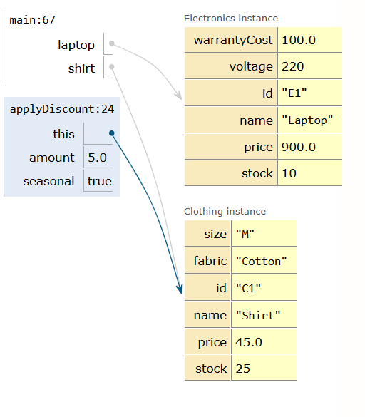
CODE:
class Product {
private String id, name;
private double price;
private int stock;

public Product(String id, String name, double price, int stock) {
this.id = id; this.name = name; this.price = price; this.stock = stock;
}

public void printBaseInfo() {
System.out.println("ID: " + id + ", Name: " + name + ", Price: $" + price + ", Stock: " + stock);
}

// Overload 1: Percentage discount
public void applyDiscount(double percent) {
price -= price * (percent / 100.0);
System.out.println(name + " price after " + percent + "% off: $" + price);
}

// Overload 2: Flat amount discount with seasonal flag
public void applyDiscount(double amount, boolean seasonal) {
price -= amount;
System.out.println((seasonal ? "[Seasonal] " : "") + name + " price after $" + amount + " off: $" + price);
}
}

class Electronics extends Product {
private double warrantyCost;
private int voltage;

public Electronics(String id, String name, double price, int stock, double warrantyCost, int voltage) {
super(id, name, price, stock); // Constructor chaining
this.warrantyCost = warrantyCost;
this.voltage = voltage;
}

public void printDetails() {
super.printBaseInfo(); // Parent method invocation using super
System.out.println("Warranty: $" + warrantyCost + ", Voltage: " + voltage + "V\n");
}
}

class Clothing extends Product {
private String size, fabric;

public Clothing(String id, String name, double price, int stock, String size, String fabric) {
super(id, name, price, stock); // Constructor chaining
this.size = size;
this.fabric = fabric;
}

public void printDetails() {
super.printBaseInfo(); // Parent method invocation using super
System.out.println("Size: " + size + ", Fabric: " + fabric + "\n");
}
}

public class Main {
public static void main(String[] args) {
Electronics laptop = new Electronics("E1", "Laptop", 1000.0, 10, 100.0, 220);
Clothing shirt = new Clothing("C1", "Shirt", 50.0, 25, "M", "Cotton");

laptop.printDetails();
shirt.printDetails();

laptop.applyDiscount(10.0);
shirt.applyDiscount(5.0, true);
}
}

