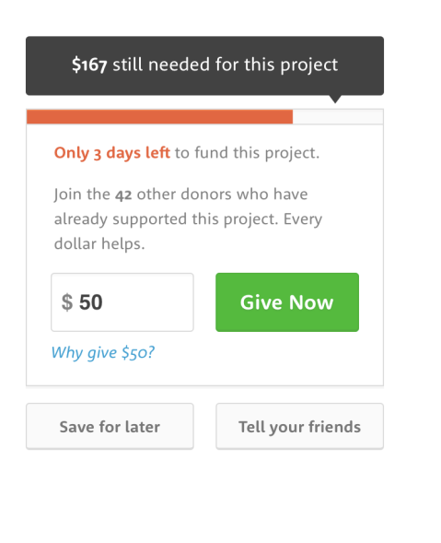

Requirements

1. When designing and implementing the frontend consider efficient, clean and reusable code

2. We want the frontend to be responsive and interactive. Update project progress interactively.

3. Consider effective and resource optimized server

4. You can use mock data on the server side

Server Api

* Days left for the project completion
* Amount of money left to complete the project
* Total Amount of money the project need to raise
* Number of donors of the project until now
* Project name

Client API

* Donation (userId, amount)

Client State

* Current donation (Typed by the user in the text box)
* Widjet hover
* currentDonation (to set feedback, encouragement message)

Client messages: {TOO_LOW, VERY_NICE, AWESOME}

Server Architecture

* Routes:
  + Auth (Signup, Login, Signout)
  + Users [] {donation
  + Projects []
* Controllers:
  + User
  + Project
  + Donation