Develop a YouTube search web-app.

You can use an online API or use the mock data (provided below)

You can use your preferable IDE or an online editor (i.e. <https://stackblitz.com/>)

When the user will search for a song they will see a list of songs with their corresponding thumbnail.

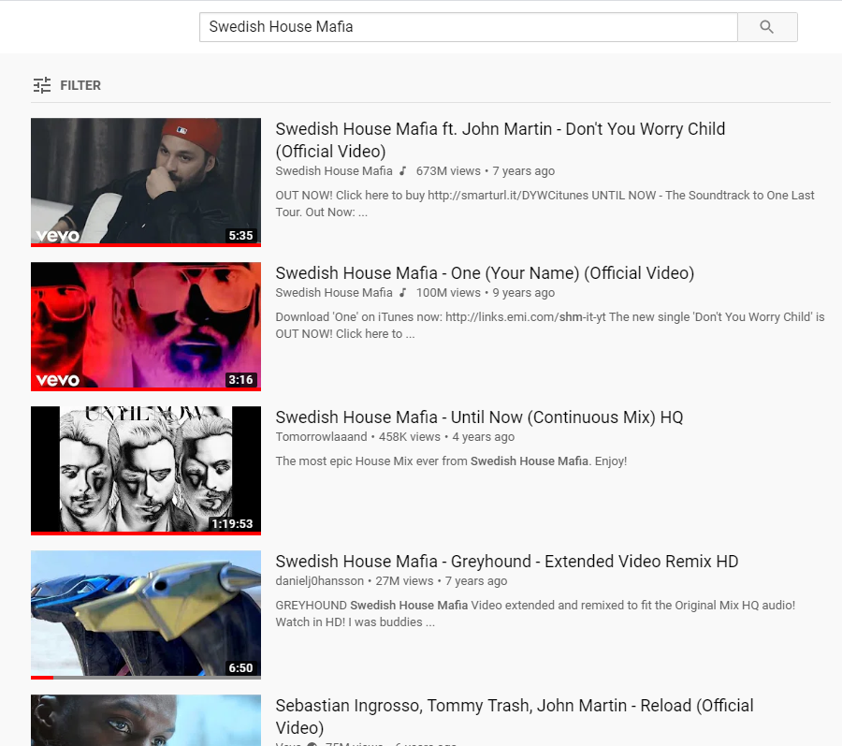

When users click on the thumbnail they will enter the song page and will be able to watch the video.

On the right, the user will see related song thumbnails. When the user clicks on a related thumbnail, the corresponding video will be displayed.

