Liver Disease Classification
Using Machine Learning
A Comparative Study of Classical Models, Class-Imbalance Handling, Interpretability, and Ensembling on the Indian Liver Patient Dataset (ILPD)
Technical Project Report
August 2026

Table of Contents
- 1. Executive Summary
- 2. Dataset & Methodology
- 3. Stage 1 — Baseline Model Comparison
- 4. Stage 2 — Class-Imbalance Handling & Hyperparameter Tuning
- 5. Stage 3 — Model Interpretability (SHAP)
- 6. Stage 4 — Ensemble Models
- 7. Conclusions & Recommendations
- 8. Limitations
- Appendix — Project Files

1. Executive Summary
This report documents an end-to-end machine learning pipeline for predicting liver disease from routine blood-test attributes, built and evaluated on the Indian Liver Patient Dataset (ILPD, UCI Machine Learning Repository). The work progressed through four stages: (1) a baseline comparison of eight classical classifiers, (2) class-imbalance handling via SMOTE combined with hyperparameter tuning, (3) model interpretability using SHAP to understand which clinical markers drive predictions, and (4) ensemble modeling to combine the strongest individual classifiers.
The final recommended model is a Soft Voting Ensemble of tuned Logistic Regression, Random Forest, and SVM classifiers, which achieved the best overall balance of accuracy (78.6%), F1-score (0.847), and ROC-AUC (0.831) on a held-out test set, with meaningfully more balanced precision and recall across both classes than any single model.

2. Dataset & Methodology

2.1 Dataset
The Indian Liver Patient Dataset contains 583 patient records (416 with liver disease, 167 without) collected in North East Andhra Pradesh, India, with 10 predictive attributes:
- Age, Gender
- Total Bilirubin, Direct Bilirubin
- Alkaline Phosphotase, Alamine Aminotransferase (ALT), Aspartate Aminotransferase (AST)
- Total Proteins, Albumin, Albumin-and-Globulin Ratio
The target class is imbalanced, with roughly 71% of records labeled as liver-disease-positive.

2.2 Preprocessing
- Gender encoded numerically (Female=0, Male=1).
- The handful of missing Albumin-and-Globulin-Ratio values imputed with the column median.
- 80/20 stratified train/test split (random_state=42) held constant across every stage for fair comparison.
- Features standardized (zero mean, unit variance) via StandardScaler, fit on the training set only.
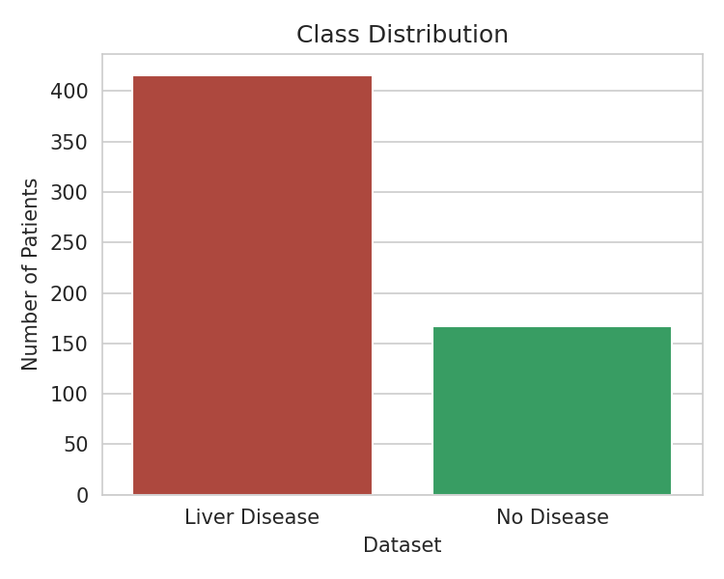
Figure 1. Class distribution — the dataset skews toward disease-positive cases.
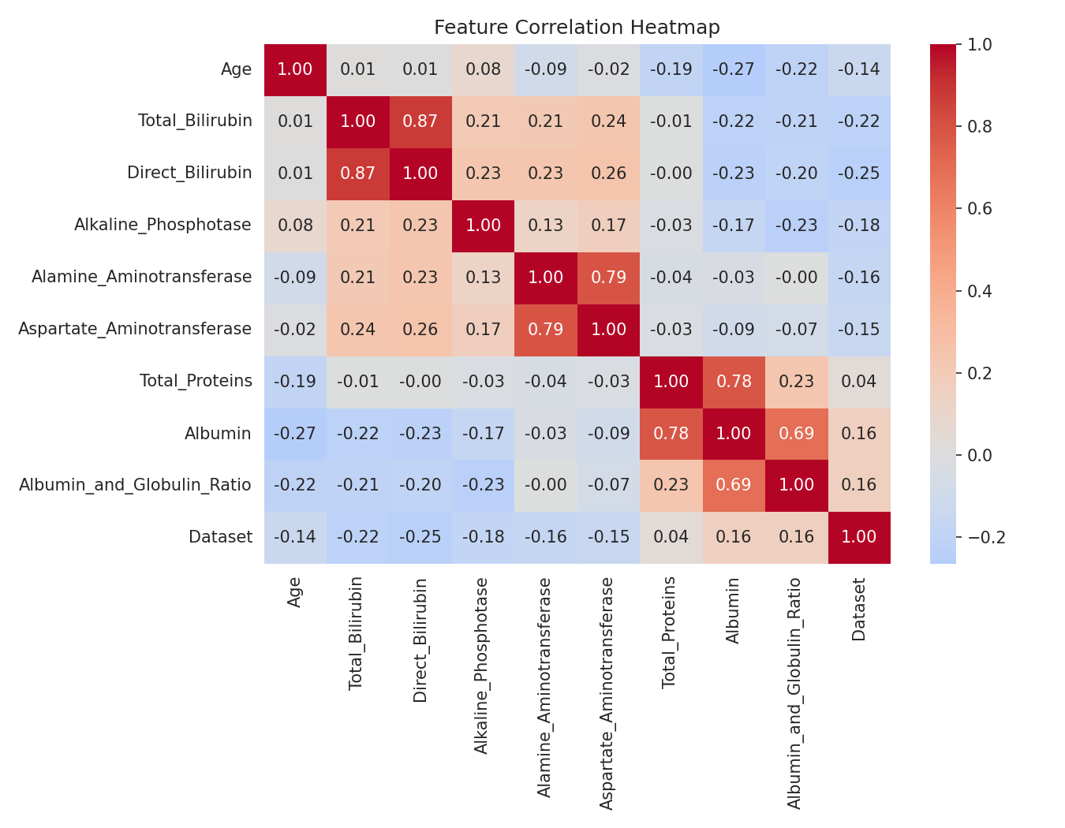
Figure 2. Feature correlation heatmap. Notable pairs: Total/Direct Bilirubin, Albumin/Total Proteins, and AST/ALT are all strongly correlated.

3. Stage 1 — Baseline Model Comparison
Eight classifiers were trained with default-ish settings (class_weight="balanced" where supported) and evaluated with 5-fold stratified cross-validation plus the held-out test set: Logistic Regression, Decision Tree, Random Forest, Gradient Boosting, SVM (RBF), K-Nearest Neighbors, Naive Bayes, and XGBoost.
Model | Test Accuracy | Test F1 | Test ROC-AUC
SVM (RBF) | 0.692 | 0.743 | 0.843
Logistic Regression | 0.735 | 0.786 | 0.830
Naive Bayes | 0.641 | 0.667 | 0.796
Random Forest | 0.735 | 0.832 | 0.780
Gradient Boosting | 0.684 | 0.798 | 0.746
XGBoost | 0.701 | 0.807 | 0.726
K-Nearest Neighbors | 0.684 | 0.796 | 0.706
Decision Tree | 0.624 | 0.744 | 0.518

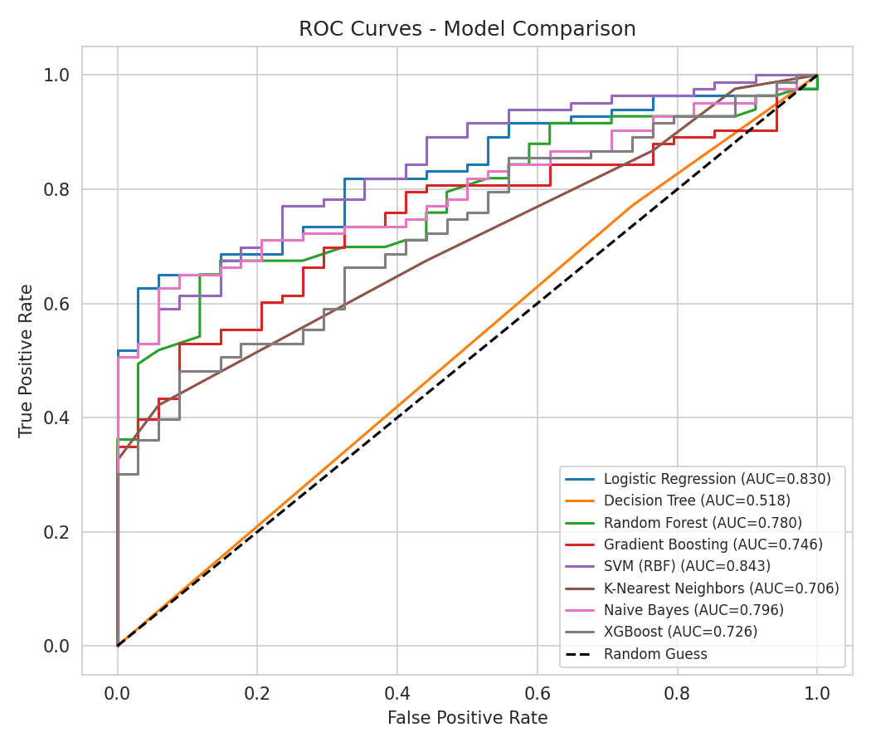
Figure 3. ROC curves for all baseline models. SVM and Logistic Regression led on ROC-AUC; Random Forest led on F1.
Takeaway: no single default model dominated across all metrics — SVM and Logistic Regression ranked ROC-AUC, while Random Forest's ensemble of trees gave it the best F1 by better balancing precision and recall. This motivated the tuning and ensembling stages that followed.

4. Stage 2 — Class-Imbalance Handling & Hyperparameter Tuning
The three strongest baseline models (Logistic Regression, Random Forest, SVM) were tuned with GridSearchCV (5-fold, scoring=ROC-AUC) after applying SMOTE oversampling to the training set only, so the minority ("no disease") class was equally represented during training while the test set retained its real-world imbalance for honest evaluation.
Model | Baseline ROC-AUC | Tuned + SMOTE ROC-AUC | Best Hyperparameters
Logistic Regression | 0.831 | 0.831 | C=0.1
Random Forest | 0.748 | 0.784 | n_estimators=200, max_depth=None
SVM (RBF) | 0.671 | 0.798 | C=50, gamma=scale

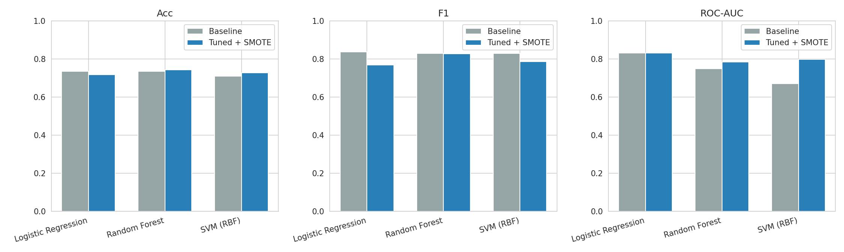
Figure 4. Baseline vs. tuned+SMOTE performance across accuracy, F1, and ROC-AUC.
Takeaway: tuning plus SMOTE gave Random Forest and SVM a clear ROC-AUC lift (+0.036 and +0.127 respectively), while Logistic Regression — already using class_weight="balanced" — stayed flat. F1 did not improve uniformly, since SMOTE trades some precision for better minority-class recall; the right operating point depends on whether missed disease cases or false alarms are costlier in a given deployment.

5. Stage 3 — Model Interpretability (SHAP)
To make the model's reasoning auditable — important for any clinically-adjacent application — SHAP (SHapley Additive exPlanations) values were computed for a Random Forest using TreeExplainer, which gives exact, fast attributions for tree ensembles.
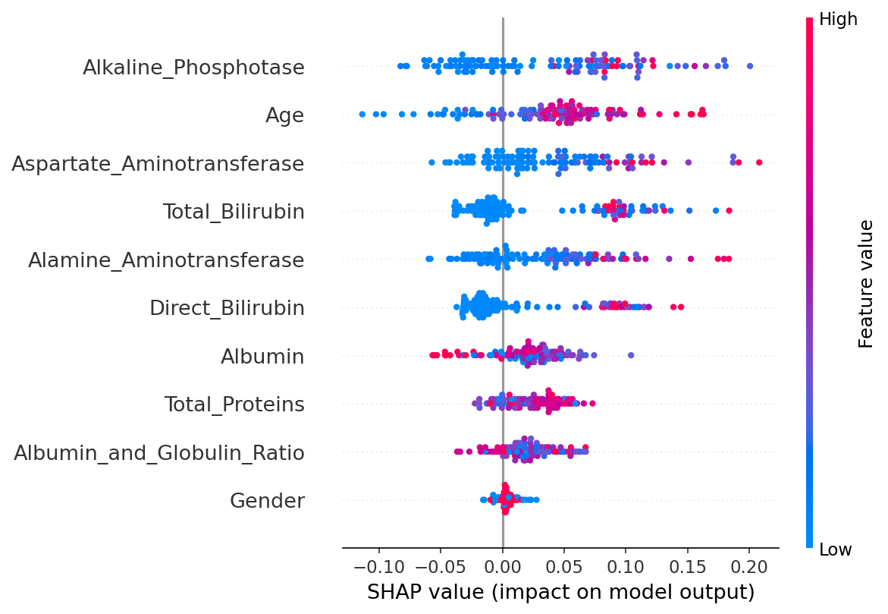
Figure 5. SHAP summary plot. Each point is one patient; color shows the feature's value, position shows its impact on the prediction (right = pushes toward disease).
The five most influential features, ranked by mean absolute SHAP value, were Alkaline Phosphotase, Age, Aspartate Aminotransferase (AST), Total Bilirubin, and Alamine Aminotransferase (ALT) — all standard liver-function markers, which lends clinical face-validity to the model. Elevated bilirubin and liver enzyme values consistently pushed predictions toward "disease," matching known diagnostic patterns.
Per-patient waterfall explanations (generated separately) allow any individual prediction to be broken down into the specific lab values that drove it, and a companion command-line tool (predict_patient.py) surfaces this explanation for any new patient at prediction time.

6. Stage 4 — Ensemble Models
The three tuned base models were combined into a Soft Voting ensemble (averaging predicted probabilities) and a Stacking ensemble (a Logistic Regression meta-model trained on the base models' out-of-fold predictions), both trained on the SMOTE-balanced data.
Model | Accuracy | F1 | ROC-AUC
Voting Ensemble | 0.786 | 0.847 | 0.831
Logistic Regression | 0.718 | 0.769 | 0.831
Stacking Ensemble | 0.744 | 0.833 | 0.799
SVM (RBF) | 0.726 | 0.787 | 0.798
Random Forest | 0.744 | 0.828 | 0.784

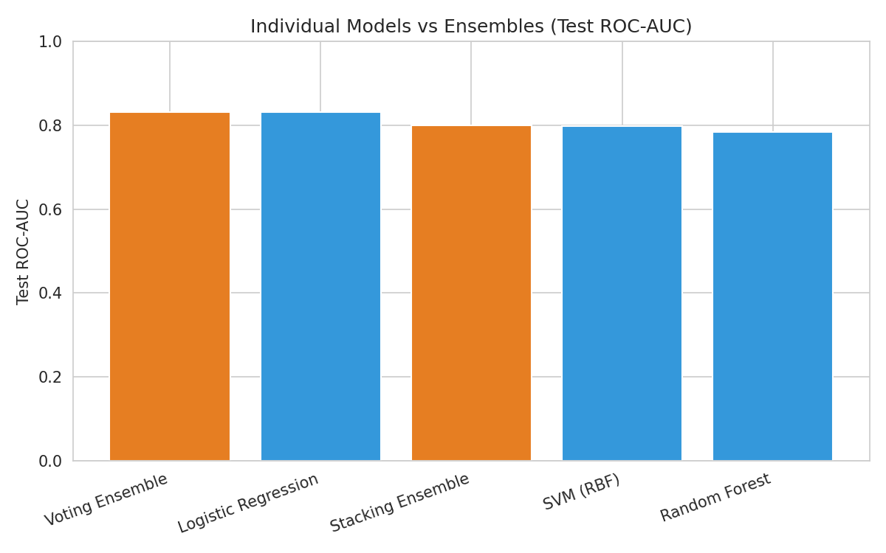
Figure 6. Test ROC-AUC — individual models (blue) vs. ensembles (orange).
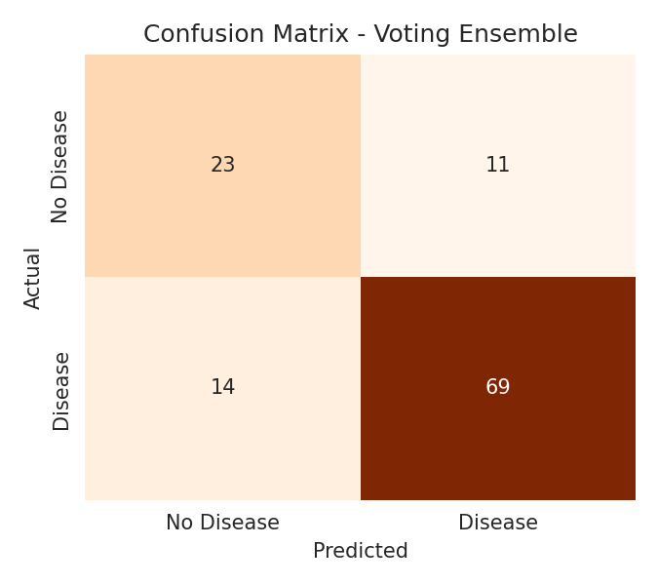
Figure 7. Confusion matrix — Voting Ensemble (final model).
The Voting Ensemble is the best-performing model in this project: it matches Logistic Regression's ROC-AUC while beating every individual model on accuracy and F1, and gives markedly more balanced precision/recall on the harder "no disease" class (0.62 precision / 0.68 recall) than Logistic Regression alone (0.92 precision / 0.66 recall). Averaging across models with different error patterns — linear, tree-based, and kernel-based — smooths out each one's individual weaknesses.

7. Conclusions & Recommendations
- Recommended model: the Soft Voting Ensemble (Logistic Regression + Random Forest + SVM), which delivers the best balance of accuracy, F1, and ROC-AUC on unseen data.
- Class imbalance matters: SMOTE plus tuning materially improved Random Forest and SVM, underscoring the value of addressing the 71/29 class split rather than relying on default settings alone.
- The model's reasoning is clinically plausible: liver enzymes and bilirubin — the standard diagnostic markers for liver dysfunction — dominate its predictions, per SHAP analysis.
- For deployment, the choice between models should be guided by the relative cost of false negatives (missed disease) vs. false positives (unnecessary follow-up); the CLI tool built for this project reports both a probability and the top contributing factors for each new patient.

8. Limitations
- Small dataset (583 records) from a single geographic region (North East Andhra Pradesh, India) — results may not generalize to other populations.
- Class imbalance (71% disease-positive) means metrics are sensitive to the random train/test split; a different seed shifts numbers by several points.
- This is a research and educational pipeline, not a validated clinical diagnostic tool, and should not be used for real patient care decisions without proper clinical validation.

Appendix — Project Files
- liver_disease_classification.py — Stage 1 baseline pipeline (EDA + 8 models)
- liver_disease_classification_advanced.py — Stage 2: SMOTE + GridSearchCV tuning
- liver_disease_interpretability.py — Stage 3: SHAP explanations
- liver_disease_ensemble.py — Stage 4: Voting & Stacking ensembles
- predict_patient.py — CLI for scoring a new patient with an explanation
- data/indian_liver_patient.csv — the ILPD dataset
- requirements.txt — Python dependencies

