

[Naven OS]

[Technical Manual]

2019

NavenOS

Version [NV-6439-10-85]

[Table of Contents]

1. Overview of the OS
2. Description of Classes
3. Attribute content and Datatypes
4. Program Flow
5. Data Structures
6. Cross References
7. Index

[1.Overview]

1.1 System Overview

NavenOS is a simple operating system, which allows a simple and quick user experience. NavenOS is programmed to create an easy interaction between the user and programs the OS includes; furthermore flexible and easy to use.

[2. Description of Classes]

* NavenOS.java

The NavenOS class contains the user interface and the user command functions, including the help function. NavenOS class runs the whole operating system and handles the function that needs to be implement using loops, recursion and if statements.

* CPU.java

The CPU class contains 4 registers with names: ax, bx, cx, dx which are String data type, a program counter which is integer data type and is referred as PC and an accumulator location which is integer data type referred to as A.

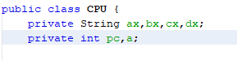

Figure(1.1)

The CPU class also deals with the setting and getting of this register, PC and A as displayed in Figure(1.2)

Moreover the CPU can also display us the current state of the four register, PC and A as shown in Figure(1.3)



Figure(1.3)

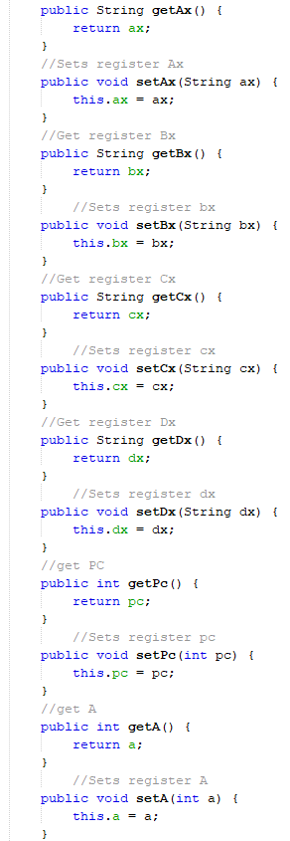Figure(1.2)

* RAM.java

The RAM class deals with the creation of an array(Figure 1.4) and assigning values in to the array to a specific RAM location(Figure 1.5), look at a value in a specific location(Figure 1.6), get the length of the array(Figure 1.7), and display the array(Figure 1.8).

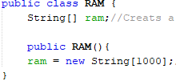

Figure 1.4



Figure 1.5

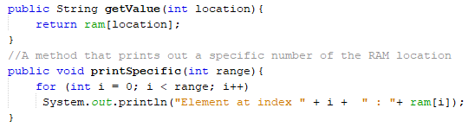

Figure 1.6



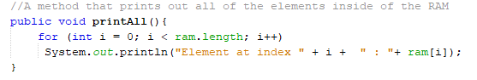 Figure 1.7

Figure 1.8

* commandDic.java

The commandDic class is the manipulation of the commands the operating system uses to perform tasks and operations. The commandDic uses Map and HashMap data structure for the storage and manipulation of the commands.

The commandDic class deals:

* + The storage of the given commands

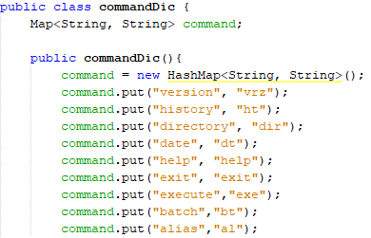Figure 1.9

* + Renaming of a given command

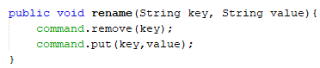Figure 1.10

* + Adding a new command

Figure 1.11

* + Returning commands

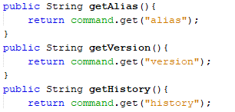 Figure 1.12

* DateTime.java

The DateTime class deals with the extraction of the current date and time for display. Uses the Java.time.format.DateTimeFormatter and java.time.LocalDateTime; java packages to do the manipulation.

* + Extraction of the current time and date

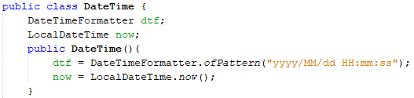

Figure 1.13

* + Display the current time and date



Figure 1.14

* Directory.java

The Directory class deals with the extraction of the files in the current directory but using the java.io.File package from java.

* + Extraction of the files in the current directory

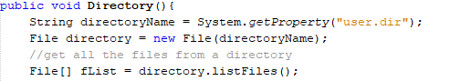

Figure 1.15

* + Display of the files in the current directory



Figure 1.16

* Version.java

The version class deals with creation of the version, setting the version of the operating system, getting the value of the version and returning the version of the operating system.

* + Creation of version

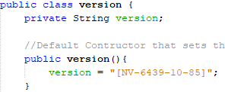

Figure 1.17

* + Setting the version



Figure 1.18

* + Getting the version



Figure 1.19

* + Returning the version



Figure 1.20

* Machine.java

The machine class is the virtual machine for the OS manage. It creates a RAM and CPU objects and perform the reading and manipulation of the file. As well perform the “FetchAndExecute” from the read file.

* + Creation of the RAM and CPU objects

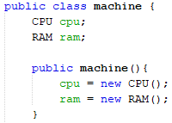

Figure 1.21

* + Read a file and storage of data from file to RAM

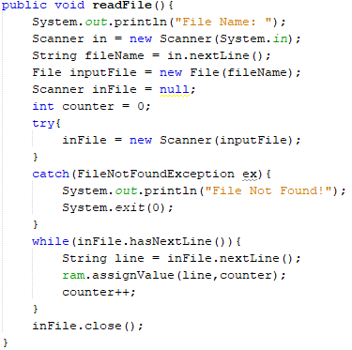

Figure 1.22

* + Manipulation of the file

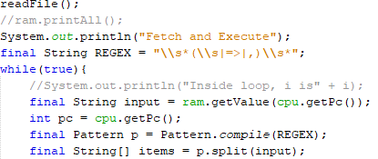

Figure 1.23

* + Performing the FetchAndExecute

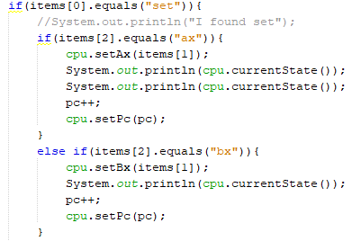

Figure 1.24

Note: Figure 1.24 just shows a portion of the if statement for the FetchAndExecute

[3. Attribute content and Datatypes]

|  |  |  |  |  |  |  |  |  |  |
| --- | --- | --- | --- | --- | --- | --- | --- | --- | --- |
| Classes | | | | | | | | | |
| Machine.java | | Version.java | | CPU.java | | RAM.java | | commandDIc | |
| Attributes | Data type | Attribute | Data types | Attrib  ute | Data type | Attribute | Data types | Attribute | Data type |
| CPU | CPU | Version | String | Ax | String | Ram | String[] | command | Map |
| Ram | RAM |  |  | Bx | String |  |  |  |  |
|  |  |  |  | Cx | String |  |  |  |  |
|  |  |  |  | Dx | String |  |  |  |  |
|  |  |  |  | PC | Integer |  |  |  |  |
|  |  |  |  | A | Integer |  |  |  |  |

Table 1.0 List of attributes in a class and there data types.

Table 1.1 List of attributes in a class and there data types.

|  |  |  |  |  |  |  |  |
| --- | --- | --- | --- | --- | --- | --- | --- |
| DateTime.java | | Directory.java | | close.java | | batchFiles.java | |
| Attributes | Data types | Attributes | Data types | Attributes | Data types | Attributes | Data types |
| Dtf | Date  Time  Formatter | - | - | Checker | String | Ram | String[] |
| Now | Local  DateTime |  |  |  |  |  |  |

[4. Program Flow]