

[Naven OS]

[User Manual]

2019

NavenOS

Version [NV-6439-10-85]

[Table of Contents]

1. Overview of the OS………………………………………………… 4
2. Summary of Commands…………………………………………. 5
3. Detailed Description of Each Command…………………… 6

a. Syntax (if applicable)

b. Use

c. Example

1. Summary of Error Messages…………………………………….. 10
2. Index……………………………………………………………………… 11

[Overview]

1.1 System Overview

NavenOS is a simple operating system, which allows a simple and quick user experience. NavenOS is programmed to create an easy interaction between the user and programs the OS includes; furthermore flexible and easy to use.

1.2 Organization of the Manual

The user’s manual consists of five sections: Overview, Summary of Commands, Detailed description of each command, summary of Error Messages and Index.

Overview section explains in general terms the system and the purpose for which it is intended.

Summary of Commands section provides a general overview of the commands.

Detailed description of each command section gives a detailed information of the commands using syntax, the use and example of usage.

Summary of error messages section provides possible error messages that a user might experience.

Index provides a roadmap to the manual

[Summary Of Commands]

[Command] [Syntax]

1. Version ----------------------------------------------------“vrz”

2. Date-------------------------------------------------------“dt”

3. Directory -------------------------------------------------“dir”

4. History----------------------------------------------------“ht”

5. Exit--------------------------------------------------------“exit”

6. Help ------------------------------------------------------“help”

7. Execute------------------------------------------------“exe”

8. Batch Files--------------------------------------------“bt”

9. Aliasing-----------------------------------------------“al”

[Detailed Description of Command]

1. Version
   1. Syntax: “vrz”
   2. Use: Display the software version number of the simulator
   3. 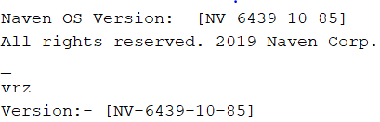Example:
2. Date
   1. Syntax: “dt”
   2. Use: Display or set the date
   3. 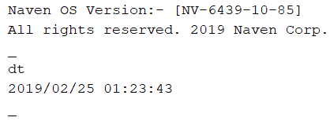Example:
3. Directory
   1. Syntax: “dir”
   2. Use: Print a list of all the files in the simulator’s directory.
   3. 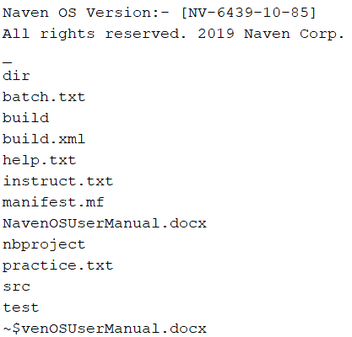Example:
4. History
   1. Syntax: “ht”
   2. Use: Print a list all the commands the user used
   3. 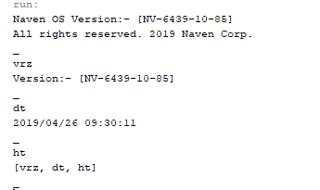Example:
5. Exit
   1. Syntax: “exit”
   2. Use: Exit the simulator
   3. 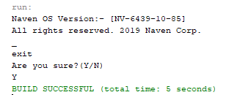Example:
6. Help
   1. Syntax: “help”
   2. Use: Display help information for each command
   3. Example:

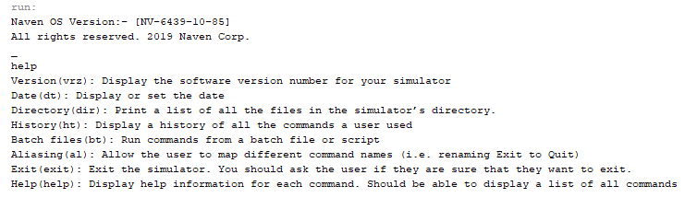

1. Execute
   1. Syntax: “exe”
   2. 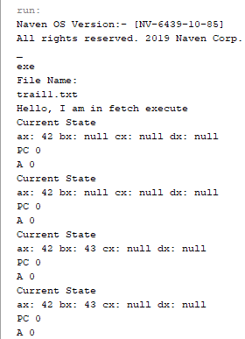Use: Reads a file and perform the fetch and execute
   3. Example:

1. Batch
   1. Syntax: “bt”
   2. Use: Reads a file and performs the commands
   3. 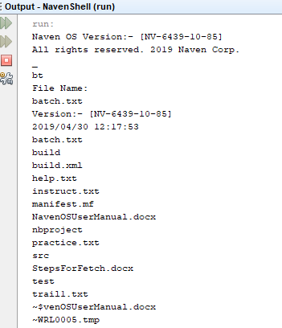Example:
2. Aliasing
   1. Syntax: “al”
   2. 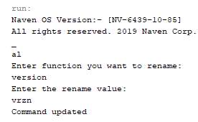Use: Allow the user to map different command names
   3. Example:

[Possible Errors]

Here are some possible errors that you may run to while using this NavenOS:

1. File Not Found: This means that NavenOS couldn’t find the specified file to read. Possible errors might be that the file name is incorrect or the file has been deleted or removed from the given directory. You can type ‘dir’ and glance through the directory and see if you can find the specified file name. If you couldn’t find that means that the file has been deleted or removed.
2. Command Not Recognized: This means that NavenOS didn’t not recognized the command that you entered and couldn’t move forward to perform. Possible error could be misspelling the command syntax. You can type in ‘help’ and it will show you a list of available commands with their command syntax.

[Index]

A

Alias 5, 9

B

Batch 5, 8

D

Date 5, 6

Directory 5, 6

E

Execute 5, 8

Exit 5, 7

H

Help 5, 7

V

Version 5, 6