Create Customer

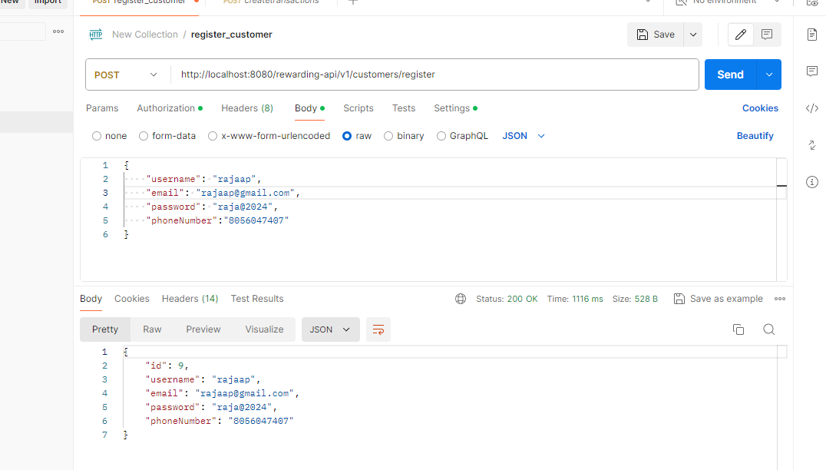

Create Transaction

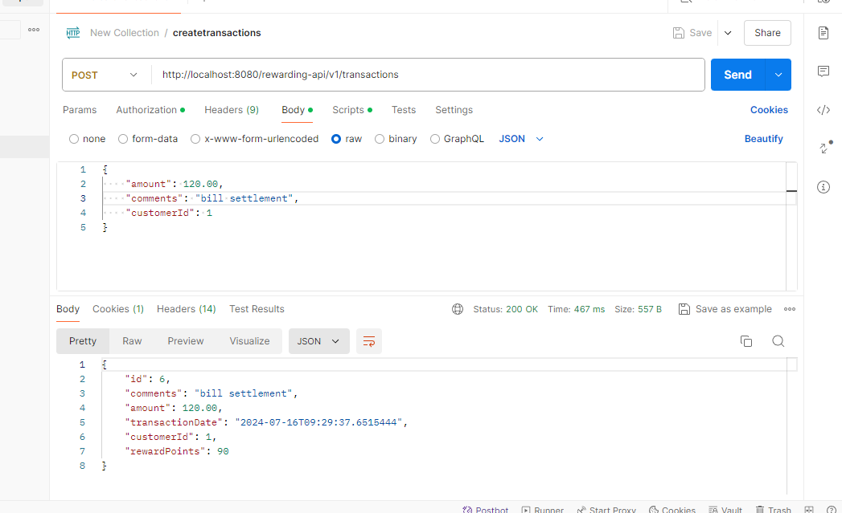

Update Transaction

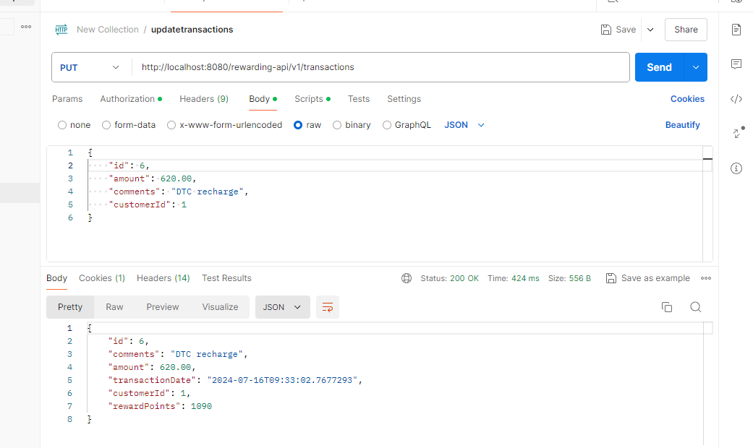

Get All Transactions

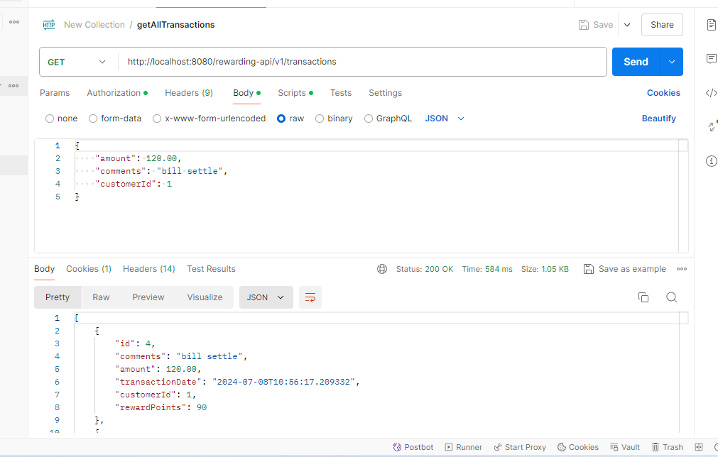

Get Transactions by Customer id

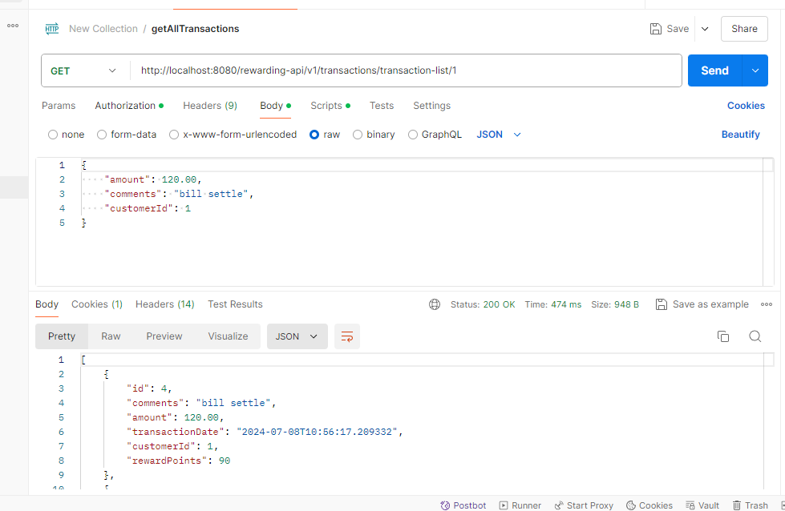

Delete Transaction by id

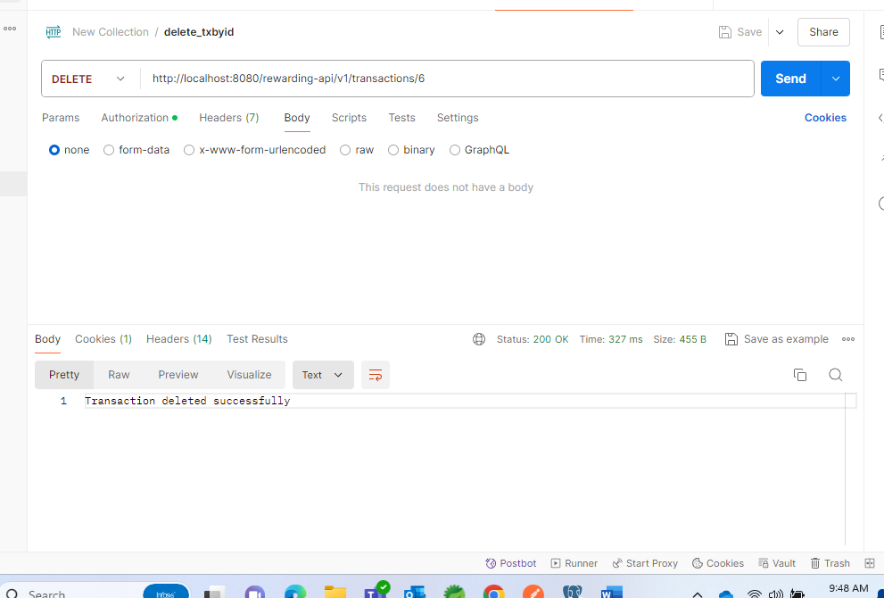

Generate Reward summary

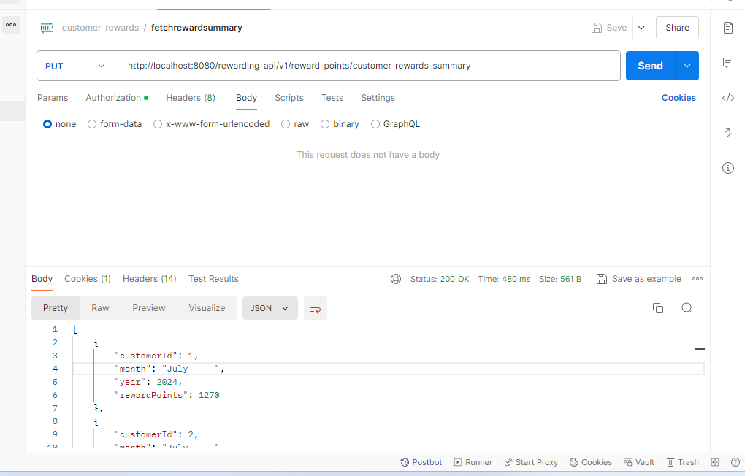

Get Reward Points Summary by customer id

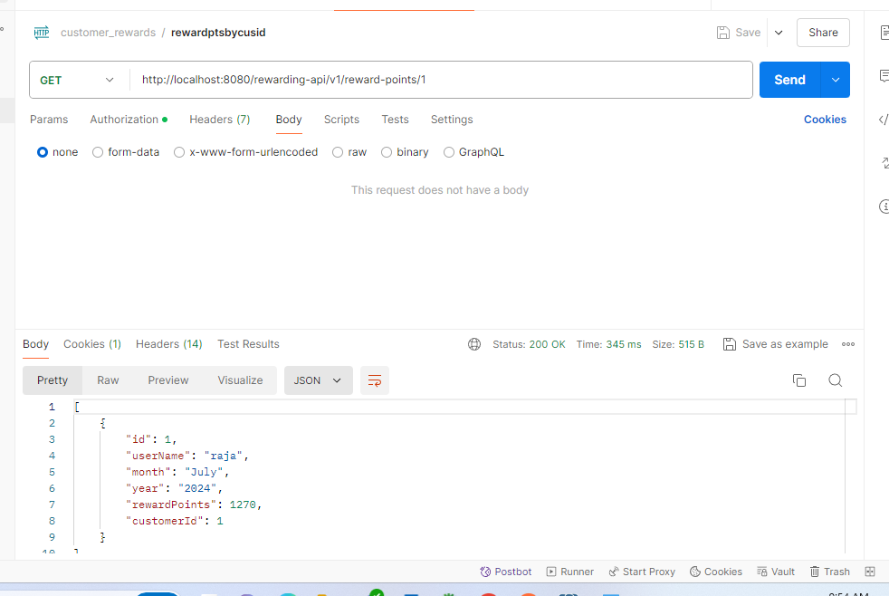

JSON response

http://localhost:8080/rewarding-api/v1/transactions

[

    {

        "id": 4,

        "comments": "bill settle",

        "amount": 120.00,

        "transactionDate": "2024-07-08T10:56:17.209332",

        "customerId": 1,

        "rewardPoints": 90

    },

    {

        "id": 2,

        "comments": "food bill",

        "amount": 120.00,

        "transactionDate": "2024-07-08T16:18:32.345087",

        "customerId": 1,

        "rewardPoints": 90

    },

    {

        "id": 3,

        "comments": "DTC recharge",

        "amount": 620.00,

        "transactionDate": "2024-07-08T16:19:13.157389",

        "customerId": 1,

        "rewardPoints": 1090

    },

    {

        "id": 5,

        "comments": "bill settle",

        "amount": 160.00,

        "transactionDate": "2024-07-08T11:19:43.995704",

        "customerId": 2,

        "rewardPoints": 170

    }

]

<http://localhost:8080/rewarding-api/v1/reward-points>

[

    {

        "id": 1,

        "userName": "raja",

        "month": "July",

        "year": "2024",

        "rewardPoints": 1270,

        "customerId": 1

    },

    {

        "id": 2,

        "userName": "rajagn",

        "month": "July",

        "year": "2024",

        "rewardPoints": 170,

        "customerId": 2

    }

]

Swagger link

<http://localhost:8080/rewarding-api/swagger-ui-custom.html>

<http://localhost:8080/rewarding-api/api-docs>

